MIS – Product

Introduction:

Goal:

Stakeholders:

Applicability:

Additional Architectural Views:

1. Functional View
2. Development View
3. Deployment View
4. Information View
5. Concurrency View
6. Operational View

Context View Diagram:

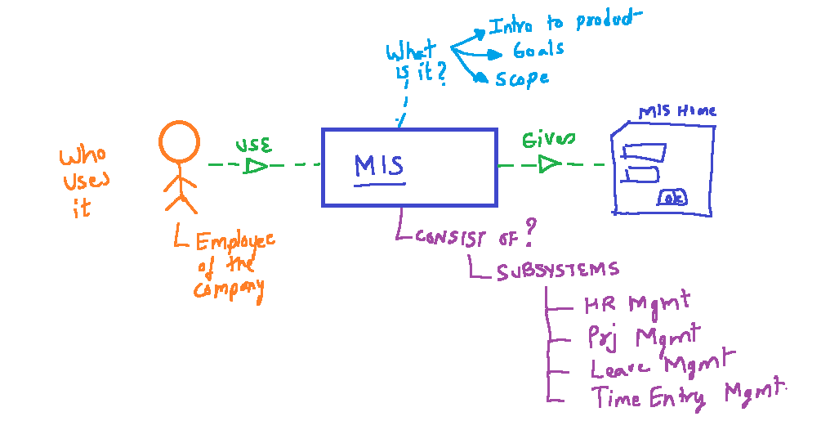

**Analysing the context view from Security view-point**

**Security ViewPoint – For Employee as User (Stakeholder)**

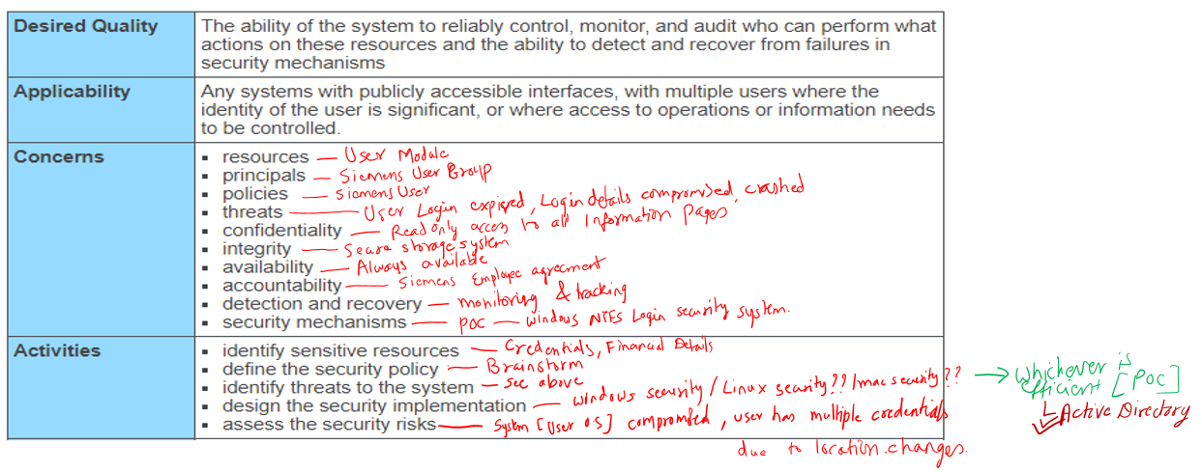

Since the Employee is the primary user of the system, the dependant sub-systems will require Employee as user to further decide on authorization to specific sub-systems and pages.

**Applicability** : To all subsystems and modules identified

Description: The entire MIS runs only if the user is an employee. Therefore any subsystem or module with subsystem will use user information to make further authorization and permission related decision.