Hunter College

CSCI127-HCR1

Professor Ligorio

Sam Prasad

September 2, 2019

Neighborhood Summary: Harlem

The neighborhood of Harlem roughly encompasses 29 census tracts throughout the upper and central areas of Manhattan. They include either the totality or partial portions of tracts 186, 190, 197.02, 200, 201.02, 208, 209.01, 212, 214, 215, 216, 218, 220, 221.02, 222, 224, 226, 227, 228, 230, 231, 232, 234, 235.01, 235.02, 236, 243.02, 257, and 259. In addition, Harlem constitutes the zip codes of 10026, 10027, 10030, 10037, and 10039. As of 2017, Harlem has a total population of 158,211 people, the majority of whom are non-Hispanic African American (53.3%). Likewise, Hispanics, non-Hispanic Whites, and Asians make up 26.3%, 14.2%, and 13.3% of the population, respectively, with the remainder consisting of other races and multiple races (i.e. multiracial). The median household income is $42,835 after adjusting for inflation, however, 23.1% of families fall below the poverty line. The majority of residents in Harlem fall between the ages of 25 to 34 years of age (21.2%), but other close age ranges include 35 to 44 years of age (13.8%), and 45 to 54 years of age (14.3%). Similarly, the median age of the population is 34.4 (approximately 35) years old. Females outnumber males in Harlem, composing 53.7% and 46.3% of the inhabitants, respectively. Regarding educational attainment for roughly 69.9% of the population over 25 years of age, 20.9% of residents hold a Bachelor’s degree, whereas 16.5% hold a higher-level degree (i.e. Master’s, Doctorate, Professional School). Families constitute 48.4% of households, and 23.8% of people over 15 years of age (82.6%) of the total population is married. Finally, the distance from Harlem to the Federal Hall is approximately 8.4 miles (walking distance), while the distance from Harlem to the Empire State Building is about 5.3 miles.

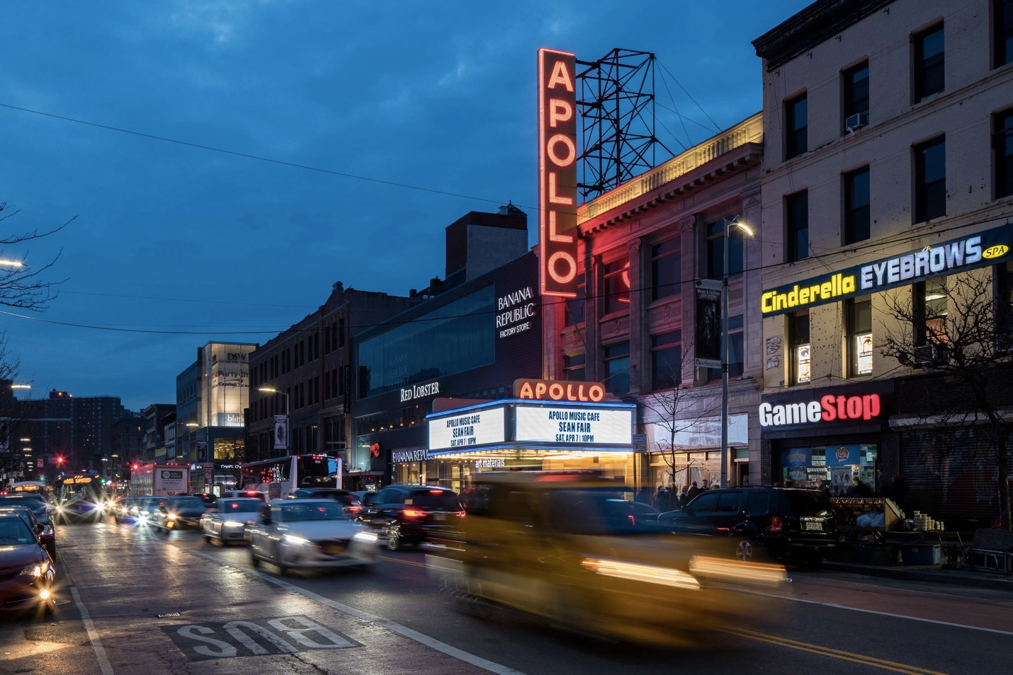

References

Dickson, B. (2018, November 8). Things to do in N.Y.C.: Share your Harlem recommendations.

*The New York Times*. Retrieved from <https://www.nytimes.com/2018/11/08/nyregion/harlem-best-things-to-do.html>

Google Maps. (2019). Retrieved from

<https://www.google.com/maps/dir/Harlem,+New+York,+NY/Empire+State+Building,+West+34th+Street,+New+York,+NY/@40.7799139,-74.0021749,13z/data=!3m1!4b1!4m14!4m13!1m5!1m1!1s0x89c2f66e2188a29f:0xb408afef09e2702e!2m2!1d-73.9464769!2d40.8115504!1m5!1m1!1s0x89c259a9b3117469:0xd134e199a405a163!2m2!1d-73.9856644!2d40.7484405!3e2?hl=en>

Google Maps. (2019). Retrieved from

<https://www.google.com/maps/dir/Harlem,+New+York,+NY/Federal+Hall,+Wall+Street,+New+York,+NY/@40.7596154,-74.049015,12z/data=!3m1!4b1!4m14!4m13!1m5!1m1!1s0x89c2f66e2188a29f:0xb408afef09e2702e!2m2!1d-73.9464769!2d40.8115504!1m5!1m1!1s0x89c25a170305a201:0x700fdb83dd5cdcf2!2m2!1d-74.0102088!2d40.7073993!3e2?hl=en>

Map of entire Manhattan Island, as well as parts of New Jersey, Brooklyn, Queens, and the

Bronx. (2001, June 26). Retrieved from <http://www.oocities.org/harlemgals/maps.html>

New York State Department of Health. (2006). Zip code definitions of New York city

neighborhoods. Retrieved from <https://www.health.ny.gov/statistics/cancer/registry/appendix/neighborhoods.htm>

U.S. Census Bureau. (2017). ACS 2017 (5-Year Estimates). Retrieved from

<https://www.socialexplorer.com/tables/ACS2017_5yr/R12276386>