**VISUALIZATION FOR A RETAIL DATA**

**Data Source**-<https://community.tableau.com/docs/DOC-1236>

**Data Description**-The data I selected is a sample data publicly available with tableau, data visualization tool. This is a data of the sales and quantity of products sold at different locations for a store. The data contains order data like Order ID, date of purchase, type of shipping if any, location at which the product was sold to and customer details to whom the products where sold and the quantity on each order. The data also contains Order ID for orders that have been returned after the purchase which can help examine the true sales. For doing so I had to merge two data sets from this data source the Order ID data and return data, I did this by means of a left joint between the two data.

**Nature of the data** – Static.

**Data Visualization tool Used**- Tableau.

**Business Scenario** – I (Data Analyst) analyzed this data to understand the quantity of sales trends with respect to the quantity returned. Also analyzed the profits trends with respect to the location of store (State) and verified to understand what the major difference in quantities sold could be in locations with maximum profit and maximum loss. This analysis will help understand the business trends in the different locations, understand if there needs any change in the products sold to avoid or at least minimizes these losses.

**The variable considered for these visualizations are**

-Quantities sold

-Quantities returned

-Year of sale

-Sum of Profits

-State with maximum profits (in 2019)

-State with minimum profits (in 2019)

-Locations of the stores (State)

-Categories of products sold

**Visualizations** – Vertical and Horizontal bar graphs.

**Audience –** The visualization is prepared by data analyst to make stake holders understand the trends in the business with respect to year, location and categories of product sold at their stores and show them the change in quantities sold, profits, losses and returns of the sold products.

**Context** – Explanatory.

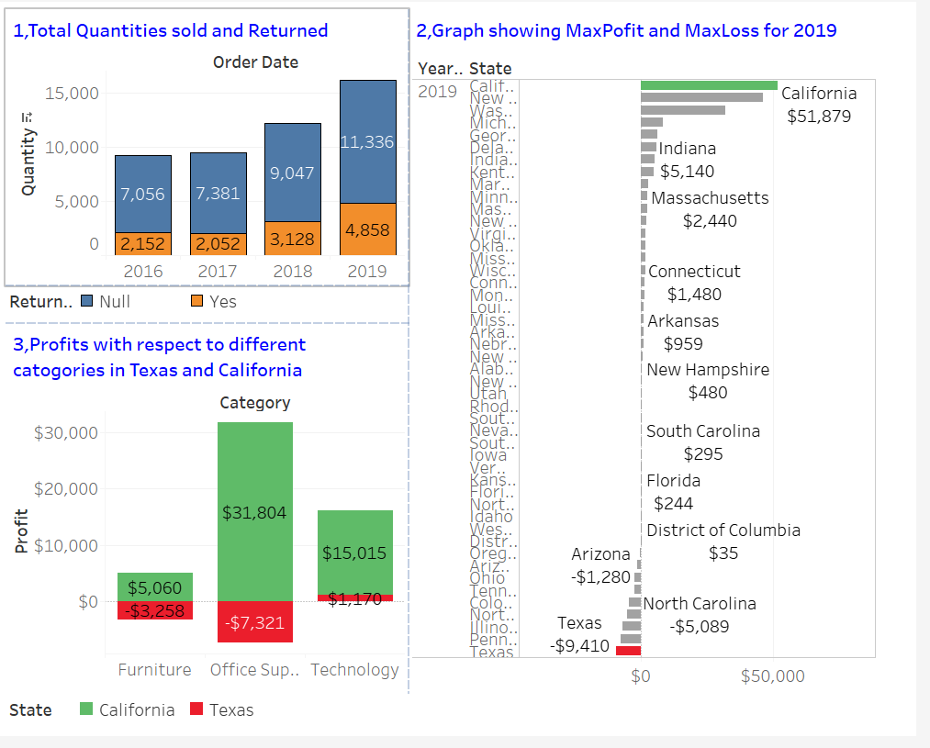

**1, Is there an increase in the quantities sold across the years if so, is there an increase or decrease in the items returned. What can we understand form the change in these quantities sold across years considering the returns?**

It is easy to say from the rise in quantities sold from previous years that the sales have increased but we can really conclude the assumption because there have been increases in the returns too. The true increase in quantities sold can only be determined by taking returns into consideration too. (Refer graph1 from the dash board)

It can be incurred from the visual that the quantities sold have increased considerably over the years but so did the returns. For determining the change, the quantities sold and not returned need to be validated which is 9047 in 2018 and increases to 11,336 in 2019. This shows the true increase in the quantities sold. This would help business in a way to understand the reason for increase in the returns, to conduct surveys, take reviews for the returned products from the customer and thus decide on to whether to continue selling these products or to switch to a different brand, supplier or others.

**2, Is there a constant profit incurred from across all the stores if not where are the losses occurring? What would be a good location to start new stores if we want to expand the business?**

Analyzing the data with respect to the location would help understand where the sales are concentrated and where can the investment be profitable. It also helps to understand where the losses are incurred which in turn helps to deep dive in to the cause for these loses. Could it be cause of the location of the store, products sold, customer satisfaction, store ambience etc. If there is a scope for expanding the business opening the new store in a location with loses would be a bad idea, instead investing on compensating these losses, relocating the existing stores from lose prone locations, switching the products sold etc. might help. (Refer graph2 from the dash board)

The profits are maximum in California state with a maximum of $51,879 where as the losses are maximum in Texas state with a loss of $9,410. With these numbers it would be a bad idea to start a new store in anywhere in Texas state as finding solutions to compensate these loses could be a better idea. But these numbers does not necessarily mean it would be a good idea to start a new store in California state because this higher number could be of many reasons like a different tax rate, greater population, lea returns, large number of stores and also there are many other factors to consider like cross checking budget with expenses that may incur, existing competition in the market, distance between new stores and existing stores, accessibility for suppliers etc.

**3, How can we understand the reason for difference in sales in California and Texas?**

All the products sold in the stores is divided in to three categories

1, Furniture

2, Office supply

3, Technology

The graph 3 shows the profits and losses with respect to these three categories in the year 2019. This analysis of deep dive in to the profits from each category will help business understand the reason for losses in certain category and scope for revival if any. From the graph California state having the maximum profits in 2019 has profits in all the three categories. Where as the Texas state with maximum losses has no profits in office supplies or furniture. The only category it made profits in is the technology. This can help analyze whether it is a feasible idea to keep selling these category products or switch the type of product or even understand if continuing the store in these locations is profitable at least in the future if so how. However, this visualization alone can not be enough to make such decisions but can help in making them.