SyncWatch
Project Documentation
Real-time Synchronized Watch Party
v1.0 — MVP Specification
March 2026

"A shared remote control over the internet for your local video player."

SECTION 1

Product Requirements Document (PRD)

What this product is
SyncWatch is a real-time synchronized watch-party application that lets two or more users watch the same locally stored video file together by sharing only playback control signals over the internet. No video data ever leaves a user's device. The server acts purely as a signal relay — it knows what happened (play at 01:23:45) but never touches the media itself.

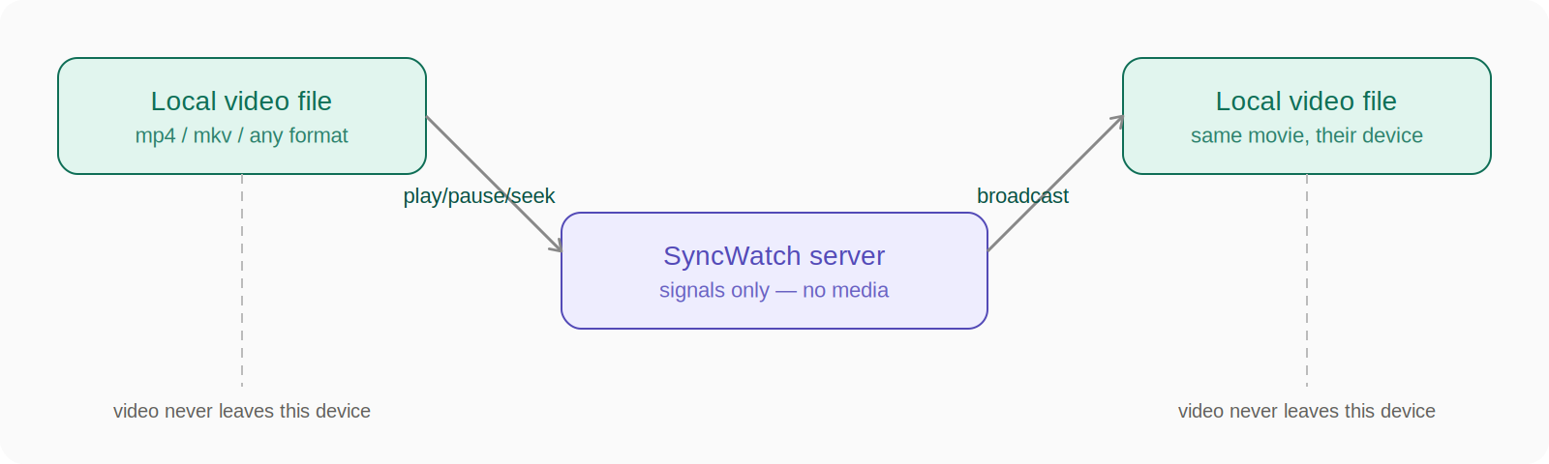

The one-line pitch: a shared remote control over the internet for your local video player.

What this product is NOT
This is the most important section. Every future feature request must be filtered through this list.

Category | Excluded | Why it matters
Video streaming | No hosting, uploading, buffering pipelines | Makes the project 10× harder, adds legal surface area
Screen sharing | No video encoding/compression/capture | Different product entirely (Discord does this)
Content platform | No library, recommendations, accounts (MVP) | Separate product category
Piracy infrastructure | App distributes zero content | Users must already possess the file
Frame-perfect sync | Target is 100–500ms accuracy, not frame-level | Frame sync requires deep media pipeline work
Large-scale infra | Not designed for public rooms or 100+ users | Scope creep killer
Netflix/YouTube clone | No CDN, no transcoding, no DRM | Wrong product entirely

Core Principles (Non-Negotiable)
These are truths the entire codebase is built around. If any feature violates one, reject it.

- No video transfer — the server and network layer never touch media bytes
- Local-first playback — each device is responsible for its own video rendering
- Host authority — one participant is the source of truth for playback state
- Continuous sync — drift correction runs on an interval, not just at join time
- File verification before sync — both parties must confirm same file before room becomes active

User Stories (MVP)

As a host
- I can create a room and get a shareable link
- I can select a local video file
- I can play, pause, and seek — and all viewers follow automatically
- I can see who is in the room and whether anyone is buffering

As a viewer
- I can join a room via a link
- I can select my local copy of the same file
- I am warned if my file doesn't match the host's
- My player follows the host's state automatically
- I can signal that I'm buffering and the host's player will pause

As either
- I can chat in a side panel
- I can see everyone's connection status
- I can see a latency indicator for my connection

Feature List

MVP — Must Ship
- Room creation with unique room code / link
- Join room via code or link
- Local file selection via browser file picker
- File verification (filename + size + partial hash)
- Play / Pause sync
- Seek sync
- Host authority model with clear visual indicator
- Drift correction loop (every 5 seconds)
- Buffering state broadcast (auto-pauses host)
- Reconnection grace period (30 seconds)
- Basic text chat
- Room participant list with status indicators
- Latency display per user

Post-MVP
- Subtitle file (.srt / .vtt) sync
- Host transfer (pass the remote to someone else)
- Latency-aware seek offset (compensate for round-trip time)
- Persistent user nicknames (localStorage, no auth)
- Room password protection
- Mobile responsive layout
- Reactions / emoji overlay

Never — Out of Scope
- Video upload or hosting
- Server-side media processing
- User accounts / authentication system
- Public room discovery
- Content recommendations
- Screen capture

Tech Stack

Frontend
Layer | Choice | Reason
Framework | React (Vite) | Fast dev server, great ecosystem, easy state management
Styling | Tailwind CSS | Rapid UI, no context switching
Video player | HTML5 <video> element | Native browser API, exposes all events (play, pause, seeked, waiting, canplay)
WebSocket client | Socket.io-client | Handles reconnection logic automatically
State management | Zustand | Lightweight, no boilerplate, easy for vibe coding

Backend
Layer | Choice | Reason
Runtime | Node.js | Same language as frontend, fast I/O
Framework | Express | Minimal, well-documented
WebSocket | Socket.io | Room abstractions built in, handles reconnects
Language | TypeScript | Catches sync-state bugs at compile time

Infrastructure
Layer | Choice | Reason
Hosting (server) | Railway or Render (free tier) | Zero config deployments
Hosting (frontend) | Vercel | Instant deploys from git
Database | None (MVP) | All state is ephemeral in-memory on the server
Room state storage | In-memory Map on server | Rooms die when server restarts — fine for MVP

No database in MVP. This is intentional. Rooms are ephemeral. When everyone leaves, the room is garbage collected. Persistence adds complexity with zero user value at this stage.

SECTION 2

Architecture Design

System Overview
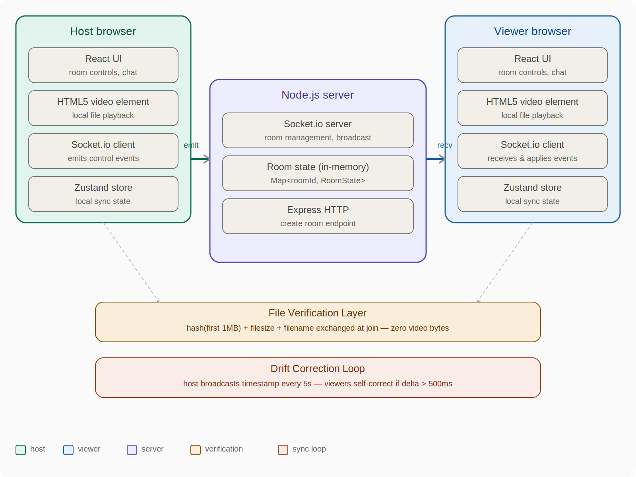

Folder Structure
syncwatch/
├── client/ # React frontend (Vite)
│ ├── src/
│ │ ├── components/
│ │ │ ├── VideoPlayer.tsx # HTML5 <video> wrapper, emits events
│ │ │ ├── RoomControls.tsx # Play/pause/seek UI buttons
│ │ │ ├── ParticipantList.tsx
│ │ │ ├── Chat.tsx
│ │ │ ├── FileSelector.tsx # File picker + hash computation
│ │ │ └── SyncStatus.tsx # Latency + drift indicators
│ │ ├── hooks/
│ │ │ ├── useSocket.ts # Socket.io connection + event listeners
│ │ │ ├── useVideoSync.ts # Core sync logic (apply incoming events)
│ │ │ ├── useFileVerify.ts # Hash computation worker
│ │ │ └── useDriftCorrection.ts
│ │ ├── store/
│ │ │ └── roomStore.ts # Zustand: room, participants, playback
│ │ ├── lib/
│ │ │ ├── hashFile.ts # Web Worker for non-blocking hashing
│ │ │ └── socketEvents.ts # Typed event name constants
│ │ ├── pages/
│ │ │ ├── Home.tsx # Create / join room
│ │ │ └── Room.tsx # Main watch room
│ │ └── main.tsx
│ └── vite.config.ts
├── server/
│ ├── src/
│ │ ├── rooms/
│ │ │ ├── RoomManager.ts # In-memory Map, create/join/leave/gc
│ │ │ └── RoomState.ts # Type definitions for room
│ │ ├── socket/
│ │ │ ├── handlers.ts # All socket event handlers
│ │ │ └── middleware.ts # Rate limiting, validation
│ │ ├── routes/
│ │ │ └── rooms.ts # POST /rooms, GET /rooms/:id/exists
│ │ └── index.ts # Express + Socket.io bootstrap
│ └── tsconfig.json
├── shared/
│ └── types.ts # Shared TypeScript types
└── package.json # Monorepo root (npm workspaces)

In-Memory Data Model
Since there's no database, all state lives in a server-side Map. Here's the exact shape:
// shared/types.ts

type ParticipantRole = "host" | "viewer"
type ParticipantStatus = "ready" | "buffering" | "disconnected"

interface Participant {
id: string // socket.id
nickname: string // user-chosen, stored in localStorage
role: ParticipantRole
status: ParticipantStatus
fileHash: string | null // null until file selected + verified
latencyMs: number // updated via ping/pong
joinedAt: number // Date.now()
}

interface PlaybackState {
isPlaying: boolean
currentTime: number // seconds
lastUpdatedAt: number // server timestamp when this was set
hostId: string
}

interface RoomState {
id: string // 6-char alphanumeric code
createdAt: number
playback: PlaybackState
participants: Map<string, Participant>
chatHistory: ChatMessage[] // capped at last 100 messages
fileHash: string | null // set by host, viewers must match
fileName: string | null
fileSize: number | null
}

interface ChatMessage {
id: string
senderId: string
senderNickname: string
text: string
timestamp: number
}

// Server-side store
const rooms = new Map<string, RoomState>()

Socket Event Map
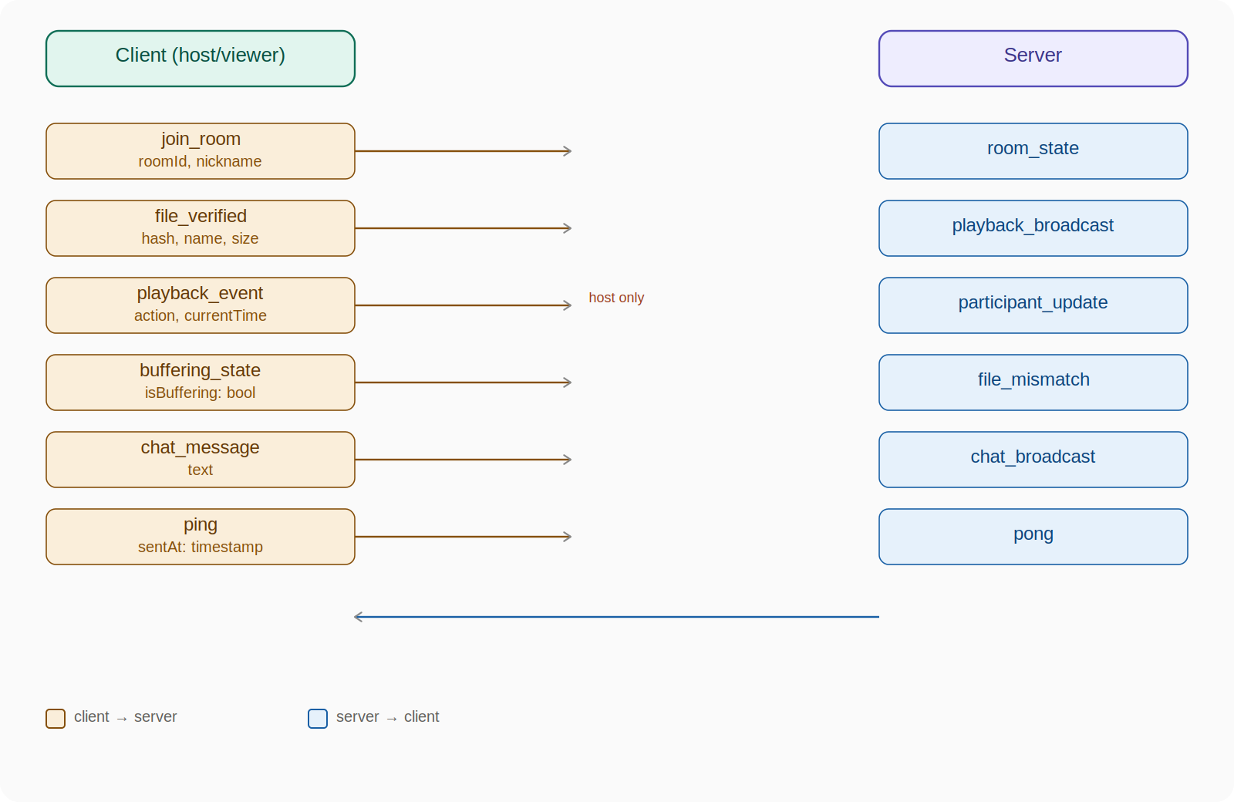

Sync Logic Flow
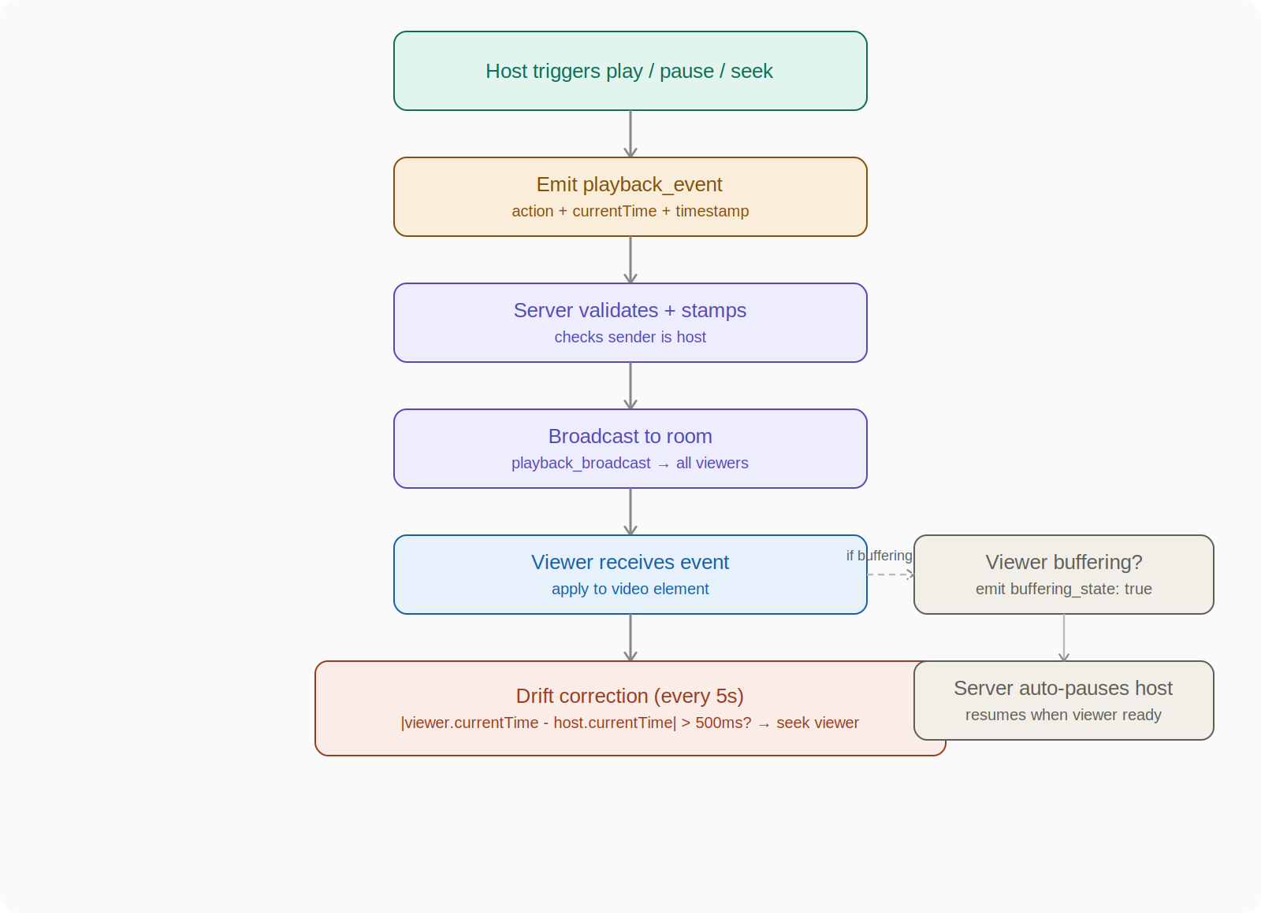

File Verification Flow
This must complete before the room enters a "ready" state. It runs entirely in the client using a Web Worker so it doesn't block the UI thread.

- Host selects file
- Client computes: SHA-256(first 1MB of file) + fileSize + fileName
- Client emits file_verified { hash, size, name } to server
- Server stores hash as the room's "expected file signature"
- Viewer selects their file
- Client computes the same three values
- Client emits file_verified to server
- Server compares: if hash/size mismatch → emit file_mismatch to that viewer
- If match → viewer.status = "ready", broadcast participant_update
- Room is fully ready when host.status = "ready" AND all viewers.status = "ready"

SECTION 3

AI Rules Document
This is your .cursorrules or system prompt for any AI assistant you use. Paste this at the top of every coding session.

## SyncWatch — AI coding rules (non-negotiable)

### What this project is
A real-time watch-party app. Users watch locally stored video files in sync.
The server relays control signals only. No video data ever touches the server.

### The golden rule
If a feature requires sending video bytes over the network → REJECT IT.
No exceptions.

Stack — Do Not Deviate Without Asking
Layer | Technology
Frontend | React + Vite + TypeScript + Tailwind + Zustand + Socket.io-client
Backend | Node.js + Express + Socket.io + TypeScript
Video | HTML5 <video> element only. No video.js, no Plyr, no third-party player.
Monorepo | npm workspaces (client/, server/, shared/)

Architecture Rules

Rule 1 — No Database in MVP
All room state is in-memory (Map on server). Ask before adding any persistence layer.

Rule 2 — Never Send Video Data
Not as chunks, not as base64, not as streams. The file picker is for local playback only.

Rule 3 — All Socket Events Must Be Typed
ALL socket events must be defined in shared/types.ts with full TypeScript types. Never use any for socket event payloads.

Rule 4 — Server-Side Host Validation
The server MUST validate that playback_event emitters are the room host. Viewers cannot emit playback events. Enforce this server-side, not just client-side.

Rule 5 — Drift Correction in Hook Only
Drift correction belongs in useDriftCorrection.ts hook. Do not inline it in the video component or anywhere else.

Rule 6 — File Hashing in Web Worker
File hashing MUST use a Web Worker (lib/hashFile.ts). Never hash on the main thread — it blocks the UI.

Rule 7 — Event Name Constants
ALL socket event names must be imported from lib/socketEvents.ts constants. Never hardcode event name strings in components or handlers.

Sync Rules — Critical
Rule | Value / Behaviour
Drift threshold | 500ms — if delta > 500ms, seek viewer to host time
Drift correction interval | Every 5 seconds — not on every frame (causes thrashing)
Echo prevention | Set isApplyingRemoteEvent = true before applying remote event, then reset
Buffering behaviour | Any participant buffering → pause all → wait for canplay → resume
Latency offset | viewer.seek(targetTime + viewer.latencyMs / 2000)

Code Style Rules
- TypeScript strict mode always. No any, no // @ts-ignore.
- Every component has a single responsibility. VideoPlayer only handles the <video> element. Sync logic lives in hooks.
- No business logic in JSX. Components render; hooks think.
- Error states must be handled. Disconnection, file mismatch, and buffering are not edge cases — they are core flows.

Things to NEVER Build
Even if asked. Even if it seems harmless.
- Video upload endpoint
- Server-side video storage or streaming
- Screen capture or encoding
- Public room directory
- Authentication / user accounts (MVP)
- Any feature that requires reading video bytes server-side

Naming Conventions
What | Convention | Example
Socket events | snake_case | join_room, playback_event, file_verified
React components | PascalCase | VideoPlayer, ParticipantList
Hooks | camelCase with "use" prefix | useVideoSync, useDriftCorrection
Types/Interfaces | PascalCase, no "I" prefix | RoomState, Participant
Constants | SCREAMING_SNAKE_CASE | DRIFT_THRESHOLD_MS

Decision Filter
When unsure about a feature, run it through these questions in order:
- "Does this require sending video data?" → Yes = REJECT
- "Does this help sync playback?" → Yes = Consider
- "Is this in the MVP feature list?" → No = Defer to post-MVP

SECTION 4

Development Roadmap

Phase Overview
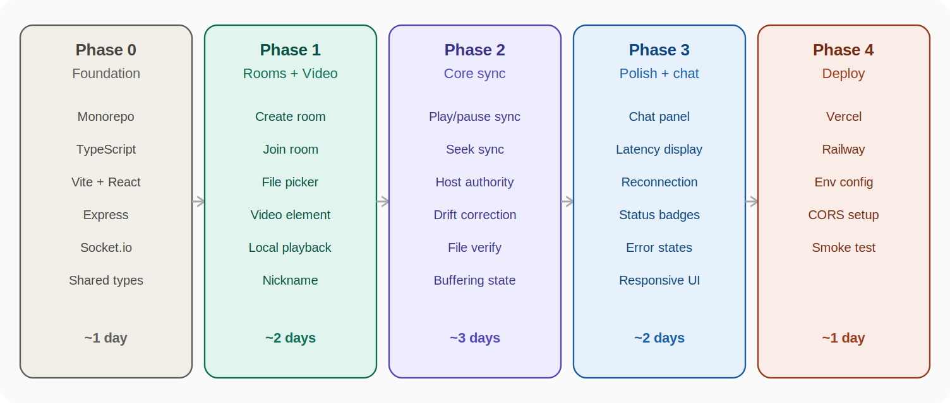

Phase 0 — Foundation (Day 1)
Goal: A monorepo that builds with zero errors. Nothing user-facing yet.

# Scaffold
mkdir syncwatch && cd syncwatch
npm init -y
mkdir client server shared

# Client
cd client && npm create vite@latest . -- --template react-ts
npm install socket.io-client zustand tailwindcss

# Server
cd ../server && npm init -y
npm install express socket.io
npm install -D typescript @types/node @types/express ts-node nodemon

# Shared types
cd ../shared && npm init -y

Deliverables:
- shared/types.ts with all interfaces written out (RoomState, Participant, PlaybackState, all socket event payloads)
- socketEvents.ts constants file with all event name strings
- Both apps boot without errors
- Server logs "listening on 3001", client renders a blank Vite page

Phase 1 — Rooms + Video Player (Days 2–3)
Goal: Users can create and join rooms. Video plays locally. No sync yet.

Step 1.1 — Room creation (server)
- POST /rooms → generates 6-char room code, creates RoomState in Map, returns { roomId }
- GET /rooms/:id/exists → returns { exists: boolean } for join validation
- Socket: join_room handler — add participant to room, set role (first joiner = host), broadcast participant_update
- Socket: disconnect handler — remove participant, start 30s grace timer before removing from room

Step 1.2 — Home page (client)
- Two buttons: Create Room, Join Room
- Join Room: text input for room code + nickname, validate with GET /rooms/:id/exists
- On create: hit POST /rooms, store roomId in Zustand, navigate to /room/:id
- Nickname stored in localStorage

Step 1.3 — Video player component
- Use <input type="file" accept="video/*"> → creates URL.createObjectURL(file) → sets as <video src>
- Expose refs to play, pause, seek, currentTime
- Listen to native events: play, pause, seeked, waiting, canplay — store in Zustand
- Do NOT wire these to socket yet — just confirm local playback works

Step 1.4 — Participant list component
- Shows connected participants, roles, and statuses
- Driven by participant_update socket events

Test checkpoint: Two browser tabs can join the same room and see each other in the participant list. Video plays locally in each tab independently.

Phase 2 — Core Sync Engine (Days 4–6)
This is the hardest phase. Take your time here.

Step 2.1 — File verification
- Implement lib/hashFile.ts as a Web Worker
- Worker takes a File, reads the first 1MB as ArrayBuffer, runs SubtleCrypto SHA-256
- Returns { hash, size, name }
- When user selects file, auto-run verification and emit file_verified to server
- Server: on file_verified from host → store as room's expected signature
- Server: on file_verified from viewer → compare with stored signature → emit file_mismatch if different
- Show clear UI error on mismatch: "Your file doesn't match the host's file"

Step 2.2 — Play / Pause sync
- Host side: intercept native play and pause events → emit playback_event { action, currentTime, timestamp }
- Server: validate sender is host → broadcast playback_broadcast to all other room members
- Viewer side: on playback_broadcast → apply: video.play() or video.pause() and seek to currentTime
- Critical: suppress the echo. Set isApplyingRemoteEvent = true, apply action, reset flag. Skip emission if flag is set.

Step 2.3 — Seek sync
- Host seeked event → emit playback_event { action: "seek", currentTime }
- Same broadcast path as play/pause
- Same echo suppression logic

Step 2.4 — Drift correction
- Implement useDriftCorrection.ts hook
- Every 5 seconds: host emits playback_event { action: "sync_check", currentTime }
- Viewer receives → if |video.currentTime - event.currentTime| > 0.5 → seek to event.currentTime
- This handles gradual drift that accumulates between explicit events

Step 2.5 — Buffering state
- Viewer waiting event → emit buffering_state { isBuffering: true }
- Server: if any participant is buffering → emit force_pause to all + store room is "paused for buffering"
- Viewer canplay event → emit buffering_state { isBuffering: false }
- Server: when all participants are no longer buffering → emit resume_allowed to host

Step 2.6 — Latency measurement
- Client emits ping { sentAt: Date.now() } every 10 seconds
- Server immediately emits pong { sentAt } back to same client
- Client receives pong: latencyMs = (Date.now() - sentAt) / 2
- Apply latency offset when seeking: targetTime + latencyMs / 2000

Test checkpoint: Two browser tabs. Host plays → viewer plays. Host pauses → viewer pauses. Host seeks to 5:00 → viewer jumps to 5:00. Viewer disconnects WiFi for 10 seconds, reconnects → viewer resyncs within one drift correction cycle.

Phase 3 — Polish and Chat (Days 7–8)

Step 3.1 — Chat panel
- Client emits chat_message { text } (server adds timestamp, senderId, nickname)
- Server broadcasts chat_broadcast { id, senderNickname, text, timestamp } to room
- Simple scrollable list, auto-scroll to bottom on new message
- Cap at 100 messages in server memory

Step 3.2 — Reconnection handling
- Socket.io handles transport reconnection automatically
- On reconnect: client re-emits join_room → server restores participant status
- Server holds room alive for 30 seconds after all participants disconnect
- Viewer rejoining gets current playback_state in room_state event → auto-seeks to current position

Step 3.3 — Status and error states
Every state needs a UI treatment. Don't leave users guessing.

State | UI Message
waiting_for_file | "Select your video file to continue"
file_mismatch | Red warning, exact file details shown
participant_buffering | Spinner badge on participant, "Waiting for [name]..." banner
disconnected | Yellow badge, "Reconnecting..."
host_left | "Host has left. Room will close in 30 seconds."
room_not_found | Redirect to home with error message

Step 3.4 — Sync status indicator
- Small persistent indicator showing: latency in ms, last sync time, drift amount
- Color coded: green < 200ms, amber 200–500ms, red > 500ms

Phase 4 — Deploy (Day 9)

Server deploy — Railway
// server/package.json
"scripts": {
"build": "tsc",
"start": "node dist/index.js"
}

// Set in Railway environment:
// PORT (Railway sets this automatically)
// CLIENT_ORIGIN=https://your-app.vercel.app

// CORS config in server/src/index.ts
const io = new Server(server, {
cors: {
origin: process.env.CLIENT_ORIGIN || "http://localhost:5173",
methods: ["GET", "POST"]
}
})

Client deploy — Vercel
# client/.env.production
VITE_SERVER_URL=https://your-server.railway.app

Smoke Test Checklist
- Create room from phone, join from laptop
- Both select the same video file
- File hash matches — no mismatch warning
- Play/pause syncs within 500ms
- Seek syncs correctly
- Chat works bidirectionally
- One tab disconnects and reconnects — resync happens automatically
- File mismatch warning shows correctly when wrong file selected

Decision Log
When you hit a fork, refer here before asking the AI.

Decision | Choice | Reason
Database in MVP? | No | Rooms are ephemeral, complexity not worth it
Third-party player? | No | HTML5 native API is sufficient and lighter
Frame-perfect sync? | No | 100–500ms is good enough, frame sync is a different product
Auth in MVP? | No | localStorage nicknames are enough
Multi-host? | No | One source of truth is the core architecture
P2P (WebRTC)? | No | Server relay is simpler, more reliable, easier to debug
Subtitle sync? | Post-MVP | Same principles, easy to add later

SyncWatch — Project Documentation
v1.0 MVP Specification — March 2026

