**MAKING HEALTHCARE CHATBOT USING NLP**

**Abstract**

To start a good life healthcare is very important. But it is very difficult to the consult the doctor if any health issues. The proposed idea is to create a healthcare chatbot using Natural Language Processing technique it is the part of Artificial Intelligence that can diagnose the disease and provide basic details about the disease before consulting a doctor. To reduce the healthcare costs and improve accessibility to medical knowledge the Healthcare chatbot is built. Some chatbots acts as a medical reference books, which helps the patient know more about their disease and helps to improve their health. The user can achieve the benefit of a healthcare chatbot only when it can diagnose all kind of disease and provide necessary information. The system provides text or voice assistance, that means user can use his own convenient language.Bot will provides which type of disease based on the user symptoms,and provides doctor details respective to user disease. and also provides food suggestion that means which type of food you have to take. Thus, people will have an idea about their health and have the right protection.

**1.Introduction:**

Now a days,health care is very important in our life.Todays people are busy with their works at home, office works and more addicted to Internet.They are not concerned about their health .So they avoid to go in hospitals for small problems.it may become a major problem.

So we can provide an idea is to create a health care chatbot system using AI that can diagnosis the disease and provide basic information about the disease before consulting a doctor.Which helps the patients know more about their disease and improves their health.User can achieve the all kind of disease information.The system application uses question and answer protocol in the form of chatbot to answer user queries.The response to the question will be replied based on the user query.The significant keywords are fetched from the sentence and answer to those sentences.If match is discovered or significant answer will be given or similar answers will be displayed.Bot will diagnosis which type of disease you have based on user symptoms and also gives doctor details of particular disease.It may reduce their health issues by using this application system.The system is developed to reduce the healthcare cost and time of the users as it is not possible for the users to visit the doctors or experts when immediately needed.

**2. Literature Survey:**

Here the studies are based on to recognize emotions classification using AI methods. The studies train emotions classification models from a lot of labelled data based on RNN, deep learning, convolutional neural network. Linguistic interaction is most important in counselling using NLP and NLG to understand dialogues of users. Here the multi-modal approach is used of emotion-recognition. They have collected corpuses to learn semantic information of words and represent as vector using the word vector, synonym knowledge of lexical are collected. [1]

In this paper a voice recognition chat-bot is developed, if the questions are not understood asked to the bot is further processed using the third party expert-system. The web-bots are created as text-based web-friends, an entertainer for the user. Here they focused on the improved system if the system is not only text-based but also voice-based trained. Here the voice recognition requires a 2 part process of capturing and analysis of an input signal. Server response recognition data retrieval and information output. The server used here is SOAP based on black box approach. The use of expert system allows unlimited and autonomous intelligence improvements. [2]

This chatbot aims to make a conversation between human and machine. Here the system stores the knowledge database to identify the sentence and making a decision to answer the question. The input sentence will get the similarity score of input

sentences using bigram. The chatbot knowledge is stored in RDBMS. [3]

The chatbot implemented using pattern comparison in which the order of the sentence is recognized and saved response pattern. Here the author describes the implementation of the chatbot Operating system, software, programming language, and database. How results input and output is stored. Here the input is taken using text () function and other punctuation is removed using trim () function and random () function is used to choose a response from the database. The chatbot is used for an entertainment purpose. [4]

Here they use n-gram technique for extracting the words from the sentences. Here n-gram is used for comparison and deduction of the input with case data using Moro phonemes and phonemes as the deciding parameter. Probability analysis for the closest match is performed. The final expression is redirected through an expert system. [5]

The chatbot developed here for healthcare purposes for the android application. The user sends the text message or voice message using Google API. Here the user gets only related answer from the chatbot. SVM algorithm is used to classify the dataset. Here the Porter algorithm is used to discard unwanted words like suffixes or prefixes. [6]

The different documents served in web, the content is checked by tagging the dataset using n-gram based low dimensional demonstration, TF-IDF matrix that generates S, U, and V and finally multiplying the 3 matrices cosine similarity is calculated. [7]

Here the chatbot is created for the customer service that functions as public health service. The application uses N- gram, TF-IDF and cosine similarity. The knowledge base is created for storing the question and answer. The application clearly shows extracted the keyword from the question ad by using unigram, bigram, and trigram which helps in fast answering. [8]

Saurav Kumar Mishra says that the chatbot will act as a virtual doctor and makes possible for the patient to interact with virtual doctor. Natural language processing and pattern matching algorithm for the development of this chatbot. It is developed using the python Language. Based on the survey given it is found that the no of correct answer given by the chatbot is 80% and incorrect/ambiguous answer given is 20%.From this survey of chatbot and analysis of result suggested that this software can be used for teaching and as a virtual doctor for awareness and primary care.

**3. Existing System:**

Simon Hoermann[1] discuss the current evidence for the feasibility and effectiveness of online one-on-one mental health interventions that use text-based synchronous chat. Synchronous written conversations are becoming popular as Web-based mental health interventions.This review is based on an evaluation of individual synchronous Web-based chat technologies.

Many of the existing systems have live chats through texts and some limitation such as there is no instant response given to the patients they have to wait for experts acknowledgement for a long time. Some of the processes may charge amount to live chat or telephony communication. However, the issue of these technologies are cost effective in clinical practice remains a consideration for future research studies.

**4. Proposed System:**

In our proposed system the user can chat with the bot regarding the query through voice or text.The system uses an expert system to answer the queries. User can also view the available doctors for that particular disease.This system can be used by the multiple users to get the counselling sessions online.The data of the chatbot stored in the database in the form of pattern-template. Bot will provide analgesics and food suggestions that means which food you have to take based on the disease

**4.1 System Architecture:**

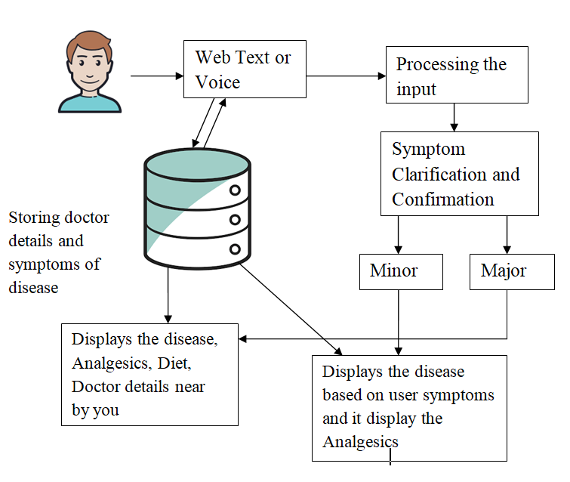**fig: system architecture**

**Tokenization:**

The sentences are separated word by word for increased processing. It separates text into words at whatever point it experiences one of the rundowns of indicated character. All the words are separated from sentences and the punctuation are disposed of. This implies the next steps.

**Stop words removal:**

The stop words are removed from the sentences to extract unique keyword. It is mainly employed to remove unnecessary things such as words occurring too frequently in sentences. It is also used to delete words that are not important or the words with no specific meanings such as an, a, or the. This step is applied to reduce processing time or computational complexity.

**Feature extraction based on N-gram TF-IDF:**

Feature extraction is a characteristic decrease process in the document; it ranks the attributes as per the document. By doing this step it upgrades the speed and adequacy of the document. It is used to extract the set of keywords and frequency of the keywords in the document.

**4.1.1 Dataflow Diagram:**

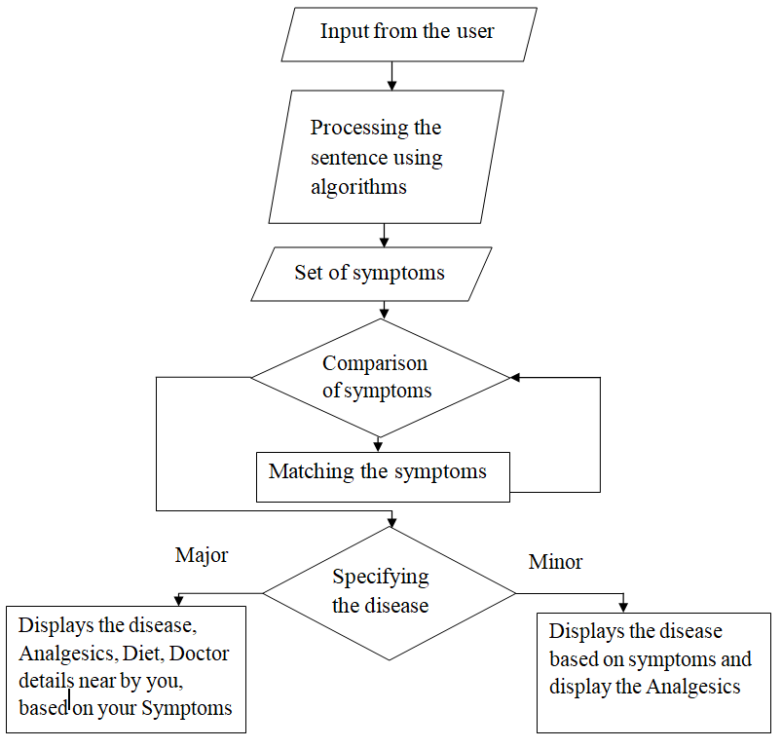

**4.2 Algorithms:**

We are using three algorithms to implement health care chatbot system.

1. N-gram Algorithm
2. TF-IDF(Term frequency-inverse data frequency)
3. Cosine similarity algorithm

**4.2.1 N-gram Algorithm**

N-Grams are way to help machines understand a word in the content to get a better understanding of word. N-gram is a neihboring sequence of n-items from a given sample of text. N-items means we can have two items, three items and so on. So , it is a contiguous sequence of some items.it helped to predicting the next words in a sentence. Items can be characters , words , sentences. When n is 2 then we can call it as bigrams and n is 3 then we can call it as trigrams.Based on sentence we can change the value of ‘n’.

**4.2.2 TF-IDF:**

**Term frequency( tf ):**

Generally, when building a model with the goal of understanding text, you’ll see all of stop words being removed. Another approach is to score the relative importance of words using TF-IDF.

The number of times a word appears in a document divided by the total number of words in the document. Every document has its own term frequency.

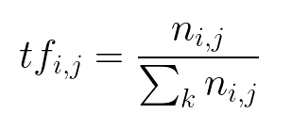

**Inverse Data Frequency (IDF):**

The log of the number of documents divided by the number of documents that contain the word . Inverse data frequency determines the weight of unique words across all documents in the corpus.

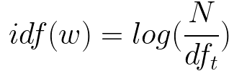

**4.2.3 Cosine similarity Algorithm:**

Cosine similarity  finds a similarity between two non-zero vectors of an inner product space that measures the cosine of the angle between them.

This technique is also used to measure cohesion within clusters in the field of data mining.

Cosine similarity=AB/|A||B|.

Cosine distance is nothing but obtaining distance between two vectors in n dimension space.Distance represent how words are related to each other.

**5.Screenshots:**

**Chatbot user interface:**

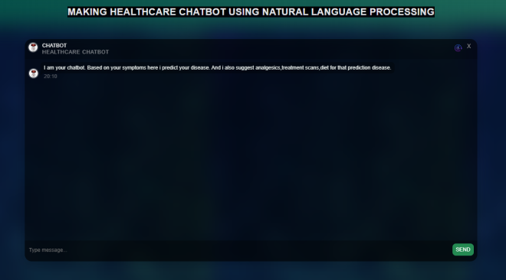

**Communication page:**

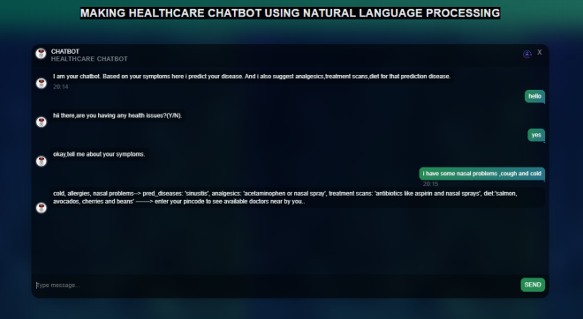

**6. Conclusion:**

Chatbot is great tool for conversation between human and machine. The application is developed for getting a quick response from the bot which means without any delay it gives the accurate result to the user. It is concluded that, the usage of chatbot is user friendly and can be used by any person who knows how to type in their own language. Chatbot provides personalized diagnosis based on symptoms.

**7. Future Enhancement:**

The future era is the era of messaging app because people going to spend more time in messaging app than any other apps. The implementation of personalized medicine would successfully save many lives and create a medical awareness among the people. No matter how far people are, they can have this medical conversation. The only requirement they need simple desktop or smartphone with active internet connection. The efficient of chatbot can be improved by adding more combination of words and increasing the use of database so that of the medical chatbot could handle all type of diseases.

**8. Refrences:**

1. K. Oh, D. Lee, B. Ko and H. Choi, "A Chatbot for Psychiatric Counseling in Mental Healthcare Service Based on Emotional Dialogue Analysis and Sentence Generation," 2017 18th IEEE International Conference on Mobile Data Management (MDM)*,* Daejeon, 2017, pp. 371-375. doi: 10.1109/MDM.2017.64
2. Du Preez, S.J. & Lall, Manoj & Sinha, S. (2009). An intelligent web-based voice chat bot. 386 - 391.10.1109/EURCON.2009.5167660
3. Bayu Setiaji, Ferry Wahyu Wibowo, "Chatbot Using a Knowledge in Database: Human-to-Machine Conversation Modeling", Intelligent Systems Modelling

and Simulation (ISMS) 2016 7th International Conference on, pp. 72-77, 2016.

1. Dahiya, Menal. (2017). A Tool of Conversation: Chatbot. INTERNATIONAL JOURNAL OF COMPUTER SCIENCES AND ENGINEERING. 5. 158-161.2017.
2. C.P. Shabariram, V. Srinath, C.S. Indhuja, Vidhya (2017). Ratatta: Chatbot Application Using Expert System, International Journal of Advanced Research in Computer Science and Software Engineering,2017
3. Mrs Rashmi Dharwadkar1, Dr.Mrs. Neeta A. Deshpande, A Medical ChatBot, International Journal of Computer Trends and Technology (IJCTT) – Volume 60 Issue 1-

June 2018

1. Farheen Naaz, Farheen Siddiqui, modified n-gram based model for identifying and filtering near-duplicate documents detection, International Journal of Advanced Computational Engineering and Networking, ISSN: 2320- 2106, Volume-5, Issue-10, Oct.-2017
2. N-gram Accuracy Analysis in the Method of Chatbot Response, International Journal of Engineering & Technology. (2018)