- #include <stdio.h>
#include <sys/types.h>
#include <sys/stat.h>

int main()
{
if (mkfifo("myfifo", 0666) == -1)
{
perror("mkfifo");
return 1;
}

printf("FIFO created\n");

return 0;
1.fifo read
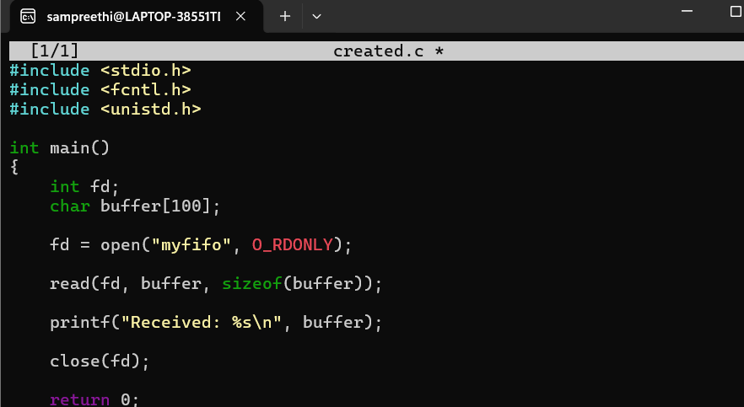
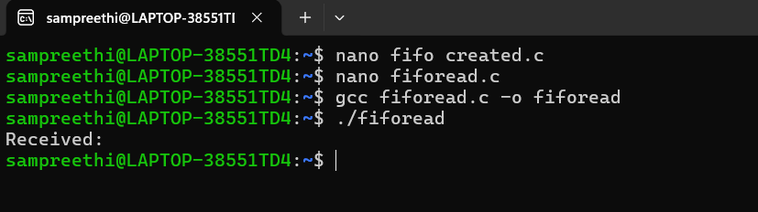
Fifo write
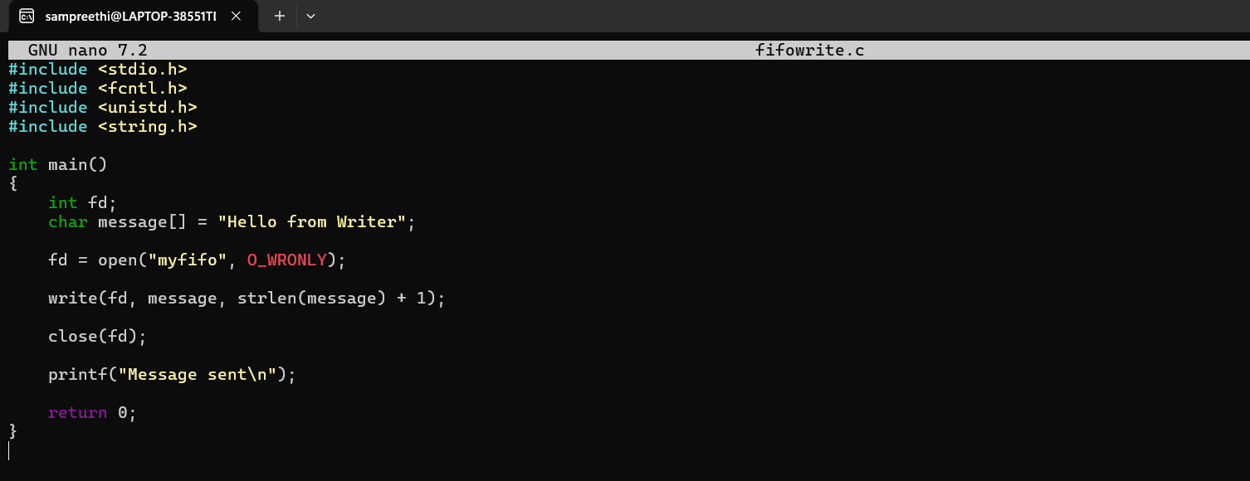
Output:
