Demo1:
Real World, Classes, Objects, Properties, Methods & Message Passing
Program:
Create an Alice world named MyGarden and add one object of WhiteRabbit. When the program starts make the rabbit to say ‘Hello World’

Steps:
1)
Open Alice tool and select Grass template out of the various templates. And then click open.

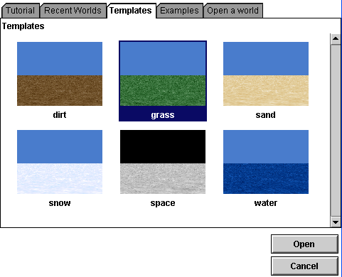

2) Click on add objects.
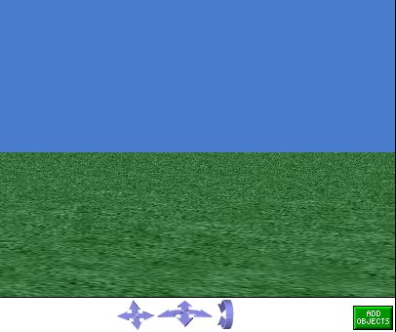
3) Select Animals from the objects. Select class WhiteRabbit from it and add instance to the world.
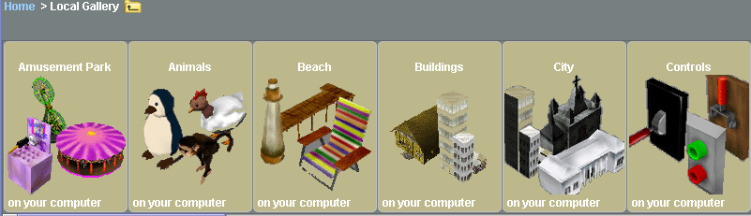

4) Rename world as MyGarden and WhiteRabbit as Rabbie.
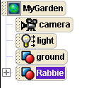
5) Select Rabbie and from the methods select “Rabbie.say”. Drag and drop in the editor area. Choose other. Write there “Hello World!”. Then click Play to see the output.

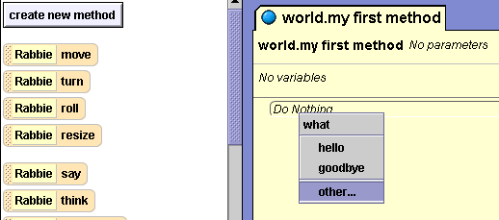

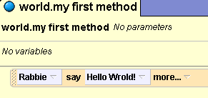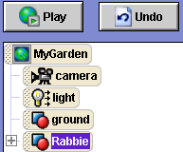

Demo2:
Variables, Parameters & Input
Program:
Open the MyGarden world and Make the White Rabbit, Rabbie to point to the Camera. Make the Rabbie to Post a question to the user. The question should be passed from the calling world. Make the Rabbie to say that “I don’t know the answer for” <Question>. Simultaneously wave the right hand.

Steps:
- Add the Whiterabbit object “Rabbie” to the world template Grass as shown in the demo 1.
- Click on the create new method after selecting the “MyGarden”. Name the method as “Interact”.
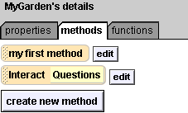

- Click on Create parameter. Write the name of the parameter as Questions and type as string.
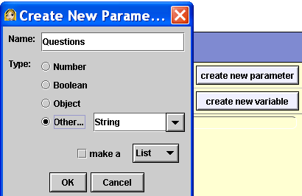

- Drag and drop the method in the events window. Write the “questions” string as “How old are you?”
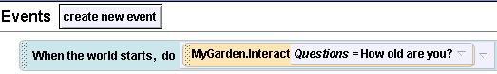
- Declare a variable named as “Name”.

- drag and drop the Point at method of Rabbie object. Then set the point at to camera.
- Drag and drop the name variable after the point at mthod. Set the value to question.
- Drag and drop the Do together from the bottom.
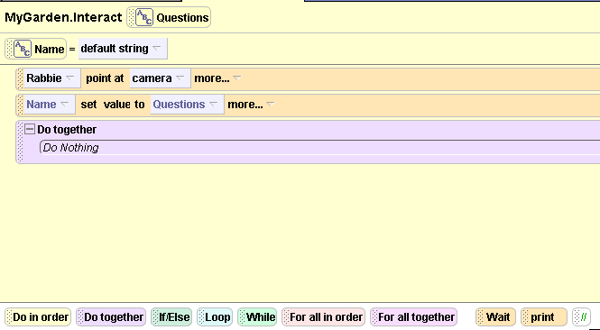

- Select Rabbie, then select the right arm. Drag and drop the turn method of the right arm and select backword ½ revolution.
- Drag and drop the rabbie.Say method and write the answer as “I do not know the answer”.
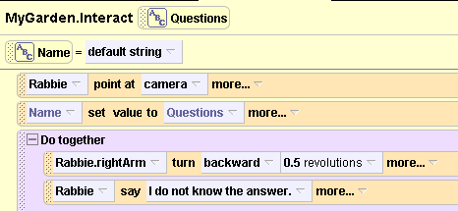

Demo3:
Sequential and Branching Constructs
Program:
Open the MyGarden world and add one Flag Pole. Make the Rabbie to move towards the flag pole. Calculate the Distance between Rabbie and the Flag Pole. If the Distance is less than .5 meters make the Rabbie to hold the Flag Pole and nod the head. Otherwise make the Rabbie to say ‘I am useless’

Steps:
- as in demo 1 and 2 add 2 objects Rabbie and a flag pole (from the objects inside local gallery) to the MyGarden.
- Create a new method approach for the mygarden.
- Drag and drop it in the events area.
- Create a number variable named as distance and set its value to 0.
- Make the rabbie point at the flag pole
- Move the rabbie forward 1 meter.
- Calculate the distance of the flag pole from the rabbie.
Drag and drop the distance. Open the functions and select rabbie.distance to function. Drag and drop in the value of the distance to the flag pole.
- drag and drop an if construct from the buttom.
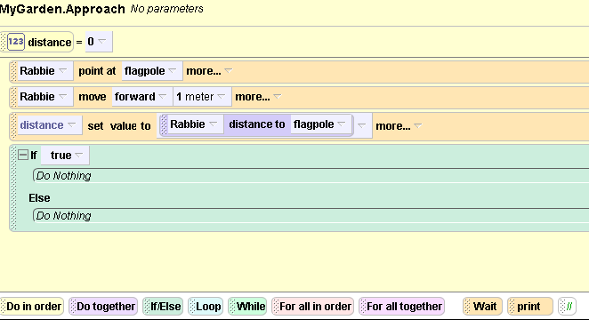

- drag and drop the distance. If the distance is less than .5 then do as shown in the following diagram.
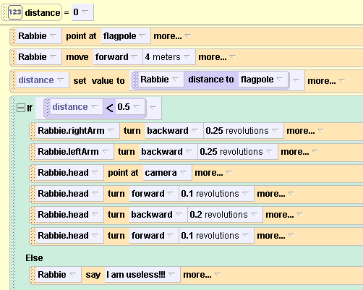

- increase the distance in the if condition (to 1,2,3 etc) and see the difference.

Demo 4 :
Iterative Constructs
Program:
Create a world ‘Water’ with ‘Rowboat’ object and write a method which moves the rowboat using Loop Construct and While Construct.
Steps:
- create a new world water.add a rowboat which is present inside vehicles into it.
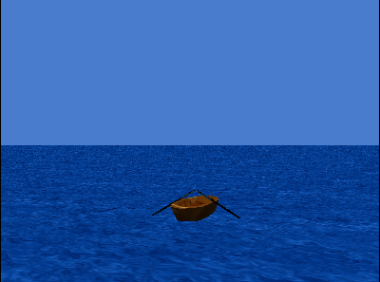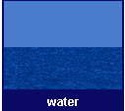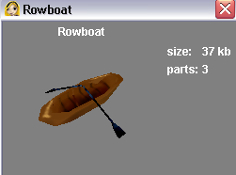
World: Water
Object: Rowboat

- declare a variable named as index.
- Drag and drop a loop construct from below.
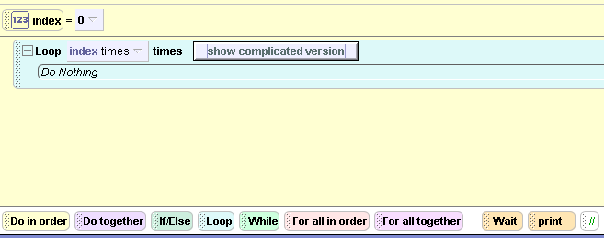

- click on the show complicated version.
- Drag and drop do together from below and write the below mentioned code in that by selecting the corresponding methods from the rightpaddle and leftpaddle object. Then start playing.
