

Vibrometer data for test objects:

Matlab interface

Noora Simonen

Contents

1. Introduction 1

2. Measurements 2

2.1 Test objects 2

2.2 Vibrometer measurement 3

2.3 Other measurements 4

3. Data 5

3.1 Processing data 5

3.2 Data structure 6

Functions 8

3.3 load_geometry 8

3.4 load_measurements 8

3.5 draw_object 10

References 11

# Introduction

The purpose of this project work is to do the data processing for a research project related to acoustic travel-time tomography. The aim is to store the data in a format which is easy to use in MATLAB environment.

We have data for two test objects. The greatest part of the data is from vibrometer measurements. In those measurements there was an acoustic signal source on the surface of the test object and the vibrations were measured on the other surfaces of the object. There were several measurements for both objects from different signal sources. In addition, CT scan and 3D scan were done for the two objects.

This report contains short descriptions of the test objects and the measurements. The data processing will be described briefly and the model of the resulting data structure will be presented. Part of this project work were also three functions which are used to load the data to MATLAB and to visualize it. A brief user’s manual for the functions is included in this report.

# Measurements

## Test objects

The measurements were done for two test objects. Both objects were originally cast synthetic resin cubes with 15 cm side length. In the casting process polished onyx stones were placed inside the test objects. There are three stones inside object one and four stones inside object two. [4] The onyx stones of object one can be seen inside the casting mold in Figure 1.

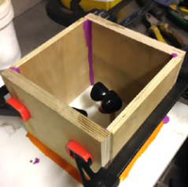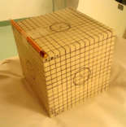

Figure 1: The casting process of object one. The onyx stones can be seen inside the casting mold. On the right is finished object one at the time of CT scan. [4]

For the acoustic measurements the objects were made less symmetric by cutting out edges. As a result, we have two different asymmetric objects. The finished test objects can be seen in Figure 2.

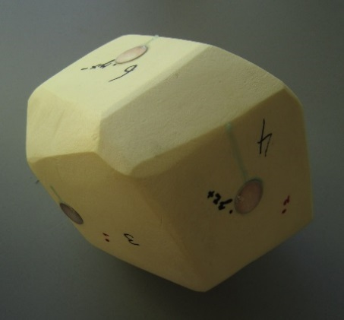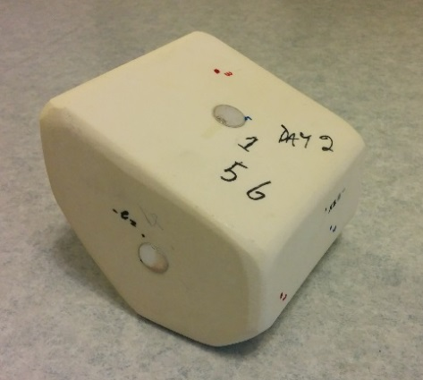

Figure 2: The final shape of the test objects. Object one is on the left and object two on the right.

Both objects have several round metal piezos attached to them. The piezos were used to create acoustic vibrations for the vibrometer measurements.

## Vibrometer measurement

The aim of travel time tomography is to use data measured from the surface of test object and create a model of the inner structure of the object. In acoustic travel-time tomography this is done by experimenting how fast acoustic signal travels through the test object. The model of the inner structure is constructed by solving the inverse problem related to the travel-times measured at each point. [5]

For our test objects acoustic signal of 120 kHz was used for the measurements. Several signal sources were used to get measurements from different sides of the test objects.

The measurements were done in Germany by Polytec GmbH [3]. Scanning laser-doppler vibrometer was used for measuring the vibrations which had travelled through the test object. This type of vibrometer can measure vibrations on the surface of test object without touching the object [2]. Polytec’s laser-doppler vibrometer can be seen in Figure 3.

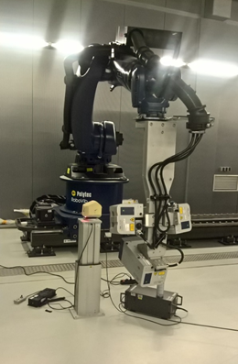

Figure 3: Laser-doppler vibrometer measurement for object one. The measurements were performed by Polytec GmbH [3].

Six different measurements were done for object one. For object two there were seven measurements from different sides of the object. From the data of these measurements we can compute travel time of the vibration for each measurement point on the surface of the object.

## Other measurements

Even though it is possible to compute the travel times with only the vibration data, we also need information about the shape of the object to be able to compare the travel times. For this purpose, the test objects were 3D scanned. The scanning was performed by AN-Cadsolutions Oy and optical surface scanner was used to create 3D-model of the object [1]. With the data from 3D scan we can create a 3D model of the surfaces of the objects in MATLAB.

The aim of travel-time tomography is to create a model of inner structure of the test objects. The main question is, how good results we can get with acoustic travel-time tomography. To be able to evaluate the results, CT scan was done for the objects. Thus, we can compare the real position of the onyx stones to the results we get from travel-time tomography.

# Data

## Processing data

At the start of this project work the data was already converted into formats which can be used in MATLAB. The first task was to get the data from three different measurements into same coordinate system. Figure 4 shows how the measurement data can be illustrated in MATLAB.

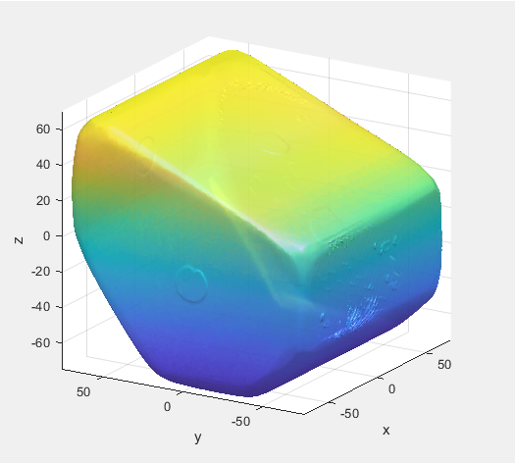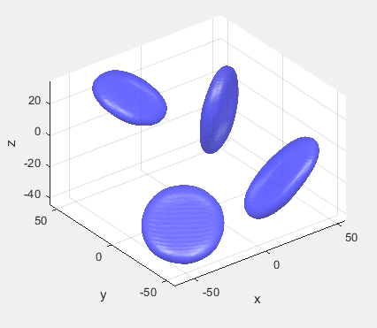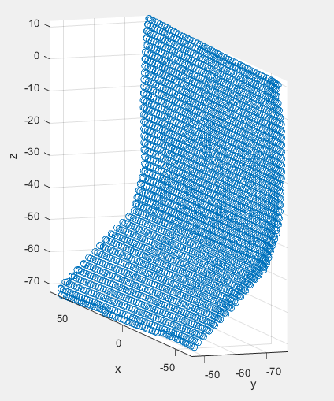

Figure 4: Data from the three measurements for object two illustrated in MATLAB. On the left is the model of the surface created by 3D scanning. In the middle are the stones detected by CT scan. On the right are the measurement points of one vibrometer measurement.

At the beginning these three types of data were at different scales and needed to be rotated and moved in order to get their positions match. Fixing the surface model and the stones to right place in relation to each other was possible because the center of CT data was at origin. We also knew the size of the objects when they were still cubes and parts of the original cubes faces were not cut away.

Vibrometer data was fixed in place by comparing it to the surface model, rotating and moving it until it fitted perfectly on the surface model. Figure 5 shows the result of this process for one vibration measurement of object two.

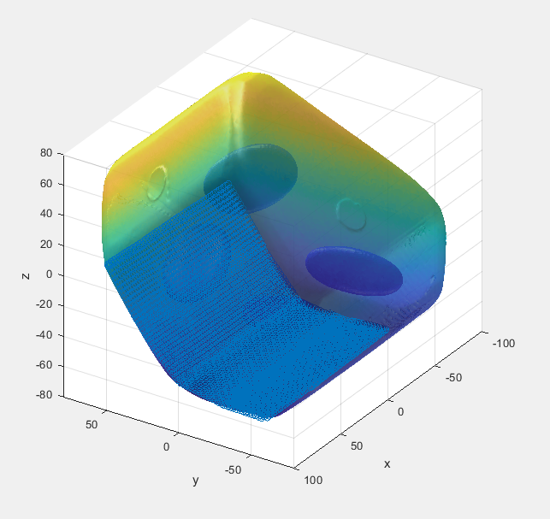

Figure 5: Face 2 of object 2 fixed on the same coordinate system with 3D and CT data.

Every set of vibrometer measurement points was fixed in place in the same way.

## Data structure

After fixing the data into the same coordinate system we needed to find a useful way to store it. The data would need to be easily loaded in MATLAB. For that purpose, we decided to use ascii format DAT files which can be edited also with text editor. Figure 6 shows the folder structure we created for the data.

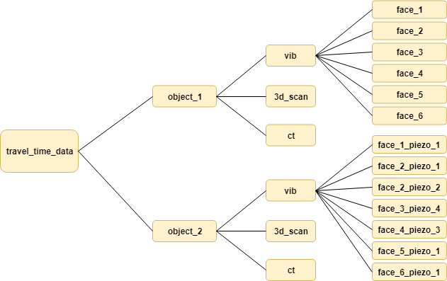

Figure 6: Folder structure of the measurement data.

Each of the folders *face_1*, *face_2*, etc. contains data from one vibrometer measurement. *3d_scan* contains data for construction 3D model for one object. Similarly, *ct* contains data from CT scan of one object.

The naming of the vibrometer data folders differs between object one and object two because for object one there was only one measurement for each piezo. This means that the signal source for face 1 was piezo 1. With object two, on the other hand, the signal sent from piezo 1 was measured on several faces of the object. Also, there were two measurements for face 2 with different signal source. We decided to use a different naming system to avoid confusion.

To make all this data easy to use in MATLAB, we created two MATLAB functions for loading the data and one function to illustrate it.

# Functions

## load_geometry

Syntax: function [g_data] = load_geometry(object)

This function loads CT and 3D data of one test object from the datafiles to MATLAB. This function takes one parameter which can have value 1 or 2 depending on which object you want to choose.

The function returns one struct which includes all the data required to make a 3D model of the chosen test object and the stones inside it. The struct has the following components

* *x_ref, y_ref* and *z_ref* are arrays with the coordinates of the value points of CT scan
* *ref_array* is an array which holds the values related to points (*x_ref*, *y_ref*, *z_ref*)
* *values* is an array with values of density of the material in each point
* *stone_threshold* is the limit value used to find the points where density is high and thus detect the location of the stones.
* *x_0, y_0* and *z_0* are arrays with the coordinates of the points which form the model of surface of the test object.
* *triangles* is an array which has the combinations of points (*x_0, y_0, z_0*). By drawing a filled triangle to each of these 3-point combinations we can draw the surface of the object.

## load_measurements

Syntax: function [m_data] = load_measurements(object, face, piezo)

This function loads the data related to one vibrometer measurement. It takes three parameters: the test object used, the face on which the vibrations were measured and the signal source. All these three parameters are integer numbers. The numbering of the faces and signal sources (piezos) for object one are presented in Figure 7.

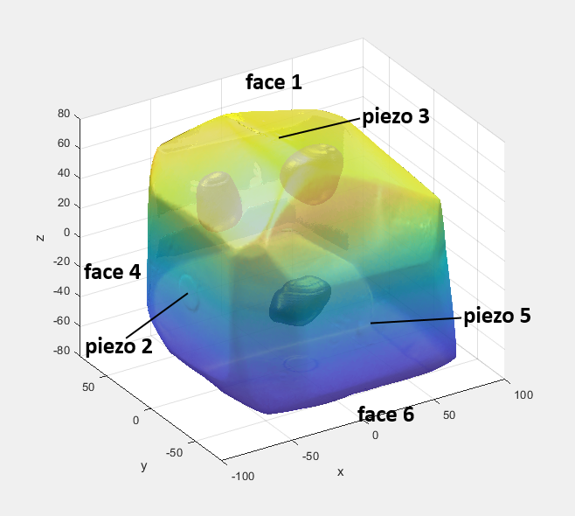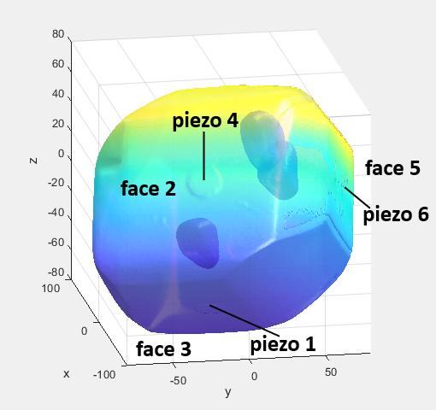

Figure 7: Faces and piezos of object one

Figure 8 shows the same information for object two.

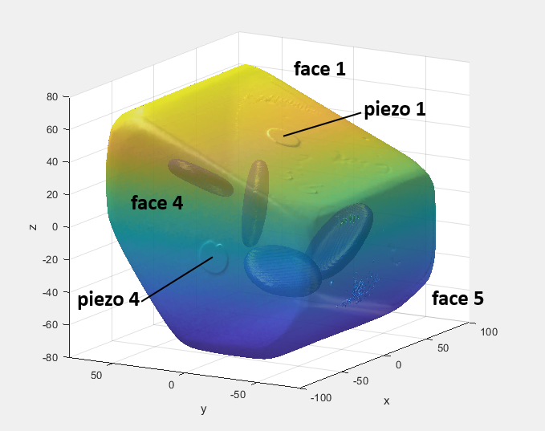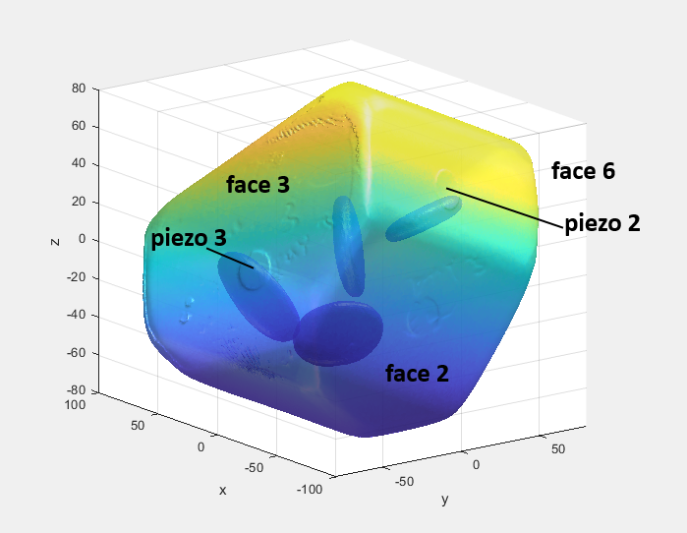

Figure 8: Faces and piezos of object two

There were 13 measurements in total. The possible inputs for the function are the following

* For object one: (1, 1, 1), (1, 2, 2), (1, 3, 3), (1, 4, 4), (1, 5, 5), (1, 6, 6)
* For object two: (2, 1, 1), (2, 2, 1), (2, 2, 2), (2, 3, 4), (2, 4, 3), (2, 5, 1), (2, 6, 1)

The function returns one struct which includes all the data related to the chosen vibrometer measurement. The struct has the following components

* *x*, *y* and *z* are arrays with the values of coordinates of the measurement points
* *vib_x*, *vib_y* and *vib_z* are the x, y and z components of measured vibrations in each measurement point.
* *t* is the time array related to the measurements
* *piezo* is an array which contains the coordinates of the signal source. The signal source is represented as a single point, so *piezo* has only three components, x, y and z coordinates of the point.

## draw_object

Syntax: function [] = draw_object(g_data, m_data)

Function draw_object draws the 3D model of the surface of test object and the stones, the measurement points of vibrometer data and the point of signal source. This function takes as parameters the structs created by load_geometry and load measurements.

Figure 9 shows an example of the 3D model created by draw_object. This was done for object two and the parameters used for load_measurements were (2,6,1). The blue points measurement points of vibrometer measurement, in this case they cover the face 6 of object 2. The red point marks piezo 1.

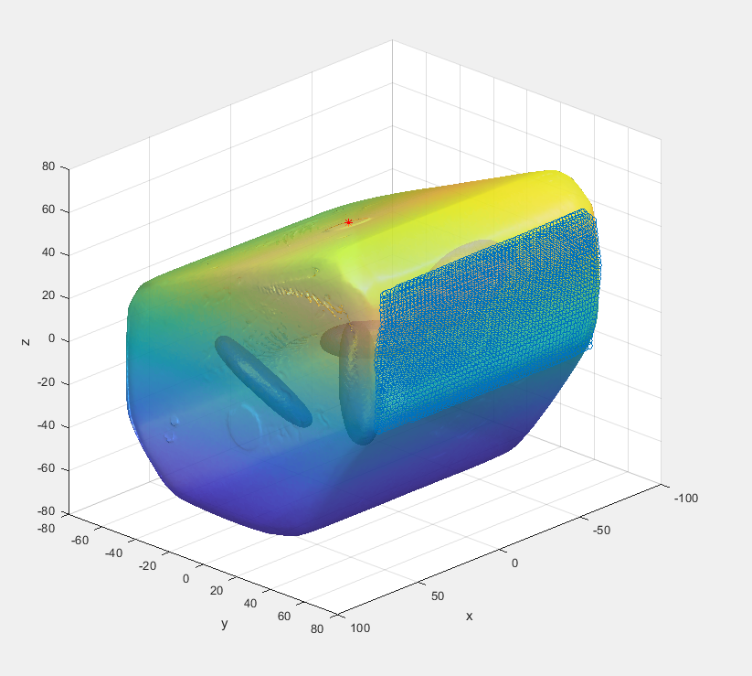

Figure 9: Example of an output of function draw_object. The blue points are the measurement points on face 6 of object 2.

# References

1. AN-Cadsolutions. Homepage: https://www.an-cadsolutions.fi/
2. Eric Lawrence. *Optical measurement techniques for dynamic characterization of mems devices*, 2012.
3. Polytec GmbH. Homepage: https://www.polytec.com/int/
4. Sampsa Pursiainen and Mikko Kaasalainen. Sparse source travel-time tomography of a laboratory target: accuracy and robustness of anomaly detection. *Inverse Problems*, 2014.
5. Albert Tarantola. *Inverse problem theory and methods for model parameter estimation*. SIAM, 2005.