Eduvo Loyalty Member Website
Implementation and Testing Report

This report documents the member-facing website developed for the Eduvo loyalty programme. The solution connects an ASP.NET Core MVC website to the supplied Loyalty App V2 API and covers the required web functions for member accounts, balances, rewards, activity, stores, profile management and communication.

Project | Group Assignment Backend
Application | Eduvo Loyalty Member Website
Technology | ASP.NET Core MVC on .NET 8
Report date | 2 October 2026

Executive Summary
The completed website provides a secure server-side member portal for the shared loyalty API. The browser never receives the API JWT credentials. The server obtains and caches the token, uses it for API calls, and maintains the member login through an authenticated cookie.
The implementation covers all mandatory member website functions identified in the assignment. It supports both login paths, registration and recovery workflows, a live member dashboard, wallet information, rewards, vouchers, stamps, transaction history, notifications, referrals, stores, profile updates, feedback and account deactivation. Food ordering remains optional and was excluded because the supplied API does not document an online payment operation.

Project Objectives
- Provide members with one responsive website for their loyalty account.
- Keep JWT credentials and API tokens on the server.
- Display live API information rather than hardcoded member data.
- Support member actions with validation, clear empty states and friendly service errors.
- Match the member web scope defined in the supplied flows and functions document.

System Scope
Area | Implemented functions
Account | Email/password login, phone OTP login, registration, referral validation, password reset and logout
Home | Live member card, tier, wallet balance, points, stamps, member QR and promotional highlights
Wallet | Balance, points, expiry, stamps, top-up history and top-up details
Rewards | Reward and voucher catalogues, detail pages, owned items and redemption QR codes
Activity | All records plus wallet, top-up, points, stamp, reward and voucher filters
Communication | Notification inbox and details, mark read, feedback submission and history
Profile | View/edit details, upload and display photo, verify email and deactivate account
Location | Outlet list, embedded OpenStreetMap and browser-based distance calculation

Solution Architecture
The application uses a conventional ASP.NET Core MVC structure. Controllers handle browser requests and authenticated sessions. Service classes isolate token management, HTTP calls, API response mapping and feature-specific operations. Razor views display the resulting models.
Layer | Responsibility
Browser | Responsive Razor pages, forms, reward tabs, referral sharing, store map and distance calculations
MVC controllers | Route handling, validation, cookie authentication and user workflow coordination
Integration services | JWT acquisition and caching, authorized API calls, response normalization and error handling
Loyalty App V2 API | Member records, wallet, activity, campaigns, rewards, notifications, stores and profile updates

Security Design
- JWT service credentials are stored in local .NET User Secrets and excluded from source control.
- The application suppresses HTTP client URL logging because the provider's JWT endpoint uses query parameters.
- Secure, HTTP-only cookies manage website sessions, with an eight-hour sliding lifetime.
- Account routes use rate limiting and form posts use anti-forgery validation.
- Profile images are restricted to image content below 2 MB.
- Upstream failures display a service interruption page without revealing internal details.

Implemented Member Experience
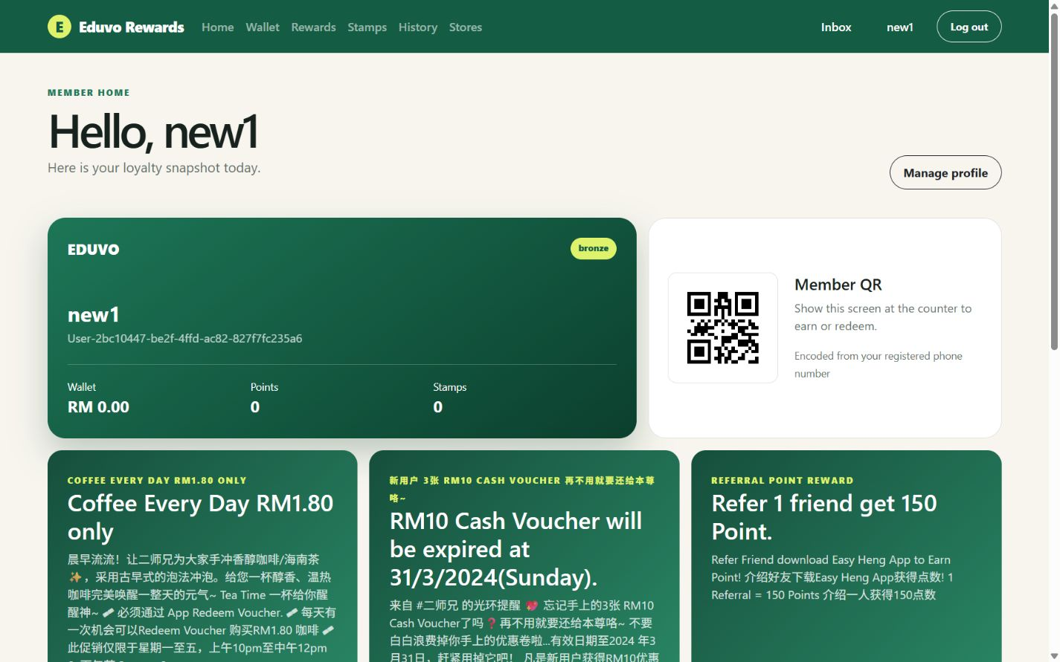
Figure 1. Authenticated member dashboard with live balances and member QR
The dashboard loads member details, promotional highlights, featured rewards and recent activity from the API. The QR encodes the registered phone number because the merchant scan endpoint uses that value to retrieve the member. API-supplied HTML descriptions are converted to readable plain text before display.

Rewards and Vouchers
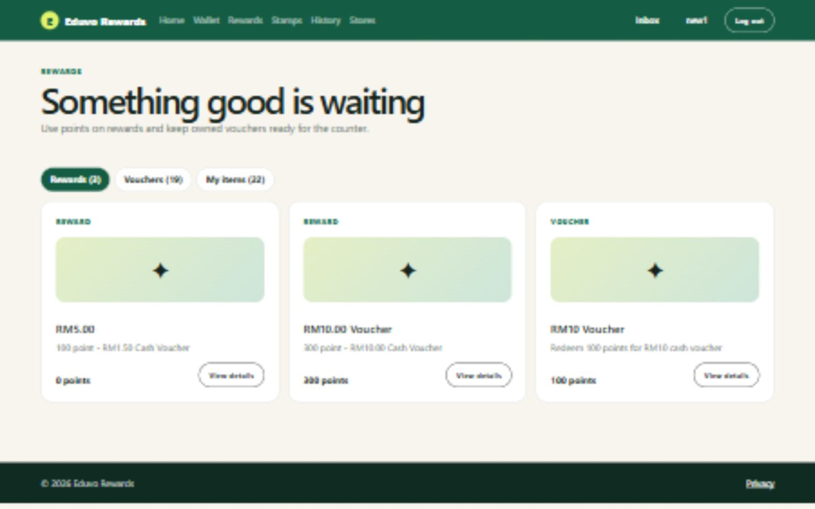
Figure 2. Live reward and voucher catalogue
Members can switch between rewards, vouchers and owned items. Catalogue cards link to API-backed detail pages. Owned rewards and vouchers display redemption QR codes when the API provides a reward identifier. Expiry information and point costs are shown when available.

Stores and Location
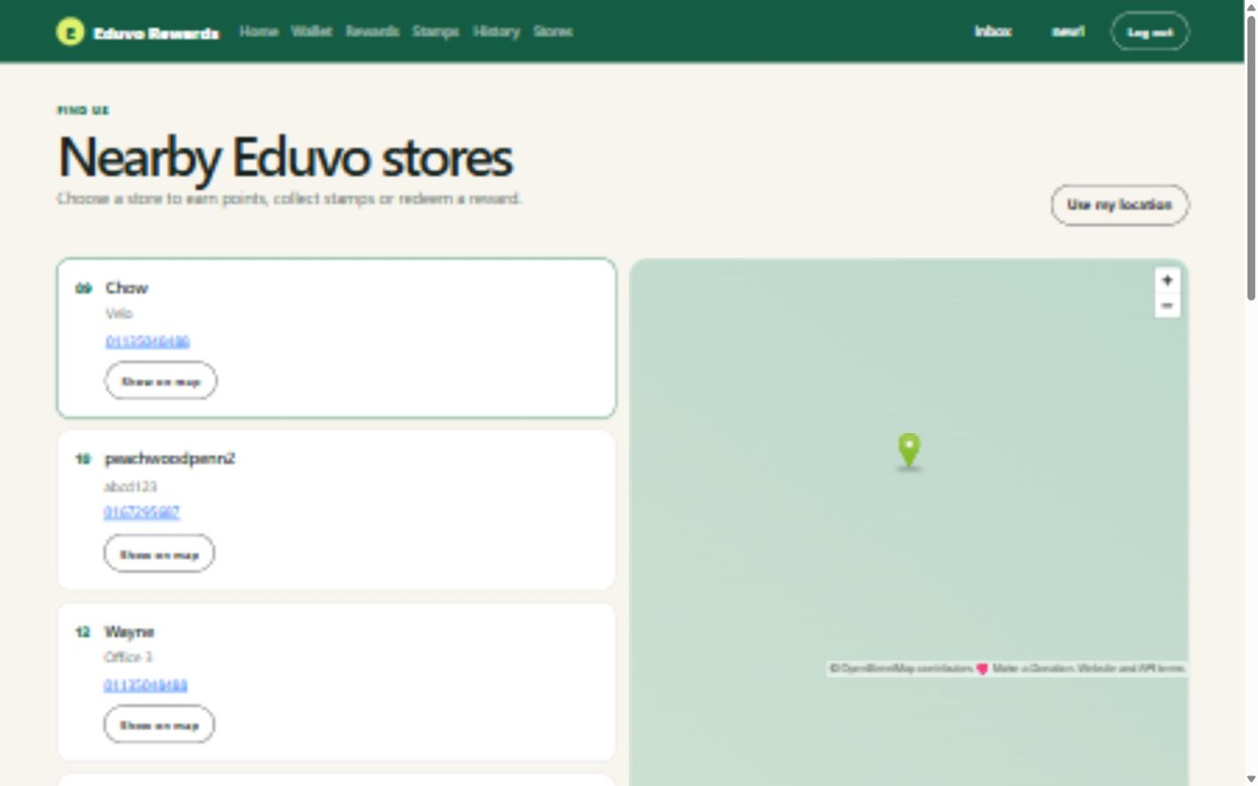
Figure 3. Outlet list and embedded map
The store page retrieves all outlets from the API. Selecting a store updates an OpenStreetMap view, while optional browser location access calculates approximate distance using the Haversine formula.

API Coverage
Website function | Primary API operations
Authentication | MemberLogin/CheckEmailPassword; MemberAccount/RequestOTP; MemberLogin/MemberMobileLoginGetProfile
Registration and recovery | MemberAccount/RegisterOtp; MemberLogin/RegisterMember; MemberAccount/MemberResetPassword
Member and wallet | MemberDetails/GetMemberDetails; MemberWallet/MemberGetWalletDetails
Rewards and vouchers | MemberReward/GetRewards; MemberReward/FindReward; MemberVoucher/GetAllVoucher; member voucher detail and owned-item calls
Stamps and history | Member stamp list and used records; all history plus six category-specific history operations
Notifications | Member notification list, details, mark one read and mark all read
Profile and feedback | MemberEditProfile; email verification operations; feedback creation and history; account deactivation
Stores and campaigns | ManageOutlets/GetAllOutlets; ManageHighlight/UserGetAllHighlight

Testing and Verification
The final build completed with zero errors and zero warnings. An authenticated smoke test signed in through the website and checked the core member routes, all six history filters, QR generation and the health endpoint against the live API.
Verification | Result
Compilation | Passed: 0 errors and 0 warnings
Authenticated route test | Passed: 20 routes returned HTTP 200
Responsive layout | Checked at mobile and 1440 x 900 desktop sizes
Live data | Dashboard, wallet, rewards, stores and history loaded from the API
Credential scan | No API JWT credentials or disposable member credentials stored in source
Destructive workflow | Account deactivation intentionally excluded from automated execution

Known API Constraints
- The API does not provide an online payment operation for food ordering, so the optional ordering flow is outside this implementation.
- Account deletion only deactivates the member. It does not permanently erase member data.
- The API does not document tier progression, earning rules or the effect of PointBonus.
- Several endpoints do not document response schemas and may return plain-text empty states.
- Email verification does not expose a separate documented server-side OTP verification operation.
- The provider returns password fields in some member responses. The website deliberately excludes them from its data contracts.

Local Setup
Each developer must configure the JWT credentials in local User Secrets:
dotnet user-secrets set "LoyaltyApi:JwtUserName" "YOUR_API_USERNAME"
dotnet user-secrets set "LoyaltyApi:JwtPassword" "YOUR_API_PASSWORD"
dotnet restore
dotnet run

Demonstration Sequence
- Log in with a registered member account.
- Show the live member card and member QR on the dashboard.
- Open the wallet, then demonstrate the category filters in activity history.
- Open rewards and vouchers, including a detail page and an owned-item QR.
- Show the outlet map, profile editing, referrals, notifications and feedback.
- Explain server-side JWT handling and the documented API limitations.

Conclusion
The Eduvo member website meets the mandatory web scope of the assignment and uses the shared loyalty API for all member data. It provides a complete, responsive demonstration flow while keeping service credentials on the server. The remaining constraints originate from missing or undocumented operations in the supplied API rather than missing website implementation.

