Web Infra — Formative 1
Exploring and Testing APIs with Postman

1. API Choice and Base URL
API: GitHub REST API — Gists endpoint
Base URL: https://api.github.com
GitHub's Gists API was chosen because it supports full CRUD (Create, Read, Update, Delete) on a single resource type, and its authentication is real and enforced — unlike some fake/demo APIs, a request without a valid token is actually rejected. It's also simpler to set up than a full OAuth2 flow (e.g. Reddit), while still counting as genuine API-key-style authentication.

2. Authentication Method
Method: Personal Access Token (PAT), sent as an Authorization: Bearer {{auth_token}} header on every request.
Unlike APIs that expose a /login endpoint returning a session token, GitHub issues long-lived Personal Access Tokens that are generated once (manually, via GitHub Settings → Developer settings → Personal access tokens) and reused across requests. The token was scoped to gist only, following the principle of least privilege.
Authentication was verified with a GET /user request — a 200 OK response containing the account's own profile confirms the token is valid.
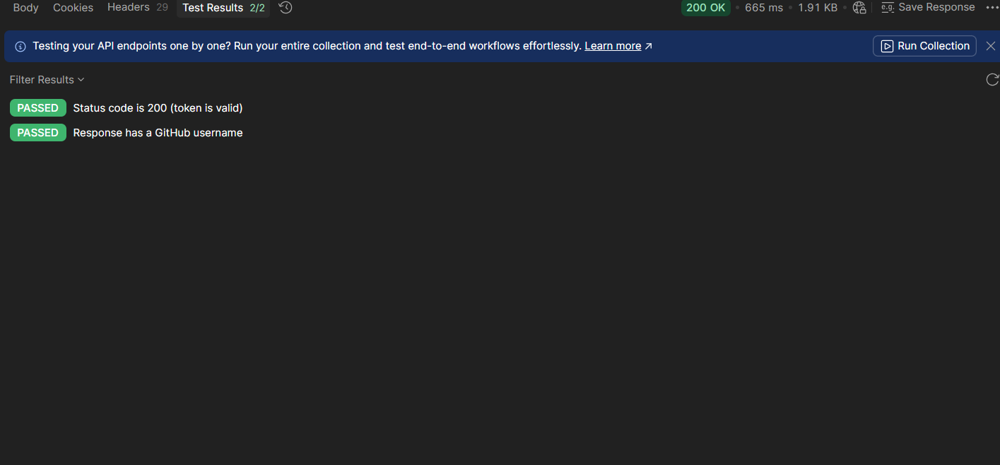
Fig. 1 — "0 - Verify Authentication" response: 200 OK, 2/2 tests passed.

3. CRUD Operations
Resource: Gists

Operation | Method | Endpoint | Result
Create | POST | /gists | 201 Created
Read (all) | GET | /gists | 200 OK
Read (one) | GET | /gists/{id} | 200 OK
Update | PATCH | /gists/{id} | 200 OK
Delete | DELETE | /gists/{id} | 204 No Content

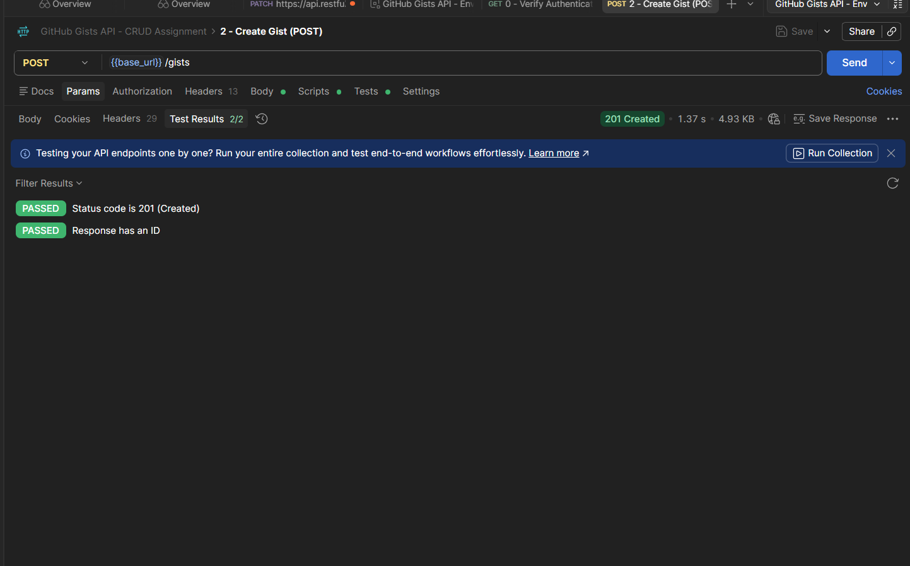
Fig. 2 — Create Gist (POST): 201 Created, 2/2 tests passed.
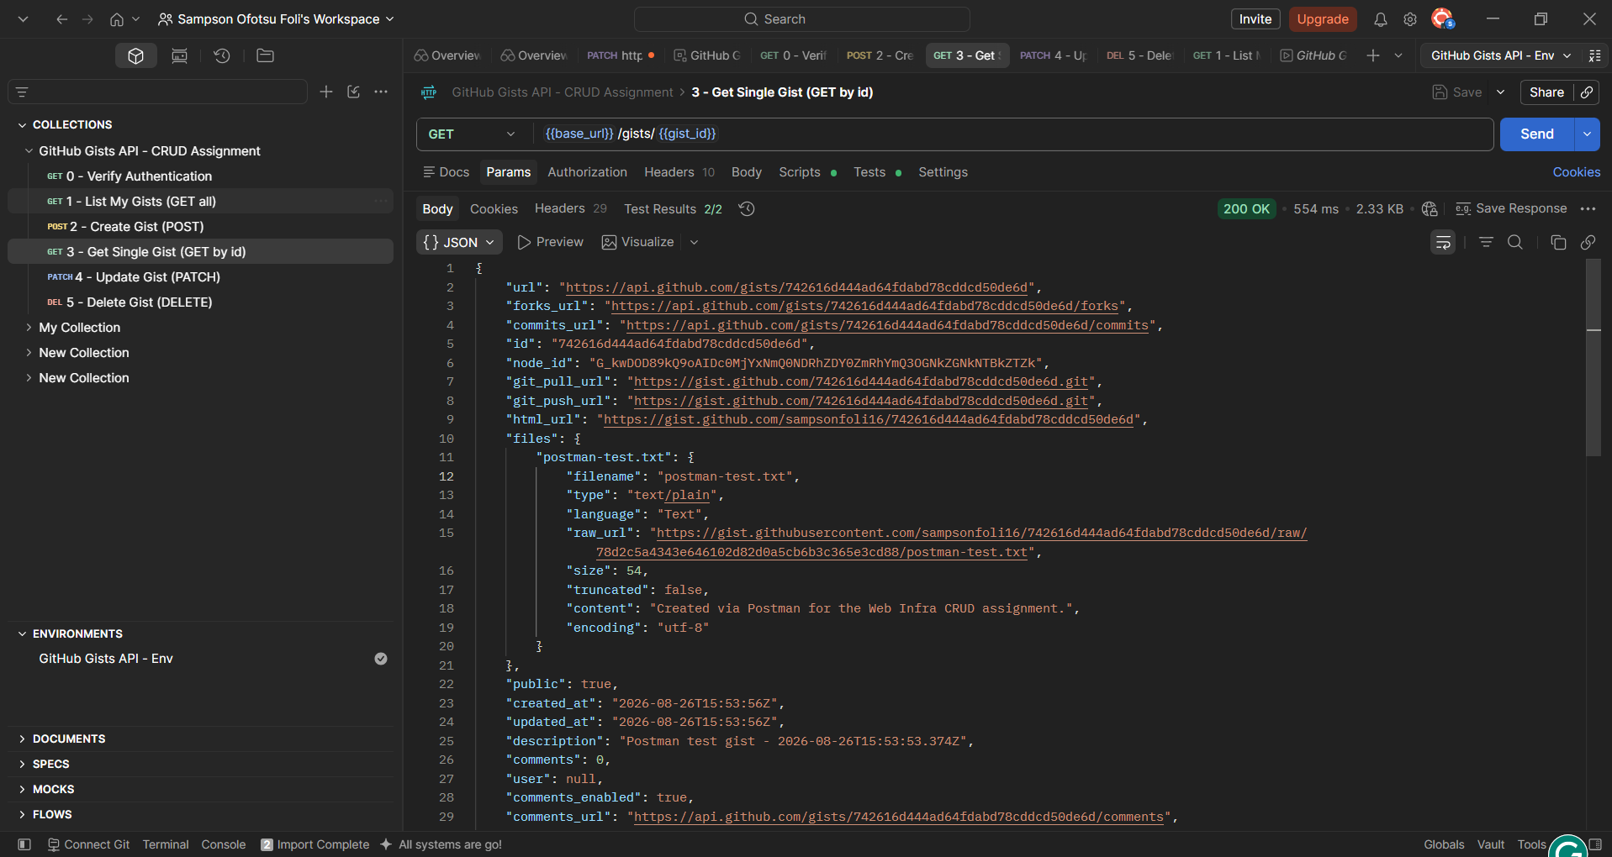
Fig. 3 — Get Single Gist (GET by id): 200 OK, response body showing the created gist's data.
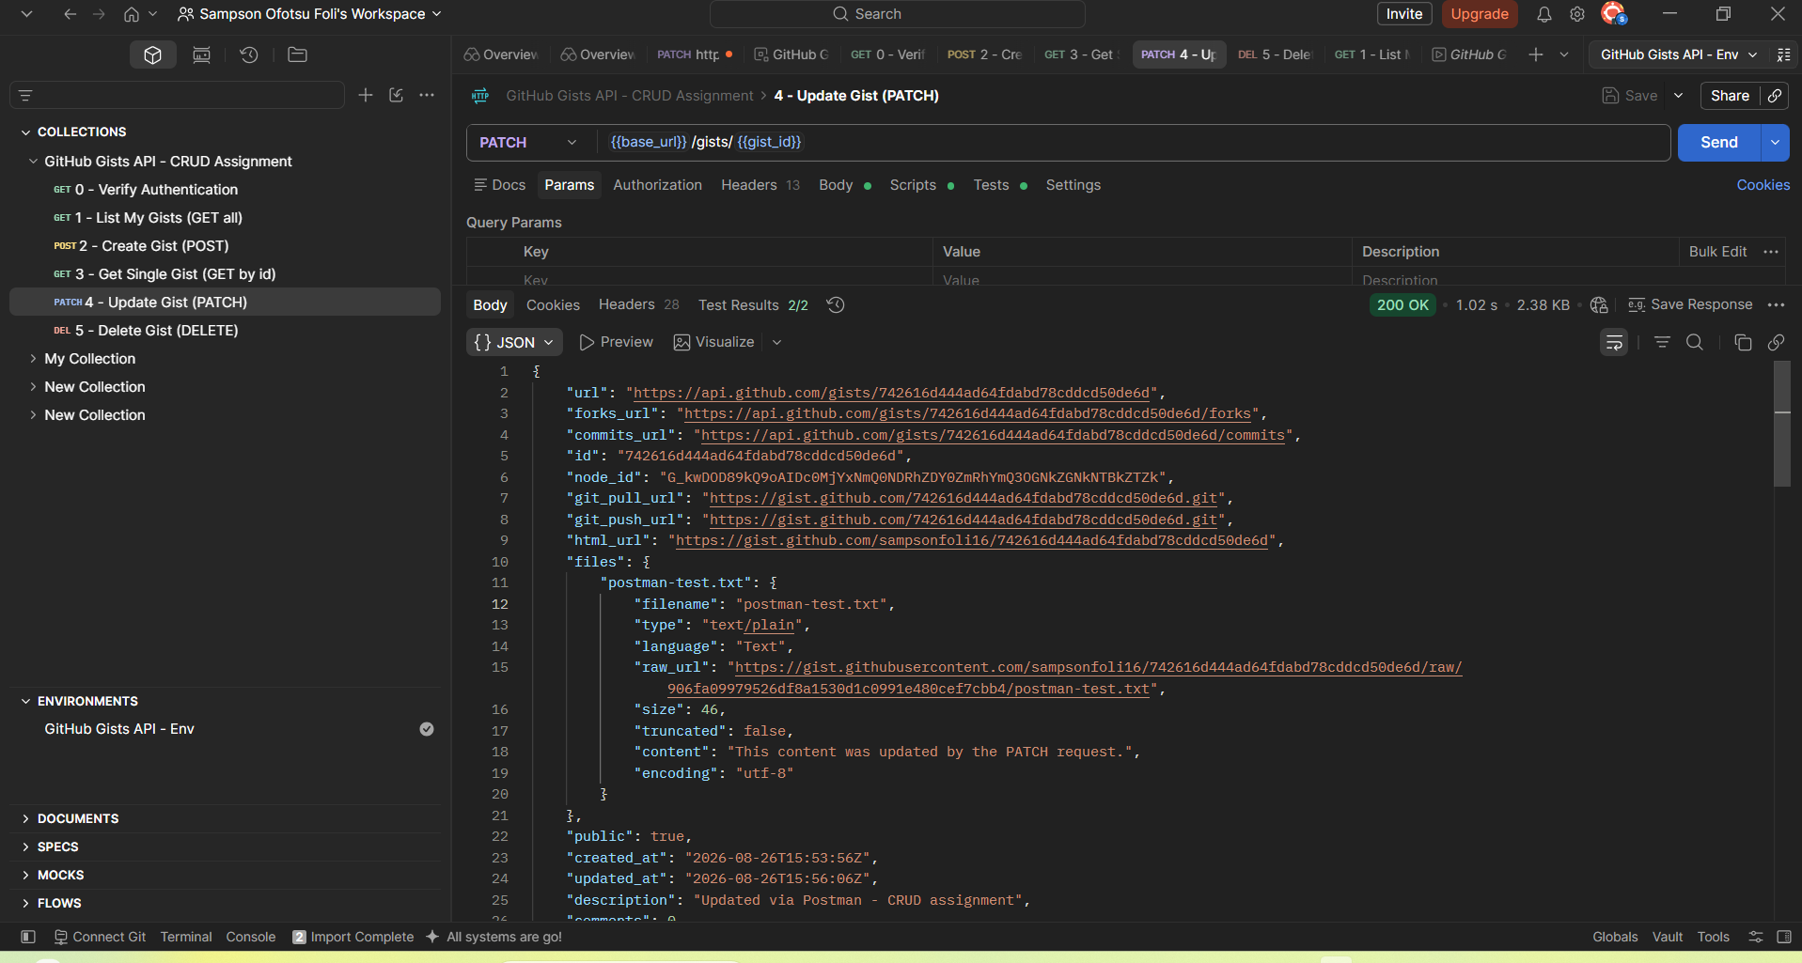
Fig. 4 — Update Gist (PATCH): 200 OK, response body showing the updated description and content.
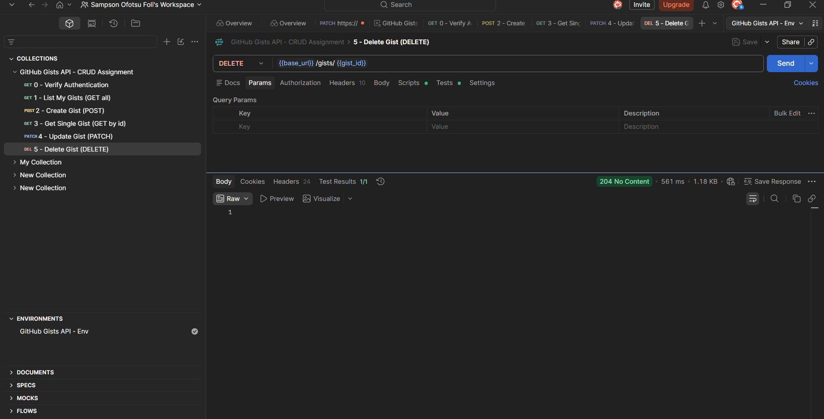
Fig. 5 — Delete Gist (DELETE): 204 No Content, 1/1 test passed.
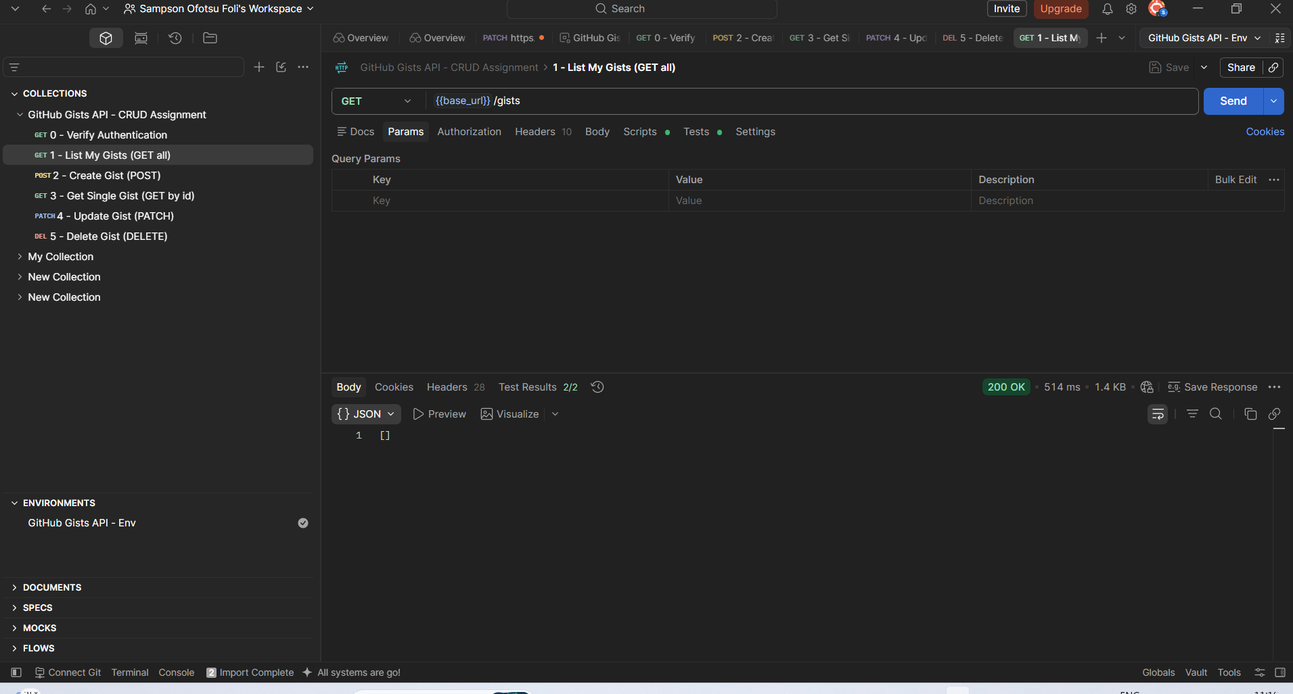
Fig. 6 — List My Gists after deletion: empty array, confirming the delete genuinely removed the resource.

4. Postman Environment & Variables
An environment ("GitHub Gists API - Env") was created to store:
- base_url — https://api.github.com
- auth_token — the PAT, marked as a secret/masked variable
- gist_id — the ID of the currently active gist
- gist_description — a dynamically generated description
Every request uses {{variable}} syntax instead of hardcoded values, so the whole collection can be reused against a different account just by swapping the environment.
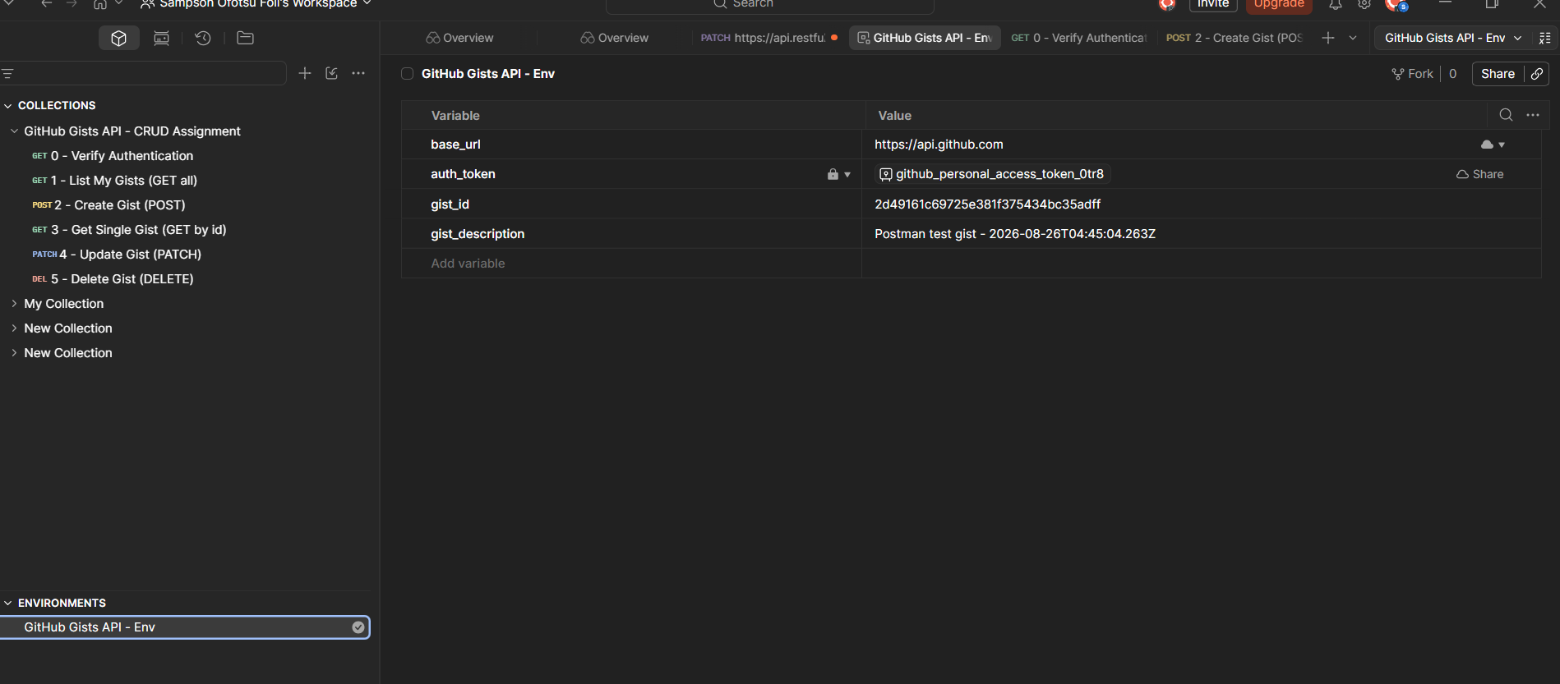
Fig. 7 — Environment showing gist_id and gist_description auto-filled after the Create request ran.

5. Automation
Two scripts demonstrate automation beyond static requests:
- Test script on Create: after a successful POST /gists, the script reads the new gist's id from the response and automatically saves it into the environment (pm.environment.set("gist_id", ...)). Every following request (Get, Update, Delete) then uses that id automatically — no manual copying between requests.
- Pre-request script on Create: generates a fresh, timestamped description on every run, so re-running the collection doesn't produce duplicate-looking gists.
- Collection-level pre-request script: checks that auth_token isn't empty before any request runs, and warns in the console if it is.

6. Collection Runner
The full collection (all 6 requests, in order) was executed via Postman's Collection Runner.
Result: 11/11 tests passed, 0 errors, 0 skipped.
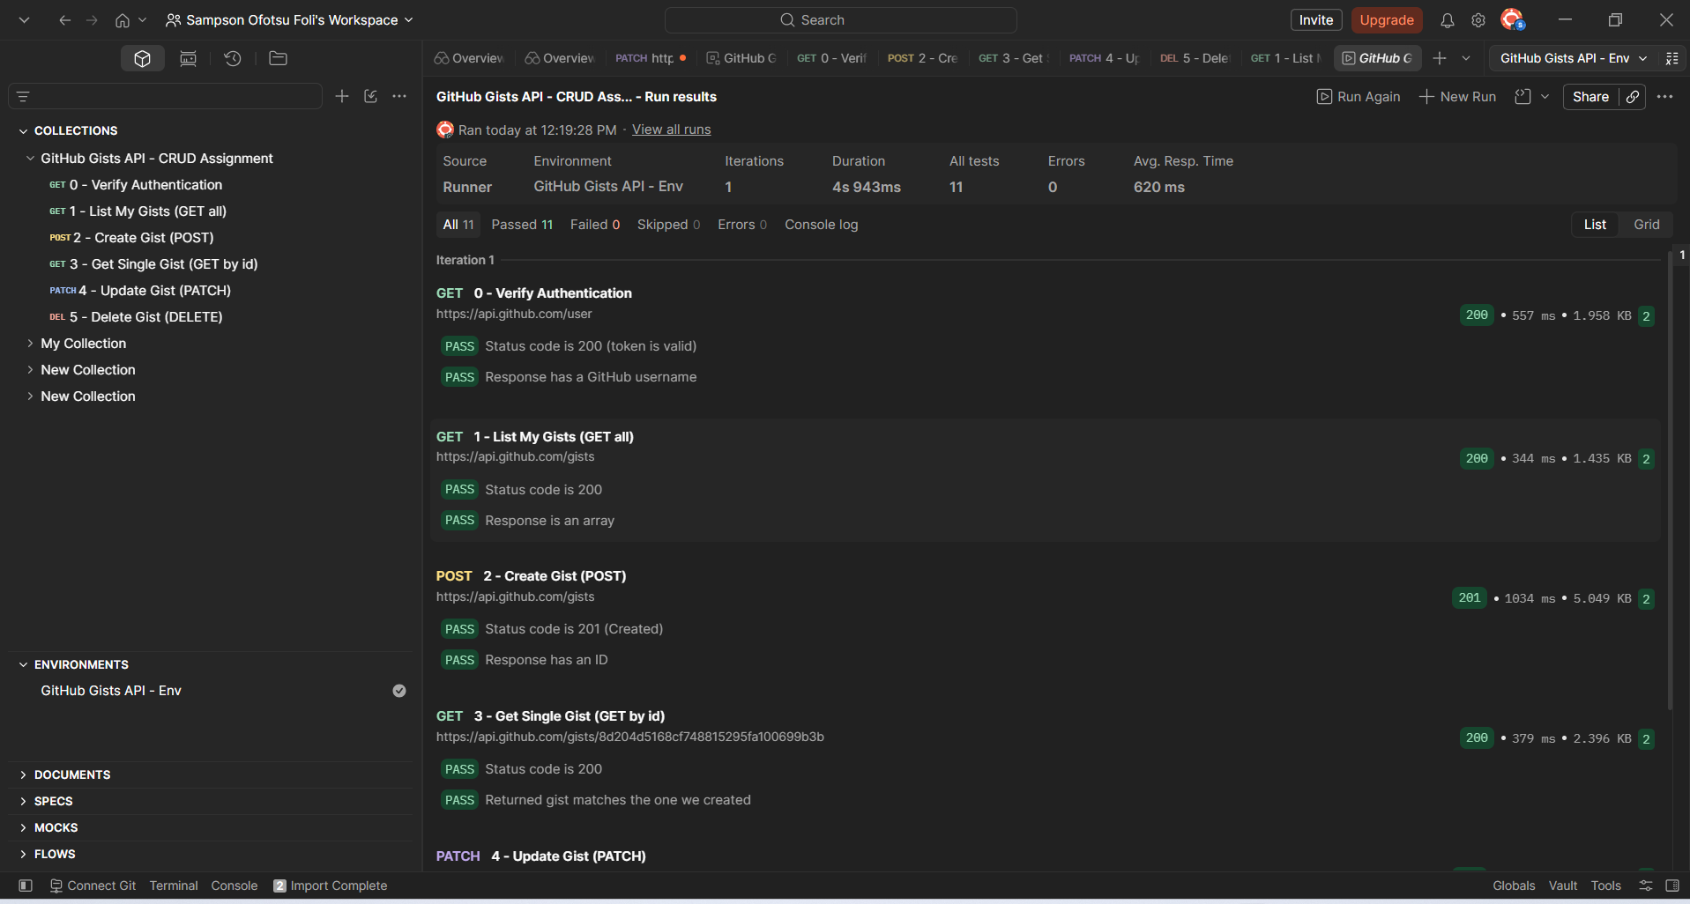
Fig. 8 — Collection Runner summary: 11/11 tests passed, 0 errors.
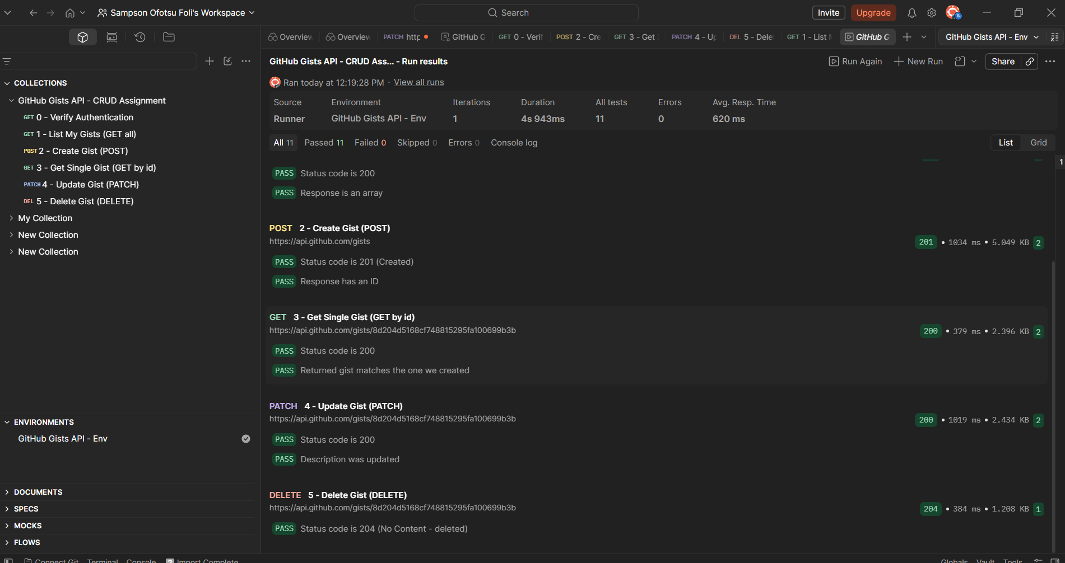
Fig. 9 — Remainder of the run, showing Update and Delete results.

7. Repository Contents
- github-gists-api.postman_collection.json — the exported collection
- github-gists-api.postman_environment.json — the exported environment (token value left blank; each user provides their own)
- REPORT.docx — this document
- screenshots/ — all screenshots referenced above

