**Online Store Requirements and Design Document**

**Project Overview:**

**Objective**

Objective is to create an online retail management system which will allow the retail outlet owner to sell their products and offer services to the customers.

**Content**

Online retail store management is an intermediary between customers and retail outlets. This application will consist of products listed by the administrator under different categories, which can be viewed by the customers and subsequently an order can be placed.

**Scope**

* The system will allow an administrator to add products and edit product details to the application so that a customer accesses the application and purchase the products displayed.
* The system will be able to manage customer’s data, data about the products in store and transaction made by the customers.
* The customer can also add products to the carts in order to buy them later. When the customer places an order, the user gets a notification of the order details.

**Target Users**

1. Customer - A Customer is a registered user who can purchase products.
2. Admin - Inventory manager is a person who manages the products in the store.

**Requirements**

* As an admin, I want to log in to the system so that I can access features specific to my role.
* As an admin, I want to logout from the system.
* As an admin, I want to add a product to the store’s catalog.
* As an admin, I want to add an item to the store’s inventory.
* As​ a Guest, I want to register as a customer to the online retail store so that I can purchase products.
* As a Customer, I want to view all the products in the store’s inventory.
* As a Customer, I want to check whether a product is available at the store currently so that I can decide whether I can buy the product or not.
* As a Customer, I want to add items to the cart​. ​
* As a Customer, I want to purchase items that are currently added to the cart.
* As a Customer, I want to view detailed information (User Name, First Name, Email address, phone number) of my profile.
* As a Customer, I want to view items (Product name, List Price, Quantity) in the cart.
* As a Customer, I want to checkout products in the cart.
* As an Inventory manager, I want to update product details in the store’s catalog.
* As a Customer, I want to get notified by my subscribed email after successful placement of the order.
* As a Customer, I want to view purchase history details.

**Site Map**

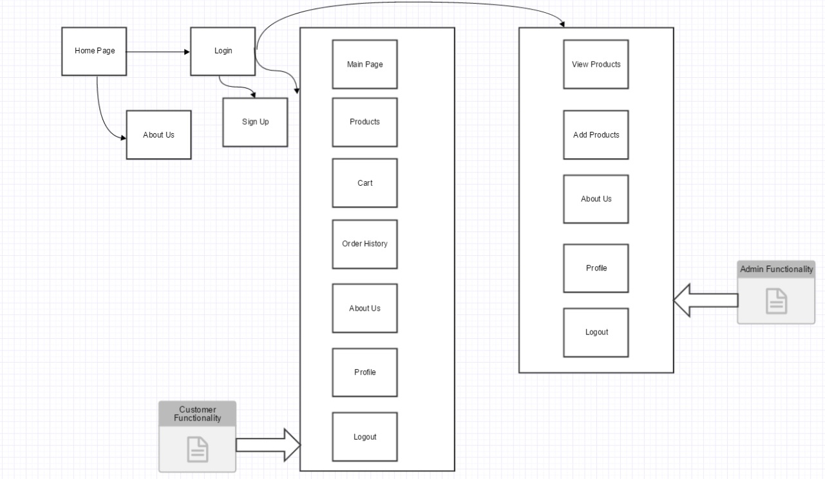

**Page Design**

**Name of the page:** Homepage

**Purpose of the page:** Homepage is the landing page of the online retail store system. Users can log in to the system by clicking on log in from this page.

**Audience of the page:** Customer and Admin.

**Data fields:** Company name, about us details.

**Validations:** No Validations

**Actions:**

* About us - Clicking on this would navigate the user to about us page where the details about the company is displayed
* Login - Clicking on this would take the user to log in page)

**Name of the page:** About Us

**Purpose of the page:** About us page gives details about the online retail store.

**Audience of the page:** Customer.

**Data fields:** Details about the company.

**Validations:** No Validations

**Actions:** No actions

**Name of the page:** Login

**Purpose of the page:** Login page validates the users and authorizes them with their respective privileges.

**Audience of the page:** Customer and Admin.

**Data fields:** Email address and password.

**Validations:** Email address and password null checks, email address format validations and user existence in the system validations are performed

**Actions:**

* Login - Clicking on this button will validate the user and route them to their respective pages (Customer or admin)
* Sign up – Clicking on this link would navigate the user to sign up page where the user can register in to the system.

**Name of the page:** Signup

**Purpose of the page:** Signup page allows the users to register their accounts with the system.

**Audience of the page:** Customer.

**Data fields:** Username, Name, Email, Password, Confirm password.

**Validations:** Null checks for all the data fields, password and confirm password match.

**Actions:**

* Create account - Clicking on this button would register the user, if all the validations are successful and navigate the user to main page.

**Name of the page:** Main page

**Purpose of the page:** Main page is the landing page when the user logs into the system.

**Audience of the page:** Customer.

**Data fields:** A running carousel of online retail store images.

**Validations:** No Validations

**Actions:**

* Home - Clicking on this would navigate the user to home page.
* Products – Clicking on this would navigate the user to products page.
* Cart – Clicking on this would navigate the user to their cart page.
* Order History – Clicking on this would navigate the user to their order history.
* About Us – Clicking on this would navigate the user to about us page.
* Products – Clicking on this would navigate the user to products page.
* Profile – Clicking on this would navigate the user to their profile page.
* Logout - Clicking on this would log out the user from the system.

**Special Notes:**

All the customer related pages will have Home, Products, Cart details, Order History, About us, Profile, and Logout as header. Organization name and host machine details are displayed on the footer page.

**Name of the page:** Products

**Purpose of the page:** Products page displays all the available products in the store.

**Audience of the page:** Customer.

**Data fields:** Product name, Product description, Unit Price.

**Validations:** OnlyAvailable products are listed.

**Actions:**

* View Item - Clicking on this button would navigate the user to View Items page where the details about the item is displayed
* Add to cart - Clicking on this button would add the selected item in the cart and increment the cart counter.

**Name of the page:** Cart

**Purpose of the page:** Cart page lets the users to buy their products at later point in time.

**Audience of the page:** Customer.

**Data fields:** Product name, Product image, and Product description.

**Validations:** No Validations

**Actions:**

* Make Payment - Clicking on this button would navigate the user to payment page and an email is sent to the registered email id of the user, confirming that the order has been placed.

**Name of the page:** Order History

**Purpose of the page:** Order history page helps the users to track their purchased products over a period.

**Audience of the page:** Customer.

**Data fields:** Product name, Unit Price, and Email address of the user.

**Validations:** No Validations

**Actions:** No actions

**Name of the page:** Profile

**Purpose of the page:** Profile page gives a brief information about the user.

**Audience of the page:** Customer and Admin.

**Data fields:** First name, Email, Phone number, Credits, and Offers.

**Validations:** No Validations

**Actions:** No actions

**Name of the page:** Admin page

**Purpose of the page:** Admin page is the landing page when the admin logs into the system.

**Audience of the page:** Admin.

**Data fields:** A running carousel of online retail store images.

**Validations:** No Validations

**Actions:**

* Home - Clicking on this would navigate the admin to home page.
* View Products – Clicking on this would navigate the admin to all the products available in the store.
* Add Products – Clicking on this would navigate the admin to the add products page where the admin can add products to the store.
* About Us – Clicking on this would navigate the user to about us page.
* Profile – Clicking on this would navigate the user to their profile page.
* Logout - Clicking on this would log out the user from the system.

**Special Notes:**

All the admin related pages will have Home, View Products, Add Products, About us, Profile, and Logout as header. Organization name and host machine details are displayed on the footer page.

**Name of the page:** View Products

**Purpose of the page:** Admin can view all the products available in the store.

**Audience of the page:** Admin.

**Data fields:** Product name, Product image, quantity, price.

**Validations:** No Validations

**Actions:** Clicking on Edit button would navigate the admin to edit product page, where the admin can edit details about a product.

**Name of the page:** Edit Product

**Purpose of the page:** Admin can Edit a product available in the store.

**Audience of the page:** Admin.

**Data fields:** Product name, Product quantity, price, Product description.

**Validations:** Null checks for all the fields.

**Actions:** Clicking on Update button would navigate the admin back to edit product page, and the details are updated for the product.

**Name of the page:** Add Product

**Purpose of the page:** Admin can Add a product to make it available in the store.

**Audience of the page:** Admin.

**Data fields:** Product code, Product name, quantity, price, Product description.

**Validations:** Null checks for all the fields.

**Actions:** Clicking on Add button would navigate the admin back to view product page, and the new product added will be available in the store.

**ER diagram**

