**Online Retail Store User Manual**

Author: Sampath Kumar Gunasekaran

800954726

Date: April 28, 2017

**Table of Content**

1. Introduction 1

2. Technological Background 1

3. User roles 1

4. System Analysis & Design 2

**3.1**  **Use Cases** 2

**3.1.1** **Customer Interface** 3

**3.1.2** **Admin Interface** 5

**3.2**  **Webpage Diagrams** 9

**3.2.1** **A general diagram of the Customer Side** 9

**3.2.2** **A general diagram of the Admin Side** 11

#### **Flopkart: An Online Store**

**Abstract:**

This user manual covers the design and implementation of the online retail store. The application is implemented using JSPs, Servlets and consists of two main components: Admin and Customer side. Admin side consists of the features such as Adding items to the store, Modify Items in the store, Log in and Logout. Customer side consists of the features such as Select Products, Buy Items, Continue Shopping, add items to Cart, View Cart, Checkout, Sign-in, Creating an Account, Order history, and View Profile.

**1. Introduction**

The main goal of this project was to create an online retail store, which allows customers to shop and purchase the products online. Moreover, the project is also designed in such a way it lets admins manage the products information.

**2. Technological Background**

The tools and technologies used to develop the online retail store include:

- JSP

- MySQL database server

- Tomcat Apache server

- HTML

- Servlets

- Net beans

Servlet technology is used to create web application (resides at server side and generates dynamic web page).

JavaServer Pages (JSP) is a technology that helps software developers create dynamically generated web pages based on HTML, XML, or other document types.

MySQL is a very fast, robust, relational database management system (RDBMS). A database enables the users to efficiently store, search, sort, and retrieve data.

Tomcat server interprets the code at the Web server and generates HTML or other output that the visitor will see.

Net beans IDE is used to write the coding in plain text that the Web server can recognize and translate into binary code.

There are advantages of using these tools to develop and run the software. Tomcat server and MySQL server are free to download from the internet if one does not have any tools.

**3. System Analysis & Design**

The system was analyzed and designed before implementation began. In this section use cases, and webpage diagrams are described in detail.

**3.1 Use Cases**

The following use cases outline the requirements for the online shopping store.

**3.1.1 Customer Interface**

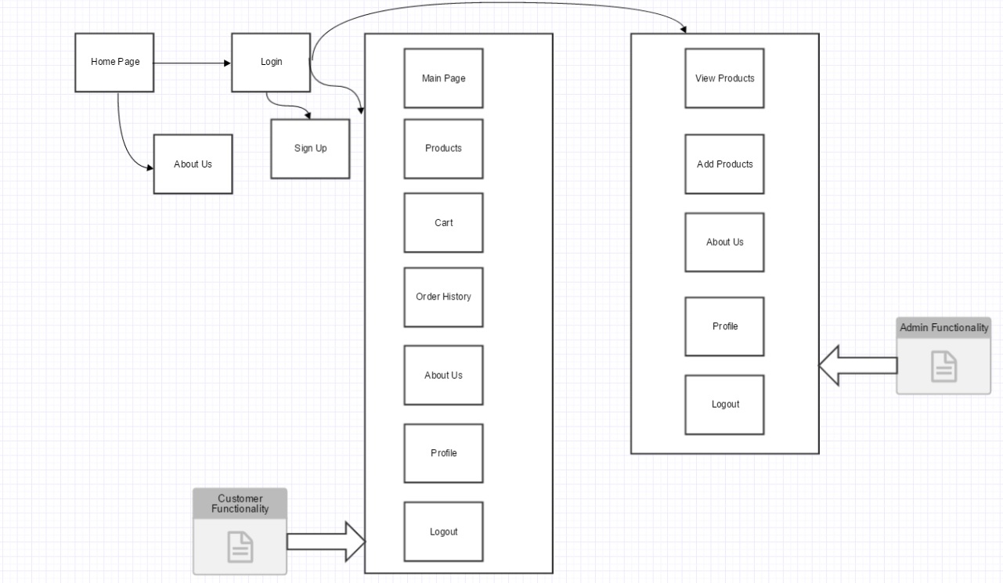

1. **Customer shops for a product**

The customer initiates this action by clicking on the desired item to be bought. The action is complete when a page is returned for the customer to view, which contains available products with product names along with their picture, price, quantity, and an option to add the product to the shopping cart.

1. **Customer adds an item to the cart**

The customer initiates this action by clicking on the *Add to cart* button on the right side of to a product’s listing. An item is added to the cart including the price. Cart’s quantity is incremented by 1.

1. **Customer views cart**

The customer initiates this action by clicking on the *Cart*, available on any webpage. The page sends message to the server and shows a list of all products in the customer’s cart, along with their quantity and price.

1. **Customer checks out and pays**

The customer starts this action by click on *make payment* button the on the cart page. A payment success page is displayed letting the customer to know about his/her order details. An email is triggered to the user about the successful placement of the order.

1. **Customer view order history**

The customer starts this action by click on *order history*, available on any webpage. Customer’s order history is displayed letting the customer to know about his/her previous order details.

1. **Customer view profile**

The customer starts this action by click on *profile*, available on any webpage. Customer’s profile information is displayed.

**3.1.2 Admin Interface**

**1. Admin logs in**

The admin starts this action by inputting the username and password and clicking on the *login* button. The page is sent to the server to validate the information from the database. After successful validation, the logged in page is returned with options for the admin to add, modify products.

1. **Admin inserts item**

The admin starts this action by clicking the *Add Products* from the logged in page. The page is displayed with a form for the admin to insert item and its details. Once *Add* button is clicked, the web page sends this information to the server, which in turns stores it in the database.

1. **Admin modifies item**

The admin starts this action by clicking on the *View products.* The web page displays list of available products from the database. The admin then chooses the item he/she wants to modify by clicking on particular item. A page is displayed letting the admin to modify all item information. Once, the *Update* button is clicked, the web page sends a message to the server, which updating the information from the database.

**3.3 Webpages**

**3.3.1 A general pages of the Customer SideHome Page**: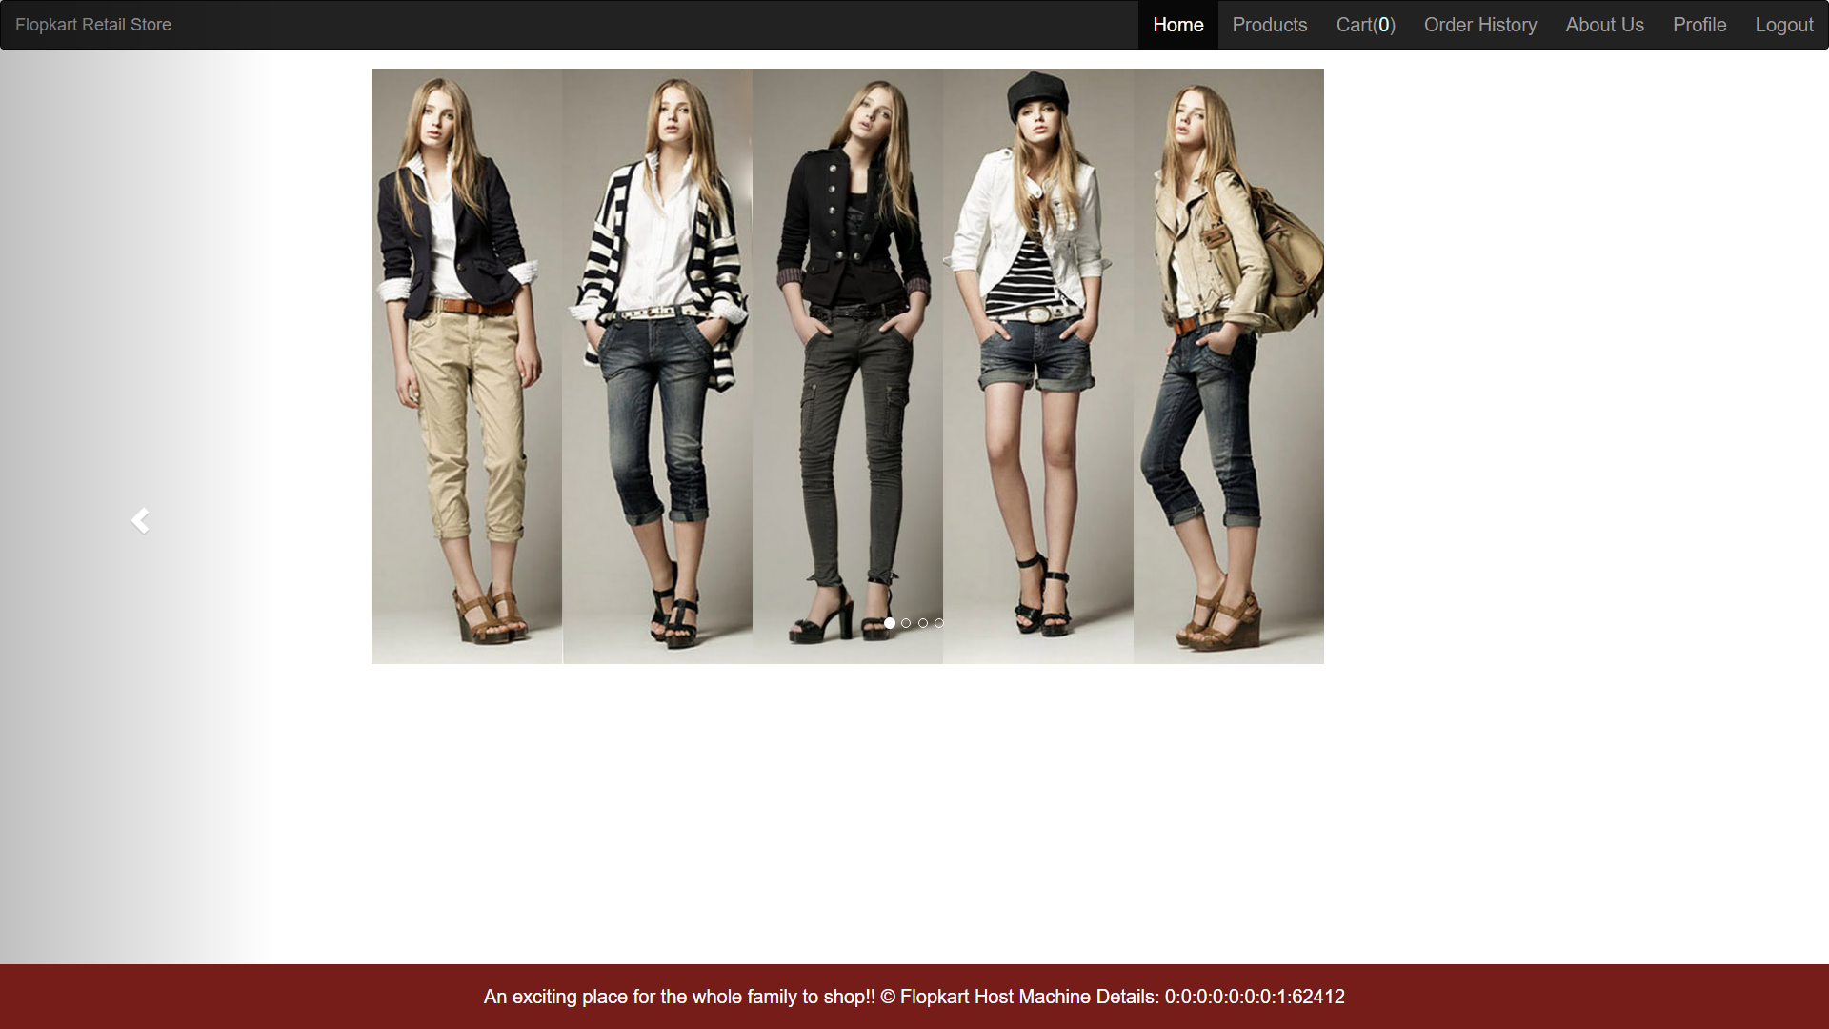

**Products Page:**

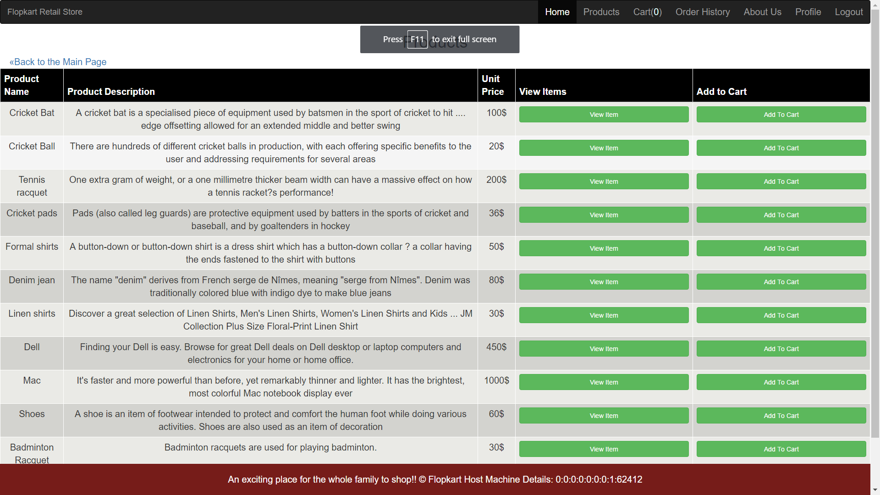

**Cart Page:**

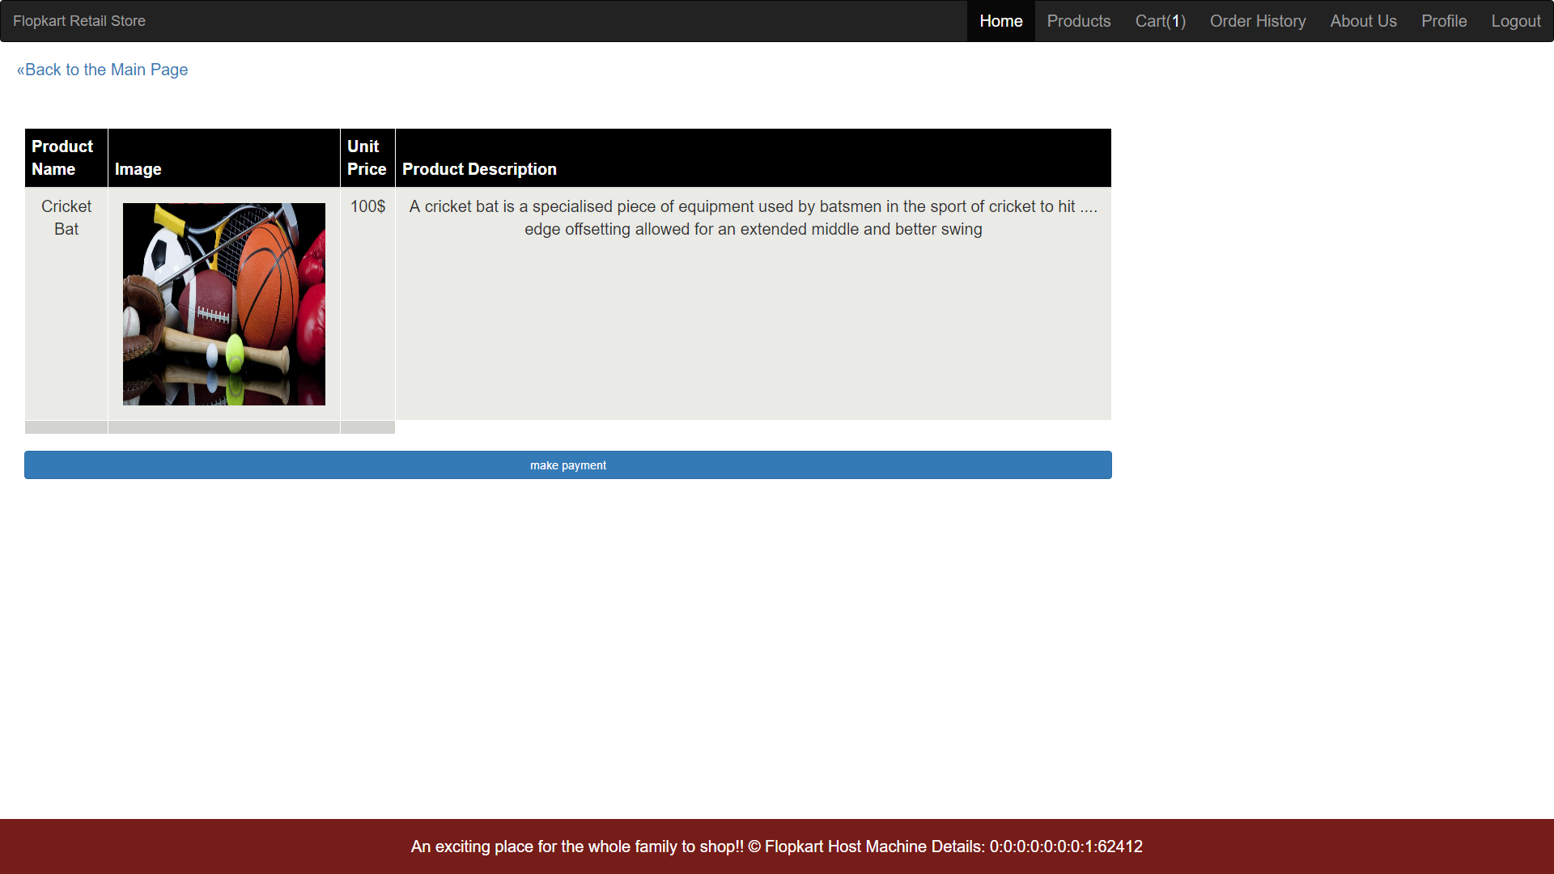

**Order History Page:**

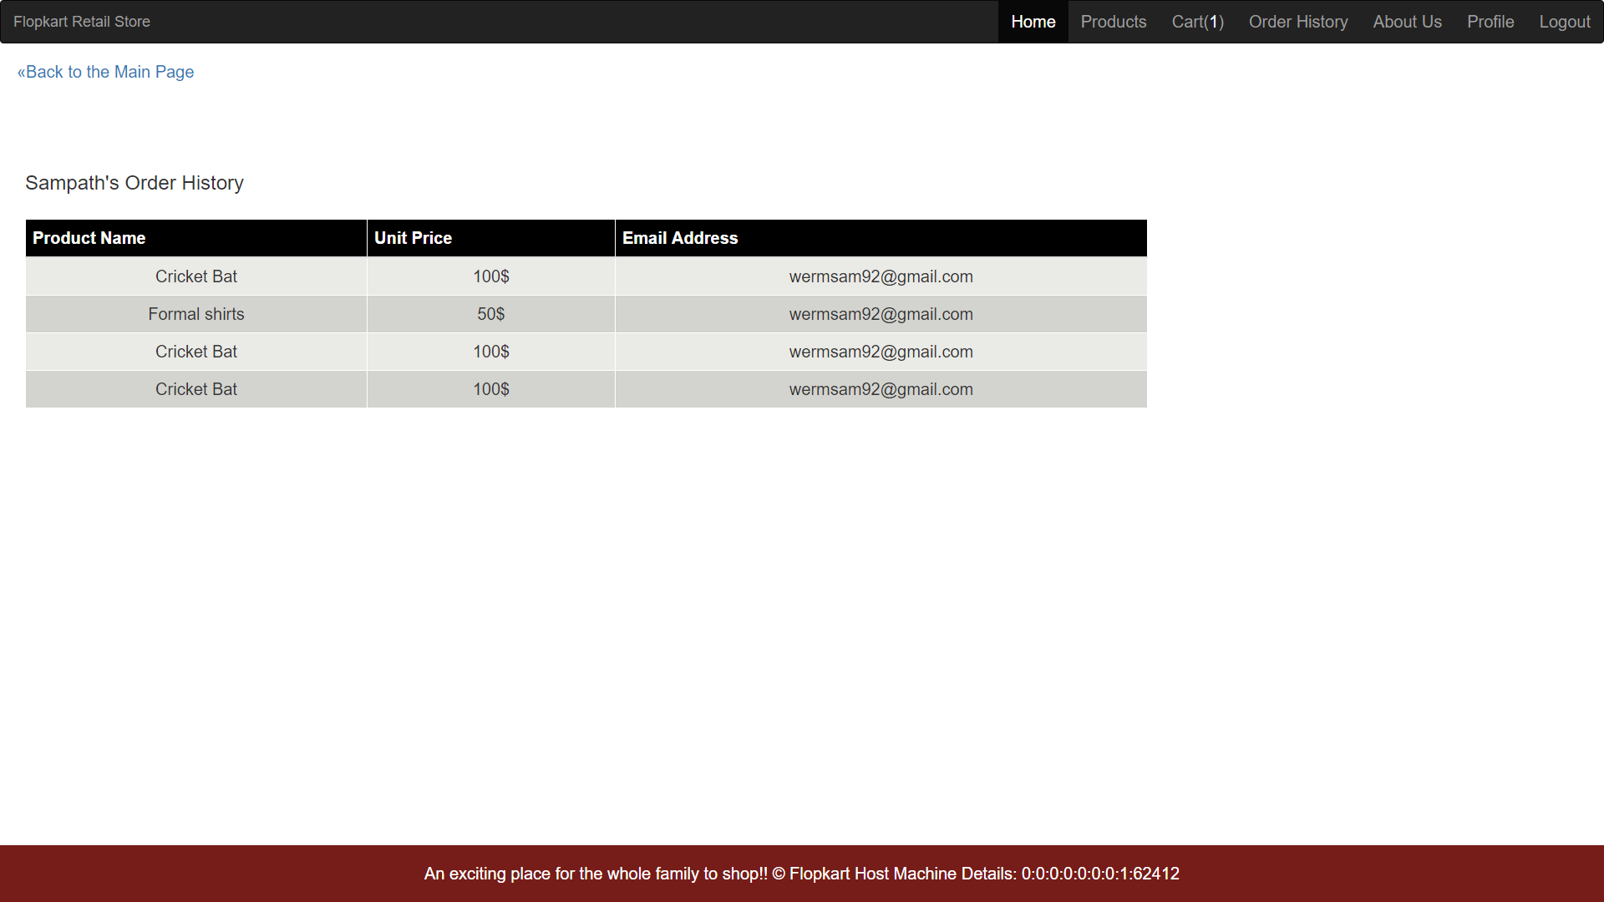

**Profile Page:**

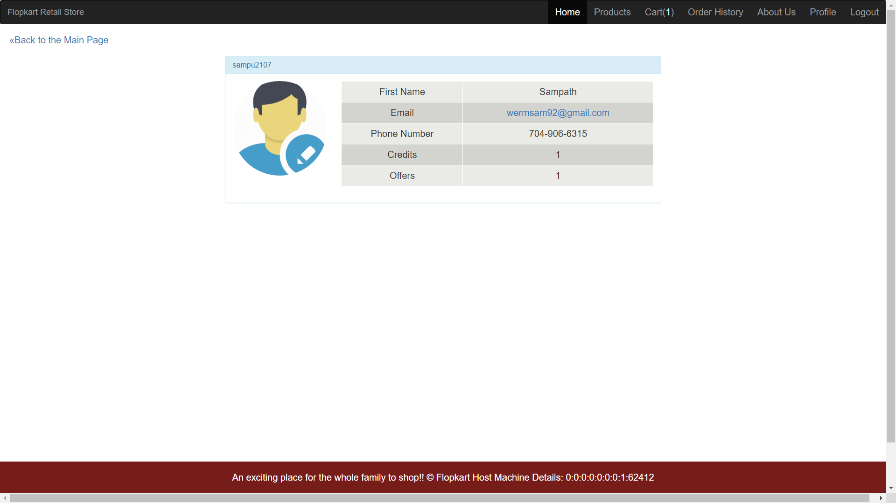

**About Us Page:**

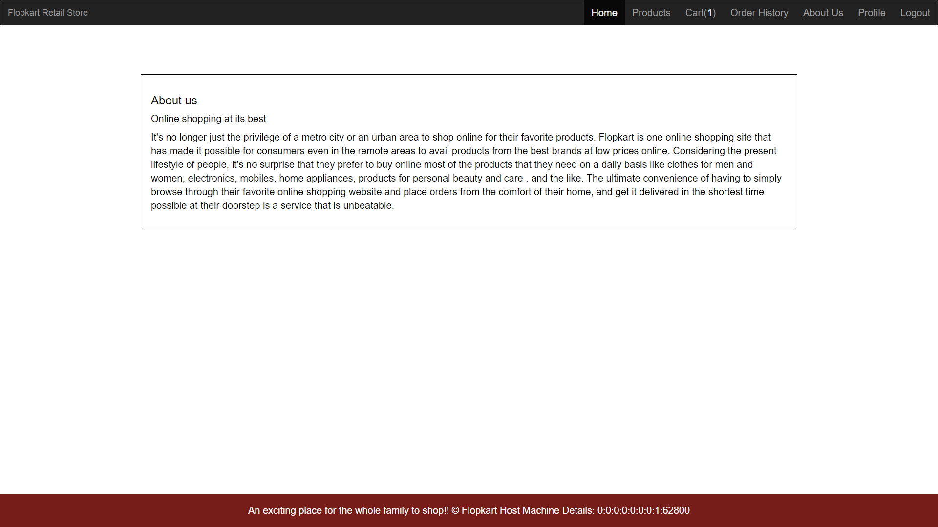

### **3.3.2 A general pages of the Admin Side**

**View Products page:**

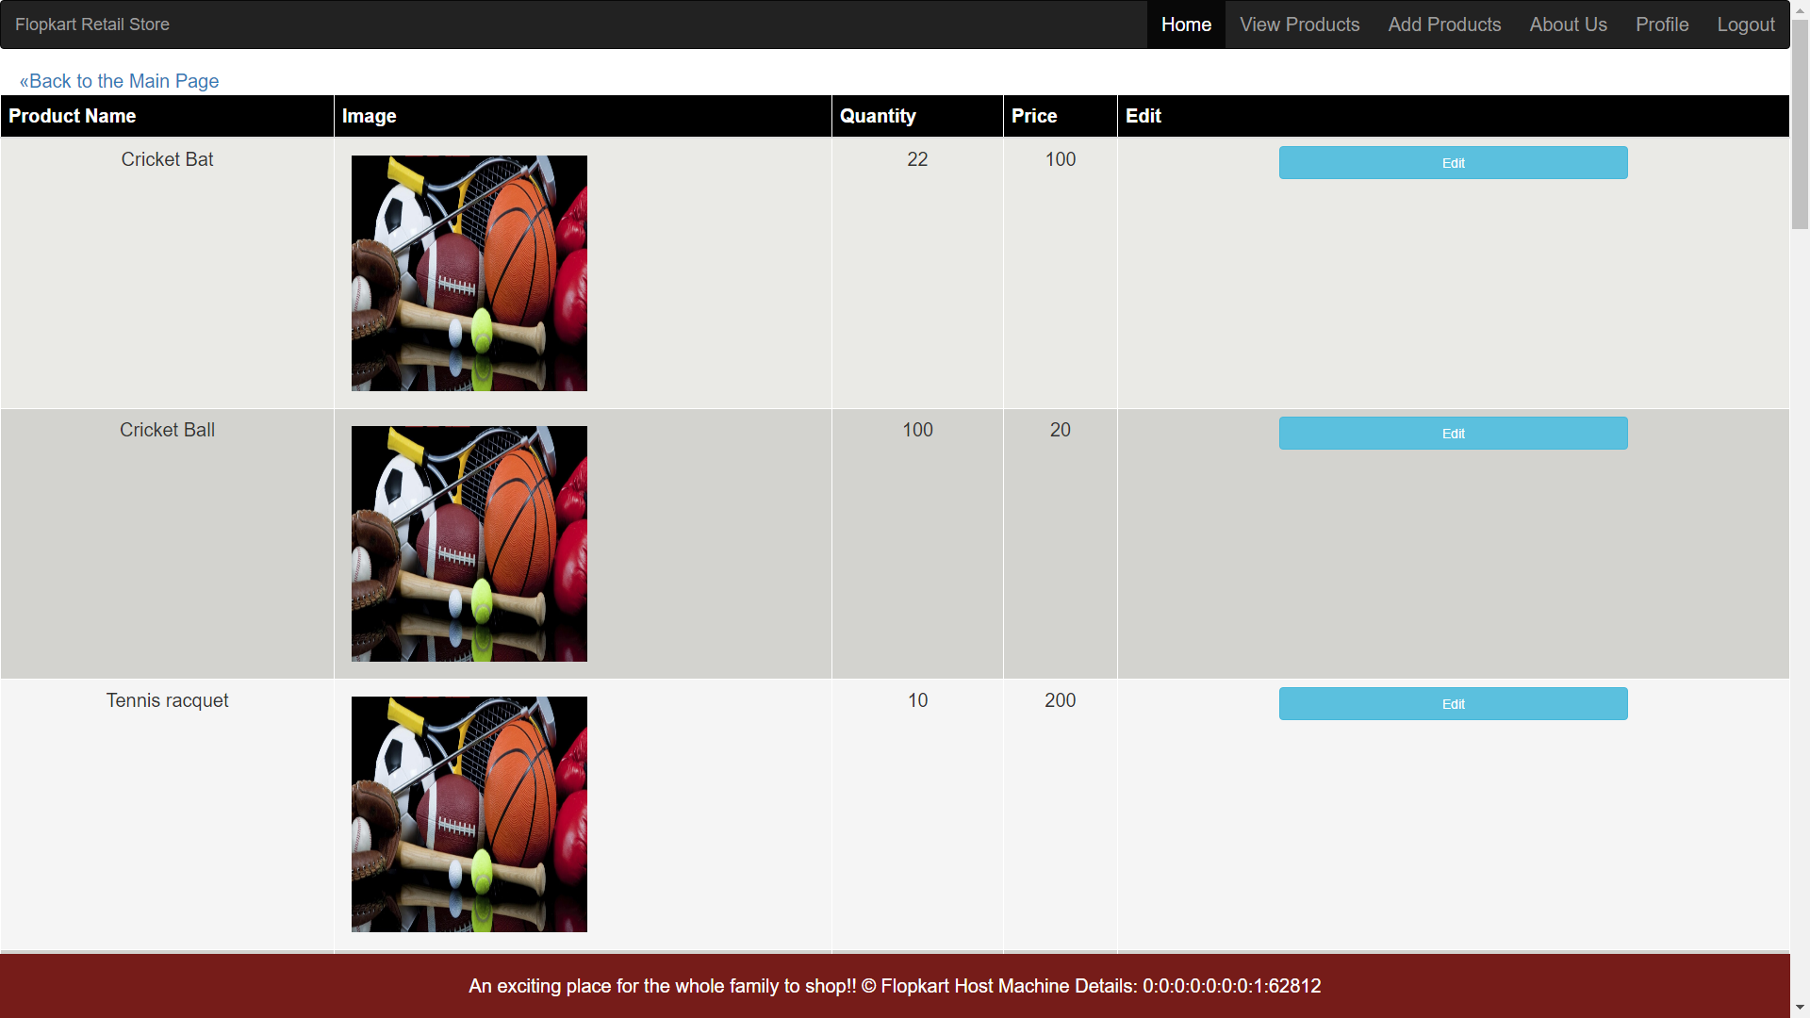

**Add Products page:**

