**LAPORAN PRAKTIKUM PEMROGRAMAN 2**

Nama : Imam Sampurno Nugroho

NIM : 4511210002

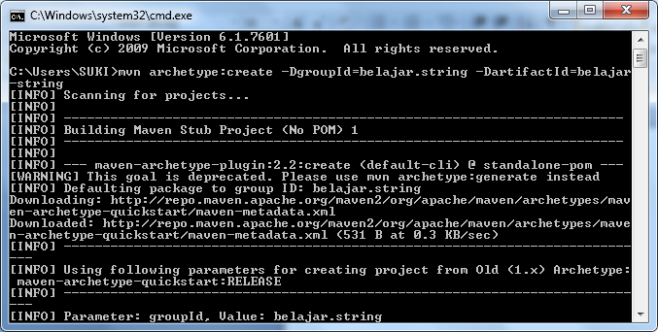

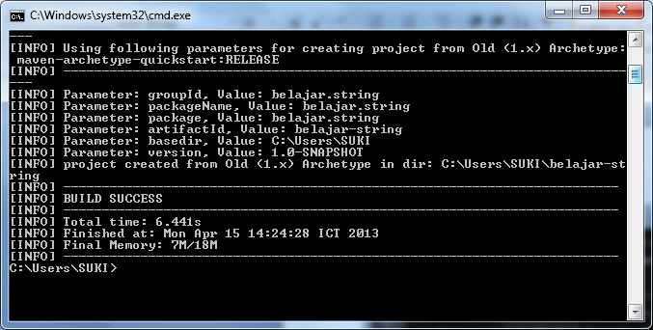

Latihan1.java

|  |
| --- |
| package belajar.string ;  public class Latihan1{  public static void main (String [] args){  String nama1=new String("tingki wingki");  System.out.println("Nama1 : "+nama1);  String nama2="lala";  System.out.println("Nama 2 : "+nama2);  }  } |

Mvn clean package exec:java –Dexec mainClass=belajar.string.namaclass

Mvn clean package exec:java –Dexec.mainClass=belajar.string.Latihan1

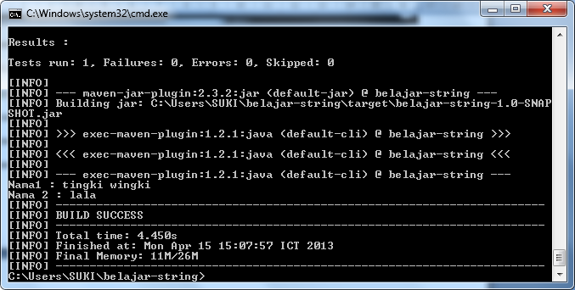

Latihan2.java

|  |
| --- |
| package belajar.string;  public class Latihan2{  public static void main(String [] args){  String s1="Go to";  String s2="Universitas Pancasila";  System.out.println (s1.concat(s2));  }  } |

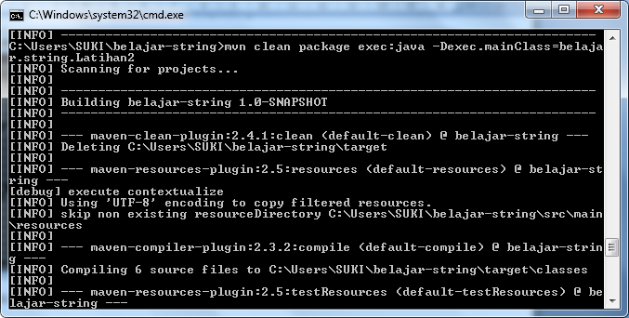

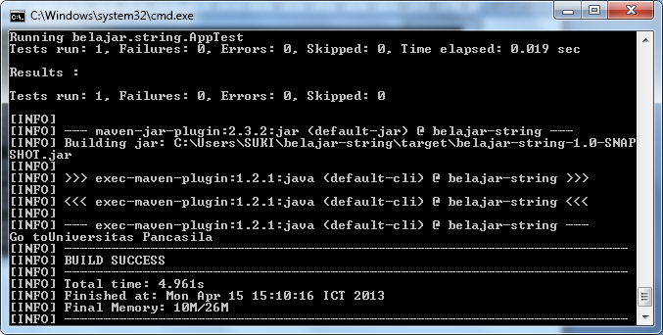

Latihan3.java

|  |
| --- |
| package belajar.string;  public class Latihan3{  public static void main (String [] args){  String text="Welcome to universitas pancasila";  System.out.println(text.substring(5));    String text2="Ayo kuliah";  System.out.println(text2.substring(4,8));  }  } |

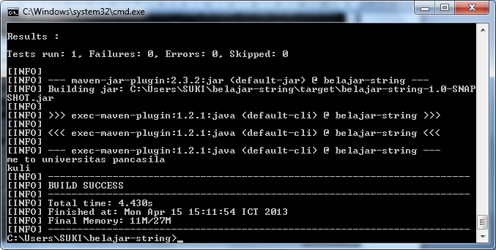

Latihan4.java

|  |
| --- |
| package belajar.string;  public class Latihan4{  public static void main (String args[]){  System.out.println (getReturn());  }    public static boolean getReturn(){  String s1="Hello";  String s2="Java";    if(s1==s2){  return true;  }    if (s1.equals(s2)){  return true ;  }    if (s1.compareTo(s2)==0){  return true;  }else{  return false;  }  }  } |

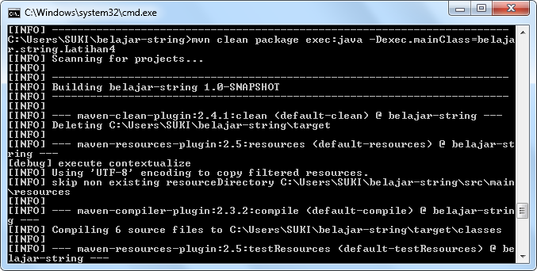

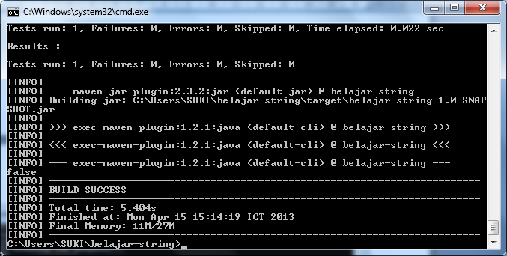

Latihan5.java

|  |
| --- |
| package belajar.string;  public class Latihan5{  public static void main (String args[]){  String text="Hello World";  System.out.println(text.toLowerCase());  }  } |

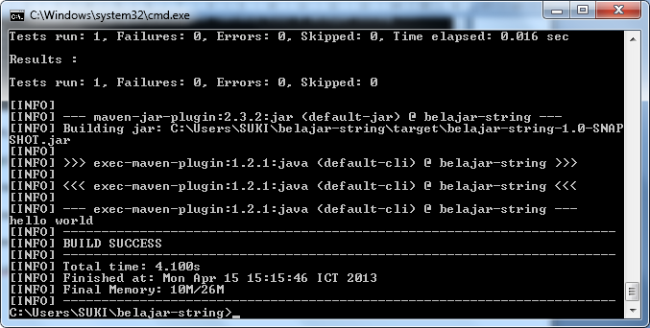

Latihan6.java

|  |
| --- |
| package belajar.string;  public class Latihan6{  public static void main (String [] args){  String text="Hello World";  System.out.println (text.toUpperCase());  }  } |

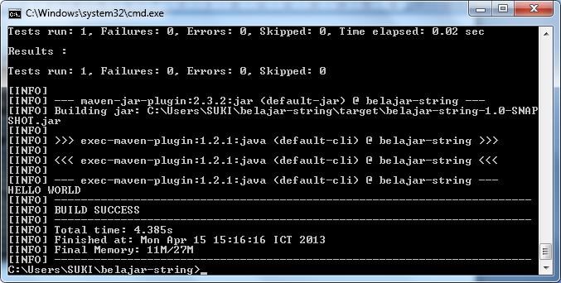

Membuat database

C:\xampp\mysql\bin\mysql\bin\mysql –u root

Lalu ketik create database p2;

Setelah itu

Use p2

create table produk( Id int (11) auto_increment primary key, Nama varchar(255), Harga decimal(10,2),);

