**Assignment 1:**

When I tried logging in with different user then it didn’t logged in, when password we give then it is throwing error as below.

Using sudo –su username will not ask for password and throw error.  
sudo su username will ask for password and then throw error.  
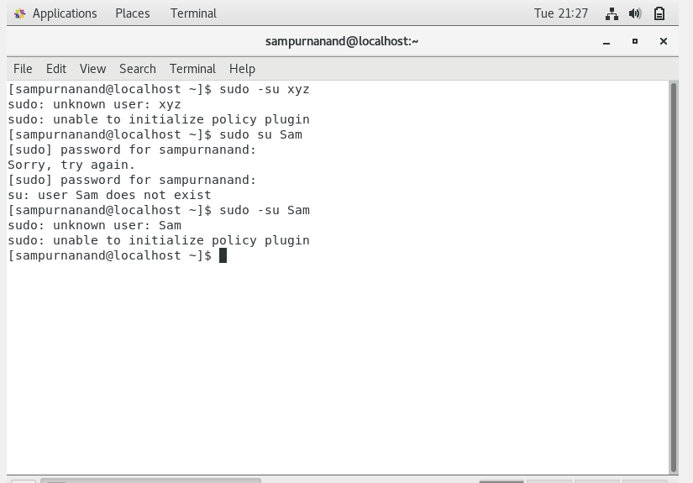

**Assignment 2:**

1. When proper non-generic/ unique password is given then password get change automatically.

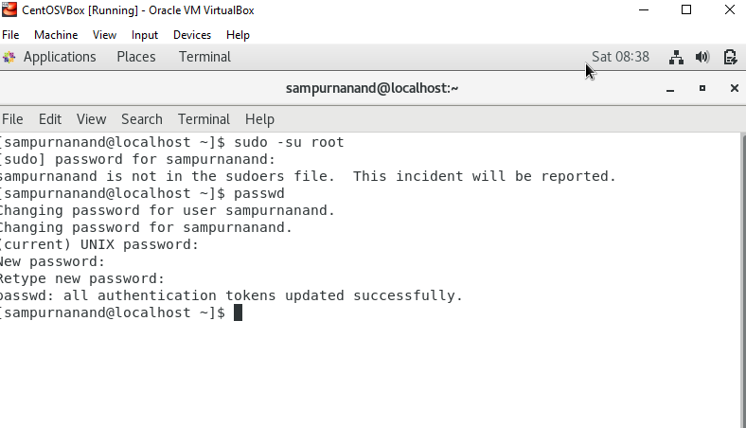

1. When Passwords like ‘abcd’ or ‘1234’ is given: When some non-unique password or short passwords less than 8 character is given then error is thrown by the system. So, what I understood is there is some criteria which we need to follow while reset/set password for a user account.

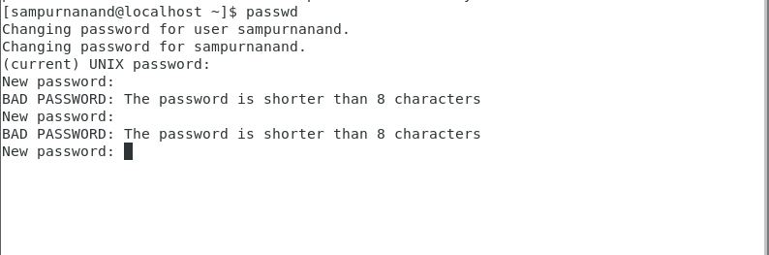

1. When no password is supplied:

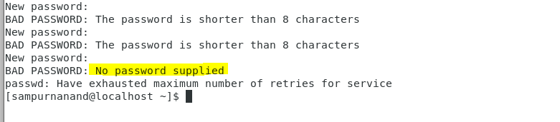

Assignment 3:

1. Using cd / command helps to change directory. ls command will list all the folders/files in the current directory.

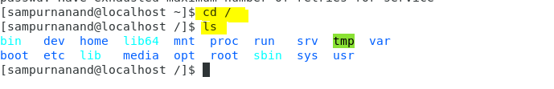

**Playing more with ls, cd, ls -al commands**

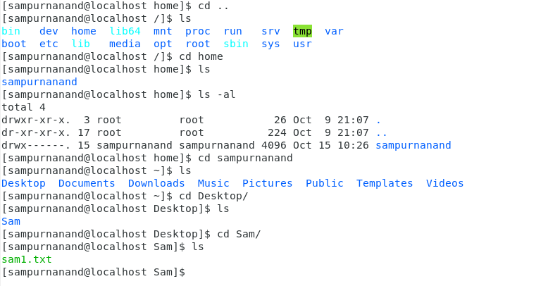

1. Cd /home will take us to our home folder which is “home” in my case.

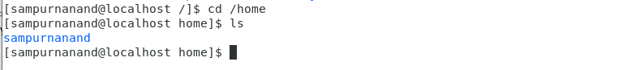

1. cd .. is used to go one directory back.



1. though cd /var/www/html is a valid command, but since www directory is not present so it is throwing corresponding error.

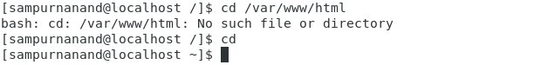

1. cd /root doesn’t work without going in sudo root mode. Otherwise it give permission denied error.

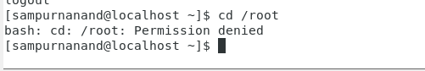 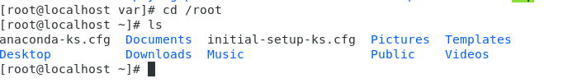

**Assignment 4:**

1. Using ls in etc directory:

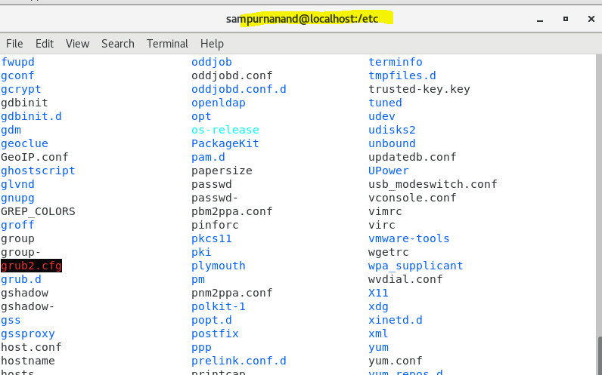

1. Total more than 1300 files. When we use ls –al in etc directory.

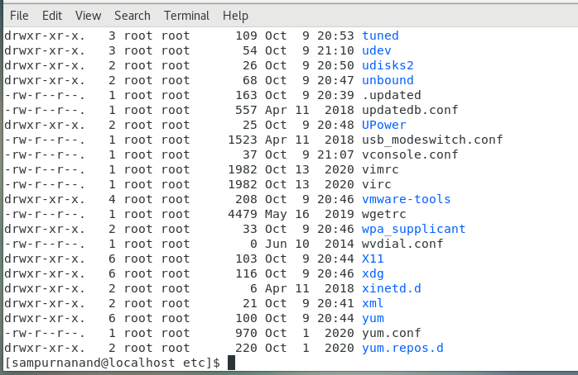

1. Using ls –i in etc directory

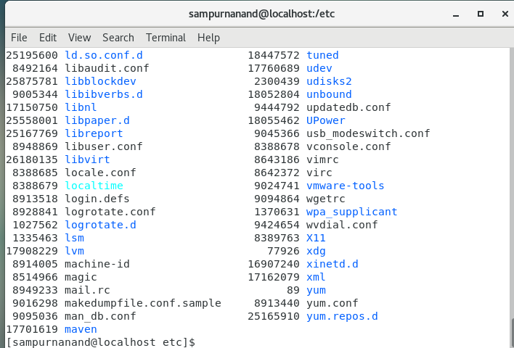

1. I tried using “ls –help” command in terminal, it showed me whatever possible command parameter we can use in “ls” command. It is of great use to use this command as per use case.

**Assignment 5:**

1. “pwd” command gives current working directory.

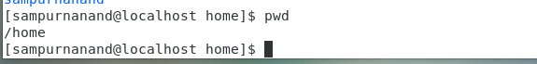

1. “cd /var” command will change the current working directory from home to var.

