HisabDo AI Website — API Endpoint Testing Report

(SQA Department - 3)

1. Test Information
Field | Details
Project | HisabDo AI Website
Testing Area | API Endpoint Testing
Endpoint Tested | /help/
Base URL | https://hisabdo-website-ai.onrender.com
Testing Tool | Postman
Tester | Eshal Kamal
Team Lead | Samra Arshad
Date Assigned | 29th August, 2026
Testing Date | 30th August, 2026

2. Objective
The objective of this testing activity was to verify the functionality, HTTP method handling, error handling, edge-case behavior, response consistency and response-time consistency of the /help/ API endpoint of the HisabDo AI Website.

3. Scope of Testing
The /help/ endpoint was tested for the following areas:
- Valid GET request
- URL variation without trailing slash
- Unsupported HTTP methods
- Invalid endpoint handling
- Query parameter handling
- Empty query parameter handling
- Multiple query parameter handling
- Repeated requests
- Response consistency
- Response-time consistency

4. Testing Environment
Item | Details
Application | HisabDo AI Website
API Endpoint | /help/
HTTP Request Tool | Postman
Testing Type | Manual API Testing
Protocol | HTTPS

5. Endpoint Overview
The root deployment endpoint confirmed that the HisabDo AI services were running and identified /help/ as one of the available service endpoints.
The /help/ endpoint returned the following successful response during testing:
{
"feature": "Context-Aware User Assistance",
"message": "HisabDo AI Help & Support API is running.",
"status": "success"
}
The response indicates that the Help & Support API is operational and returns a success status for valid requests.

6. Test Execution Summary
Metric | Result
Total Test Cases | 11
Passed | 11
Failed | 0
Pass Rate | 100%
All executed test cases passed according to the defined expected behavior.

7. Test Results Summary
TC ID | Test Scenario | Status
TC-01 | Valid GET request | Pass
TC-02 | Request without trailing slash | Pass
TC-03 | Unsupported POST request | Pass
TC-04 | Unsupported PUT request | Pass
TC-05 | Unsupported PATCH request | Pass
TC-06 | Unsupported DELETE request | Pass
TC-07 | Invalid Help route | Pass
TC-08 | Query parameter with valid text | Pass
TC-09 | Empty query parameter | Pass
TC-10 | Multiple query parameters | Pass
TC-11 | Repeated requests, response consistency and load-time check | Pass
Detailed test case execution results are maintained in the accompanying Excel test case sheet.

8. Detailed Findings

8.1 Valid Request
A valid GET request was sent to /help/.
The endpoint returned 200 OK with the expected JSON response and a success status.
Result: Pass
Response Time: 31.61 seconds
Observation: Although the endpoint returned the correct response, the initial request showed a significantly higher response time than subsequent requests.
Screenshot:
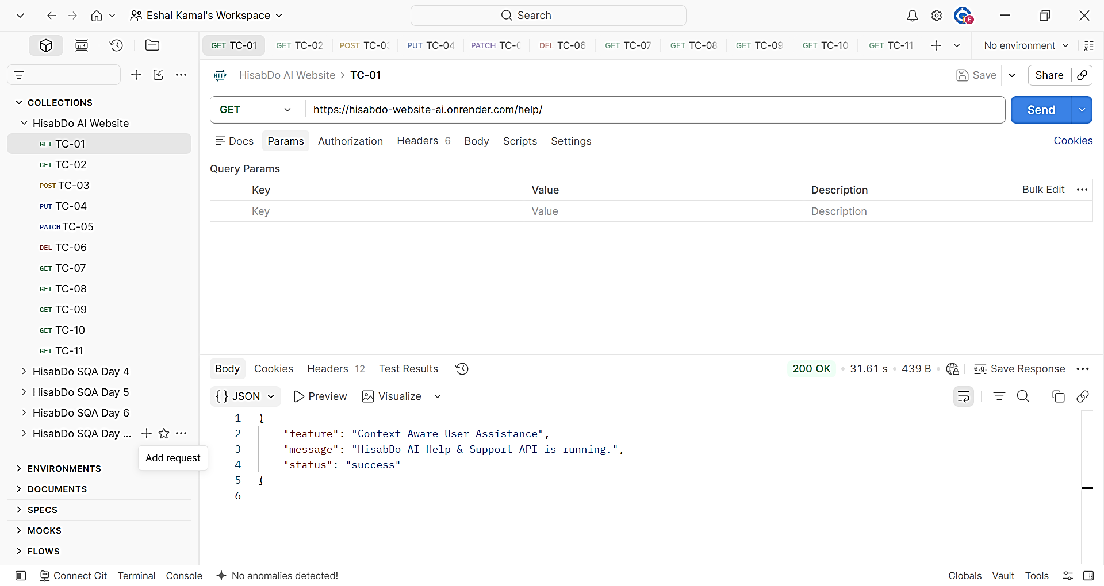
TC-01: Valid GET request showing 200 OK, response body and 31.61-second response time.

8.2 URL Without Trailing Slash
A GET request was sent to /help without the trailing slash.
The endpoint returned the expected Help & Support response with 200 OK.
Result: Pass
Response Time: 468 ms
Screenshot:
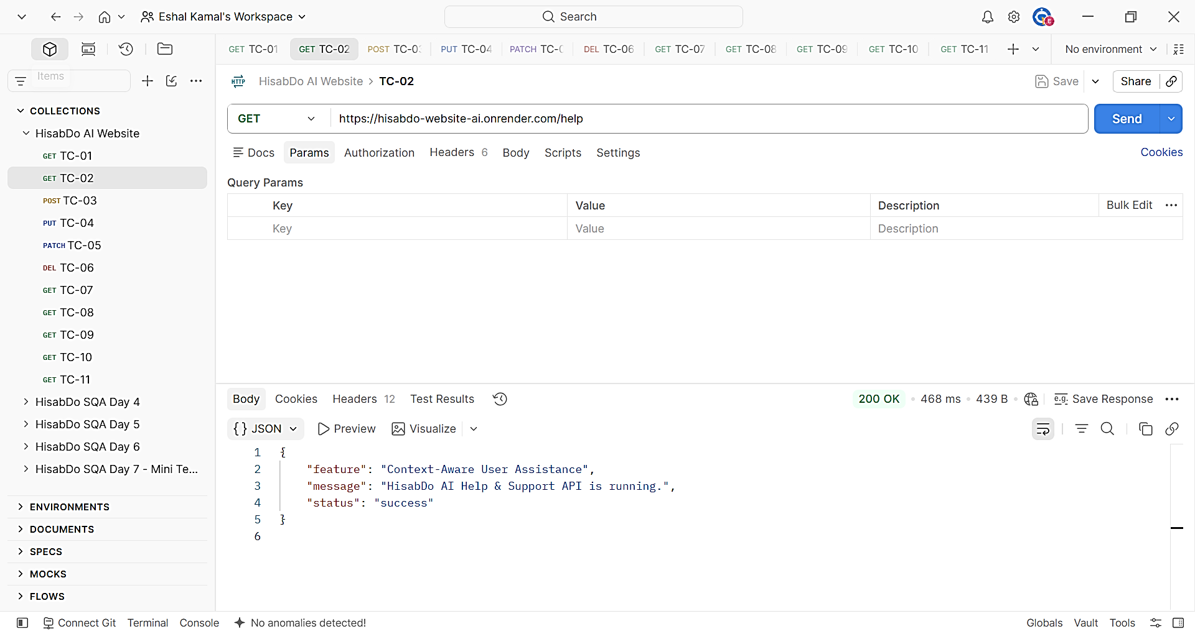
TC-02: GET /help response.

8.3 Unsupported HTTP Methods

POST, PUT, PATCH, and DELETE requests were sent to /help/.
All four unsupported methods returned:
{
"message": "HTTP method not allowed.",
"status": "error"
}
The endpoint returned 405 Method Not Allowed for each request.
Method | Status Code | Response Time | Result
POST | 405 | 589 ms | Pass
PUT | 405 | 356 ms | Pass
PATCH | 405 | 853 ms | Pass
DELETE | 405 | 343 ms | Pass
The endpoint correctly prevented unsupported HTTP methods from being processed.
Screenshots:
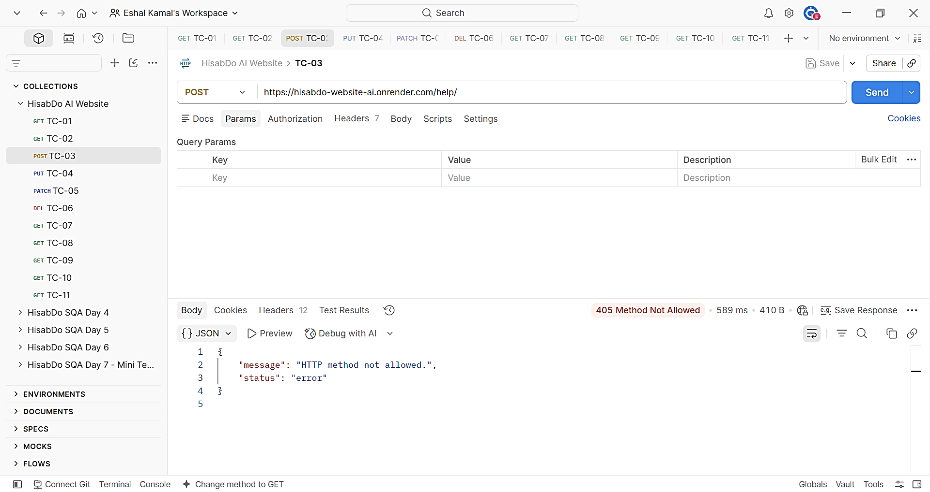
TC-03: POST request returning 405 Method Not Allowed.

TC-04: PUT request returning 405 Method Not Allowed.
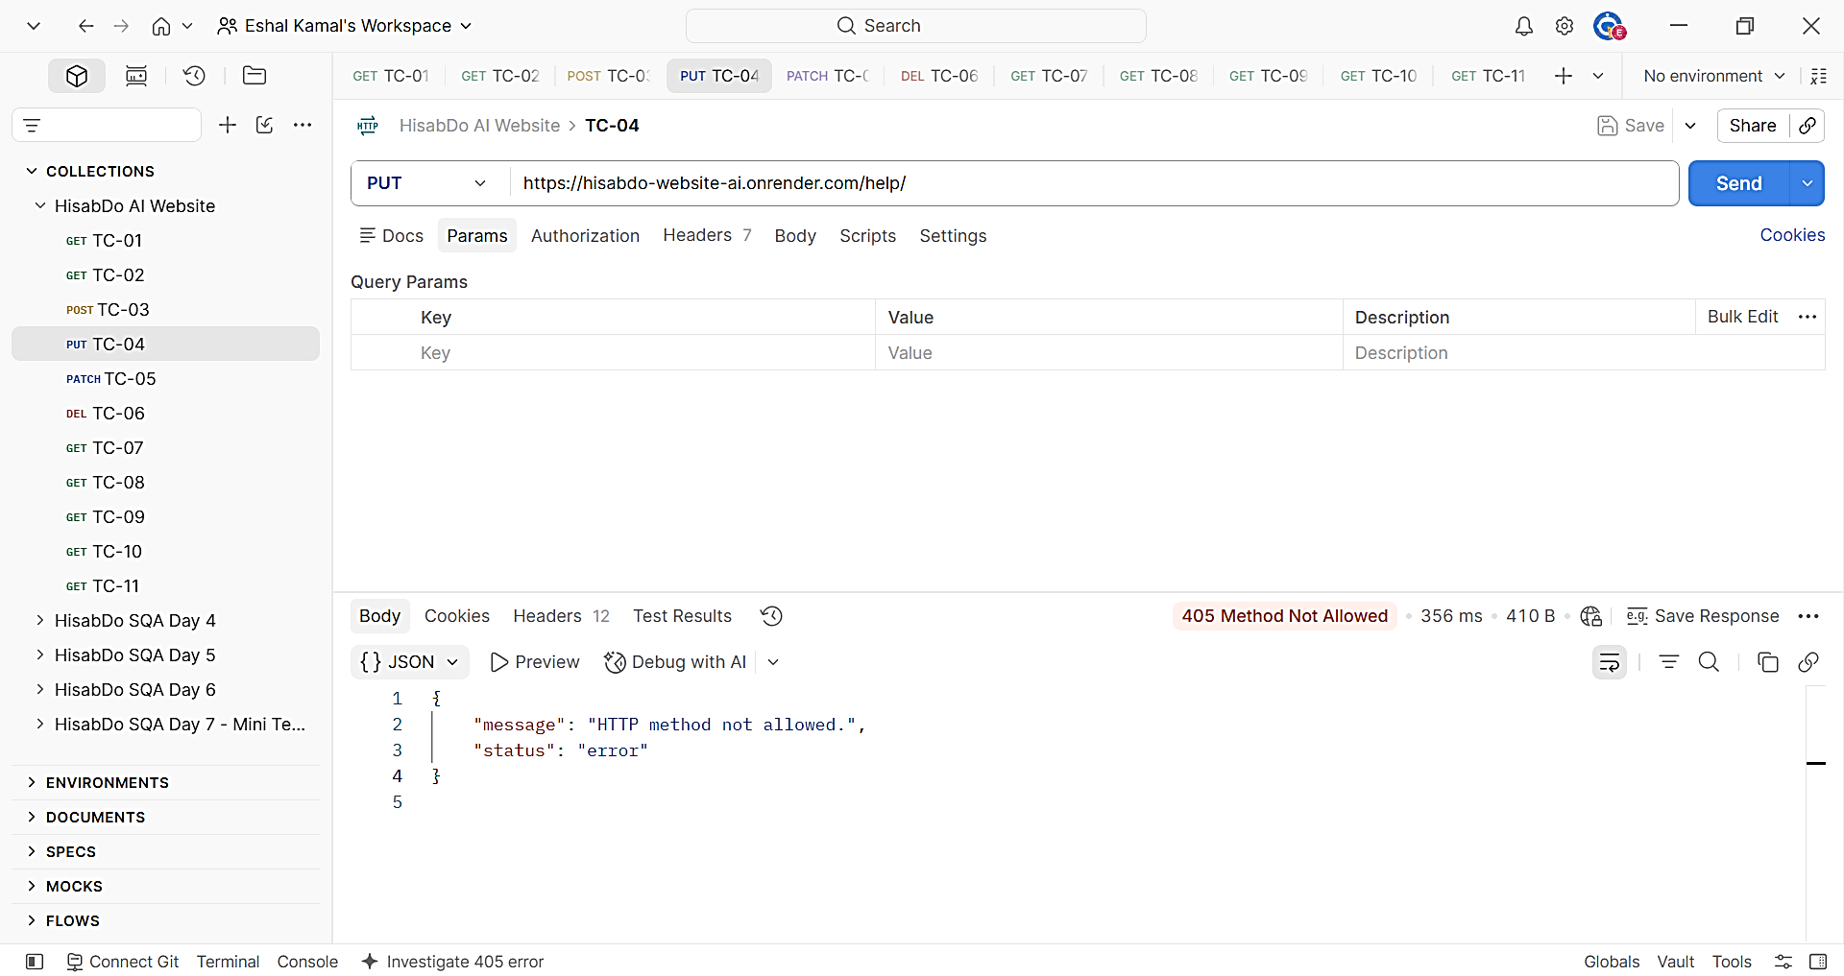

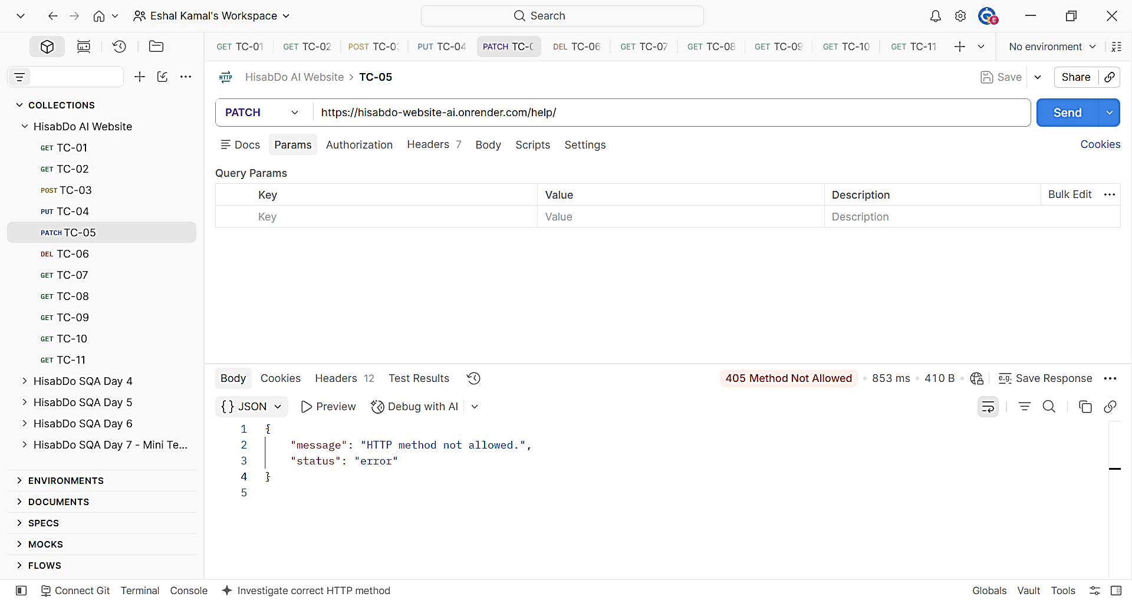
TC-05: PATCH request returning 405 Method Not Allowed.

TC-06: DELETE request returning 405 Method Not Allowed.
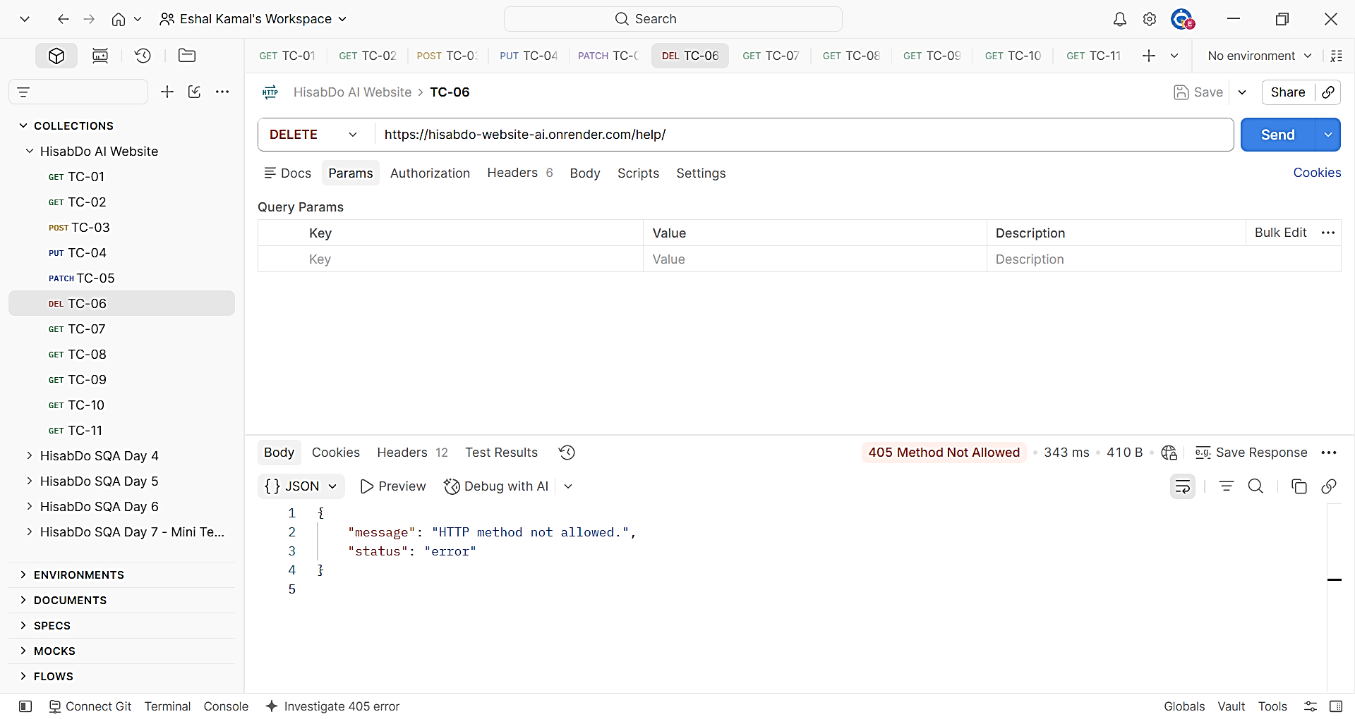

8.4 Invalid Endpoint
A request was sent to:
GET /help/invalid

The API returned:
{
"message": "API endpoint not found.",
"status": "error"
}
with a 404 Not Found status.
Response Time: 462 ms
Result: Pass
The invalid route was handled correctly without producing an unexpected server error.
Screenshot:
TC-07: Invalid endpoint returning 404 Not Found.
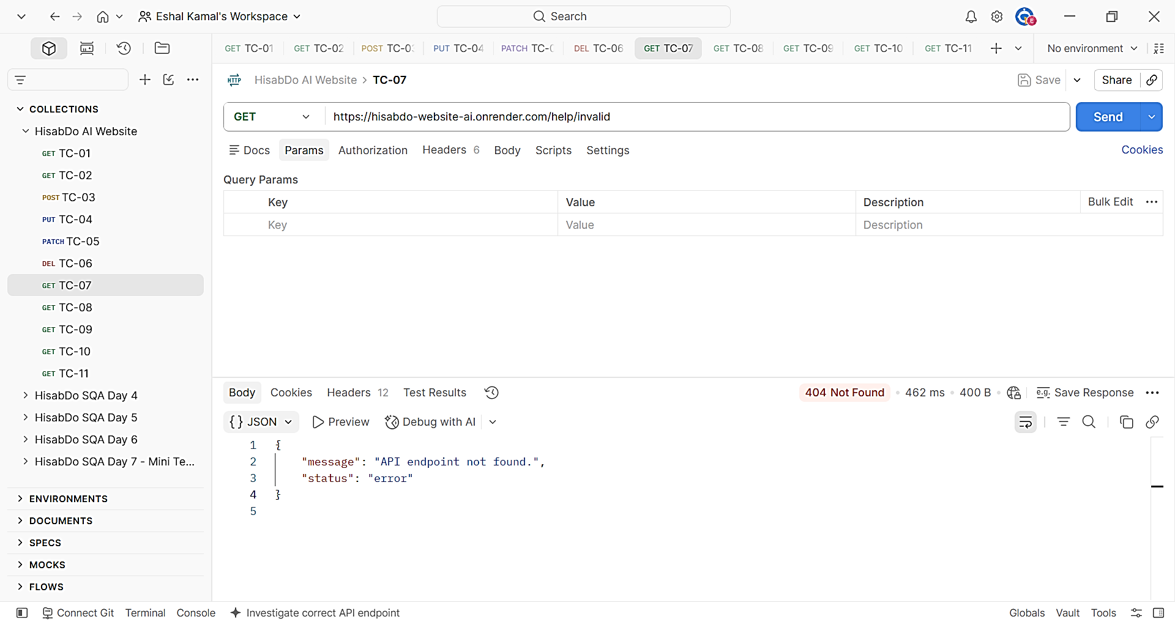

8.5 Query Parameter Testing
The endpoint was tested with a valid query parameter, an empty query parameter, and multiple query parameters.
Test Case | Request | Status Code | Response Time | Result
TC-08 | /help/?test=abc | 200 OK | 336 ms | Pass
TC-09 | /help/?test= | 200 OK | 326 ms | Pass
TC-10 | /help/?test=abc&sample=123 | 200 OK | 363 ms | Pass
All three requests returned the normal Help & Support response.
No unexpected server error was observed when query parameters were included.
Screenshots:
TC-08: Request with query parameter.
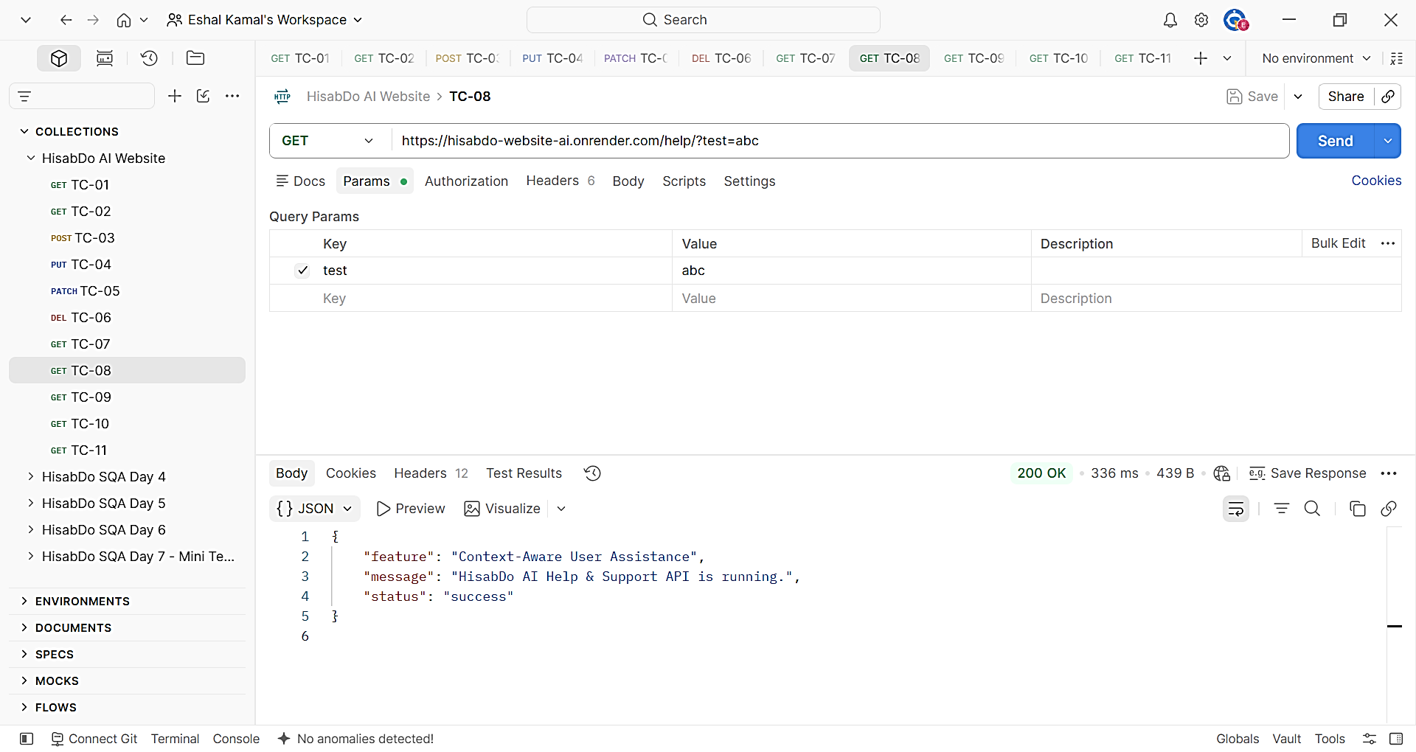

TC-09: Request with empty query parameter.
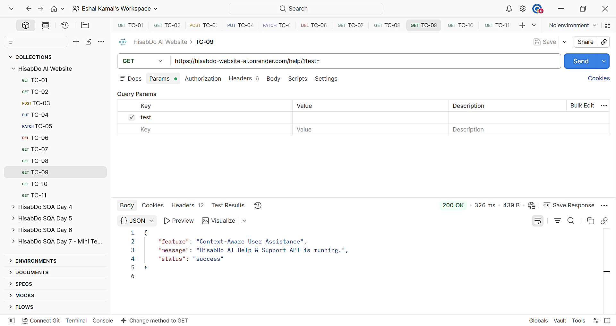

TC-10: Request with multiple query parameters.
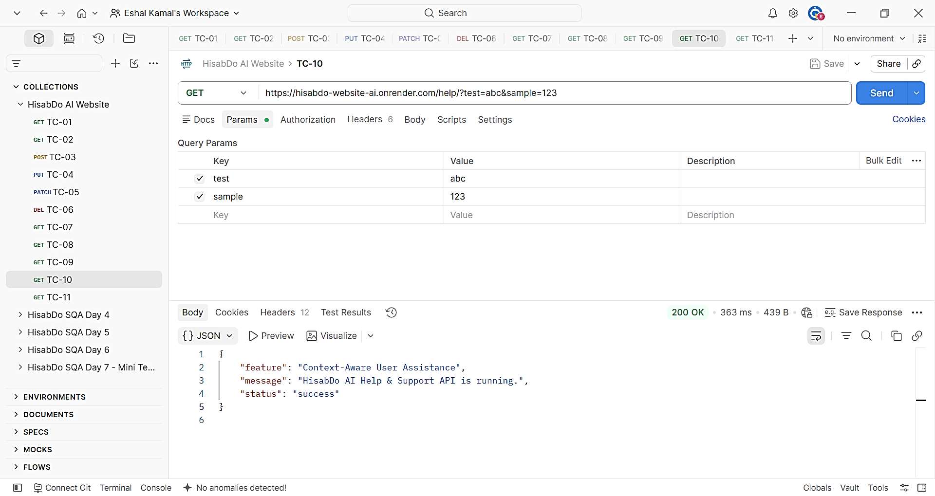

9. Repeated Request and Response-Time Testing
Ten consecutive GET /help/ requests were executed to evaluate response consistency and response-time consistency.
Round | Status Code | Response Time
1 | 200 OK | 958 ms
2 | 200 OK | 291 ms
3 | 200 OK | 295 ms
4 | 200 OK | 291 ms
5 | 200 OK | 290 ms
6 | 200 OK | 402 ms
7 | 200 OK | 295 ms
8 | 200 OK | 280 ms
9 | 200 OK | 872 ms
10 | 200 OK | 291 ms

Results:
- Successful requests: 10/10
- Failed requests: 0/10
- Status code consistency: 10/10 returned 200 OK
- Fastest response: 280 ms
- Slowest response: 958 ms
- Average response time: approximately 427 ms
- Response body: Consistent across the tested requests
Two comparatively higher response times were recorded at 958 ms and 872 ms. However, no request failure or response-content inconsistency was observed.
Result: Pass
Screenshot:
TC-11: Postman repeated request execution/results showing the repeated successful requests.
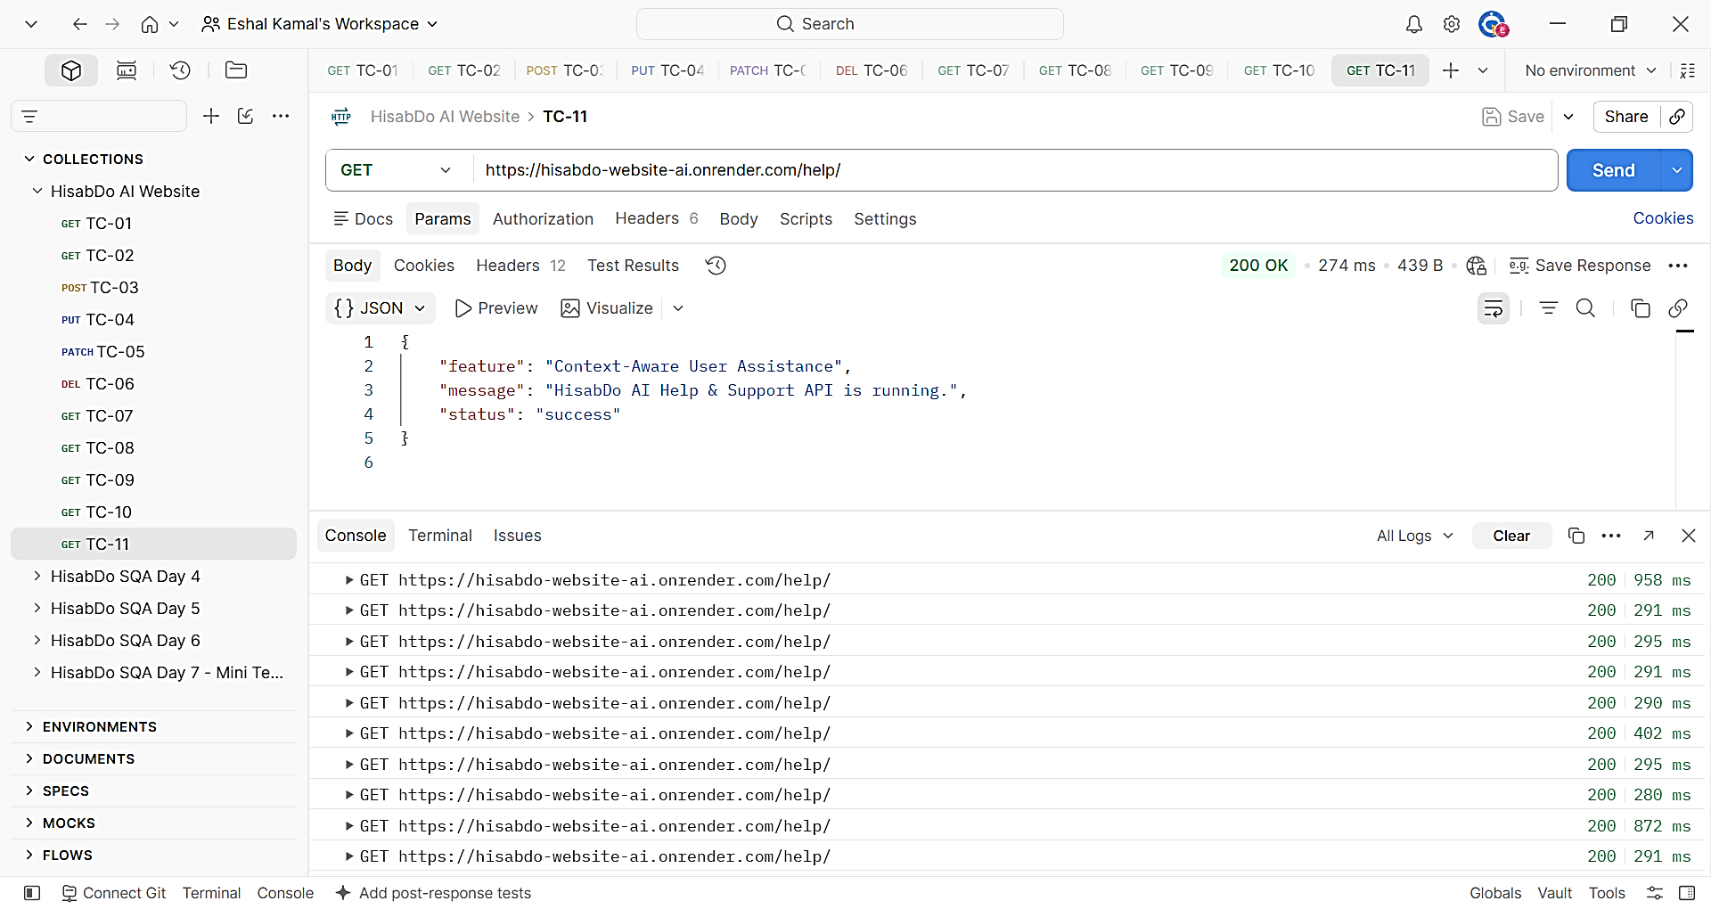

10. Issues and Observations

OBS-01 — High Initial Response Time
Field | Details
Observation ID | OBS-01
Endpoint | /help/
Request | GET
Status Code | 200 OK
Observed Response Time | 31.61 seconds
Type | Performance Observation
Priority | Medium
Status | Requires Investigation

Description:
The first valid request to the /help/ endpoint returned the expected successful response with 200 OK; however, the response time was 31.61 seconds.
This was significantly higher than the subsequent requests, which completed between 280 ms and 958 ms during the repeated-request test.

Impact:
A user making the initial request may experience a noticeable delay before receiving the Help & Support API response.

Recommendation:
Investigate the initial response delay to determine whether it is related to server cold-start behavior, deployment/runtime initialization, hosting configuration, or another deployment-related factor.
Screenshot:
TC-01 showing the 31.61-second initial response time.


11. Overall Findings
The /help/ endpoint performed correctly across the tested functional and error-handling scenarios.
The following behavior was observed:
- Valid GET requests returned 200 OK with the expected success response.
- Requests without the trailing slash were handled successfully.
- Unsupported POST, PUT, PATCH, and DELETE methods returned 405 Method Not Allowed.
- Invalid routes returned 404 Not Found.
- Query parameters did not cause unexpected server errors.
- Repeated requests consistently returned 200 OK.
- Response content remained consistent across repeated requests.
- No unexpected 5xx server errors were observed during testing.
- An unusually high initial response time of 31.61 seconds was observed and should be investigated.

12. Conclusion
The /help/ API endpoint was successfully tested for valid requests, unsupported HTTP methods, invalid routes, query parameters, repeated requests, response consistency, and response-time consistency.
All 11 test cases passed based on the defined expected behavior, resulting in a 100% test pass rate.
No functional or error-handling defects were identified during the testing activity. However, a significant initial response delay of 31.61 seconds was observed during the first valid request. Since subsequent requests were substantially faster, this has been documented as a performance observation requiring further investigation rather than a confirmed functional defect.
The detailed test execution data and response-time measurements are provided in the accompanying Excel test case sheet.

