HisabDo AI Website — /support/ Endpoint Testing
Test 1 — Valid GET Request
- Endpoint Tested: /support/
- Request Method & URL: GET https://hisabdo-website-ai.onrender.com/support/
- Expected Result: The API should return a successful JSON response containing the support service information, message, and status.
- Actual Result: The API returned the expected support service response:
{ "data": { "service": "HisabDo AI Help & Support", "status": "running" }, "message": "HisabDo AI Help & Support API is running.", "status": "success" }
- Status Code: 200 OK
- Response Time: 286 ms
- Pass / Fail: PASS
- Screenshot: 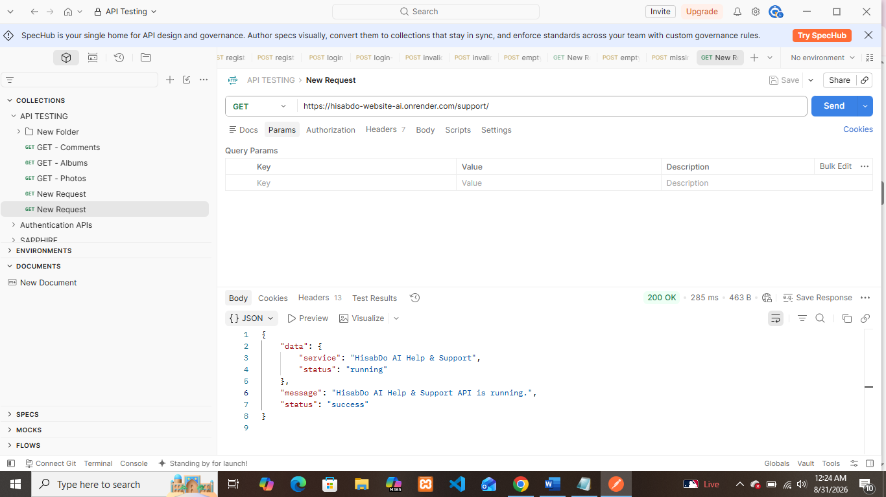
Remarks / Bug Description: No bug found. The endpoint responded successfully with the expected JSON structure.
Test 2 — POST Method
- Endpoint Tested: /support/
- Request Method & URL: POST https://hisabdo-website-ai.onrender.com/support/
- Expected Result: The API should reject the unsupported POST method and return an appropriate error response.
- Actual Result: The API returned:
{ "data": null, "message": "HTTP method not allowed.", "status": "error" }
• Status Code: 405
• Response Time: 429
• Pass / Fail: PASS
• Screenshot: 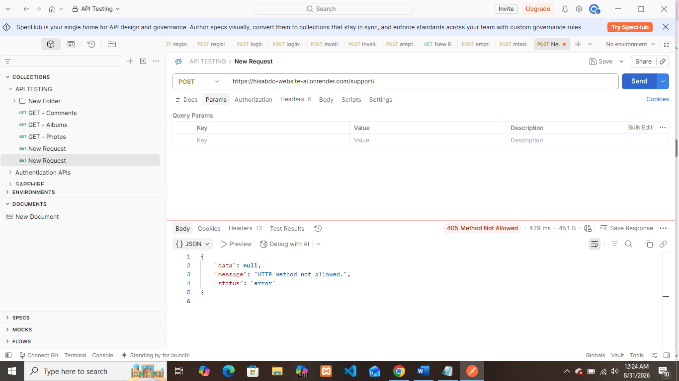
• Remarks / Bug Description: No bug found. Unsupported POST requests were correctly rejected with a structured error response.
Test 3 — PUT Method
- Endpoint Tested: /support/
- Request Method & URL: PUT https://hisabdo-website-ai.onrender.com/support/
- Expected Result: The API should reject the unsupported PUT method and return an appropriate error response.
- Actual Result: The API returned:
{ "data": null, "message": "HTTP method not allowed.", "status": "error" }
- Status Code: 405
- Response Time: 698
- Pass / Fail: PASS
- Screenshot: 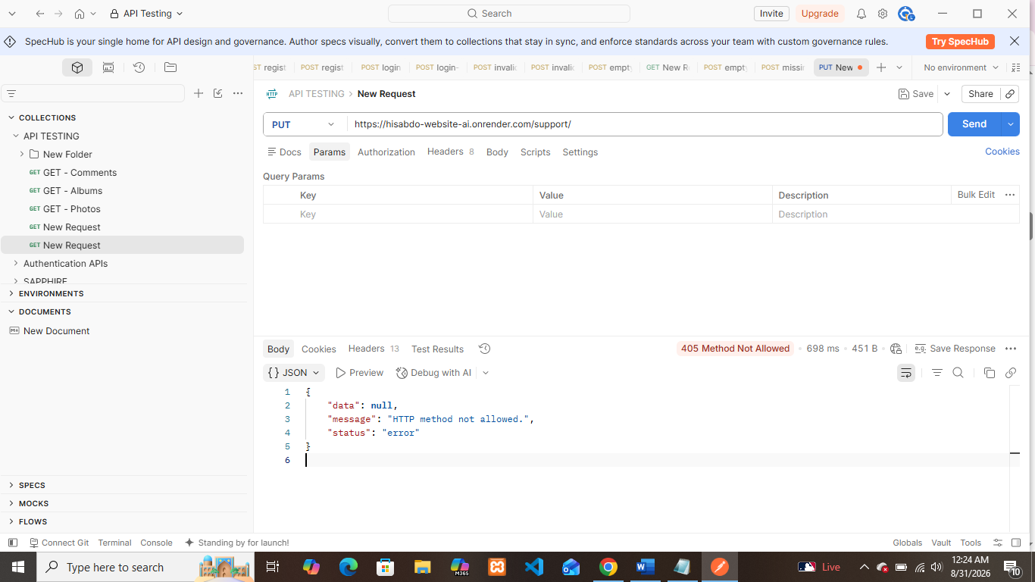
- Remarks / Bug Description: No bug found. Unsupported PUT requests were correctly rejected.

Test 4 — DELETE Method
- Endpoint Tested: /support/
- Request Method & URL: DELETE https://hisabdo-website-ai.onrender.com/support/
- Expected Result: The API should reject the unsupported DELETE method and return an appropriate error response.
- Actual Result: The API returned:
{ "data": null, "message": "HTTP method not allowed.", "status": "error" }
- Status Code: 405
- Response Time: 566
- Pass / Fail: PASS
- Screenshot: 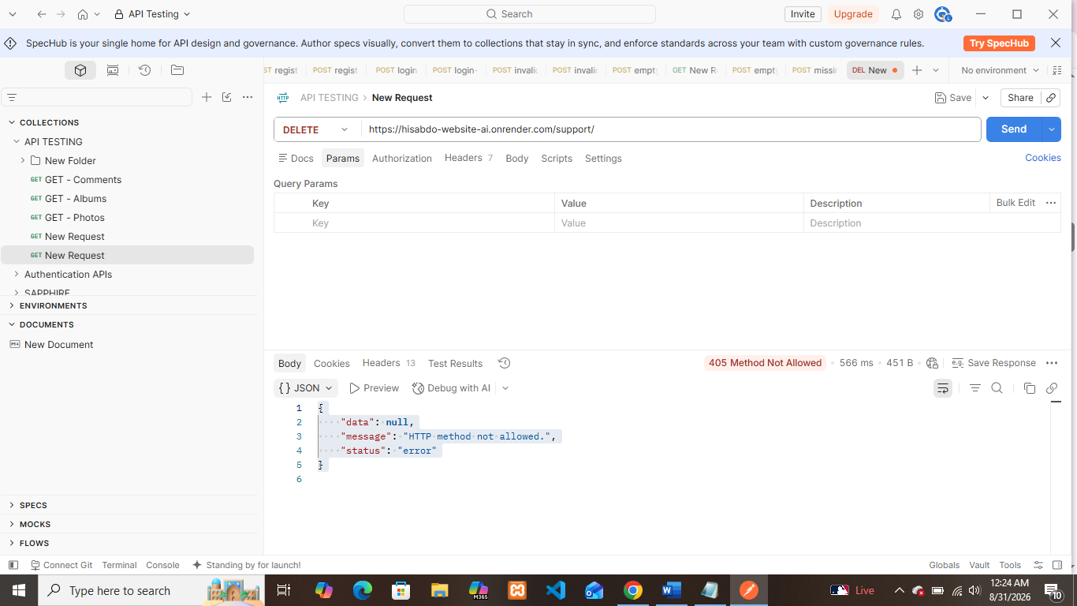
- Remarks / Bug Description: No bug found. Unsupported DELETE requests were correctly rejected.
Test 5 — URL Without Trailing Slash
- Endpoint Tested: /support
- Request Method & URL: GET https://hisabdo-website-ai.onrender.com/support
- Expected Result: The API should correctly handle the endpoint without the trailing slash, either by returning the valid response or appropriately redirecting the request.
- Actual Result: The API returned the same successful support response as /support/.
- Status Code: 200 OK
- Pass / Fail: PASS
- Remarks / Bug Description: No bug found. The endpoint successfully handled the URL without the trailing slash.

Test 6 — Typographical Error
- Endpoint Tested: /suport/
- Request Method & URL: GET https://hisabdo-website-ai.onrender.com/suport/
- Expected Result: The server should return 404 Not Found because the endpoint does not exist.
- Actual Result: The server returned a 404 Not Found HTML response.
- Status Code: 404 Not Found
- Response Time: 782ms
- Pass / Fail: PASS
- Screenshot: 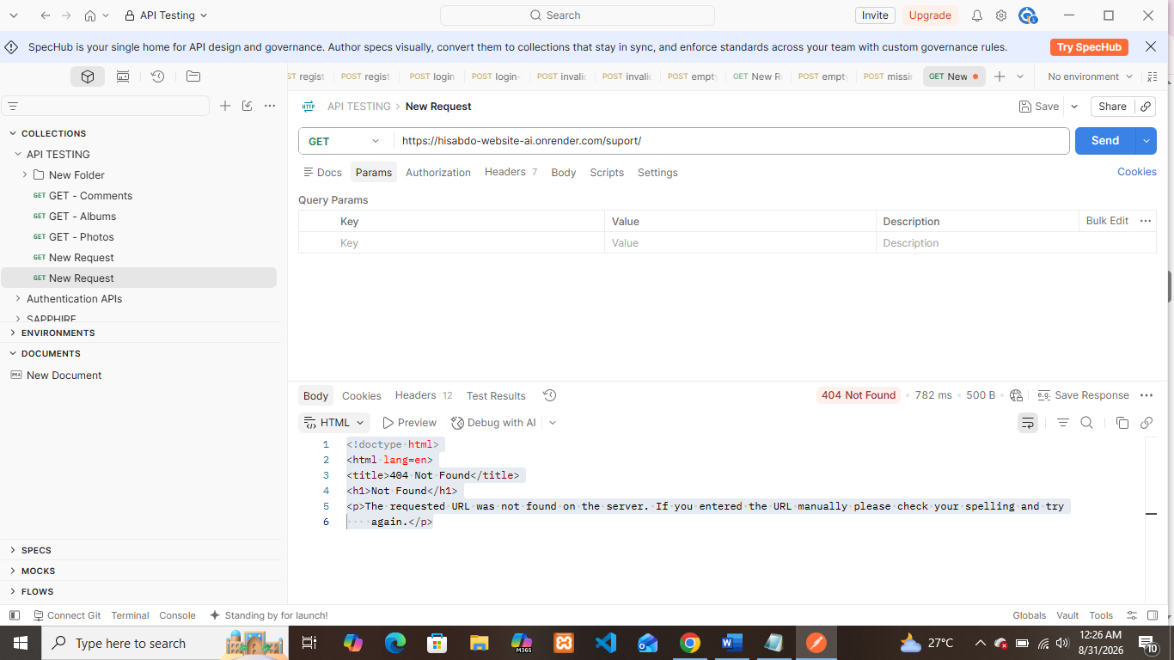
- Remarks / Bug Description: No bug found. The invalid endpoint was correctly rejected with a 404 response.

Test 7 — Case Sensitivity: /Support/
- Endpoint Tested: /Support/
- Request Method & URL: GET https://hisabdo-website-ai.onrender.com/Support/
- Expected Result: The incorrectly capitalized endpoint should not be treated as the valid /support/ endpoint.
- Actual Result: The server returned a 404 Not Found response.
- Status Code: 404 Not Found
- Response Time: 615ms
- Pass / Fail: PASS
- Screenshot: 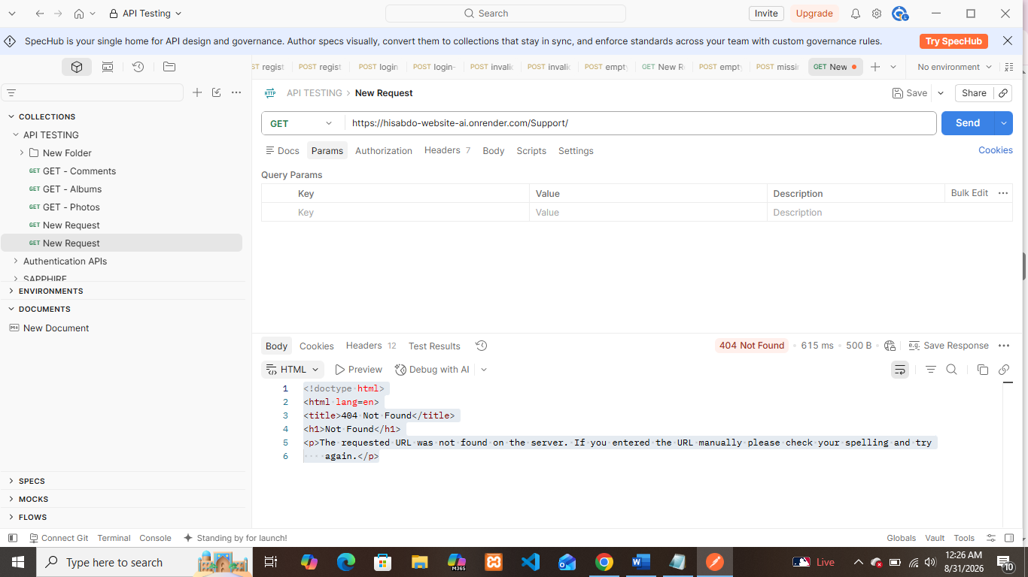
- Remarks / Bug Description: No bug found. The endpoint correctly handled case-sensitive paths.

Test 8 — Case Sensitivity: /SUPPORT/
- Endpoint Tested: /SUPPORT/
- Request Method & URL: GET https://hisabdo-website-ai.onrender.com/SUPPORT/
- Expected Result: The incorrectly capitalized endpoint should not be treated as the valid /support/ endpoint.
- Actual Result: The server returned a 404 Not Found response.
- Status Code: 404 Not Found
- Pass / Fail: PASS
- Remarks / Bug Description: No bug found. The endpoint correctly handled uppercase paths as invalid.

Test 9 — Response Consistency
- Endpoint Tested: /support/
- Request Method & URL: GET https://hisabdo-website-ai.onrender.com/support/
- Expected Result: Repeated requests should return a consistent response structure, status, and support service information.
- Actual Result: Five consecutive requests returned the same response structure and successful status.
Request | Response Time
1 | 286 ms
2 | 361 ms
3 | 306 ms
4 | 843 ms
5 | 811 ms
Status Code: 200 OK for the successful requests
Response Time: 286–843 ms
Pass / Fail: PASS
Remarks / Bug Description: No bug found. The response remained consistent across repeated requests, although response time varied between 286 ms and 843 ms.
Test 10 — Chrome Browser
- Endpoint Tested: /support/
- Request Method & URL: GET https://hisabdo-website-ai.onrender.com/support/
- Expected Result: The endpoint should load successfully and display the API response correctly.
- Actual Result: The endpoint loaded successfully in Google Chrome.
- Status Code: 200 OK
- Pass / Fail: PASS
- Screenshot: 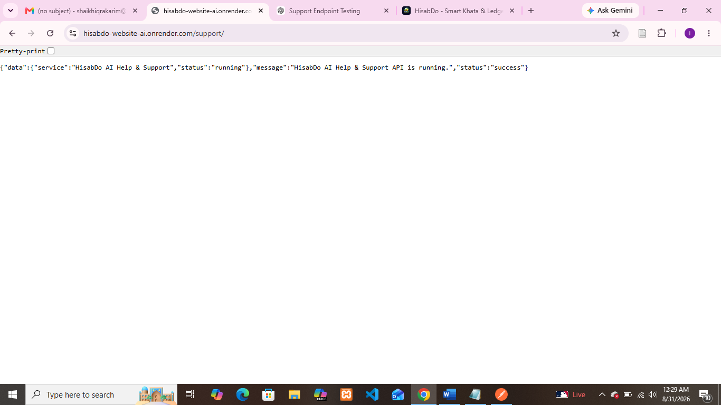
- Remarks / Bug Description: No bug found. API response displayed successfully in Chrome.

Test 11 — Microsoft Edge Browser
- Endpoint Tested: /support/
- Request Method & URL: GET https://hisabdo-website-ai.onrender.com/support/
- Expected Result: The endpoint should load successfully and display the API response correctly.
- Actual Result: The endpoint loaded successfully in Microsoft Edge.
- Status Code: 200 OK
- Pass / Fail: PASS
- Screenshot: 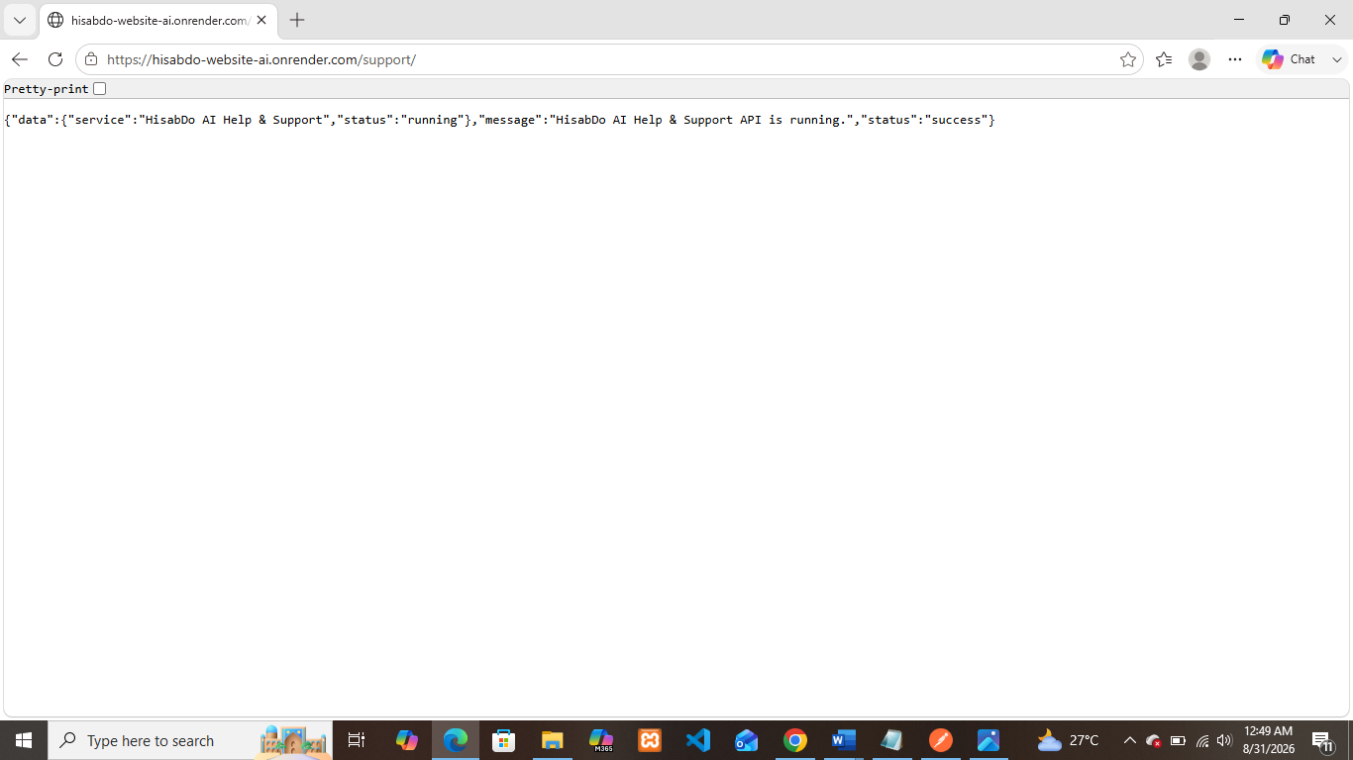
- Remarks / Bug Description: No bug found. API response displayed successfully in Microsoft Edge.

Test 12 — Firefox Browser
- Endpoint Tested: /support/
- Request Method & URL: GET https://hisabdo-website-ai.onrender.com/support/
- Expected Result: The endpoint should load successfully and display the API response correctly.
- Actual Result: The endpoint loaded successfully in Mozilla Firefox.
- Status Code: 200 OK
- Pass / Fail: PASS
- Screenshot: 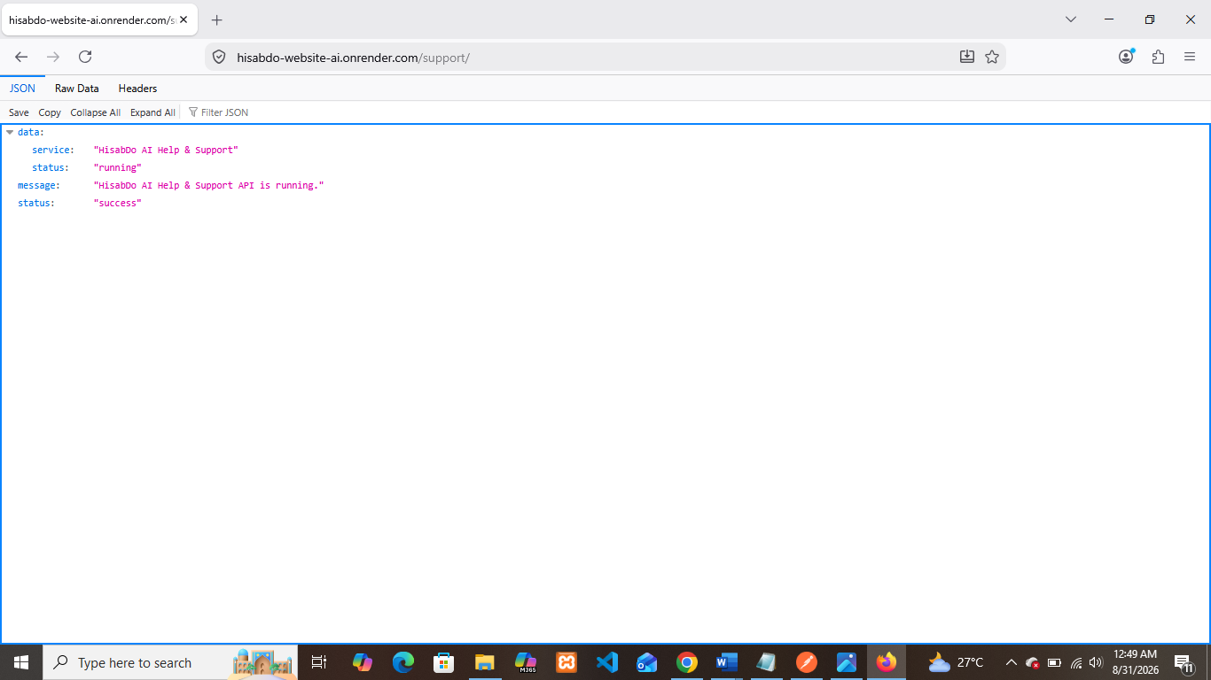
- Remarks / Bug Description: No bug found. API response displayed successfully in Firefox.

Test 13 — Mobile Browser
- Endpoint Tested: /support/
- Request Method & URL: GET https://hisabdo-website-ai.onrender.com/support/
- Expected Result: The endpoint should load successfully on a mobile browser and display the API response correctly.
- Actual Result: The endpoint loaded successfully on mobile.
- Status Code: 200 OK
- Pass / Fail: PASS
- Screenshot: 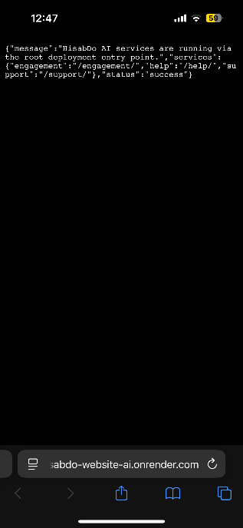
- Remarks / Bug Description: No bug found. The endpoint was successfully accessed from a mobile device.

Overall Result
Total Test Cases: 13
Passed: 13
Failed: 0
Bugs Found: 0
Overall Status: PASS

