HisabDo – Regression Testing
Iqra Karim – Browser Compatibility and Navigation Links

Navigation Links
TC ID | Test Case | Steps | Expected Result | Actual Result | Status |  |  | Screenshot
NAV-01 | Verify Home navigation link | 1. Open website.2. Click Home from navigation menu. | User should be redirected to the Home page. | Home page opens successfully. | Pass
NAV-02 | Verify About navigation link | 1. Click About from navigation menu. | User should be redirected to the About page. | About page opens successfully. | Pass
NAV-03 | Verify App navigation link | 1. Click App from navigation menu. | User should be redirected to the App page. | App page opens successfully. | Pass
NAV-04 | Verify Founder navigation link | 1. Click Founder from navigation menu. | User should be redirected to the Founder page. | Founder page opens successfully. | Pass
NAV-05 | Verify Leadership navigation link | 1. Click Leadership from navigation menu. | User should be redirected to the Leadership page. | Leadership page opens successfully. | Pass
NAV-06 | Verify Leadership profile link | 1. Open Leadership page.2. Select View Mian Usman Khalid's Profile. | User should be redirected to the correct profile/details page. | Profile opens successfully. | Pass
NAV-07 | Verify GitHub social link on leadership profile | 1. Open Mian Usman Khalid's Profile.2. Click the GitHub social link. | GitHub profile should open successfully without errors. | GitHub link redirects to a 404 Not Found page. | Fail – Bug |  |  | 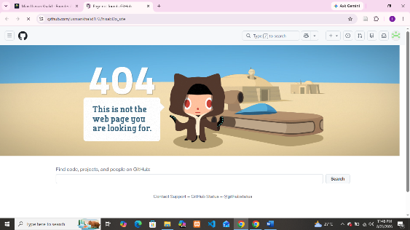
NAV-08 | Verify Blog navigation link | 1. Click Blog from navigation menu. | User should be redirected to the Blog page. | Blog page opens successfully. | Pass
NAV-09 | Verify FAQ navigation link | 1. Click FAQ from navigation menu. | User should be redirected to the FAQ page/section. | FAQ opens successfully. | Pass
NAV-10 | Verify Careers navigation link | 1. Click Careers from navigation menu. | User should be redirected to the Careers page. | Careers page opens successfully. | Pass
NAV-11 | Verify Media navigation link | 1. Click Media from navigation menu. | User should be redirected to the Media page. | Media page opens successfully. | Pass
NAV-12 | Verify Contact navigation link | 1. Click Contact from navigation menu. | User should be redirected to the Contact page. | Contact page opens successfully. | Pass
NAV-13 | Verify Privacy Policy navigation link | 1. Click Privacy Policy from navigation menu. | User should be redirected to the Privacy Policy page. | Privacy Policy page opens successfully. | Pass
NAV-14 | Verify Get App navigation link | 1. Click Get App from navigation menu. | User should be redirected to the appropriate app/download destination. | Destination opens successfully. | Pass
NAV-15 | Verify navigation menu consistency across pages | 1. Open Home page and note navigation options.2. Navigate to Media page.3. Compare navigation options. | Navigation menu should contain the same required navigation options consistently across pages. | About, Leadership, FAQ, and Careers are missing from the Media page navigation menu. | Fail – Bug |  |  | 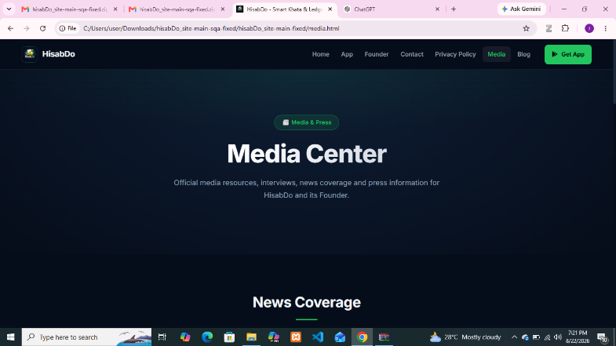

Browser Compatibility
TC ID | Test Case | Browser | Expected Result | Actual Result | Status |  |  |  | Screenshot
BC-01 | Verify website compatibility | Google Chrome | Website should render correctly without layout issues. | Website renders correctly. | Pass
BC-02 | Verify website compatibility | Mozilla Firefox | Website should render correctly without layout issues. | Website renders correctly. | Pass
BC-03 | Verify website compatibility | Microsoft Edge | Website should render correctly without unintended spacing or layout issues. | Visible white space appears around the webpage content. | Fail – Bug |  |  |  | 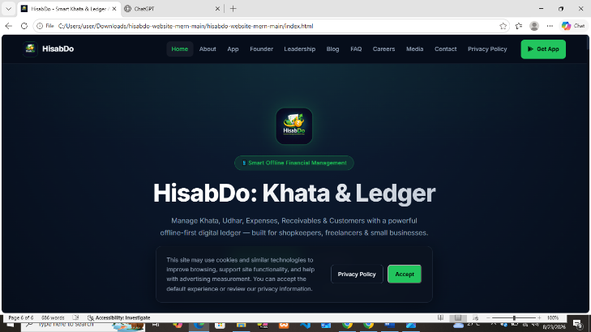
Regression Testing Summary
Regression testing was conducted to verify that the previously tested website functionality remained working correctly after the latest fixes/changes. The testing focused on navigation links and browser compatibility across Google Chrome, Mozilla Firefox, and Microsoft Edge.
All navigation links were tested by opening each page and verifying that the correct destination was reached. The Leadership page and Mian Usman Khalid’s profile were also checked, including the GitHub social link. Browser compatibility was tested by comparing the website layout and functionality across the three browsers.
Most of the tested functionality is working correctly. However, the following previously identified issues are still not fixed:
- The Media page has an inconsistent navigation menu, with About, Leadership, FAQ, and Careers missing from the navigation.
- The GitHub social link on Mian Usman Khalid’s profile redirects to a 404 Not Found page.
- In Microsoft Edge, visible white space appears around the webpage, while the website renders correctly in Google Chrome and Mozilla Firefox.
Therefore, the regression testing confirms that the majority of functionality remains stable, but the above issues continue to exist and require fixing.

