**Practical -11**

**Delete Database -By Compass**

**Delete Database - By Shell**

**drop a collection that is already in a database.**

**Delete one data**

**Update one data**

**Update many data**

**Find only courseName and id**

**Find courseName , credits use projection**

**Get only object ID**

**Exercise**

**(01)create a database bookshop.**



**(02)create a collection books.**

**(03)insert the following data.**

**Find all books**

**Find all books published after 1950**

**Find the avilable books**

**Find all books that belong to the "Dystopian" genre**

)

**Find the books which published after 1960 and had rating more than 4.0**



**Project only title and author fields:**

**Update the book "1984" to set available: false:**

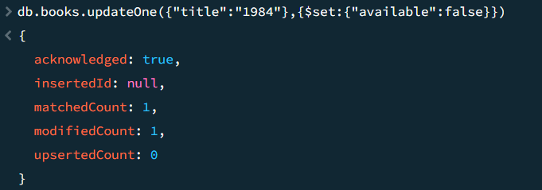 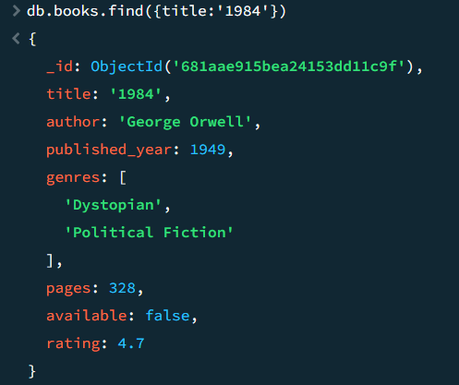

**Increase the rating of "Brave New World" by +0.1:**

**Add a new genre "Classic" to "The Great Gatsby":**

**Sort books by published_year ascending:**

**Sort books by rating descending:**

**Delete all books with a rating lower than 4.5:**

