UNIFIED MARKETING &
E-COMMERCE MANAGEMENT
PLATFORM
Comprehensive Project Plan, Architecture & Premium Accounting Module
Version 2.0 | May 2026
CONFIDENTIAL — INTERNAL USE
Prepared for: Elskov Services

1. Executive Summary
This document is the consolidated master plan for the Unified Marketing and E-Commerce Management Platform — a single, role-controlled web application that brings together five tightly integrated capabilities into one product:
- Centralised social media control across Facebook, Instagram and TikTok — compose once, publish everywhere, reply from a single inbox.
- A full e-commerce engine with product catalogue, cart, checkout, multi-gateway payments (eSewa, Khalti, card) and customer self-service.
- End-to-end order tracking and inventory management — every sale auto-deducts stock, every return auto-restocks, every status change auto-notifies.
- Granular Role-Based Access Control with Super Admin, Admin, Editor, Accountant, Viewer and unlimited custom roles.
- A premium Accounting & Audit module unlocked via monthly, yearly or lifetime subscription — full double-entry ledger, VAT/GST, immutable audit trail and regulator-ready reports.
The platform replaces 5–7 separate SaaS tools that businesses typically stitch together (a social scheduler, an inbox tool, a storefront platform, an order/inventory app and an accounting system). By consolidating them into one product with a shared identity layer, RBAC engine and database, it eliminates duplicate data entry, removes integration drift, and gives leadership a single source of truth across marketing, sales, fulfilment and finance.
1.1 What this report contains
- Project objectives, scope and success criteria.
- Detailed specifications for every module — including new screens, data and APIs.
- Role and permission matrix.
- Premium Accounting & Subscription module (full deep-dive, new in v2.0).
- System architecture diagram and end-to-end flow diagram.
- Technology stack, database design and security model.
- Phased delivery roadmap with timelines and dependencies.
- Indicative budget in USD and NPR, plus team structure.
- Risk register, KPIs and next-step checklist.

2. Project Objectives & Scope
2.1 Business Objectives
- Eliminate tool fragmentation by consolidating social media management, e-commerce, fulfilment and accounting into one platform.
- Increase team productivity through role-based workspaces that surface only the tools and data each user needs.
- Enable data-driven decisions by unifying analytics across social channels, sales, inventory turnover and finance.
- Open a recurring-revenue stream by offering the Accounting module as a paid, subscription-gated add-on (monthly / yearly / lifetime).
- Ensure security and compliance — robust authentication, immutable audit logging, RBAC enforcement, GDPR-aligned data handling.
- Scale gracefully to multi-warehouse, multi-currency and additional social channels without re-architecting.
2.2 In Scope
- Public storefront with full catalogue, cart and checkout.
- Customer profile, address book, wishlist, order history and tracking.
- Admin web console for social, catalogue, orders, inventory, CRM, finance.
- Payment integrations: eSewa, Khalti, Stripe (card), Cash-on-Delivery.
- Social integrations: Meta Graph API (Facebook + Instagram), TikTok API.
- Premium Accounting module with subscription paywall.
- Mobile-responsive (PWA) — no native mobile apps in this phase.
- Cloud deployment (AWS or GCP), CI/CD, monitoring and backups.
2.3 Out of Scope (this release)
- Native iOS / Android apps (planned for Phase 2 / Year 2).
- B2B wholesale portal with negotiated pricing tiers (future enhancement).
- Physical POS hardware integration in retail stores (future enhancement).
- Marketplace functionality (multi-vendor sellers) — single-tenant only.

3. Platform Modules — Detailed Specification
3.1 Social Media Management Hub
A single control panel for Facebook, Instagram and TikTok. Connects to each platform via the official business API and abstracts platform-specific formatting rules behind one composer.
Core Features
- Unified Post Composer — create one post, publish simultaneously to all connected channels with platform-specific overrides for caption length, hashtags and media dimensions.
- Content Scheduler — calendar view to plan posts days or weeks ahead; best-time-to-post recommendations driven by historical engagement; draft saving and approval workflow before publish.
- Unified Inbox — aggregates comments, DMs and mentions from all channels into one queue; reply in-platform; assign conversations to teammates; track resolution status and response-time SLAs.
- Analytics Dashboard — follower growth, reach, impressions, engagement rate per channel; post performance comparison across channels; exportable reports as PDF or Excel.
- Media Library — central asset store (S3-backed) with tags, search and re-use across posts.
- Approval Workflow — drafts can require sign-off from an Admin before publishing, enforced via RBAC.
3.2 E-Commerce Engine
Full operational control over the online store, from product listing to order fulfilment and payment reconciliation.
Core Features
- Product Catalogue Manager — CRUD, image management, variant trees (size/colour/material), category hierarchies, bulk CSV import.
- Pricing & Promotions — base price, discount, scheduled sales, coupon engine (percentage / flat / free-ship / BOGO), customer-segment-specific offers.
- Order Management — view, filter, process all orders; full status workflow (Pending → Confirmed → Processing → Shipped → Delivered → Returned).
- Payments & Invoicing — eSewa, Khalti, Stripe and Cash-on-Delivery; auto-generated PDF invoices; refund processing and dispute notes.
- Customer Management (CRM Lite) — profile, order history, communication log, tagging, segmentation for marketing.
- Storefront SEO — server-side rendering, structured data (JSON-LD), sitemap and robots.txt management, Open Graph metadata for social sharing.
3.3 End User (Customer) Portal
The public-facing website where customers register, browse, shop, pay and track orders — fully responsive across desktop, tablet and mobile.
3.3.1 Registration & Profile
- Sign-up via Email + Password (with email OTP verification), Phone + SMS OTP, or Social Login (Google / Facebook OAuth 2.0).
- Profile fields: name, email, phone, password (bcrypt), avatar, date of birth, gender, addresses (up to 5 labelled — Home / Work / Other), default address, linked eSewa / Khalti wallets, notification preferences, wishlist, order history, GDPR-compliant data export and delete-account flows.
3.3.2 Product Browsing & Discovery
- Homepage with hero carousel, category grid, featured / trending / flash-sale sections, recently-viewed products.
- Product Listing Page (PLP) — grid / list view toggle, sort (newest, price, popularity, rating), filter sidebar (category, brand, price slider, star rating, in-stock, discount band), infinite scroll or pagination.
- Product Detail Page (PDP) — image gallery with zoom, variant selector with live stock check, tabbed description / specs / reviews / Q&A, delivery ETA by pin code, related and frequently-bought-together suggestions.
- Global search with auto-suggest (Elasticsearch / Meilisearch), saved search history for logged-in users.
3.3.3 Cart, Checkout & Payment
- Persistent cart for logged-in users; guest cart auto-migrates on login; real-time stock validation on quantity change.
- Coupon and promotions engine with instant validation; loyalty-points redemption (when enabled).
- 5-step checkout: Address → Delivery Method → Review → Payment → Confirmation. Guest checkout supported (email required).
- Payment options: eSewa (signed redirect flow), Khalti (popup + Lookup API), Visa / MasterCard via Stripe with 3-D Secure 2, Cash on Delivery.
- Payment failure handling: order held in Pending for 24h, retry-payment link, alternative-method suggestion, abandoned-checkout email after 1h.
3.3.4 Post-Purchase
- My Orders dashboard — active orders highlighted, full history, reorder button, invoice download.
- Live order tracking — visual status stepper, courier scan timeline, dynamic ETA, map view where the courier supports GPS.
- Guest tracking page at /track using Order ID + Email / Phone.
- Verified reviews and ratings; helpful-vote system; photo / video uploads.
- Returns within configurable window (default 7 days) with reason + photo; refunds auto-routed to original wallet / card via the relevant API.
- Support — live chat widget, searchable Help Centre, ticketing tied to specific orders, optional WhatsApp Business integration.
3.4 Order Tracking & Inventory Management
The operational heart of the platform — tightly coupled with the catalogue and payment systems via atomic database transactions.
3.4.1 Admin Order Operations
- Orders dashboard with summary tiles (Today, Pending Payments, To Dispatch, Returns Pending) and full table with filters and search.
- Order detail panel: customer info, line items, pricing breakdown, address, payment info, status history, internal notes, action buttons.
- Bulk operations — status update, courier assign, invoice / label print.
- Courier registry with auto-tracking-link generation; optional Pathao / Aramex webhook ingestion for fully automated status updates.
3.4.2 Inventory Management
- Live stock per SKU and per variant, with reserved-vs-available split.
- Stock adjustment with reason and audit trail.
- Low-stock alerts (configurable threshold) — dashboard banner, email, SMS.
- Out-of-stock handling with customer 'Notify Me' subscriptions and auto-restock notifications.
- Bulk CSV import; barcode / QR scan intake (optional mobile companion).
- Purchase Order (PO) workflow: Draft → Sent → Partially Received → Fully Received.
- Stock movement log — every in/out event with type, qty, balance, user, reference (order ID / PO ID), filterable and exportable.
3.4.3 Customer Order Tracking
- My Orders list with status badges, quick reorder.
- Order detail with visual progress bar (Placed → Confirmed → Processing → Shipped → Delivered) and timestamp per stage.
- Live shipment tracking widget with courier name, tracking number and direct courier link; courier-API-pushed scan events when available.
- Customer actions: cancel (until Processing), download invoice, request return, view refund status, write review, reorder.
3.4.4 Notification Triggers
Email + SMS + Push fire automatically on each business event; customers can opt out per channel in their profile. Admin-only events (low stock, payment failure spike) route to the admin dashboard and an internal email list.

4. Role-Based Access Control (RBAC)
RBAC is a foundational, cross-cutting layer of the platform. Every API route is guarded by middleware that checks the caller's role(s) and permission(s) before processing the request. Roles can be created, modified and assigned by Super Admins (and by Admins for any role below them).
4.1 Role Definitions
- Super Admin — unrestricted access; the only role allowed to manage other Super Admins, change system settings, configure billing / Stripe Connect, and purge audit logs.
- Admin — full operational control: social, e-commerce, CRM, analytics, user management for non-admin roles; cannot modify Super Admins or system-level configuration.
- Editor — content & catalogue: publish on social, edit products, update order status; no access to finance or user management.
- Accountant — finance focus: view revenue, invoices, payouts, reconciliation, exports; gateway to the premium Accounting module if subscribed.
- Viewer — read-only analytics for stakeholders / investors / juniors.
- Custom Roles — Super Admins and Admins can compose roles from individual permissions (e.g. 'Social Media Manager' = posting + analytics, no e-commerce).
4.2 Permission Matrix
Legend: ✓ Full · ✗ None · ~ Limited / partial · R Read-only
Permission / Feature | Super Admin | Admin | Editor | Accountant | Viewer
Create / Delete Users | ✓ | ✓ | ✗ | ✗ | ✗
Assign Roles | ✓ | ✓ | ✗ | ✗ | ✗
System Settings | ✓ | ✗ | ✗ | ✗ | ✗
Social Media Post | ✓ | ✓ | ✓ | ✗ | ✗
Social Media Analytics | ✓ | ✓ | ✓ | ✗ | ✓
Schedule Posts | ✓ | ✓ | ✓ | ✗ | ✗
E-Commerce Products (CRUD) | ✓ | ✓ | ✓ | ✗ | ✗
Orders — View All | ✓ | ✓ | ~ | R | R
Orders — Update Status | ✓ | ✓ | ~ | ✗ | ✗
Orders — Cancel / Refund | ✓ | ✓ | ✗ | ✗ | ✗
Inventory — Adjust Stock | ✓ | ✓ | ✗ | ✗ | ✗
Inventory — View Reports | ✓ | ✓ | R | ✓ | R
View Financial Reports | ✓ | ✓ | ✗ | ✓ | ✗
Premium Accounting Module | ✓ | ✓ | ✗ | ✓ (if subscribed) | ✗
Tax Module | ✓ | ✓ | ✗ | ✓ (if subscribed) | ✗
Audit Logs | ✓ | ✓ | ✗ | R | ✗
Subscription / Billing Admin | ✓ | ✗ | ✗ | ✗ | ✗
CRM / Customers | ✓ | ✓ | ✓ | ~ | ✓

5. Premium Module — Accounting, Tax & Audit (Subscription-Gated)
This is a paid add-on. Out of the box, every tenant receives the operational platform (sections 3 and 4). The Accounting, Tax and Audit module is subscription-gated and unlocks a complete double-entry accounting suite, tax computation and an immutable audit trail.
5.1 Why It's Premium
- Replaces a separate accounting subscription (Tally / QuickBooks / Xero / Zoho) — so the willingness-to-pay already exists in the customer's budget.
- Reduces double data entry by sourcing journal entries directly from real-time platform events (orders, refunds, payouts, inventory write-offs).
- Provides regulator-ready VAT / GST returns and audit packs — a compliance lifeline that justifies recurring fees.
- Creates predictable MRR / ARR for the platform vendor and a high-margin expansion path beyond the base seat licence.
5.2 Feature Set
5.2.1 Double-Entry Ledger
- Configurable Chart of Accounts (CoA) — pre-loaded templates for Retail, Services and Manufacturing; editable.
- Auto-generated journal entries from platform events — each order, refund, payout reconciliation, stock write-off and PO receipt posts the correct debits and credits.
- Manual journal entry interface for adjustments, accruals, depreciation.
- Multi-currency support with daily FX rates; settlement currency configurable.
- Period close: monthly / quarterly / yearly close with locking and reopening controls (Super Admin only).
5.2.2 Tax Module
- VAT / GST configuration per product or product category.
- Tax computation at cart and invoice level; correct treatment of inclusive vs exclusive pricing, exemptions and zero-rated items.
- Tax-period returns: VAT 200 / GST returns in regulator-ready format; Nepal IRD (Inland Revenue Department) e-invoice JSON export.
- Withholding-tax handling on supplier payouts and commissions.
- Tax-jurisdiction routing for international orders (placeholder for future OECD / DST changes).
5.2.3 Reports & Statements
- Profit & Loss (monthly, quarterly, yearly, custom range).
- Balance Sheet with comparative periods.
- Cash-flow statement (direct or indirect method).
- Trial balance, general ledger, sub-ledger drill-down.
- Aged receivables and payables.
- Inventory valuation report (FIFO, weighted-average, configurable).
- All reports exportable as PDF / Excel; scheduled email delivery option.
5.2.4 Audit Trail
- Immutable, append-only audit log of every accounting event — who, when, what, before / after values, source (UI, API, automation).
- WORM-style storage (write-once-read-many) to satisfy auditor requirements.
- Audit pack export: zip of trial balance + GL + audit log + supporting documents, signed with a cryptographic hash for tamper-evidence.
- Read-only auditor user role — external auditor can be invited with time-bounded access, scoped to one fiscal year.
5.2.5 Bank Reconciliation
- Import bank statements (CSV / OFX / direct API where available).
- Auto-match rules engine with confidence score; manual override.
- Outstanding-items report; reconciliation lock when complete.
5.2.6 Budgeting & Forecasting
- Annual budget setup per cost centre / department.
- Actual-vs-budget variance reports with drill-down.
- Cash-flow forecast using payment terms and historical conversion patterns.
5.3 Subscription Plans
Plan | Billing | Indicative Price | Best For | Key Benefits
Free Trial | 14 days | $0 | Evaluation | Full feature access, 100 transactions cap
Monthly | Per month | $29 / NPR 3,900 / month | Small business | Cancel anytime, all reports, 1 user
Yearly | Per year | $290 / NPR 39,000 / year (save ≈17%) | Growing SMB | Includes Tax Module + scheduled exports, 3 users
Lifetime | One-off | $1,499 / NPR 199,000 (one-time) | Long-term commit | Forever access at v1; major-version upgrades discounted 50%
Enterprise | Custom | Contact sales | Multi-entity / multi-currency | Dedicated support, SSO, advanced audit, on-prem option
Prices are indicative for planning only. Final pricing should be set after competitive benchmarking against Tally, QuickBooks Online, Zoho Books and Xero in target markets.
5.4 Feature Gating Logic
- A central Subscription & Billing Engine stores each tenant's active plan, expiry date and feature entitlements as a JSON blob.
- Every accounting API route checks: (1) authenticated user, (2) RBAC role allows accounting, (3) tenant has an active entitlement covering that feature.
- UI components in the Accounting Portal are rendered conditionally on entitlements — locked features show an upgrade prompt rather than an error.
- Grace period of 7 days on expiry — read-only access, prevents data loss; after 14 days the data is archived (export available on reactivation).
- Lifetime plan is bound to a major version; major upgrades are sold separately at 50% of the then-current lifetime price.
5.5 Billing & Payment for the Subscription
- Stripe Billing (international cards), eSewa and Khalti subscriptions (NPR market) — recurring charge handled by the payment gateway.
- Auto-invoice generation in the customer's name, with VAT line where applicable.
- Dunning workflow on failed renewals: retry on day 1, 3, 7; downgrade automatically on day 14.
- Customer-facing self-service: change plan, update card, download invoices, cancel subscription with reason capture.
5.6 Compliance & Regulatory Mapping (Nepal-first)
- Nepal IRD: PAN integration, e-invoice JSON, VAT 200 return format.
- Indian GST (when expanding): GSTR-1 and GSTR-3B export.
- International readiness: IFRS-style P&L and Balance Sheet formats included.
- Data residency: tenant data can be pinned to a specific cloud region (Enterprise plan).

6. System Architecture
The platform follows a layered, service-oriented architecture. The diagram below shows the six layers, the major components in each layer, and the primary integrations.
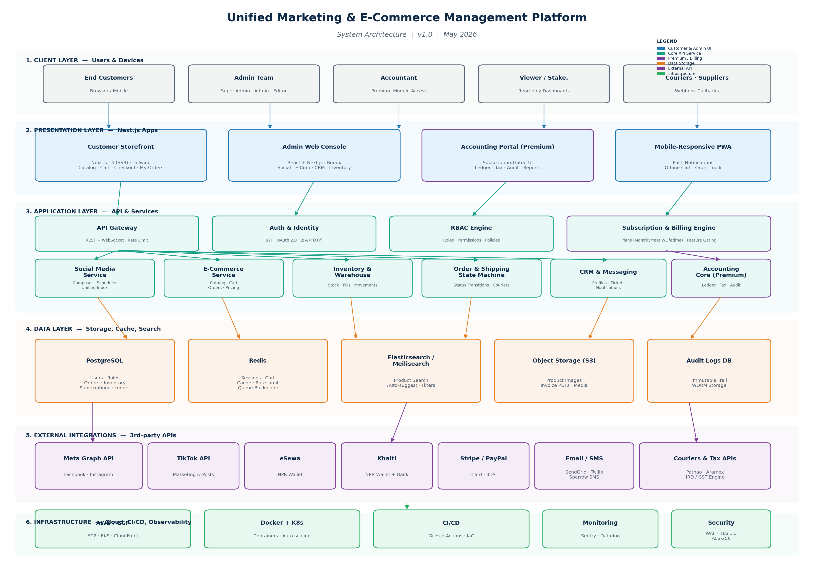
Figure 1 — Unified Platform System Architecture (6-Layer View)
6.1 Layer-by-Layer Walkthrough
Client Layer
- End Customers on browsers and mobile devices.
- Admin Team users (Super Admin, Admin, Editor) on desktop browsers.
- Accountants accessing the premium portal (subscription-gated).
- Viewers / stakeholders consuming dashboards.
- Courier partners and suppliers calling our webhook endpoints.
Presentation Layer (Next.js Applications)
- Customer Storefront — Next.js 14 with server-side rendering for SEO and fast first-paint; Tailwind CSS; Redux Toolkit + React Query.
- Admin Web Console — React-based SPA inside Next.js shell; component library shared with the storefront.
- Accounting Portal — separate route group with entitlement-aware components.
- PWA layer — installable, offline cart cache, push notifications.
Application Layer (API & Services)
- API Gateway with rate limiting, request validation and WebSocket upgrade.
- Auth & Identity service — registration, login, 2FA, JWT issuance, OAuth 2.0.
- RBAC Engine — central policy decision point, evaluated on every request.
- Subscription & Billing Engine — entitlements check, plan management, dunning.
- Domain services — Social Media, E-Commerce, Inventory, Order State Machine, CRM & Messaging, Accounting Core (Premium).
Data Layer
- PostgreSQL — primary relational store for users, roles, orders, inventory, subscriptions, ledger.
- Redis — sessions, cart cache, rate-limit counters, job queue backplane.
- Elasticsearch / Meilisearch — fast catalogue search and auto-suggest.
- Object Storage (S3) — product images, invoice PDFs, social media assets.
- Audit Logs DB — append-only, WORM-style storage for compliance.
External Integrations
- Meta Graph API (Facebook + Instagram), TikTok API.
- eSewa, Khalti, Stripe / PayPal.
- SendGrid / SMTP, Twilio / Sparrow SMS, Firebase Cloud Messaging.
- Courier APIs (Pathao, Aramex) and Tax / IRD engine.
Infrastructure
- AWS or GCP — EC2 / EKS, CloudFront / Cloud CDN, S3 / GCS.
- Containers via Docker + Kubernetes for horizontal auto-scaling.
- CI/CD with GitHub Actions and Infrastructure-as-Code (Terraform).
- Monitoring: Sentry (errors), Datadog or New Relic (APM and infra).
- Security: WAF, TLS 1.3 in transit, AES-256 at rest, automated backups.

7. End-to-End System Flow
The flow diagram on the next page shows how an end-to-end customer purchase moves through the system, alongside the parallel administrative and accounting workflows that get triggered automatically.
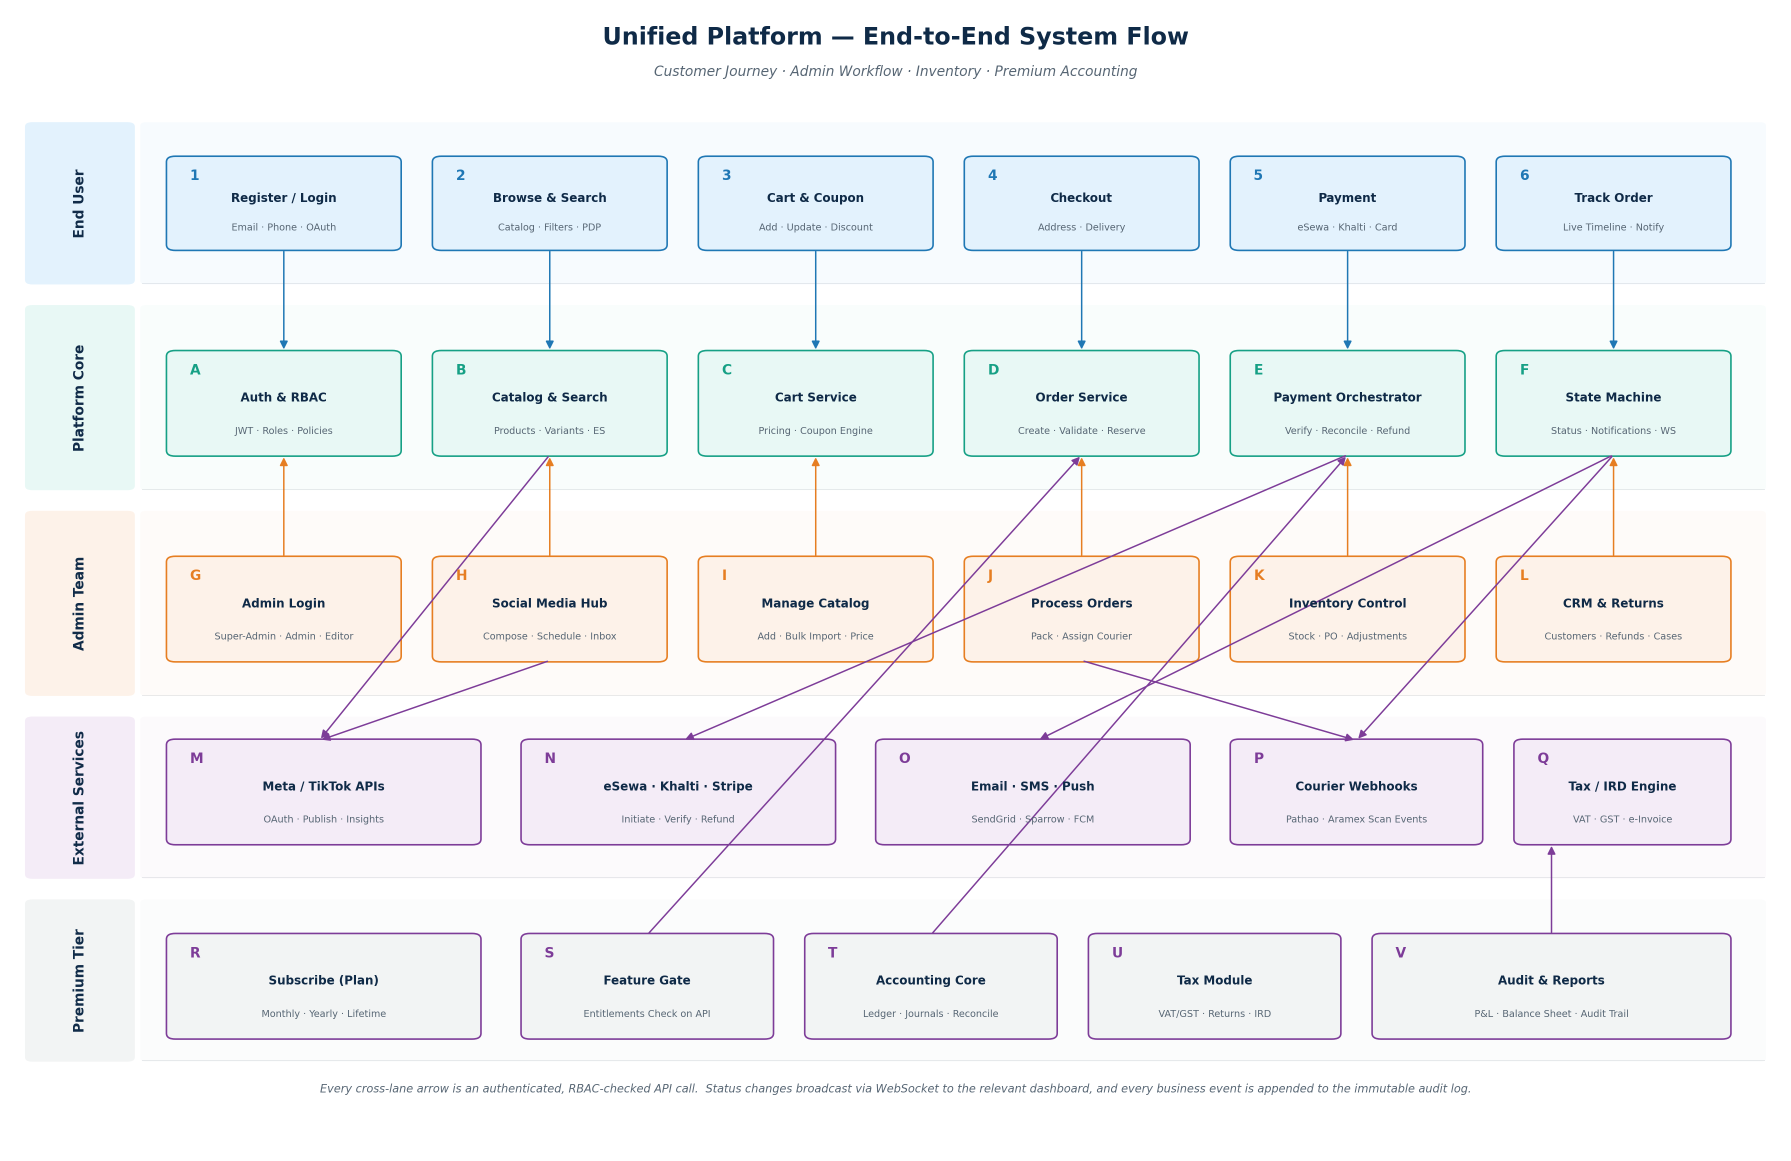
Figure 2 — End-to-End System Flow (Swim-Lane View)
7.1 Walkthrough — A Typical Purchase
- Customer registers (or logs in) on the storefront — Auth & RBAC service issues a JWT.
- Customer browses the catalogue (served from PostgreSQL via Elasticsearch) and adds items to their cart (cached in Redis).
- At checkout, the Order Service creates a Pending order, the inventory service reserves stock, and the Payment Orchestrator initiates the selected gateway (eSewa / Khalti / Stripe).
- On payment verification, the State Machine transitions the order to Confirmed, fires Email + SMS + Push notifications, and posts a journal entry to the Accounting Core (if the tenant has a Premium subscription).
- Admin sees the order in real time via WebSocket; assigns courier; the courier webhook later pushes Out-for-Delivery and Delivered events.
- Customer can track the order live, raise a return inside the return window, or rate the product after delivery.
- Returns and refunds reverse the stock and post the offsetting journal entries, keeping inventory, finance and customer records consistent.
7.2 Cross-Cutting Concerns
- Every cross-lane arrow in the diagram is an authenticated, RBAC-checked API call.
- Every status change broadcasts via WebSocket to relevant dashboards in real time.
- Every business event is appended to the immutable audit log.
- Premium-gated calls go through an entitlement check before executing.

8. Technology Stack
Layer | Technology | Purpose
Frontend | Next.js 14 + React, Tailwind CSS, Redux Toolkit, React Query | SSR storefront, admin SPA, PWA
Backend | Node.js (NestJS) or Laravel (PHP) | REST APIs, queues, webhooks
Database | PostgreSQL 16 | Relational primary store
Cache / Queue | Redis 7 | Sessions, cart, rate limits, job queue
Search | Elasticsearch or Meilisearch | Catalogue full-text and faceted search
Object Store | AWS S3 / GCS | Images, PDFs, media assets
Real-time | Socket.IO / WebSockets | Live order updates, inbox events
Auth | JWT (15-min) + refresh (7d), OAuth 2.0, 2FA (TOTP) | Stateless secure access
Social APIs | Meta Graph API, TikTok Marketing API | Post, schedule, analytics, inbox
Payments | Stripe, eSewa, Khalti, PayPal | Checkout, refunds, subscriptions
Notifications | SendGrid / SMTP, Twilio / Sparrow SMS, FCM | Email, SMS, push
Search Infra | OpenSearch (managed) optional | Hosted scaling path
Cloud | AWS or GCP (EC2/EKS or GKE, CloudFront / Cloud CDN) | Scalable infra, global edge
Containers | Docker + Kubernetes | Service packaging and orchestration
CI/CD | GitHub Actions + Terraform | Automated build, test, deploy, IaC
Monitoring | Sentry, Datadog / New Relic, Prometheus + Grafana | Errors, APM, infra metrics
Security | WAF (Cloudflare / AWS), TLS 1.3, AES-256, Vault for secrets | Defence in depth
Accounting | Custom service in primary stack; PDF via Puppeteer | Premium module
8.1 Security Architecture
- Authentication: short-lived JWT access tokens + rotating refresh tokens; OAuth 2.0 for social login; 2FA (TOTP) enforced for Super Admin and Admin.
- Authorization: every API route guarded by RBAC middleware; entitlement check for premium routes.
- Encryption: AES-256 at rest, TLS 1.3 in transit, secrets in Vault / KMS.
- Audit logging: every CRUD action captures user, timestamp, IP and payload diff.
- Rate limiting and brute-force lockout on auth endpoints.
- Periodic dependency scanning (Dependabot / Snyk), third-party pen test pre-launch, annual re-test thereafter.
- PCI scope minimisation: card data never touches our servers (Stripe Elements).
- Data privacy: GDPR-aligned consent, data export, right-to-deletion flows.

9. Database Design — Key Entities
9.1 Identity & Access
- users (id, email, phone, password_hash, status, two_fa_enabled, created_at).
- roles (id, name, is_system).
- permissions (id, code, description).
- role_permissions (role_id, permission_id).
- user_roles (user_id, role_id).
9.2 Catalogue & Inventory
- products (id, sku, name, slug, brand_id, category_id, base_price, status).
- product_variants (id, product_id, sku, attributes_json, price, stock).
- inventory (product_id, variant_id, on_hand, reserved, available, threshold).
- stock_movements (id, sku, type, qty_change, balance_after, reference_id, user_id, created_at).
- purchase_orders (id, supplier_id, status, expected_at, created_by).
9.3 Orders & Fulfilment
- orders (id, user_id, status, subtotal, discount, delivery_fee, tax, total, payment_method, payment_status, address_id, courier_id, tracking_number, created_at).
- order_items (id, order_id, product_id, variant_id, qty, unit_price, subtotal).
- order_status_history (id, order_id, from_status, to_status, changed_by, created_at).
- returns (id, order_id, reason, photos_json, status).
- refunds (id, order_id, amount, gateway_ref, status, processed_at).
9.4 Social Media
- social_accounts (id, platform, account_id, oauth_token_enc, refresh_token_enc).
- posts (id, content, media_urls_json, status, scheduled_at, published_at).
- post_targets (post_id, social_account_id, platform_post_id, status).
- inbox_messages (id, social_account_id, thread_id, body, direction, assigned_to, status).
9.5 Premium Accounting
- subscriptions (id, tenant_id, plan_code, billing_cycle, status, started_at, expires_at, gateway_ref).
- plan_entitlements (plan_code, feature_code).
- chart_of_accounts (id, code, name, type, parent_id).
- journal_entries (id, posted_at, period_id, reference, source, created_by).
- journal_lines (id, journal_id, account_id, debit, credit, currency).
- tax_rates (id, code, rate_pct, jurisdiction, valid_from).
- invoices (id, order_id, number, issued_at, total, tax_total, pdf_url).
- audit_log (id, actor_id, action, entity, entity_id, before_json, after_json, ip, created_at).

10. Delivery Roadmap
Two work streams run in parallel: the Internal Platform (Admin + Operations) and the Customer Portal (Storefront + Tracking). The Premium Accounting module is sequenced after the operational platform is stable so it can consume real transactional data.
Phase | Scope | Duration | Milestone
Phase 0 | Sprint 0 — repos, CI/CD, design system, API skeleton | 2 weeks | Foundations Ready
Phase 1 | Auth, RBAC, user management, Super Admin console | 8 weeks | Identity Layer
Phase 2 | Social Media Hub (Meta + TikTok), composer, inbox, scheduler | 10 weeks | Marketing Hub
Phase 3 | E-Commerce engine + Customer Storefront + Payments (eSewa, Khalti, Stripe, COD) | 12 weeks | Storefront Live
Phase 4 | Order Tracking + Inventory + Courier integration + CRM lite | 8 weeks | Operations Engine
Phase 5 | Reporting, dashboards, analytics consolidation | 5 weeks | Intelligence Layer
Phase 6 | Premium Accounting & Tax & Audit + Subscription billing | 10 weeks | Premium Tier
Phase 7 | QA, security audit (third-party), UAT, performance tuning, launch | 5 weeks | Go-Live
With Phases 1–4 running with overlapping teams, total wall-clock time is approximately 12 months including the Premium tier. Without the Premium tier, launch is achievable in 9–10 months.
10.1 Phase Dependencies
- Phase 1 (Identity) must complete before any other module — every API depends on it.
- Phases 2, 3 and 4 can run with overlapping teams once Phase 1 is stable.
- Phase 5 needs at least one of Phase 2 / 3 / 4 in production to be meaningful.
- Phase 6 (Premium) reads from Phases 3 and 4 — start no earlier than Phase 3 finish.
- Phase 7 is a hard gate — no production traffic until security and UAT pass.

11. Indicative Budget
Budget figures are planning estimates; final numbers depend on team location (in-house, near-shore, off-shore), seniority mix and any reuse of existing components. Conversions use 1 USD ≈ 133 NPR.
11.1 Build Cost — Team (12 months)
Role | Count | Monthly Cost (USD) | 12-mo Cost (USD) | 12-mo Cost (NPR)
Project / Delivery Manager | 1 | 4,500 | 54,000 | ~ NPR 71.8 L
Backend Engineers | 2 | 4,500 | 108,000 | ~ NPR 1.44 Cr
Frontend Engineers | 2 | 4,000 | 96,000 | ~ NPR 1.28 Cr
Social API Specialist | 1 | 4,500 | 54,000 | ~ NPR 71.8 L
DevOps / Cloud Engineer | 1 | 5,000 | 60,000 | ~ NPR 79.8 L
UI / UX Designer | 1 | 3,500 | 42,000 | ~ NPR 55.9 L
QA Engineer | 1 | 3,000 | 36,000 | ~ NPR 47.9 L
Accounting-domain Specialist (Phase 6) | 1 (6mo) | 5,000 | 30,000 | ~ NPR 39.9 L
Sub-total — Team | 10 | — | 480,000 | ~ NPR 6.4 Cr
11.2 Infrastructure & Third-Party (Year 1)
Item | Annual Cost (USD) | Notes
Cloud (AWS / GCP) — compute, DB, CDN, S3 | 12,000 – 24,000 | Right-sized for ~50k MAU
Managed PostgreSQL + Redis + Search | 6,000 – 9,000 | RDS / ElastiCache / OpenSearch
Stripe fees (variable) | %2.9 + $0.30 per txn | Pass-through
eSewa / Khalti merchant fees | 1.5–2.5% per txn | Negotiable at volume
SendGrid / Twilio / Sparrow SMS | 1,800 – 4,800 | Depends on volume
Monitoring (Sentry + Datadog) | 3,000 – 6,000 | Tiered by host count
Domain, SSL, WAF, DNS | 1,200 | Cloudflare Pro tier
Security pen-test (one-off) | 8,000 – 15,000 | Third-party audit pre-launch
Sub-total — Infra & 3rd-party | ≈ 32,000 – 60,000 | Excludes payment fees
11.3 Contingency & Total
Item | Cost (USD) | Cost (NPR)
Team (12 months) | 480,000 | ~ 6.4 Cr
Infrastructure & 3rd-party | ≈ 46,000 (mid) | ~ 61.2 L
Contingency (15%) | ≈ 79,000 | ~ 1.05 Cr
Total — Year 1 | ≈ 605,000 | ~ 8.05 Cr
Reducing scope to MVP (drop Premium Accounting and TikTok integration) cuts build cost by roughly 25–30%. Off-shoring all engineering to Nepal / India can reduce team cost by 40–60%, bringing Year-1 cost into the USD 250–350k range.

12. Risk Register & Mitigations
Risk | Likelihood | Impact | Mitigation
Social API policy / pricing changes (Meta, TikTok) | Medium | High | Abstraction layer in code; design swap-out path; track official API changelogs.
Payment gateway downtime (eSewa / Khalti / Stripe) | Low | High | Implement multiple gateways with automatic failover; clear retry UI.
Scope creep delaying launch | High | Medium | Strict change-control; new requests go to post-launch backlog; signed-off scope per phase.
Data privacy / GDPR / local regulator gaps | Medium | High | Privacy-by-design in Phase 1: consent, export, deletion; legal review pre-launch.
Performance under flash-sale load | Medium | Medium | Load test before launch; CDN + Redis caching; queue-based order intake; auto-scaling.
Key engineer departure mid-build | Low | Medium | Documentation standards from day 1; pair programming; knowledge-sharing each sprint.
Accounting module accuracy issues | Medium | High | Hire a domain specialist; double-entry test fixtures; reconciliation tooling; independent CA review before pricing as a paid product.
Premium subscription churn | Medium | Medium | Strong onboarding, scheduled health-check emails, in-app NPS; export-on-cancel reduces lock-in fear.
Courier integration unreliability | Medium | Medium | Manual override path; tracking via courier-pulled status if webhook is silent for >2h.
Currency / FX fluctuation in pricing | Low | Low | Daily FX feed; tenant chooses settlement currency; quote-in-NPR option.

13. Success Metrics & KPIs
13.1 Operational KPIs
- Order processing time from payment confirmation to dispatch — target < 4 hours.
- Cart-to-checkout conversion rate — target > 35%.
- Checkout-to-paid conversion rate — target > 75%.
- Average order-tracking events delivered per order — target ≥ 5.
- Customer support ticket resolution time — target < 24 hours median.
13.2 Marketing KPIs
- Time saved per week on social management — target ≥ 40% vs manual tool switching.
- Social engagement rate uplift — target +20% within 90 days post-launch.
- Cross-channel post-failure rate — target < 0.5%.
13.3 Technical KPIs
- Platform uptime — target 99.9% monthly.
- p95 API latency — target < 300 ms.
- Zero critical security incidents in first 12 months post-launch.
- Deployment frequency — target weekly to production.
13.4 Premium / Commercial KPIs
- Free-trial-to-paid conversion — target ≥ 20%.
- Monthly recurring revenue (MRR) — target USD 25k by month 6 post-launch.
- Churn — target < 4% monthly.
- Net revenue retention — target > 105%.

14. Recommended Team Structure
- 1 × Project / Delivery Manager — sprint planning, stakeholder communication.
- 2 × Backend Engineers — APIs, database, RBAC, payments, accounting service.
- 2 × Frontend Engineers — Next.js storefront and admin console.
- 1 × Social Media API Specialist — Meta and TikTok integrations, OAuth flows.
- 1 × DevOps / Cloud Engineer — infra, CI/CD, security, monitoring.
- 1 × UI / UX Designer — design system, wireframes, user testing.
- 1 × QA Engineer — test plans, automation, regression, UAT coordination.
- 1 × Accounting Domain Specialist (Phase 6) — CoA, tax rules, audit pack.
Total: 9–10 FTE for the duration of the project, with the accounting specialist engaged only for the Phase 6 window (6 months).
15. Recommended Next Steps
- Stakeholder sign-off on this plan and on scope boundaries (especially the Premium tier and pricing).
- Apply for Meta Business API and TikTok Marketing API developer access (can take 2–4 weeks).
- Apply for eSewa and Khalti merchant accounts and sandbox credentials (1–2 weeks).
- Confirm backend framework (NestJS vs Laravel) and cloud provider (AWS vs GCP).
- Assemble the core team — start with PM, 1 BE, 1 FE, 1 designer; ramp up by Phase 2 kickoff.
- Sprint 0 (2 weeks): set up monorepo or polyrepo, CI/CD, design system, API skeleton, staging environment.
- Begin Phase 1 (Identity & RBAC) — the foundation everything else depends on.
- Run a focused 4-week discovery with a Chartered Accountant before Phase 6 to lock down chart of accounts, tax rules and audit pack format.
- Define pricing experiments for the Premium tier — competitive benchmark, WTP survey, lifetime-vs-recurring breakeven analysis.
- Establish a post-launch operations runbook — on-call rota, incident playbook, weekly metrics review.

End of Report | Unified Marketing & E-Commerce Management Platform | v2.0 | May 2026

