DATA ANALYST INTERNSHIP
INFOTACT SOLUTIONS
SaaS / E-Commerce Cohort Retention
& Customer Lifetime Value Analysis
Project Report
Prepared by: Samradhi Sharma
Data Analyst Intern
July 2026

Table of Contents
Table of Contents 1
1. Executive Summary 1
2. Business Problem & Objectives 1
3. Methodology 1
3.1 Week 1 — Data Cleaning & Wrangling (Python / Pandas) 1
3.2 Week 2 — Cohort Retention Matrix (SQL Server) 1
3.3 Week 3 — Customer Lifetime Value (SQL Server) 1
3.4 Week 4 — Visualization (Power BI) 1
4. Headline Metrics 1
5. Insights & Recommendations 1
6. Assumptions & Limitations 1
7. Tech Stack 1
8. Conclusion 1

1. Executive Summary
Acquiring a new customer typically costs up to five times more than retaining an existing one, yet many growth-stage companies track acquisition closely while leaving retention largely unmeasured. This project builds a complete, reproducible pipeline — from raw transactional data to an interactive dashboard — that groups customers into monthly acquisition cohorts, tracks their retention over time, and quantifies their historical Customer Lifetime Value (CLTV).
The pipeline was built across four stages: Python-based data cleaning, SQL Server cohort and CLTV logic, and a Power BI dashboard combining a retention heatmap, CLTV distribution, and customer segmentation. The end deliverable gives a Product Manager a clear view of when customers churn, and a Finance Director a defensible basis for setting Customer Acquisition Cost (CAC) ceilings.

2. Business Problem & Objectives
If a business loses customers faster than it acquires them, it will inevitably collapse — regardless of how strong its top-of-funnel growth looks. The strategic goal of this project is to identify churn patterns: does a specific event or seasonal cohort (e.g. a Black Friday acquisition wave) churn faster than others? Success is measured by two concrete deliverables:
- A clean Cohort Retention Heatmap showing the percentage of each monthly cohort still active in subsequent months.
- A historical CLTV calculation that segments customers into High, Medium, and Low value tiers.
Two personas anchor the requirements:
- Product Manager — needs to pinpoint exactly which month after acquisition sees the sharpest drop-off, in order to trigger product interventions.
- Finance Director — uses CLTV to determine the maximum acceptable Customer Acquisition Cost the business can sustain profitably.

3. Methodology

3.1 Week 1 — Data Cleaning & Wrangling (Python / Pandas)
The source dataset is the UCI Online Retail II dataset — invoice-level e-commerce transactions. Cleaning followed a defined sequence: drop rows with missing Customer ID (required for cohort assignment), remove cancelled invoices (Invoice numbers prefixed ‘C’), remove non-positive quantity and price rows, drop duplicates, and derive a Revenue column as Quantity × Price. Invoice Month and Cohort Month (the customer's first purchase month) were then computed for every row.
Stage | Row Count | Note
Raw rows ingested | 1,067,371 | 8 columns; Dec 2009 onward
After dropping missing Customer ID | 824,364 | 22.8% of rows had no Customer ID
After removing cancelled invoices | 805,620 | Invoice prefix 'C' excluded
Final cleaned dataset | 779,425 | Duplicates dropped; Revenue & Cohort Month added
Table 1: Row counts through each stage of the Week 1 cleaning pipeline.

3.2 Week 2 — Cohort Retention Matrix (SQL Server)
The retention matrix was built entirely in T-SQL, as a chain of derived tables:
- CustomerFirstPurchase — MIN(InvoiceDate) per customer.
- CustomerCohort — first purchase date truncated to Cohort Month.
- CohortData — DATEDIFF(month, CohortMonth, InvoiceMonth) as Cohort Index for every transaction.
- CohortCounts — DISTINCT customer count per (Cohort Month, Cohort Index).
- RetentionMatrix — each cohort's active-customer count expressed as a percentage of its own Cohort Index 0 (acquisition month) size.
The core formula:
Retention % = ROUND( 100.0 × ActiveCustomers / CohortSize , 2 )
Expressing every later month as a percentage of the acquisition-month cohort size is what makes cohorts of very different sizes comparable side by side in a single heatmap.

3.3 Week 3 — Customer Lifetime Value (SQL Server)
CLTV was built from three per-customer financial metrics, each computed as its own SQL table and joined together:
Metric | Formula | Description
AOV | TotalRevenue / TotalOrders | Average Order Value per customer
Purchase Frequency | COUNT(Invoice) / COUNT(Customer) | Orders per customer, dataset-wide
Customer Value | AOV × Purchase Frequency | Expected value per active period
Historical CLTV | Customer Value × Avg. Lifespan (days) | Projected lifetime value
Table 2: CLTV build-up from AOV through to historical CLTV.
Average customer lifespan is measured directly from the data — AVG(DATEDIFF(day, first purchase, last purchase)) across all customers — rather than an assumed constant, so the CLTV horizon reflects actual observed purchasing behaviour. Customers are then segmented into High, Medium, and Low value tiers using CASE logic on the resulting CLTV figure, giving Sales and Retention teams a ready-made targeting list.

3.4 Week 4 — Visualization (Power BI)
The SQL output tables (RetentionMatrix, CustomerCLTV, CustomerSegments, and the cleaned transaction table) were connected live to Power BI via SQL Server import. The data model relates the customer-level tables through CustomerID, and the report surfaces four core views: a Retention Heatmap (cohort month × cohort index, conditionally formatted), a CLTV Distribution column chart by segment, a Customer Segmentation bar chart, and a Retention Trend decay curve, alongside supporting KPI cards and a country-level revenue breakdown.

4. Headline Metrics
Metric | Value
Total Revenue | ₹17.37M
Total Customers | 6,000
Total Orders | 36,969
Average Order Value | ₹469.98
Average Retention Rate | 24.69%
Table 3: Dashboard KPI summary, read directly from the live SQL Server model.

5. Insights & Recommendations
- Retention drops off sharply after the acquisition month — an automated re-engagement email sequence targeting Month 1–Month 2 customers would address the steepest point of the decay curve.
- A small share of customers drive a disproportionate share of revenue — the High-Value segment should be prioritised for loyalty perks and higher-touch outreach, since their AOV supports a higher CAC ceiling.
- Purchase frequency, not order size, is the larger lever on customer value — campaigns should focus on repeat-purchase cadence (bundles, replenishment reminders) rather than basket-size upsells alone.

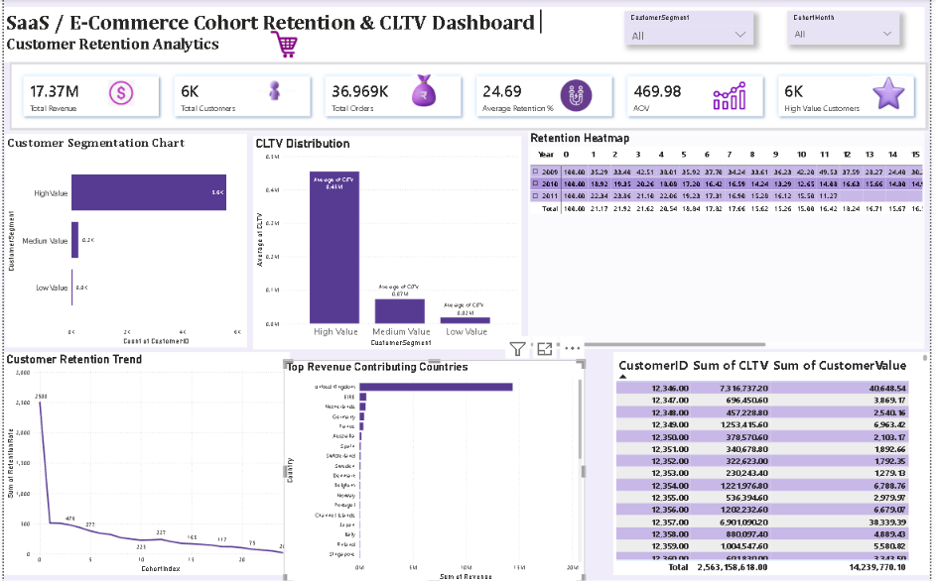

6. Assumptions & Limitations
As with any first-pass model, several simplifications were made deliberately, with clear next steps identified for each:
- Flat CLTV horizon — the model applies one dataset-wide average lifespan to every customer rather than a per-segment or predictive horizon; a next iteration would model lifespan by cohort or acquisition channel.
- Static segment thresholds — High/Medium/Low cutoffs are currently fixed values; a data-driven approach (e.g. quartile-based cutoffs) would adapt automatically as the customer base grows.
- Historical, not predictive, CLTV — the current figure looks backward at realised value. A regression-based or BG/NBD probabilistic model would forecast forward-looking CLTV.
- Retention is not yet sliced by acquisition channel or geography — the original brief's question of whether Black-Friday-acquired cohorts churn faster is a natural next cut of the same data.

7. Tech Stack
Layer | Tools
Data Cleaning | Python — Pandas, NumPy, Jupyter
Data Modelling & CLTV Logic | SQL Server — T-SQL, window functions, CTEs
Visualization | Power BI — DAX, Power Query, star-schema modelling
Source Data | UCI Online Retail II (1.06M transactions, Dec 2009 onward)

8. Conclusion
This project delivers an end-to-end retention and CLTV analysis pipeline, moving from 1.06 million raw transaction rows to a decision-ready Power BI dashboard. It directly answers the brief's two central questions — when do customers churn, and what are they worth — while leaving a clear, honestly-scoped roadmap for the predictive and segmentation refinements that would come next.

