## Lab 1 - HTML Fundamentals

### Objective

This assignment will help you practice HTML structure, semantic elements, and attributes without relying on CSS or JavaScript. You will create layouts, display structured data, and add interactivity using only HTML.

### Task 1: Table-Based Web Layout

• Create a simple web page layout using <table>.

• Your layout must include:

* A header,
* A navigation sidebar,
* A main content area,
* A footer.

• Use <thead>, <tbody>, and <tfoot> appropriately.

• Implement rowspan and colspan where required.

• Inside your layout:

* Use at least one <figure> with <figcaption> for an image.
* A black screen with white text

  AI-generated content may be incorrect.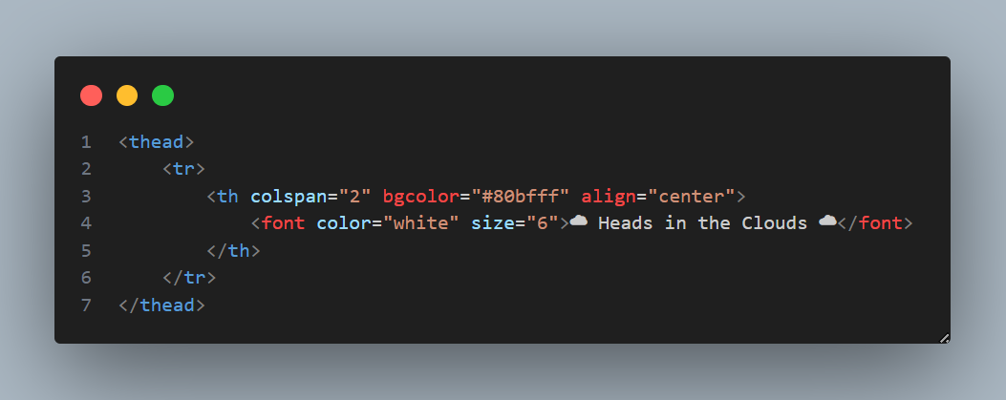Use at least one <details> and <summary> to show/hide additional information.

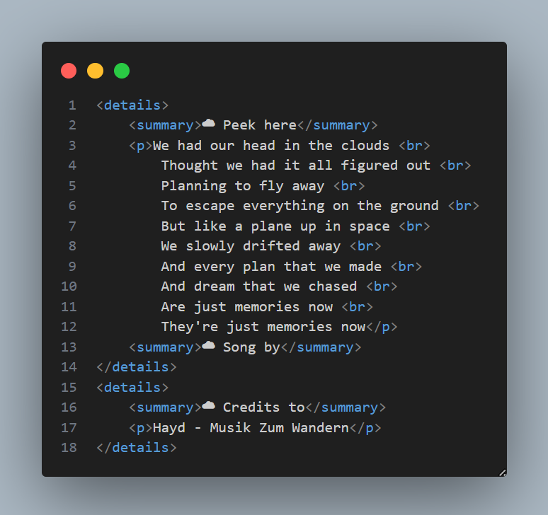

### Task 2: Periodic Table (Without CSS)

• Create a Periodic Table using only <table>.

• Do not use CSS. Use the bgcolor attribute for coloring.

• Represent atomic number using <sup> and atomic mass using <sub>.

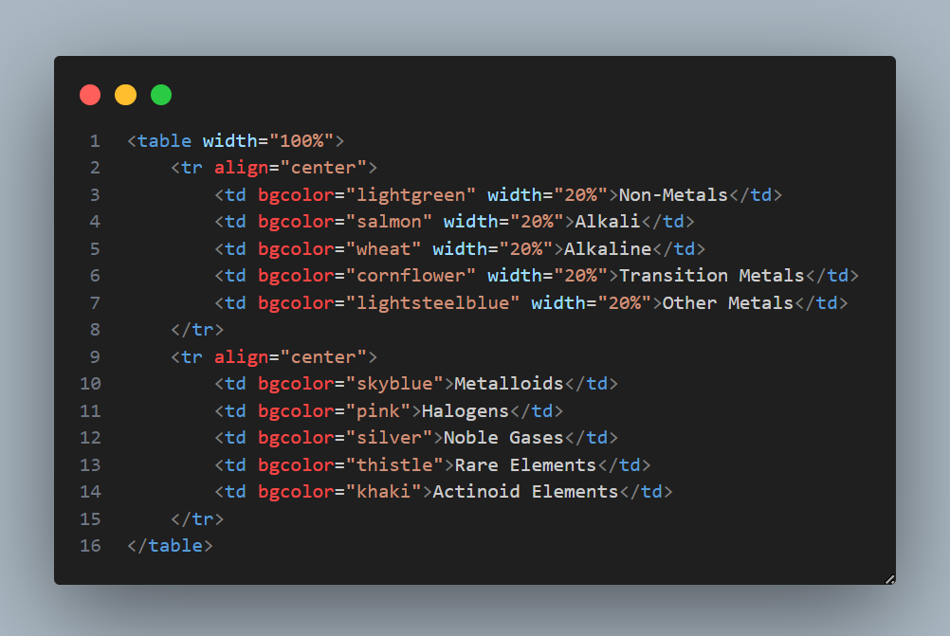

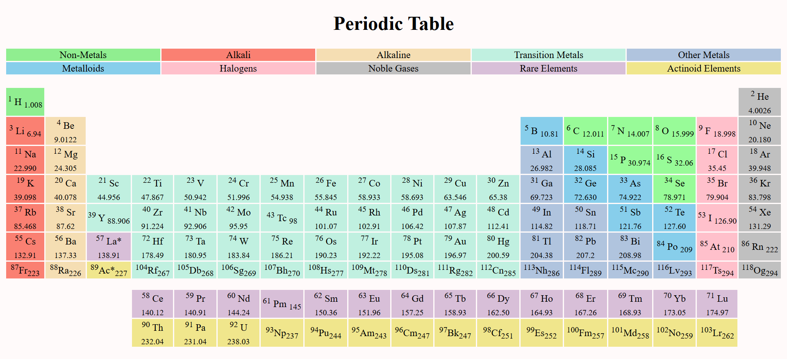

### Task 3: Resume Page (Using Semantic Tags)

Create a resume/profile web page using only semantic HTML tags.

Must include:

• <header> for your name and designation,

• <nav> for quick links (Education, Skills, Contact, etc.),

• <section> for education and experience,

• <article> for a project or achievement description,

• <footer> for contact information.

### Submission Guidelines

1. Upload your project to GitHub repository.

2. Deploy the project using GitHub Pages.

3. Submit the live GitHub Pages URL along with screenshots of your output.

4. Your work will be evaluated on:

• Correct usage of HTML structure and semantic tags,

• Proper use of attributes (rowspan, colspan, bgcolor, etc.),

• Completeness of all tasks,

• Professional presentation of code.