**Step 1:**

1. Register a new Application.
2. Set “CRETToolFE” as Name of Application.
3. Select Single tenant in Supported account types and click on Register.

We need this Application for App Authentication.

**Step 2:**

1. Click on Authentication from left Menu and then Click on Add a Platform.
2. Click on Single-page application.

**Step 3:**

1. Enter application’s URL but for now you can enter **“https://localhost:44409”** in Redirect URI**. (we will change it later on)**
2. Check Access tokens (used for implicit flows) checkbox and click on configure.

**Step 4:**

1. Click on API permissions from left menu and click on Add a permission**.**
2. Click on Microsoft Graph.

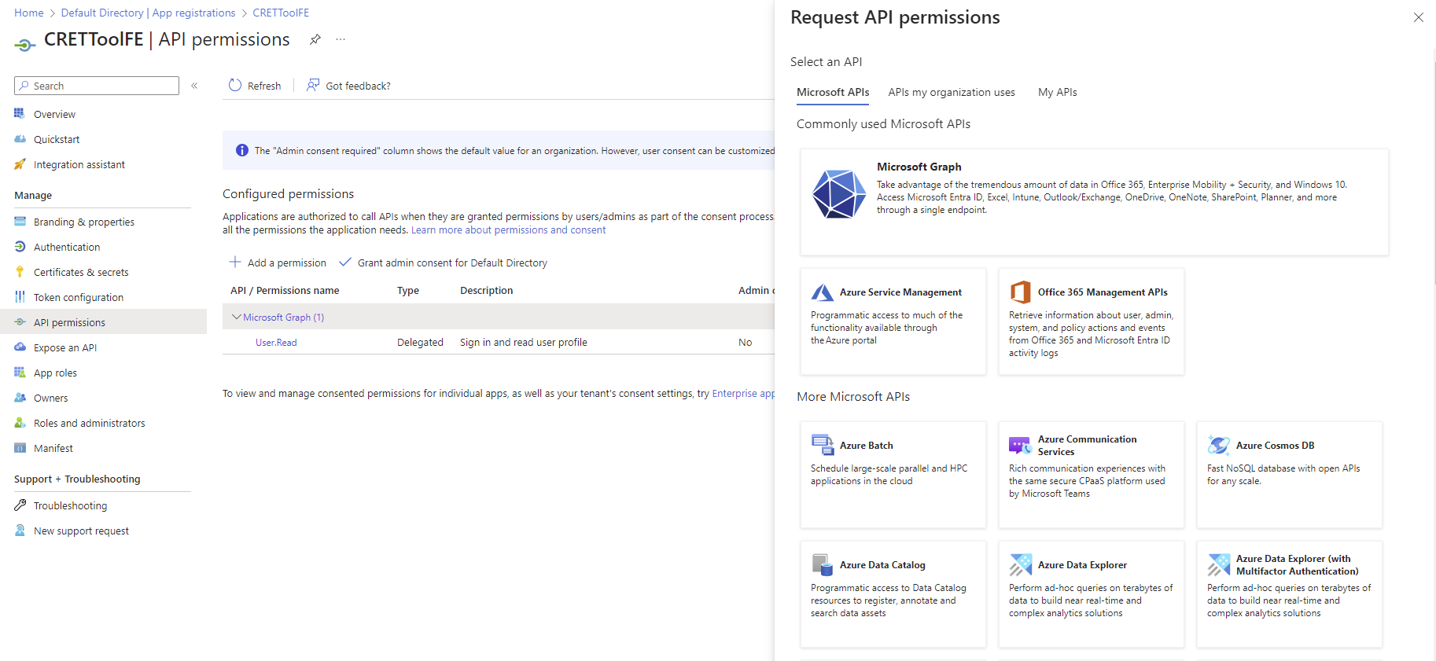

**Step 4:**

1. Click on Delegated Permissions.
2. Search for Permission **“User.Read.All”.**
3. Check the permission checkbox and click on Add permissions.

**Step 5:**

1. Grant admin consent for Default Directory to get the permissions working.

**Step 6:**

1. Click on Expose an API from left menu.
2. Click on Add Application ID URI and then click save.

**Step 7:**

1. Copy **clientId** and **Tenant Id** and send it over.

