**Step 1:**

1. Register a new Application.
2. Set “CRETToolBE” as Name of Application.
3. Select Single tenant in Supported account types and click on Register.

We need this Application for API Authorization.

**Step 2:**

1. Click on Expose an API.
2. Click on Add Application ID URI and then click save.

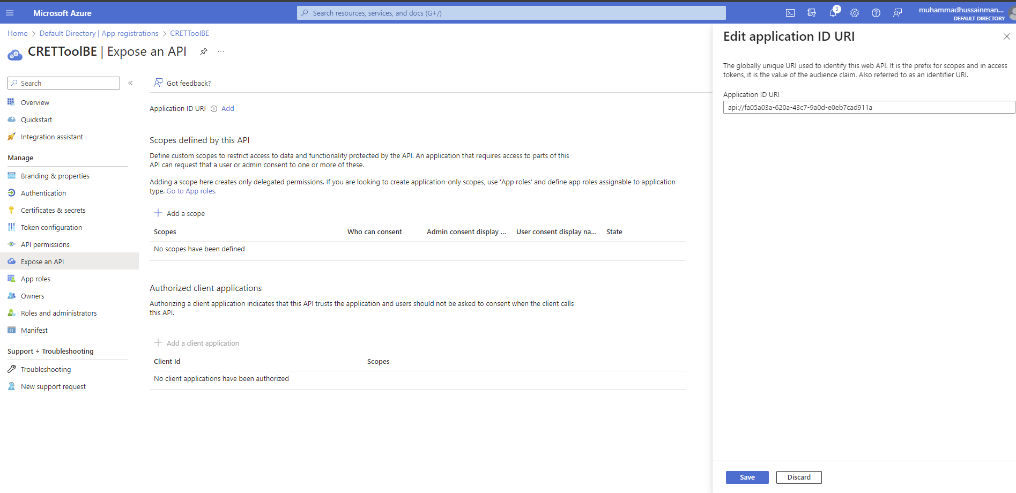

**Step 3:**

1. Click on Add a scope.

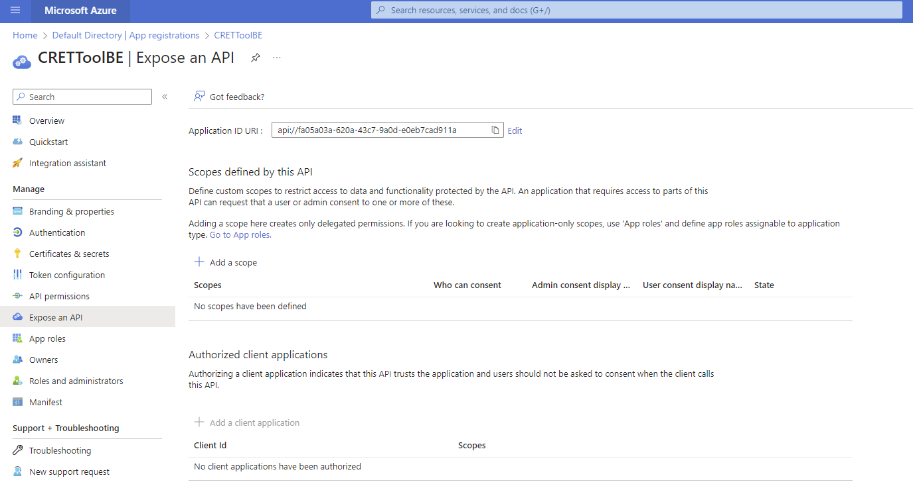

**Step 4:**

1. Click on Add a scope.
2. Enter api.scope in Scope name, Admin Consent display name and Admin consent description.
3. Select Admins and users in who can consent.
4. Select state as Enabled and click on Add scope.

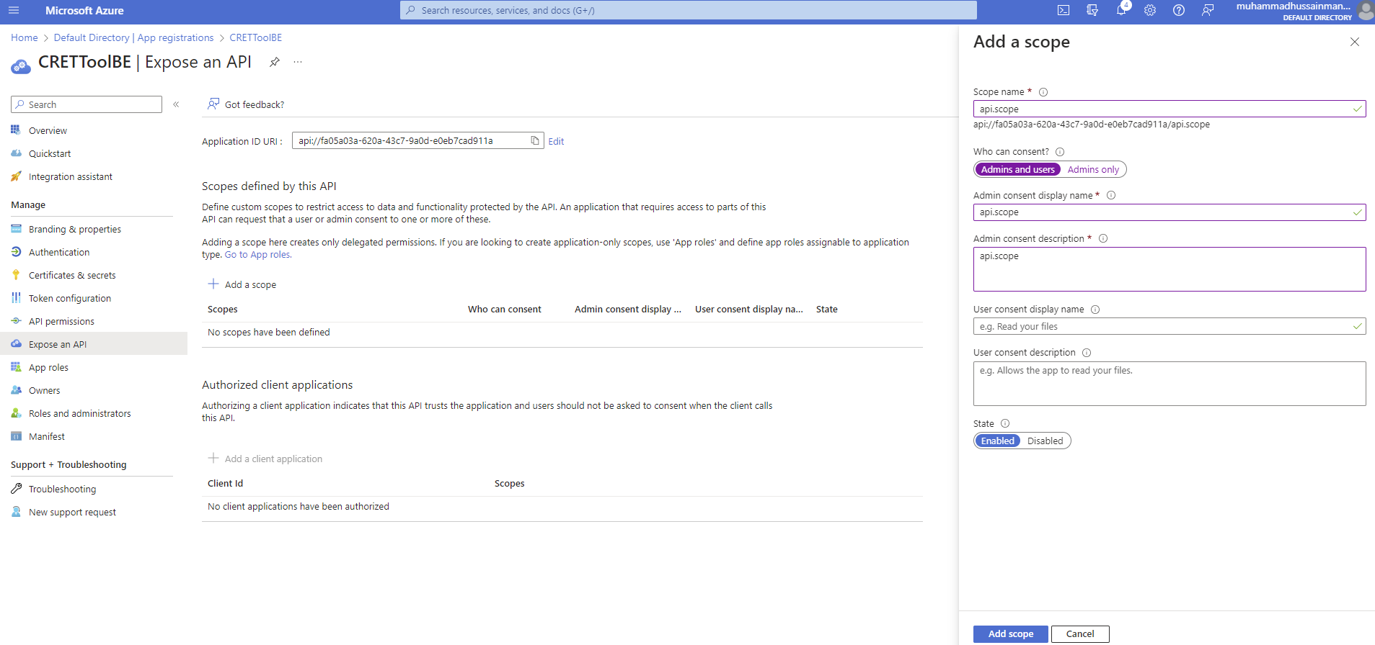

**Step 5:**

1. Click on App Roles Menu from side bar and then click on Create app role.

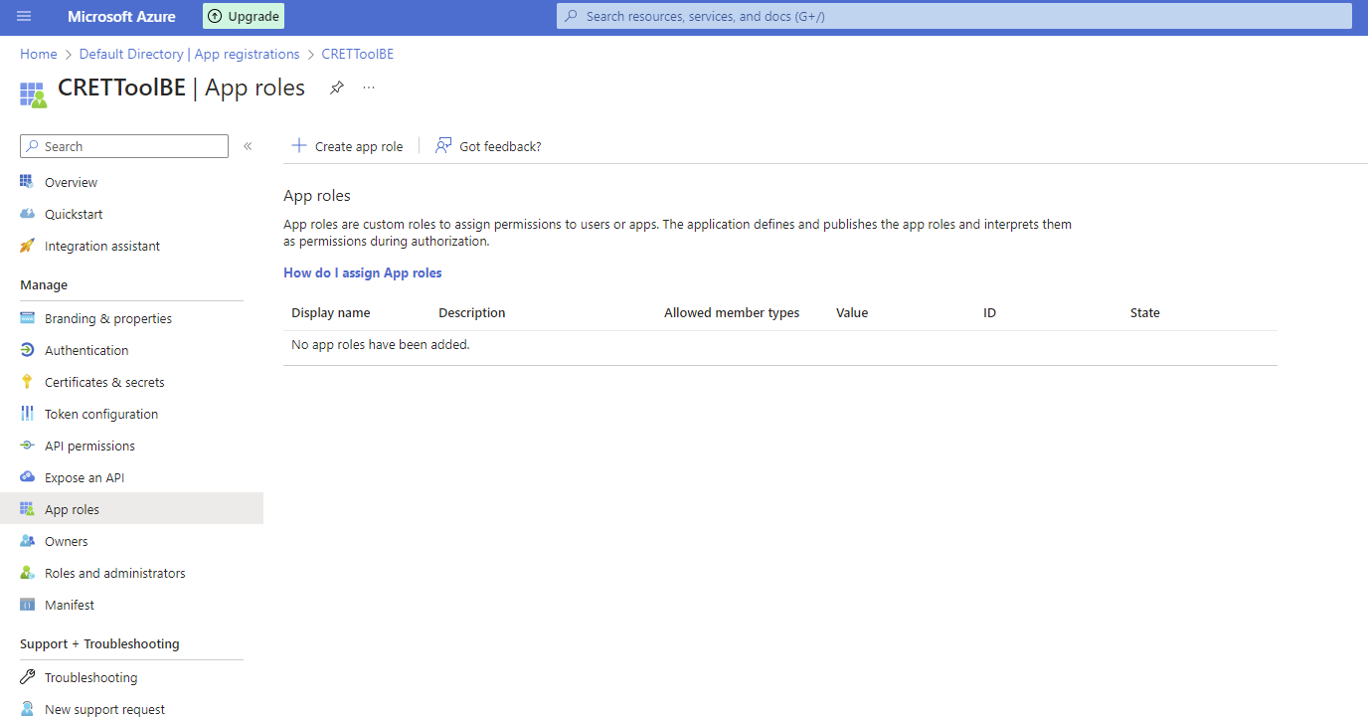

**Step 6:**

1. Enter Manager in Display name, value and description.
2. Select Users/Groups in Allowed member types.
3. Select Do you want to enable this app role checkbox and click on apply.

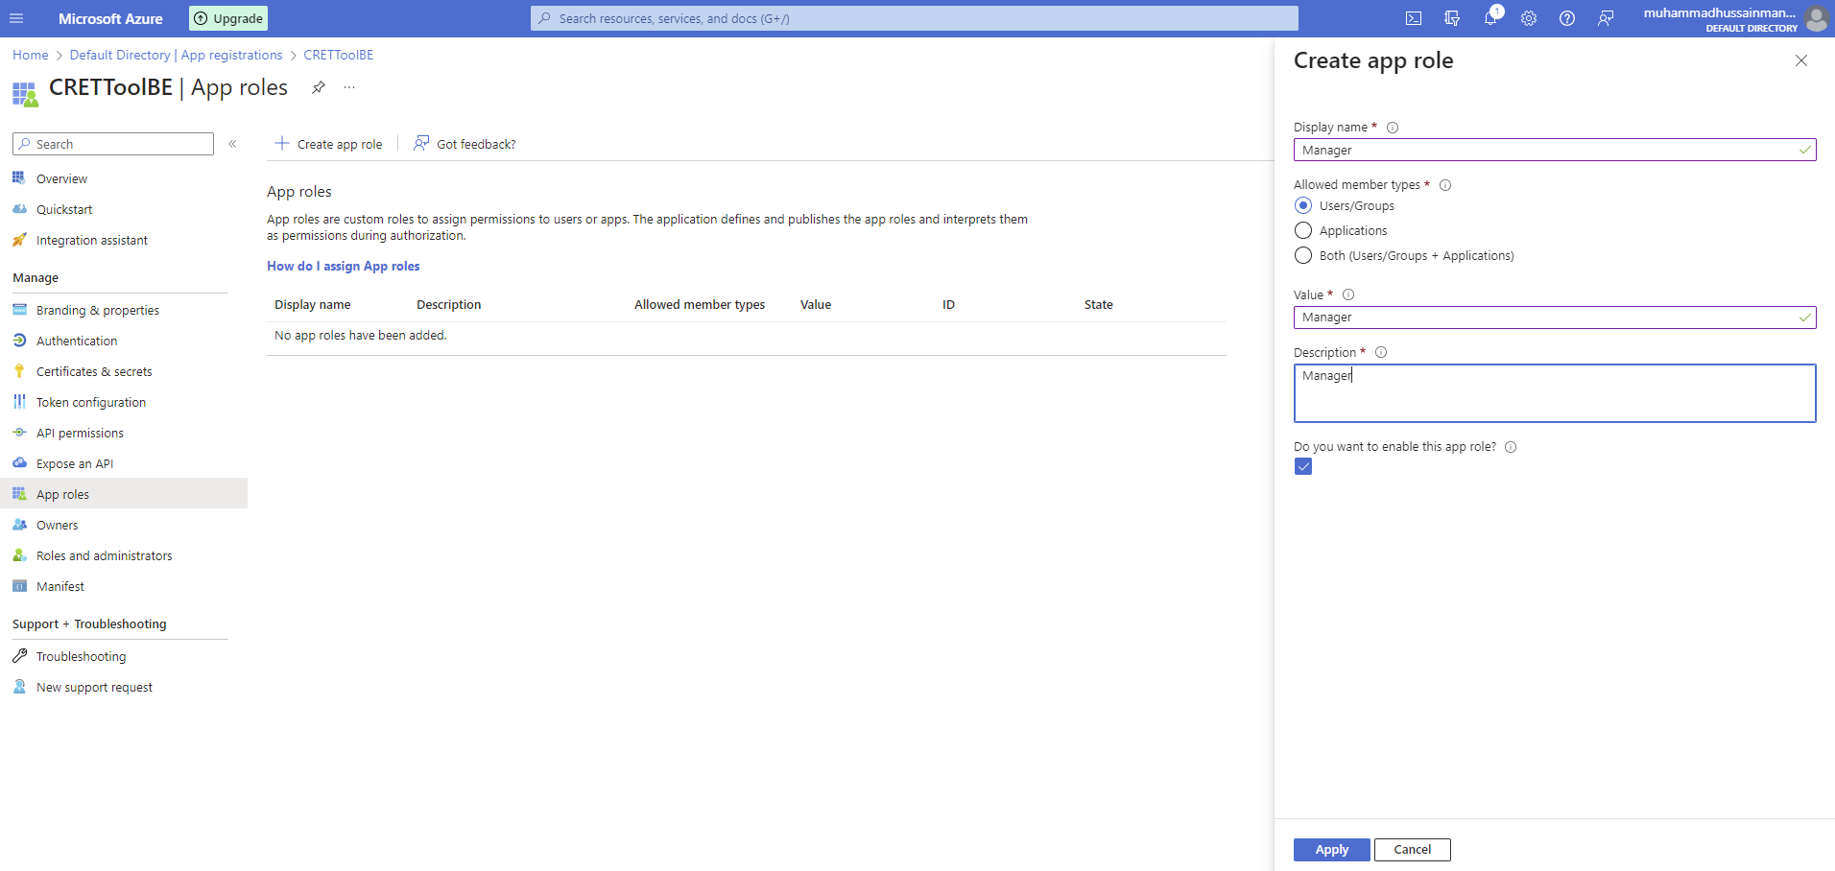

**Step 7:**

1. Copy **clientId** and **Tenant Id** and send it over.

