**Gateway setup in Production environment:- It is Two server setup in production. One server in TST.**

**Prod Server names are =** gtmvlprdap829.washdc.state.sbu

gtmvlprdap830.washdc.state.sbu

**Test Server Names=** **gtmvltstap819.washdc.state.sbu**

**Step 1) Make sure all ODBC connections enter in the following Location:**

Location: /home/oacle**/.odbc.ini**

For Example: If a new entry or service  called ‘**PRD_EAPS**’ in a database name ‘**EAPS**’  on a server instance  ‘HREEWPRDDB1218.washdc.state.sbu\PRD’  to be created,  Following entry to be added to the file.

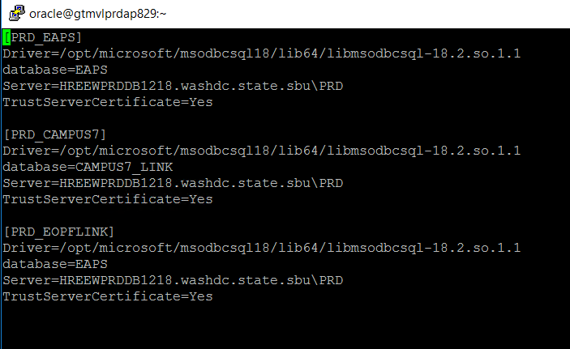

**Step 2) Add entry to Listener.ora :**

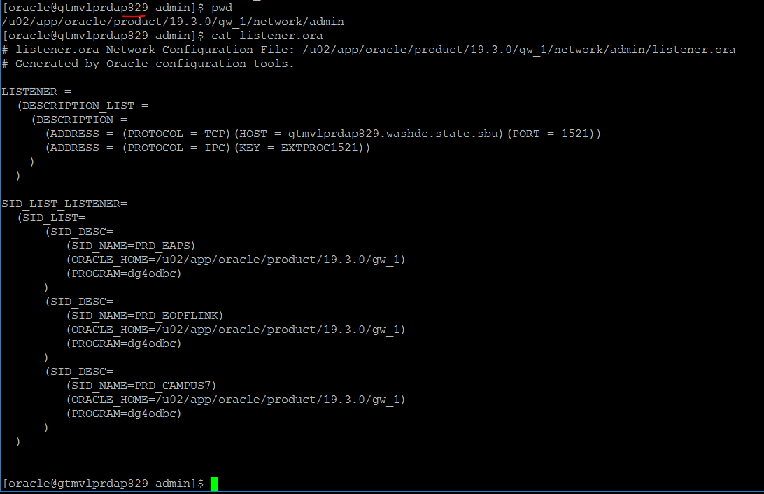

3. **Step 3) Create a new file for the service :**

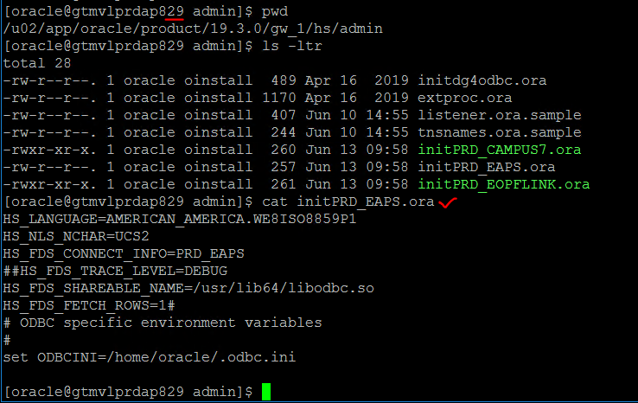

**Step 4: Reload the Gateway listener**

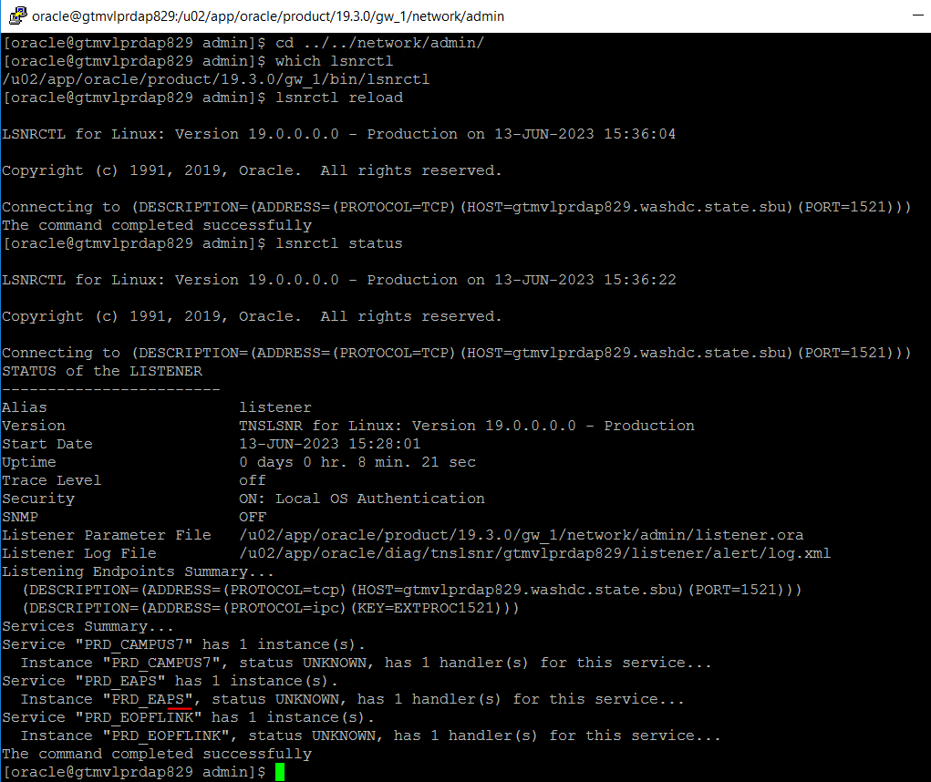

**Step 5: Setup Monitor job to monitor GateWay listener:**



**Step 5: To set up load balancing, following TNS need to be added on Oracle database server.**

