**MDC2 cluster ( KCMDC-CLUSTER) set up in MDC .**

1. **Create directories on all Nodes.:-**

[oracle@hrmdc1oel01 software]$ more rac.txt

groupadd -g 54421 oinstall

groupadd -g 54322 dba

groupadd -g 54323 oper

groupadd -g 54324 backupdba

groupadd -g 54325 dgdba

groupadd -g 54326 kmdba

groupadd -g 54327 asmdba

groupadd -g 54328 asmoper

groupadd -g 54329 asmadmin

groupadd -g 54330 racdba

/usr/sbin/useradd -u 54331 -g oinstall -G dba,asmdba,asmoper,asmadmin,backupdba,dgdba,kmdba,racdba grid

usermod -aG dba,asmdba,asmoper,asmadmin,racdba grid

mkdir -p /u02/app/19.3.0/grid

mkdir -p /u02/app/grid

mkdir -p /u02/app/oracle

chown -R grid:oinstall /u02

chown oracle:oinstall /u02/app/oracle

chmod -R 775 /u02/

**2. Run Cluvffy on NODE1**

-- AS "GRID" user

/u02/app/19.3.0/grid

./runcluvfy.sh stage -pre crsinst -n hrmdc1oel07.washdc.state.sbu,hrmdc1oel08.washdc.state.sbu -r 19 > /tmp/runcluvfy_pre_hrmdc2.txt

1. **Remove ASMLIB package from all nodes. AFD will replace ASMLIB.**

[root@hrmdc1oel08 ~]# **yum search oracleasm**

[root@hrmdc1oel08 ~]# **yum remove oracleasm-support.x86_64**

1. **Label and initiate disks for OCRDG diskgroup on First node, these disks will be used for initial GI home installation.**

**--As root**

[root@hrmdc1oel07 ~]# export ORACLE_HOME=/u02/app/19.3.0/grid

[root@hrmdc1oel07 ~]# export ORACLE_BASE=/tmp

[root@hrmdc1oel07 ~]# export PATH=$PATH:$ORACLE_HOME/bin

export ORACLE_HOME=/u02/app/19.3.0/grid

export ORACLE_BASE=/tmp

export PATH=$PATH:$ORACLE_HOME/bin

Partion disks:-

[root@hrmdc1oel01 ~]#

fdisk -l /dev/dm-10 <--------- Check if disk is partioned.

fdisk -l /dev/dm-11 <--------- Check if disk is partioned.

fdisk -l /dev/dm-16 <--------- Check if disk is partioned.

fdisk -l /dev/dm-10 <--------- Partion disk

fdisk -l /dev/dm-11 <--------- Partion disk.

fdisk -l /dev/dm-16 <--------- Partion disk

[root@hrmdc1oel01 ~]# fdisk /dev/dm-10 <---------- Partion disk

Welcome to fdisk (util-linux 2.23.2).

Changes will remain in memory only, until you decide to write them.

Be careful before using the write command.

Device does not contain a recognized partition table

Building a new DOS disklabel with disk identifier 0x651c738f.

Command (m for help): n

Partition type:

p primary (0 primary, 0 extended, 4 free)

e extended

Select (default p): p

Partition number (1-4, default 1):

First sector (8192-1048575999, default 8192):

Using default value 8192

Last sector, +sectors or +size{K,M,G} (8192-1048575999, default 1048575999):

Using default value 1048575999

Partition 1 of type Linux and of size 5 GiB is set

Command (m for help): w

The partition table has been altered!

Calling ioctl() to re-read partition table.

WARNING: Re-reading the partition table failed with error 22: Invalid argument.

The kernel still uses the old table. The new table will be used at

the next reboot or after you run partprobe(8) or kpartx(8)

Syncing disks.

Label disks to use for OCRDG (Initial GI setup):-

Note:- Use “—init” only if you lable them before installing grid infrastructure.

it's not needed if you label after the GI installation complete.

export ORACLE_HOME=/u02/app/19.3.0/grid

export ORACLE_BASE=/tmp

export PATH=$PATH:/u02/app/19.3.0/grid/bin

**ls -l /dev/oracleafd/disks**

asmcmd afd_label ASM_DISK_01 /dev/dm-10 --init

asmcmd afd_label ASM_DISK_02 /dev/dm-11 --init

asmcmd afd_label ASM_DISK_03 /dev/dm-16 --init

[root@hrmdc1oel07 ~]# asmcmd afd_label ASM_DISK_01 /dev/dm-10 --init

Creating diag directory /tmp/diag

[root@hrmdc1oel07 ~]# asmcmd afd_label ASM_DISK_02 /dev/dm-11 --init

[root@hrmdc1oel07 ~]# asmcmd afd_label ASM_DISK_03 /dev/dm-16 –init

[root@hrmdc1oel07 ~]# ls -l /dev/oracleafd/disks/

total 12

-rw-rw-r--. 1 grid oinstall 34 Jul 28 10:53 ASM_DISK_01

-rw-rw-r--. 1 grid oinstall 34 Jul 28 10:53 ASM_DISK_02

-rw-rw-r--. 1 grid oinstall 34 Jul 28 10:54 ASM_DISK_03

**3. Ptach Oracle GRID software on NODE1:-**

**[grid@hrmdc1oel07 grid]$ ./gridSetup.sh -applyRU /u01/software/PSU/APR2023/35058172/35037840**

ERROR: Unable to verify the graphical display setup. This application requires X display. Make sure that xdpyinfo exist under PATH variable.

Preparing the home to patch...

Applying the patch /u01/software/PSU/APR2023/35058172/35037840...

Successfully applied the patch.

The log can be found at: /tmp/GridSetupActions2023-07-28_07-11-38AM/installerPatchActions_2023-07-28_07-11-38AM.log

No X11 DISPLAY variable was set, but this program performed an operation which requires it.

[grid@hrmdc1oel07 grid]$ ./gridSetup.sh -applyRU /u01/software/PSU/APR2023/35058172/35050341/

ERROR: Unable to verify the graphical display setup. This application requires X display. Make sure that xdpyinfo exist under PATH variable.

Preparing the home to patch...

Applying the patch /u01/software/PSU/APR2023/35058172/35050341/...

Successfully applied the patch.

The log can be found at: /tmp/GridSetupActions2023-07-28_07-17-22AM/installerPatchActions_2023-07-28_07-17-22AM.log

No X11 DISPLAY variable was set, but this program performed an operation which requires it.

Patch Oracle software before installation as user oracle.

[oracle@gtmvlsbxdb12 JUL2023]$ cd /u02/app/oracle/product/19.3.0/db_1/

./runInstaller -silent -applyRU /u01/software/PSU/JUL2023/35370167/35319490/

**3. Find scam name :-**

[root@hrmdc1oel07 ~]# nslookup kcmdc-scan

Server: 10.68.21.13

Address: 10.68.21.13#53

Non-authoritative answer:

Name: kcmdc-scan.hr.state.sbu

Address: 10.65.34.109

Name: kcmdc-scan.hr.state.sbu

Address: 10.65.34.108

Name: kcmdc-scan.hr.state.sbu

Address: 10.65.34.107

1. **Begin GRID install start on NODE1 :-**

Stop firewall before on all nodes before installer.

[root@gtmvlsbxdb13 ~]# systemctl status firewalld

[root@gtmvlsbxdb13 ~]# systemctl stop firewalld

[root@gtmvlsbxdb13 ~]# systemctl disable firewalld

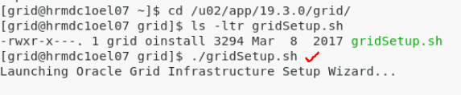

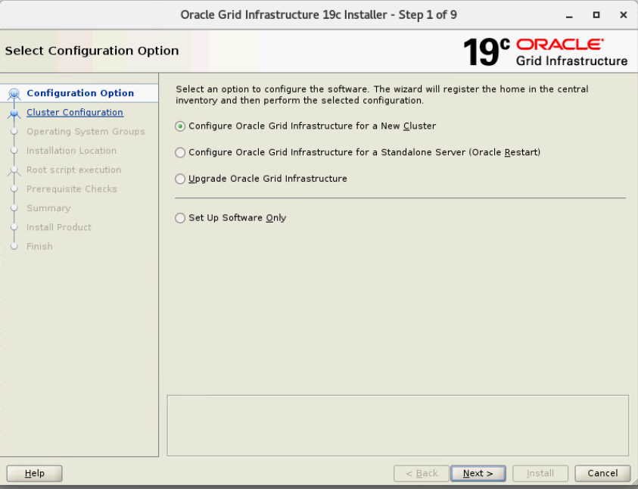

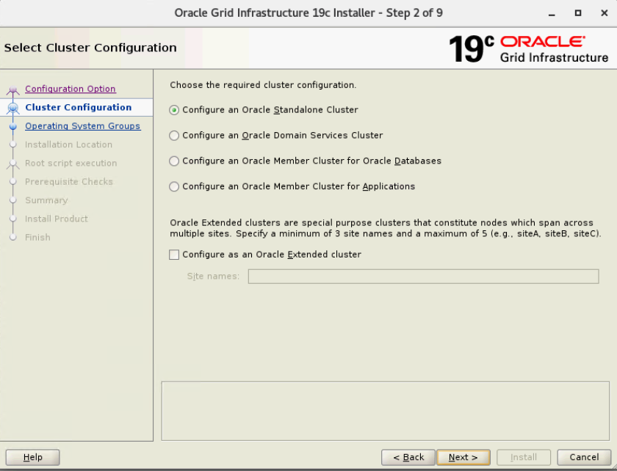

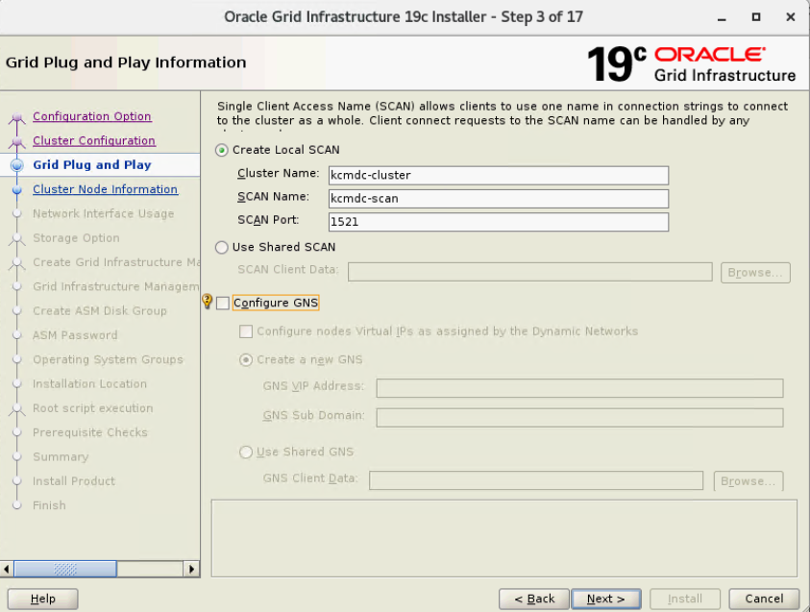

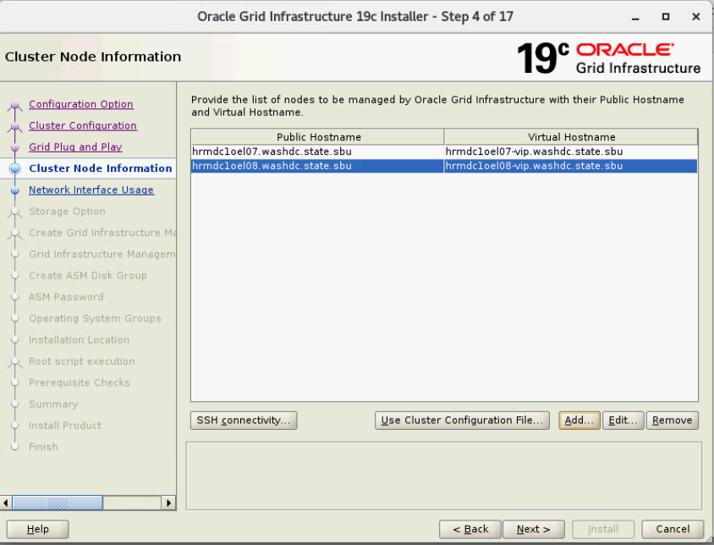

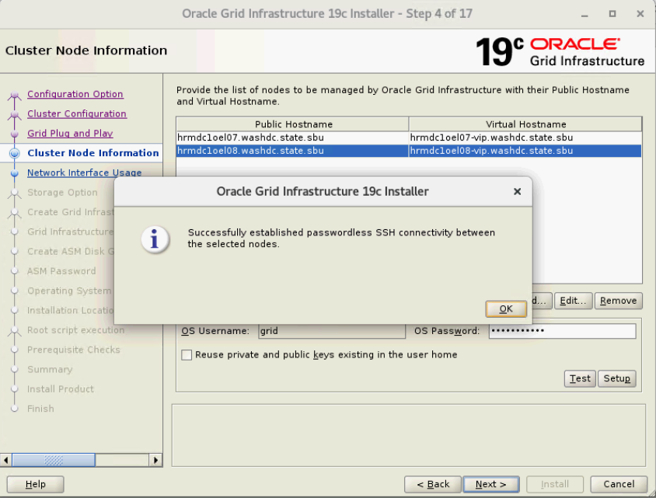

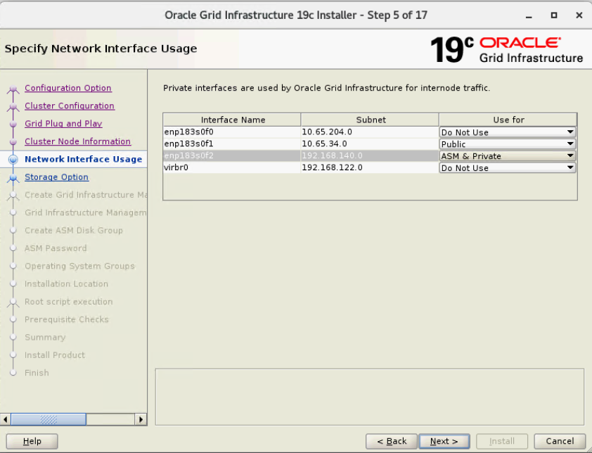

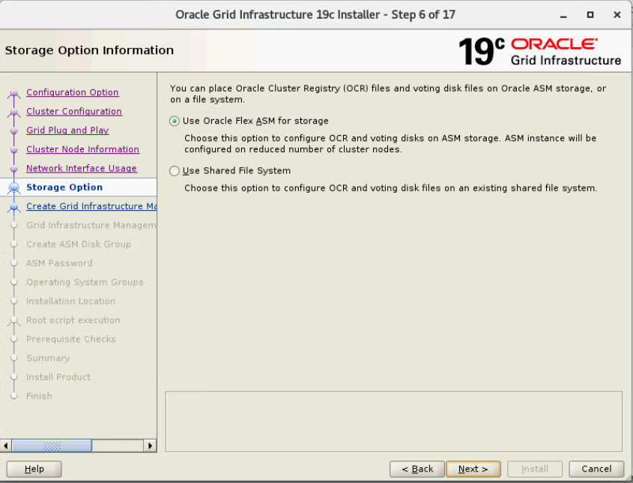

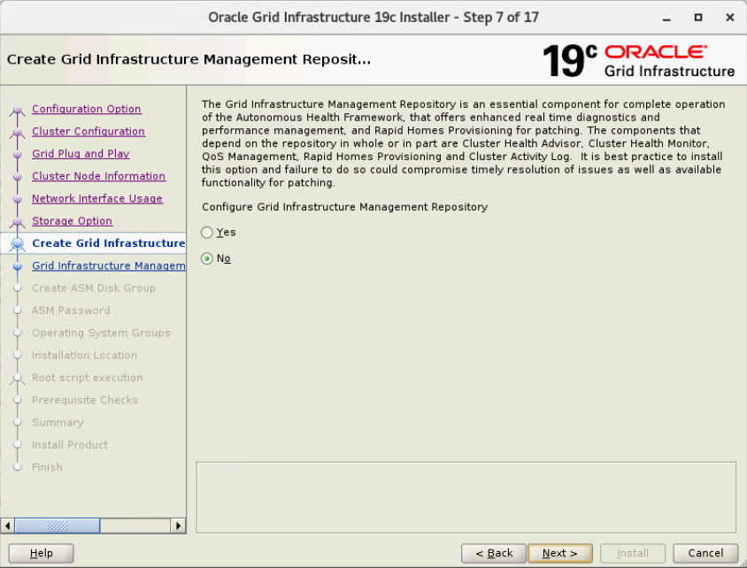

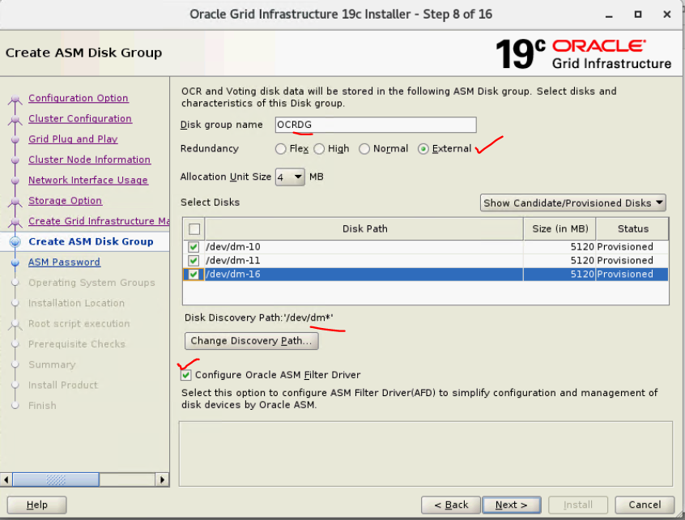

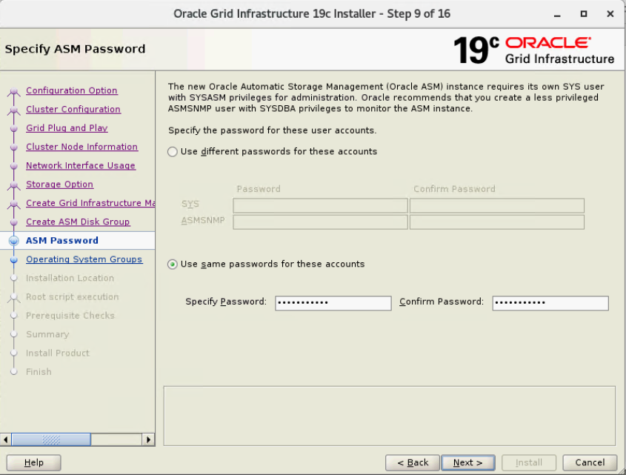

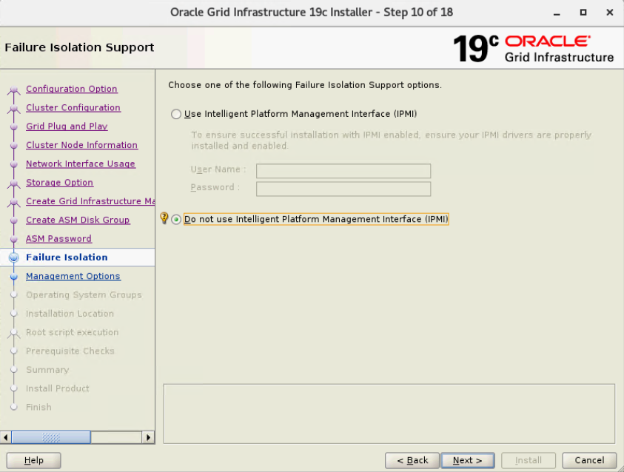

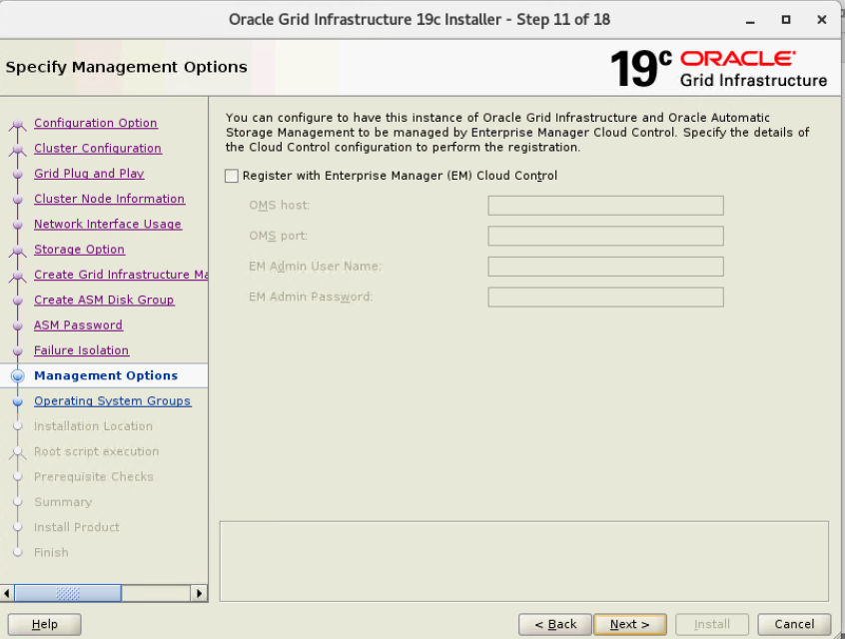

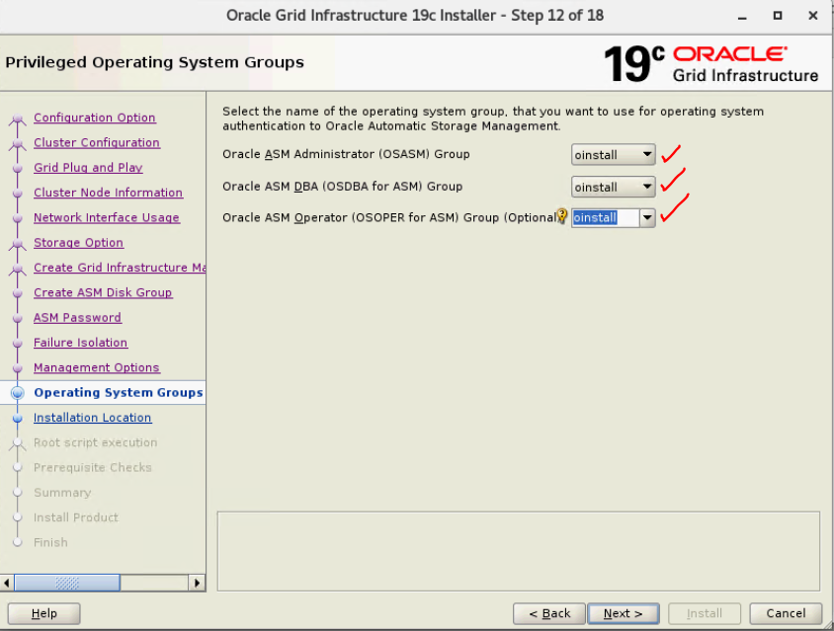

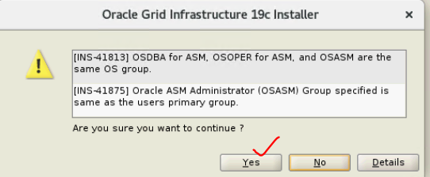

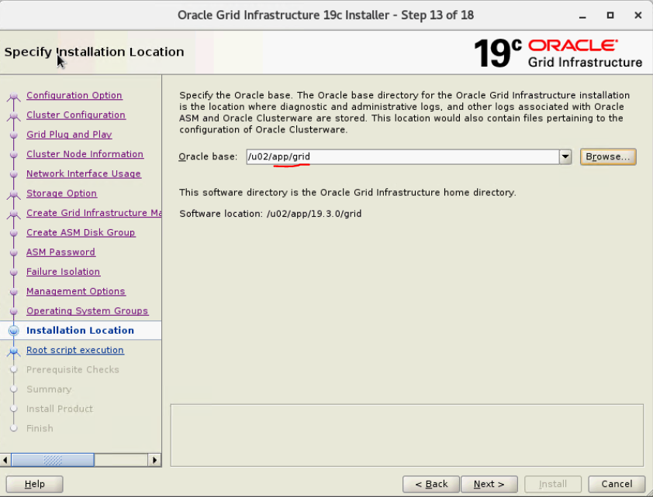

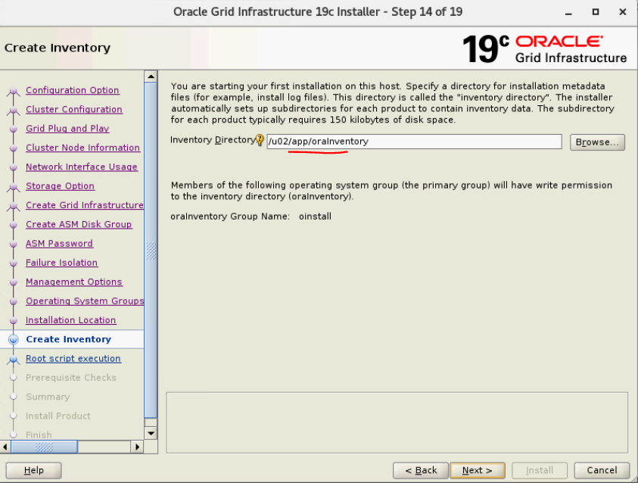

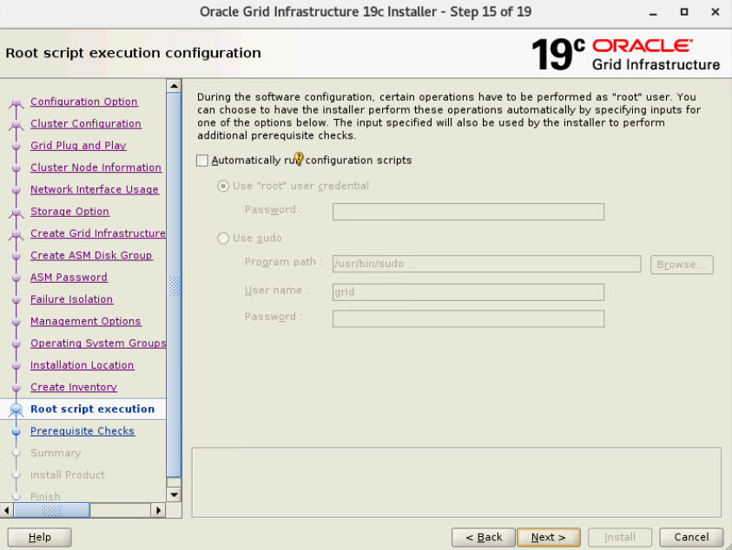

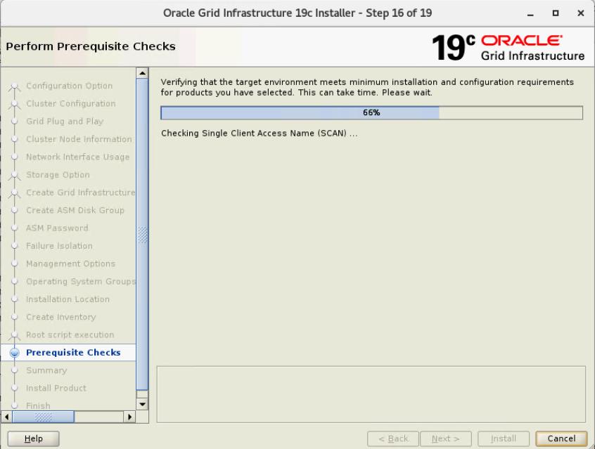

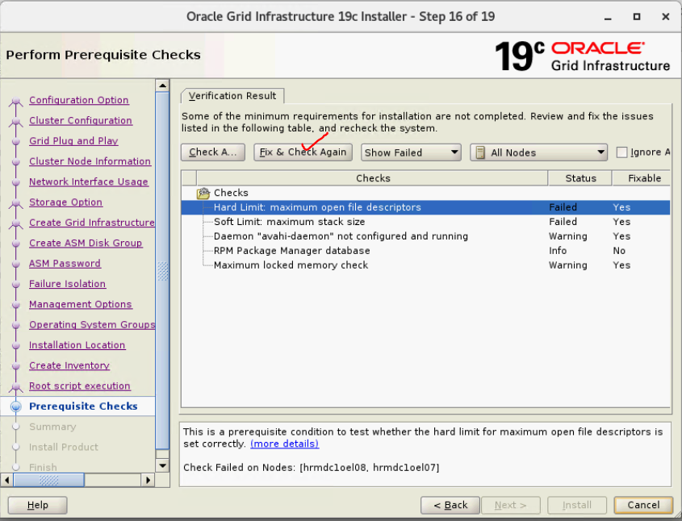

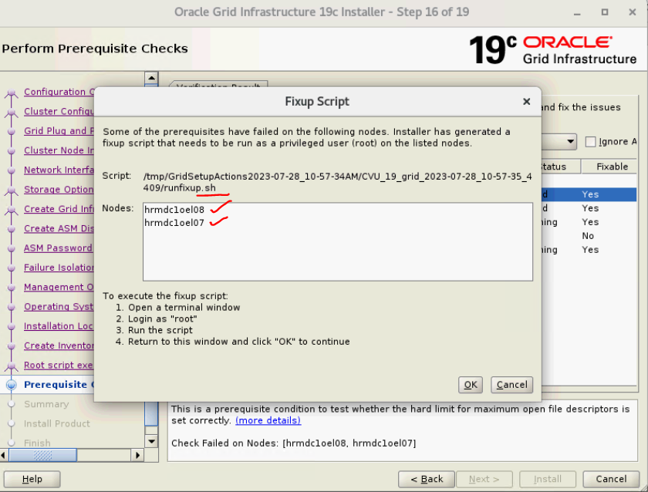

* Exit Oracle Installer and resart the./gridsetup again.
* 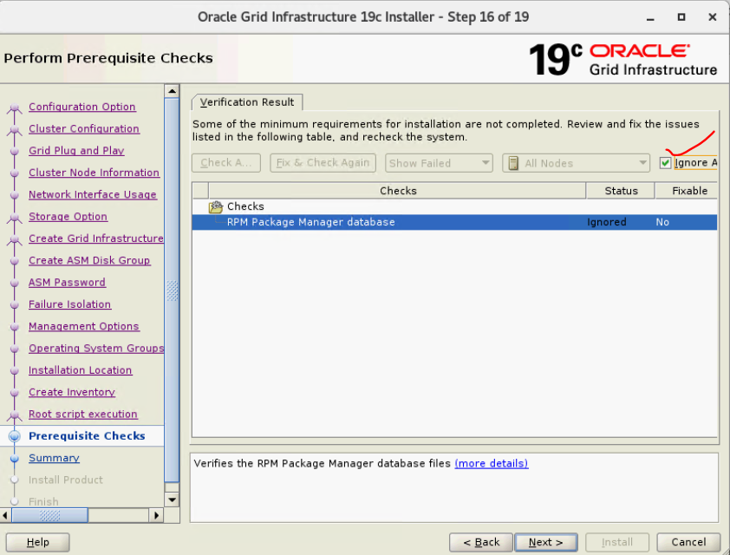

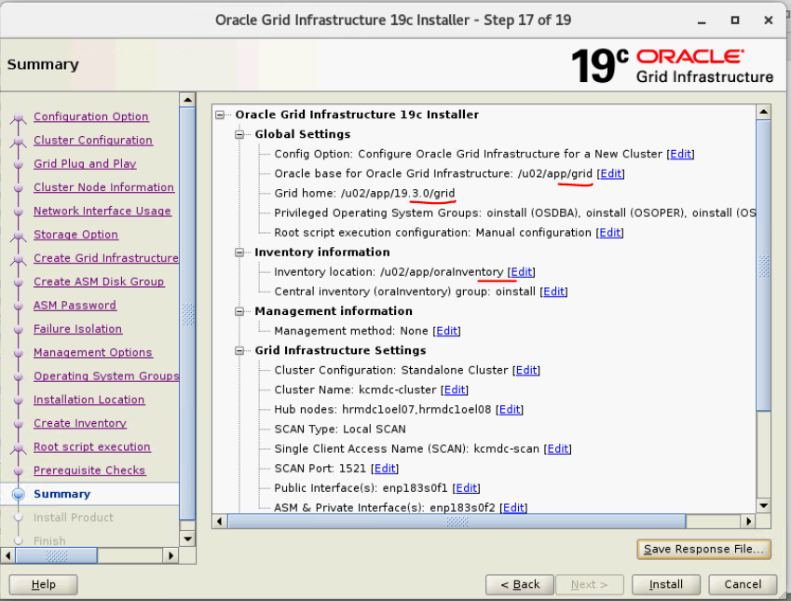

**-- Labeled ASM disks for KC Cluster**

**Partion disks:-**

[root@hrmdc1oel07 ~]#

fdisk -l /dev/dm-3 <--------- Check if disk is partioned.

fdisk -l /dev/dm-4 <--------- Check if disk is partioned.

fdisk -l /dev/dm-5 <--------- Check if disk is partioned.

fdisk -l /dev/dm-3 <--------- Partion disk

fdisk -l /dev/dm-4 <--------- Partion disk.

fdisk -l /dev/dm-5 <--------- Partion disk

[root@hrmdc1oel01 ~]# fdisk /dev/dm-3 <---------- Partion disk

Welcome to fdisk (util-linux 2.23.2).

Changes will remain in memory only, until you decide to write them.

Be careful before using the write command.

Device does not contain a recognized partition table

Building a new DOS disklabel with disk identifier 0x651c738f.

Command (m for help): n

Partition type:

p primary (0 primary, 0 extended, 4 free)

e extended

Select (default p): p

Partition number (1-4, default 1):

First sector (8192-1048575999, default 8192):

Using default value 8192

Last sector, +sectors or +size{K,M,G} (8192-1048575999, default 1048575999):

Using default value 1048575999

Partition 1 of type Linux and of size 500 GiB is set

Command (m for help): w

The partition table has been altered!

Calling ioctl() to re-read partition table.

WARNING: Re-reading the partition table failed with error 22: Invalid argument.

The kernel still uses the old table. The new table will be used at

the next reboot or after you run partprobe(8) or kpartx(8)

Syncing disks.

**Label disks:-**

Note:- Use “—init” only if you lable them before installing grid infrastructure.

it's not needed if you label after the GI installation complete.

asmcmd afd_label ASM_DISK_04 /dev/dm-3 --init

asmcmd afd_label ASM_DISK_05 /dev/dm-4 --init

asmcmd afd_label ASM_DISK_06 /dev/dm-5 --init

asmcmd afd_label ASM_DISK_07 /dev/dm-6 --init

asmcmd afd_label ASM_DISK_08 /dev/dm-7 --init

asmcmd afd_label ASM_DISK_09 /dev/dm-8 --init

asmcmd afd_label ASM_DISK_10 /dev/dm-9 --init

asmcmd afd_label ASM_DISK_11 /dev/dm-22 --init

asmcmd afd_label ASM_DISK_12 /dev/dm-17 --init

asmcmd afd_label ASM_DISK_13 /dev/dm-21 --init

asmcmd afd_label ASM_DISK_14 /dev/dm-18 --init

asmcmd afd_label ASM_DISK_15 /dev/dm-15 --init

asmcmd afd_label ASM_DISK_16 /dev/dm-13 --init

asmcmd afd_label ASM_DISK_17 /dev/dm-20 --init

asmcmd afd_label ASM_DISK_18 /dev/dm-19 --init

[root@hrmdc1oel07 ~]# asmcmd afd_label ASM_DISK_05 /dev/dm-4 --init

[root@hrmdc1oel07 ~]# asmcmd afd_label ASM_DISK_06 /dev/dm-5 --init

[root@hrmdc1oel07 ~]# asmcmd afd_label ASM_DISK_07 /dev/dm-6 --init

[root@hrmdc1oel07 ~]# asmcmd afd_label ASM_DISK_08 /dev/dm-7 --init

[root@hrmdc1oel07 ~]# asmcmd afd_label ASM_DISK_09 /dev/dm-8 --init

[root@hrmdc1oel07 ~]# asmcmd afd_label ASM_DISK_10 /dev/dm-9 --init

[root@hrmdc1oel07 ~]# asmcmd afd_label ASM_DISK_11 /dev/dm-22 --init

[root@hrmdc1oel07 ~]# asmcmd afd_label ASM_DISK_12 /dev/dm-17 --init

[root@hrmdc1oel07 ~]# asmcmd afd_label ASM_DISK_13 /dev/dm-21 --init

[root@hrmdc1oel07 ~]# asmcmd afd_label ASM_DISK_14 /dev/dm-18 --init

[root@hrmdc1oel07 ~]# asmcmd afd_label ASM_DISK_15 /dev/dm-15 --init

[root@hrmdc1oel07 ~]# asmcmd afd_label ASM_DISK_16 /dev/dm-13 --init

[root@hrmdc1oel07 ~]# asmcmd afd_label ASM_DISK_17 /dev/dm-20 --init

[root@hrmdc1oel07 ~]# asmcmd afd_label ASM_DISK_18 /dev/dm-19 --init

==============

[root@hrmdc1oel07 ~]# pwd

/root

[root@hrmdc1oel07 ~]# ls -l /dev/oracleafd/disks/

total 72

-rw-rw-r--. 1 grid oinstall 34 Jul 28 10:53 ASM_DISK_01

-rw-rw-r--. 1 grid oinstall 34 Jul 28 10:53 ASM_DISK_02

-rw-rw-r--. 1 grid oinstall 34 Jul 28 10:54 ASM_DISK_03

-rw-rw-r--. 1 grid oinstall 35 Jul 28 11:37 ASM_DISK_04

-rw-rw-r--. 1 grid oinstall 35 Jul 28 11:37 ASM_DISK_05

-rw-rw-r--. 1 grid oinstall 35 Jul 28 11:37 ASM_DISK_06

-rw-rw-r--. 1 grid oinstall 35 Jul 28 11:37 ASM_DISK_07

-rw-rw-r--. 1 grid oinstall 35 Jul 28 11:37 ASM_DISK_08

-rw-rw-r--. 1 grid oinstall 35 Jul 28 11:37 ASM_DISK_09

-rw-rw-r--. 1 grid oinstall 35 Jul 28 11:37 ASM_DISK_10

-rw-rw-r--. 1 grid oinstall 36 Jul 28 11:39 ASM_DISK_11

-rw-rw-r--. 1 grid oinstall 36 Jul 28 11:39 ASM_DISK_12

-rw-rw-r--. 1 grid oinstall 36 Jul 28 11:39 ASM_DISK_13

-rw-rw-r--. 1 grid oinstall 36 Jul 28 11:39 ASM_DISK_14

-rw-rw-r--. 1 grid oinstall 36 Jul 28 11:39 ASM_DISK_15

-rw-rw-r--. 1 grid oinstall 36 Jul 28 11:39 ASM_DISK_16

-rw-rw-r--. 1 grid oinstall 36 Jul 28 11:39 ASM_DISK_17

-rw-rw-r--. 1 grid oinstall 36 Jul 28 11:39 ASM_DISK_18

[root@hrmdc1oel07 ~]#

UNINSTALL oracle ASM package from all nodes

=======================================

[root@hrmdc1oel08 ~]# **yum search oracleasm**

Loaded plugins: langpacks, rhnplugin

This system is receiving updates from Spacewalk server.

================================================================ N/S matched: oracleasm =================================================================

kmod-oracleasm.x86_64 : oracleasm kernel module(s)

oracleasm-support.x86_64 : The Oracle Automatic Storage Management support programs.

Name and summary matches only, use "search all" for everything.

[root@hrmdc1oel08 ~]# **yum remove oracleasm-support.x86_64**

Loaded plugins: langpacks, rhnplugin

This system is receiving updates from Spacewalk server.

Resolving Dependencies

--> Running transaction check

---> Package oracleasm-support.x86_64 0:2.1.11-2.el7 will be erased

--> Finished Dependency Resolution

--> Finding unneeded leftover dependencies

Found and removing 0 unneeded dependencies

Dependencies Resolved

=========================================================================================================================================================

Package Arch Version Repository Size

=========================================================================================================================================================

Removing:

oracleasm-support x86_64 2.1.11-2.el7 @oel7-latest 266 k

Transaction Summary

=========================================================================================================================================================

Remove 1 Package

Installed size: 266 k

Is this ok [y/N]: y

Downloading packages:

Running transaction check

Running transaction test

Transaction test succeeded

Running transaction

Erasing : oracleasm-support-2.1.11-2.el7.x86_64 1/1

warning: /etc/sysconfig/oracleasm saved as /etc/sysconfig/oracleasm.rpmsave

Verifying : oracleasm-support-2.1.11-2.el7.x86_64 1/1

Removed:

oracleasm-support.x86_64 0:2.1.11-2.el7

Complete!

[root@hrmdc1oel08 ~]#