**SAMPLE OUTPUT:**

**Scenario 1:**

**Low Health, no potion, enemy nearby**

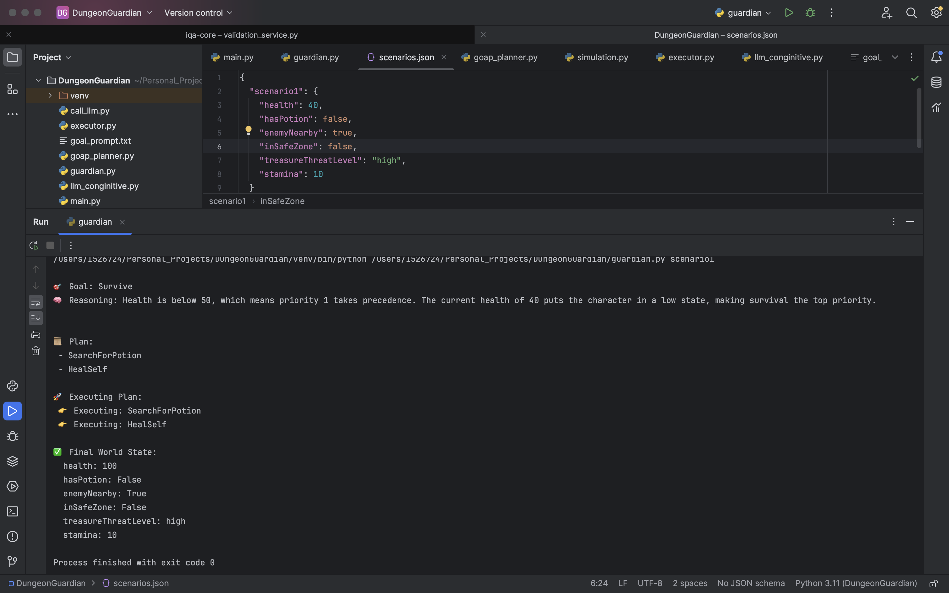

*After applying BFS for the planning*

**Scenario 2:**

**Good Health, Medium Treasure Threat**

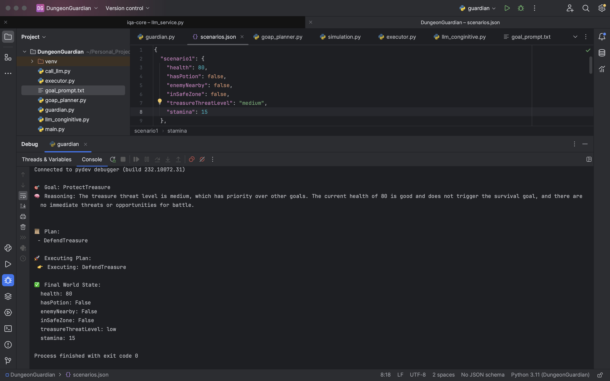

*Greedy planning, returning only one best action*