EAP Support Site Guide

Contents
INTRODUCTION 3
Purpose 3
Audience 3
SITE LOGIN 3
ALL PROCESS 3
Run Configuration 3
IO Configuration 3
Email Whitelist 4
Manage Escalation 4
Dynamic Workflow 4
HISTORICAL REQUEST 4
Upload Bulk Historical Data 5
Prerequisites to upload historical data 5
Existing Request (1) 8
New Request (2) 8
View Created/Updated Request 9
ALL REQUEST 10
ADMIN CONSOLE 10
Manage Process Users 10
Add User (1) 13
Modify User (2) 14
Activate/Inactivate User (3) 14
Upload Bulk Historic Data 15
Existing Request (1) 17
New Request (2) 17
Manage Integrated System Availability 17
BULK UPLOAD 17
Upload Bulk Users 18
TROUBLESHOOTING 19

INTRODUCTION
EAP Support site hosts multiple support functions which are necessary for Business-As-Usual support operations.

Purpose
The purpose of this document is to list out each feature of the EAP Support site and detail the Standard Operating Procedure for all EAP Platform support activities

Audience
- Prod support team
- UAT team
- SIT team
- Developers

SITE LOGIN
After logging into Appian, click on the site drop down (indicated by the arrow) and select ‘EAP Production Support’ site from the drop down list.
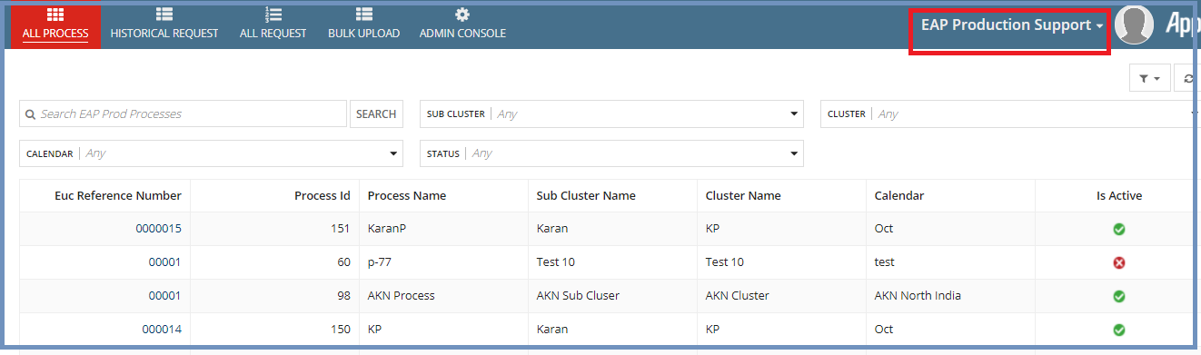

ALL PROCESS
This tabbed section lists all the processes which are created from EUC site. The search feature helps to find the process by process name, sub cluster, cluster, calendar and status. Clicking on Euc Reference Number takes to the respective process. There are various related actions like Run Configuration, IO Configuration etc. that a user can perform with respect to the process either through the related Actions tab of the process or by going inside the tabs. Now let us see each section into details.

Run Configuration
This lists all the existing run configurations created for the process which are created by End User Computing site. These run configuration can be managed only and cannot be created. While managing the run config a user can make changes to its status only as all other fields are disabled for him.

IO Configuration
This lists all the existing IO configurations created for the process which are created by End User Computing site. A user can view, manage/edit the created IO configs. For an IO configuration, only Escalation Config Details can be managed by a user. A user can add/removes escalation details for an IO config.

Email Whitelist
Email Whitelist can be managed by adding, removing the In-Bound, and Out-Bound email details. Also a user can make any email active/inactive.

Manage Escalation
This shows the existing process escalation recipients for Level 1, 2, 3 and 4. A user can manage escalations as well by adding/removing the details and by making it active/inactive.

Dynamic Workflow
This tab lists all the existing workflows with all its details. A user has only privilege to make changes to SLA duration and escalation threshold entries.

HISTORICAL REQUEST
Historical Request tab shows all requests for which a user has uploaded the historical data from EAP Production Support site-Admin Console->Upload Bulk Historical Data.
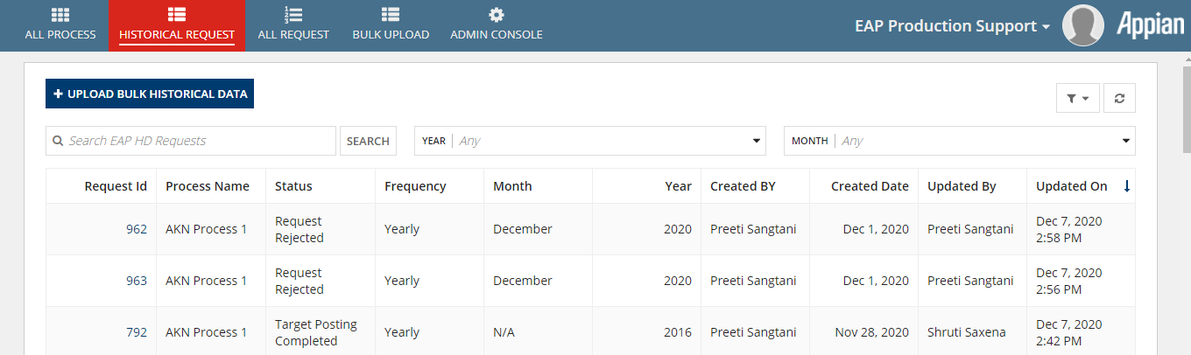

Clicking any Request Id takes to the respective request summary dashboard where a user can see the historical Tran’s data for each run. User can also view each run by clicking eye icon to see the status i.e. success or failed, along with other details like Uploaded Document, Exception message in case of failed, Requested By and Requested On etc.
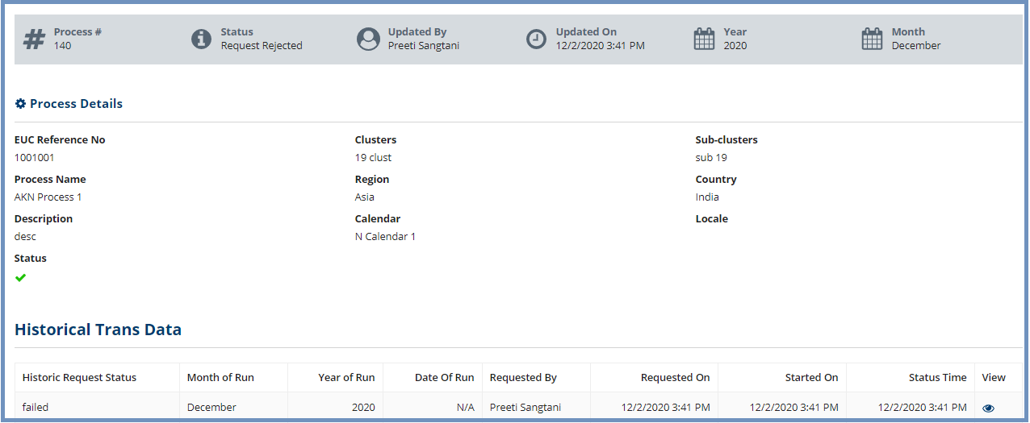

Upload Bulk Historical Data
This feature available under HISTORICAL REQUEST tab is same as of ADMIN CONSOLE-> Upload Bulk Historic Data.

Prerequisites to upload historical data
Entity sheet mapping from End User Computing site->Admin Console->Manage Historical Data
In order to upload the historical data from production support site, entity sheet mapping needs to be done from End User Computing site->Admin Console->Manage Historical Data.
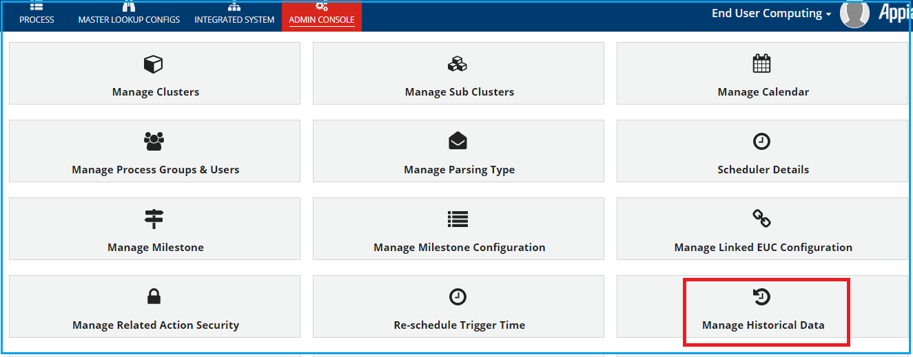
Navigate to End User Computing site->Admin Console->Manage Historical Data. Select EUC Reference Number, Process Name and Run Config Name from dropdown, click EDIT ENTITY. Provide the entity- sheet mapping and save it as shown in below screenshot.
Note: “Manage Historical Data” is now moved to “End User Computing” site.

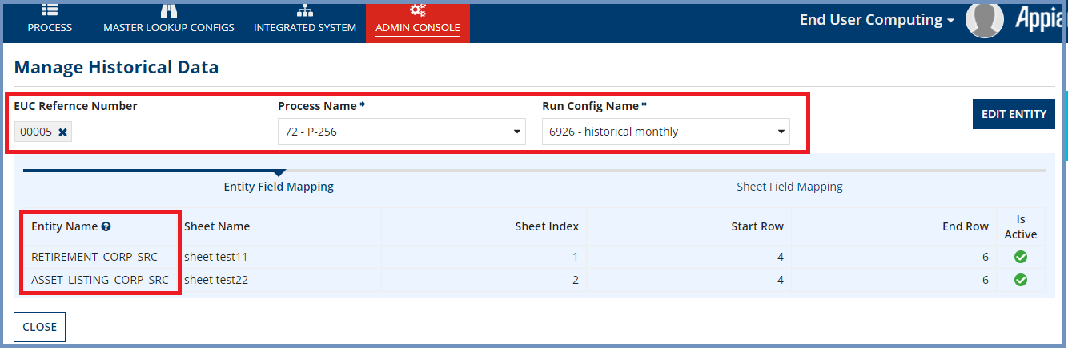
Preparing the excel sheet to upload
Before uploading the file, make following changes in it: Cell A2 should contain the month and cell B2 should contain the year and cell C2 should contain the date for which you are uploading the file.(always A2, B2 and C2)
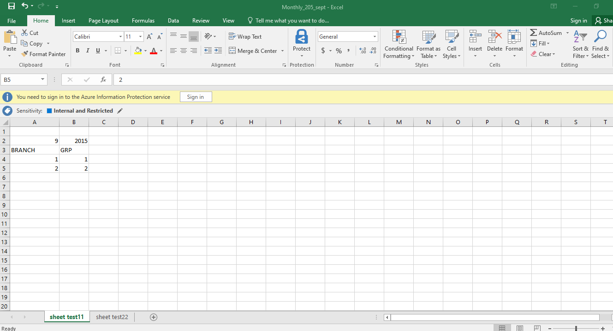
Now go back to Production Support Site->Historical Request tab and click UPLOAD BULK HISTORICAL DATA to upload the historical data.
Select the same EUC Reference Number, Process Name and Run Config Name for which mapping is done from End User Computing site->Admin Console->Manage Historical Data. It will show frequency as per the run config.
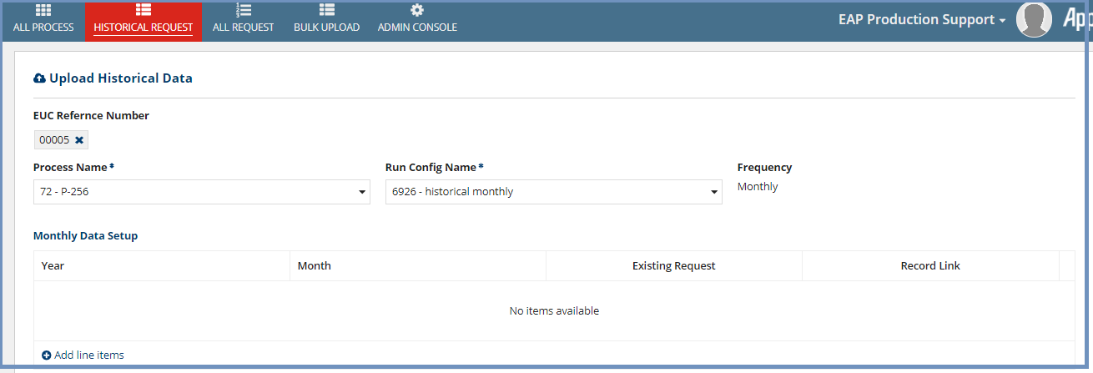
Note: User can upload the data only for yearly, monthly, daily type of run config. For weekly type of run config user cannot upload the historical data. If user selects a weekly run config from dropdown, an error message will be displayed like below:
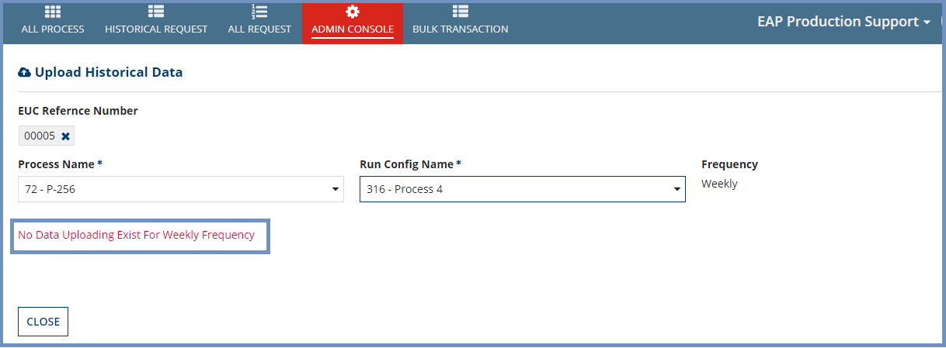
For instance, in the below screenshot, monthly type run config is selected.
Click Add line items and select year and month from dropdown.
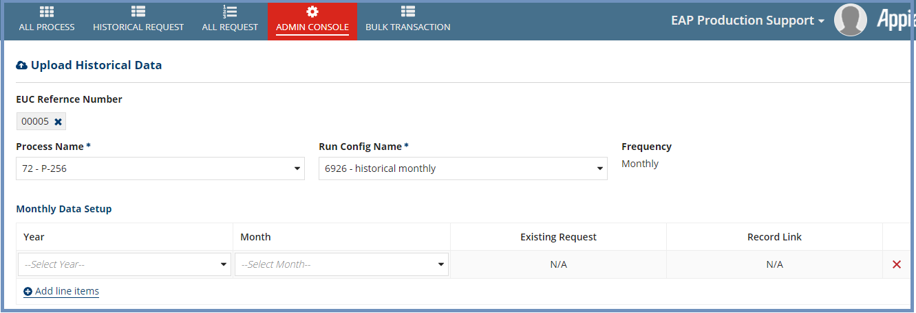
If the request is already raised for the respective year and month, existing request Id and request link is shown under the field Existing Request and Record link respectively otherwise N/A will be displayed.
Now click PROCEED TO UPLOAD DOCUMENT button. The page will display the process and run config details along with upload file feature to upload the file for all the entities which are mapped with the sheets as a prerequisite from End User Computing site->Admin Console->Manage Historical Data.
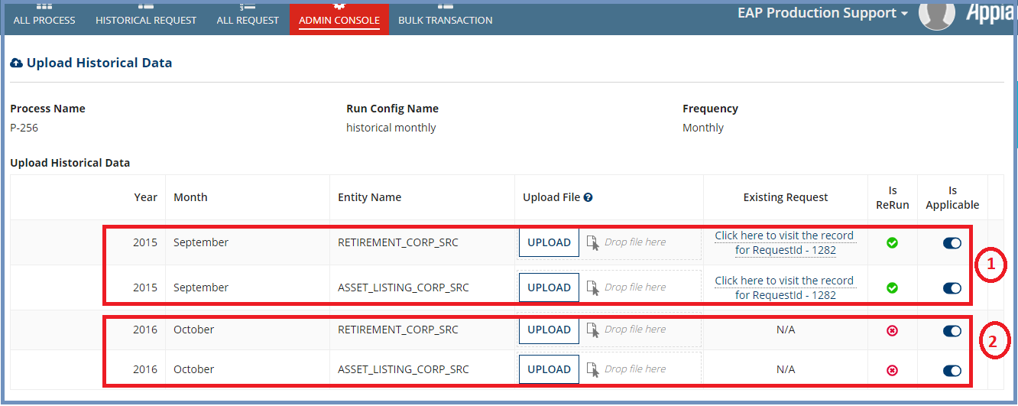

Existing Request (1)
For existing request user can rerun the request by uploading the file again or he/she can disable the rerun by making Is Applicable fields inactive and submit the request(s).
Note: For existing requests which are triggered on Ad-Hoc basis from End User Computing site->Run Configuration, a user cannot proceed with uploading the file.
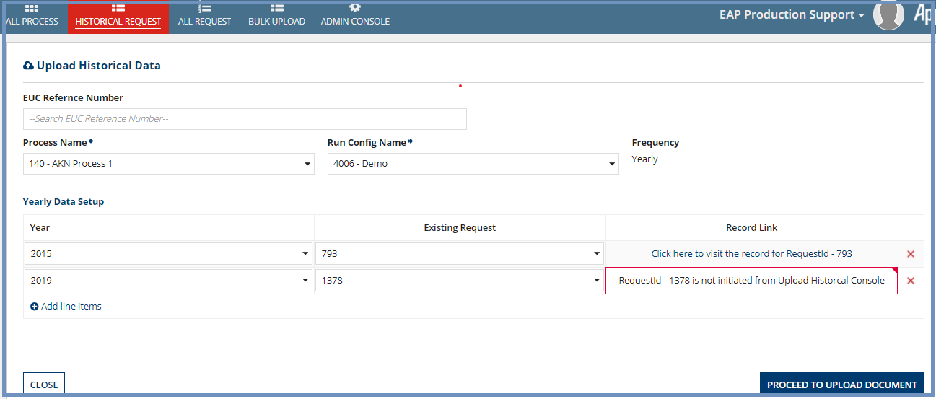

New Request (2)
A new file can be uploaded against the new request. Also it can be discarded/disabled by making Is Applicable field inactive submit the request(s).
Note: In case of multiple requests for year there should be at least one request applicable. If user wants to inactivate all request for a year he has to remove the year entry from previous page (i.e. Data Setup grid).
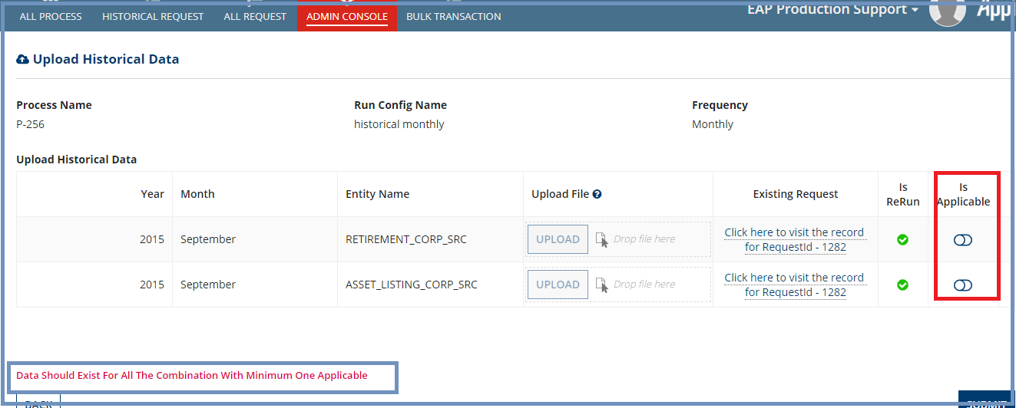

View Created/Updated Request
Click the created request link on HISTORICAL REQUEST tab to see the details on summary dashboard and the historical Tran’s data for each run.
Click on view for any run to view the details and download the last uploaded file.
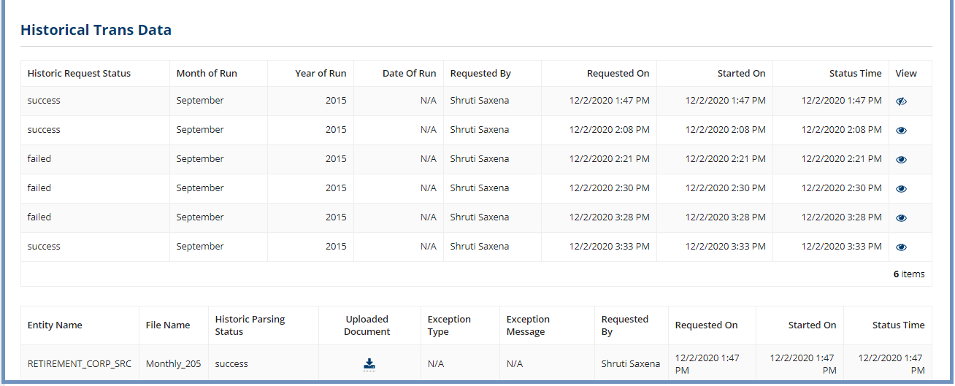
Now navigate to its Related Actions tab where a user can upload the file by using by Manage Bulk Upload Historical Data.
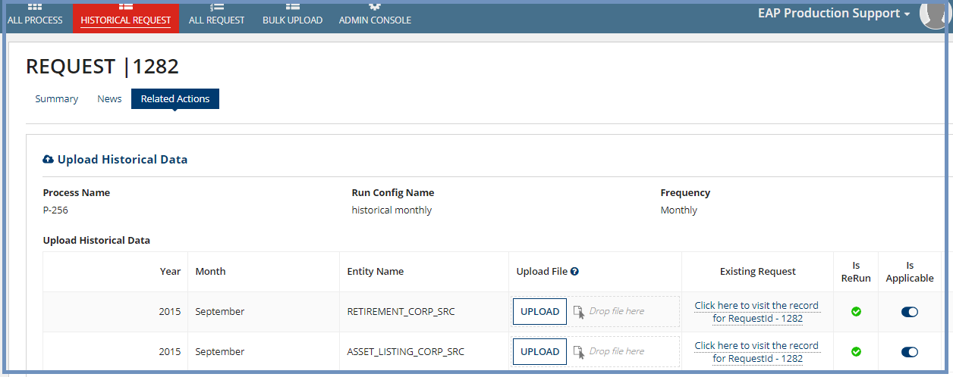

ALL REQUEST
This lists all the requests including historical requests.
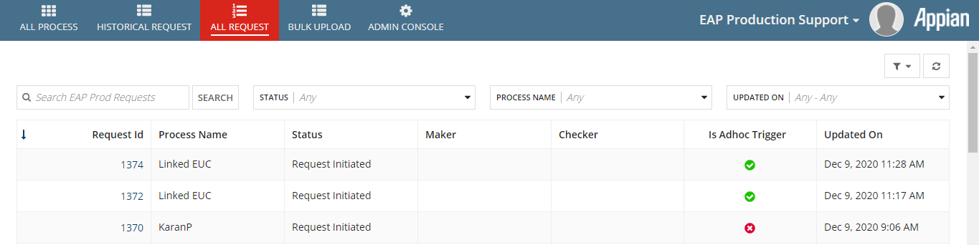
Clicking any request takes a user to respective request summary detail view.
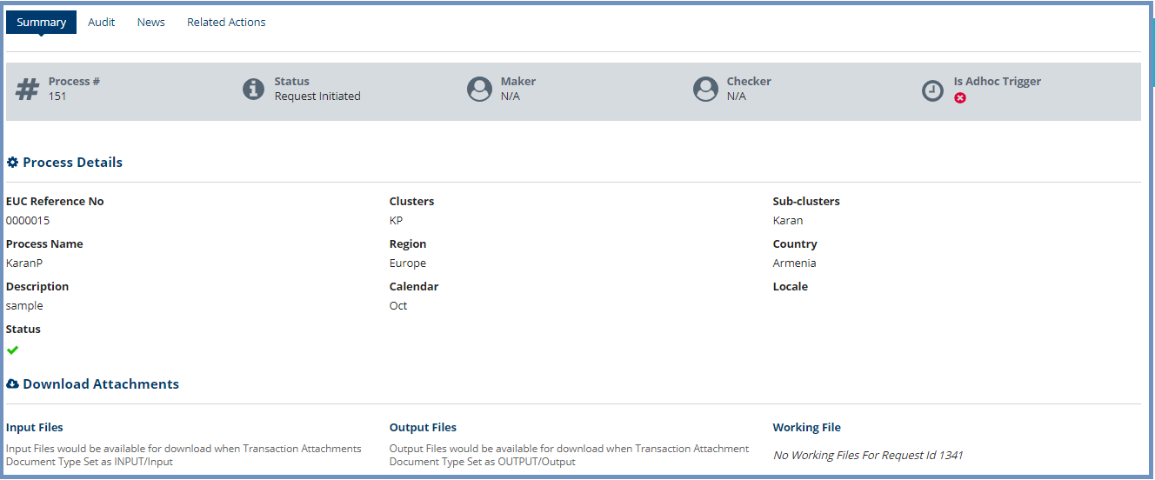

ADMIN CONSOLE

Manage Process Users
Click on the ‘Manage Process Users’ link to open the User Management page.
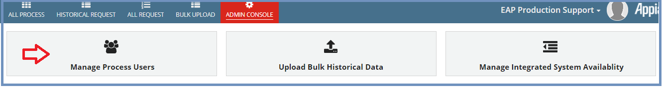
Enter EUC Reference Number (picker) [1] and select the appropriate Process Name (Drop down) [2]
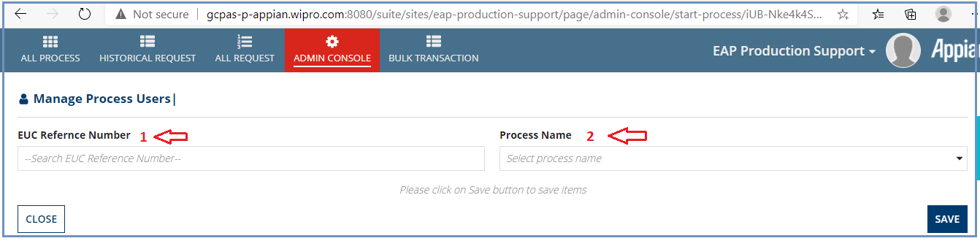
The page with the list of existing user configuration is displayed (if users are already added for the particular EUC, otherwise no entries displayed). Review the list and make sure what actions need to be performed.
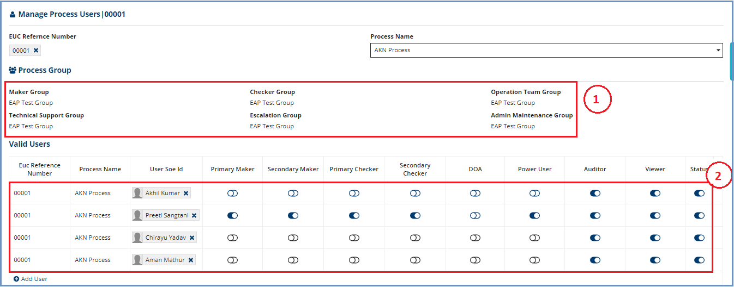
1 – Group information
Review if the group information is correct. If the Group information is not correct, contact the development team to correct it in development and redeploy the EUC configuration.
2 – User list and their configured role
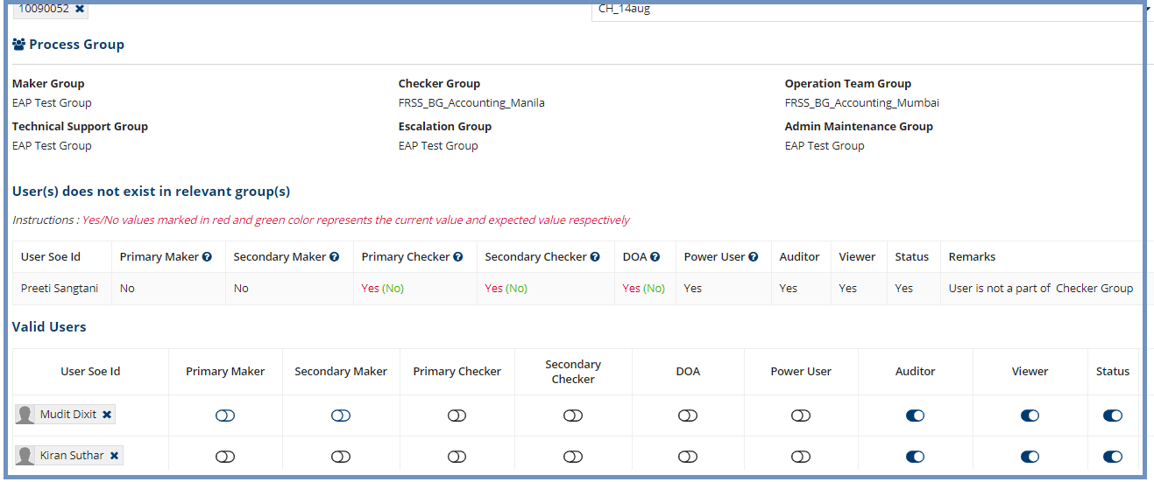
On this page there can be three types of user grids.
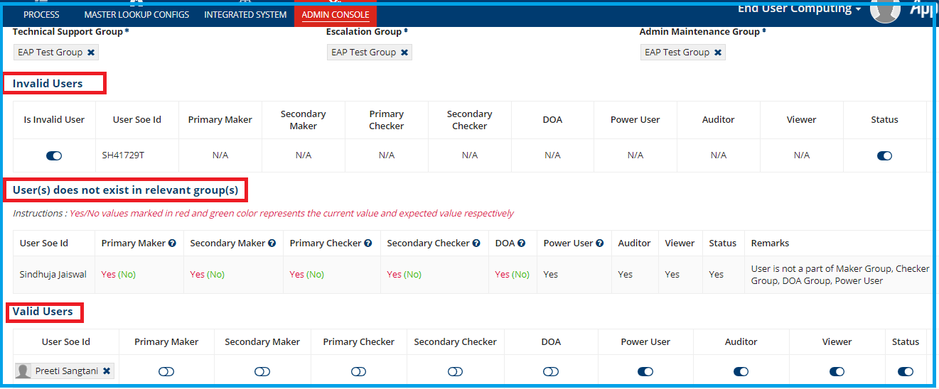
- Invalid Users
This grid will automatically be shown:-
- If invalid user(s) have been entered from backend
- If that particular user got inactivated from the environment
- Valid Users
This section will display all the valid user details with all the current roles assigned.
- User(s) does not exist in relevant group(s)
This section shows the list of all the users entered from backend which are not a part of Maker/Checker group as per the Maker/Checker group assigned for the respective process. The details will display the conflict in Yes/No for group where Yes/No values marked in red and green color represents the current value and expected value respectively.
Click Save button to save the users. It will display Users have been added message.
Once save button is clicked, users in “User(s) does not exist in relevant group(s)” group will get moved to valid users grid and the users across “Invalid Users” and “User(s) does not exist in relevant group(s)” grid will get added to the process summary dashboard with all the expected roles value.
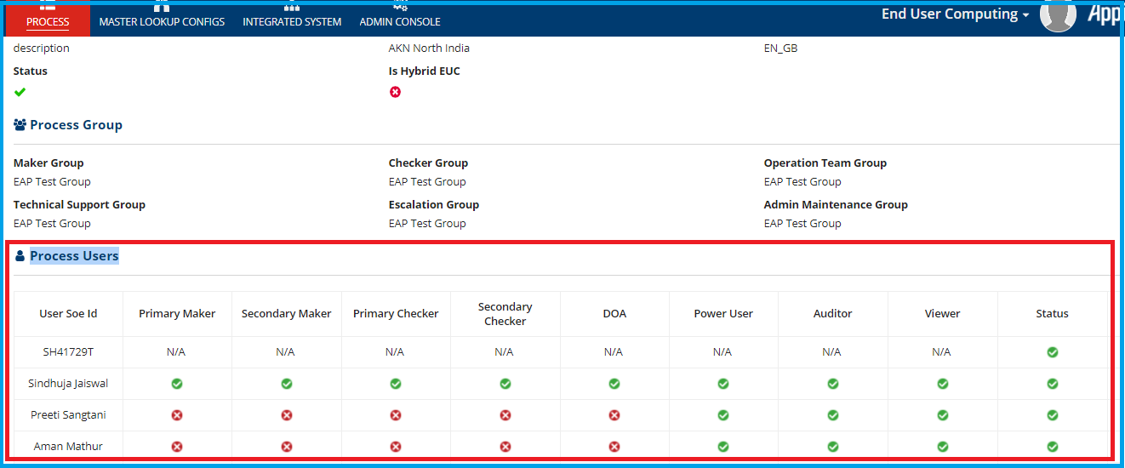
Check if the required users are configured correctly with the appropriate roles (Primary Maker, Secondary Maker, Primary Checker, Secondary Checker, DOA, Viewer) and active/Inactive configuration for each of the user grids provided.

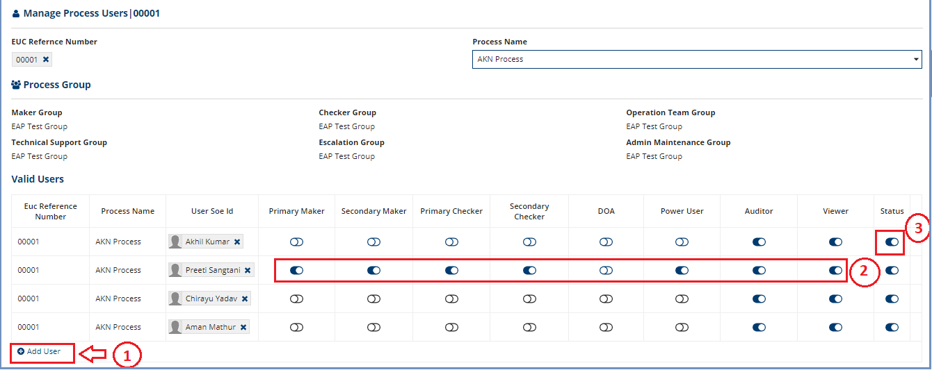

Add User (1)
Click on the Add User link (as indicated – 1) to add new user. New row will be added with the user picker to enter new user.
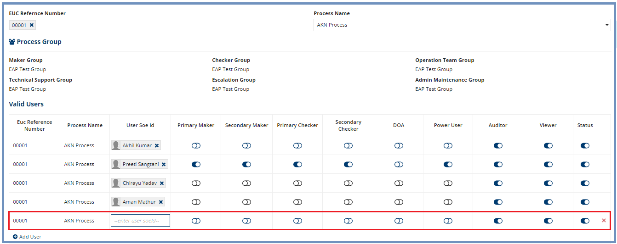
Type in Name of the user or SOEID of the user. User Picker displays the matching user, select user from the list.
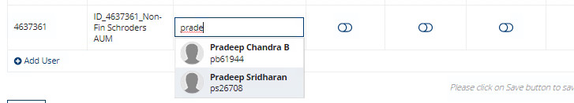
Based on the user participation in Appian Groups, the toggle button is enabled against each role. For instance, the selected user below is available in all groups (Maker/Checker/DOA) and hence toggle button is enabled for each role.
#User is part of all groups (Maker / Checker)
#User is part of only Checker group
Note: User can be a part of DOA if he is a member of either Maker or Checker group whereas any valid user can be a Power User.
#User is neither part of Maker nor Checker group
Do’s:
- If the toggle button is disabled (unable to enable), then that means the User doesn’t belong to the corresponding group. Follow the process to add user to the Appian Group
- If the User is not listed in the picker, then that means the User is not present in Appian. Follow the process to onboard the user into Appian

Modify User (2)
Select required role by clicking on the toggle button for the user.
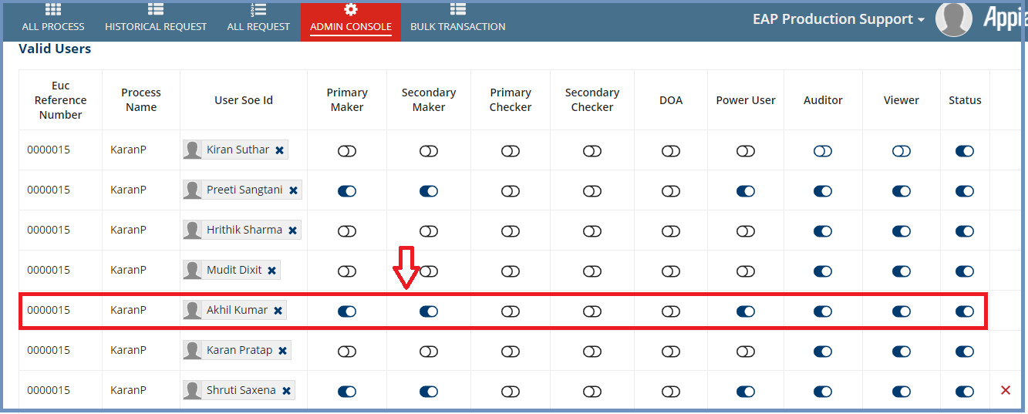

Activate/Inactivate User (3)
Locate the ‘Status’ column and the user for whom Active/Inactive action to be performed. Click on the toggle button to either Activate or Inactivate the user.
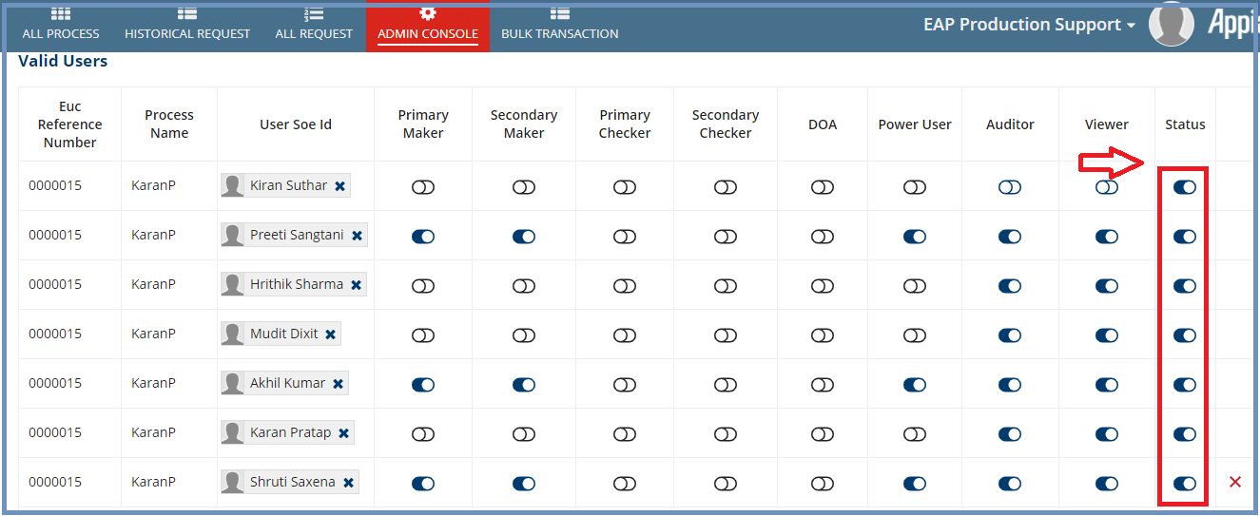
Click on the ‘Save’ button to save the changes.
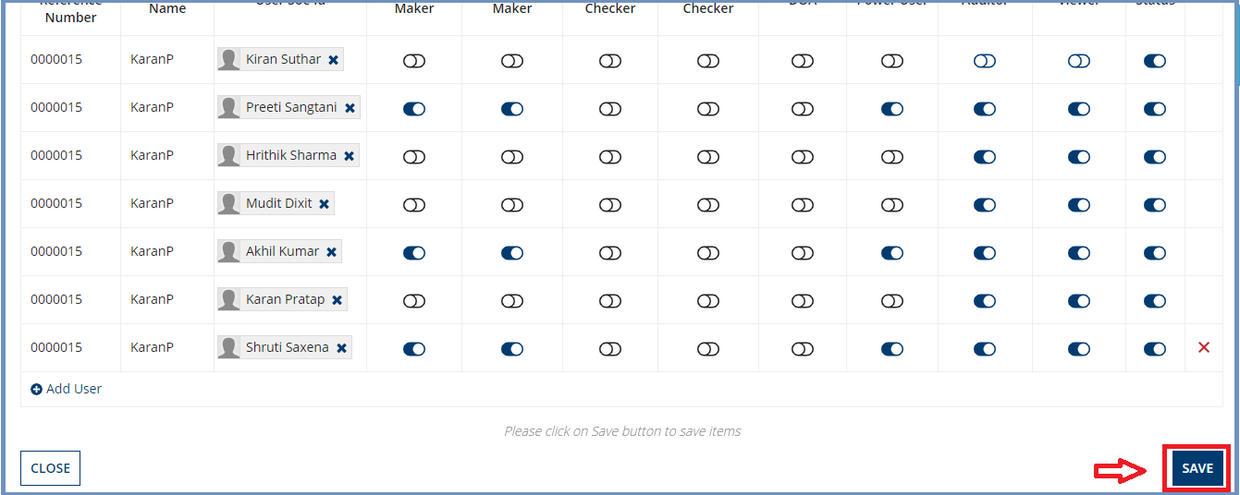
If the changes are successfully saved, then it displays an ‘Users has been added’ message.
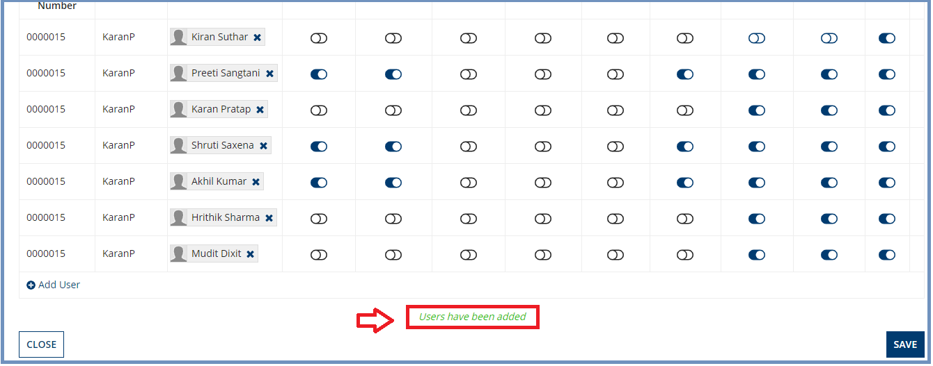
Click on the ‘Close’ button if changes don’t need to be saved.

Upload Bulk Historic Data
Go to Admin console and select Upload Bulk Historical Data
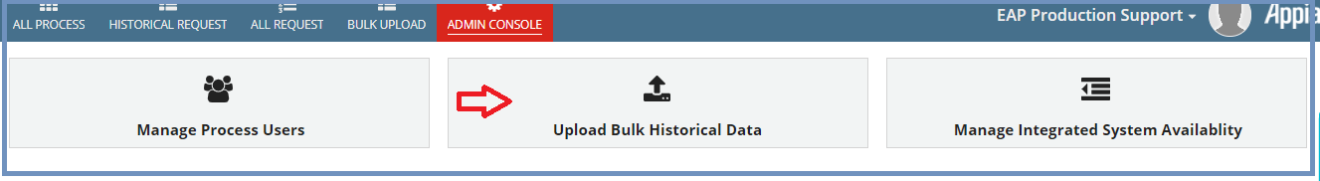
Enter EUC Reference Number (picker) [1], select the appropriate Process Name (Drop down) [2] and Run Config Name (Drop down) [3].
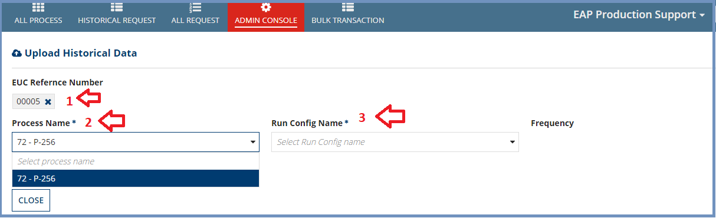
Click Add line items and select year and month from dropdown.
Now click PROCEED TO UPLOAD DOCUMENT.

Existing Request (1)
For existing request user can rerun the request by uploading the file again or he/she can disable the rerun by making Is Applicable fields inactive.

New Request (2)
A new file can be uploaded against the new request. Also it can be disabled by making Is Applicable field inactive.
Created request(s) can be viewed on HISTORICAL REQUEST tab.

Manage Integrated System Availability
This enables user to manage the integration by making it active/inactive.
Click on Manage Integrated System Availability to open the page.
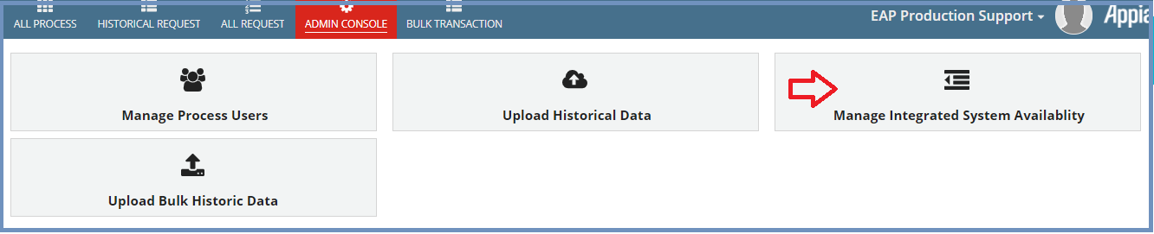
Selecting look up system code shows associated system type code. Now user can make the toggle button active or inactive and submit.
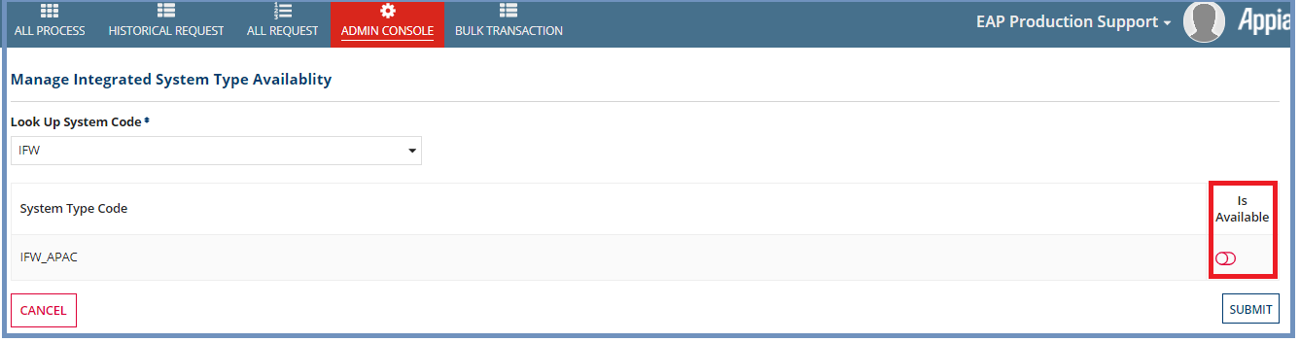

BULK UPLOAD
This tabbed section lists all the transaction requests in which users have been added for one or multiple processes. Search feature enables user to search the requests based on Transaction Id and Status filter. Users for multiple processes can be added by clicking UPLOAD BULK USERS.
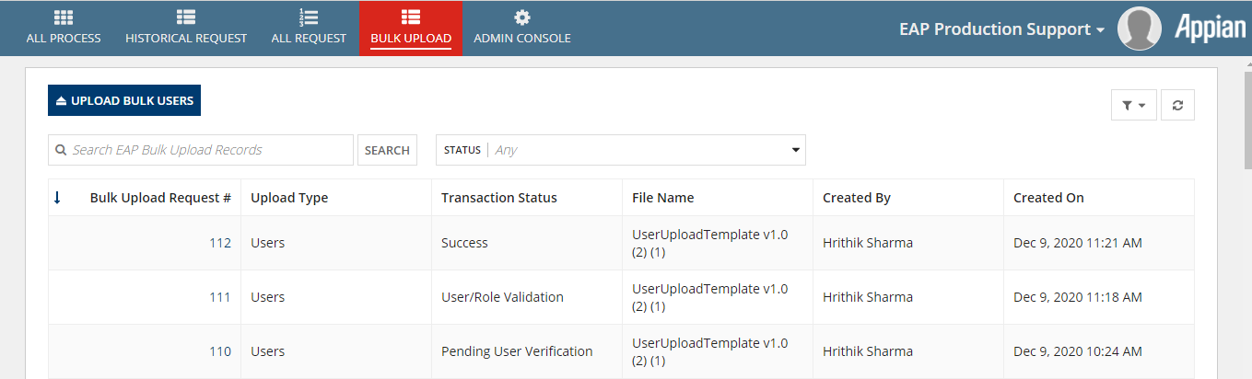
Clicking each request navigates to respective request summary dashboard. On summary it shows the successfully added user details and failed user details under SUCCESS and FAILED tabs respectively as shown in below picture.
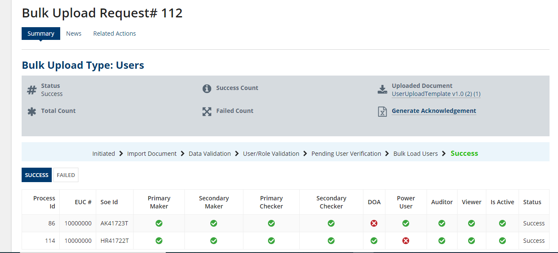

Upload Bulk Users
Click UPLOAD BULK USERS button on BULK UPLOAD tab. This page will give an option to upload the excel document.
Note:- User can download the sample template by clicking Download Sample Template link, modify it as per his/her inputs and upload it back.
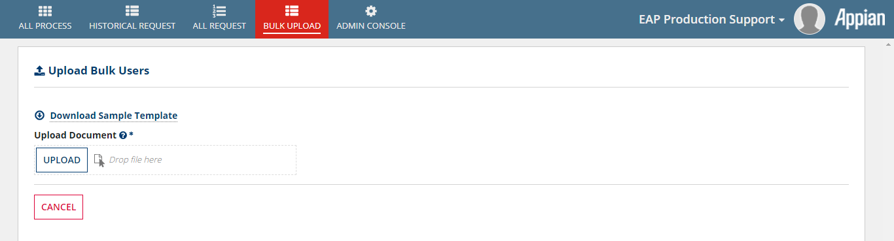

TROUBLESHOOTING
‘Task Could Not Be Submitted’ Error
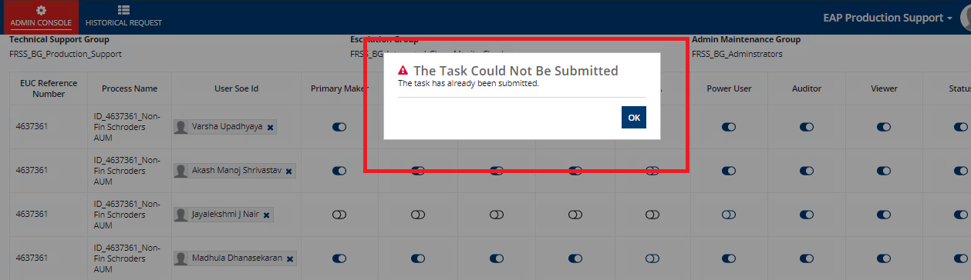
This error occurs when the activity expires/timed out. If this error comes, then start from beginning.

