|  |  |
| --- | --- |
| Bike service  WEB APP | SAMRATH SINGH  0225648043  [Samrath9988@gmail.com](mailto:Samrath9988@gmail.com)  Final -Project  Level- 6 |

Level - 6

# Task 1 – Identyfying Task Problems:

-Information of Client

1. Client Name: Lovepreet Singh

2. Client Contact: 02268159863.

3.Project Name: Bike Services

4. Client Email: [pb02love@gmail.com](mailto:pb02love@gmail.com)

5. Expected Date: 24 nov 2021

## Project Performance

The deliverables of the project are:

|  |  |
| --- | --- |
| Deliverable | Description |
| Final Report | This will be the final report of the project. |
| Coding | The executable code of the project will go under this. |
| Documentation | This portrays the documentation of the project. |
| Testing | All the test details will be covered in this part. |

## Appropriate Resources

* Windows Operating System.
* Microsoft word for documentation.
* Asp.net MVC Framework
* 64-bit Processor and 4 GB or more RAM
* Identity framework- ASP

**Project Tasks and Milestones**

|  |  |  |  |  |
| --- | --- | --- | --- | --- |
| **Tasks** | **Week-1** | **Week-2** | **Week-3** | **Week-4** |
| Brainstorming and analysis |  |  |  |  |
| Planning and initial meeting Project Proposal document. |  |  |  |  |
| Database Design and UI Design |  |  |  |  |
| Identity framework implementation |  |  |  |  |
| Coding for admin and reporter |  |  |  |  |
| Testing |  |  |  |  |
| Final Documentation and closing |  |  |  |  |

Objectives:

1. **To reduce error :** There are number of roadblocks in the Web App project but the main problems in project are as follows :

* *Slow Server and Loading time*
* *Poor coding*

In order to cope up with the above stated problem my app is hosted by sharing the account to cope up the slow server .However poor coding is tackle with optimal coding practices

1. **App Design :**The overall app design needs to both functional and unfunctional because visitors usually judge the app how it look and how often its been updated as such in my app everything is presented with images and regularly updated which makes brand looks professional..
2. **Mobile Compability :** In the modern era , the web traffic is increasing day by day and it is noticed most of web traffic is through the smartphones. So the app should be mobile friendly . My bikes app is mobile friendly which will attract more web traffic.

**Task-2** Document Requirments

Scope of Work- The Scope of my web app defines my project as it tells about the project setup tasks and also gives the information about the web app. Some features of the scope are defined below:

Functional Scope- My web app Provides different types of bikes services products Like batteries which can be added in the cart by the customer when he register himself in the web app.

Non-Funtional Scope- Non-Functional scope reffers to the Security and performance in the web app and the web app has https function which makes the web app fully secured.

**Functional and Non-Functional**

|  |  |
| --- | --- |
| Users | Functional |
| Admin | * Login/logout * Register new admins * Admin can add, edit, delete and check details of Services, Packages, Companies and their Bike Models which they serviced * Admin can also view the all booking of Bike Packages done at online and have authority to confirm them. |
| Customer | * Can view details of all services, packages, companies and their Bike models which available at service station * Registered user capable to book their bike service packages at their given time and date. * Registered user capable to view all booking history done at Bike Service * New customers can register for free. * Login using valid credentials |
|  | Non- Functional |
|  | * High speed * Fast Loading time * High performance and security * All browsers compatibility. |

Timing:

The total timing taken to make the project is defined below:

|  |  |
| --- | --- |
| Analyse the Project Requirement | It took me few days between 08/11/2021 to 11/11/2021 to analyse the requirements for projects approximately an hour a day |
| Making the Project Proposal | In order to make the project proposal after analysing the requirements I made the checklist which helps to ulitise the time and took around three hours each for further two days |
| Research and Final Project | Once everything for theory part was finalised , I decided logo and images for my bike app |

Cost of the Project-

|  |  |
| --- | --- |
| Web App Features | Web App Cost |
| Web Domain | $115 |
| Web Theme | $250 |
| Web Content | $550 |
| Login Page | $200 |
| Total cost | $1115 |

Project Management:

|  |  |  |  |
| --- | --- | --- | --- |
| No. | Pages | Pass | Fail |
| 1. | Homepage | Pass |  |
| 2. | Section Page | Pass |  |
| 3. | Category | Pass |  |
| 4. | Product | Pass |  |
| 5. | Admin | Pass |  |

Risk Management:

It is the negative factor that occurs internally and exterally that causes the risk management failure in the website . Some of few examples are :

Adding Unnecessary features: Web apps with unnecessary features and pages are at risk of losing customers, since they drive them away

Web App Stability: In order to avoid errors like browser crashes, incompatible browsers, and incorrect memory usage, app should be properly designed.

Poor Scope: Scope is an important factor in determining the effectiveness of the web application, as it identifies all its useful features.

Identifying: An application can be made better by finding errors in its content, scope, and goals to prevent potential risks.

Client Meeting:

In this case, the client was a mutual friend who wanted a Web App developed for his business. He provided me with several requirements such as the Scope, Purpose and Type of App he wants, about the business and shared templates of APP

Target Audience

People from the ages of 18 to 100 can take part in this project, who are seeking a hassle-free way to maintain their bike.

## **Presumptions for Project**

Following are the assumption made while implementing the project:

* In default, a user and an admin will be registered.
* The application will be free and open source.

Wireframes

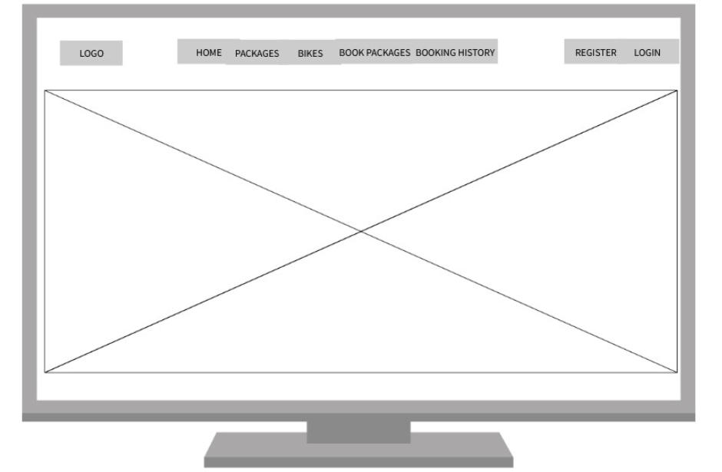

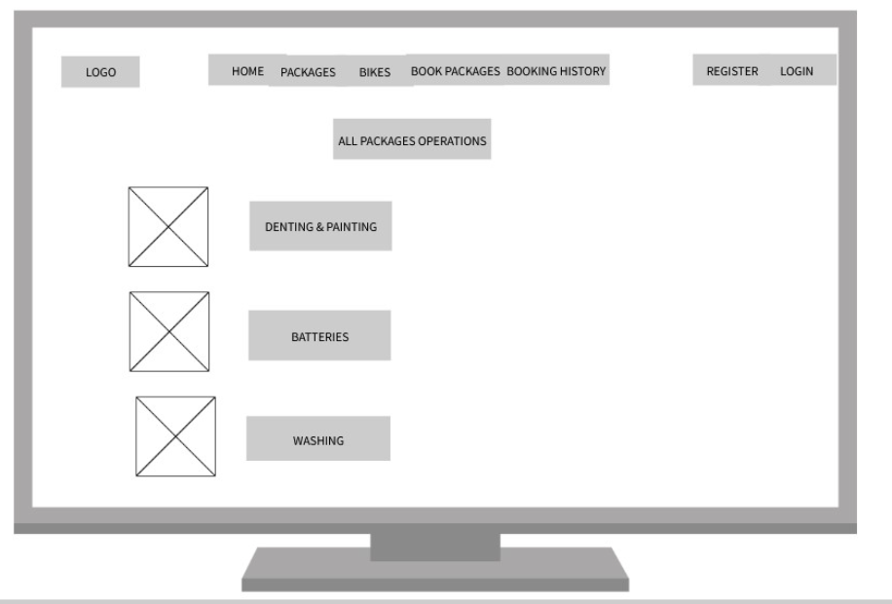

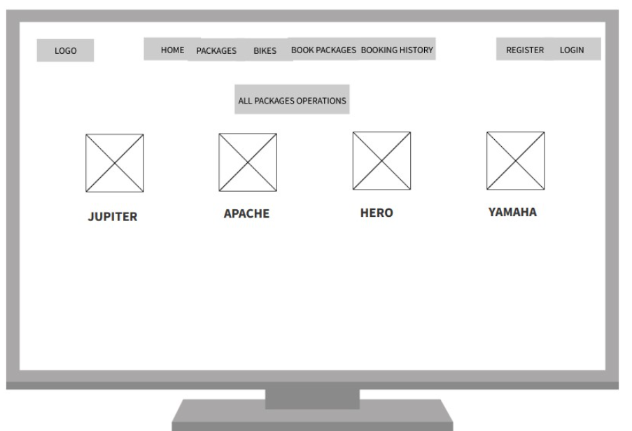

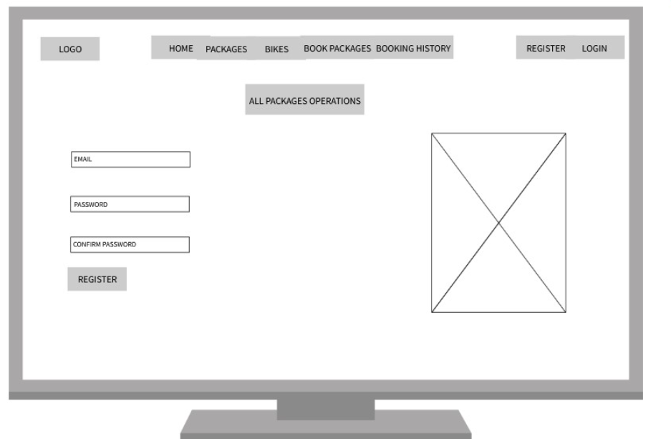

### Task 3- Design Mockups

## *Detail Design*

### Home Page

The main landing page of the application. This is the first page of our application with a map to visit our web application.

### All Package Page

With the help of this page, we can show all services packages available on our service station.

### All Bikes Page

With the help of this page, visitor have a glimpse of bike model which we are handle at our Bike Service.

All Bike Model Admin View

This page provides a way to Admin View of All Bike Model and their operations.

### Booking Package Page View

With the help of this page registered user booking their bike service package after successful login.

All Service Home Page View

With the help of this page Visitor/Registered user can all services provided by our service station.

My Booking Page View

With the help of this page register user can view all booking history with our Bike Service Web App.

All Booking Admin View

This page shows the all booking of services done at online web application and this page is for Admin user and he is capable of confirm the booking.

**Color Scheme**

Different color combination are added in the Web App to make it more attractive as the Logo is of the blue and white color by which the client was so impressed.

Section 2 – Project Development

Task 4-

Coding:

In this project web app I added the coding with well mention.

Task 5- Usability Testing

|  |  |  |  |  |  |  |  |  |  |  |  |  |  |  |  |  |  |  |  |  |  |  |  |  |  |  |  |  |  |  |  |
| --- | --- | --- | --- | --- | --- | --- | --- | --- | --- | --- | --- | --- | --- | --- | --- | --- | --- | --- | --- | --- | --- | --- | --- | --- | --- | --- | --- | --- | --- | --- | --- |
|  |  |  |  |  |  |  |  |  |  |  |  |  |  |  |  |  |  |  |  |  |  |  |  |  |  |  |  |  |  |  |  |
|  |  |  |  |  |  |  |  |  |  |  |  |  |  |  |  |  |  |  |  |  |  |  |  |  |  |  |  |  |  |  |  |
|  | **DOCUMENT INFORMATION** | | | | | | | | | | | | | | | | | | | | | | | | | | | | | |  |
|  |  |  |  |  |  |  |  |  |  |  |  |  |  |  |  |  |  |  |  |  |  |  |  |  |  |  |  |  |  |  |  |
|  | **Document Title:** | | | | | | | |  | **BIKE SERVICE** | | | | | | | | | | | | | | | | | | |  |  |  |
|  |  |  |  |  |  |  |  |  |  |  |  |  |  |  |  |  |  |  |  |  |  |  |  |  |  |  |  |  |  |  |  |
|  | **Document No:** | | | | | | | |  | **BIKE SERVICE_01** | | | | | | | | | | | | | | | | | | |  |  |  |
|  |  |  |  |  |  |  |  |  |  |  |  |  |  |  |  |  |  |  |  |  |  |  |  |  |  |  |  |  |  |  |  |
|  | **Release Date:** | | | | | | | |  | **26-Nov-2021** | | | | | | | | | | | | | | | | | | |  |  |  |
|  |  |  |  |  |  |  |  |  |  |  |  |  |  |  |  |  |  |  |  |  |  |  |  |  |  |  |  |  |  |  |  |
|  | **Prepared For:** | | | | | | | |  | **LOVEPREET SINGH** | | | | | | | | | | | | | | | | | | |  |  |  |
|  |  |  |  |  |  |  |  |  |  |  |  |  |  |  |  |  |  |  |  |  |  |  |  |  |  |  |  |  |  |  |  |
|  | **Prepared By:** | | | | | | | |  | **SAMRATH SINGH** | | | | | | | | | | | | | | | | | | |  |  |  |
|  |  |  |  |  |  |  |  |  |  |  |  |  |  |  |  |  |  |  |  |  |  |  |  |  |  |  |  |  |  |  |  |
|  | **Persons Responsible:** | | | | | | | | | |  |  |  |  |  |  |  |  |  |  |  |  |  |  |  |  |  |  |  |  |  |
|  |  |  |  |  |  |  |  |  |  |  |  |  |  |  |  |  |  |  |  |  |  |  |  |  |  |  |  |  |  |  |  |
|  |  | | | | | **OWNER** | | | | | | **CUSTODIAN** | | | | | | **REVIEWED BY** | | | | | | **APPROVED BY** | | | | | |  |  |
|  | **NAME** | | | | | **BIKE SERVICE** | | | | | | **SAMRATH SINGH** | | | | | | **SAMRATH SINGH** | | | | | | **LOVEPREET SINGH** | | | | | |  |  |
|  | **DESIGNATION** | | | | | **-** | | | | | | **Developer** | | | | | | **Developer** | | | | | | **Client** | | | | | |  |  |
|  |  |  |  |  |  |  |  |  |  |  |  |  |  |  |  |  |  |  |  |  |  |  |  |  |  |  |  |  |  |  |  |
|  |  |  |  |  |  |  |  |  |  |  |  |  |  |  |  |  |  |  |  |  |  |  |  |  |  |  |  |  |  |  |  |
|  |  |  |  |  |  |  |  |  |  |  |  |  |  |  |  |  |  |  |  |  |  |  |  |  |  |  |  |  |  |  |  |
|  |  |  |  |  |  |  |  |  |  |  |  |  |  |  |  |  |  |  |  |  |  |  |  |  |  |  |  |  |  |  |  |
|  |  |  |  |  |  |  |  |  |  |  |  |  |  |  |  |  |  |  |  |  |  |  |  |  |  |  |  |  |  |  |  |
|  |  |  |  |  |  |  |  |  |  |  |  |  |  |  |  |  |  |  |  |  |  |  |  |  |  |  |  |  |  |  |  |
|  | **DOCUMENT CONTROL PAGE** | | | | | | | | | | | | | | | | | | | | | | | | | | | | | |  |
|  |  |  |  |  |  |  |  |  |  |  |  |  |  |  |  |  |  |  |  |  |  |  |  |  |  |  |  |  |  |  |  |
|  | **Revision History** | | | | | | | | |  |  |  |  |  |  |  |  |  |  |  |  |  |  |  |  |  |  |  |  |  |  |
|  |  |  |  |  |  |  |  |  |  |  |  |  |  |  |  |  |  |  |  |  |  |  |  |  |  |  |  |  |  |  |  |
|  | **VERSION NO.** | | | | **RELEASE DATE** | | | | **AUTHOR** | | | | **SECTION/ PAGE # CHANGED** | | | | | **DETAILS OF CHANGES** | | | | | | | | | **APPROVED BY** | | | |  |
|  | **FROM** | | **TO** | |  |
|  | - | | 1.0.0 | | 19-Nov-2021 | | | | SAMRATH SINGH | | | | Home Page | | | | | • Prepare functional test cases for Home Page functionality | | | | | | | | | LOVEPREET SINGH | | | |  |
|  | 1.0.0 | | 1.0.1 | | 20-Nov-2021 | | | | SAMRATH SINGH | | | | All Package Page | | | | | • Prepare functional test cases for All Package Page functionality | | | | | | | | | LOVEPREET SINGH | | | |  |
|  | 1.0.1 | | 1.0.2 | | 20- Nov-2021 | | | | SAMRATH SINGH | | | | All Bikes Page | | | | | • Prepare functional test cases for All Bikes Page functionality | | | | | | | | | LOVEPREET SINGH | | | |  |
|  | 1.0.2 | | 1.0.3 | | 21- Nov-2021 | | | | SAMRATH SINGH | | | | All Bike Model Admin View | | | | | • Prepare functional test cases for All Bike Model Admin View functionality | | | | | | | | | LOVEPREET SINGH | | | |  |
|  | 1.0.3 | | 1.0.4 | | 22- Nov-2021 | | | | SAMRATH SINGH | | | | Booking Package Page View | | | | | • Prepare functional test cases for Booking Package Page View functionality | | | | | | | | | LOVEPREET SINGH | | | |  |
|  | 1.0.4 | | 1.0.5 | | 22-Nov-2021 | | | | SAMRATH SINGH | | | | All Service Home Page View | | | | | • Prepare functional test cases for All Service Home Page View functionality | | | | | | | | | LOVEPREET SINGH | | | |  |
|  | 1.0.5 | | 1.0.6 | | 23- Nov-2021 | | | | SAMRATH SINGH | | | | My Booking Page View | | | | | • Prepare functional test cases for My Booking Page View functionality | | | | | | | | | LOVEPREET SINGH | | | |  |
|  | 1.0.6 | | 1.0.7 | | 23-Nov-2021 | | | | SAMRATH SINGH | | | | All Booking Admin View | | | | | • Prepare functional test cases for All Booking Admin View functionality | | | | | | | | | LOVEPREET SINGH | | | |  |
|  |  | |  | |  | | | |  | | | | **Comments** | | | | | **There is one error in Booking package which is not updating in database** | | | | | | | | |  | | | |  |
|  |  |  |  |  |  |  |  |  |  |  |  |  |  |  |  |  |  |  |  |  |  |  |  |  |  |  |  |  |  |  |  |

Task 6- Meeting with your client

Meeting with Client

Client was my mutual friend we meet at café on 15/10/2021. He describes me their project and requirements. After that we fix a Real meeting at their office for confirm all the requirements.

Grading scale

You must grade your developer for each item listed in the tables below. 1 being the very unsatisfied, 5 very satisfied.

|  |  |  |  |  |
| --- | --- | --- | --- | --- |
| **1** | **2** | **3** | **4** | **5** |
| Strongly disagree | Disagree | Ok | Agree | **Strongly agree** |

Client Review Snapshot

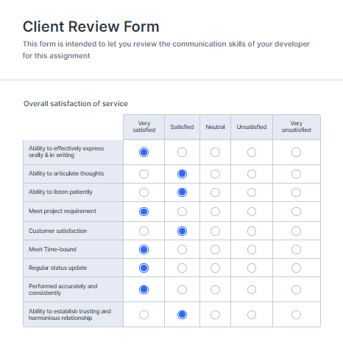

**Signed by Client**

|  |  |
| --- | --- |
| **Signature: Lovepreet singh** | **Date: 23/11/2021** |
| **Name: Lovepreet** | **Title: Final Project** |
| **Contact details (email/Tel):**  **pb02love@gmail.com** | |

Section 3- Presentation and reflection

Task 7- Presentation

Video Recording Presentation Submitted in the Github.

Task 8- Software Development Cycle

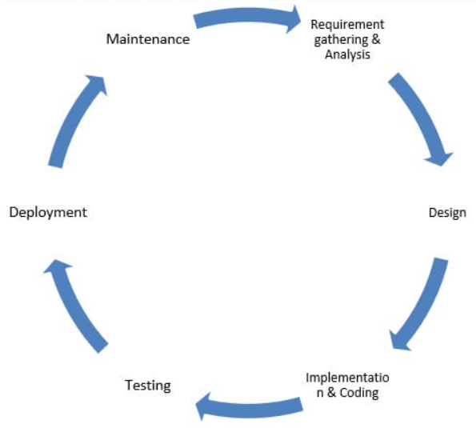

Planning:

*Our App Vs Competitor App*

Before you can plan your strategy, you must first determine where you stand in relation to your competition. This entails comparing your app's strengths and shortcomings to those of your competitors, as well as the opportunities and challenges you may encounter in the market.

Requirments gathering & Analysis:

In this phase we gather all project requirements which are as following

##### General Standards

Web applications must meet the following general standards:

* It must have easy and intuitive.
* It must have function in a logical manner.
* It must have adhere to industry best practices.

Development Technology and Programming Language

* Framework: **Microsoft ASP.NET 4.7 or Microsoft ASP.NET Core 3.1**
* Development Environment: **Microsoft Visual Studio 2017**
* Server Side Programming Language: **Microsoft Visual Basic 2017 or C# (C-sharp) Version 7.0**
* Database: **Microsoft SQL 2016**
* Web Server Software: **Microsoft IIS 8.0**

##### Responsive

The application should work on any advice such as Mobile,Tab, PC etc.Public facing web applications must be responsive.

##### Navigation

Every web page should have navigation button that allow user to go in any page without doing brower back button.

##### Validation of Form Input Fields

Form fields should have validation to ensure required fields should be filled, numeric fields should be filled, and data input is properly formatted (e.g., date, email address).

##### Input Buttons

Bootstrap buttons should be used and not img tag in button

##### The Label Tag

The HTML Label tag must be used to associate a text description to a form field.

##### Input Textbox Display Width

Textbox input controls in a web form must have properties set for display width and maximum input characters.

##### Javascript

Javascript should be used in client-side on very action

##### AJAX

To call API ajax should be used in client side

##### Database Standards

Microsoft SQL 2016 is required if a database is used

Software Design:

In the design phase we have done as following:

1) Ideation : I generate ideas and turn them into prototypes .

2) Information architecture : I created the architecture of every page and page endpoint which will fetch,create,delete,edit data.

3) Prototyping: I demonstrates the design of the product itself.

4)User interface design : I create mockups and any other graphics (icons, banners, illustrations, animations, etc.)

Implentation:

After the Mockup designs , I implement everything according to my initial planning. Using code first technique I make MVC project according to client requirement.

Testing:

Software testing has been completed effectively, and a testing excel format has been included to the documentation folder.

The Code is well written with the comments and the Web App is Browsing fast in the browsers

# User Manual

The main purpose of the application Bike Service Web Application is to provide a portal where customer stay in the comforts of your home or office and make the most of our complimentary pick-up and drop-in service. In this application there are two types of users- admin and registered user or visitor. Admin has different functionalities as compare to registered user. Admin can can add, edit, delete and check details of Services, Packages, Companies and their Bike Models which they serviced. Registered User is capable to book their car packages and view their booking history at single click.

### User Access Levels

Only registered users can access the features of this application.

* **Admin:** Admin has full access of the app can register new admins.

**Registered Visitor:** New visitor can register and existing can login using their own credentials. They have limited access.

Deployement:

After testing phase,I Create the deployment processes and deployed all code on production environment. Deploy a web application means to make it ready to be used by its clients.

Task 9- Project Management

Project Management Evaluation :

The Bike Service App is designed by me which is a free app used by millions of bikers around the globe to records their riding records , plan different routes apart from these they use this app to compete virtually. The only reason this app is popular is it is free to download.

We can use Agile management methodology to break project in several phases and involves constant improvement in all phases.Once the work begins,cycle of process starts with planning,execution and evaluating.Agile have four main values are as following:

1.Interaction over processes and tools

2.Responding to change over following a plan.

3.Working software on documentation

4.Fast and data-backed

When it comes to putting the Agile manifesto in place, teams often choose specific methodologies to use alongside Agile. These could include Scrum, Kanban, extreme programming, crystal, or even Scrumban.

When it comes to putting the Agile manifesto in place, teams often choose specific methodologies to use alongside Agile. These could include Scrum, Kanban, extreme programming, crystal, or even Scrumban.

Overall the app have good navigation and very simple to use.