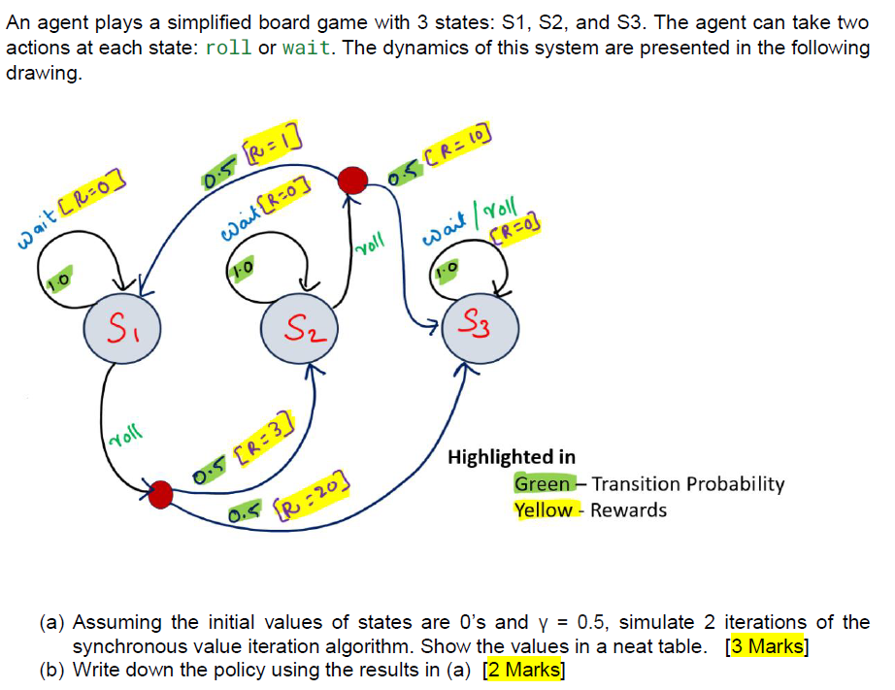
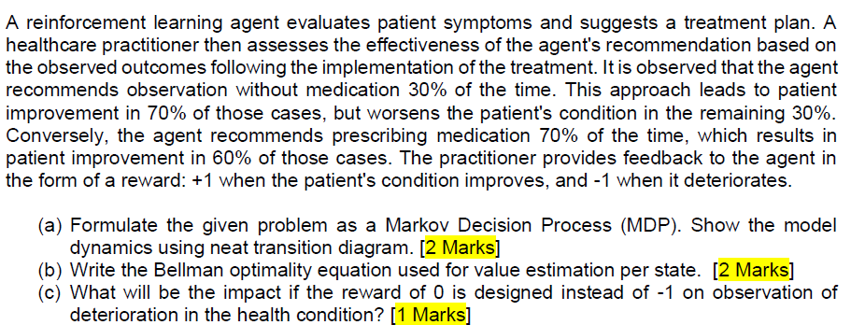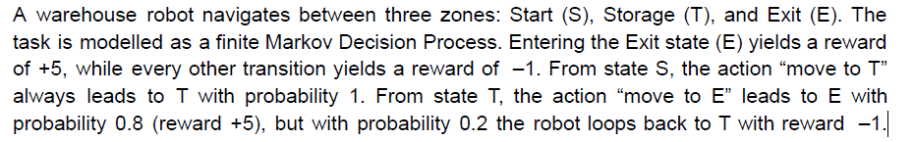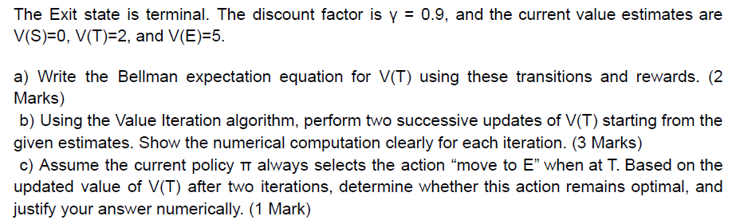

a) V(T) = 0.8 x [ +5 + ( 0.9 x V(E) ) ] + 0.2 x [ −1 + ( 0.9 x V(T) ) ].

Iter 0 values: V0(T) = 2, V0(E) = 5.
V1(T) = 0.8 * (5 + 0.9 * 5) + 0.2 * (-1 + 0.9 * 2)
= 0.8 * 9.5 + 0.2 * 0.8
= 7.6 + 0.16
= 7.76
V2(T) = 0.8 * (5 + 0.9 * 5) + 0.2 * (-1 + 0.9 * 7.76)
= 7.6 + 0.2 * (-1 + 6.984)
= 7.6 + 0.2 * 5.984
= 8.7968

Iter 0 values: V0(T) = 2, V(E) = 0.
V1(T) = 0.8 * (5 + 0.9 * 0) + 0.2 * (-1 + 0.9 * 2)
= 4 + 0.2 * 0.8
= 4.16

V2(T) = 0.8 * 5 + 0.2 * (-1 + 0.9 * 4.16)
= 4 + 0.2 * (-1 + 3.744)
= 4 + 0.2 * 2.744
= 4.5488

(c) This question must be answered as below:
(Direction) From the state E, the transition model supports to go to state T with probability 0.8 and stay in the state E with probability 0.2. If the policy says we always to T from E, will that be optimal? To answer this, we need to verify the values for when we take action to go to T and we decide to stay in E. Compare two values, and declare if going to T is indeed optimal.
Value for Moving to (T) = 0.8 * (5 + 0.9 * 5) + 0.2 * (-1 + 0.9 * 8.7968)
= 7.6 + 0.2 * 6.91712
= 8.983424 (~8.98)
Value for staying in (E) = -1 + 0.9 * 8.7968
= 6.91712 (~6.92)
