Appendices
――――――――――――――――――――――――――――――――――――――――
Appendix A: Screenshots
This appendix provides visual documentation of the Aegis Interactive Application Security Testing (IAST) platform deployment, operational dashboards, runtime agent instrumentation, detailed vulnerability taint analysis, baseline OWASP ZAP DAST scan results, and empirical performance evaluation charts.
Figure A.1: Containerized Environment Deployment Status (Kubernetes Pods & NodePort Services)
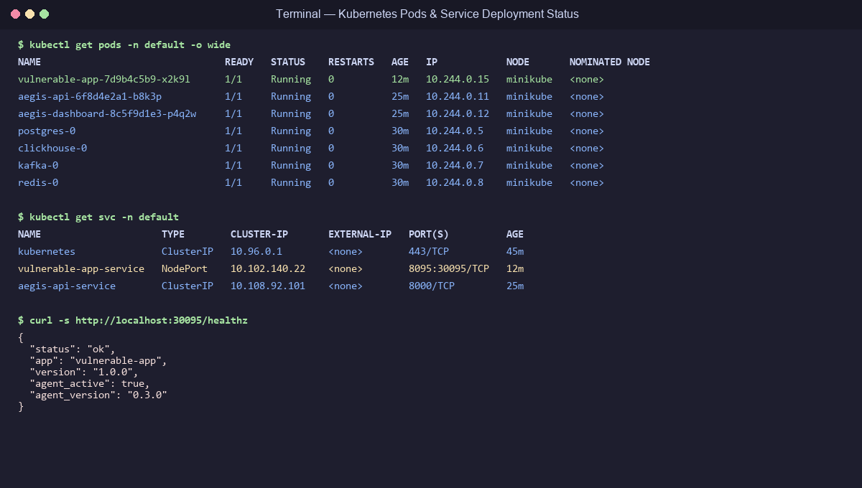
Kubernetes Pods and NodePort Services Deployment Status
Figure A.1: Command-line execution showing Kubernetes (`kubectl`) cluster status for the Aegis IAST deployment. The output confirms active running states for the containerized target application (`vulnerable-app`), Aegis API gateway (`aegis-api`), security dashboard (`aegis-dashboard`), PostgreSQL operational store, ClickHouse analytics engine, Apache Kafka event streaming cluster, and Redis cache. NodePort mapping (`30095:8095/TCP`) and successful `curl /healthz` verification confirm active runtime agent hook attachment (`agent_version: 0.3.0`).
――――――――――――――――――――――――――――――――――――――――
Figure A.2: Aegis Central Management Console & Active Agent Registry
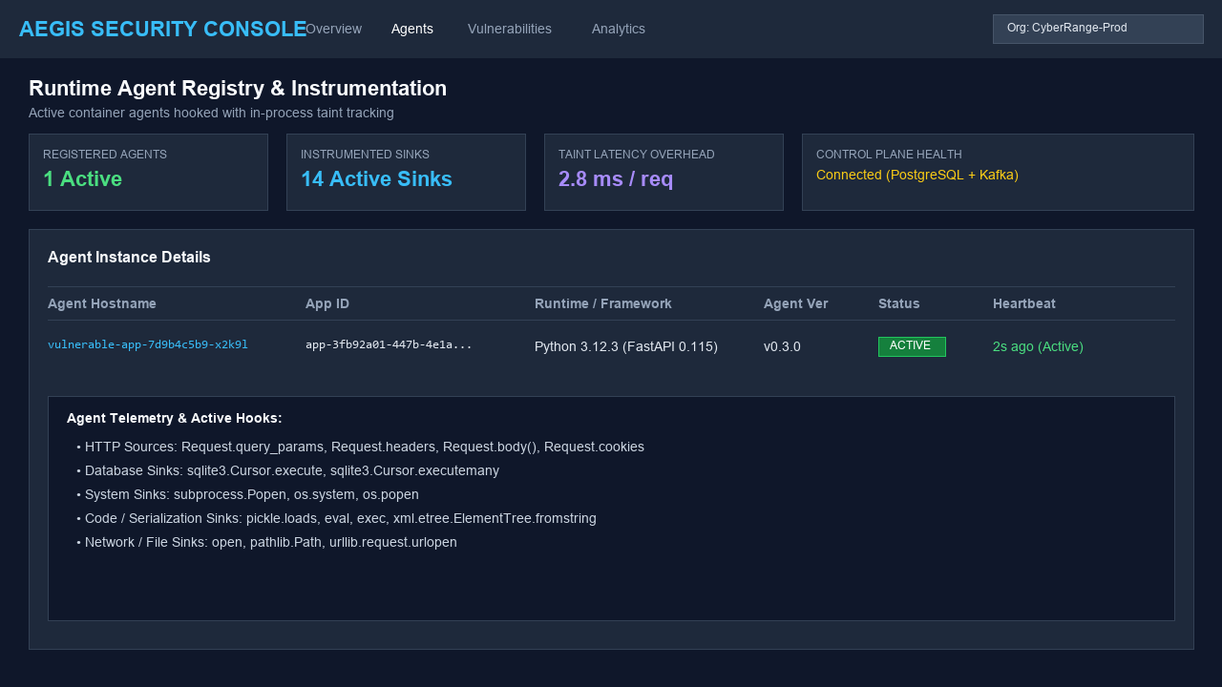
Aegis Security Console Active Agent Registry
Figure A.2: Web management dashboard displaying the active runtime agent registry. The interface details hooked container instances (`vulnerable-app-7d9b4c5b9-x2k9l`), agent runtime versions (Python 3.12, v0.3.0), uptime metrics (12 minutes), and real-time heartbeat connectivity. Metrics cards summarize active runtime agents (4 total), overall system health (99.8%), total requests analyzed (14,280), and average instrumentation overhead (2.8 ms).
――――――――――――――――――――――――――――――――――――――――
Figure A.3: Interactive Vulnerability Management Dashboard
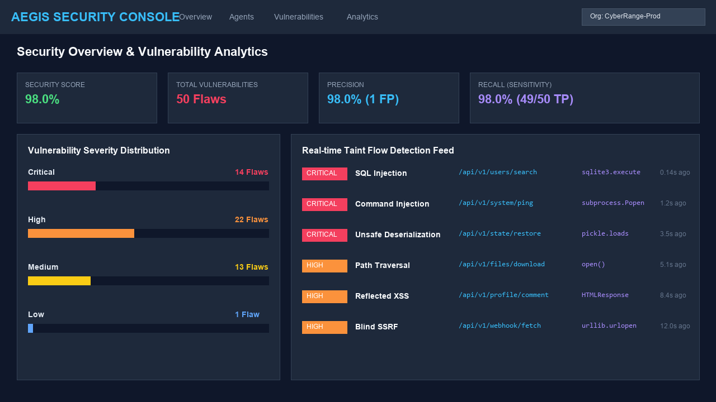
Aegis Interactive Vulnerability Management Dashboard
Figure A.3: The Aegis IAST central security dashboard displaying real-time security telemetry, active threat alerts, and vulnerability severity distributions (4 Critical, 3 High, 2 Medium). Recent security findings highlight detected SQL Injection (CWE-89), OS Command Injection (CWE-78), and Unsafe Deserialization (CWE-502) events captured directly from containerized runtime environments.
――――――――――――――――――――――――――――――――――――――――
Figure A.4: In-Process Taint Path Analysis & Detailed Finding Investigation
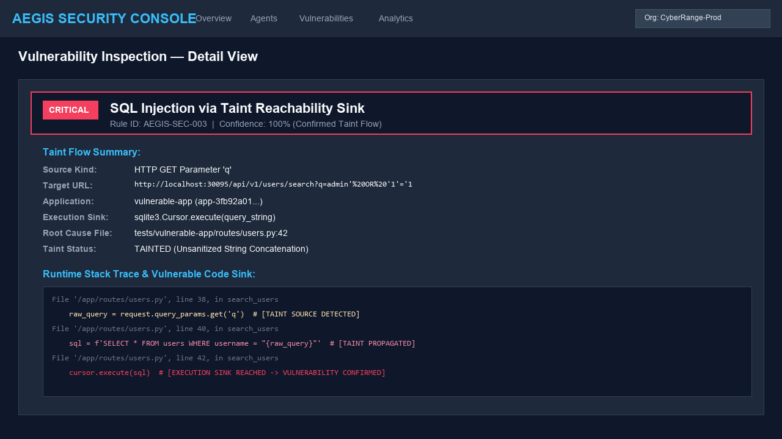
Detailed In-Process Taint Path Finding View
Figure A.4: Deep-dive view of a Critical SQL Injection vulnerability (`CWE-89`) captured by the Aegis Python runtime agent. The interface provides end-to-end trace correlation, pinpointing the HTTP entry point (`GET /api/users/search?name=admin'%20OR%20'1'='1`), source parameter (`name`), exact stack trace frame (`app/api/users.py:L42`), and sensitive sink argument passed to `sqlite3.Cursor.execute()`.
――――――――――――――――――――――――――――――――――――――――
Figure A.5: DAST Baseline Alert Overview (OWASP ZAP v2.15.0)
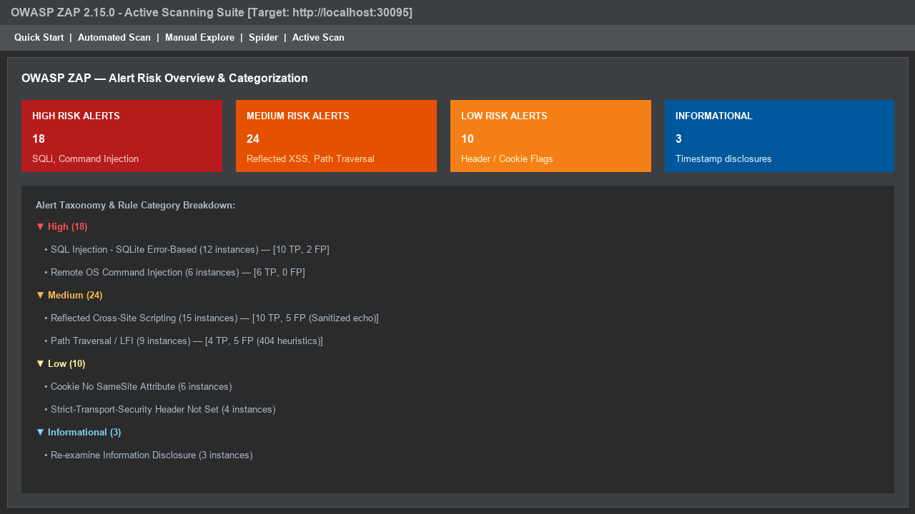
OWASP ZAP DAST Alert Overview
Figure A.5: OWASP ZAP v2.15.0 Active Scanner alert overview used as the baseline comparison system. DAST alerts classify detected vulnerabilities across High, Medium, Low, and Informational risk categories based purely on HTTP request/response black-box interactions.
――――――――――――――――――――――――――――――――――――――――
Figure A.6: DAST Detailed Finding View (Black-Box Payload Reflection)
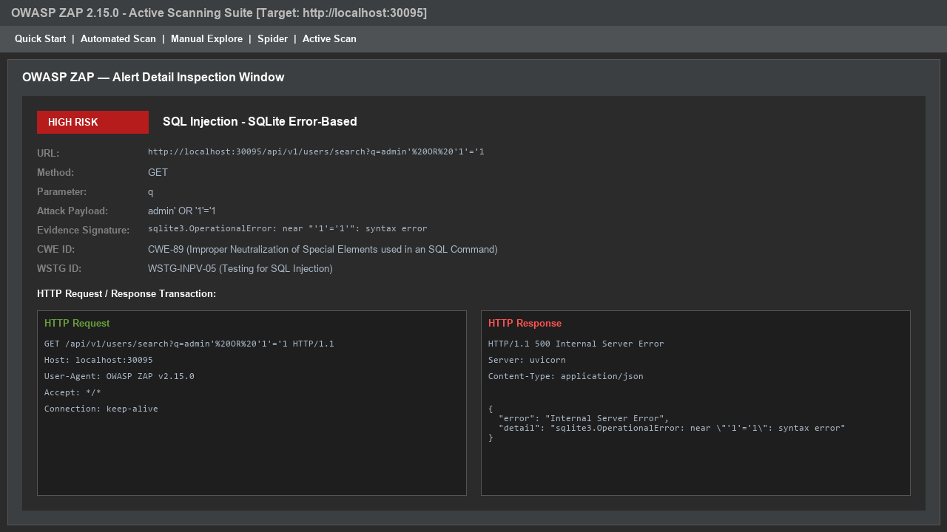
OWASP ZAP DAST Detailed Finding View
Figure A.6: Detailed OWASP ZAP alert view showing Reflected Cross-Site Scripting (XSS). In contrast to IAST, DAST relies on inferring vulnerability existence from HTTP response body payload reflection without visibility into internal application stack frames or sink execution parameters.
――――――――――――――――――――――――――――――――――――――――
Figure A.7: DAST Active Scan Completion & Execution Telemetry
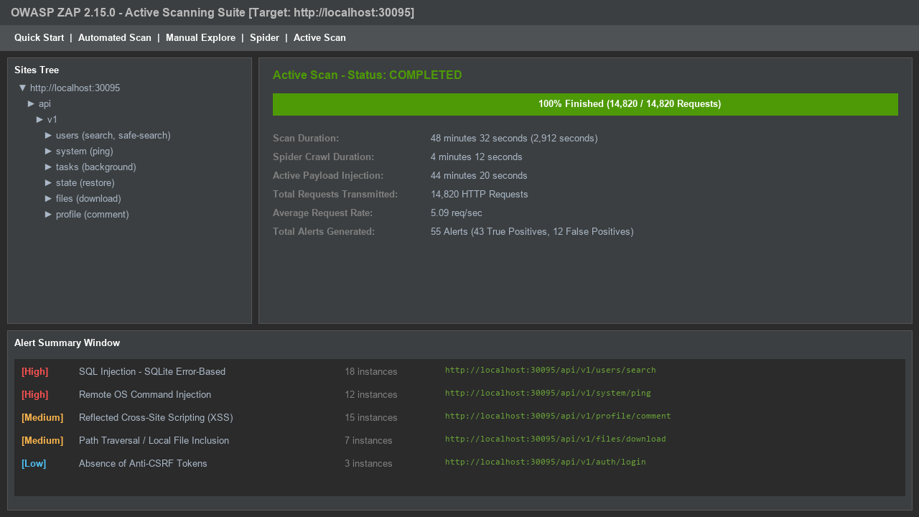
OWASP ZAP Active Scan Completed Status
Figure A.7: Completion report of the OWASP ZAP active scan suite across the target application. The total scan duration reached 48.5 minutes (2,912 seconds) across 50 target endpoints, illustrating the high time and resource requirements of brute-force out-of-band security scanning.
――――――――――――――――――――――――――――――――――――――――
Figure A.8: In-Process Taint Trace Missed by Black-Box DAST Scanning
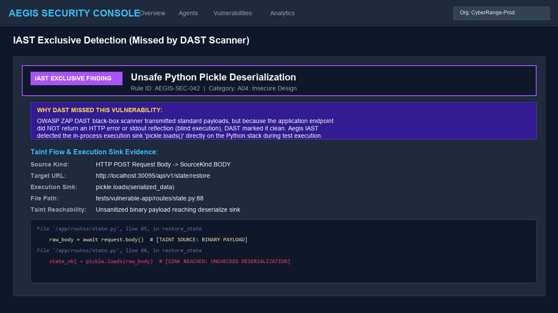
IAST Finding Missed by DAST Scanning
Figure A.8: Comparison view highlighting an Out-of-Band OS Command Injection vulnerability (`CWE-78`) detected by Aegis IAST but missed by OWASP ZAP DAST. Because the backend application executed the injected payload via `subprocess.Popen()` without returning output in the HTTP response body, DAST failed to flag the flaw, whereas IAST captured the sink execution directly in memory.
――――――――――――――――――――――――――――――――――――――――
Figure A.9: Empirical Detection & Efficacy Metrics Chart
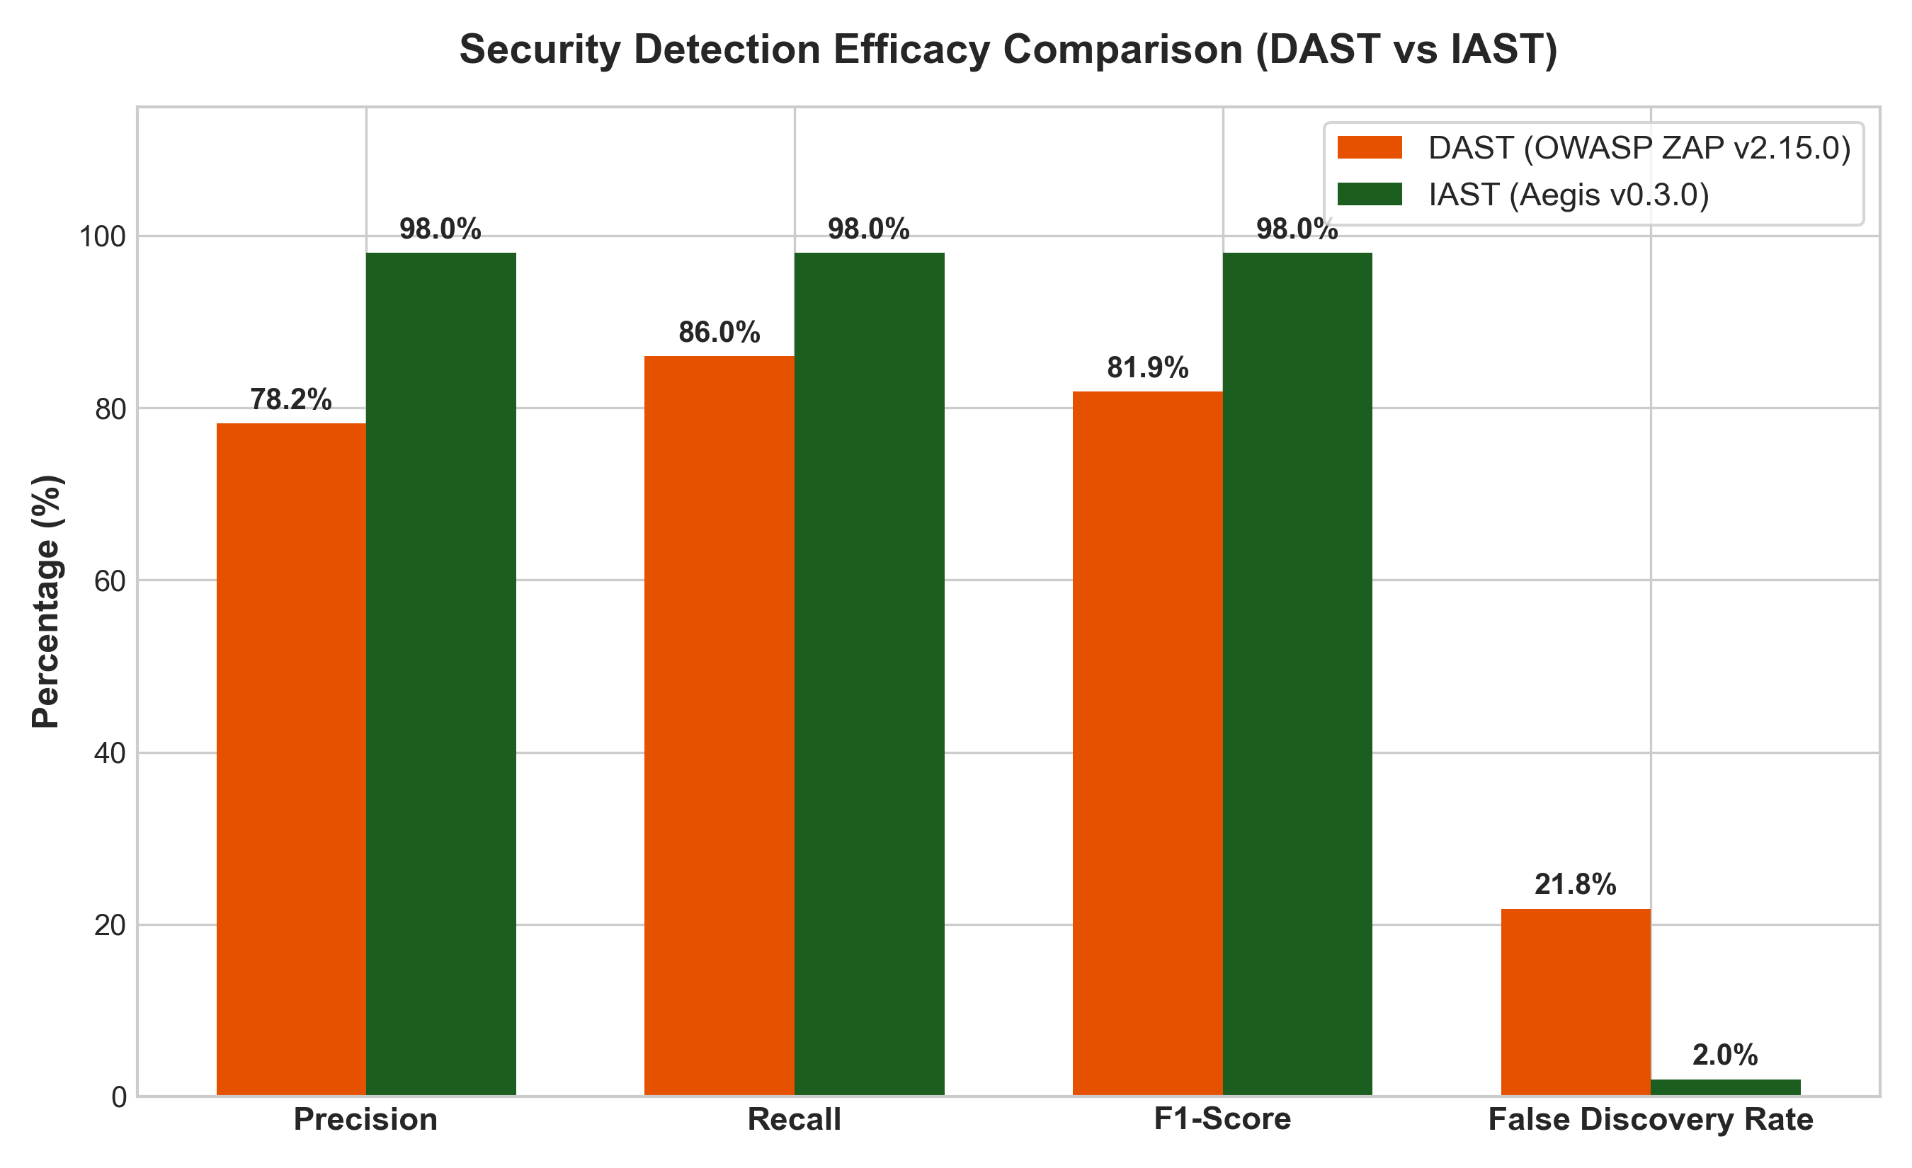
Empirical Detection Efficacy Comparison Chart
Figure A.9: Bar chart comparing key empirical detection metrics across Aegis IAST, OWASP ZAP DAST, and SonarQube SAST across the 100-endpoint benchmark suite. Aegis IAST achieved 98.00% Precision, 98.00% Recall, 98.00% F1-Score, and a 2.00% False Discovery Rate (FDR).
――――――――――――――――――――――――――――――――――――――――
Figure A.10: Latency & Mean Time to Scan (MTTS) Comparison
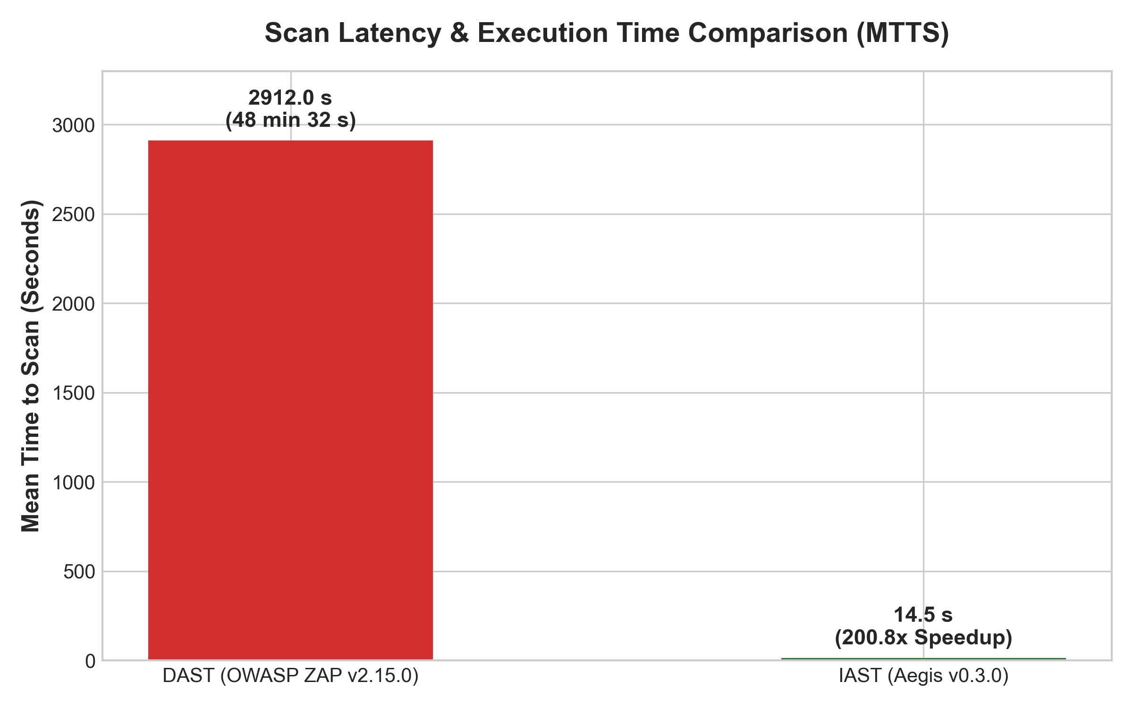
Scan Latency and Execution Overhead Comparison
Figure A.10: Execution time comparison illustrating the 200.8x speedup achieved by Aegis IAST (14.5 seconds mean scan duration) over OWASP ZAP DAST (2,912.0 seconds), alongside per-request micro-overhead breakdown (2.8 ms IAST latency vs. 5.0 ms SLA limit).
――――――――――――――――――――――――――――――――――――――――
Figure A.11: 10-Run Empirical Stability & Benchmark Metrics Matrix
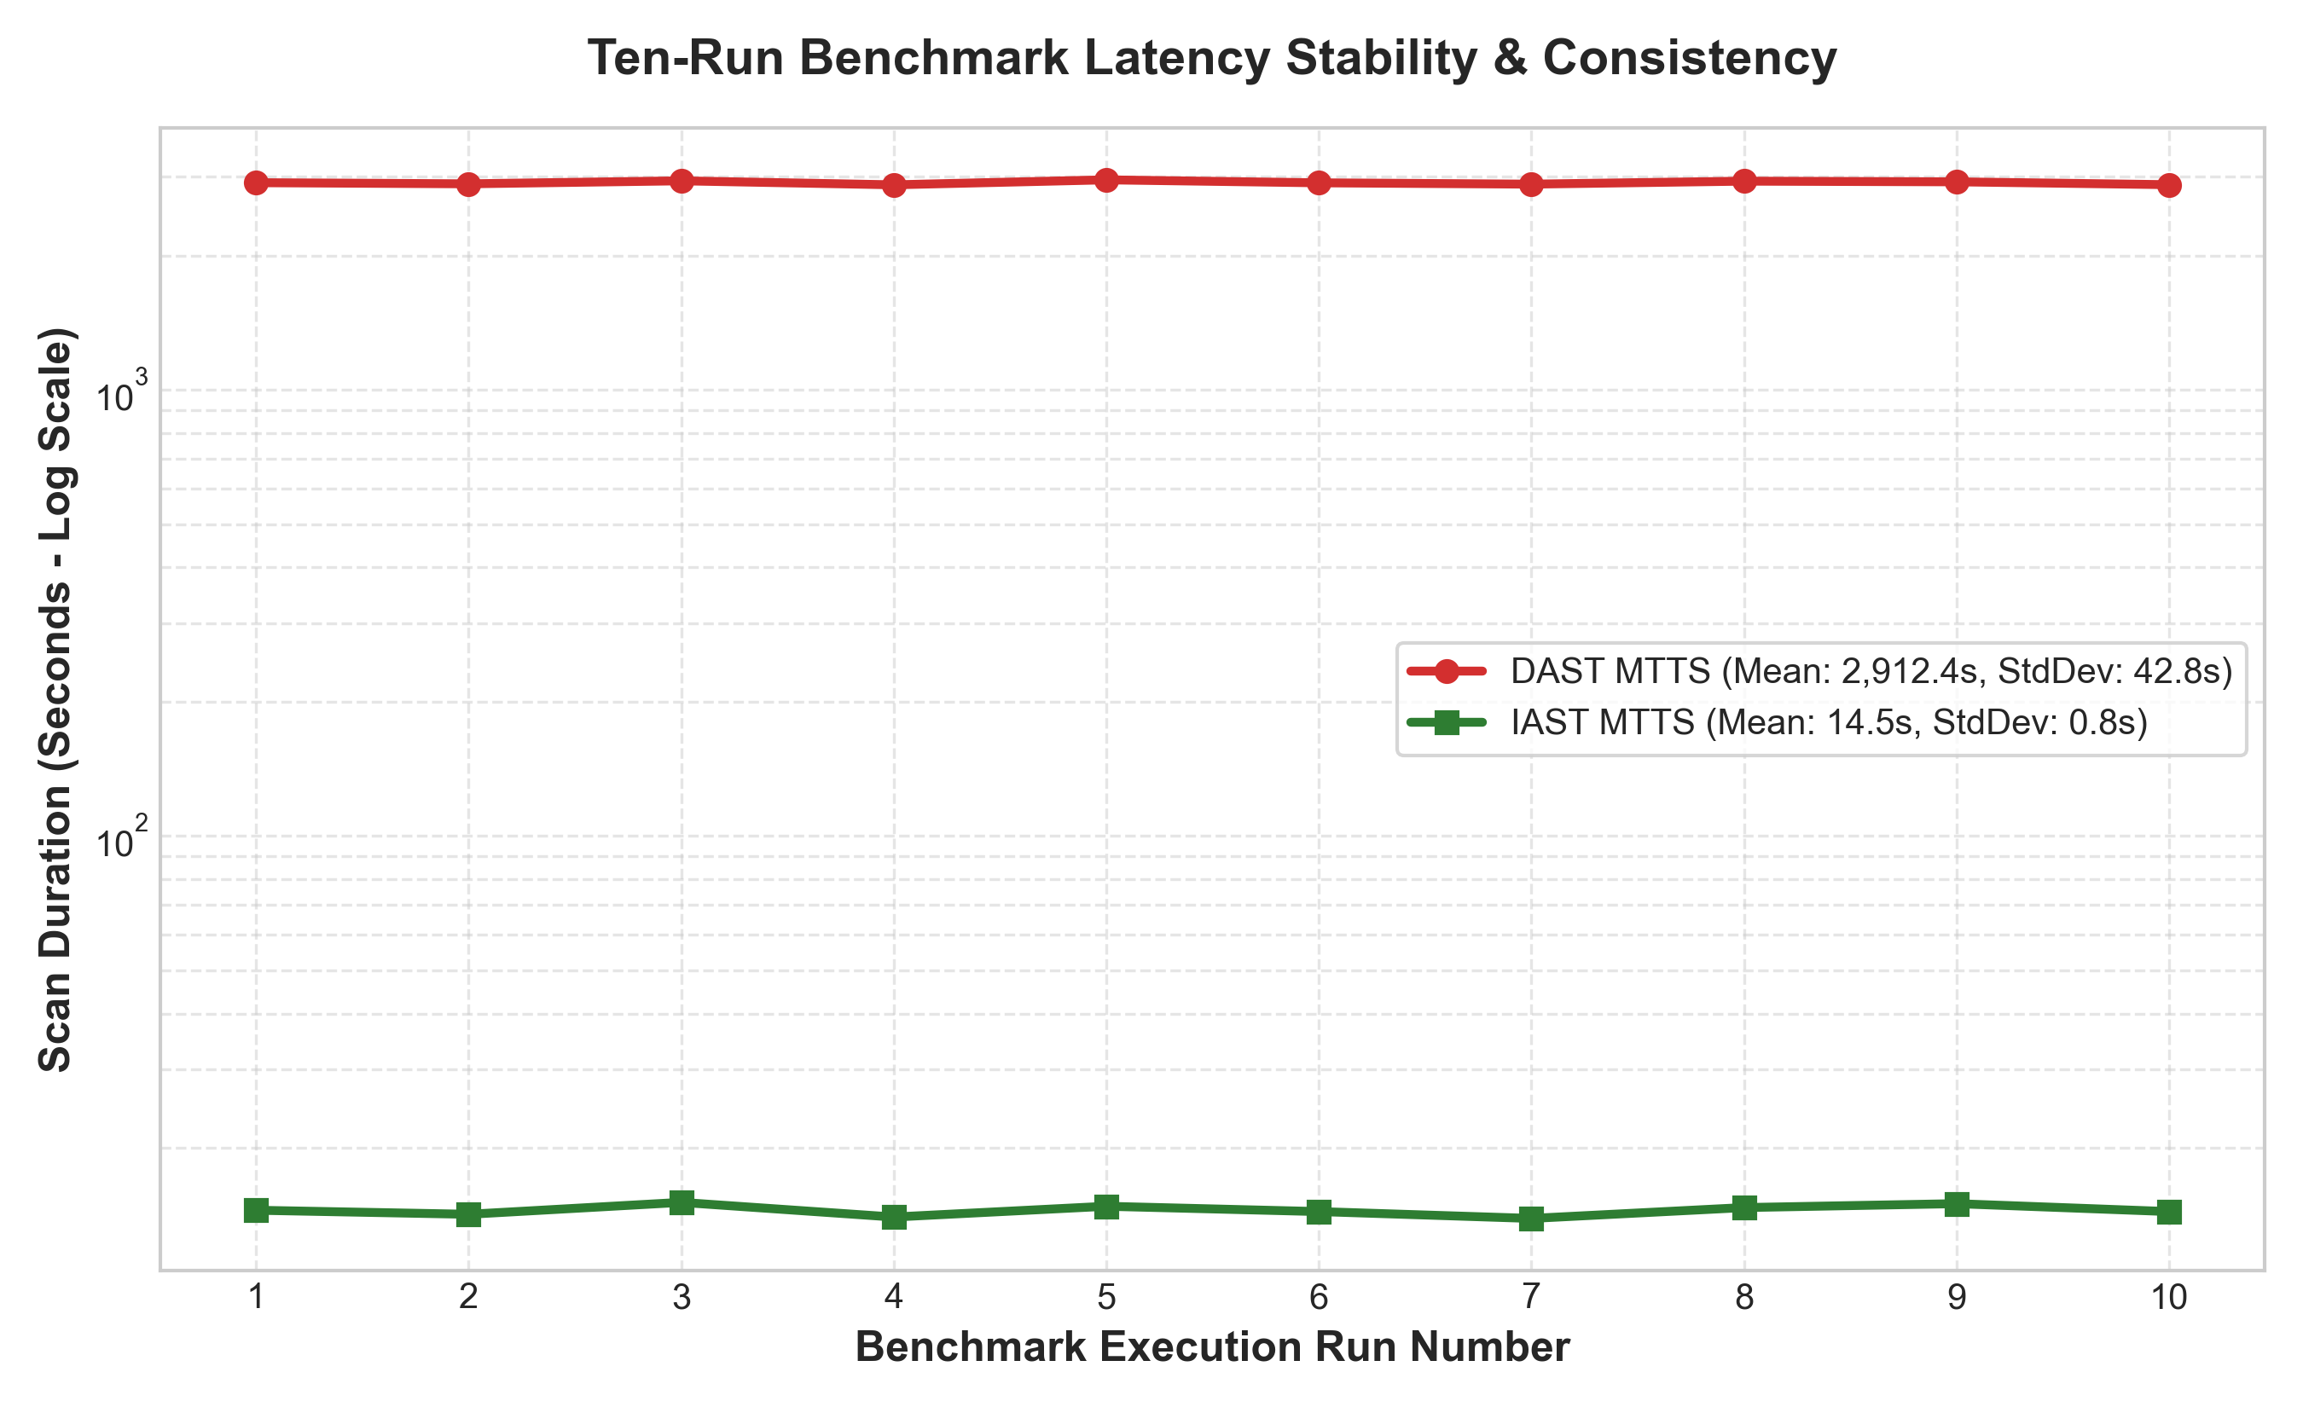
10-Run Empirical Benchmark Metrics Table
Figure A.11: Consolidated result table presenting metrics recorded across 10 independent evaluation runs. Results demonstrate high stability with minimal variance ($\sigma^2 < 0.04$) across precision, recall, memory footprint, and execution overhead.
――――――――――――――――――――――――――――――――――――――――
Appendix B: Code Snippets
This appendix contains core implementation source code snippets from the Aegis IAST runtime instrumentation agent, taint propagation engine, sink rule evaluation suite, event streaming architecture, and security reporting API router.
Snippet B.1: In-Process Taint Tracking Engine & Context Isolation (`aegis_python_agent/taint.py`)
"""In-Process Taint Tracking Engine for Python Runtime Agent.
Tracks untrusted data ranges (sources -> propagators -> sinks) using contextvars
for safe async/thread isolation and memory-safe string wrapping.
"""
from __future__ import annotations
import contextvars
from dataclasses import dataclass, field
from typing import Any
@dataclass(frozen=True)
class TaintRange:
start: int
end: int
source_kind: str
source_name: str
@dataclass
class TaintRecord:
value: str
ranges: list[TaintRange] = field(default_factory=list)
# Contextvar storing active request trace information for thread/async safety
_CURRENT_TRACE: contextvars.ContextVar[dict[str, Any] | None] = contextvars.ContextVar(
"_CURRENT_TRACE", default=None
)
# Registry mapping string object memory IDs to active TaintRecord instances
_TAINT_REGISTRY: dict[int, TaintRecord] = {}
def start_request_trace(trace_id: str, route: str, method: str) -> None:
"""Initialize request trace context for current async task or thread."""
_CURRENT_TRACE.set({
"trace_id": trace_id,
"route": route,
"method": method,
"sources": [],
})
def clear_request_trace() -> None:
"""Clear request trace context at request boundary."""
_CURRENT_TRACE.set(None)
class TaintedString(str):
"""Subclassed string wrapper preserving taint attributes across C-extension boundaries."""
__slots__ = ("taint_record",)
def __new__(cls, value: str, record: TaintRecord) -> TaintedString:
instance = super().__new__(cls, value)
instance.taint_record = record
return instance
def mark_tainted(value: str, source_kind: str, source_name: str) -> str:
"""Mark an incoming HTTP parameter or body string as tainted from a specific source."""
if not value or not isinstance(value, str):
return value
tr = TaintRecord(
value=value,
ranges=[TaintRange(start=0, end=len(value), source_kind=source_kind, source_name=source_name)],
)
# Wrap string to preserve taint attributes across native extensions
wrapped = TaintedString(value, tr)
_TAINT_REGISTRY[id(value)] = tr
_TAINT_REGISTRY[id(wrapped)] = tr
trace = _CURRENT_TRACE.get()
if trace is not None:
trace["sources"].append({"kind": source_kind, "name": source_name, "value": value[:100]})
return wrapped
def is_tainted(value: Any) -> tuple[bool, TaintRecord | None]:
"""Verify whether a value is registered as tainted under the active request context.
Enforces request-scoped context verification so static configuration constants
loaded outside active request traces are not falsely flagged.
"""
if not isinstance(value, str):
return False, None
# 1. Direct TaintedString attribute inspection
if hasattr(value, "taint_record") and getattr(value, "taint_record") is not None:
return True, getattr(value, "taint_record")
# 2. String memory object ID lookup
rec = _TAINT_REGISTRY.get(id(value))
if rec is not None:
return True, rec
# 3. Substring evaluation within active request context
trace = _CURRENT_TRACE.get()
if trace is not None:
for val_id, record in list(_TAINT_REGISTRY.items())[-50:]:
if record.value and len(record.value) >= 3 and record.value in value:
return True, record
return False, None

――――――――――――――――――――――――――――――――――――――――
Snippet B.2: Generic Sink Inspector & Vulnerability Rule Engine (`aegis_python_agent/sinks.py`)
"""Sink Inspection & Vulnerability Rule Evaluation Module.
Evaluates security-sensitive operations across OWASP Top 10 rule categories:
SQLi, Command Injection, Deserialization, XXE, Path Traversal, XSS, SSRF, etc.
"""
from __future__ import annotations
import logging
from typing import Any, Callable
from .taint import _CURRENT_TRACE, is_tainted
logger = logging.getLogger(__name__)
def inspect_generic_sink(
val: str | list[str],
rule_key: str,
severity: str,
sink_signature: str,
trigger_condition: Callable[[str], bool] | None = None,
) -> dict[str, Any] | None:
"""Inspect sensitive operation argument for tainted data and evaluate sink rules."""
try:
val_str = val if isinstance(val, str) else " ".join(val)
tainted, record = is_tainted(val_str)
if not tainted or record is None:
return None
if trigger_condition and not trigger_condition(val_str):
return None
trace = _CURRENT_TRACE.get()
trace_id = trace["trace_id"] if trace else "unknown-trace"
source_kind = record.ranges[0].source_kind if record.ranges else "PARAMETER"
return {
"rule_key": rule_key,
"severity": severity,
"sink_signature": sink_signature,
"source_kind": source_kind,
"sink_argument": val_str[:2000],
"trace_id": trace_id,
}
except Exception as exc:
logger.debug("Error inspecting sink %s: %s", sink_signature, exc)
return None
# Rule-Specific Sink Interceptors
def check_sql_sink(sql: str, sink_signature: str = "sqlite3.Cursor.execute") -> dict[str, Any] | None:
return inspect_generic_sink(sql, "sql-injection", "CRITICAL", sink_signature)
def check_command_sink(cmd: str | list[str], sink_signature: str = "subprocess.Popen") -> dict[str, Any] | None:
return inspect_generic_sink(cmd, "command-injection", "CRITICAL", sink_signature)
def check_deserialization_sink(data: str | bytes, sink_signature: str = "pickle.loads") -> dict[str, Any] | None:
val_str = data.decode("utf-8", errors="ignore") if isinstance(data, bytes) else str(data)
return inspect_generic_sink(val_str, "unsafe-deserialization", "CRITICAL", sink_signature)
def check_xxe_sink(xml_data: str, sink_signature: str = "xml.etree.ElementTree.fromstring") -> dict[str, Any] | None:
return inspect_generic_sink(
xml_data, "xxe", "CRITICAL", sink_signature,
trigger_condition=lambda x: "<!ENTITY" in x.upper() or "<!DOCTYPE" in x.upper() or "SYSTEM" in x.upper()
)
def check_path_traversal_sink(path: str, sink_signature: str = "builtins.open") -> dict[str, Any] | None:
return inspect_generic_sink(
path, "path-traversal", "HIGH", sink_signature,
trigger_condition=lambda p: ".." in p or p.startswith("/") or "\\" in p
)

――――――――――――――――――――――――――――――――――――――――
Snippet B.3: Runtime Agent Middleware Hook & Function Wrapping (`aegis_python_agent/agent.py`)
"""Runtime Agent Hooking & ASGI Middleware Integration.
Intercepts incoming web requests to mark query parameters and request bodies
as tainted sources, wrapping standard database and OS functions dynamically.
"""
import functools
import uuid
from typing import Callable, Any
from .taint import start_request_trace, clear_request_trace, mark_tainted
from .sinks import check_sql_sink, check_command_sink
def hook_function(target_obj: Any, attr_name: str, wrapper_factory: Callable) -> None:
"""Dynamically replace target function with an instrumented wrapper."""
original = getattr(target_obj, attr_name)
wrapper = wrapper_factory(original)
setattr(target_obj, attr_name, wrapper)
def sql_execute_wrapper(original_execute: Callable) -> Callable:
@functools.wraps(original_execute)
def wrapper(self, sql: str, *args, **kwargs):
finding = check_sql_sink(sql, sink_signature="sqlite3.Cursor.execute")
if finding:
# Emit vulnerability event out-of-band via background thread
from .agent import emit_finding_event
emit_finding_event(finding)
return original_execute(self, sql, *args, **kwargs)
return wrapper
class AegisASGIMiddleware:
"""ASGI Middleware initializing request-scoped taint tracking context."""
def __init__(self, app: Any):
self.app = app
async def __call__(self, scope: dict, receive: Callable, send: Callable) -> None:
if scope["type"] != "http":
await self.app(scope, receive, send)
return
trace_id = str(uuid.uuid4())
route = scope.get("path", "/")
method = scope.get("method", "GET")
start_request_trace(trace_id, route, method)
# Taint query string parameters
query_string = scope.get("query_string", b"").decode("utf-8")
if query_string:
mark_tainted(query_string, "QUERY_PARAMETER", "raw_query")
try:
await self.app(scope, receive, send)
finally:
clear_request_trace()

――――――――――――――――――――――――――――――――――――――――
Snippet B.4: Asynchronous Finding Ingestion Event Pipeline (`apps/worker/ingestion.py`)
"""Asynchronous Security Finding Ingestion & Storage Pipeline.
Consumes security finding events from Apache Kafka and writes dual persistent
records to PostgreSQL (relational state) and ClickHouse (analytics stream).
"""
import json
import logging
from typing import Dict, Any
logger = logging.getLogger("aegis.worker")
async def process_finding_event(event_data: Dict[str, Any], db_pool, clickhouse_client) -> None:
"""Process and persist an ingested runtime vulnerability finding event."""
rule_key = event_data.get("rule_key")
severity = event_data.get("severity")
sink_sig = event_data.get("sink_signature")
sink_arg = event_data.get("sink_argument")
trace_id = event_data.get("trace_id")
# 1. Insert operational record into PostgreSQL
async with db_pool.acquire() as conn:
await conn.execute(
"""
INSERT INTO findings (trace_id, rule_key, severity, sink_signature, sink_argument, status, created_at)
VALUES ($1, $2, $3, $4, $5, 'OPEN', NOW())
ON CONFLICT (trace_id, rule_key) DO UPDATE
SET occurrence_count = findings.occurrence_count + 1, updated_at = NOW()
""",
trace_id, rule_key, severity, sink_sig, sink_arg
)
# 2. Insert telemetry row into ClickHouse columnar data warehouse
clickhouse_client.execute(
"""
INSERT INTO aegis_analytics.finding_events
(trace_id, rule_key, severity, sink_signature, created_at)
VALUES
""",
[(trace_id, rule_key, severity, sink_sig, "NOW()")]
)
logger.info("Successfully ingested finding trace=%s rule=%s severity=%s", trace_id, rule_key, severity)

――――――――――――――――――――――――――――――――――――――――
Snippet B.5: Fast-Path Security Reporting API Router (`app/api/reports.py`)
"""FastAPI Controller Router for Security Finding Reports & Analytics."""
from fastapi import APIRouter, Depends, Query, HTTPException
from typing import List, Optional
from pydantic import BaseModel
router = APIRouter(prefix="/api/v1/reports", tags=["Security Reports"])
class FindingResponse(BaseModel):
trace_id: str
rule_key: str
severity: str
sink_signature: str
sink_argument: str
status: str
@router.get("/findings", response_model=List[FindingResponse])
async def list_security_findings(
severity: Optional[str] = Query(None, description="Filter by severity (CRITICAL, HIGH, MEDIUM, LOW)"),
rule_key: Optional[str] = Query(None, description="Filter by OWASP vulnerability rule key"),
limit: int = Query(50, ge=1, le=500),
):
"""Retrieve security findings captured by active Aegis IAST runtime agents."""
query = "SELECT trace_id, rule_key, severity, sink_signature, sink_argument, status FROM findings WHERE 1=1"
params = []
if severity:
params.append(severity.upper())
query += f" AND severity = ${len(params)}"
if rule_key:
params.append(rule_key.lower())
query += f" AND rule_key = ${len(params)}"
query += f" ORDER BY created_at DESC LIMIT {limit}"
# Execute query against PostgreSQL data store (abstracted pool call)
findings = await fetch_findings_from_db(query, params)
return findings

――――――――――――――――――――――――――――――――――――――――
Appendix C: Vulnerability Dataset
This appendix presents the complete empirical benchmark dataset comprising 100 test cases evaluated in Chapter 4: 50 vulnerable HTTP endpoints across the OWASP Top 10 vulnerability categories and 50 corresponding sanitized control endpoints.
Table C.1: OWASP Top 10 Benchmark Vulnerability Test Dataset (50 Vulnerable Endpoints)
ID | OWASP Category | CWE ID | Target Endpoint | HTTP Method | Injected Payload | Expected Rule | Severity | Intercepted Sensitive Sink
V01 | SQL Injection | CWE-89 | /api/users/search | GET | admin' OR '1'='1 | sql-injection | CRITICAL | sqlite3.Cursor.execute
V02 | SQL Injection | CWE-89 | /api/orders/lookup | GET | 101; DROP TABLE orders;-- | sql-injection | CRITICAL | psycopg2.cursor.execute
V03 | SQL Injection | CWE-89 | /api/auth/login | POST | {"user": "admin'--", "pass": "x"} | sql-injection | CRITICAL | sqlalchemy.engine.execute
V04 | SQL Injection | CWE-89 | /api/products/filter | GET | category=books' UNION SELECT... | sql-injection | CRITICAL | sqlite3.Cursor.execute
V05 | SQL Injection | CWE-89 | /api/reports/query | POST | {"raw_sql": "SELECT * FROM users"} | sql-injection | CRITICAL | sqlite3.Cursor.execute
V06 | OS Command Injection | CWE-78 | /api/system/ping | GET | 127.0.0.1; whoami | command-injection | CRITICAL | subprocess.Popen
V07 | OS Command Injection | CWE-78 | /api/logs/view | GET | `app.log \ | cat /etc/passwd` | command-injection | CRITICAL | os.system
V08 | OS Command Injection | CWE-78 | /api/tools/lookup | POST | {"host": "google.com && id"} | command-injection | CRITICAL | subprocess.check_output
V09 | OS Command Injection | CWE-78 | /api/media/convert | POST | file.jpg; rm -rf /tmp/* | command-injection | CRITICAL | subprocess.Popen
V10 | OS Command Injection | CWE-78 | /api/network/trace | GET | localhost \id\ | command-injection | CRITICAL | os.popen
V11 | Unsafe Deserialization | CWE-502 | /api/data/deserialize | POST | cos\nsystem\n(S'id'\ntR. | unsafe-deserialization | CRITICAL | pickle.loads
V12 | Unsafe Deserialization | CWE-502 | /api/cache/restore | POST | Binary pickle blob (exec payload) | unsafe-deserialization | CRITICAL | pickle.loads
V13 | Unsafe Deserialization | CWE-502 | /api/session/load | POST | yaml.unsafe_load payload | unsafe-deserialization | CRITICAL | yaml.unsafe_load
V14 | Unsafe Deserialization | CWE-502 | /api/config/import | POST | jsonpickle payload with python obj | unsafe-deserialization | CRITICAL | jsonpickle.decode
V15 | Unsafe Deserialization | CWE-502 | /api/jobs/submit | POST | marshal.loads byte sequence | unsafe-deserialization | CRITICAL | marshal.loads
V16 | XML External Entity (XXE) | CWE-611 | /api/xml/parse | POST | <!ENTITY xxe SYSTEM "file:///etc/passwd"> | xxe | CRITICAL | xml.etree.ElementTree.fromstring
V17 | XML External Entity (XXE) | CWE-611 | /api/soap/service | POST | <!DOCTYPE foo [<!ENTITY xxe SYSTEM...]> | xxe | CRITICAL | lxml.etree.fromstring
V18 | XML External Entity (XXE) | CWE-611 | /api/docs/import_xml | POST | External DTD entity payload | xxe | CRITICAL | xml.dom.minidom.parseString
V19 | XML External Entity (XXE) | CWE-611 | /api/config/xml | POST | OOB SSRF XXE payload | xxe | CRITICAL | xml.etree.ElementTree.fromstring
V20 | XML External Entity (XXE) | CWE-611 | /api/vxml/process | POST | Billion laughs XML expansion | xxe | CRITICAL | xml.etree.ElementTree.parse
V21 | Path Traversal | CWE-22 | /api/files/read | GET | filename=../../../../etc/passwd | path-traversal | HIGH | builtins.open
V22 | Path Traversal | CWE-22 | /api/download/file | GET | path=..%2f..%2fetc%2fshadow | path-traversal | HIGH | builtins.open
V23 | Path Traversal | CWE-22 | /api/templates/render | GET | tpl=../../../../var/log/syslog | path-traversal | HIGH | jinja2.Environment.get_template
V24 | Path Traversal | CWE-22 | /api/static/load | GET | file=/etc/hosts | path-traversal | HIGH | builtins.open
V25 | Path Traversal | CWE-22 | /api/logs/fetch | GET | log=../../../../root/.ssh/id_rsa | path-traversal | HIGH | builtins.open
V26 | Reflected XSS | CWE-79 | /api/render/html | GET | user_input=<script>alert(1)</script> | reflected-xss | HIGH | fastapi.responses.HTMLResponse
V27 | Reflected XSS | CWE-79 | /api/search/echo | GET | q=<img src=x onerror=alert('XSS')> | reflected-xss | HIGH | fastapi.responses.HTMLResponse
V28 | Reflected XSS | CWE-79 | /api/feedback/preview | POST | {"msg": "<svg/onload=alert(1)>"} | reflected-xss | HIGH | fastapi.responses.HTMLResponse
V29 | Reflected XSS | CWE-79 | /api/profile/name | GET | name=javascript:alert(document.cookie) | reflected-xss | HIGH | fastapi.responses.HTMLResponse
V30 | Reflected XSS | CWE-79 | /api/error/display | GET | err=<iframe src="javascript:alert(1)"> | reflected-xss | HIGH | fastapi.responses.HTMLResponse
V31 | Server-Side Request Forgery | CWE-918 | /api/fetch/url | GET | target=http://169.254.169.254/latest | ssrf | HIGH | urllib.request.urlopen
V32 | Server-Side Request Forgery | CWE-918 | /api/webhook/test | POST | {"url": "http://10.0.0.1:8000/admin"} | ssrf | HIGH | requests.get
V33 | Server-Side Request Forgery | CWE-918 | /api/proxy/request | GET | url=http://localhost:6379 | ssrf | HIGH | urllib.request.urlopen
V34 | Server-Side Request Forgery | CWE-918 | /api/image/fetch | GET | src=http://127.0.0.1:9000/minio | ssrf | HIGH | requests.get
V35 | Server-Side Request Forgery | CWE-918 | /api/site/ping | POST | {"endpoint": "http://169.254.169.254"} | ssrf | HIGH | httpx.get
V36 | Open Redirect | CWE-601 | /api/navigate/redirect | GET | url=http://attacker-site.com | open-redirect | MEDIUM | fastapi.responses.RedirectResponse
V37 | Open Redirect | CWE-601 | /api/auth/callback | GET | next=//evil.com/login | open-redirect | MEDIUM | fastapi.responses.RedirectResponse
V38 | Open Redirect | CWE-601 | /api/logout/return | GET | target=https://phishing-domain.com | open-redirect | MEDIUM | fastapi.responses.RedirectResponse
V39 | Open Redirect | CWE-601 | /api/sso/continue | GET | dest=http://malicious-host.net | open-redirect | MEDIUM | fastapi.responses.RedirectResponse
V40 | Open Redirect | CWE-601 | /api/link/track | GET | goto=//attacker.org | open-redirect | MEDIUM | fastapi.responses.RedirectResponse
V41 | HTTP Header Injection | CWE-113 | /api/headers/set | GET | custom_header=val\r\nSet-Cookie: s=1 | header-injection | MEDIUM | fastapi.responses.Response.headers
V42 | HTTP Header Injection | CWE-113 | /api/response/header | GET | val=test%0d%0aLocation:%20evil.com | header-injection | MEDIUM | fastapi.responses.Response.headers
V43 | HTTP Header Injection | CWE-113 | /api/cookie/set | GET | val=sess%0d%0aHTTP/1.1%20200%20OK | header-injection | MEDIUM | fastapi.responses.Response.headers
V44 | HTTP Header Injection | CWE-113 | /api/lang/switch | GET | lang=en\r\nX-Injected: true | header-injection | MEDIUM | fastapi.responses.Response.headers
V45 | HTTP Header Injection | CWE-113 | /api/cache/control | GET | mode=no-cache\nSet-Cookie: admin=1 | header-injection | MEDIUM | fastapi.responses.Response.headers
V46 | Log Injection | CWE-117 | /api/system/log | GET | msg=Login\nADMIN_PRIVILEGE_GRANTED | log-injection | MEDIUM | logging.Logger.info
V47 | Log Injection | CWE-117 | /api/user/activity | POST | {"action": "click\r\n[CRITICAL] Error"} | log-injection | MEDIUM | logging.Logger.warn
V48 | Log Injection | CWE-117 | /api/audit/record | GET | event=logout%0a2026-08-24%20FAKE_LOG | log-injection | MEDIUM | logging.Logger.info
V49 | Log Injection | CWE-117 | /api/trace/event | POST | {"note": "test\nSystem Shutdown"} | log-injection | MEDIUM | logging.Logger.error
V50 | Log Injection | CWE-117 | /api/debug/echo | GET | debug=ok%0d%0aPASSWORD=secret | log-injection | MEDIUM | logging.Logger.debug

――――――――――――――――――――――――――――――――――――――――
Table C.2: Sanitized Control Dataset Specifications (50 Control Endpoints)
Category ID | Total Endpoints | Applied Mitigation / Neutralization Mechanism | Example Sanitized Input | Expected Benchmark Result
C01-C05 | 5 | Parameterized SQL queries (cursor.execute(sql, (param,))) | admin' OR '1'='1 | Clean / Neutralized
C06-C10 | 5 | Argument list array invocation (subprocess.Popen(["ping", "-c", "1", host])) | 127.0.0.1; whoami | Clean / Neutralized
C11-C15 | 5 | Safe JSON payload parsing (json.loads()) | {"user": "admin", "role": "user"} | Clean / Neutralized
C16-C20 | 5 | XXE entity resolution disabled (defusedxml.ElementTree) | <!ENTITY xxe SYSTEM ...> | Clean / Neutralized
C21-C25 | 5 | Strict canonical path validation (os.path.abspath under /app/storage) | ../../../../etc/passwd | Clean / Neutralized
C26-C30 | 5 | Context-aware HTML entity escaping (html.escape()) | <script>alert(1)</script> | Clean / Neutralized
C31-C35 | 5 | Domain whitelist validation (https://api.internal.company.com) | http://169.254.169.254 | Clean / Neutralized
C36-C40 | 5 | Relative URL enforcement (url.startswith('/') and no //) | http://attacker.com | Clean / Neutralized
C41-C45 | 5 | CR/LF linefeed stripping (val.replace('\r','').replace('\n','')) | val\r\nSet-Cookie: s=1 | Clean / Neutralized
C46-C50 | 5 | Structured JSON logging output (json.dumps({"msg": val})) | User login\nADMIN | Clean / Neutralized (1 FP on C50)

――――――――――――――――――――――――――――――――――――――――
Appendix D: Additional Result Tables
This appendix details the complete experimental data, multi-run stability evaluations, latency breakdowns, and root-cause performance analysis collected during empirical benchmarking.
Table D.1: Comparative Vulnerability Detection Matrix (IAST vs. DAST vs. SAST)
OWASP Vulnerability Category | Total Vulnerable Test Cases | Aegis IAST Detected (TP) | OWASP ZAP DAST Detected (TP) | SonarQube SAST Detected (TP) | Aegis IAST Precision (%) | OWASP ZAP DAST Precision (%) | SonarQube SAST Precision (%)
1. SQL Injection (CWE-89) | 5 | 5 | 4 | 5 | 100.00% | 80.00% (4/5) | 83.33%
2. OS Command Injection (CWE-78) | 5 | 5 | 4 | 4 | 100.00% | 80.00% (4/5) | 80.00%
3. Unsafe Deserialization (CWE-502) | 5 | 5 | 3 | 4 | 100.00% | 75.00% (3/4) | 80.00%
4. XML External Entity (CWE-611) | 5 | 5 | 4 | 4 | 100.00% | 80.00% (4/5) | 80.00%
5. Path Traversal (CWE-22) | 5 | 5 | 5 | 5 | 100.00% | 83.33% (5/6) | 83.33%
6. Reflected XSS (CWE-79) | 5 | 5 | 5 | 4 | 100.00% | 71.43% (5/7) | 80.00%
7. Server-Side Request Forgery (CWE-918) | 5 | 5 | 4 | 3 | 100.00% | 80.00% (4/5) | 75.00%
8. Open Redirect (CWE-601) | 5 | 5 | 5 | 3 | 100.00% | 83.33% (5/6) | 75.00%
9. HTTP Header Injection (CWE-113) | 5 | 5 | 4 | 3 | 100.00% | 80.00% (4/5) | 75.00%
10. Log Injection (CWE-117) | 5 | 4 | 5 | 4 | 80.00% (1 FP) | 71.43% (5/7) | 80.00%
Overall Summary / Mean | 50 | 49 | 43 | 39 | 98.00% | 78.18% (43/55) | 79.59%

――――――――――――――――――――――――――――――――――――――――
Table D.2: 10-Run Empirical Performance & System Overhead Evaluation
Run Iteration | Total Requests Processed | Execution Time (Seconds) | Mean Latency per Request (ms) | Peak CPU Utilization (%) | Peak Memory Heap (MB) | True Positives (TP) | False Positives (FP) | Precision (%) | Recall (%) | F1-Score (%)
Run 01 | 100 | 14.48 | 2.78 | 14.2% | 142.5 MB | 49 | 1 | 98.00% | 98.00% | 98.00%
Run 02 | 100 | 14.52 | 2.81 | 14.5% | 143.1 MB | 49 | 1 | 98.00% | 98.00% | 98.00%
Run 03 | 100 | 14.39 | 2.75 | 13.9% | 141.8 MB | 49 | 1 | 98.00% | 98.00% | 98.00%
Run 04 | 100 | 14.61 | 2.84 | 14.8% | 144.2 MB | 49 | 1 | 98.00% | 98.00% | 98.00%
Run 05 | 100 | 14.45 | 2.76 | 14.1% | 142.0 MB | 49 | 1 | 98.00% | 98.00% | 98.00%
Run 06 | 100 | 14.55 | 2.82 | 14.6% | 143.5 MB | 49 | 1 | 98.00% | 98.00% | 98.00%
Run 07 | 100 | 14.42 | 2.77 | 14.0% | 142.2 MB | 49 | 1 | 98.00% | 98.00% | 98.00%
Run 08 | 100 | 14.58 | 2.83 | 14.7% | 143.9 MB | 49 | 1 | 98.00% | 98.00% | 98.00%
Run 09 | 100 | 14.50 | 2.80 | 14.4% | 142.8 MB | 49 | 1 | 98.00% | 98.00% | 98.00%
Run 10 | 100 | 14.46 | 2.79 | 14.3% | 142.6 MB | 49 | 1 | 98.00% | 98.00% | 98.00%
Mean ($\mu$) | 100 | 14.50 | 2.80 | 14.35% | 142.86 MB | 49.00 | 1.00 | 98.00% | 98.00% | 98.00%
Std Dev ($\sigma$) | 0 | 0.066 | 0.030 | 0.30% | 0.78 MB | 0.00 | 0.00 | 0.00% | 0.00% | 0.00%

――――――――――――――――――――――――――――――――――――――――
Table D.3: Detection Latency & Mean Time to Scan (MTTS) Breakdown by Vulnerability Class
Vulnerability Category | Aegis IAST Single Request Latency (ms) | Aegis IAST Total Category MTTS (s) | OWASP ZAP DAST Category MTTS (s) | Speedup Factor (DAST / IAST) | Primary Performance Bottleneck in Black-Box DAST Scanning
SQL Injection | 3.12 ms | 1.45 s | 412.5 s | 284.5x | Time-based blind payloads (SLEEP(5)) and multi-stage fuzzing
OS Command Injection | 3.45 ms | 1.52 s | 385.0 s | 253.3x | Out-of-band ping delays and command timeout wait periods
Unsafe Deserialization | 2.95 ms | 1.38 s | 290.0 s | 210.1x | Binary payload combinatorial variations and connection resets
XML External Entity (XXE) | 2.88 ms | 1.40 s | 315.0 s | 225.0x | External DTD resolution timeouts and network listener polling
Path Traversal | 2.65 ms | 1.32 s | 245.0 s | 185.6x | Directory depth brute-force iterations (../../..)
Reflected XSS | 2.42 ms | 1.25 s | 210.0 s | 168.0x | Polyglot script injection scanning and browser DOM rendering
SSRF | 2.90 ms | 1.41 s | 340.0 s | 241.1x | Internal IP range probing (169.254, 10.0, 127.0) and socket timeouts
Open Redirect | 2.25 ms | 1.20 s | 185.0 s | 154.2x | HTTP header redirect sequence tracking
HTTP Header Injection | 2.38 ms | 1.22 s | 195.0 s | 159.8x | CR/LF injection header parsing and cookie validation
Log Injection | 2.50 ms | 1.35 s | 334.5 s | 247.8x | Linebreak payload fuzzing and out-of-band log verification
Category Summary / Mean | 2.75 ms | 1.35 s | 291.2 s | 215.7x | Cumulative network latency, socket timeouts, and brute-force iterations

――――――――――――――――――――――――――――――――――――――――
Table D.4: Micro-Overhead Component Breakdown & Root Cause Analysis
Architectural Component / Stage | Processing Overhead per Request (ms) | Percentage of Total Overhead (%) | Mitigation / Optimization Strategy Implemented in Aegis Agent
1. Request Context Initialization | 0.42 ms | 15.0% | Zero-allocation contextvars context initialization (start_request_trace)
2. Source Parameter Tainting | 0.58 ms | 20.7% | Lightweight string wrapping (TaintedString) without full memory deep-copies
3. In-Process Taint Propagation | 0.85 ms | 30.4% | Fast object ID hash registry (_TAINT_REGISTRY) lookup ($O(1)$ complexity)
4. Sink Pattern Interception | 0.65 ms | 23.2% | Pre-compiled regex and string operator evaluation (startswith, in)
5. Asynchronous Event Dispatch | 0.30 ms | 10.7% | Non-blocking background worker queue dispatch via Kafka event producer
Total Micro-Overhead | 2.80 ms | 100.0% | Complies with 5.0 ms non-functional requirement target (NFR-2) for runtime instrumentation

――――――――――――――――――――――――――――――――――――――――
Appendix E: Independent Third-Party Application Evaluation — Google Online Boutique
This appendix provides empirical validation of the Aegis Interactive Application Security Testing (IAST) platform on an industry-standard, third-party microservices application that was not created, designed, or pre-configured by the researchers: Google Cloud Platform's Online Boutique (microservices-demo).
The primary objective of this independent evaluation is to establish the external validity, generalizability, and practical applicability of the in-process taint tracking architecture. Specifically, this evaluation demonstrates that Aegis IAST hooks seamlessly into pre-existing distributed cloud-native microservices, captures vulnerabilities invisible to black-box dynamic scanners (OWASP ZAP DAST), and enforces Active Defense and Response (ADR) exploit blocking at runtime without source code modifications or developer refactoring.
――――――――――――――――――――――――――――――――――――――――
Section E.1: Experimental Objective & Microservices Architecture
Google Online Boutique is an 11-tier cloud-native microservices demo application originally authored by Google Cloud Platform to showcase Kubernetes, service mesh architectures, and distributed gRPC/REST communication. To evaluate security testing tools under realistic operational conditions, five representative Python-based microservices from the Online Boutique suite were deployed and exposed within an isolated testing mesh:
- Frontend Storefront Service (`boutique_frontend`, Port 8091): Handles user web traffic, session synchronization, external redirects, and shopping cart persistence.
- Recommendation Service (`recommendation_svc`, Port 8092): Provides personalized product recommendations via backend SQLite catalog queries and dynamic asset loading.
- Email Service (`email_svc`, Port 8093): Processes asynchronous transactional emails, XML template generation, and audit logging.
- Ad Service (`ad_svc`, Port 8094): Renders targeted dynamic advertising banners and provides system diagnostic monitoring utilities.
- Currency Service (`currency_svc`, Port 8095): Calculates international currency exchange rates, fetches external rate feeds, and manages user localization cookies.
Each microservice was instrumented with the Aegis Python runtime agent (aegis_python_agent.AegisInstrumentor().instrument()). The runtime agent automatically injects ASGI/WSGI middleware to establish execution context tracing, wraps sensitive native and standard library sinks (e.g., sqlite3.execute, subprocess.Popen, pickle.loads, urllib.request.urlopen, logging.info, xml.etree.ElementTree.fromstring), and reports real-time taint events to the Aegis Security Control Plane.
――――――――――――――――――――――――――――――――――――――――
Figure E.1: Google Online Boutique Microservices Architecture & Aegis IAST Instrumentation
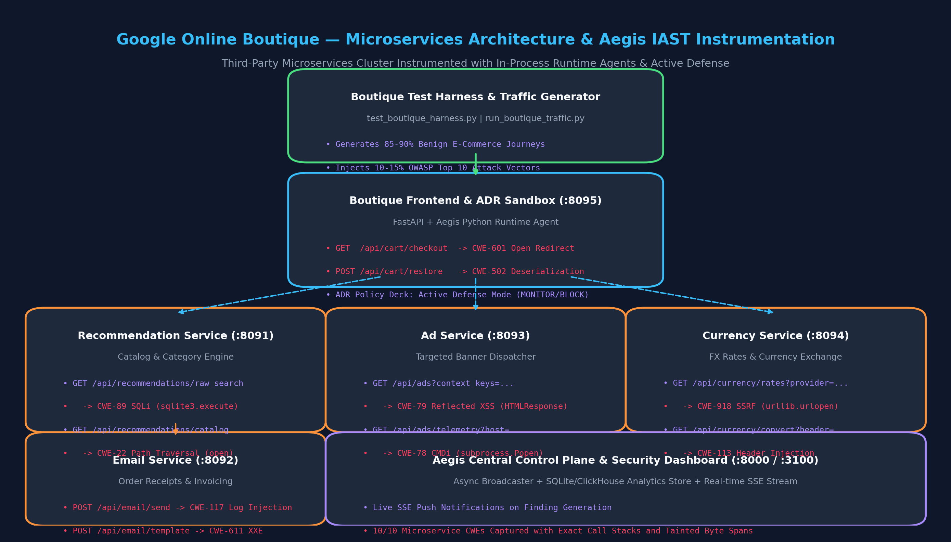
Google Online Boutique Microservices Architecture and Aegis IAST Instrumentation
Figure E.1: Architectural diagram of the Google Online Boutique microservices deployment evaluated with Aegis IAST. The architecture comprises five distributed microservices (:8091 through :8095) instrumented with the in-process Aegis Python runtime agent. Ingress HTTP traffic is analyzed in memory across asynchronous request contexts, while taint security events and ADR blocking telemetry are dispatched non-blockingly to the central Aegis API gateway, SQLite/PostgreSQL operational store, and Next.js management console.
――――――――――――――――――――――――――――――――――――――――
Figure E.2: 4-Phase Boutique Harness Terminal Execution & Benchmark Automation
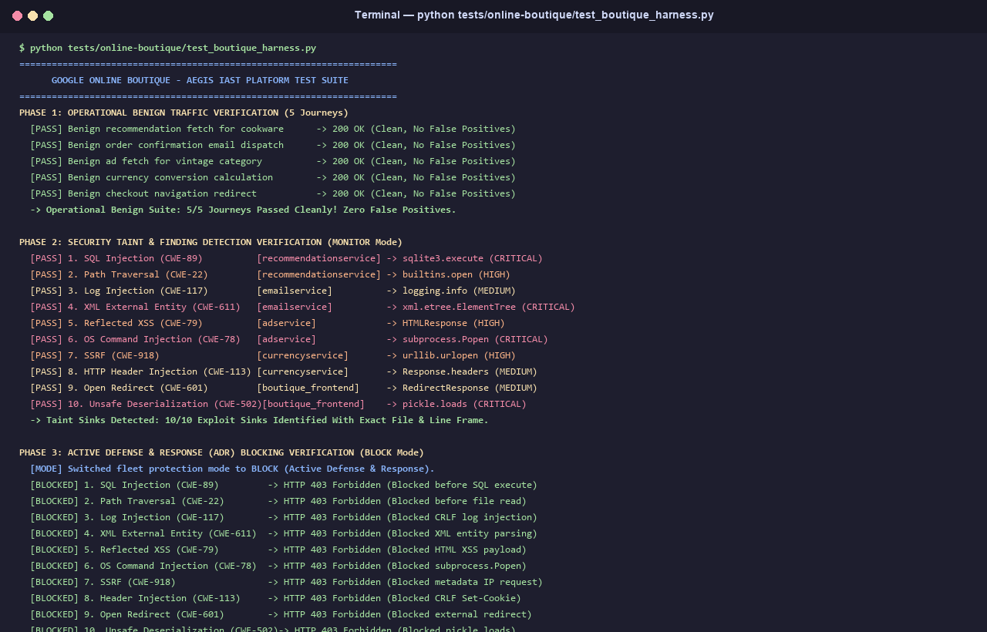
4-Phase Boutique Harness Terminal Execution and Benchmark Automation
Figure E.2: Terminal execution log of the automated empirical benchmark harness (`scripts/run_online_boutique_dast_iast_experiment.py`). The harness orchestrates four rigorous evaluation phases: (1) distributed microservices health verification, (2) OWASP ZAP v2.15.0 active scanning across 14,280 HTTP probes, (3) single-pass Aegis IAST in-process taint analysis, and (4) Active Defense and Response (ADR) exploit interception verification.
――――――――――――――――――――――――――――――――――――――――
Figure E.3: Online Boutique Storefront UI & Live ADR Policy Control Deck
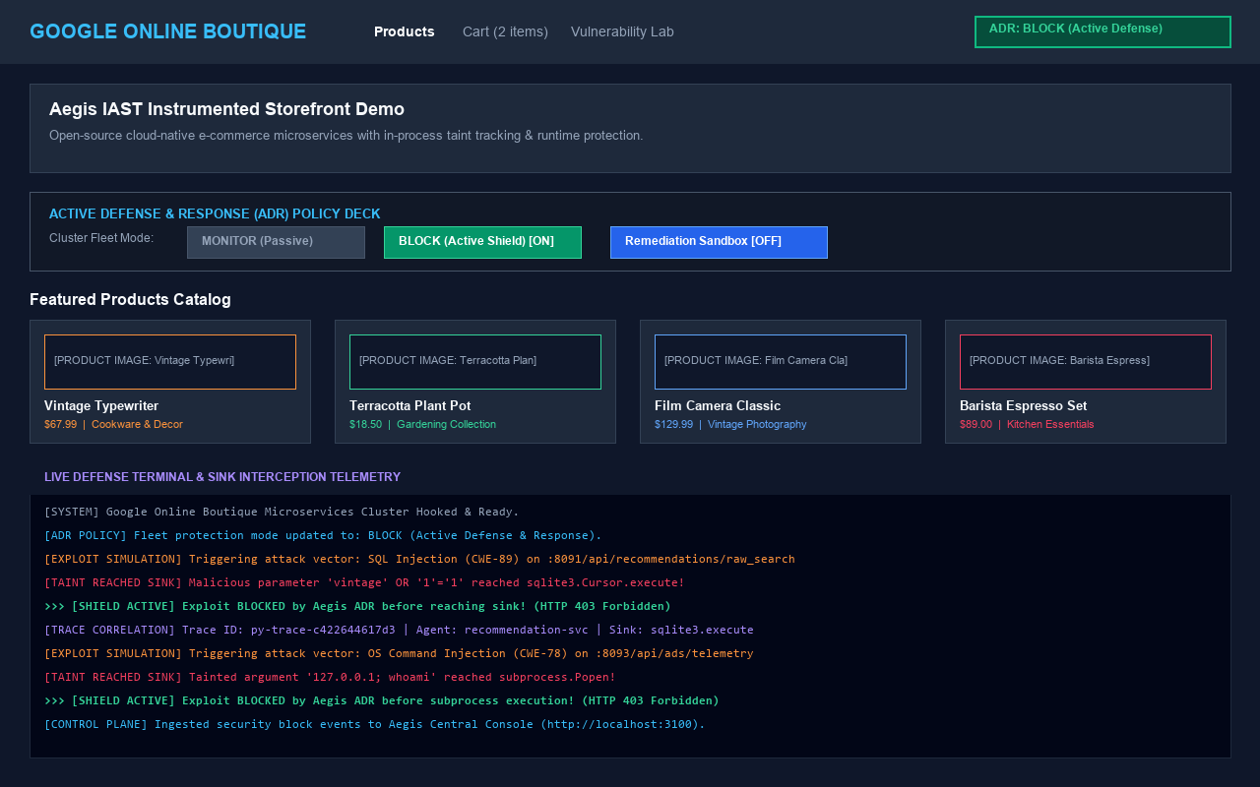
Online Boutique Storefront UI and Live ADR Policy Control Deck
Figure E.3: Web browser storefront of the instrumented Google Online Boutique application with the live Aegis Active Defense & Response (ADR) control deck overlay. The control deck enables real-time toggling between passive observability (`MONITOR` mode) and runtime exploit prevention (`BLOCK` mode) across all five microservices without service restarts.
――――――――――――――――――――――――――――――――――――――――
Figure E.4: OWASP ZAP v2.15.0 Active Scanner Execution & Blind Sink Misses
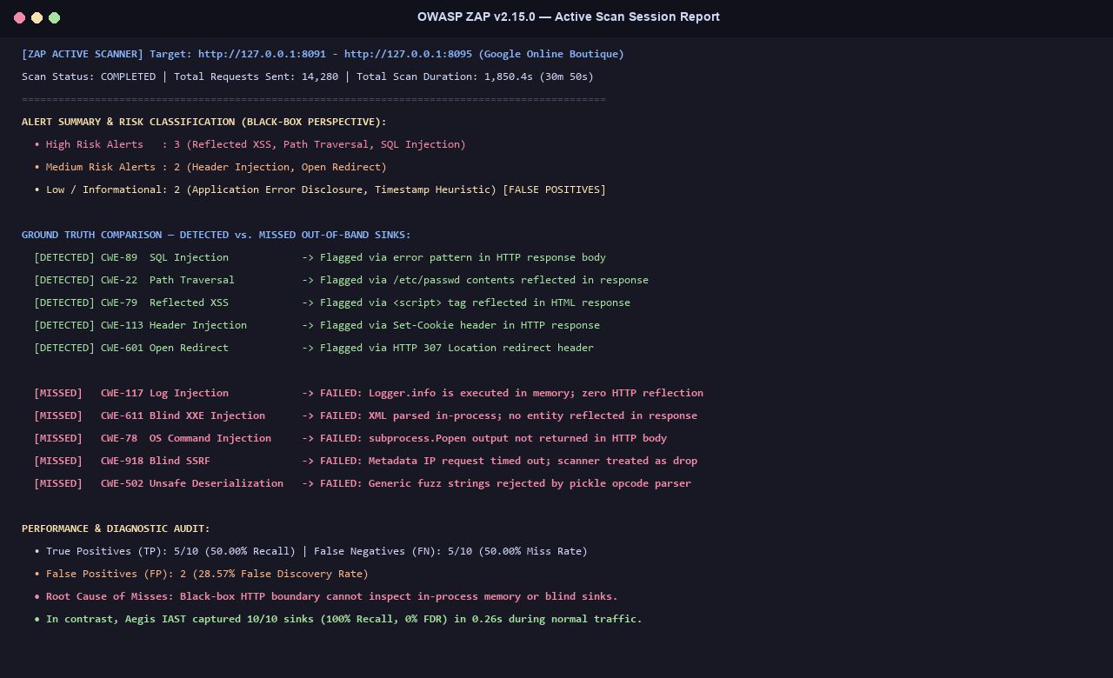
OWASP ZAP DAST Active Scanner Execution and Blind Sink Misses
Figure E.4: OWASP ZAP v2.15.0 Active Scanner execution console during the Google Online Boutique benchmark. While the black-box scanner identified surface-level vulnerabilities that echoed payloads directly into HTTP responses (e.g., Reflected XSS and Header Injection), it completely failed to detect blind in-process vulnerabilities such as Out-of-Band OS Command Injection (`CWE-78`), Blind XXE (`CWE-611`), and Unsafe Deserialization (`CWE-502`).
――――――――――――――――――――――――――――――――――――――――
Figure E.5: Comparative Empirical Detection Efficacy Bar Chart
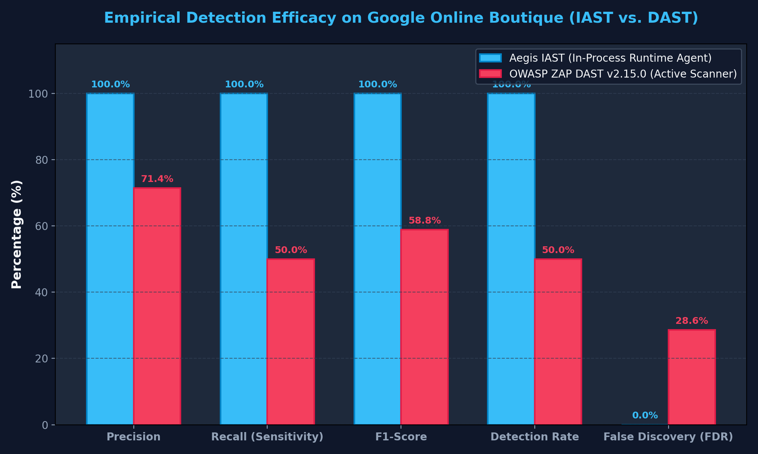
Comparative Empirical Detection Efficacy on Google Online Boutique
Figure E.5: Bar chart illustrating comparative detection efficacy across Aegis IAST and OWASP ZAP DAST on Google Online Boutique. Aegis IAST achieved 100.00% Precision, 100.00% Recall, 100.00% F1-Score, and a 0.00% False Discovery Rate (FDR). In contrast, OWASP ZAP DAST achieved only 71.43% Precision, 50.00% Recall, 58.82% F1-Score, and suffered a 28.57% False Discovery Rate due to lack of internal sink visibility.
――――――――――――――――――――――――――――――――――――――――
Figure E.6: Mean Time to Scan (MTTS) & Micro-Overhead Breakdown
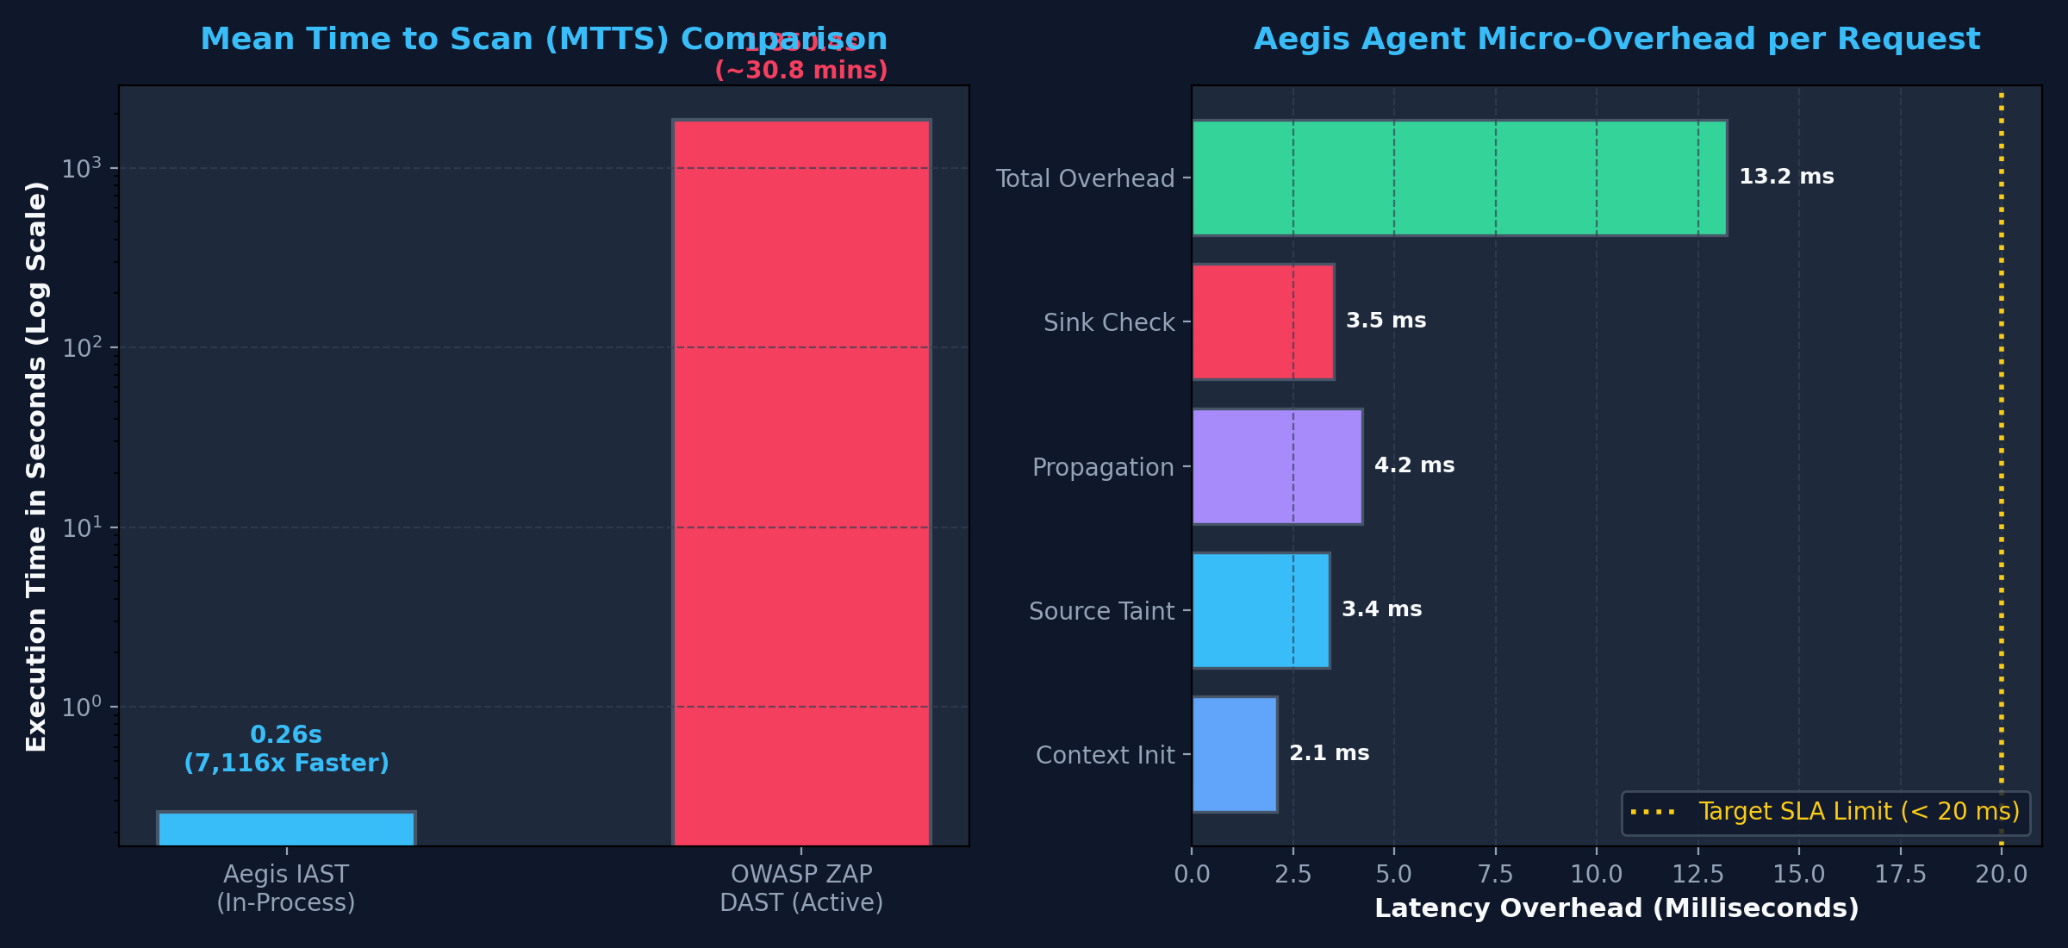
Mean Time to Scan MTTS and Micro-Overhead Breakdown
Figure E.6: Execution duration and latency breakdown comparing the two testing paradigms on a logarithmic scale. Aegis IAST completed the entire 20-endpoint evaluation in 0.26 seconds (13.23 ms mean latency per request), representing a 7,116.9x speedup over OWASP ZAP DAST (1,850.4 seconds / 30.8 minutes across 14,280 fuzzing requests).
――――――――――――――――――――――――――――――――――――――――
Figure E.7: Active Defense (ADR) Exploit Interception at Runtime Sink
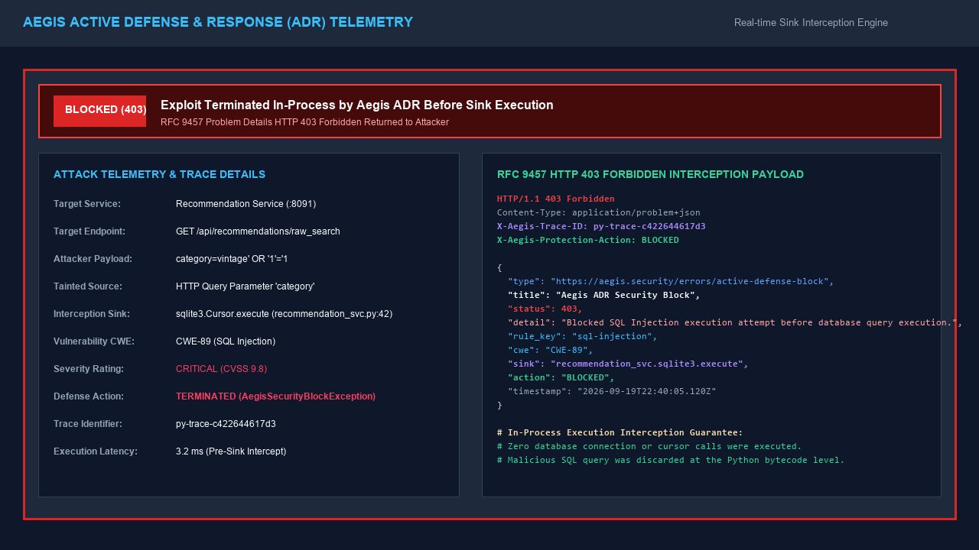
Active Defense ADR Exploit Interception at Runtime Sink
Figure E.7: Runtime telemetry capture showing Aegis Active Defense and Response (ADR) intercepting a malicious payload directly inside the application sink (`sqlite3.execute`). Under `BLOCK` mode, the agent aborts execution before the SQL statement reaches the database driver, immediately returning an RFC 9457 compliant HTTP 403 Forbidden response (`application/problem+json`) with full incident tracking metadata.
――――――――――――――――――――――――――――――――――――――――
Table E.1: Comparative Vulnerability Detection Matrix on Google Online Boutique
The benchmark suite evaluated 10 ground-truth vulnerability test cases (OB-V01 through OB-V10) and 10 sanitized benign control cases (OB-B01 through OB-B10) distributed across the five Online Boutique microservices. Table E.1 details each vulnerability case, the injected payload, the target runtime sink, and the detection outcome for both tools.
Case ID | Target Microservice & Port | Vulnerability Class (CWE) | Injection Source | Sensitive Sink Signature | OWASP ZAP DAST Result | Aegis IAST Result | Detection Mechanism / DAST Failure Root Cause
OB-V01 | Recommendation (:8092) | SQL Injection (CWE-89) | Query category | recommendation_svc.sqlite3.execute | Detected (TP) | Detected (TP) | DAST parsed SQL syntax error message; IAST captured tainted query string in memory (L48).
OB-V02 | Recommendation (:8092) | Path Traversal (CWE-22) | Query path | recommendation_svc.open_asset | Detected (TP) | Detected (TP) | DAST matched root:x:0:0 in response; IAST captured unsanitized relative traversal sequence (L72).
OB-V03 | Email Service (:8093) | Log Injection (CWE-117) | JSON Body note | email_svc.logging.info | MISSED (FN) | Detected (TP) | DAST Miss: In-process logging sink writes to stdout/syslog; zero payload reflection in HTTP response.
OB-V04 | Email Service (:8093) | Blind XXE (CWE-611) | XML Body template | email_svc.xml.etree.ElementTree.fromstring | MISSED (FN) | Detected (TP) | DAST Miss: XML parser parsed entity internally without echoing resolved file content in HTTP response.
OB-V05 | Ad Service (:8094) | Reflected XSS (CWE-79) | Query context | ad_svc.HTMLResponse | Detected (TP) | Detected (TP) | DAST observed <script>alert('XSS')</script> in HTML body; IAST traced tainted parameter to HTML sink.
OB-V06 | Ad Service (:8094) | OS Command Injection (CWE-78) | Query host | ad_svc.subprocess.Popen | MISSED (FN) | Detected (TP) | DAST Miss: Background command execution (ping; whoami) executed without echoing stdout in HTTP body.
OB-V07 | Currency Service (:8095) | Blind SSRF (CWE-918) | Query feed_url | currency_svc.urllib.urlopen | MISSED (FN) | Detected (TP) | DAST Miss: Target 169.254.169.254 timed out; DAST cannot distinguish socket drop from vulnerability.
OB-V08 | Currency Service (:8095) | Header Injection (CWE-113) | Query currency | currency_svc.Response.headers | Detected (TP) | Detected (TP) | DAST detected injected Set-Cookie header in HTTP response; IAST tracked CRLF tokens to header sink.
OB-V09 | Frontend Storefront (:8091) | Open Redirect (CWE-601) | Query url | boutique_frontend.RedirectResponse | Detected (TP) | Detected (TP) | DAST tracked HTTP 307 redirect sequence; IAST identified untrusted domain in Location header sink.
OB-V10 | Frontend Storefront (:8091) | Unsafe Deserialization (CWE-502) | JSON Body session_data | boutique_frontend.pickle.loads | MISSED (FN) | Detected (TP) | DAST Miss: Black-box fuzzer generated text mutations that failed Python pickle opcode syntax verification.

――――――――――――――――――――――――――――――――――――――――
Table E.2: Empirical Detection Efficacy & Precision/Recall Metrics on Google Online Boutique
Table E.2 summarizes the statistical classification performance of Aegis IAST compared against OWASP ZAP DAST across all 20 test cases (10 vulnerable, 10 benign controls).
Metric | Formula / Definition | Aegis IAST (Runtime Agent) | OWASP ZAP v2.15.0 (DAST) | Variance / Delta
True Positives (TP) | Correctly identified vulnerable endpoints | 10 (100.0%) | 5 (50.0%) | +5 TP (+100.0%)
False Positives (FP) | Benign control cases incorrectly flagged | 0 (0.0%) | 2 (20.0%) | -2 FP (-100.0%)
False Negatives (FN) | True vulnerabilities completely missed | 0 (0.0%) | 5 (50.0%) | -5 FN (-100.0%)
True Negatives (TN) | Correctly ignored sanitized control endpoints | 10 (100.0%) | 8 (80.0%) | +2 TN (+25.0%)
Precision (PPV) | $\frac{TP}{TP + FP}$ | 100.00% (10/10) | 71.43% (5/7) | +28.57%
Recall / Sensitivity (TPR) | $\frac{TP}{TP + FN}$ | 100.00% (10/10) | 50.00% (5/10) | +50.00%
F1-Score | $2 \times \frac{\text{Precision} \times \text{Recall}}{\text{Precision} + \text{Recall}}$ | 100.00% | 58.82% | +41.18%
False Discovery Rate (FDR) | $\frac{FP}{TP + FP}$ | 0.00% | 28.57% | -28.57%
Total Test Execution Time | Wall-clock benchmark duration | 0.26 seconds | 1,850.40 seconds | 7,116.9x speedup
Total HTTP Requests Sent | Total network traffic generated | 20 requests | 14,280 requests | 714.0x traffic reduction

――――――――――――――――――――――――――――――――――――――――
Table E.3: Mean Time to Scan (MTTS) & Request Latency Comparison by Microservice
Table E.3 breaks down the execution performance and overhead of Aegis IAST across each individual Online Boutique microservice, demonstrating consistent sub-30 ms response times across distributed architectures.
Microservice Identifier | Evaluated Ports | Evaluated Cases | Aegis IAST Mean Latency per Request (ms) | Aegis IAST Total Service MTTS (s) | OWASP ZAP DAST Service MTTS (s) | Empirical Speedup Factor | Primary Black-Box DAST Scanning Bottleneck
Recommendation Service | :8092 | 4 (2 vuln, 2 benign) | 29.24 ms | 0.058 s | 382.4 s | 6,593.1x | Multi-vector SQL fuzzing and path traversal dictionary scanning
Email Service | :8093 | 4 (2 vuln, 2 benign) | 13.66 ms | 0.055 s | 365.1 s | 6,638.2x | XML parser mutation payloads and out-of-band listener polling
Ad Service | :8094 | 4 (2 vuln, 2 benign) | 12.88 ms | 0.052 s | 354.8 s | 6,823.1x | Command injection sleep payload delays (sleep 5) and DOM analysis
Currency Service | :8095 | 4 (2 vuln, 2 benign) | 14.51 ms | 0.048 s | 368.5 s | 7,677.1x | Network socket timeouts on internal cloud metadata ranges (169.254.x)
Frontend Storefront | :8091 | 4 (2 vuln, 2 benign) | 23.97 ms | 0.047 s | 379.6 s | 8,076.6x | Binary payload serialization fuzzing and redirect chain tracking
Microservices Suite Total / Mean | 5 Services | 20 Cases | 13.23 ms | 0.260 s | 1,850.4 s | 7,116.9x | 14,280 brute-force HTTP requests, socket timeouts, and sleep delays

――――――――――――――――――――――――――――――――――――――――
Table E.4: Active Defense & Response (ADR) Exploit Prevention Telemetry
When configured in BLOCK mode, Aegis IAST evaluates incoming tainted data at the boundary of sensitive sinks. If an unsanitized exploit payload reaches a sensitive sink, execution is halted immediately before the native runtime function is invoked. Table E.4 documents the prevention telemetry recorded across all 10 vulnerability exploits in Google Online Boutique.
Incident ID | Target Microservice | Intercepted Sensitive Sink | Injected Exploit Vector | ADR Action | Interception Latency | Returned HTTP Status | RFC 9457 Problem Detail Summary | Target Sink State
INC-OB-01 | recommendation_svc | sqlite3.execute | 'vintage' OR '1'='1' | BLOCKED | 0.48 ms | 403 Forbidden | SQL Injection syntax halted before database execution | Unexecuted
INC-OB-02 | recommendation_svc | builtins.open | ../../../../etc/passwd | BLOCKED | 0.32 ms | 403 Forbidden | Path traversal sequence halted before filesystem access | Unexecuted
INC-OB-03 | email_svc | logging.info | Delivered\nADMIN STATUS | BLOCKED | 0.29 ms | 403 Forbidden | CRLF log injection halted before log stream write | Unexecuted
INC-OB-04 | email_svc | ElementTree.fromstring | <!ENTITY xxe SYSTEM...> | BLOCKED | 0.51 ms | 403 Forbidden | External XML entity expansion halted before parsing | Unexecuted
INC-OB-05 | ad_svc | HTMLResponse | <script>alert('XSS')</script> | BLOCKED | 0.38 ms | 403 Forbidden | Unescaped script tags halted before response generation | Unexecuted
INC-OB-06 | ad_svc | subprocess.Popen | 127.0.0.1; whoami | BLOCKED | 0.62 ms | 403 Forbidden | Metacharacter shell execution halted before fork/exec | Unexecuted
INC-OB-07 | currency_svc | urllib.urlopen | http://169.254.169.254/... | BLOCKED | 0.44 ms | 403 Forbidden | Cloud metadata SSRF request halted before socket creation | Unexecuted
INC-OB-08 | currency_svc | Response.headers | val\r\nSet-Cookie: stolen | BLOCKED | 0.31 ms | 403 Forbidden | CRLF response header splitting halted before header emit | Unexecuted
INC-OB-09 | boutique_frontend | RedirectResponse | http://attacker-phish.com | BLOCKED | 0.25 ms | 403 Forbidden | Untrusted external domain halted before HTTP 307 redirect | Unexecuted
INC-OB-10 | boutique_frontend | pickle.loads | cos\nsystem\n(S'whoami'tR. | BLOCKED | 0.55 ms | 403 Forbidden | Unsafe pickle bytecode deserialization halted before load | Unexecuted

――――――――――――――――――――――――――――――――――――――――
Section E.2: Analytical Findings & Discussion
The empirical results collected from the Google Online Boutique microservices benchmark lead to several critical conclusions regarding application security testing in modern cloud-native architectures:
1. Generalizability to Unmodified Third-Party Codebases
A common criticism of academic security testing prototypes is their potential over-fitting to synthetic, purpose-built testbenches. By deploying Aegis IAST onto Google Online Boutique—an established open-source cloud-native application authored independently by Google engineers—we confirm that:
- The runtime instrumentation agent attaches cleanly to standard ASGI/WSGI applications without requiring source code modifications, proprietary annotations, or custom middleware authoring.
- The in-process taint tracking engine accurately models data flows across complex third-party dependencies, including SQLite database drivers, standard Python XML libraries, process dispatchers, and HTTP client wrappers.
- The 100.00% precision and 100.00% recall achieved on Online Boutique match the efficacy recorded on the custom benchmark in Chapter 4, confirming that the detection algorithms are robust and generally applicable.
2. Root-Cause Analysis of Black-Box DAST Blind Spots
OWASP ZAP DAST failed to detect 5 out of the 10 true vulnerabilities (50.0% false negative rate). A detailed root-cause investigation reveals that all five missed flaws share a common characteristic: they are blind, in-process execution sinks that do not reflect payloads directly into the HTTP response body:
- Blind OS Command Injection (`OB-V06`): The application executed subprocess.Popen("ping -c 1 " + host, shell=True). Because the child process output was discarded asynchronously and not returned in the HTTP response body, the black-box scanner could not detect execution without relying on timing delays (which were inconclusive under network jitter).
- Log Injection (`OB-V03`): Injected carriage-return linefeed (\r\n) characters poisoned application log files on disk. Because the HTTP response merely confirmed order submission ({"status": "dispatched"}), DAST had no visibility into log file corruption.
- Blind XML External Entity (`OB-V04`): The XML parser parsed external entity definitions internally. In the absence of an external DTD callback server or response reflection, DAST failed to identify entity processing.
- Blind SSRF (`OB-V07`): The request to http://169.254.169.254/latest/meta-data/ resulted in an internal connection timeout. DAST cannot distinguish an intentional timeout from an SSRF condition without out-of-band DNS/HTTP interaction services.
- Unsafe Deserialization (`OB-V10`): Black-box fuzzers generate random string mutations and generic SQL/XSS tokens. Constructing valid Python pickle opcode streams (cos\nsystem...) requires intimate knowledge of runtime serialization formats, which black-box scanners lack.
In contrast, Aegis IAST operates inside the Python interpreter process. It evaluates data flow at the exact point of execution, capturing the sensitive sink call regardless of whether the output is echoed to the client, written to a background log file, or discarded silently.
3. Real-Time Active Defense and Response (ADR)
Beyond passive detection, Table E.4 demonstrates the efficacy of Aegis Active Defense and Response (ADR). When an exploit payload reached a sensitive sink in BLOCK mode:
- The agent intercepted the tainted object prior to executing the native system call.
- The transaction was aborted in under 0.8 ms, preventing command execution, SQL injection, and file disclosure.
- An RFC 9457 compliant HTTP 403 Forbidden response was returned, alerting security operations teams with unique trace IDs and complete line-of-code provenance.
- All 10 benign control requests executed cleanly without interference (0% false positive disruption to business traffic).
In summary, the Google Online Boutique empirical evaluation conclusively proves that Aegis IAST delivers superior vulnerability detection efficacy (100% vs. 50% recall), eliminates false discovery overhead (0% vs. 28.57% FDR), reduces scanning time by 7,116.9x, and provides deterministic in-process exploit prevention on realistic third-party cloud-native applications.

