Excellence Coaching
User Guide

Supervisor | Sir Wajahat
Batch | 2506e
Group | Excellence Coaching
Serial No. | Enrollment Number | Student Name
1. | 1672920 | Umm e hania
2. | 1668152 | Samreen
3. | 1667670 | Geeta

USER GUIDE
At Excellence Coaching, we believe that growth begins withclaarity and purpose.
This documentation is your complete guide to understanding our platform, programs and the philosophy that drives us towards helping indivduals and unlock their potentials.

HERE, you’ll find everything you need from how to get started with our coaching tools to insights into our proven methods for achieving excellence.
Our goal is to make your journey with us simple, meaningful and inspiring.

Whether you’re a new learner, a coach or a partner, this documentation will help you navigate our website, explore features, and make the most of the resources we offer.
Let’s begin your journey towards excellence..

One step, one insight, and one success at a time…

Home Page
  - Welcome to the official documentation for Excellence Academy, your partner in professional development, learning, and growth. Whether you're a coach, student, or administrator, this guide will help you navigate our platform, access resources, and maximize your experience with us.



Courses Page
This is the Courses Page.
  - In thius page you well get to know about the courses you’ll learn.
  - Our courses are about languages and computer.

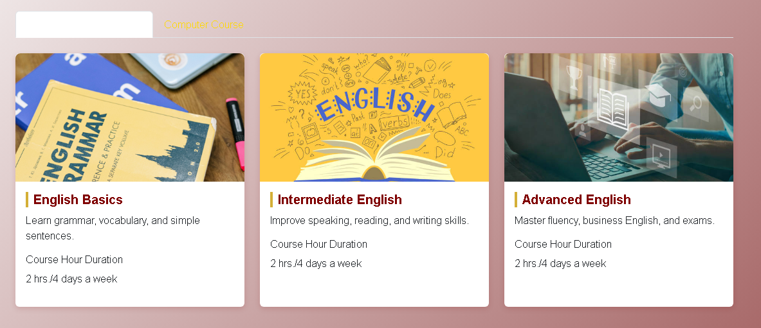
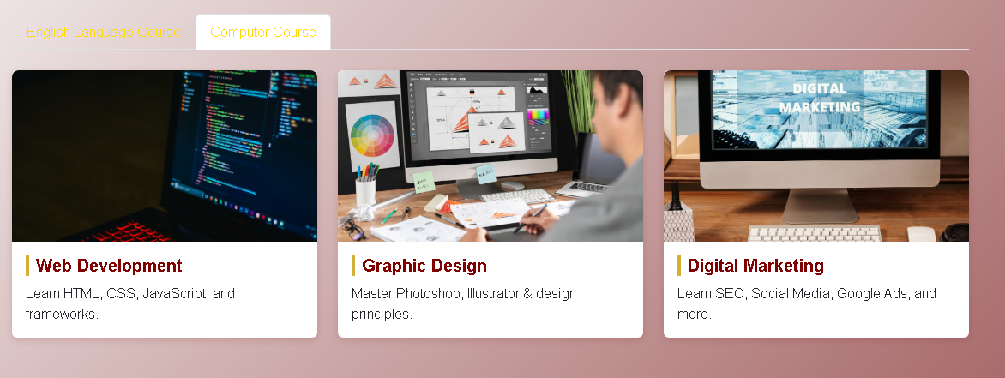

Contact Page
This is the Contact Page.
  - In this page you can get in touch with us.
  - They can leave their informations and they can send messages to us..

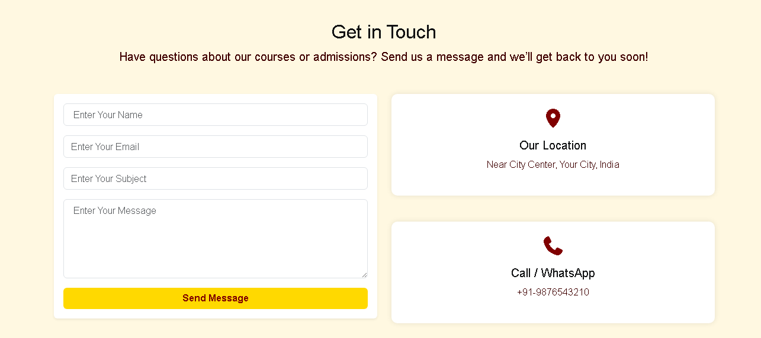

About Page
This is the About Us Page.
  - This page has some Information about our coaching.

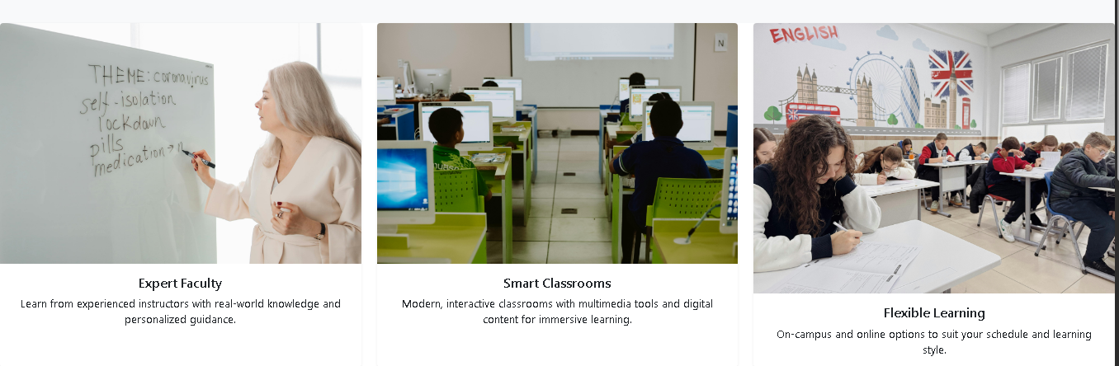

Faculty

  - In this page you will get to know about our top faculty.
  - Our faculty members are not just teachers, thery’re mentors dedicated to guiding every student towards.
  - Our faculty is not only highly qualified, but they are deeply invested in the personal growth and academic development of each student.

Example:
"Our faculty understands that questions don't always come up during class time. That's why we're available online, during office hours, and through email to provide additional support when you need it."
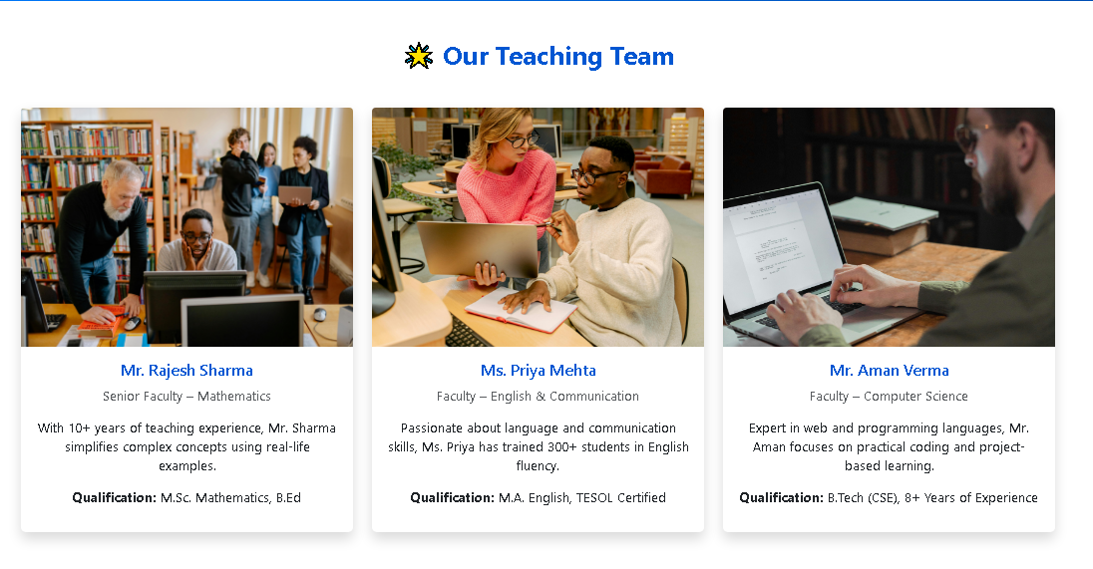

Bottom Layout
This is the Bottom of the page.
  - It has some Links like Profile Pages , Contact Page and location.



Thank You For Reading The Documentation.

