1. What does an empty dictionary's code look like?

Ans: dic = {}

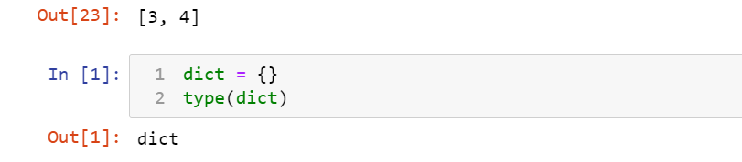

1. What is the value of a dictionary value with the key 'foo' and the value 42?

Ans: 

1. What is the most significant distinction between a dictionary and a list?

Ans: Most significant difference:

List - items in list are Ordered

Dictionary : iten in dictionary are unordered

1. What happens if you try to access spam['foo'] if spam is {'bar': 100}?

Ans: This will give us KeyError

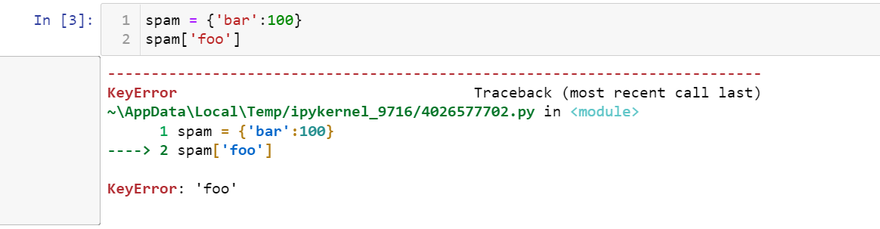

1. If a dictionary is stored in spam, what is the difference between the expressions 'cat' in spam and 'cat' in spam.keys()?

Ans: There is no differnce, both check if 'cat' is key of the dictionary and if its a key, returns True.

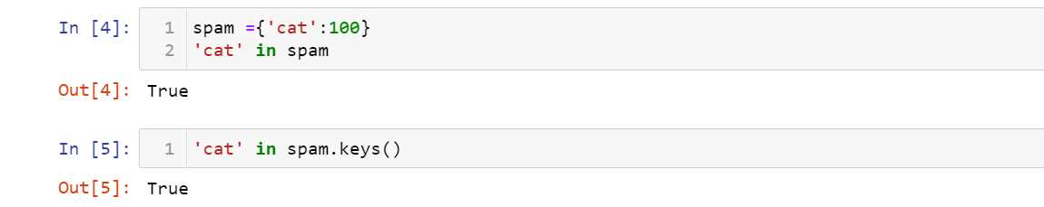

1. If a dictionary is stored in spam, what is the difference between the expressions 'cat' in spam and 'cat' in spam.values()?

Ans: 'cat' in spam checks whether there is a 'cat' key in the dictionary

'cat' in spam.values() checks whether there is a value 'cat' for one of the keys in spam.

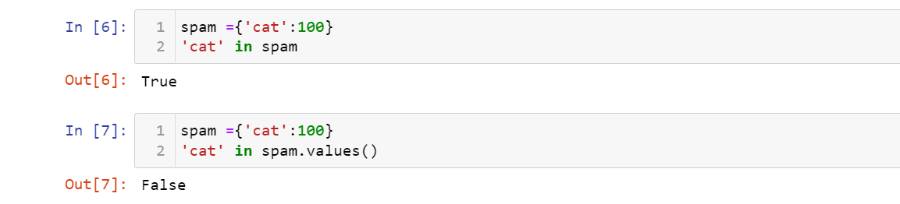

1. What is a shortcut for the following code?

if 'color' not in spam:

spam['color'] = 'black'

Ans: This can be achieved by using setdefault() which Inserts key with a value of default if key is not in the dictionary

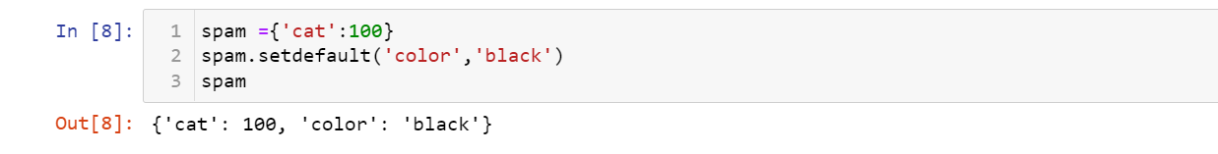

1. How do you "pretty print" dictionary values using which module and function?

Ans: Pretty printing means to present something in a more readable format or style

