1. Is the Python Standard Library included with PyInputPlus?

Ans: PyInputPlus is not a part of the Python Standard Library, so you must install it separately using Pip



1. Why is PyInputPlus commonly imported with import pyinputplus as pypi?

Ans: pypi is alias of PyInputPlus.

The as pyip code in the import statement saves us from typing pyinputplus each time we want to call a PyInputPlus function. Instead we can use the shorter pyip name

1. How do you distinguish between inputInt() and inputFloat()?

Ans: inputInt() : Accepts an integer value, and returns int value

inputFloat() : Accepts integer/floating point value and returns float value

Both takes additional parameters ‘min’, ‘max’, ‘greaterThan’ and ‘lessThan’ for bounds

**import** pyinputplus **as** pyip

pyip**.**inputInt()

pyip**.**inputFloat()

3.5

'3.5' is not an integer.

2

3

Out[8]:

3.0

1. Using PyInputPlus, how do you ensure that the user enters a whole number between 0 and 99?

Ans: In the inputint function we can set the min = 0 and max =99 to ensure user enters number between 0 and 99

pyip**.**inputInt(min **=** 0, max **=**99)

180

Number must be at maximum 99.

3

Out[9]:

3

1. What is transferred to the keyword arguments allowRegexes and blockRegexes?

Ans: we can also use regular expressions to specify whether an input is allowed or not. The allowRegexes and blockRegexes

keyword arguments take a list of regular expression strings to determine what the PyInputPlus function will accept or reject as valid input.

response **=** pyip**.**inputNum(allowRegexes**=**[r'(I|V|X|L|C|D|M)+', r'zero']) *# it allowes roman letters as numbers too*

V

response **=** pyip**.**inputNum(blockRegexes**=**[r'[02468]$'])*# blocks the even numbers*

When you run:

44

This response is invalid.

46

This response is invalid.

68

This response is invalid.

45

1. If a blank input is entered three times, what does inputStr(limit=3) do?

Ans: it will throw RetryLimitException exception.

response **=** pyip**.**inputStr(limit**=**3)

Blank values are not allowed.

Blank values are not allowed.

Blank values are not allowed.

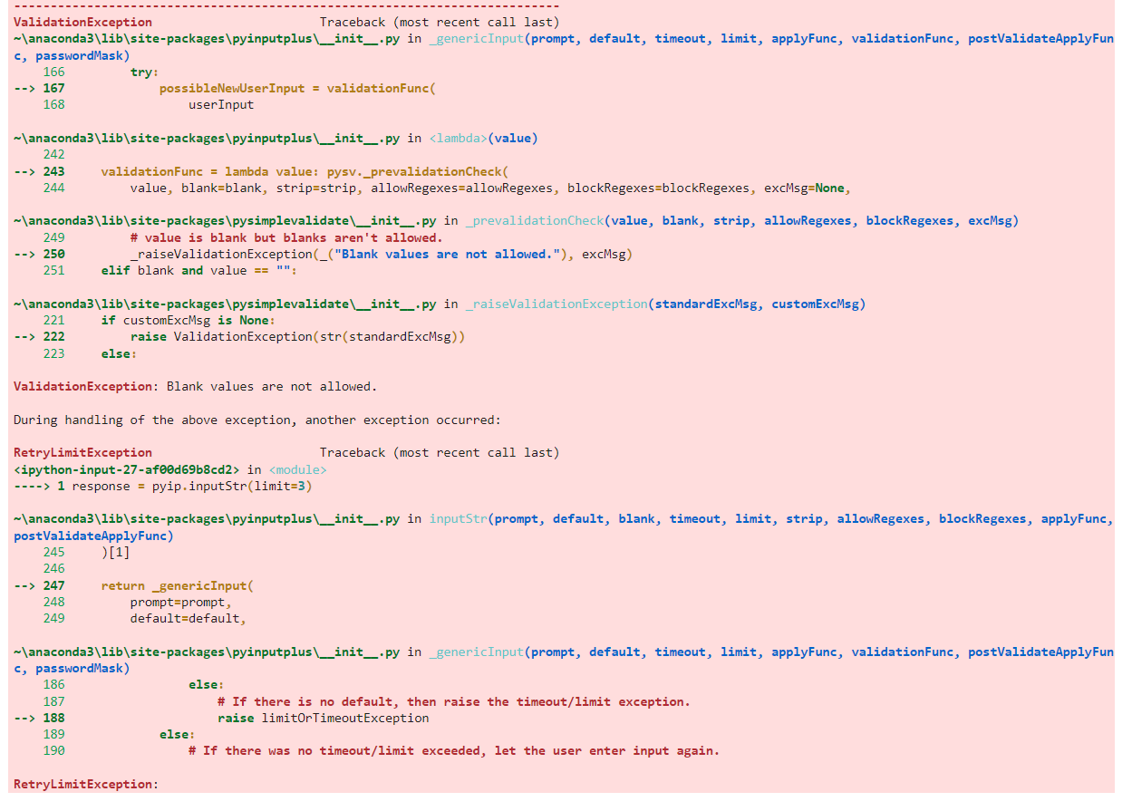

1. If blank input is entered three times, what does inputStr(limit=3, default='hello') do?

Ans: When you use limit keyword arguments and also pass a default keyword argument, the function returns the default value instead of raising an exception

response **=** pyip**.**inputStr(limit**=**3,default**=**'hello')

response

Blank values are not allowed.

Blank values are not allowed.

Blank values are not allowed.

Out[32]:

'hello'