RADIANTILYK AESTHETIC
Clinical Protocol · Practice Reference Document
VASCULAR OCCLUSION
Recognition, Response & Management Protocol
For Dermal Filler Complications
PROTOCOL AUTHORS
Kiem Vukadinovic, NP
Lead Aesthetic Injector
Alyosius Fobi, MD
Medical Director
Version 1.0 · Effective: 2026
CONFIDENTIAL · Internal Clinical Reference

1. Purpose & Scope
Vascular occlusion (VO) is a time-critical medical emergency that can occur during or after the injection of any dermal filler. Filler material entering or compressing an artery interrupts perfusion and can lead to tissue necrosis, permanent scarring, blindness, or stroke.
This protocol provides every clinician at RadiantilyK Aesthetic with a standardized, evidence-informed approach to recognition, immediate response, and management of suspected vascular occlusion. Adherence to this protocol is mandatory for all providers who perform soft-tissue augmentation in our practice.

1.1 Scope of Application
- All hyaluronic acid (HA) and non-HA dermal filler procedures
- All injection sites, with heightened vigilance in defined high-risk zones
- All licensed providers, support staff, and on-call coverage
- Both intra-procedural and post-procedural complications

1.2 Goals
- Rapid recognition of vascular compromise within minutes of onset
- Initiation of hyaluronidase therapy within 60–90 minutes for HA fillers
- Prevention of tissue necrosis, blindness, and stroke
- Consistent documentation and follow-up across all providers
- Clear escalation pathway including emergency transfer when indicated

2. Facial Vascular Anatomy & Risk Zones
A thorough understanding of facial arterial anatomy is the single most important factor in preventing vascular occlusion. The arteries below are end-arterial or have rich anastomoses with the ophthalmic system — embolization can travel retrograde and reach the retinal or cerebral circulation.
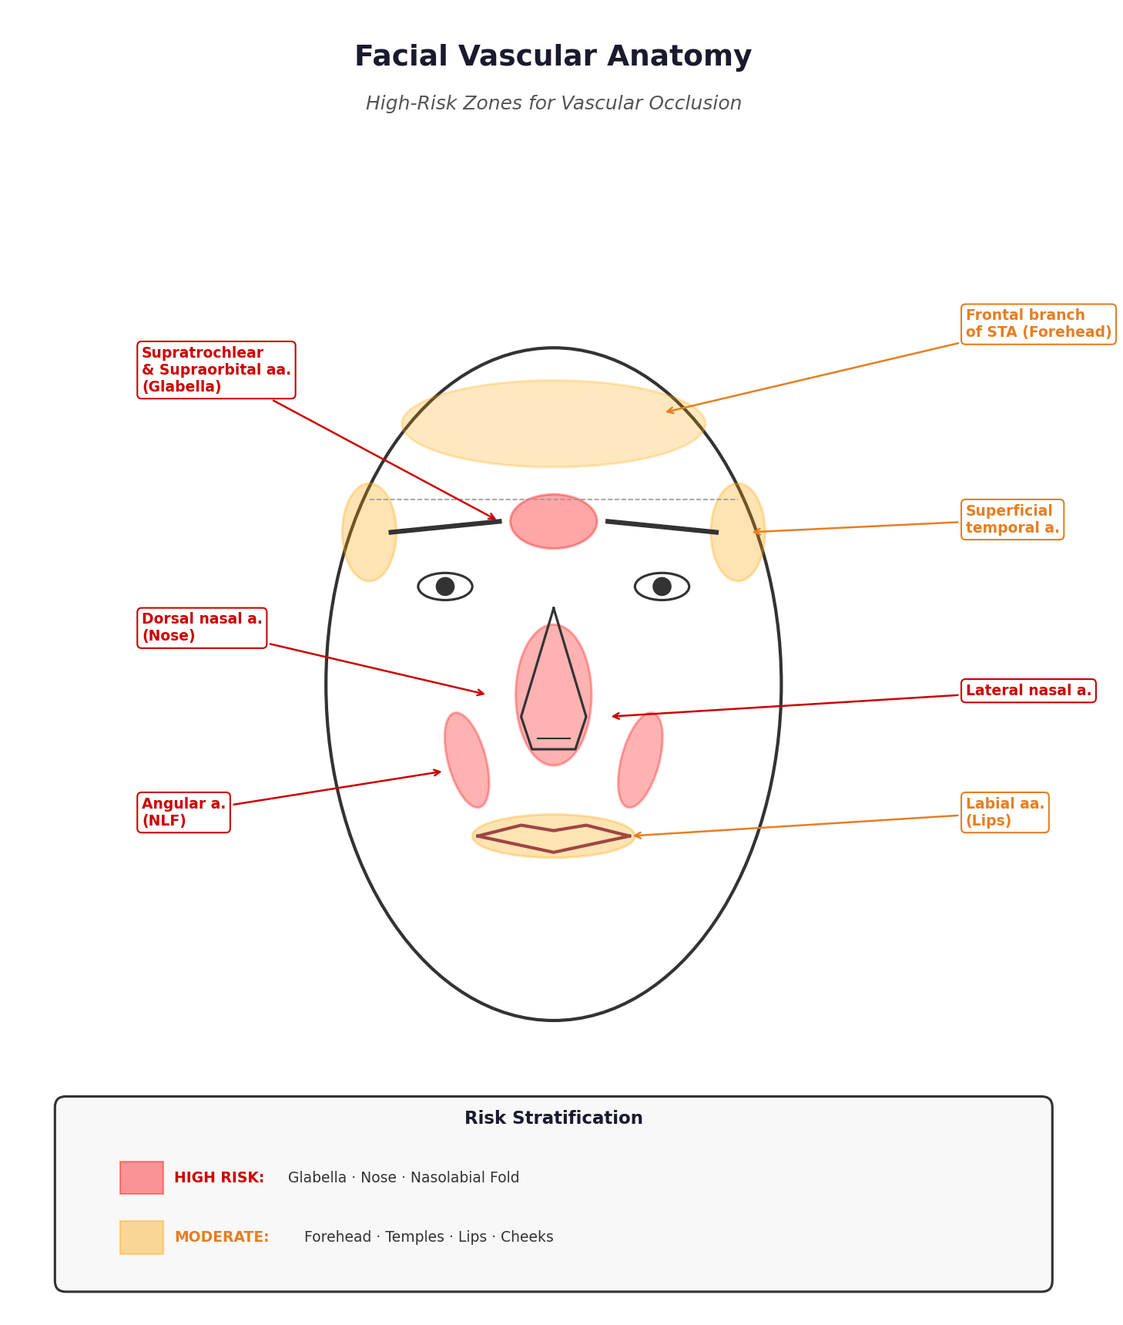
Figure 1. Facial vascular anatomy with high-risk and moderate-risk injection zones.

2.1 High-Risk Zones (HIGHEST Caution)
Zone | Key Artery | Catastrophic Risk
Glabella | Supratrochlear / supraorbital aa. | Blindness, forehead/scalp necrosis
Nasal dorsum & tip | Dorsal nasal, lateral nasal aa. | Tip necrosis, blindness via retrograde flow
Nasolabial fold | Angular artery (terminal facial a.) | Mid-face necrosis, blindness
Forehead (deep) | Frontal branch of supratrochlear | Blindness, scalp necrosis

2.2 Moderate-Risk Zones
Zone | Key Artery | Complication
Temple | Superficial temporal a., middle temporal vein | Necrosis, hematoma, blindness (rare)
Lips | Superior / inferior labial aa. | Lip necrosis, scarring
Cheek / midface | Transverse facial, infraorbital a. | Cheek necrosis
Chin | Mental artery | Lower-lip / chin necrosis
ℹ Pearl: Aspirate Before You Inject
Pull back on the plunger for 5–10 seconds before each bolus.
A negative aspiration does NOT exclude intravascular placement, but a positive one absolutely confirms it.
Use cannulas (≥25G blunt-tip) in high-risk zones whenever feasible.
Inject slowly (< 0.3 mL per site), with low pressure, in retrograde fashion.

3. Recognition: Signs & Symptoms
Vascular occlusion can present immediately during injection or up to 24–48 hours later. Maintain a high index of suspicion any time the clinical picture is not what you expect.
⚠ Cardinal Signs — Any ONE of these mandates immediate action
1. Pain disproportionate to procedure (severe, burning, persistent)
2. Blanching of skin in arterial distribution (white, pale)
3. Livedo reticularis — mottled, dusky, lace-like discoloration
4. Delayed capillary refill (> 3 seconds) compared to contralateral side
5. Skin that is cool to the touch in the affected zone
6. Any visual changes — blurred vision, partial vision loss, eye pain, ptosis

3.1 Clinical Progression
If untreated, vascular occlusion follows a predictable progression. Each stage represents an opportunity for intervention, but the window narrows rapidly.
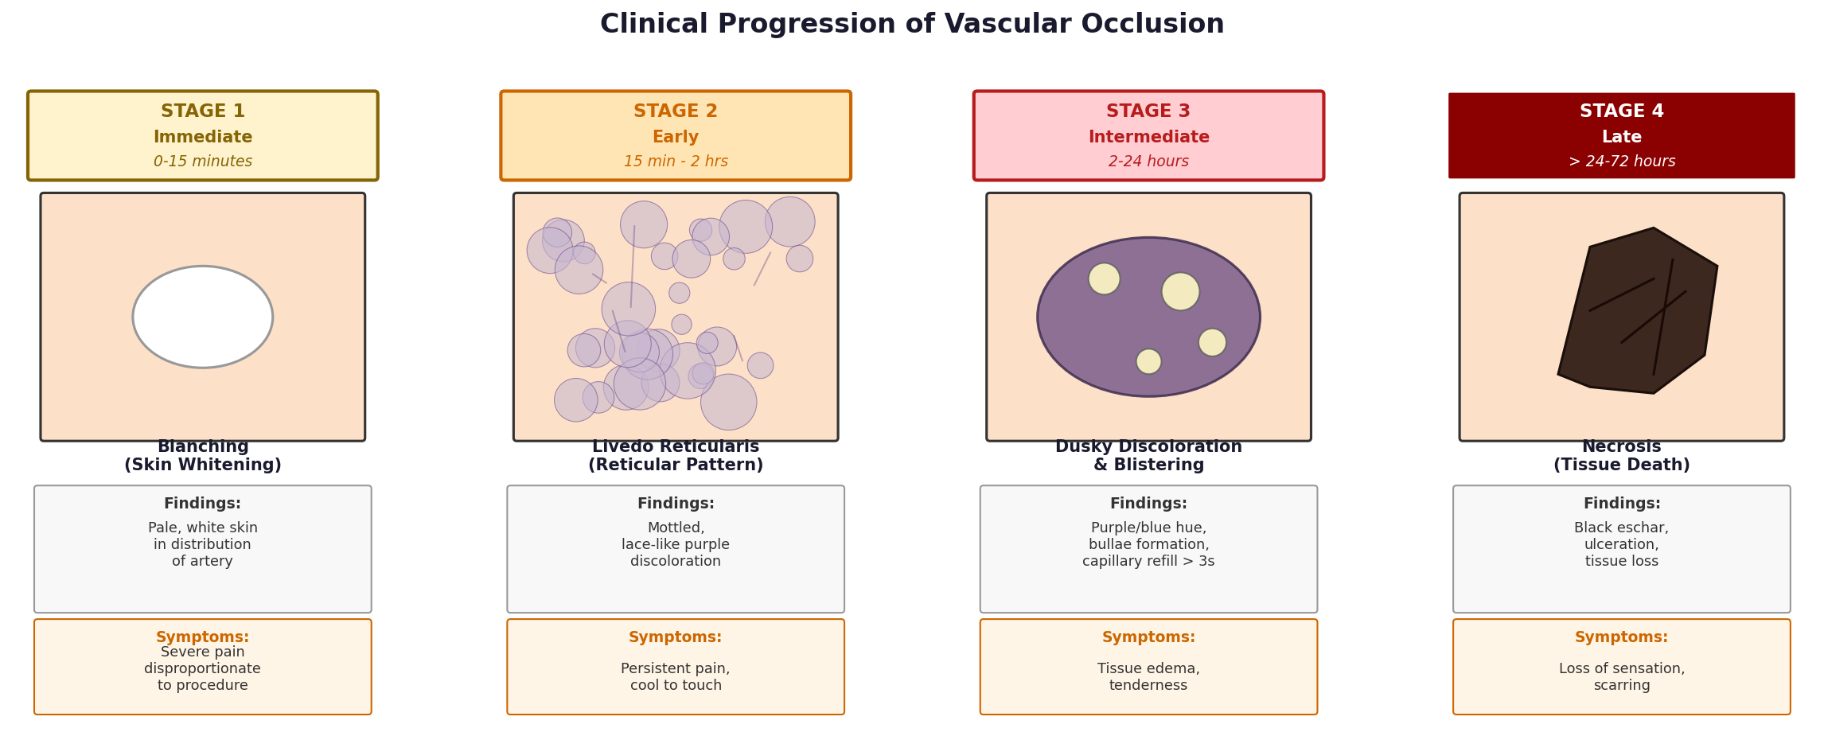
Figure 2. Clinical progression of vascular occlusion across four stages.

3.2 Red Flags — Vision-Threatening / Stroke
🚨 CALL 911 IMMEDIATELY if ANY of the following develop
Sudden vision loss, blurring, double vision, or visual-field defect
Eye pain, ptosis, ophthalmoplegia, or proptosis
Severe one-sided headache disproportionate to procedure
Facial droop, slurred speech, weakness, altered mental status
Nausea, vomiting accompanying any neurologic finding

3.3 Differential Considerations
Several findings can mimic vascular occlusion. When in doubt, treat as VO until proven otherwise — under-treatment is more dangerous than unnecessary hyaluronidase.
- Vasovagal reaction: pallor with bradycardia/diaphoresis, resolves with positioning
- Bruising / hematoma: soft, purple, conforming, not in arterial distribution
- Inflammatory reaction: delayed (days–weeks), warm and tender, not blanched
- Compression ischemia: from product volume — may resolve with massage; manage as VO if persistent

4. Emergency Response Algorithm
The moment vascular occlusion is suspected, every member of the team has a defined role. Time is tissue. Begin hyaluronidase administration within 60–90 minutes for optimal outcomes; for periocular involvement, treat immediately.
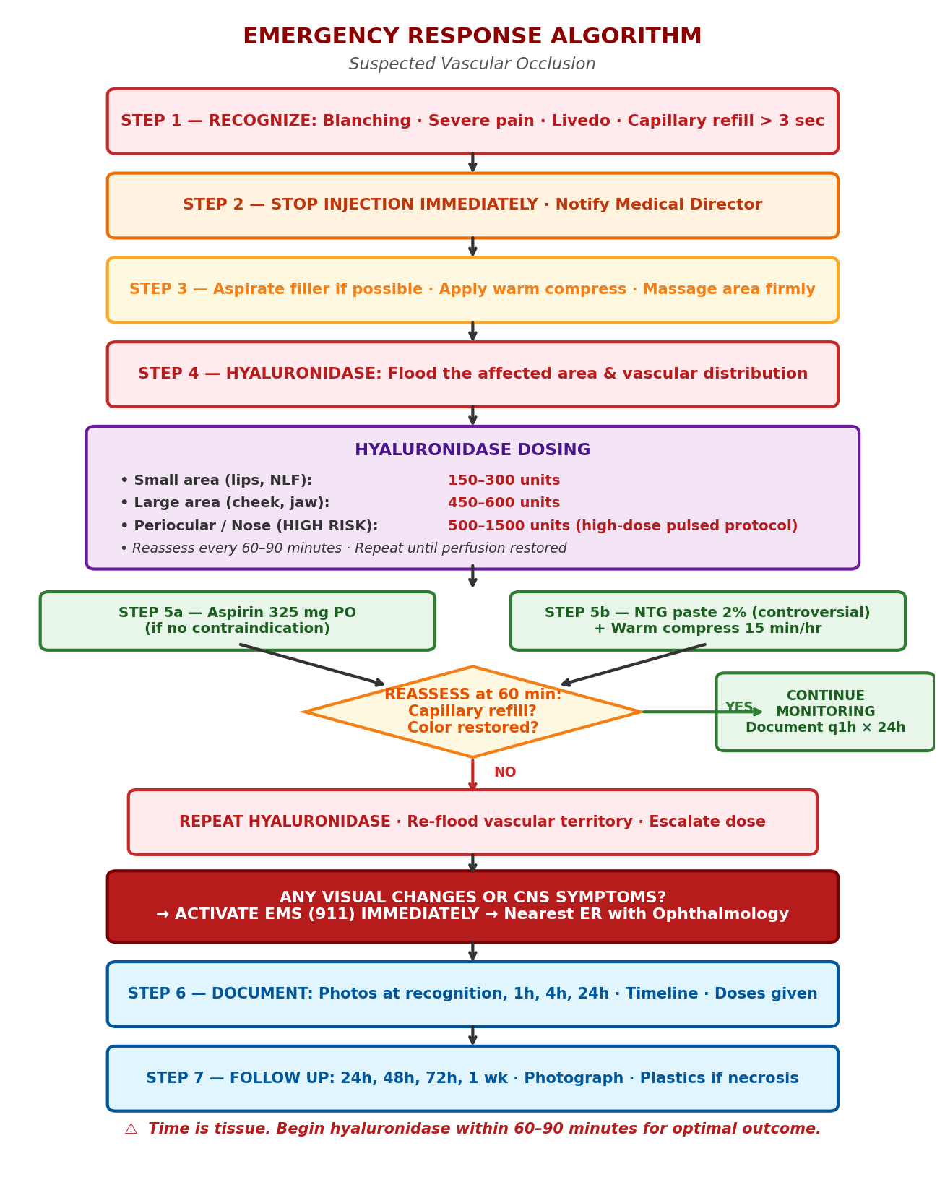
Figure 3. Step-by-step response algorithm for suspected vascular occlusion.

4.1 Step-by-Step Response

Step 1 — Recognize
At first sign of disproportionate pain, blanching, livedo, or delayed capillary refill, verbalize the concern. Speaking it aloud activates the team.

Step 2 — Stop & Notify
- Stop the injection immediately. Withdraw the needle/cannula.
- Notify the Medical Director (Dr. Fobi) and assign a team member to document timeline.
- Position patient supine; ensure airway, breathing, circulation.
- Bring the VO Emergency Kit to bedside.

Step 3 — Initial Maneuvers
- Attempt aspiration through the existing needle/cannula.
- Apply firm massage to the affected area for 5 minutes to attempt to dislodge or fragment the embolus.
- Apply warm compress (not hot) to promote vasodilation.
- Tap the area firmly with a fingertip — gentle percussion may help mobilize product.

Step 4 — Hyaluronidase (HA Fillers)
Hyaluronidase is the cornerstone of management for HA-filler occlusion. It is safe, fast-acting, and underdosing is the most common mistake.
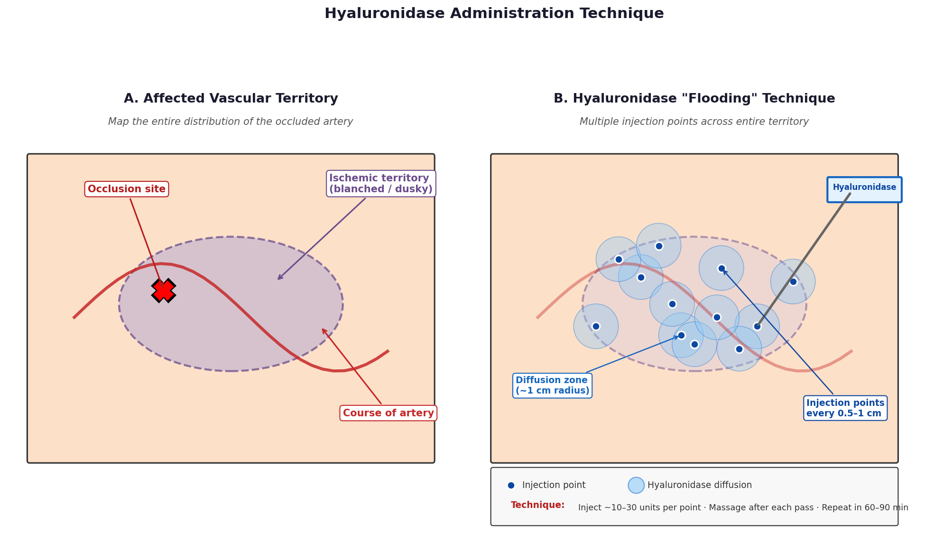
Figure 4. Hyaluronidase "flooding" technique across the entire vascular territory.
⚡ Hyaluronidase Dosing (per session)
Small territory (lips, single NLF): 150–300 units
Large territory (cheek, jawline, forehead): 450–600 units
Periocular or nasal involvement: 500–1,500 units, high-dose pulsed
Inject ~10–30 units per point, every 0.5–1 cm across the entire ischemic territory
Massage vigorously after each pass to distribute the enzyme
Reassess every 60–90 minutes; repeat dosing until perfusion is restored
No maximum daily dose has been established in acute VO management

Step 5 — Adjunctive Therapy
- Aspirin 325 mg PO × 1, then 81 mg daily × 7 days (if no contraindication — confirm no bleeding disorder, no pregnancy, no NSAID allergy)
- Warm compress: 15 minutes every hour while awake × 48 hours
- Nitroglycerin paste 2%: evidence is mixed. May be considered in select cases but is not first-line; consult Medical Director before use.
- Sildenafil: some protocols include for vasodilation — physician decision
- Hyperbaric oxygen therapy: consider referral if necrosis develops despite hyaluronidase
- Antibiotic coverage: if skin compromise — cephalexin 500 mg QID × 7 days (or alternative if PCN-allergic)

Step 6 — Reassess
- Reassess at 60 minutes after first dose: capillary refill, color, pain.
- If improving — continue monitoring; document hourly × first 4 hours, then q4h × 24 h.
- If NOT improving — repeat hyaluronidase, escalate dose, escalate care.
- Persistent or progressive findings after 2 doses warrant emergency referral.

Step 7 — Document & Follow Up
- Photograph at recognition, then at 1 h, 4 h, 24 h, 48 h, 72 h, and 1 week.
- Document every dose, time, location, and clinical response.
- Re-evaluate in clinic at 24 h, 48 h, 72 h, and 1 week minimum.
- Refer to plastic surgery / wound care if any necrosis develops.
- File incident report and notify carrier per practice policy.

5. Hyaluronidase: Drug & Technique Reference

5.1 Product Information
Property | Detail
Brand names | Hylenex (recombinant) · Vitrase · Amphadase · Wydase
Concentration | Typically 150 units/mL (reconstituted)
Onset of action | < 5 minutes (peak at 24–48 hours)
Half-life | Approximately 2 minutes (rapidly degraded)
Storage | Refrigerate 2–8°C; protect from light; do not freeze
Stability after reconstitution | Use within 6 hours; do not retain unused product

5.2 Reconstitution & Preparation
- Verify expiration date and lot number; document both.
- Reconstitute per manufacturer instructions (typically 1 mL bacteriostatic saline per 150-unit vial unless otherwise specified).
- Mix by gentle inversion — do NOT shake (denatures enzyme).
- Draw into 1 mL syringes with 30G needles for delivery.
- Label syringes with concentration and time of reconstitution.

5.3 Allergy & Safety Considerations
ℹ Pre-Treatment Allergy Screen
Document any prior reaction to hyaluronidase, bee/wasp venom, or hymenoptera stings.
True hypersensitivity is rare (< 0.1%) but can be anaphylactic.
In a true vascular emergency, the risk of withholding hyaluronidase exceeds the risk of allergic reaction in nearly all patients.
Have epinephrine (1:1000 IM), diphenhydramine 50 mg, and oxygen immediately available.
Skin testing (intradermal 3 units) may be considered for elective dissolutions but NOT for active VO.

5.4 Injection Technique
- Use 30G needle (or 27G for high-volume sessions).
- Inject directly into the affected ischemic tissue — do NOT inject only at the original entry site.
- Cover the entire vascular distribution of the suspected occluded artery, not just the visible blanched area.
- Use multiple small injection points (10–30 units each) spaced 0.5–1 cm apart.
- Aspirate before each bolus (especially in high-risk zones such as glabella).
- Massage vigorously for 1–2 minutes after each pass to facilitate enzyme diffusion.
- Reassess perfusion; repeat the entire flood every 60–90 minutes until restored.

5.5 Periocular / Suspected Ocular Involvement
🚨 Visual Symptoms = Ophthalmologic Emergency
Activate EMS (911) immediately. Transport to a center with on-call ophthalmology.
Do NOT wait for symptoms to progress. The window for retinal salvage is < 90 minutes.
En route: continue retrobulbar/peribulbar hyaluronidase ONLY if you are trained and credentialed; otherwise, manage as transport priority.
Reduce intraocular pressure: digital ocular massage, breathe into a paper bag (mild hypercapnia), consider acetazolamide if available.
Lay patient supine; loosen any restrictive clothing.
Notify receiving facility en route with full timeline and doses administered.

6. Vascular Occlusion Emergency Kit
A dedicated VO kit must be checked weekly and immediately accessible in every treatment room. The Medical Director or designee is responsible for kit integrity.

6.1 Required Contents
Item | Quantity | Expiration Check
Hyaluronidase (Hylenex 150 U vials) | Minimum 10 vials (1,500 U total) | Monthly
Bacteriostatic saline (for reconstitution) | 10 × 1 mL ampules | Monthly
1 mL syringes | 20 | N/A
30G needles | 30 | N/A
Aspirin 325 mg | 10 tablets | Quarterly
Nitroglycerin paste 2% | 1 tube | Monthly
Epinephrine 1:1000 IM auto-injector | 2 | Monthly
Diphenhydramine 50 mg PO/IM | 10 doses | Quarterly
Pulse oximeter | 1 | Monthly (battery)
BP cuff | 1 | Monthly
Warm compress / instant hot pack | 4 | N/A
Penlight | 1 | Monthly (battery)
Protocol laminate (this document, abbreviated) | 1 | N/A
Incident report form | 5 copies | N/A

6.2 Weekly Kit Verification
- Designated staff member checks kit every Monday; signs and dates the verification log.
- Medical Director audits kit monthly.
- Any item used or expired is replaced within 24 hours.
- Hyaluronidase stock must never fall below 1,500 units total.

7. Prevention
The best vascular occlusion is the one that never happens. The following techniques significantly reduce — but never eliminate — risk.

7.1 Pre-Procedure
- Comprehensive consultation including specific consent for VO risk.
- Photographic documentation of pre-treatment anatomy.
- Review of medications: anticoagulants, NSAIDs, immunosuppressants.
- Verify no active infection, herpes simplex outbreak, or recent dental work in field.
- Patient education on warning signs to report (any pain, color change, or vision change).
- Confirm product, lot, expiration; mark site; review anatomy.

7.2 Intra-Procedure — Best Practices
- Know the anatomy. Map vessels mentally before every injection.
- Use cannulas (25G blunt) in all high-risk zones whenever feasible.
- Aspirate for 5–10 seconds before every bolus; negative aspiration is reassuring but not definitive.
- Inject slowly: < 0.3 mL per pass, low pressure.
- Inject in motion with retrograde technique (sharp needle) or fanning (cannula).
- Use the smallest effective volume — more is rarely better in high-risk zones.
- Stay in the correct plane: supraperiosteal in midface, subdermal in lips, never deep glabella.
- Maintain visual contact with the skin throughout the injection — blanching is detected by looking.
- Reposition or aspirate if you feel any resistance change or the patient reports pain.

7.3 Post-Procedure
- Inspect the entire treated area for blanching and asymmetric color before patient is discharged.
- Provide written aftercare with VO warning signs in plain language.
- Patient must have 24-hour direct contact number for clinical concerns.
- Schedule follow-up call within 24–48 hours for higher-risk treatments.

8. Documentation Requirements
Complete documentation is essential for clinical care, quality improvement, and medico-legal protection. The following must be completed for every VO event.

8.1 Required Elements
- Date, time of onset, and time of recognition (separately).
- Procedure details: product, lot number, volume, location, needle vs cannula.
- Clinical findings at recognition (photo, narrative, location, distribution).
- All interventions with time stamps: dose of hyaluronidase, sites, additional therapies.
- Response to each intervention at 60 minutes.
- Communications: Medical Director notified at [time], patient consent for treatment, family notification, EMS activation if applicable.
- Disposition: discharged home, transferred to ER, admitted.
- Follow-up plan with appointments scheduled.

8.2 Photography Standards
- Standardized lighting, distance, and angle.
- Include date/time stamp and patient identifier.
- Capture affected area + contralateral side for comparison.
- Photographs at minimum: recognition, 1 h, 4 h, 24 h, 48 h, 72 h, 1 week.
- Store in patient chart with appropriate consent and HIPAA safeguards.

8.3 Incident Report
An internal incident report is required within 24 hours of any suspected VO event, regardless of outcome. Reports support quality improvement and are reviewed in monthly clinical meetings.

9. Emergency Contacts
🚨 Activate EMS for any suspected stroke, vision loss, or anaphylaxis
Call 911 — Identify yourself, location, and the words "vascular emergency, possible filler embolism."

9.1 Internal Contacts
Role | Name | Contact
Medical Director | Alyosius Fobi, MD | [Mobile] · [Email]
Lead Injector | Kiem Vukadinovic, NP | [Mobile] · [Email]
Practice Manager | [Name] | [Mobile] · [Email]
On-call Nurse Line | 24/7 | [Number]

9.2 External Referrals — San Jose & San Mateo Locations
Primary destination for vision-threatening or limb-threatening events: Stanford Hospital ED — Level 1 Trauma Center co-located with the Byers Eye Institute, serving both San Mateo and Santa Clara counties. Equidistant from both clinic locations.
Service | Facility | Contact
Emergency Dept.  (PRIMARY — has Ophthalmology) | Stanford Hospital  Marc & Laura Andreessen Adult ED  1199 Welch Rd, Palo Alto, CA 94304 | (650) 723-5111  24/7
Emergency Dept.  (San Mateo backup) | Mills-Peninsula Medical Center  1501 Trousdale Dr, Burlingame, CA 94010 | (650) 696-5400  24/7
Emergency Dept.  (San Jose backup) | Good Samaritan Hospital  2425 Samaritan Dr, San Jose, CA 95124 | (408) 559-2011  24/7
Ophthalmology on call | Stanford Byers Eye Institute  2452 Watson Court, Palo Alto, CA 94303 | Business hrs: (650) 723-6995  After-hours page: (650) 732-6661
Plastic Surgery referral | Stanford Plastic & Reconstructive Surgery | Clinic: (650) 723-7001  Transfer Ctr: 1-800-800-1551
Hyperbaric Oxygen Center | Bay Area Hyperbarics  14589 S Bascom Ave, Los Gatos, CA 95032 | (408) 356-7438  Mon–Fri 5:30a–8p · Sat/Sun 7:30a–4p
Pharmacy — 24h  (San Jose location) | Walgreens (24-hour)  440 Blossom Hill Rd, San Jose, CA 95123 | (408) 229-8013  24/7 (closed 1:30–2 a.m.)
Pharmacy — 24h  (San Mateo location) | Walgreens (24-hour)  1414 El Camino Real, San Carlos, CA 94070 | (650) 637-9777  24/7 (closed 1:30–2 a.m.)
Poison Control | National Capital Poison Center | 1-800-222-1222  24/7
ℹ Practice Standard: Hyaluronidase Must Be On-Site
Retail pharmacies do not reliably stock hyaluronidase. The VO Emergency Kit (Section 6) maintains a minimum of 1,500 units on-site at all times.
The 24-hour pharmacies above are for adjunctive medications (aspirin, antibiotics, NTG paste) or emergency hyaluronidase resupply only after Medical Director authorization.
Confirm directly with the receiving pharmacy that hyaluronidase is in stock before sending a courier — call ahead every time.

9.3 Manufacturer / Medical Affairs
- Allergan / AbbVie Medical Affairs (Juvéderm): 1-800-433-8871
- Galderma Medical Affairs (Restylane): 1-866-735-4137
- Merz Aesthetics Medical Affairs (Belotero / Radiesse): 1-866-862-1211
- Revance (RHA): 1-877-273-8669
- Obagi Medical / Obagi Cosmeceuticals (saypha MagIQ HA filler): 1-800-636-7546 ext. 3
- BENEV / Hugel (Letybo — neurotoxin): 1-877-390-2906
- Note on Letybo: Letybo is letibotulinum toxin A, not a dermal filler. It is not reversed by hyaluronidase. Include this contact for general adverse-event reporting; for toxin spread (dysphagia, dyspnea, ptosis beyond expected effect), follow neurotoxin-specific guidance and consider EMS activation.
- General reminder: Confirm phone numbers periodically — manufacturer hotlines change.

10. Protocol Approval & Review
This protocol represents the clinical standard of care for RadiantilyK Aesthetic. It is reviewed and updated at minimum annually, or whenever new evidence, regulatory guidance, or adverse-event experience warrants revision.

10.1 Review Schedule
- Annual review by Medical Director
- Quarterly review of incident reports and quality metrics
- Updates published with version number and effective date
- All providers must sign acknowledgment of current version

10.2 Provider Acknowledgment
By signing below, the provider attests that they have read this protocol in full, understand its contents, and agree to follow it for every patient encounter involving dermal filler. They further agree to participate in annual VO simulation drills and any required continuing education.

Provider Signature | Date
Printed Name & Credentials | Protocol Version

Approved by:

Alyosius Fobi, MD — Medical Director | Date

Disclaimer: This protocol is intended as an internal clinical reference for licensed providers at RadiantilyK Aesthetic. It does not replace independent clinical judgment, regional standards of care, or the most current peer-reviewed evidence. Always treat the patient in front of you.

