

DEPARTMENT OF SOFTWARE ENGINEERING

CLOUD COMPUTING

ASSIGNMENT NO 01:

Git, Gitea, Git LFS, and GitHub Pages

Submitted by: Samreen Zia
Registration Number: FA24B1-SE-067
GitHub Username: samreenzia75
Course: Cloud Computing (BSE-410)

Introduction
This assignment demonstrates the use of Git and remote repositories with Gitea and GitHub. It also covers Git Large File Storage (Git LFS) for tracking large files and GitHub Pages for publishing a portfolio website.
The practical work was performed using an Ubuntu server, Git, Docker Compose, Gitea, GitHub, and a Windows PC for preparing the final submission.

Task 1: Gitea

Objective
The objective of this task was to run Gitea on the Ubuntu server, create an Assignment01 repository, and push the local Git repository to it.

Steps Performed
- Connected to the Ubuntu server and checked the installed Git, Git LFS, and Docker tools.
Cloned the provided Gitea setup repository and entered its directory:
git clone https://github.com/WaqasSaleem97/Gitea.git
- cd Gitea
Started the Gitea services with Docker Compose:
docker compose up -d
- docker compose ps
- Opened Gitea in a browser at:
http://192.168.121.129:3000
- Completed the initial configuration, created the Gitea account, and created a repository named Assignment01.
In the local Ubuntu repository, added Gitea as a remote and pushed the main branch:
git remote add gitea http://samreenzia75@127.0.0.1:3000/samreenzia75/Assignment01.git
- git push -u gitea main

Result
The Gitea containers started successfully. The Assignment01 repository was created, and the local main branch was pushed to Gitea.
Gitea repository:
http://192.168.121.129:3000/samreenzia75/Assignment01

Evidence
Screenshot 1: Gitea running
task1_gitea_running.png.png
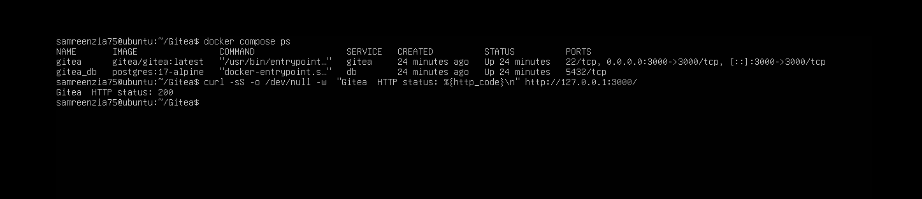
Screenshot 2: Successful push to Gitea
task1_gitea_push.png.png
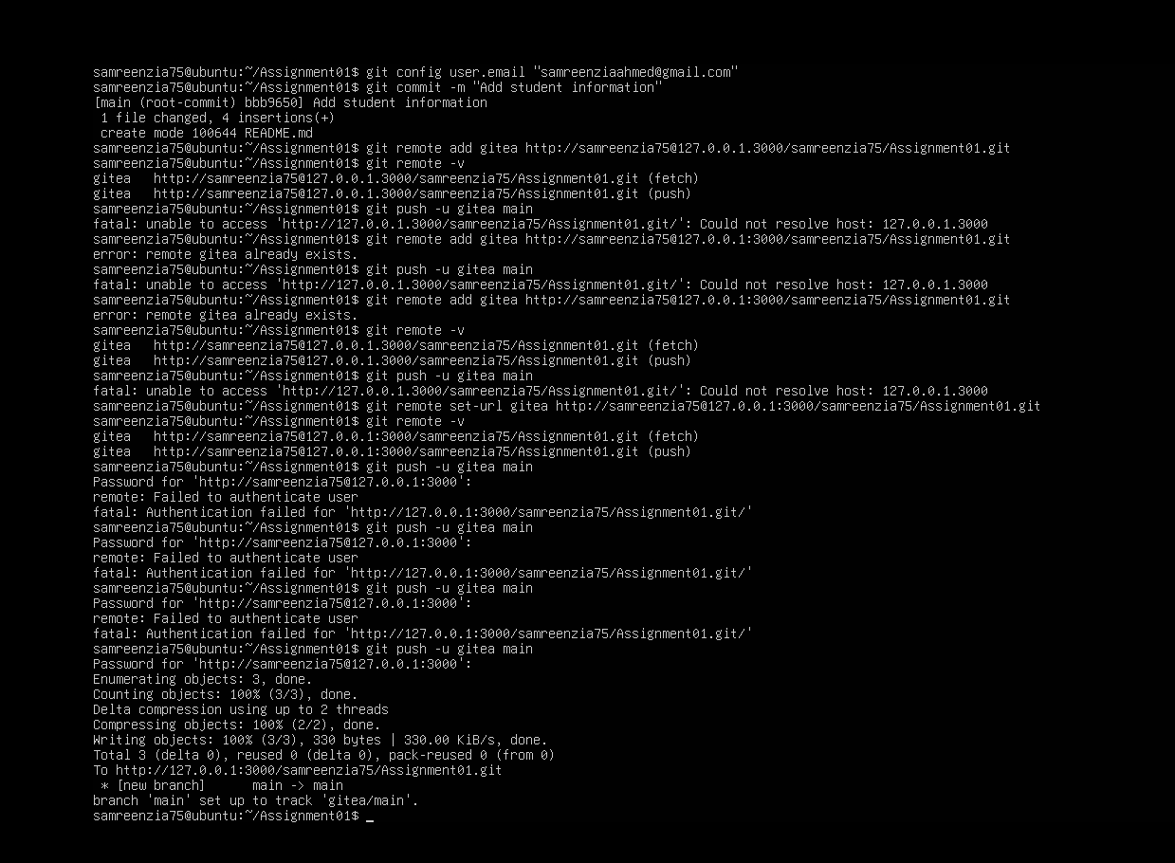
Screenshot 3: Gitea Assignment01 repository
task1_gitea_repository.png.png
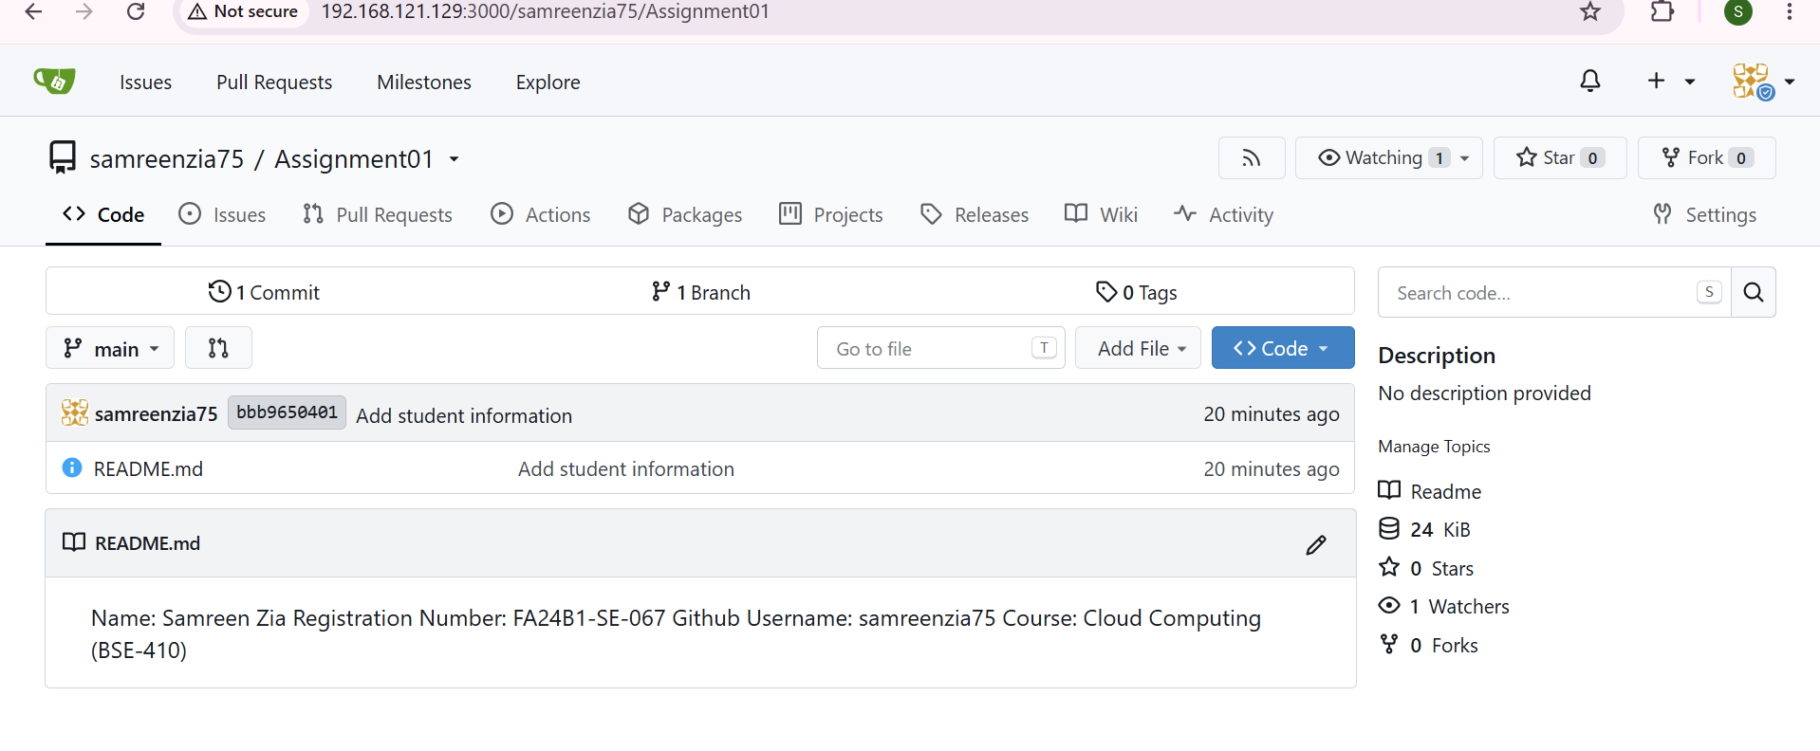

Task 2: GitHub

Objective
The objective of this task was to connect the same local repository to GitHub and push the main branch.

Steps Performed
- Created a public GitHub repository named Assignment01.
- Added the GitHub repository as a second remote:
git remote add github https://github.com/samreenzia75/Assignment01.git
- Checked that both Gitea and GitHub remotes were configured:
git remote -v
- Pushed the main branch to GitHub:
git push -u github main

Result
The local repository was connected to both Gitea and GitHub. The main branch was pushed successfully to GitHub.
GitHub repository:
https://github.com/samreenzia75/Assignment01

Evidence
Screenshot 1: Configured Git remotes
task2_remotes.png.png
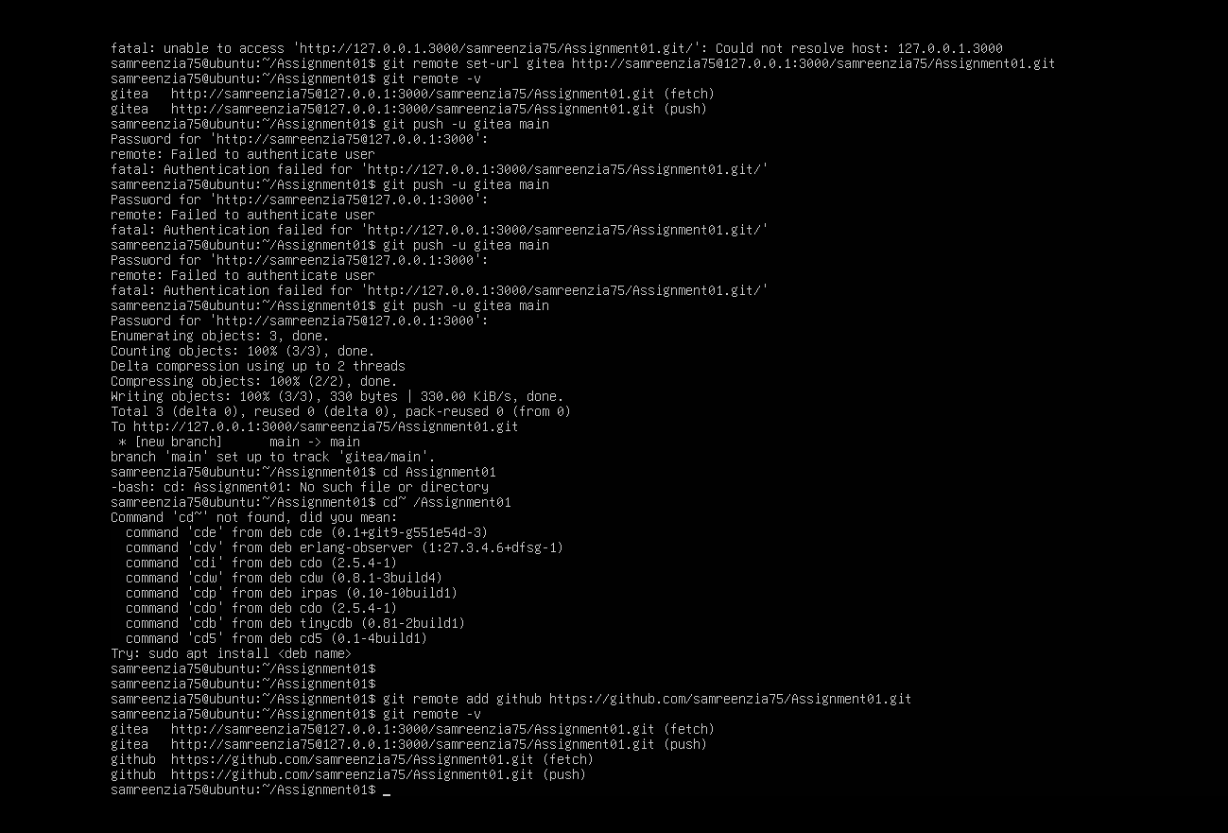
Screenshot 2: Successful push to GitHub
task2_github_push.png.png
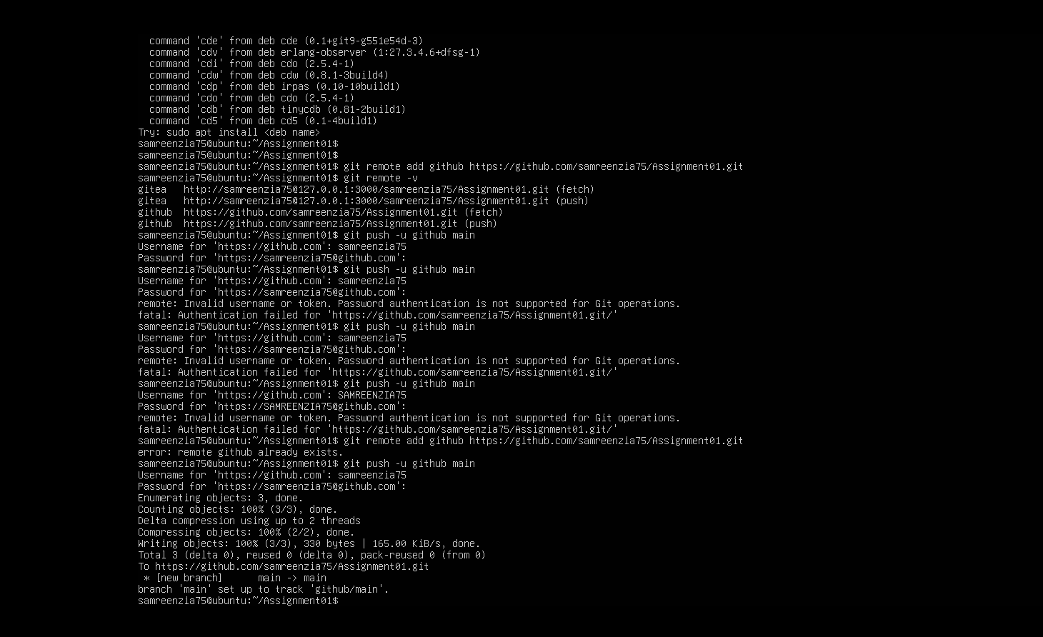
Screenshot 3: GitHub Assignment01 repository
task2_github_repository.png.png
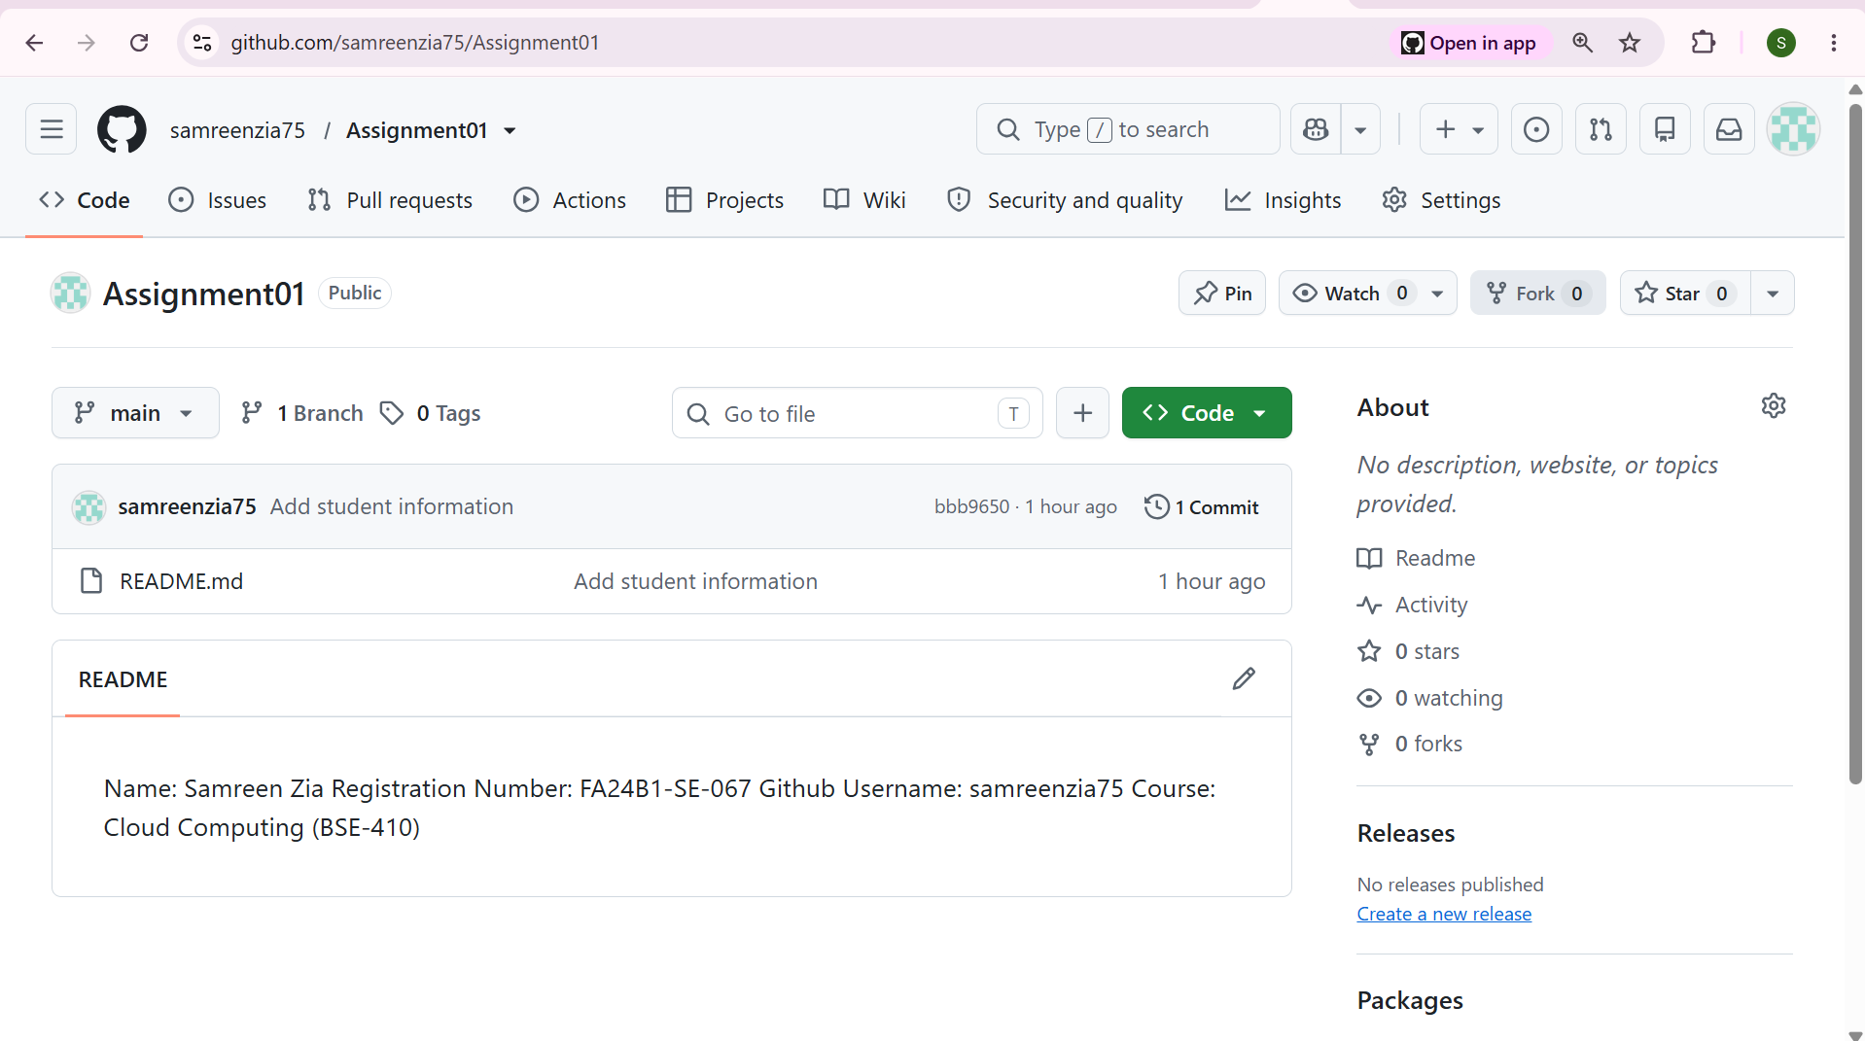

Task 3: Git LFS

Objective
The objective of this task was to configure Git LFS, create three files larger than 100 MiB, track them with Git LFS, and push them to GitHub.

Steps Performed
Initialized Git LFS in the local repository and configured it to track .bin files:
git lfs install
git lfs track "*.bin"
- cat .gitattributes
Created three files larger than 100 MiB:
truncate -s 101M large-file-1.bin
truncate -s 102M large-file-2.bin
- truncate -s 103M large-file-3.bin
Added the LFS rule and files, then checked the tracked files and sizes:
git add .gitattributes large-file-1.bin large-file-2.bin large-file-3.bin
- git lfs ls-files --size
Committed the files and pushed them to GitHub:
git commit -m "Add three files using Git LFS"
- git push github main

Result:

Git LFS tracked all three .bin files. The files were approximately 101 MiB, 102 MiB, and 103 MiB. All three LFS objects and the commit were pushed successfully to GitHub.
File | Size created
large-file-1.bin | 101 MiB
large-file-2.bin | 102 MiB
large-file-3.bin | 103 MiB

Evidence
Screenshot 1: Git LFS setup and tracking rule
task3_lfs_setup.png.png
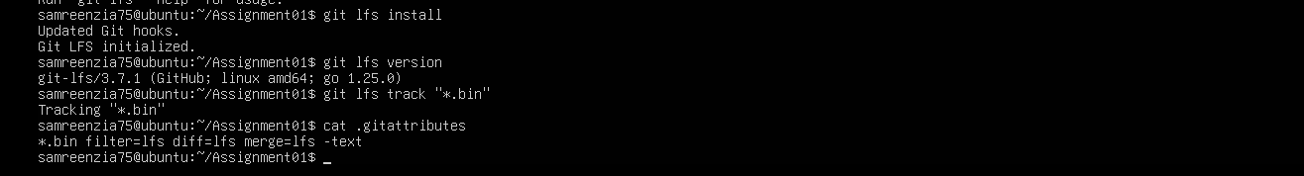
Screenshot 2: LFS-tracked files and sizes
task3_lfs_files.png.png
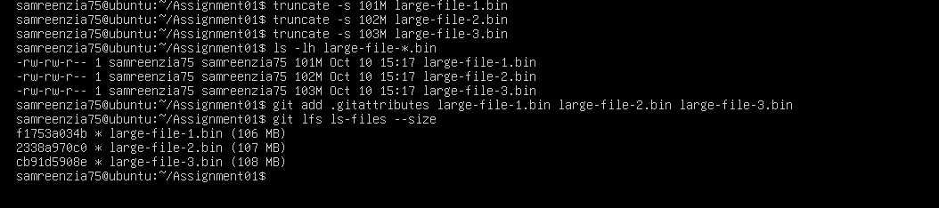
Screenshot 3: Successful GitHub LFS push
task3_lfs_push.png.png
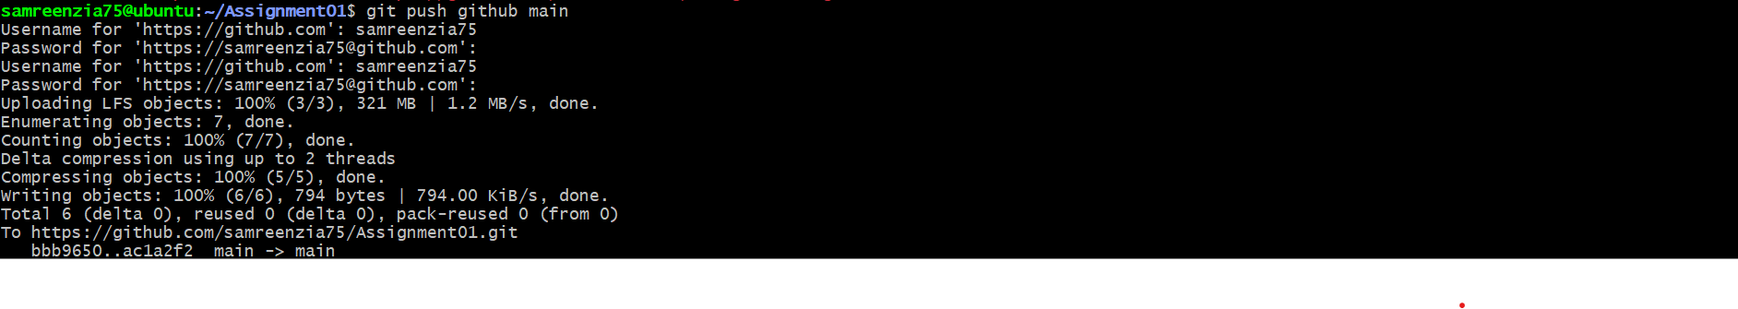

Task 4: GitHub Pages

Objective
The objective of this task was to create a portfolio homepage and publish it using GitHub Pages.

Steps Performed
- Created a public GitHub repository named samreenzia75.github.io.
- Created an index.html file containing the portfolio homepage.
- Opened the repository’s Settings → Pages section.
- Selected Deploy from a branch, chose the main branch and the /(root) folder, and saved the settings.
- Opened the published website and confirmed that the portfolio page was live.

Result
The portfolio repository was published using GitHub Pages.
Portfolio repository:
https://github.com/samreenzia75/samreenzia75.github.io
Published website:
https://samreenzia75.github.io/

Evidence
Screenshot 1: Portfolio repository
task4_pages_repository.png.png
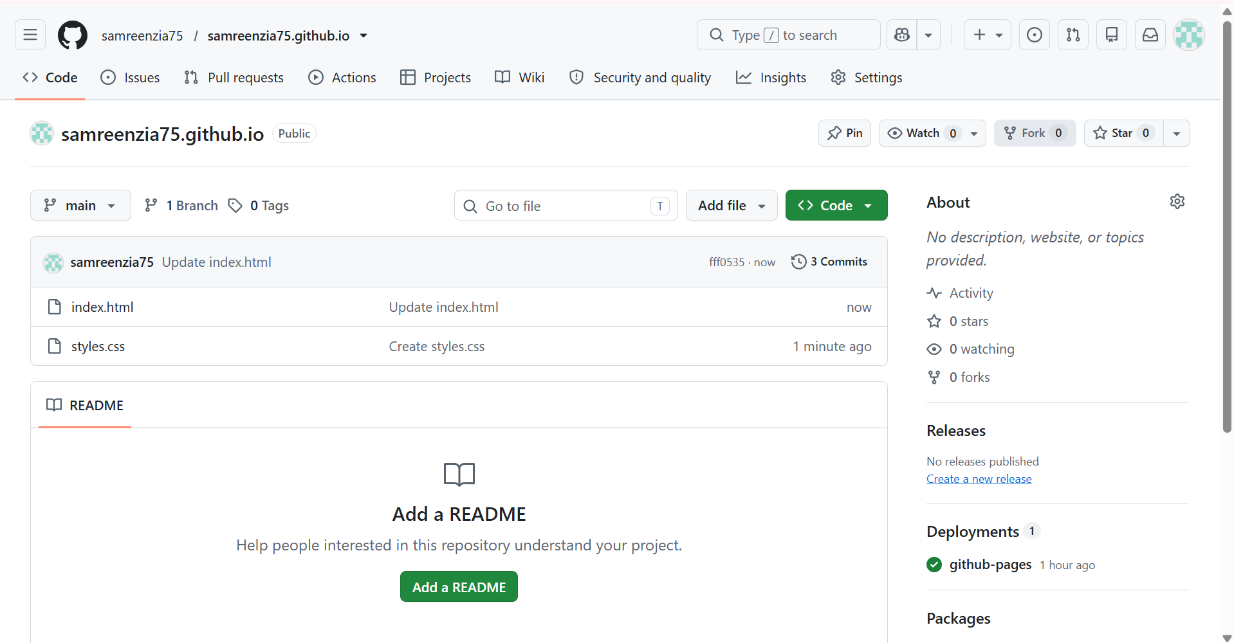
Screenshot 2: GitHub Pages deployment settings
task4_pages_deployment.png.png
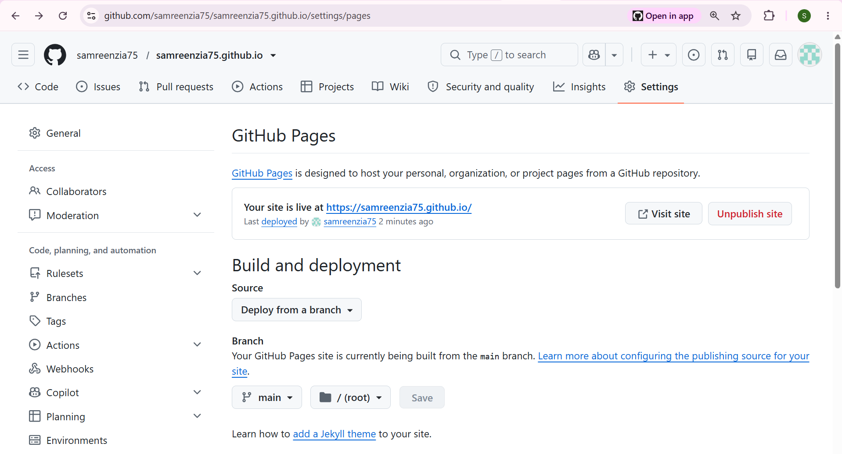
Screenshot 3: Live portfolio website
task4_portfolio_live.png.png
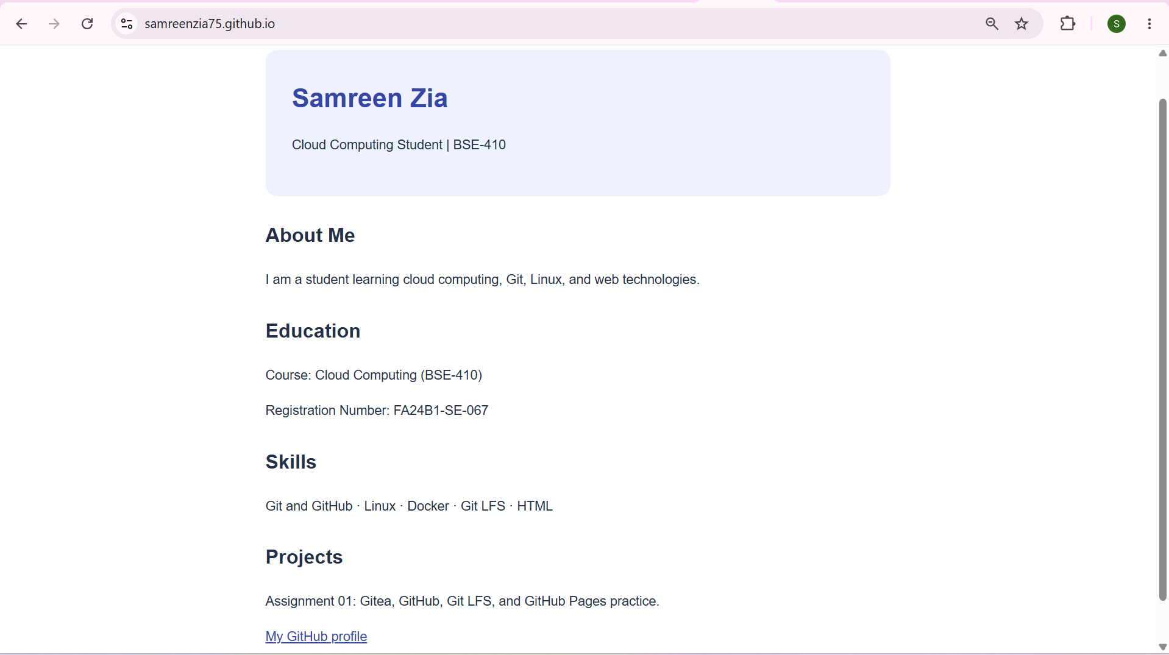

Conclusion
This assignment provided practical experience with Git repositories, remote configuration, Gitea, GitHub, Git LFS, and GitHub Pages. The Assignment01 repository was pushed to Gitea and GitHub, three large files were tracked with Git LFS and pushed to GitHub, and a portfolio homepage was published through GitHub Pages.

