BEFORE & AFTER PROJECT PORTFOLIO
Modern Renovation Showcase
Volume 02
Featured projects: Arnprior • Asiya
A curated set of before-and-after renovation visuals arranged in a clean modern presentation.
July 2026

Arnprior
Selected transformation views
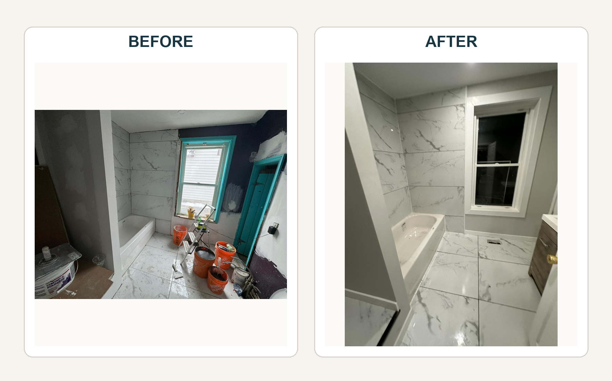
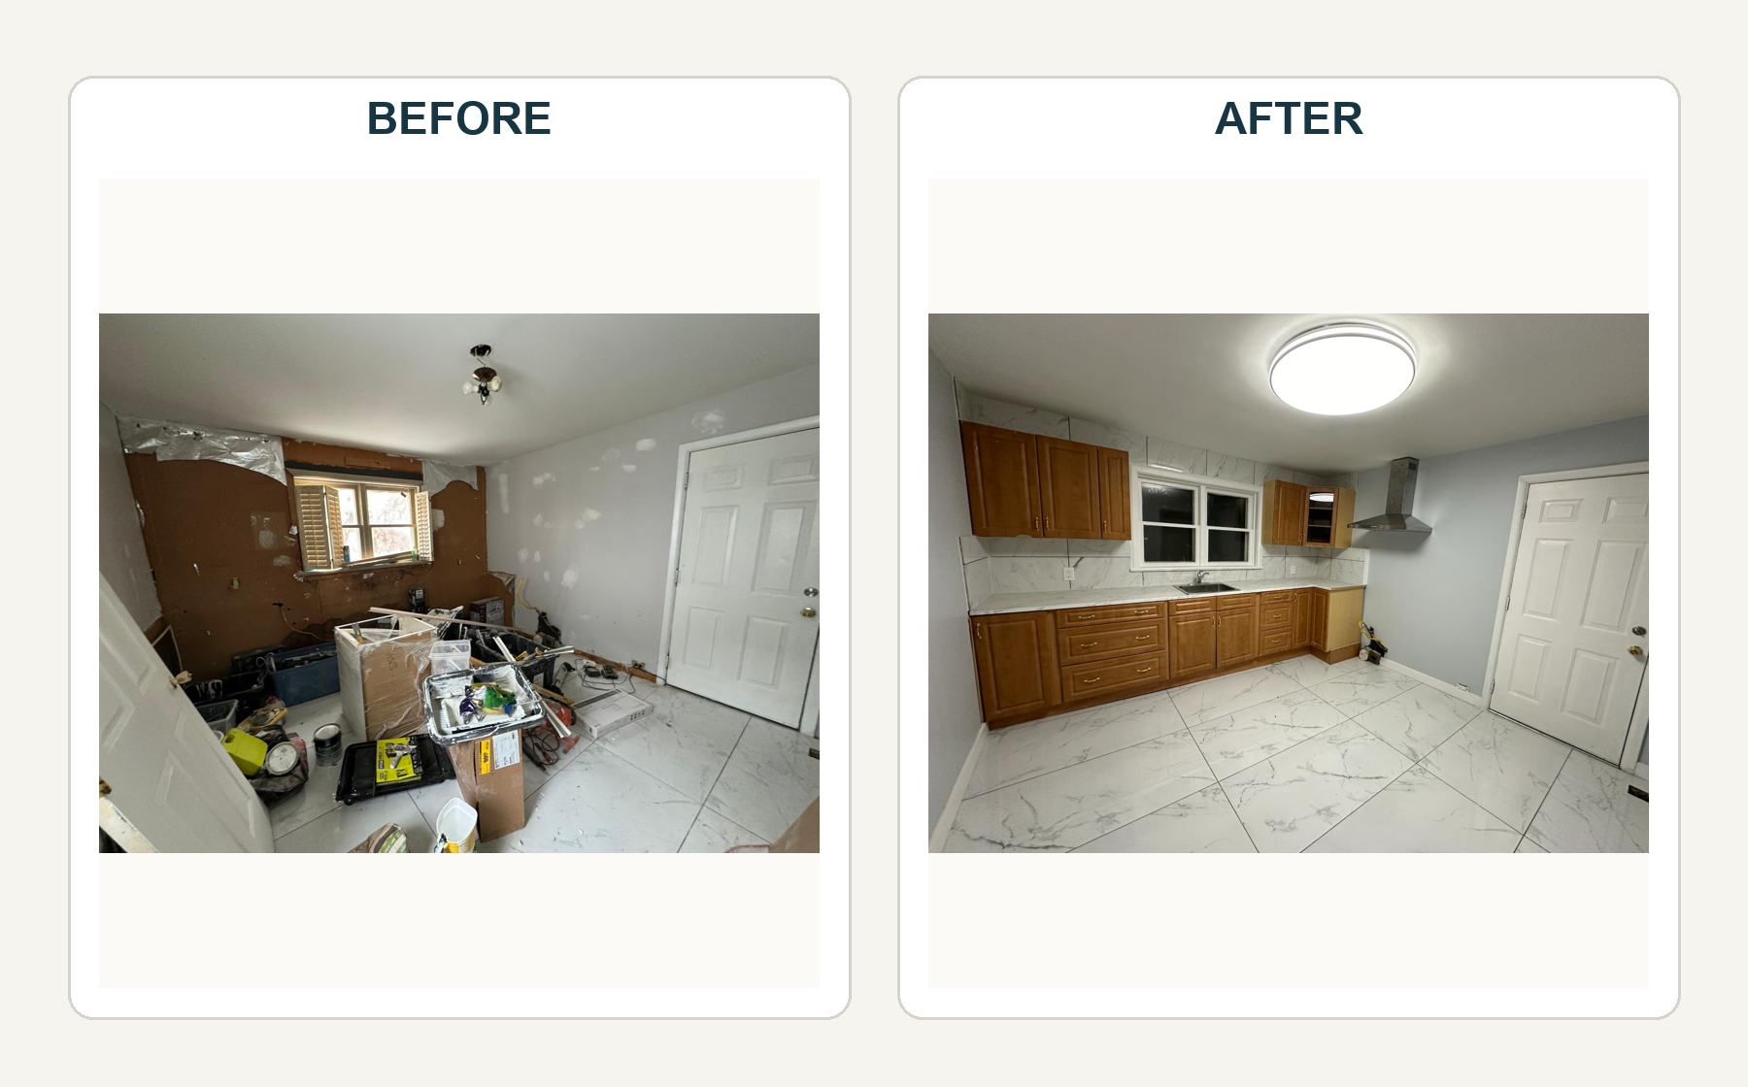

Asiya
Selected transformation views
