BEFORE & AFTER PROJECT PORTFOLIO
Modern Renovation Showcase
Volume 03
Featured projects: Carleton • Orleans
A curated set of before-and-after renovation visuals arranged in a clean modern presentation.
July 2026

Carleton
Selected transformation views
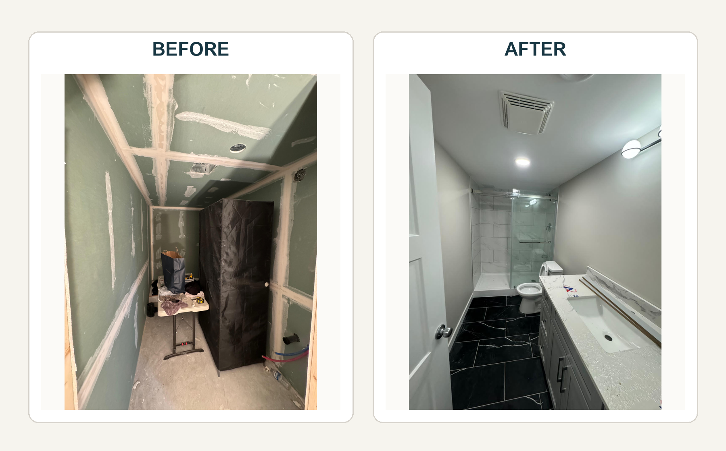
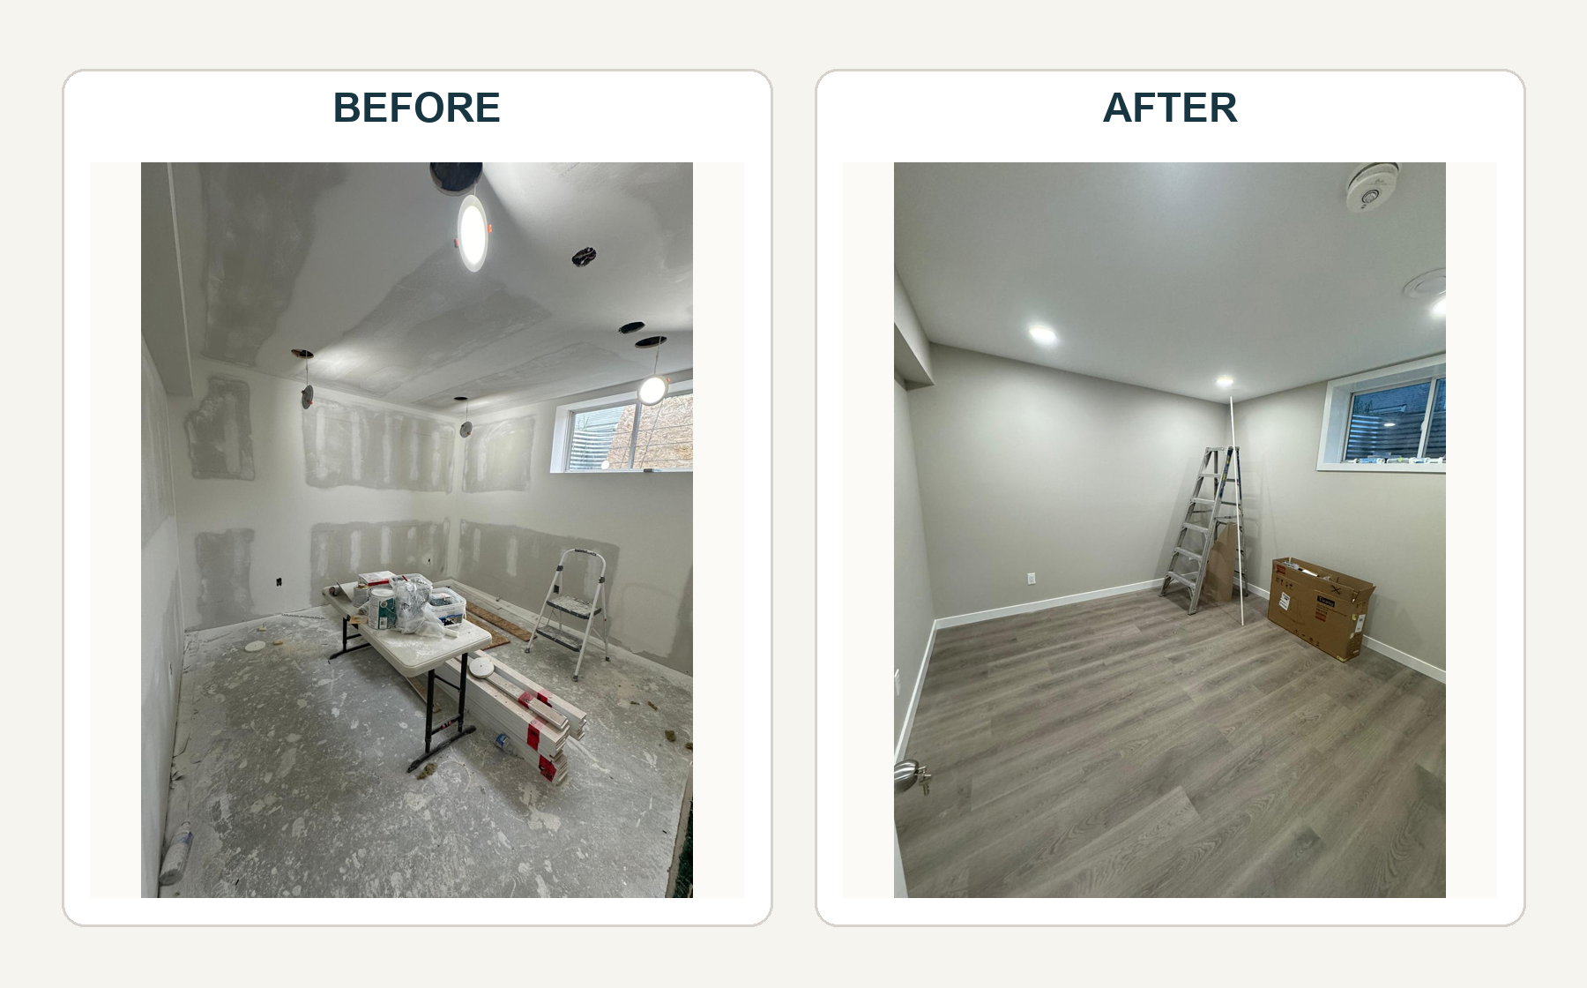

Orleans
Selected transformation views
