BEFORE & AFTER PROJECT PORTFOLIO
Modern Renovation Showcase
Volume 04
Featured projects: Ali Bathroom • Gimli
A curated set of before-and-after renovation visuals arranged in a clean modern presentation.
July 2026

Ali Bathroom
Selected transformation views
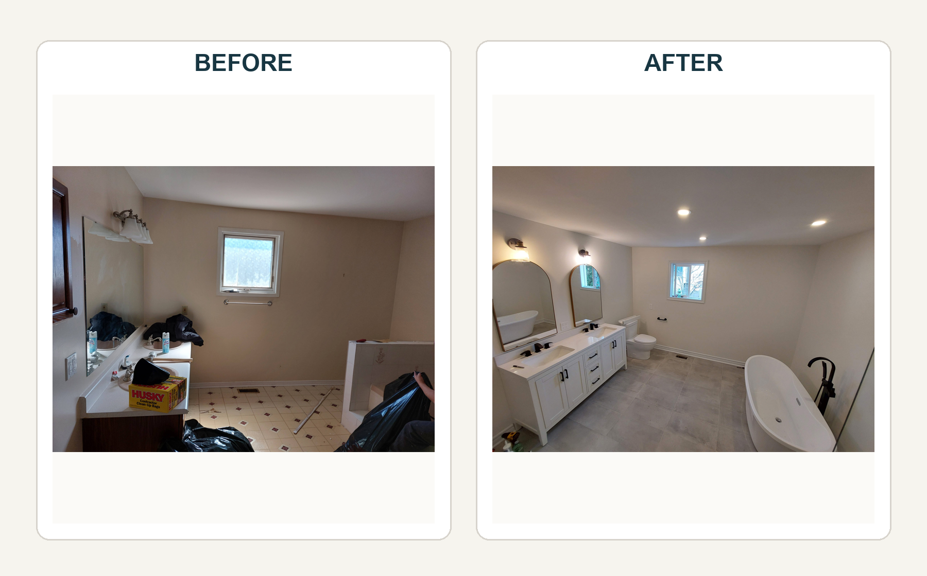

Gimli
Selected transformation views
