BEFORE & AFTER PROJECT PORTFOLIO
Modern Renovation Showcase
Volume 05
Featured projects: Krishna Bathroom • Penny
A curated set of before-and-after renovation visuals arranged in a clean modern presentation.
July 2026

Krishna Bathroom
Selected transformation views
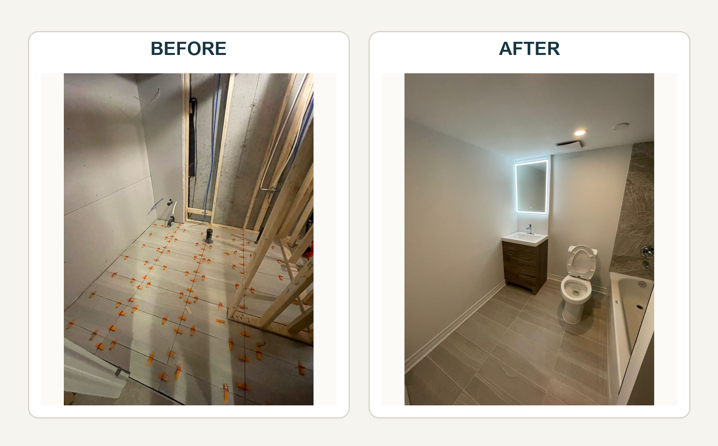

Penny
Selected transformation views
