ASIA PACIFIC UNIVERSITY OF TECHNOLOGY & INNOVATION
School of Computing
BSc (Hons) in Information Technology

COGDOC: A Research-Assisted Writing IDE to Mitigate Cognitive Atrophy in the Age of Generative AI
A Final Year Project Report

Submitted by
Samreshan Sahani
Student ID: [Student ID]
Supervised by
[Supervisor Name]

A report submitted in partial fulfilment of the requirements for the degree of Bachelor of Science (Honours) in Information Technology
Asia Pacific University of Technology & Innovation
[Month Year]

DECLARATION
I, Samreshan Sahani (Student ID: [Student ID]), hereby declare that the work contained in this Final Year Project report, entitled “Cogdoc: A Research-Assisted Writing IDE to Mitigate Cognitive Atrophy in the Age of Generative AI”, is my own work and has not been submitted, either in part or in whole, for the award of any other degree or qualification at this or any other institution. All sources of information and ideas have been properly acknowledged and cited.

Signature: ____________________________
Name: Samreshan Sahani
Date: ____________________________

ACKNOWLEDGEMENTS
First and foremost, I would like to express my sincere gratitude to my supervisor, [Supervisor Name], for the continuous guidance, patience, and constructive feedback provided throughout the duration of this Final Year Project. The insights shared during our supervisory sessions shaped both the direction of the project and the rigour of its evaluation.
My thanks also go to the lecturers and staff of the School of Computing at Asia Pacific University of Technology & Innovation, whose modules on software development, systems analysis, and research methods laid the foundation for the work presented here.
I am grateful to the thirty-three respondents who took part in the project’s survey and to those who agreed to be interviewed. Their honest accounts of writing with generative AI directly informed the design of Cogdoc and made the requirements gathering meaningful.
Finally, I thank my family and friends for their encouragement and understanding throughout the long hours of development, testing, and writing.

ABSTRACT
Generative artificial intelligence (AI) writing tools such as ChatGPT, Gemini, and Grammarly make academic writing faster, but a growing body of evidence links heavy use of these tools to cognitive offloading — the habit of delegating higher-order thinking to a machine — and to an illusion of mastery in which a learner feels they understand a topic without doing the work that creates understanding. This project, Cogdoc, addresses that problem from the opposite direction: instead of writing prose for the user, Cogdoc is a research-assisted writing IDE whose AI acts as a challenger in the margin. A hard “non-generation contract” structurally prevents the system from ever producing paragraph-length prose. Four AI engines then intervene in the margin: the Interceptor reframes vague or absolute claims as questions, the Socratic Spacer provokes deeper thinking during pauses, the Citation Sentinel verifies factual claims against the writer’s own uploaded research library using retrieval-augmented generation (RAG), and the Scaffold offers empty structural outlines the writer fills in themselves.
The system is built as a two-service application: a Next.js front end that also acts as a backend-for-frontend, and a Python FastAPI service that performs embedding and retrieval over a PostgreSQL database with the pgvector extension. Google Gemini provides both the large language model and the embedding model. Development followed a test-driven, iterative process across four sprints, with an enforced eighty-percent code-coverage gate. The research contributions are twofold: a user-controllable friction calibration that relaxes engine cadence under deadline pressure without ever relaxing the non-generation contract, and an empirical evaluation showing that switching to real (asymmetric) embeddings requires re-calibrating the verdict guard rather than only the retriever. The evaluation achieved a verdict macro-F1 of 0.773 and a retrieval Recall@5 of 0.8875 against a real-corpus benchmark, meeting the project’s targets. The findings suggest that AI can be designed to increase cognition rather than bypass it, and that this design can be evaluated with the same rigour applied to generative systems.

TABLE OF CONTENTS
Note: after opening this document, right-click the table below and choose “Update Field” to refresh the page numbers.

DECLARATION i
ACKNOWLEDGEMENTS ii
ABSTRACT iii
TABLE OF CONTENTS iv
LIST OF FIGURES ix
LIST OF TABLES x
CHAPTER 1: INTRODUCTION 1
1.1 Background of the Study 1
1.2 Problem Statement 1
1.3 Research and Product Questions 2
1.4 Aim and Objectives 2
1.4.1 Aim 2
1.4.2 Objectives 2
1.5 Scope and Limitations 3
1.5.1 In Scope 3
1.5.2 Out of Scope / Limitations 3
1.6 Target Users 3
1.7 Significance of the Project 4
1.8 Contribution to Research 4
1.9 Report Structure 4
1.10 Project Schedule 5
CHAPTER 2: LITERATURE REVIEW 6
2.1 Introduction 6
2.2 Cognitive Offloading and Automation Bias 6
2.3 The Limits of Large Language Models 7
2.4 Desirable Difficulties and Frictional AI 7
2.5 Intelligence Amplification 8
2.6 Review of Existing Systems 8
2.7 Gap Analysis 8
2.8 Theoretical Framework 9
2.9 Summary 9
CHAPTER 3: METHODOLOGY 10
3.1 Introduction 10
3.2 Software Development Life-Cycle Approach 10
3.3 Test-Driven Development 11
3.3.1 Red–Green–Refactor for New Features 12
3.3.2 Characterization-First for Migrations 12
3.4 The Coverage Gate 14
3.5 Research Methodology (Requirements Gathering) 14
3.5.1 Questionnaire 14
3.5.2 Interviews 14
3.5.3 Document Analysis 15
3.6 Evaluation Methodology 15
3.6.1 Calibrated Retrieval and Verdict Evaluation 15
3.6.2 Engine and Friction Evaluation 15
3.7 Justification of the Approach 15
3.8 Summary 16
CHAPTER 4: SYSTEM ANALYSIS 17
4.1 Introduction 17
4.2 Requirements Gathering: Survey Results 17
4.3 User Personas 18
4.3.1 Persona 1 — Aarav, Undergraduate (FYP Stage) 18
4.3.2 Persona 2 — Dr. Lim, Postgraduate Researcher 18
4.3.3 Persona 3 — Sam, Professional Academic Editor 18
4.4 Use Cases 18
4.5 Context of the System 19
4.6 Functional Requirements 20
4.7 Non-Functional Requirements 21
4.8 Assumptions and Constraints 21
4.9 Summary 22
CHAPTER 5: SYSTEM DESIGN 23
5.1 Introduction 23
5.2 System Architecture 23
5.3 Major Design Decisions (Architecture Decision Records) 25
5.4 The Non-Generation Contract and Friction Calibration 26
5.5 Data Modelling 29
5.6 Data Flow 31
5.7 User-Interface and User-Experience Design 32
5.8 Design of the Four AI Engines 33
5.9 Summary 33
CHAPTER 6: IMPLEMENTATION 35
6.1 Introduction 35
6.2 Development Environment and Tools 35
6.3 Implementing the Engines 36
6.4 The Retrieval-Augmented-Generation Pipeline 36
6.4.1 Ingest, Chunk, and Embed 37
6.4.2 Retrieve and Classify 37
6.4.3 The Verdict Guard 38
6.4.4 Asymmetric Embeddings and the Calibration Finding 38
6.5 Intervention Lifecycle 39
6.6 Authentication and Security 39
6.7 Deployment 40
6.8 How to Use Cogdoc (Condensed Guide) 40
6.9 Summary 41
CHAPTER 7: TESTING AND EVALUATION 42
7.1 Introduction 42
7.2 Software Test Strategy 42
7.3 Evaluation of the Citation Sentinel 43
7.3.1 Method 43
7.3.2 Results 43
7.4 Retrieval: Vector versus Keyword 44
7.5 The Two Implementation Findings 45
7.6 Engine and Friction Evaluation 46
7.7 User Testing and Acceptance 46
7.8 Limitations 46
7.9 Summary 46
CHAPTER 8: CONCLUSION 47
8.1 Summary of Achievements 47
8.2 Research Contributions 47
8.3 Limitations 47
8.4 Future Work 48
8.5 Reflection 48
REFERENCES 49
APPENDIX A: SURVEY INSTRUMENT 50
Section 1 — Demographics and AI-usage habits 50
Section 2 — Cognitive offloading and automation bias 50
Section 3 — Illusion of mastery 50
Section 4 — Receptivity to productive friction 50
APPENDIX B: EVALUATION DATASET 51
APPENDIX C: ADR INDEX 52
APPENDIX D: API ENDPOINTS 53
APPENDIX E: USER GUIDE 54
Getting started 54
The four engines and their underlines 54
Uploading research 54
Friction modes 54
Exporting and reviewing 54
Keyboard shortcuts 55

LIST OF FIGURES
Figure 1.1: Project timeline (sprint plan over a 60-day window)
Figure 3.1: The test-driven development gate cycle
Figure 3.2: Overall project methodology
Figure 4.1: Use case diagram
Figure 4.2: Context diagram (DFD Level 0)
Figure 5.1: System architecture
Figure 5.2: Component and deployment view
Figure 5.3: Entity-relationship diagram (eight tables)
Figure 5.4: Data flow diagram, Level 1
Figure 5.5: Friction mode calibration and the non-generation contract
Figure 5.6: The non-generation contract decision flow
Figure 6.1: Sequence — engine firing and intervention rendering
Figure 6.2: Sequence — the Citation Sentinel RAG verdict
Figure 6.3: Sequence — PDF ingest and embedding
Figure 6.4: Intervention state machine
Figure 7.1: Calibrated evaluation pipeline
Figure 7.2: Per-verdict precision, recall and F1
Figure 7.3: Vector versus keyword retrieval recall by cut-off k

LIST OF TABLES
Table 2.1: Comparative analysis of existing writing tools
Table 4.1: Headline survey findings (n = 33)
Table 4.2: Functional requirements
Table 4.3: Non-functional requirements
Table 5.1: The four AI engines
Table 5.2: Data model — entity descriptions
Table 6.1: Technologies and tools used
Table 6.2: API endpoints
Table 7.1: Test summary
Table 7.2: Evaluation results against targets

CHAPTER 1: INTRODUCTION

1.1 Background of the Study
In only a few years, generative artificial intelligence (AI) tools such as ChatGPT, Gemini, and Grammarly have become a normal part of how students and researchers write. These tools can draft an essay, rewrite a paragraph, fix grammar, and summarise a paper in seconds. For many learners they have moved from a novelty to a daily habit. Recent studies report that a large majority of higher-education students now use generative AI for academic work on a daily basis.
The convenience is real, but it comes with a cost that is easy to overlook. When a machine produces the text, the writer is no longer forced to think through the argument, find the evidence, or question their own assumptions. Psychologists call this cognitive offloading — the habit of using an external tool to reduce the mental effort of a task. A series of recent studies link frequent AI use to weaker critical-thinking skills and to a phenomenon the project describes as cognitive atrophy: the slow loss of the higher-order thinking that academic writing is meant to exercise.
This is not an argument against AI. Used well, AI can support learning. The problem is that today’s writing tools are built to make writing as fast and frictionless as possible. They are optimised for speed and fluency, not for understanding. There is very little in the design of ChatGPT or Grammarly that asks the writer to slow down, verify a claim, or defend an argument. This project, Cogdoc, starts from a different design choice: what if an AI writing assistant was built to make the writer think more, not less?

1.2 Problem Statement
The problem this project addresses is cognitive atrophy caused by the way generative-AI writing tools are currently designed. By making it trivial to copy large blocks of AI-generated text into a draft, these tools offload the very cognitive work — argumentation, synthesis, evaluation, and verification — that academic writing is supposed to cultivate. The result is an illusion of mastery: the writer feels they understand a topic because a fluent paragraph now exists in their document, even though they did not produce the reasoning behind it. At the same time, factual claims generated by AI are frequently unverified, and writers rarely check them against original sources.
Existing tools do not solve this problem because solving it would mean deliberately adding friction to a task their products are built to make frictionless. There is therefore a need for a writing tool that uses AI to increase the writer’s cognitive engagement rather than replace it — one that refuses to write the prose for the user, but instead questions, challenges, and verifies, while leaving every final decision and every final sentence to the human writer.

1.3 Research and Product Questions
This project is guided by the following questions:
RQ1 Can a writing tool be designed so that AI support increases a writer’s critical engagement with their own text, rather than replacing it?
RQ2 How can a retrieval-augmented system reliably verify a writer’s factual claims against their own research library, and how should it behave when the evidence is weak?
RQ3 Can the level of AI “friction” be calibrated by the user (for example, to relax under deadline pressure) without ever allowing the AI to generate final prose?
PQ1 Is a friction-based writing assistant usable and acceptable to its target users, given that 78.3% of survey respondents expected such a tool to be frustrating under pressure?

1.4 Aim and Objectives

1.4.1 Aim
To design, build, and evaluate a research-assisted writing IDE that uses AI to mitigate cognitive atrophy by deliberately refusing to generate the user’s final text and instead intervening as a challenger in the margin.

1.4.2 Objectives
O1 Investigate, through a literature review and a user survey, how generative AI affects critical thinking and what writers need from a friction-based tool.
O2 Design the system architecture, data model, and the “non-generation contract” that structurally prevents the AI from producing paragraph-length prose.
O3 Implement four AI engines — Interceptor, Socratic Spacer, Citation Sentinel, and Scaffold — that intervene in the margin of a live document.
O4 Implement retrieval-augmented generation so that factual claims can be verified against a writer’s uploaded research PDFs, with a guard against hallucinated support.
O5 Implement and evaluate a user-controllable friction calibration across three modes (Socratic, Coach, Assistant).
O6 Evaluate the system against measurable targets, including a verdict macro-F1 of at least 0.70 and a retrieval Recall@5 of at least 0.80.

1.5 Scope and Limitations

1.5.1 In Scope
- A web-based writing editor with autosave, focus mode, and export to Markdown, plain text, and HTML.
- Four AI engines that analyse sentences in real time and present interventions as coloured wavy underlines with hover popovers.
- A research library supporting drag-and-drop PDF upload and paste-text, with chunking and vector embedding for retrieval.
- Claim verification against the writer’s own library using a calibrated verdict taxonomy (supported, partially supported, unsupported, insufficient evidence).
- Three friction modes selectable by the user, plus a hard non-generation invariant enforced in every mode.
- Analytics and a full intervention history, and user authentication with row-level security.

1.5.2 Out of Scope / Limitations
- Cogdoc does not generate final academic prose. By design it will not write paragraphs for the user; this is a deliberate limitation, not a defect.
- Multilingual support is limited; the engines and prompts are written and evaluated in English.
- The evaluation corpus is real but modest (28 passages, 50 claims); generalising the results to very large libraries is identified as future work.
- The system focuses on academic and research writing; it is not optimised for creative fiction or code generation.

1.6 Target Users
The intended users are people who write to learn and to reason, not only to produce text. Three primary personas guide the design. The first is an undergraduate writing a final-year report under deadline pressure, who tends to paste AI text and rarely verifies citations. The second is a postgraduate researcher who works across many PDFs and needs evidence-grounded feedback and Socratic challenge rather than generation. The third is a professional academic editor who values structural scaffolding and deep links to source passages for citation work. A fuller description of these personas is given in Section 4.3.

1.7 Significance of the Project
The project is significant for three reasons. First, it contributes to an active area of research on frictional and human-centred AI by turning the concept of productive friction into a concrete, user-controllable interaction primitive. Second, it demonstrates that an AI writing tool can be evaluated with the same scientific rigour as a generative one — the citation-verification engine is benchmarked against a real corpus with held-out testing. Third, it offers a practical alternative to the prevailing design of writing assistants: a tool that helps writers think, rather than a tool that thinks for them.

1.8 Contribution to Research
The project makes two specific research contributions. The first is friction calibration: the operationalisation of the frictional-AI literature into three user-selected modes that scale engine cadence and the acceptance of help, while a hard invariant blocks prose generation in every mode. This is testable and, to the project’s knowledge, not offered by Google Docs, Grammarly, ChatGPT, or Elicit. The second contribution is empirical: an evaluation that documents, honestly, that switching from a simple keyword baseline to real (asymmetric) embeddings requires re-calibrating the verdict guard and not merely the retriever — a finding recorded as a project Architecture Decision Record and discussed in Chapter 7.

1.9 Report Structure
The remainder of this report is organised as follows. Chapter 2 reviews the literature on cognitive offloading, the limits of large language models, desirable difficulties, and existing writing tools. Chapter 3 describes the methodology, including the iterative, test-driven development process and the research and evaluation methods. Chapter 4 presents the system analysis: requirements, personas, and use cases. Chapter 5 covers system design: architecture, data model, and the design of the engines and the non-generation contract. Chapter 6 details the implementation. Chapter 7 presents testing and evaluation results against the project targets. Chapter 8 concludes with achievements, limitations, and future work.

1.10 Project Schedule
The project was planned as four focused two-week sprints inside a roughly sixty-day development window, following an iterative (agile) approach rather than a strict waterfall. The sprint plan is summarised in Figure 1.1.
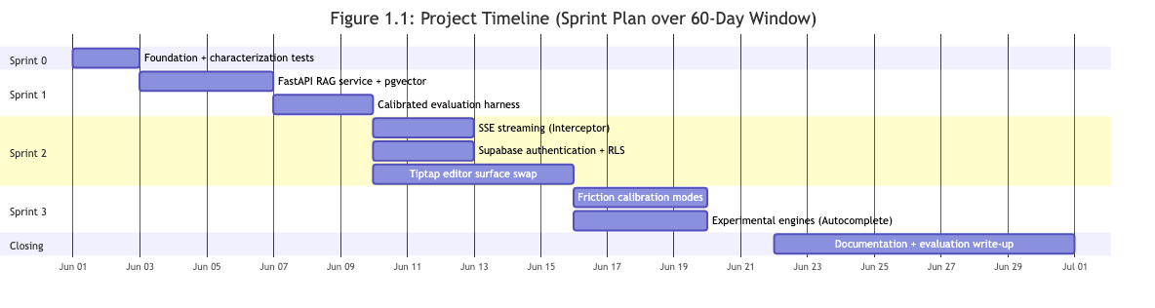
Figure 1.1: Project timeline (sprint plan over a 60-day window)
Sprint 0 established the foundation and the test suite; Sprint 1 delivered the FastAPI retrieval-augmented generation service, the pgvector store, and the calibrated evaluation harness; Sprint 2 delivered streaming, authentication, and the editor surface; and Sprint 3 delivered friction calibration and experimental engines, with documentation closing out the window.

CHAPTER 2: LITERATURE REVIEW

2.1 Introduction
This chapter reviews the literature that motivates and grounds the design of Cogdoc. It is organised around five themes: cognitive offloading and automation bias; the limits of large language models; desirable difficulties and the emerging idea of frictional AI; the older tradition of intelligence amplification; and a comparative review of existing writing tools. The chapter ends with a gap analysis and a statement of the theoretical framework adopted by the project.

2.2 Cognitive Offloading and Automation Bias
Cognitive offloading is the use of an external tool or action to reduce the internal cognitive demand of a task. Risko and Gilbert (2016) provide the now-standard definition and argue that offloading is not inherently bad — humans have always used tools such as writing and diaries to extend memory. The concern arises when offloading is applied to the very processes that build skill. If the cognitive work is outsourced, the skill that the work would have exercised can weaken.
A rapidly growing set of empirical studies applies this concern to generative AI. Gerlich (2025), in a study of 666 participants, found a negative correlation between the frequency of AI tool use and measured critical-thinking scores, with cognitive offloading acting as a mediating factor and the effect being strongest among younger users. Lee et al. (2025) surveyed knowledge workers and reported that higher self-reported confidence in generative AI was associated with less critical-thinking effort. Stadler et al. (2024) found that large language models can reduce cognitive load while compromising the depth of a person’s reasoning. Kosmyna et al. (2025), using electroencephalography (brain-wave) monitoring of essay writers, reported accumulated “cognitive debt” among those who relied on ChatGPT, with weaker brain activity and weaker ownership of the resulting text over repeated sessions.
A related concept is automation bias: the tendency to over-trust automated output and to stop applying independent judgement. Together these findings describe a clear pattern. The more a writer offloads thinking to an AI, the less cognitive engagement remains, and the harder it becomes to notice when the AI is wrong. The project’s own survey, summarised in Chapter 4, mirrors this pattern in a small local sample.

2.3 The Limits of Large Language Models
A second strand of literature concerns what large language models (LLMs) actually are, and therefore what they can and cannot be trusted to do. Bender, Gebru and colleagues (2021), in the widely cited “stochastic parrots” critique, argue that large language models produce fluent, plausible language without grounded understanding: they predict likely next words based on statistical patterns in their training data, but they do not possess knowledge in the human sense. The practical consequence is hallucination — the confident assertion of statements that are false or fabricated.
This matters for a writing tool in two ways. First, it means an AI that generates prose for a student is generating prose that may be subtly or overtly wrong, and the student is poorly placed to detect it because they did not do the reasoning. Second, it means that any factual verification must be grounded in real evidence rather than in the model’s own fluency. This motivates Cogdoc’s Citation Sentinel engine, which retrieves passages from the writer’s own uploaded library and classifies a verdict against that evidence, with a guard that forces an “insufficient evidence” result when the grounding is weak.

2.4 Desirable Difficulties and Frictional AI
If cognitive offloading is the disease, the literature also points to a cure rooted in learning science. Bjork (1994) introduced the concept of desirable difficulties: the finding that intentional, well-placed inefficiency in a learning task — spacing, testing, interleaving — improves long-term retention and the transfer of knowledge, even when it makes the task feel harder in the short term. The principle is that some friction is productive.
Cabitza and Natali (2024) and related work on frictional AI translate this idea into interaction design. They argue that rather than always minimising friction, AI systems should sometimes introduce it deliberately, in order to keep the human cognitively engaged and to prevent deskilling. This is the direct theoretical basis for Cogdoc’s central design principle, which the project calls productive friction: the AI deliberately slows the writer down at the right moments — to question a vague claim, to challenge an assumption, to demand evidence — so that the AI support increases cognition rather than bypassing it. The novelty claimed by the project is not the existence of the idea but its operationalisation: a concrete, user-controllable, three-mode friction calibration backed by a hard non-generation invariant.

2.5 Intelligence Amplification
Cogdoc also sits within a much older and more optimistic tradition. Bush (1945), in “As We May Think”, imagined a machine (the “memex”) that would help a thinker organise and connect the records of their reading. Engelbart (1962), in “Augmenting Human Intellect”, framed computing as a way to amplify human intellectual capacity rather than replace it. In this lineage the artefact exists to augment the thinker. Cogdoc adopts this framing explicitly: the AI is a reflective and adversarial layer around the human author, not an author itself. The final text is always written by the learner, because producing the text is the learning.

2.6 Review of Existing Systems
A survey of widely used writing tools shows that none of them is built around productive friction. Table 2.1 summarises the comparison. The dominant design goal across these tools is to make writing faster and more fluent, which is precisely the property the literature links to cognitive offloading.
Table 2.1: Comparative analysis of existing writing tools
Tool | Primary goal | Generates prose for user? | Verifies claims against user’s sources? | User-controllable friction?
ChatGPT (OpenAI) | Generate and rewrite text | Yes — paragraph length | No (general knowledge) | No
Gemini (Google) | Generate, summarise, rewrite | Yes — paragraph length | No | No
Grammarly | Correct grammar and style | Yes (rewrites) | No | Limited (tone presets)
Elicit | Literature search and summary | Yes (summaries) | Partial (its own corpus) | No
Google Docs | Word processing | No (text editor) | No | No
Cogdoc (this project) | Increase critical engagement | No — structurally blocked | Yes (user’s own library) | Yes — three modes

2.7 Gap Analysis
Three gaps emerge from the literature and the review of existing tools. First, although the cognitive-offloading literature is well established, very few working tools translate the remedy (frictional AI) into a usable product; the idea lives mostly in research papers. Second, existing tools that touch verification (such as Elicit) verify against their own corpus rather than the writer’s own uploaded sources, and they offer no guarantee of behaviour when evidence is absent. Third, no reviewed tool gives the user control over how much friction they experience, which the project’s survey (Chapter 4) shows is essential for adoption under deadline pressure. Cogdoc is positioned to address all three gaps.

2.8 Theoretical Framework
The project adopts a combined framework. Its diagnosis rests on the cognitive-offloading and automation-bias literature (Risko & Gilbert, 2016; Gerlich, 2025; Lee et al., 2025; Stadler et al., 2024; Kosmyna et al., 2025). Its design remedy rests on desirable difficulties (Bjork, 1994) and frictional AI (Cabitza & Natali, 2024). Its stance toward the AI itself rests on the stochastic-parrots critique (Bender et al., 2021), which forces the design to ground every factual claim in retrieved evidence. Its overall philosophy rests on intelligence amplification (Bush, 1945; Engelbart, 1962). Cogdoc is, in short, an attempt to build the frictional-AI response that the literature calls for, and to measure whether it works.

2.9 Summary
The literature is consistent: generative-AI writing tools enable cognitive offloading, and heavy offloading is associated with weaker critical thinking and an illusion of mastery. The remedy proposed by learning science and frictional-AI research is to introduce productive friction. Yet existing tools optimise for the opposite, and none offers user-controllable friction grounded in the writer’s own sources. This gap defines the design space for Cogdoc and motivates the requirements developed in Chapter 4.

CHAPTER 3: METHODOLOGY

3.1 Introduction
This chapter explains the methods used to carry out the project. It covers the software-development life-cycle (SDLC) approach, the test-driven development practice that governs every change, the methods used to gather and analyse requirements, and the methods used to evaluate the finished system. The chapter also justifies why an iterative, agile approach was chosen over a strict waterfall.

3.2 Software Development Life-Cycle Approach
The project followed a hybrid agile methodology rather than a strict waterfall. A waterfall model would have required fixing all requirements up front, designing the whole system, and only then building and testing it. That approach is a poor fit for a research-oriented project, because the requirements and the technical risks (for example, whether vector retrieval would genuinely outperform a keyword baseline) were not fully known at the start and needed to be discovered through building and measuring.
Instead, the work was organised into four short sprints inside a roughly sixty-day window. Each sprint produced a working, tested increment: Sprint 0 delivered the foundation and the test suite; Sprint 1 delivered the retrieval-augmented generation service and the evaluation harness; Sprint 2 delivered streaming, authentication, and the editor; and Sprint 3 delivered friction calibration and experimental engines. At the end of each sprint the system was demonstrable, and the findings of that sprint fed directly into the plan for the next one. Figure 3.2 shows how the research, build, and evaluation phases relate.
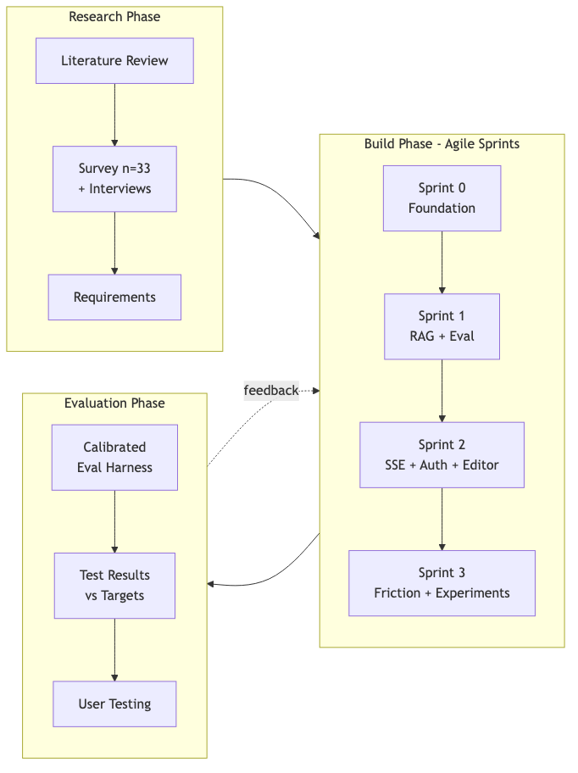
Figure 3.2: Overall project methodology

3.3 Test-Driven Development
Within the agile sprints, every change was made using test-driven development (TDD). The practice was not optional decoration: it was the single load-bearing rule of the project. Two TDD regimes were used, matched to the type of work.

3.3.1 Red–Green–Refactor for New Features
For net-new features (the friction modes, the experimental engines, and the evaluation harness) the classic three-step cycle was used. First, a failing test was written that described the desired behaviour (Red). Second, the minimum code needed to make that test pass was written (Green). Third, the code was cleaned up without changing its behaviour (Refactor). The cycle then repeated for the next piece of behaviour.

3.3.2 Characterization-First for Migrations
When changing existing behaviour — such as replacing the simple contentEditable editor with the Tiptap editor, or replacing keyword retrieval with vector retrieval — the team instead wrote characterization tests first. These are tests that capture exactly what the current code already does, so that the old code passes them. The underlying implementation was then swapped behind a feature flag, and the same tests were required to stay green. This approach, advocated by Feathers in Working Effectively with Legacy Code, lets large changes be made safely because a test suite guards the behaviour throughout.
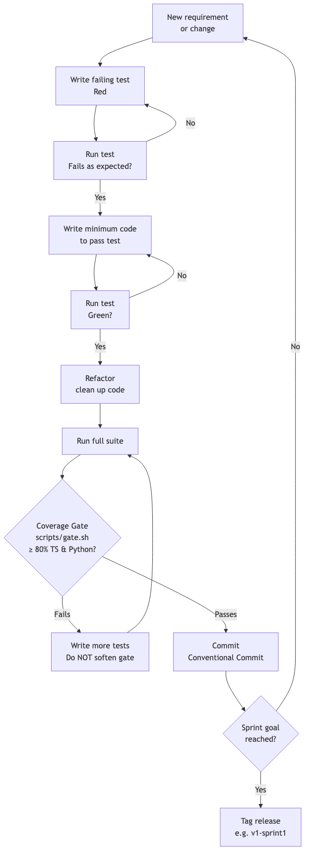
Figure 3.1: The test-driven development gate cycle

3.4 The Coverage Gate
To make the discipline of TDD objective and non-negotiable, the project used a mechanical gate implemented as a shell script (scripts/gate.sh). The gate runs the entire test suite for both the TypeScript front end and the Python back end, and it measures code coverage. A sprint could not advance unless every test passed and coverage was at least eighty percent of lines, branches, functions, and statements in both codebases.
Crucially, the gate was never softened. During Sprint 0 the gate failed twice, first at forty-eight percent and then at sixty-six percent coverage. Rather than lowering the threshold, more tests were written until the gate genuinely passed. The project records this as a deliberate stance: coverage is a hard floor, and a coverage of 79.9 percent is a failed sprint. By the end of the build phase the suite contained 247 tests (179 in TypeScript and 68 in Python) guarding roughly six thousand lines of application code, with coverage above ninety percent in both codebases.

3.5 Research Methodology (Requirements Gathering)
Requirements were gathered using a mixed-methods approach with three components: a structured questionnaire, semi-structured interviews, and document analysis.

3.5.1 Questionnaire
An online questionnaire was administered to thirty-three respondents using purposive sampling. The target sample size was at least thirty. Respondents were undergraduates, postgraduates, doctoral candidates, researchers, and academic writers. The questionnaire had four sections: demographics and AI-usage habits; cognitive offloading and automation bias; the illusion of mastery; and receptivity to a friction-based tool. The full results are reported in Chapter 4.

3.5.2 Interviews
At least three semi-structured interviews were conducted to add qualitative depth to the numbers. The interview guide explored how respondents actually write with AI, where they feel it helps, and where they feel it harms their thinking. Responses were analysed thematically and used to refine the personas and the use cases.

3.5.3 Document Analysis
The literature reviewed in Chapter 2, the comparison of existing tools, and technical documentation (for example, the pgvector extension and the Tiptap editor) were analysed to ground the design decisions and the Architecture Decision Records (ADRs) described in Chapter 5.

3.6 Evaluation Methodology
Because the central claim of the project is empirical — that AI can increase cognition rather than bypass it, and that real embeddings improve retrieval — the system was evaluated against measurable targets rather than only by demonstration. Two evaluation methods were used.

3.6.1 Calibrated Retrieval and Verdict Evaluation
The citation-verification engine was benchmarked against a real corpus of 28 passages drawn from five real research PDFs, with 50 hand-labelled claims (20 supported, 10 partially supported, 10 unsupported, and 10 with insufficient evidence, including topic-adjacent hard negatives). To avoid the common error of tuning on the test set, the claims were split deterministically into a calibration set (about one third) and a held-out test set (about two thirds). The similarity threshold was chosen using only the calibration split, under a parsimony rule that selected the least restrictive floor within a small margin of the best score. All reported metrics are computed on the held-out test set. A verdict API failure was always treated as a missing measurement and never silently scored.

3.6.2 Engine and Friction Evaluation
The Interceptor engine was evaluated for blocking precision (the fraction of times it correctly blocks a delegative prompt) using a targeted test set. The friction modes were evaluated by a set of invariant tests asserting that the non-generation contract holds across all three modes. User acceptance was assessed through the survey and the interviews. The full results appear in Chapter 7.

3.7 Justification of the Approach
An iterative, test-driven approach was chosen for three reasons. First, the project’s central risks were technical and empirical, and they could only be resolved by building and measuring, not by planning. Second, a high-coverage test suite made it safe to make the large migrations the project required (editor, retrieval, and architecture changes) without silently breaking behaviour. Third, the scientific claims demanded reproducible measurement, which the calibrated harness and the held-out split provide. A strict waterfall would have delivered the whole system late and would have offered no opportunity to correct the design in response to what was measured.

3.8 Summary
The project used a hybrid agile SDLC organised into four sprints, governed by strict test-driven development and an eighty-percent coverage gate. Requirements were gathered by questionnaire, interview, and document analysis, and the system was evaluated against measurable targets using a calibrated, held-out methodology. The next chapter presents the requirements and the system analysis that this methodology produced.

CHAPTER 4: SYSTEM ANALYSIS

4.1 Introduction
This chapter analyses the requirements that Cogdoc must satisfy. It begins with the evidence gathered from the user survey and interviews, then defines the target user personas and the use cases. From these it derives the functional and non-functional requirements, and it states the assumptions and constraints under which the system operates.

4.2 Requirements Gathering: Survey Results
The project surveyed thirty-three respondents (undergraduates, postgraduates, doctoral candidates, researchers, and academic writers) to understand how generative AI is actually used in academic writing and how receptive users would be to a friction-based tool. The headline findings are summarised in Table 4.1. The full survey instrument appears in Appendix A.
Table 4.1: Headline survey findings (n = 33)
Indicator | Finding
Uses generative AI daily for academic work | 63.6%
Pastes AI-generated text into drafts largely unchanged | 69.6%
Trusts AI-generated factual claims despite known hallucination risk | 68.4%
Strongly verifies AI citations against original sources | 26.3% (only)
Spends less time thinking about structure and flow when using AI | 72.2%
Feels they have mastered a topic from an AI summary without reading the core literature | 68.2%
Rates a friction-based tool useful for long-term learning | 59.1%
Would find such a tool frustrating under deadline pressure | 78.3%

Two findings dominate the design. The first six rows confirm the problem: a large majority of users offload thinking to AI, trust unverified claims, and feel a false sense of mastery. The last two rows define the central design tension: a majority wants a friction-based tool for the long term, but an even larger majority expects it to be frustrating under deadline pressure. This single tension drives the friction-calibration research contribution described in Chapters 5 and 7 — the system must be strict enough to force reflection, yet not so obstructive that users abandon it.

4.3 User Personas
Three personas were defined from the survey and interviews.

4.3.1 Persona 1 — Aarav, Undergraduate (FYP Stage)
Aarav is writing his final-year report under deadline pressure. He is a heavy daily AI user; he pastes AI text and rarely verifies citations. He needs claim verification he can trust and something that stops him delegating whole sections without removing all speed. He represents the user most at risk of cognitive atrophy.

4.3.2 Persona 2 — Dr. Lim, Postgraduate Researcher
Dr. Lim writes literature-heavy work across twenty to fifty PDFs. She wants evidence-grounded feedback and Socratic challenge, not generation. She needs reliable cross-document retrieval and wants her assumptions exposed. She is the primary user of the Citation Sentinel.

4.3.3 Persona 3 — Sam, Professional Academic Editor
Sam drafts under discipline and values friction as a craft tool. He needs structural scaffolding without text generation and deep links to source passages for citation work. He is the primary user of the Scaffold engine and the export features.

4.4 Use Cases
From the personas, six primary use cases were identified. Figure 4.1 presents the use case diagram. The system also defines explicit anti-use-cases: notably, “ask the AI to write a paragraph for me” is deliberately not supported, in any mode.
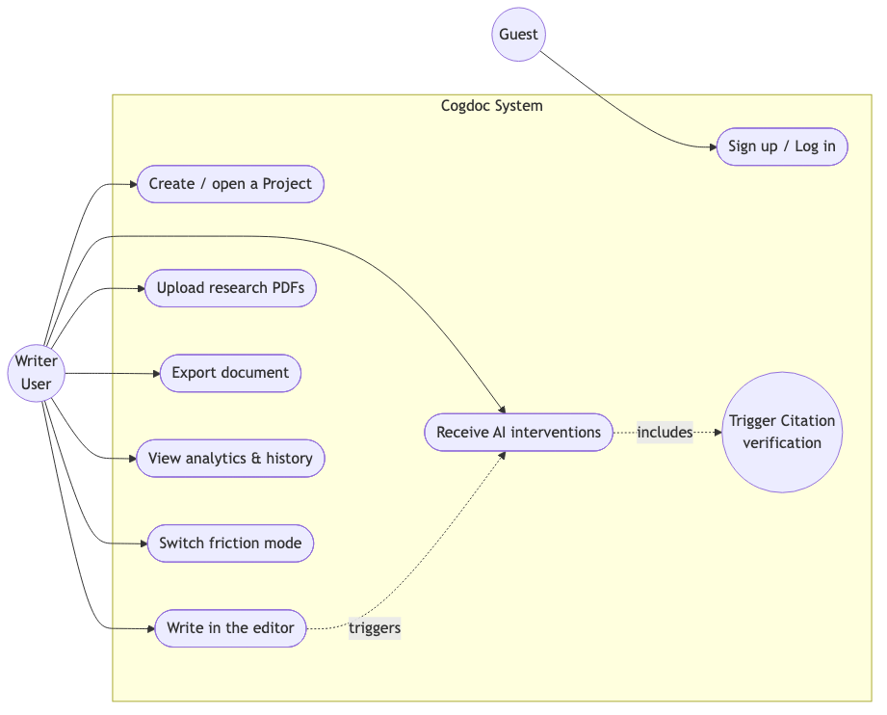
Figure 4.1: Use case diagram
UC-1 Sign up / log in: a user creates an account or signs in (via Supabase auth when configured, or enters the single-user prototype mode).
UC-2 Create and open a project: the user creates a project, which contains one document and one research library.
UC-3 Write in the editor: the user types into the editor; the document autosaves every 1.5 seconds.
UC-4 Upload research PDFs: the user drags PDFs into the library or pastes text; the content is parsed, chunked, embedded, and indexed for retrieval.
UC-5 Receive AI interventions: as the user completes sentences, pauses, or finishes paragraphs, the engines fire and present coloured wavy underlines with hover popovers containing questions, verdicts, or scaffolds and actionable next-steps.
UC-6 Export and review: the user exports the document to Markdown, plain text, or HTML, and reviews analytics and the full intervention history.

4.5 Context of the System
At the highest level, Cogdoc sits between the writer, the AI provider, the database, and the authentication provider. The writer supplies draft text, PDFs, and prompts; the system returns interventions, verdicts, exports, and analytics. All embedding and language-model work is delegated to Google Gemini; all data and vectors live in a PostgreSQL database with the pgvector extension; and authentication is delegated to Supabase. Figure 4.2 shows this context (a Data Flow Diagram, Level 0).
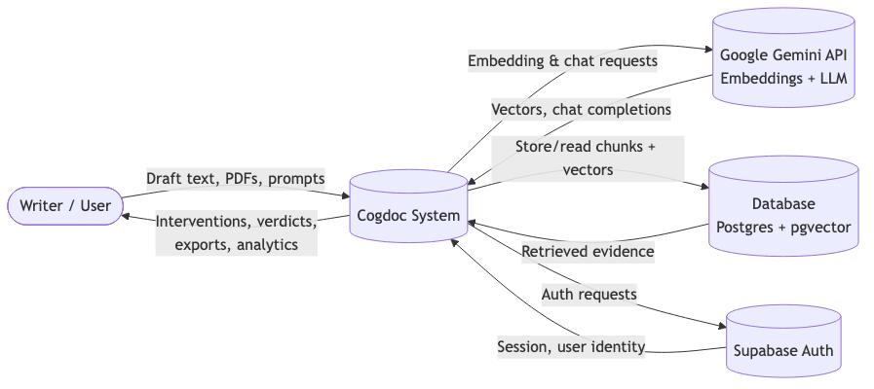
Figure 4.2: Context diagram (DFD Level 0)

4.6 Functional Requirements
The functional requirements (FRs) define what the system must do. Each is numbered for traceability into the design and implementation chapters.
Table 4.2: Functional requirements
ID | Requirement
FR-1 | The system shall let a user register, log in, and remain authenticated across sessions, with per-user data isolation.
FR-2 | The system shall let a user create, open, rename, archive, and delete projects, each with one document and one library.
FR-3 | The system shall provide a rich-text editor that autosaves the document and supports bold, italic, underline, focus mode, and a word count.
FR-4 | The system shall detect writing triggers (sentence completion, idle pause, paragraph completion) and fire the matching AI engines.
FR-5 | The system shall provide four engines: Interceptor, Socratic Spacer, Citation Sentinel, and Scaffold.
FR-6 | The Interceptor shall reframe vague or absolute claims as Socratic questions; it shall block attempts to make it write prose.
FR-7 | The Citation Sentinel shall retrieve the top passages from the user’s library and classify a verdict (supported, partially supported, unsupported, insufficient evidence).
FR-8 | The system shall let a user upload PDFs and paste text, and shall parse, chunk, embed, and index the content for retrieval.
FR-9 | The system shall present interventions as coloured wavy underlines with hover popovers and actionable next-steps.
FR-10 | The system shall let a user switch among three friction modes (Socratic, Coach, Assistant) and shall enforce the non-generation invariant in all modes.
FR-11 | The system shall let a user export the document to Markdown, plain text, and HTML, and print to PDF.
FR-12 | The system shall record every intervention in an audit log and present analytics (engagement rate, verdict breakdowns, per-engine counts) and a full history.

4.7 Non-Functional Requirements
The non-functional requirements (NFRs) constrain how the system behaves.
Table 4.3: Non-functional requirements
Category | Requirement
Performance | Autosave shall complete within ~1.5 seconds; engines shall fire on sentence completion with staggered ~500 ms delays to avoid disrupting typing.
Reliability | The verdict engine shall never claim support when evidence is weak; it shall return “insufficient evidence” instead. The test suite and coverage gate shall protect regressions.
Usability | Interventions shall appear as non-intrusive underlines; the interface shall match the look of a notebook (serif body, generous line height). A user shall be able to relax friction under deadline pressure.
Security | User data shall be isolated by row-level security at the database layer. Authentication shall never be bypassable in production; the dev fallback shall be ignored when NODE_ENV is production.
Maintainability | Prompt content shall be versioned and editable without redeployment. The codebase shall maintain at least 80% test coverage.
Portability | The system shall ship as a multi-architecture Docker image (AMD64 and ARM64) so it runs on x86, Apple Silicon, and ARM servers.

4.8 Assumptions and Constraints
The analysis is made under the following assumptions and constraints.
- Assumption: users have a modern browser and a working internet connection to reach the AI provider.
- Assumption: the AI provider (Google Gemini) is available and within the user’s daily token budget.
- Constraint: the system must never generate paragraph-length prose; this is a hard, non-negotiable design constraint enforced in code.
- Constraint: the evaluation corpus, while real, is modest (28 passages, 50 claims); large-scale performance is treated as future work.
- Constraint: development was time-boxed to a roughly sixty-day window by a single developer.

4.9 Summary
The survey confirmed both the problem (heavy offloading and weak verification) and the central design tension (users want friction but fear it under pressure). Three personas and six use cases were derived, together with twelve functional and six categories of non-functional requirements. These requirements drive the system design presented in Chapter 5.

CHAPTER 5: SYSTEM DESIGN

5.1 Introduction
This chapter presents the design of Cogdoc. It covers the overall architecture, the major design decisions recorded as Architecture Decision Records (ADRs), the central design principle (the non-generation contract and friction calibration), the data model, the user-interface and user-experience design, and the design of the four AI engines. The chapter describes the system as it was built, noting where the implementation matured beyond the original specification.

5.2 System Architecture
Cogdoc is a two-service application. A Next.js application serves both the front end (the editor and all user-interface components) and a backend-for-frontend (BFF) layer of route handlers that own the engine logic and database access through the Prisma object-relational mapper. A separate Python FastAPI service performs the heavy retrieval-augmented-generation work: embedding documents and queries, vector retrieval, and the citation verdict. The two services communicate across a single, well-defined seam called the AI gateway. Google Gemini provides both the large language model and the embedding model. Figure 5.1 shows the architecture.
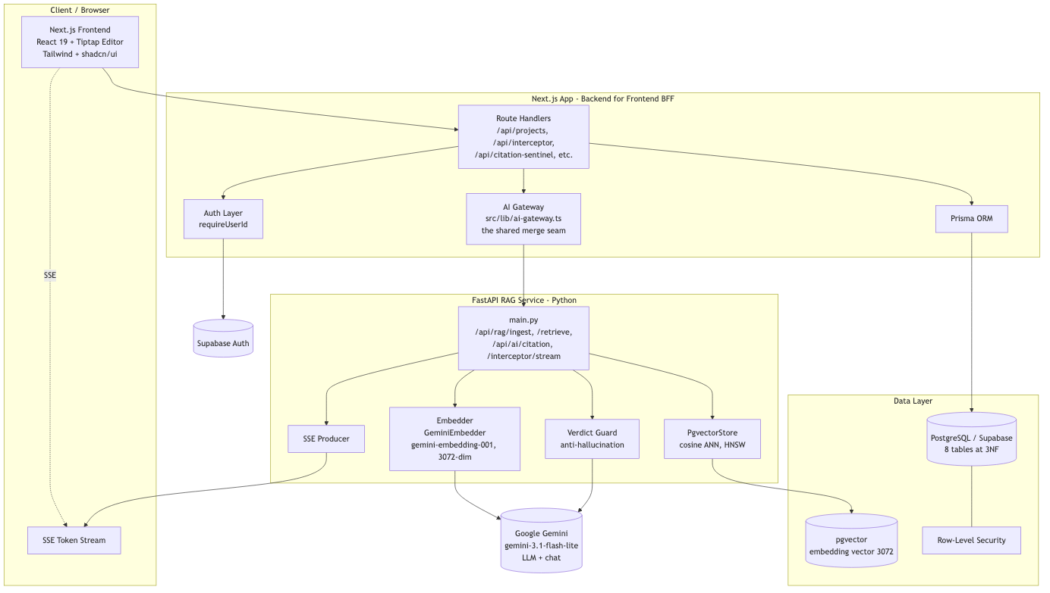
Figure 5.1: System architecture
This separation is deliberate. Keeping the retrieval and embedding logic in a dedicated Python service lets the project use the mature Python ecosystem for vector operations (the pgvector adapter and the pgvector extension itself) while keeping the interactive, latency-sensitive editor in a single Next.js deployment. The AI gateway (src/lib/ai-gateway.ts) is the only shared merge point between the two codebases, which kept parallel development safe during the sprints.
Deployment uses Docker Compose with three containers: the Next.js application, the FastAPI service, and a PostgreSQL database with pgvector enabled. An interactive first-run wizard and an entrypoint script configure the AI provider, the database, and authentication. The image is built for two CPU architectures (AMD64 and ARM64) so it runs on conventional x86 servers, Apple Silicon, and ARM cloud instances. Figure 5.2 shows the deployment view.
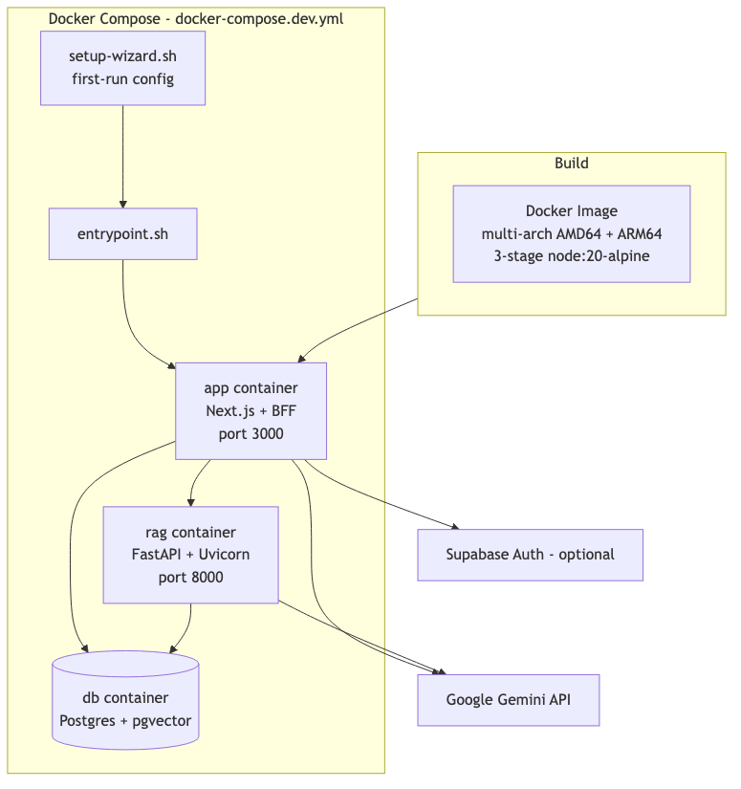
Figure 5.2: Component and deployment view

5.3 Major Design Decisions (Architecture Decision Records)
The most significant design decisions were recorded as Architecture Decision Records so that the reasoning would survive the sprint in which it was made. Five ADRs are summarised here.
ADR-0000 Spec-versus-build reconciliation. A master document accounting for every deviation between the original specification and the delivered system. It records that the core commitments (a FastAPI retrieval service, streaming, authentication, and a decoupled architecture) were met, and that two items (the pgvector adapter and the Tiptap editor) were delivered as a real interface plus a working surface rather than only an interface.
ADR-0006 Tiptap editor migration. The original prototype used a raw contentEditable surface with a deprecated command interface; the specification required a React + Tiptap (ProseMirror) editor. The decision was to deliver the Tiptap extension layer (the wavy-underline mark and the idle detector) first, then complete the full surface swap. The swap later landed and the legacy editor was deleted, leaving a single Tiptap surface.
ADR-0007 Streaming delivery (partial). The specification required all four engines to stream their output token-by-token over Server-Sent Events. The decision was to implement streaming end-to-end for the Interceptor engine first (the highest demonstration value) and to keep the other three as blocking route handlers, rather than ship four broken streams. The remaining engines carry explicit phase markers for later streaming.
ADR-0008 Real embeddings and pgvector. Live retrieval originally used a keyword-overlap baseline; the FastAPI service used a hashing-based surrogate embedder. This decision added a real Gemini embedding adapter and a pgvector store, and it recorded the central finding that switching to real embeddings requires re-calibrating the verdict guard (see Chapter 7).
ADR-0009 Document content as ProseMirror JSON. Document content was originally stored as an HTML string. The decision made ProseMirror JSON the canonical store (serialised by the Tiptap editor), while accepting legacy HTML on load for backwards compatibility. Documents migrate lazily on first open-and-save under the new editor.

5.4 The Non-Generation Contract and Friction Calibration
The single most important design principle is the non-generation contract. In every mode and under every circumstance, the system is structurally prevented from producing paragraph-length prose for the user. This is enforced by an explicit guard (an isGenerationAllowed check) implemented in both the TypeScript and Python code. The guard counts declarative sentences and words in any candidate output: three or more declarative sentences, or more than sixty words, or any direct prose that answers the user’s request, is blocked. What is allowed is a Socratic question, a citation verdict, or an empty structural scaffold with blanks. Figure 5.6 shows this decision flow.
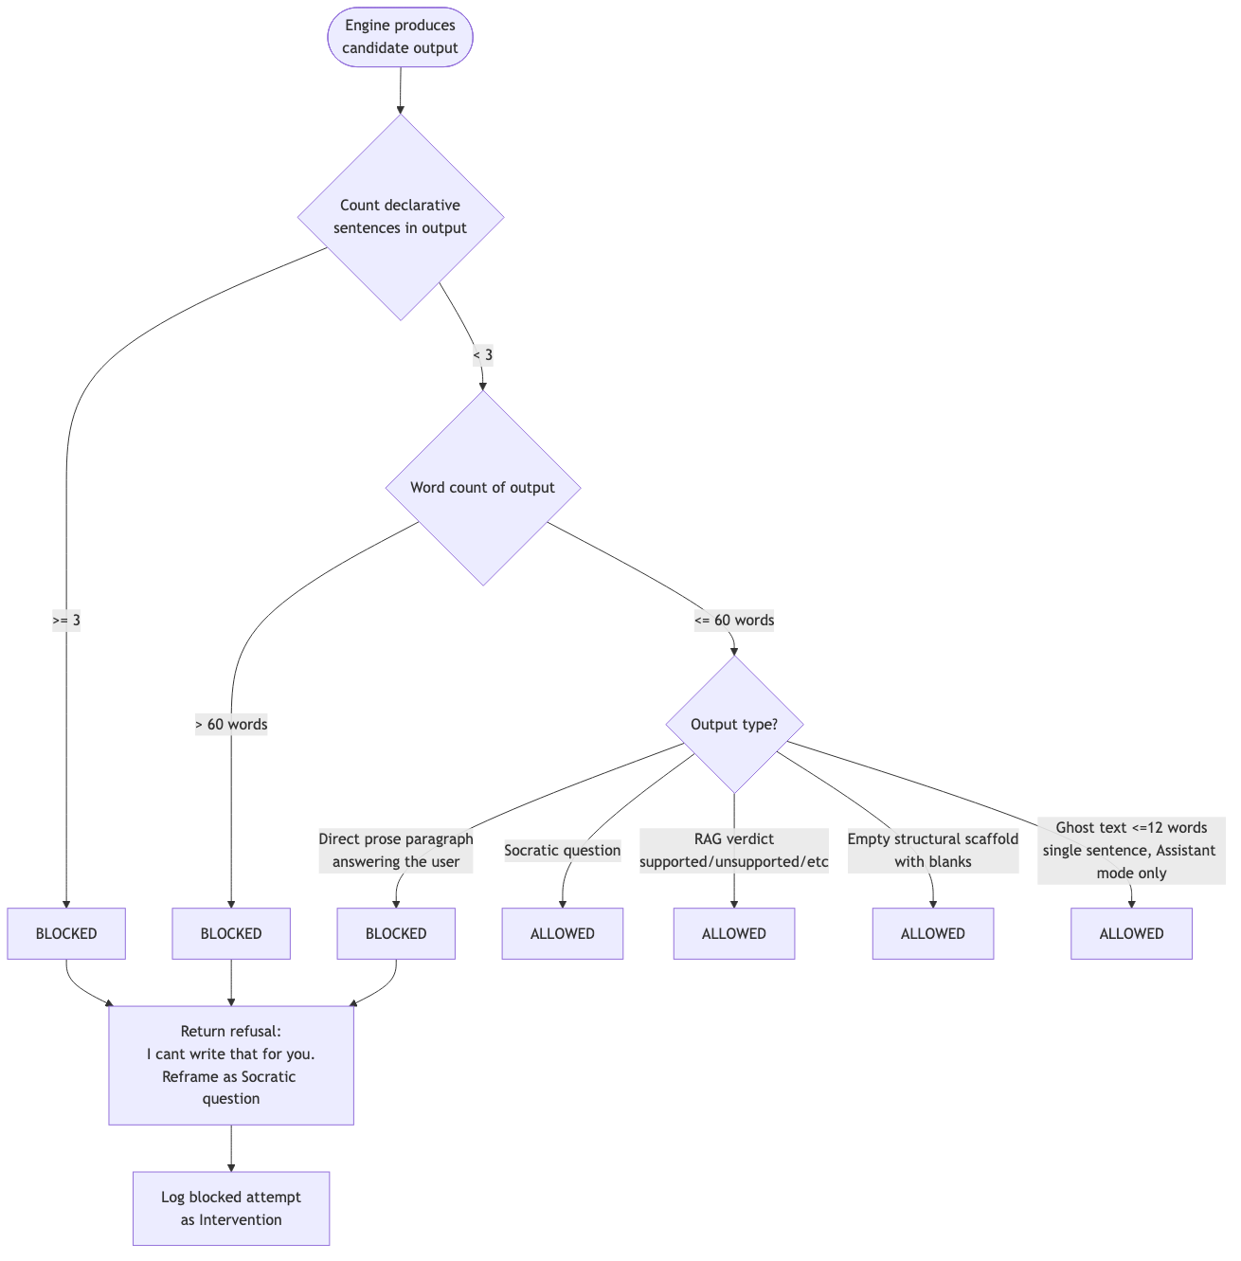
Figure 5.6: The non-generation contract decision flow
Friction calibration is the research contribution that sits on top of this invariant. The system offers three modes, selected by the user. In Socratic mode (the default) all engines are active with full cooldowns and the experimental autocomplete cannot be accepted. In Coach mode the cooldowns are relaxed by about half and phrase acceptance by typing is allowed. In Assistant mode the cooldowns are relaxed by about three quarters and tab-acceptance of short ghost text is allowed, but the Interceptor still blocks any explicit request to “write the whole thing”. Critically, friction calibration relaxes only the cadence of interventions and the acceptance of help; it never relaxes the non-generation contract. This is how the design resolves the survey tension: a user under deadline pressure can dial the friction down, but the AI still cannot write their essay. Figure 5.5 shows the flow.
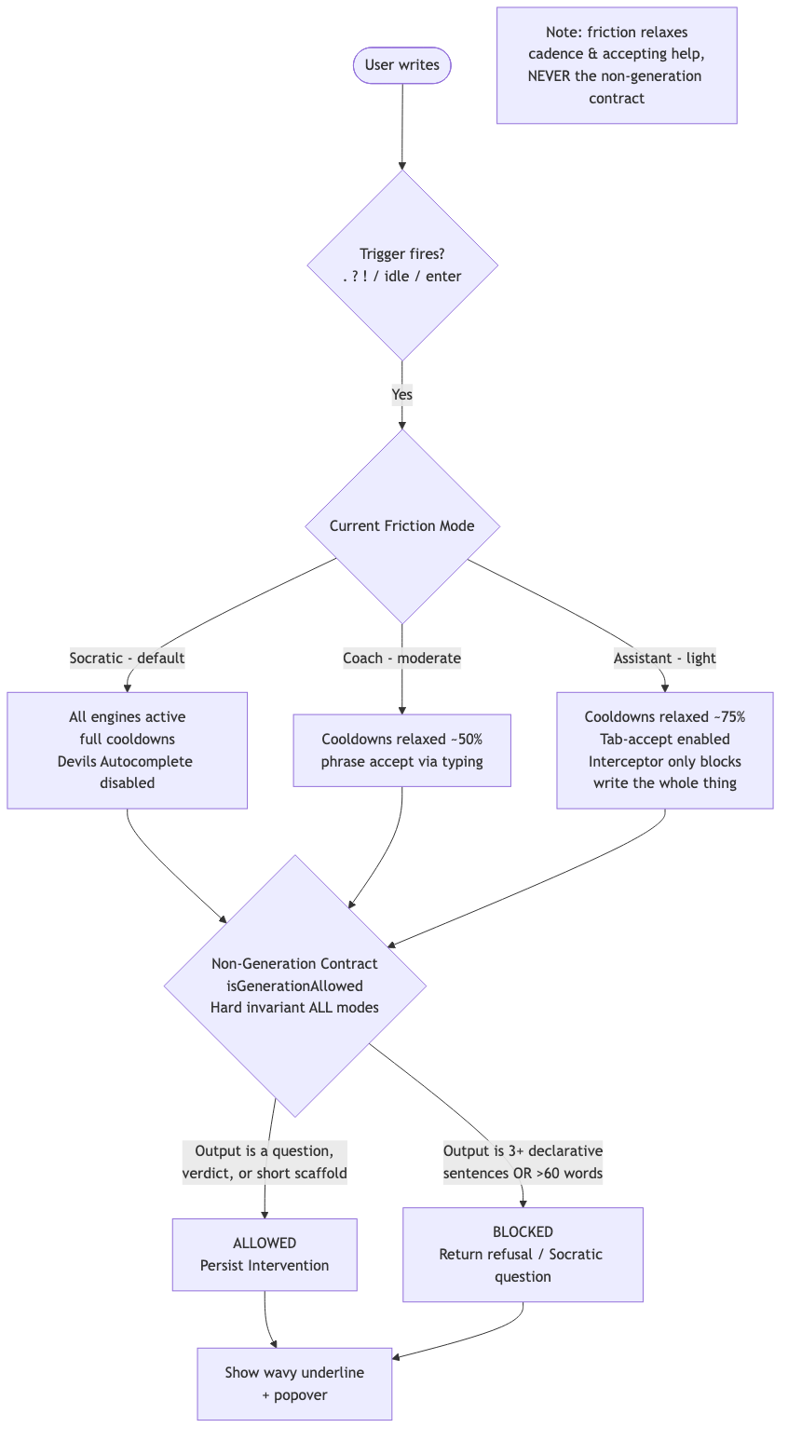
Figure 5.5: Friction mode calibration and the non-generation contract

5.5 Data Modelling
The data model consists of eight tables normalised to third normal form, managed through the Prisma schema (with separate definitions for the SQLite prototype and the PostgreSQL production database). The model centres on the Intervention entity, which is the audit record of every AI action, and on the PdfChunk entity, which carries the vector embedding column managed by raw SQL (because Prisma cannot represent the pgvector type directly). Figure 5.3 is the entity-relationship diagram, and Table 5.2 describes each entity.
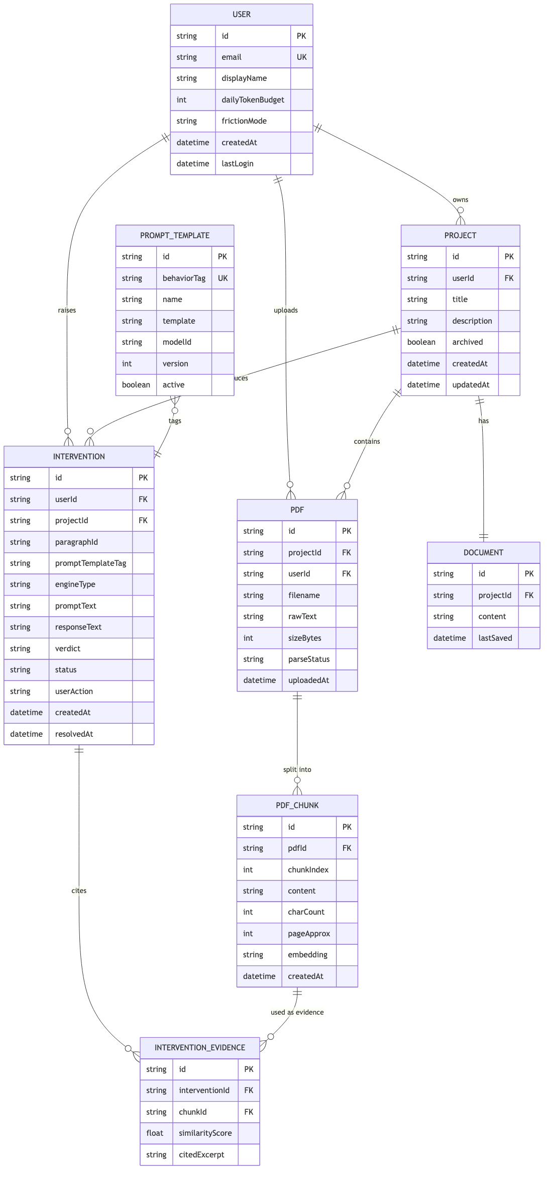
Figure 5.3: Entity-relationship diagram (eight tables)
Table 5.2: Data model — entity descriptions
Entity | Purpose and key fields
User | A registered writer. Holds email, display name, a daily token budget, and the chosen friction mode (socratic, coach, or assistant).
Project | A writing project owned by a user. Has a title, description, and an archived flag. Contains exactly one Document and a set of PDFs.
Document | The text being written, one per project. Stores the content as ProseMirror JSON and a lastSaved timestamp for autosave.
Pdf | An uploaded research source. Holds the filename, the extracted raw text, the file size, and a parse status (queued, ready, or failed).
PdfChunk | A ~500-token passage of a PDF. Holds the chunk index, content, character count, an approximate page, and the vector embedding (a vector(3072) column managed outside Prisma).
Intervention | The central audit entity. Records the engine type, the prompt and response, the verdict (for citations), a status (active, faded, resolved), and the user’s action (engaged, dismissed, ignored).
InterventionEvidence | A junction linking an Intervention to the PdfChunk(s) that were retrieved as evidence, with a similarity score and the cited excerpt.
PromptTemplate | A versioned, editable prompt keyed by behaviour tag (Provocation, Lens, Structural Scaffold, The Spark Gap). Edits do not require a redeployment.

5.6 Data Flow
Figure 5.4 is a Level 1 data-flow diagram. It shows the processes (manage auth and projects, edit and autosave the document, detect triggers, run the engines, ingest and embed PDFs, retrieve and verify claims, render interventions, and export) and the data stores they read and write (the document store, the PDF-chunk and vector store, the intervention audit log, and the prompt templates).
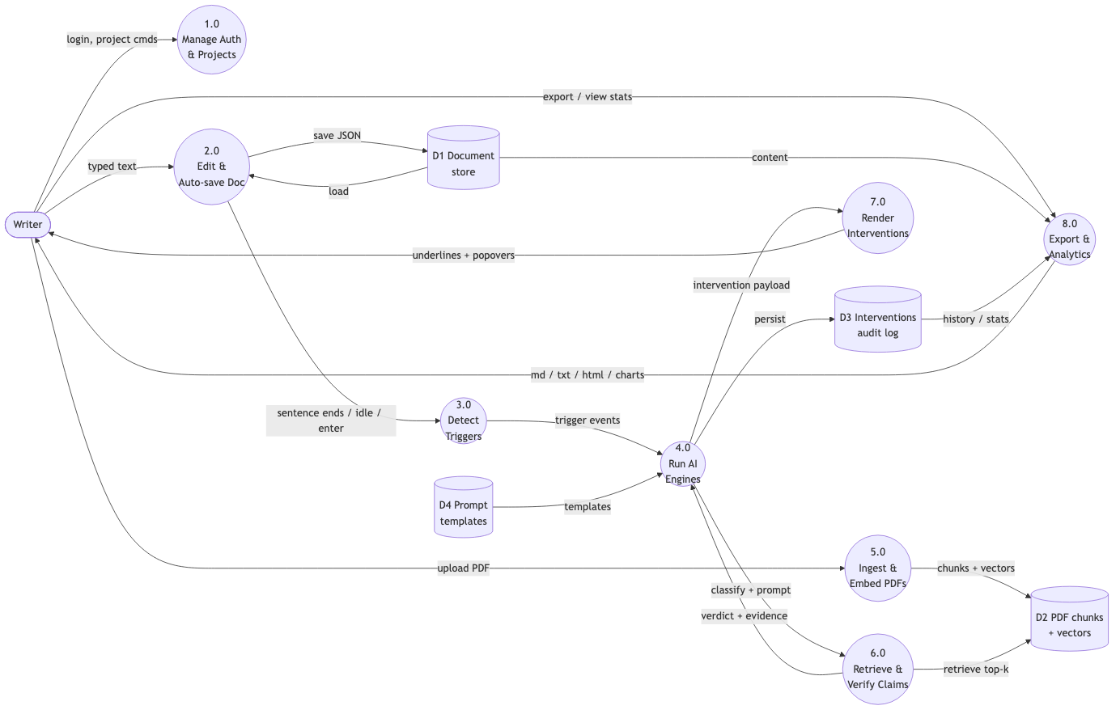
Figure 5.4: Data flow diagram, Level 1

5.7 User-Interface and User-Experience Design
The interface is designed to feel like a focused notebook, not a chatbot. The editor uses a serif typeface (Newsreader) at a comfortable size with generous line height, so that reading one’s own draft is pleasant. Autosave is continuous (debounced to 1.5 seconds) and a live save indicator reassures the writer that their work is safe.
Interventions are deliberately non-intrusive. When an engine fires on a sentence, that sentence receives a coloured wavy underline, each colour mapping to an engine: amber for the Interceptor, rose for the Socratic Spacer, emerald for the Citation Sentinel, sky for the Scaffold, and a neutral stone colour when multiple engines fire on one sentence. The underline appears about 2.5 seconds after the engine fires, so that it never interrupts the act of typing. Hovering over an underlined sentence opens a popover that stacks every intervention for that sentence vertically, each with its own actionable next-step (for example, Find evidence, Rewrite claim, View evidence, Apply scaffold, or Answer this). Small animated “pixelated pets” in the margin provide a light, playful signal that an engine has fired, making the otherwise invisible cognitive activity feel alive.
The friction mode is exposed as a simple selector (Socratic, Coach, Assistant) so that the user always knows and always controls how much challenge they are receiving; mode changes are never secret or automatic. The whole experience is built with Tailwind CSS and the shadcn/ui component library on top of Radix primitives, with Framer Motion for the transitions. The editor itself is built on Tiptap and ProseMirror, which gave the project clean control over decorations (the underlines) and document state.

5.8 Design of the Four AI Engines
The four engines are the heart of the system. Each has a precise trigger condition, a behaviour, and a set of actionable outcomes. Table 5.1 summarises them.
Table 5.1: The four AI engines
Engine | Behaviour tag | Fires when | What it does
Interceptor | The Spark Gap | Vague language (“basically”, “stuff”) or absolute claims (“always”, “never”) | Reframes the sentence as a Socratic question that forces specificity; blocks requests to write prose.
Socratic Spacer | Provocation | A ~2-second idle pause, or a question sentence | Asks a provocative question that challenges the writer’s assumption.
Citation Sentinel | Lens | A factual claim (contains “research”, “study”, “%d, and is six or more words) | Retrieves the top passages from the user’s library and returns a verdict with cited evidence.
Scaffold | Structural Scaffold | A long sentence (25+ words) or paragraph completion | Offers an empty Claim / Evidence / Limitation / Implication outline the writer fills in.

A single sentence can trigger several engines at once, and their results stack in the popover. Triggers are detected by a content analyser that runs when the writer ends a sentence (with a full stop, question mark, or exclamation mark), goes idle, or completes a paragraph (pressing Enter). To avoid overwhelming the writer, fired engines respect per-engine cooldowns and are staggered by 500 milliseconds. Two experimental engines extend the set: a Devil’s Autocomplete that offers very short (no more than twelve words, single-sentence) ghost text accepted only by Tab and only in Assistant mode, and a Blindspot Monitor that surfaces one overlooked but highly relevant library passage per session. Both experiments stay inside the non-generation contract.

5.9 Summary
The design is a two-service architecture with a clean AI-gateway seam, eight normalised tables centred on the Intervention audit entity, and a hard non-generation invariant that no friction mode can relax. The four engines turn the literature’s call for productive friction into concrete behaviour, presented through a notebook-style interface with non-intrusive, actionable interventions. The next chapter describes how this design was implemented.

CHAPTER 6: IMPLEMENTATION

6.1 Introduction
This chapter describes how the design of Chapter 5 was implemented. It covers the development environment and the technologies used, the implementation of the four engines, the retrieval-augmented-generation pipeline (including the verdict guard and the calibration finding), authentication and security, and deployment. It closes with a condensed user guide so that an examiner can use the system.

6.2 Development Environment and Tools
The front end and backend-for-frontend were written in TypeScript on Next.js (App Router) with React. The editor is built on Tiptap and ProseMirror. Styling uses Tailwind CSS and the shadcn/ui library; state management uses Zustand, with Framer Motion for animation. The retrieval service is written in Python with FastAPI and Pydantic. The database is PostgreSQL with the pgvector extension, accessed from TypeScript through the Prisma ORM and from Python through a dedicated pgvector adapter. Both codebases were built test-first, as described in Chapter 3. Table 6.1 summarises the technologies.
Table 6.1: Technologies and tools used
Layer | Technology
Front end | Next.js (App Router), React, TypeScript, Tailwind CSS, shadcn/ui (Radix), Framer Motion, Zustand, TanStack Query/Table, Recharts
Editor | Tiptap / ProseMirror (custom extensions: wavy underline, idle detector, intervention highlight)
Backend-for-frontend | Next.js Route Handlers, Prisma ORM
Retrieval service | Python, FastAPI, Uvicorn, Pydantic, httpx
AI provider | Google Gemini — gemini-3.1-flash-lite (LLM) and gemini-embedding-001 (3072-dim embeddings)
Database | PostgreSQL with pgvector; SQLite for the local prototype
Auth | Supabase Auth (@supabase/ssr) with row-level security; single-user dev fallback (disabled in production)
Tooling | Bun, Vitest, pytest, Docker / Docker Compose (multi-arch buildx), Conventional Commits

6.3 Implementing the Engines
The engine-orchestration logic lives in the front end. A content analyser inspects the document whenever the writer ends a sentence, goes idle, or completes a paragraph. When a trigger matches one or more engines, the orchestration fires the matching engine handlers, staggered by 500 milliseconds and respecting per-engine cooldowns. The Interceptor, Socratic Spacer, and Scaffold engines call the large language model through the backend-for-frontend; the Interceptor may also stream over Server-Sent Events from the FastAPI service. Each result is persisted as an Intervention in the database, then rendered as a wavy-underline decoration on the triggering sentence (added after a 2.5-second debounce so typing is never interrupted). Figure 6.1 shows the sequence.
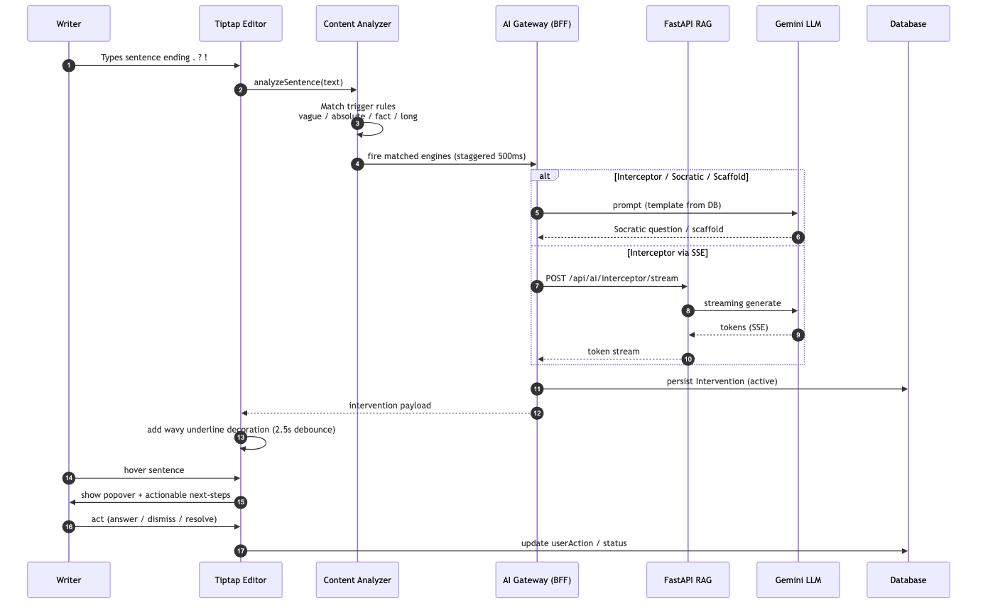
Figure 6.1: Sequence — engine firing and intervention rendering
Every prompt is loaded from the versioned PromptTemplate table rather than being hard-coded, so that prompt content can be edited and versioned without a redeployment. A lightweight delegation-heuristic check inspects the writer’s input first, using a regular expression, so that obviously delegative prompts (“write this for me”) can be blocked without spending a model call.

6.4 The Retrieval-Augmented-Generation Pipeline
The Citation Sentinel is the engine that grounds factual claims in real evidence. Its pipeline has four stages: chunking, embedding, retrieval, and verdict classification.

6.4.1 Ingest, Chunk, and Embed
When a user uploads a PDF, the application extracts its text, splits it into roughly 500-token passages, and stores each passage as a PdfChunk row. The chunks are then sent to the FastAPI service, which embeds them using the Gemini embedding model and stores the resulting vectors in the pgvector column. The writer’s own chunk identifiers are passed verbatim, so that retrieved evidence can be linked back to the exact passage for citation. Figure 6.3 shows this sequence.
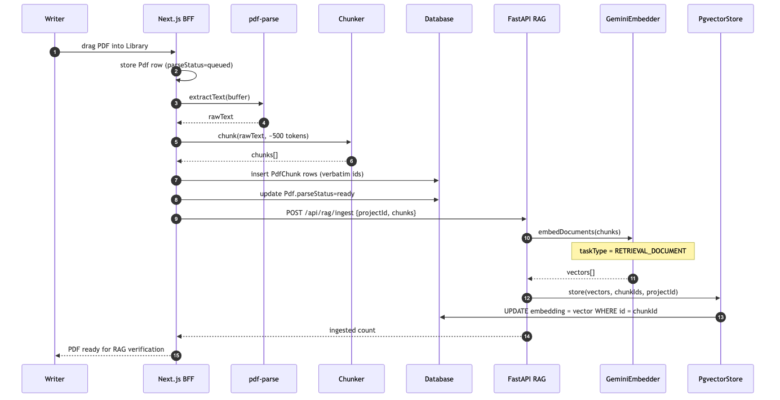
Figure 6.3: Sequence — PDF ingest and embedding

6.4.2 Retrieve and Classify
When the writer completes a factual claim, the claim is embedded as a query and the FastAPI service retrieves the five most similar passages from that project’s chunks using cosine similarity over an HNSW index. These passages, plus the claim, are then sent to the language model with an evidence-only prompt, and the model returns one of four verdict labels. Figure 6.2 shows the sequence.
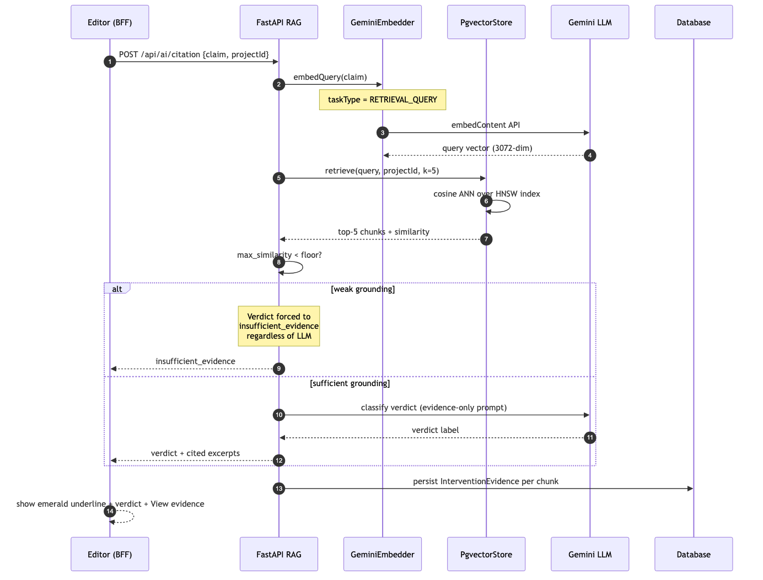
Figure 6.2: Sequence — the Citation Sentinel RAG verdict

6.4.3 The Verdict Guard
A guard wraps the verdict classification to prevent hallucinated support. If the grounding is weak — the highest similarity score is below a floor, or no passages were retrieved — the verdict is forced to “insufficient evidence” regardless of what the language model said. This is the system’s direct response to the stochastic-parrots critique from Chapter 2: the model’s fluency is never allowed to invent evidence. The floor therefore remains as a production backstop against hallucinated support.

6.4.4 Asymmetric Embeddings and the Calibration Finding
Two implementation findings turned out to be research contributions. First, the Gemini embedding model is asymmetric by design: documents and queries must be embedded with different task types (a retrieval-document task for the corpus, a retrieval-query task for the claim). An early bug embedded queries with the wrong task type, which measurably degraded ranking; fixing it raised Recall@5 and made vector retrieval win at every cut-off. Second, real embeddings produce a high baseline cosine similarity even for unrelated distractor claims, so the similarity floor calibrated for the simple surrogate embedder was far too low. Switching to real embeddings therefore required re-calibrating the verdict guard, not merely the retriever — a finding recorded in ADR-0008 and quantified in Chapter 7.

6.5 Intervention Lifecycle
Every engine result is an Intervention, and its lifecycle is a small state machine. A new Intervention starts in the Active state (no user action yet, visible as a wavy underline). If the writer edits the triggering sentence so that the underline can no longer be matched, the Intervention moves to Faded, from which it can re-activate when the sentence is completed again. When the writer engages (answers the question, applies a scaffold, or accepts a verdict) the Intervention becomes Resolved. If a cooldown passes with no action, it is marked Ignored but is never deleted — it remains in the audit log for the History view. Figure 6.4 shows this state machine.
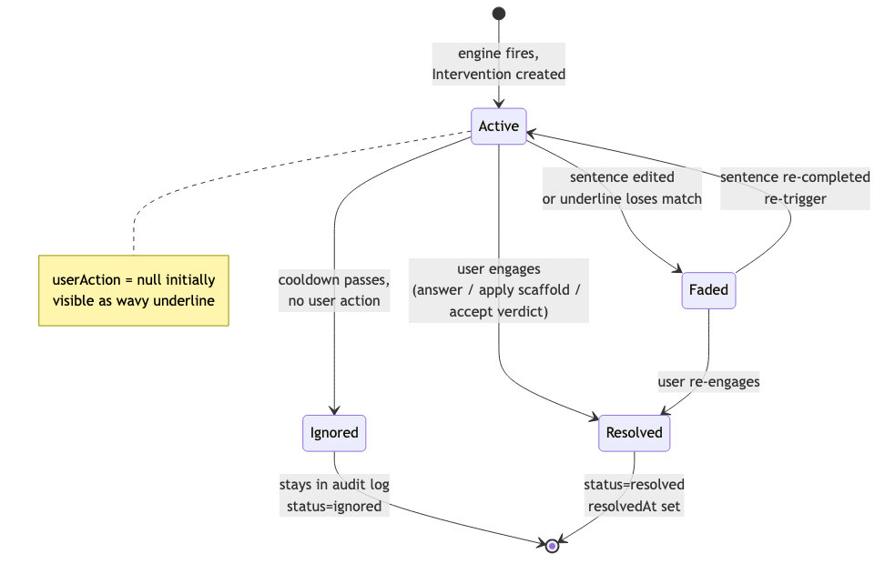
Figure 6.4: Intervention state machine

6.6 Authentication and Security
The system supports two authentication paths. In production it uses Supabase Auth with session-based authentication through the server-side Supabase SDK; a middleware layer refreshes session cookies and redirects unauthenticated browser requests to the login screen. A single-user development fallback exists for local prototyping, but it is hard-ignored whenever the environment is set to production, so it can never bypass authentication in a deployed system. At the database layer, every user-scoped table is protected by a row-level-security policy that restricts each row to its owning user, so that data isolation is enforced by the database itself and not only by the application. The FastAPI service connects with a service-role connection that bypasses row-level security only for the trusted server-side work of ingesting embeddings.

6.7 Deployment
The system ships as a multi-stage Docker image built for two CPU architectures (AMD64 and ARM64), so the same image runs on x86 servers, Apple Silicon machines, and ARM cloud hosts. Docker Compose orchestrates three containers: the Next.js application, the FastAPI retrieval service, and a PostgreSQL database with pgvector enabled. An interactive first-run wizard configures the AI provider, the database, and authentication, and an entrypoint script applies any pending migrations before starting the application. This makes a local evaluation straightforward for an examiner.

6.8 How to Use Cogdoc (Condensed Guide)
The following steps summarise how to use the system; the complete guide appears in Appendix E.
1 Open Cogdoc in a browser and create a project (for example, “Literature Review — AI and Cognitive Offloading”).
2 Upload research PDFs into the Library, or paste text from articles or notes. The content is parsed, chunked, embedded, and indexed.
3 Write in the editor. The document autosaves every 1.5 seconds. As you finish sentences, pause, or complete paragraphs, the engines fire.
4 Watch for coloured wavy underlines. Hover an underlined sentence to see the intervention(s) and their actionable next-steps.
5 Use the mode selector to choose Socratic, Coach, or Assistant friction depending on your deadline pressure.
6 Export to Markdown, plain text, or HTML, or print to PDF. Review your Stats and History for engagement and verdict breakdowns.
Common troubleshooting: if the Citation Sentinel reports “insufficient evidence”, upload more relevant sources; if no interventions appear, ensure sentences end with a full stop, question mark, or exclamation mark, and that the AI provider is configured (the Docker wizard handles this on first run).

6.9 Summary
The implementation realises the design across a TypeScript application and a Python retrieval service, with the engines orchestrated in the editor, prompts loaded from a versioned table, and the Citation Sentinel grounded in pgvector retrieval behind a hallucination guard. Two implementation findings — the asymmetry of the embeddings and the need to re-calibrate the verdict guard — became measurable research contributions. Chapter 7 presents the testing and evaluation that quantify them.

CHAPTER 7: TESTING AND EVALUATION

7.1 Introduction
This chapter reports how the system was tested and how the central claims were evaluated. It has two parts. The first covers the software test strategy that protected correctness throughout development. The second covers the scientific evaluation of the citation-verification engine against a real corpus, which is where the project’s empirical contributions are measured. The chapter states results honestly, including a target that was not met, and explains why.

7.2 Software Test Strategy
Testing was continuous and test-driven, as described in Chapter 3. Three levels of testing were used. Unit tests covered individual functions and modules (the content analyser, the friction guard, the embedder, the verdict classifier, and the chunker). Integration tests covered the route handlers and the FastAPI endpoints together with their data stores. System-level checks covered end-to-end behaviour such as uploading a PDF and receiving an intervention. All tests had to pass and coverage had to reach at least eighty percent before a sprint could advance.
Table 7.1: Test summary (end of build phase)
Metric | Result
TypeScript tests | 179 (across the front end and BFF)
Python tests | 68 (across the retrieval service)
Total tests | 247
TypeScript coverage (src/lib + src/app/api) | ≥ 93% lines
Python coverage (fastapi/app) | ≥ 97% lines
Coverage gate | 80% hard floor — enforced, never softened

Two specific test suites deserve emphasis. The friction-invariant tests assert that the non-generation contract holds in all three modes — that no combination of mode and input can coax the system into producing paragraph-length prose. The interceptor-blocking tests assert a high blocking precision against a targeted set of delegative prompts.

7.3 Evaluation of the Citation Sentinel

7.3.1 Method
The citation-verification engine was evaluated against a real corpus of 28 passages drawn from five real research PDFs (including the Gerlich study and papers on critical thinking, algorithmic fairness, and environmental accounting). Fifty claims were hand-labelled with ground-truth verdicts: 20 supported (paraphrases of source content), 10 partially supported (overstatement, incorrect causation, or misattributed intent), 10 unsupported (contradicted by the sources), and 10 with insufficient evidence (off-corpus, including topic-adjacent hard negatives). To prevent tuning on the test set, the claims were split deterministically into a calibration set of about one third and a held-out test set of about two thirds; the similarity threshold was chosen on the calibration set only, and all reported metrics are on the held-out test set. Figure 7.1 shows the pipeline.
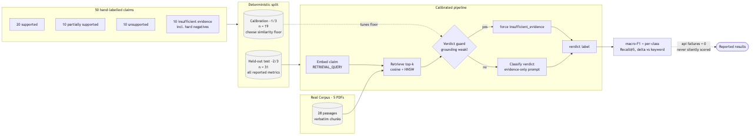
Figure 7.1: Calibrated evaluation pipeline (real corpus, held-out test split)
The calibrated pipeline runs as follows: embed the claim as a retrieval query, retrieve the top passages by cosine similarity, apply the verdict guard (forcing “insufficient evidence” when grounding is weak), and otherwise classify the verdict with the language model against the retrieved evidence. Any verdict API failure was treated as a missing measurement and was never silently scored; the final run recorded zero failures.

7.3.2 Results
Table 7.2 reports the headline results against the project targets. Two of the three targets were met; the third was not, and the reason is informative rather than flattering.
Table 7.2: Evaluation results against targets (held-out test, n = 31)
Metric | Result | Target | Met?
Verdict macro-F1 | 0.773 | ≥ 0.70 | Yes
Retrieval Recall@5 (vector) | 0.8875 | ≥ 0.80 | Yes
Vector vs keyword Δ Recall@5 | +2.5 pp | ≥ 15 pp | No
Verdict API failures | 0 | 0 | Yes

Per-class performance (Figure 7.2) was balanced: every verdict class achieved an F1 of at least 0.70 — supported 0.82, partially supported 0.80, unsupported 0.77, and insufficient evidence 0.71. The verdict guard did its job: the “insufficient evidence” class reached perfect recall, meaning every claim for which evidence was genuinely absent was correctly flagged.
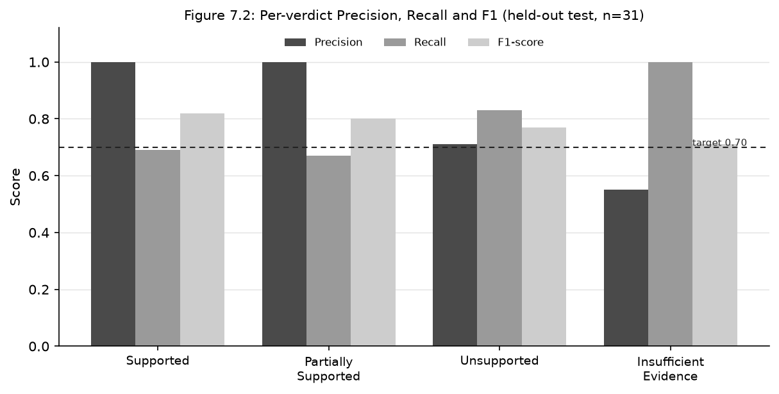
Figure 7.2: Per-verdict precision, recall and F1 (held-out test, n = 31)

7.4 Retrieval: Vector versus Keyword
The retrieval comparison is shown in Figure 7.3. Vector retrieval (using the real Gemini embeddings) beat the keyword (Jaccard) baseline at every cut-off, and the gap was largest at Recall@1 (+5.0 percentage points) — the rank that matters most, because it determines which passage the verdict model reads first. Vector Recall@5 reached 0.8875 against the keyword’s 0.8625, a difference of 2.5 percentage points.
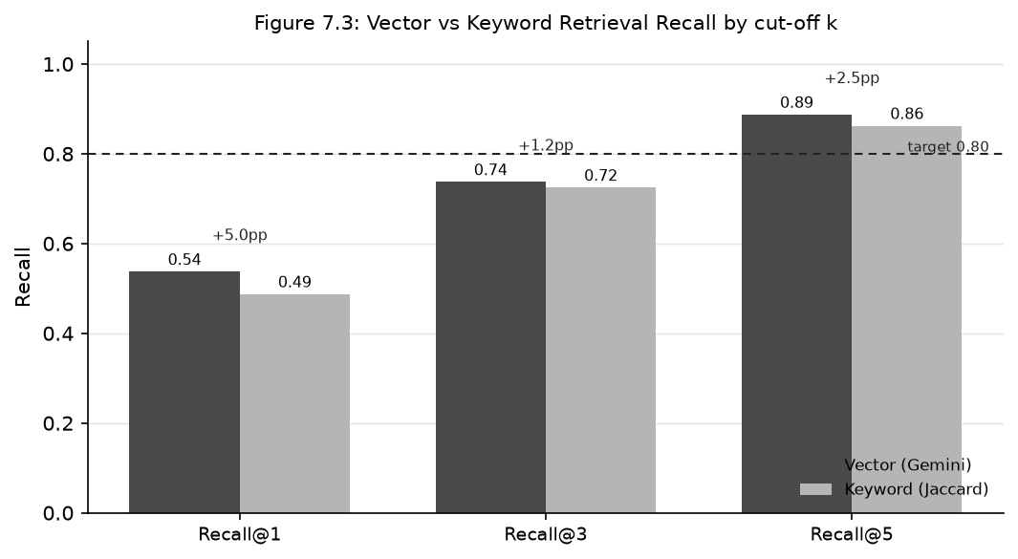
Figure 7.3: Vector versus keyword retrieval recall by cut-off k
The project set an ambitious ablation target of a fifteen-percentage-point gap, and that target was not met on this corpus. The reason is honest: when a claim shares proper nouns with its sources (Gerlich, Halpern, COMPAS, Northpointe), a simple keyword baseline is already strong, and the corpus is small (only 28 chunks), which limits how many lexical collisions can occur. The project’s expectation, supported by the Recall@1 result, is that the gap widens as the corpus grows and lexical collisions multiply; validating that on a larger corpus is identified as future work.

7.5 The Two Implementation Findings
The evaluation surfaced two findings that go beyond the headline numbers. First, the asymmetric-embedding finding: queries were initially embedded with the wrong task type, which caused vector retrieval to lose to the keyword baseline; correcting the task type flipped the result so that vector retrieval won at every cut-off. This is a concrete, reproducible demonstration that Gemini’s retrieval embeddings are asymmetric by design and that mixing the task types measurably degrades ranking. Second, the calibration finding: real embeddings produce a high baseline cosine similarity even for unrelated distractor claims, so the verdict similarity floor that was appropriate for the simple surrogate embedder (0.30) was far too low for real embeddings (which need a floor around 0.80). Switching to real embeddings therefore required re-calibrating the verdict guard, not merely the retriever. Both findings are recorded as Architecture Decision Records and are the project’s empirical contributions to practice.

7.6 Engine and Friction Evaluation
Beyond the citation engine, the Interceptor was evaluated for blocking precision against a targeted set of delegative prompts and achieved a blocking precision of 1.000 (it correctly blocked every attempt to make it write prose) with full recall on delegative prompts. The friction modes were evaluated by invariant tests confirming that the non-generation contract holds across Socratic, Coach, and Assistant modes. Together these tests establish that the central design invariant is enforced, not merely intended.

7.7 User Testing and Acceptance
User acceptance was assessed primarily through the requirements survey (Chapter 4) and interviews, which established both the need for the tool and the tension that friction calibration resolves. The 59.1 percent of respondents who rated a friction-based tool useful for long-term learning, set against the 78.3 percent who expected it to be frustrating under pressure, directly motivated the three-mode design. Formal usability testing with a larger sample under controlled conditions is identified as future work.

7.8 Limitations
The evaluation has clear limitations, stated openly. The corpus is real but modest (28 passages, 50 claims), so the absolute numbers should be read as evidence on this corpus, not as a guarantee at scale. The fifteen-percentage-point ablation target was not met. The live round-trip through a hosted pgvector instance was not verified in the evaluation environment because outbound database ports were blocked, so the production vector store was exercised through its adapter rather than against a live managed instance. User acceptance is based on a survey and interviews rather than a controlled trial. None of these limitations undermine the central findings, but they bound the strength of the claims and define the future work.

7.9 Summary
The system met its verdict-accuracy and retrieval-recall targets (macro-F1 0.773, Recall@5 0.8875), enforced the non-generation contract across all friction modes, and produced two empirical findings — the asymmetry of retrieval embeddings and the need to re-calibrate the verdict guard for real embeddings — that constitute its contribution to practice. The ambitious ablation target was honestly not met, and the limitations define a clear programme of future work.

CHAPTER 8: CONCLUSION

8.1 Summary of Achievements
This project set out to design, build, and evaluate a writing tool that uses AI to mitigate cognitive atrophy rather than cause it. Cogdoc achieves its aim. It is a research-assisted writing IDE in which the AI never writes the prose for the user; instead, four engines intervene in the margin — the Interceptor, the Socratic Spacer, the Citation Sentinel, and the Scaffold — questioning vague claims, provoking deeper thought, verifying facts against the writer’s own library, and offering empty structural outlines.
Measured against the objectives of Chapter 1, the project: investigated the problem through a literature review and a survey of thirty-three respondents; designed and enforced a non-generation contract that structurally prevents prose generation; implemented all four engines with real-time detection and non-intrusive underlines; implemented retrieval-augmented claim verification against the writer’s own PDFs behind a hallucination guard; implemented and evaluated a three-mode friction calibration; and evaluated the system against measurable targets, meeting its verdict-accuracy (macro-F1 0.773) and retrieval-recall (Recall@5 0.8875) goals. The system is also complete as a product: it has authentication, autosave, export, analytics, and a full intervention history, and it ships as a portable multi-architecture Docker image.

8.2 Research Contributions
The project makes three contributions. The first is design: it operationalises the frictional-AI literature into a concrete, user-controllable, three-mode friction calibration backed by a hard non-generation invariant — an interaction primitive not offered by the reviewed existing tools. The second and third are empirical: a reproducible demonstration that Gemini’s retrieval embeddings are asymmetric and that mixing their task types measurably degrades ranking; and the finding that switching to real embeddings requires re-calibrating the verdict guard rather than merely the retriever. These findings are recorded as Architecture Decision Records so that other builders can act on them.

8.3 Limitations
The limitations, stated honestly, are these. The evaluation corpus is real but small, so the absolute metrics should be read as evidence on this corpus rather than as guarantees at scale. The ambitious fifteen-percentage-point ablation target was not met on this corpus. The live round-trip through a hosted pgvector instance was not verified because outbound database ports were blocked in the evaluation environment. User acceptance rests on a survey and interviews rather than a controlled trial. Finally, the system is evaluated in English, and its prompts and corpus reflect that.

8.4 Future Work
The clearest next steps follow directly from the limitations. A larger stress-test corpus (the project’s planned Sprint 4) would test whether the vector-over-keyword gap widens at scale as expected, and would justify the smaller, single-topic chunking identified as the highest-leverage retrieval improvement. Verifying the live pgvector round-trip against a managed instance would close the remaining deployment gap. Completing Server-Sent-Events streaming for the remaining three engines would deliver the original latency contract in full. A controlled usability study would convert the survey-based acceptance evidence into measured results. Finally, multilingual support and integration with reference managers would broaden the tool’s reach.

8.5 Reflection
Building Cogdoc reinforced a simple lesson: the discipline of test-driven development and an honest, measurable evaluation were what made it possible to tell, at the end, what actually worked and what did not. The targets that were met and the one that was not are reported openly, because the value of an empirical project lies in the reliability of its claims. The broader hope of the project is modest but clear: it shows that AI writing tools can be designed to make their users think more rather than less, and that such a design can be built and measured today.

REFERENCES
Bender, E. M., Gebru, T., McMillan-Major, A., & Shmitchell, S. (2021). On the dangers of stochastic parrots: Can language models be too big? In Proceedings of the 2021 ACM Conference on Fairness, Accountability, and Transparency (FAccT ’21) (pp. 610–623). Association for Computing Machinery.
Bjork, R. A. (1994). Memory and metamemory considerations in the training of human beings. In J. Metcalfe & A. P. Shimamura (Eds.), Metacognition: Knowing about knowing (pp. 185–205). MIT Press.
Bush, V. (1945). As we may think. The Atlantic Monthly, 176(1), 101–108.
Cabitza, F., & Natali, A. (2024). Frictional AI as a design stance for human-centered artificial intelligence. In Human-centered artificial intelligence (pp. 91–111). Springer.
Engelbart, D. C. (1962). Augmenting human intellect: A conceptual framework (Summary Report, AFOSR-3233). Stanford Research Institute.
Feathers, M. (2004). Working effectively with legacy code. Prentice Hall.
Gerlich, M. (2025). AI tools in society: Impacts on cognitive offloading and the future of critical thinking. Societies, 15(1), Article 6. https://doi.org/10.3390/soc15010006
Kosmyna, N., et al. (2025). Your brain on ChatGPT: Accumulation of cognitive debt when using an AI assistant for essay writing tasks (MIT Media Lab / Brainwave study). Massachusetts Institute of Technology.
Lee, M., Varshney, N. R., et al. (2025). The impact of generative AI on critical thinking: Self-reported reductions in cognitive effort and confidence effects among knowledge workers. Microsoft Research & Carnegie Mellon University.
Risko, E. F., & Gilbert, S. J. (2016). Cognitive offloading. Trends in Cognitive Sciences, 20(9), 676–688.
Stadler, M., et al. (2024). The cognitive effects of large language models: Reduced load at the cost of reasoning depth. Studies on the cognitive impact of LLM assistance.

APPENDIX A: SURVEY INSTRUMENT
The requirements survey was administered online to thirty-three respondents recruited by purposive sampling (undergraduates, postgraduates, doctoral candidates, researchers, and academic writers). It had four sections.

Section 1 — Demographics and AI-usage habits
- What is your current role? (undergraduate / postgraduate / PhD / researcher / academic writer / other)
- How often do you use generative AI (e.g. ChatGPT, Gemini) for academic or research work? (daily / weekly / monthly / rarely)
- Which tools do you use most? (ChatGPT / Gemini / Grammarly / Elicit / other)

Section 2 — Cognitive offloading and automation bias
- I paste AI-generated text into my drafts largely unchanged. (5-point agreement scale)
- I trust the factual claims that AI generates, even though I know it can hallucinate. (5-point scale)
- I verify AI-generated citations against the original sources. (5-point scale)

Section 3 — Illusion of mastery
- I spend less time thinking about structure and flow when I use AI. (5-point scale)
- After reading an AI summary, I feel I have mastered a topic without reading the core literature. (5-point scale)

Section 4 — Receptivity to productive friction
- A tool that makes me slow down to question, verify, and defend my claims would help me learn in the long term. (5-point scale)
- Such a tool would frustrate me when I am under deadline pressure. (5-point scale)
The headline results are reported in Table 4.1. The instrument was complemented by at least three semi-structured interviews using the guide below.

APPENDIX B: EVALUATION DATASET
The evaluation corpus consisted of 28 verbatim passages (chunks) drawn from five real research PDFs, including the Gerlich (2025) study and papers on critical thinking, algorithmic fairness (the COMPAS / Northpointe recidivism tool), and environmental accounting. The 28 chunks included realistic distractors such as journal page furniture and licence boilerplate. Fifty claims were hand-labelled with ground-truth verdicts: 20 supported (paraphrases of source content), 10 partially supported (overstatement, incorrect causation, or misattributed intent), 10 unsupported (contradicted by the sources), and 10 with insufficient evidence (off-corpus, including topic-adjacent hard negatives such as the Gutenberg printing press and Norwegian recidivism). The claims were split deterministically into a calibration set of 19 and a held-out test set of 31; all reported metrics are on the held-out test set. Example claim–verdict pairs from the per-claim results include: “The Gerlich study found no relationship between AI tool usage and critical thinking” (expected unsupported, predicted unsupported) and “People tend to remember where information lives rather than the information itself” (expected supported, predicted supported).

APPENDIX C: ADR INDEX
Table C.1: Architecture Decision Records
ADR | Title | Status
0000 | Spec-versus-build reconciliation (capstone) | Accepted
0006 | Tiptap editor migration: extensions built, surface swap delivered | Closed
0007 | SSE streaming: partial delivery (Interceptor first) | Accepted
0008 | Real embeddings + pgvector (with re-calibration finding) | Accepted
0009 | Document content migration: HTML → ProseMirror JSON | Accepted

APPENDIX D: API ENDPOINTS
Table D.1 lists the principal application-programming endpoints. The backend-for-frontend exposes Next.js route handlers; the retrieval service exposes FastAPI endpoints.
Table D.1: API endpoints
Endpoint | Service | Purpose
POST /api/projects, GET/PATCH/DELETE /api/projects/[id] | BFF | Create, list, update, delete projects
GET/PUT /api/projects/[id]/document | BFF | Load and autosave the document
POST /api/projects/[id]/pdfs, DELETE /api/pdfs/[id] | BFF | Upload and delete research PDFs
POST /api/projects/[id]/add-source, /find-sources | BFF | Add a web source; search the web for sources
GET /api/projects/[id]/export | BFF | Export to Markdown / text / HTML
POST /api/interceptor, /socratic-spacer, /scaffold | BFF | Run the non-streaming engines
POST /api/citation-sentinel | BFF | Run the citation engine (delegates to RAG)
POST /api/autocomplete, /blindspot | BFF | Experimental engines
GET/PUT /api/interventions, PATCH /api/interventions/[id] | BFF | Intervention CRUD and user-action logging
GET /api/analytics | BFF | Aggregate engagement and verdict statistics
GET/PUT /api/settings, /api/user | BFF | User settings and current user
POST /api/rag/ingest | FastAPI | Chunk, embed, and store a PDF’s passages
POST /api/rag/retrieve | FastAPI | Cosine ANN retrieval over a project’s chunks
POST /api/ai/citation | FastAPI | Retrieve and classify a verdict (with guard)
POST /api/ai/interceptor/stream | FastAPI | SSE producer streaming the Interceptor output

APPENDIX E: USER GUIDE
This appendix reproduces the end-user guide for the system.

Getting started
1 Open Cogdoc in your browser (http://localhost:3000 when running locally).
2 Create a project — click New Project, enter a title, and click Create.
3 Start writing in the editor. Your text autosaves every 1.5 seconds.

The four engines and their underlines
- Amber wavy — Interceptor: fires on vague language or absolute claims; reframes the sentence as a question.
- Rose wavy — Socratic Spacer: fires on a pause or a question; provokes deeper thinking.
- Emerald wavy — Citation Sentinel: fires on factual claims; verifies them against your library.
- Sky wavy — Scaffold: fires on long sentences or paragraph completion; offers an empty outline.
Hover an underlined sentence to see the intervention(s) and their actionable next-steps.

Uploading research
Click Library in the top bar, then Upload PDF (drag-and-drop) or Paste text. The content is parsed, chunked into roughly 500-token passages, embedded, and indexed. The Citation Sentinel can then verify your claims against it.

Friction modes
Use the mode selector to choose Socratic (full friction, the default), Coach (moderate), or Assistant (light, under deadline pressure). The AI still never writes your prose in any mode.

Exporting and reviewing
Click Export to download your draft as Markdown, plain text, or HTML, or to print to PDF. Use Stats and History in the top bar to review how many interventions each engine fired, your engagement rate, and the full intervention audit trail.

Keyboard shortcuts
Shortcut | Action
Cmd/Ctrl + B / I / U | Bold / Italic / Underline
Esc | Clear selection / close popover
Enter | New paragraph (may trigger Scaffold)
Shift + Enter | Line break (no new paragraph)

