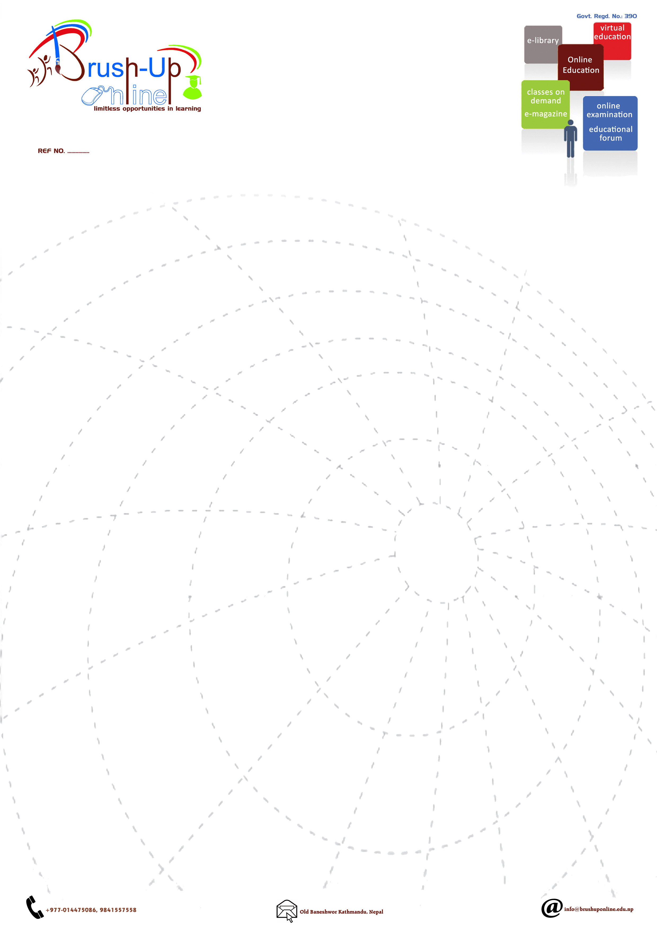

Date:

To,
_________________________________
_________________________________
_________________________________
Subject: Participation of your school in National Cyber Olympiad
(3rd ICT QUIZ CONTEST 2073)

Dear sir/madam,

Brush-Up Online is a government registered organization managed by various educators from well-known institutions. The team has been organizing various IT related workshops, seminars, competitions, practice exams to inculcate the current and challenging skills in our students. We would like to notify you that Brush-Up Online is going to conduct one of it's annual event National Cyber Olympiad for 3rd time with an aim at building up confidence level in the students so that they can be updated with the current technologies in the Computer field.
This event starts on 26th August 2016 (10th Bhadra 2073) and the final will be held at Russian Center of Science and Culture, Kamal Pokhari on 14th September 2016 (29th Bhadra 2073).
We kindly request you to make sure your students participate in this grand event. Details of the Cyber Olympiad are attached herewith.

Please feel free to get more information regarding the program in case of requirement.

Laxman Pokhrel
Secretary
Cell: 9851037897
Email: info@brushuponline.edu.np

