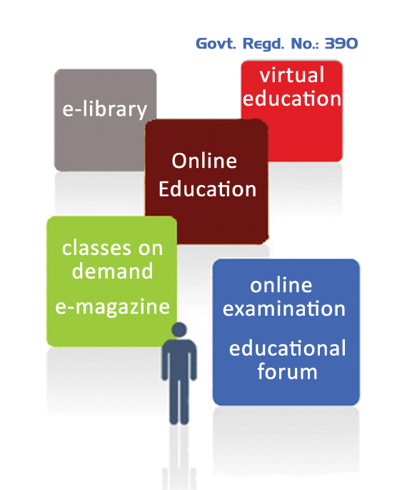


National Cyber Olympiad
Inter School ICT Quiz Contest

26th August – 14th September 2016
(10th Bhadra-29th Bhadra 2073)
Kathmandu

PARTICIPANTS REGISTRATION FORM

Name of the school : ______________________________________________
Address : ______________________________________________
Contact no. : ______________________________________________
Contact person/rep. : ______________________________________________
Contact No./Cell no. of rep. : ______________________________________________
E-Mail Address of Rep. : ______________________________________________
Total no. of team : ______________________________________________
Registration fee enclosed : ______________________________________________
Note: Please fill out this form along with the participant's details and submit it to the Brush-Up Online representative no later than 21st August 2016, 4:00PM.
Registration Fee: 1000/- per team.

______________________ __________________________ ________________________
Date School Stamp Authorized Signature

EVENTS PARTICIPANTS DETAIL
National Cyber Olympiad

ICT Quiz Contest 2073 (2016)
S. No. | Name of Participant / Level/Class | Photograph of Participants | Address/Cell Phone/ Email/Parents or guardians Contact
1.
2.
3.
We have solemnly filled this registration form to the best of our knowledge all about us. We have read the Brush-Up Online National Cyber Olympiad rules and agree to abide by its provisions.

1st Candidate Signature: 2nd Candidate Signature:

3rd Candidate Signature:
Date:

INDIVIDUAL PARTICIPANT REGISTRATION FORM
EVENTS PARTICIPANTS DETAIL
(Applicable only for individual participant)
Individual Event
National Cyber Olympiad

ICT Quiz Contest 2073 (2016)
S. No. | Name of Participant / Level/Class | Photograph of Participants | Address/Cell Phone/ Email/Parents or guardians Contact
1.
2.
3.
Registration Fee: 200/- per student.

We have solemnly filled this registration form to the best of our knowledge all about us. We have read the Brush-Up Online National Cyber Olympiad rules and agree to abide by its provisions.
Please make a copy of it in case of requirement.
Date:

