Samriddh Gupta

CSC 468: Artificial Intelligence

Nathalie Japkowicz

November 23, 2018

Robot-Reader

A picture containing object, wall, microscope, indoor

Description generated with very high confidencePeople have been writing since the second century. Writing is an important part in our day to day life. From writing an essay to email, if you are not able to make sense of your sentence, you losses something. You might have written several articles, letters, essays, and thesis. They took time and effort to check for grammatical mistakes which sometimes can be a lot of work for both the writer and teacher who is grading the work. But now this work can be done fast very fast and accurately with a robot checking your work and grading it.

Technology is growing very quickly in the 21st century and it won’t be long when a robot is teaching students how to study and work. Lately by one of England's big three exam board had introduced artificial intelligence-based, automated marking of exam essays in the UK. This technology was used for checking the exams Which can decrease the workload on the teacher and save their time. On Average, teachers spent from 30 mins to several days to checks one set of assignments according to study at San Diego State University. This can be stressful since teachers always want to give the exact same amount of credit on how the student is writing but Since these assignments can take a long time, this can be stressful and can leads to mistakes when they are doing the work at night. Moreover, teachers do not only have this task, but they also must plan class, prepare assignments and watch movies which can be shown in class. Apart from this, they also have family and must spend some quality time with them. By introducing this robot reader technology, we can achieve these goals where at least the teacher doesn’t have to spend time checking assignments and essays.

Robot reader is a result of several techniques such as machine learning, natural language processing deep learning, cloud computing, statistical analysis etc. These technologies work together to form an application robot which can read, assist and grade different work. I will be explaining all of them and what each of these technologies does and work individually.

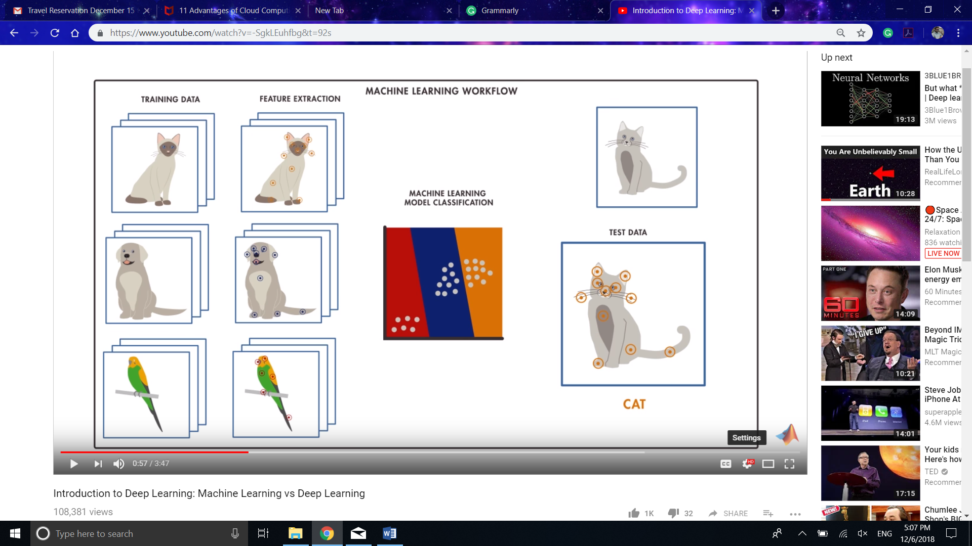Whenever the word “Artificial Intelligence” come up. Most people say that it is made up of machine learning and deep learning. But what we don’t know is that machine learning and deep learning are two separate technologies and follow different ideology and methods. Machine learning and Deep learning can be express in the Venn diagram. Here We can say that Artificial intelligence is the big circle in which Machine learning is inside it and deep learning is inside the machine learning. An example of the difference can be explained by method analysis followed by each of them on identifying an image of the cat when they are inputted in the system. When an application using machine learning is shown cat. It decides based on the feature such as edges and corners which are manually inputted by the coder to train the machine learning model. This model will then classify and analysis these features when a new image is given to it. In this case, it will be pointy ears, facial structure etc. the general structure of obtaining a machine learning model will be by taking an image, then extracting all the features from that image. Then, we add those feature recognitions on the model which can analyze any other image and can predict and describe that object. Now, there are many merits and demerits of using these Machine learning. According to article Advantages and Disadvantages of Machine Learning Language BY DATAFLAIR TEAM · PUBLISHED FEBRUARY 6, 2018: These are the advantage of using machine learning:

• As machine learning has many wide applications. Such as the banking and financial sector, healthcare, retail, publishing etc.

• Google and Facebook are using machine learning to push relevant advertisements. That advertisements are based on user’s past search behavior.

• Machine learning is used to handle multi-dimensional and multi-variety data in dynamic environments.

• Machine learning allows time cycle reduction and efficient utilization of resources.

• If one wants to provide continuous quality, large and complex process environments. There are some tools present because of machine learning.

• As there are too many things that come under the practical benefit of machine learning. Also, they involve the development of autonomous computers, software programs. Hence, it includes processes that can lead to the automation of tasks.

While their advantages of machine learning, there are demerits too which are as follows:

• Machine learning has a major challenge called Acquisition. Also, based on different algorithms data need to be processed. And, it must be processed before providing as input to respective algorithms. Thus, it has a significant impact on results to be achieved or obtained.

• As we have one more term interpretation. That it results is also a major challenge. That need to determine the effectiveness of machine learning algorithms.

• Machine learning does not have any surety that it’s algorithms will always work in every case imaginable. As we have seen that in most cases machine learning fails. Thus, it requires some understanding of the problem at hand to apply the right algorithm.

• Like deep learning algorithm, machine learning also needs a lot of training data. As we can say it might be cumbersome to work with a large amount of data. Fortunately, there are a lot of training data for image recognition purposes.

• One notable limitation of machine learning is its susceptibility to errors. Brynjolfsson and McAfee said that the actual problem with this inevitable fact. That when they do make errors, diagnosing and correcting them can be difficult. As because it will need going through the underlying complexities.

• There are fewer possibilities to make immediate predictions with a machine learning system. Also, don’t forget that it learns through historical data. Thus, the bigger the data and the longer it needs to expose to these data, the better it will perform.

• Lack of variability is another machine learning limitation. Brynjolfsson and McAfee said that machine learning deals with statistical truths. In situations where ML is not included in the historical data, it will be difficult to prove. That the predictions made by this system are suitable for all scenarios.

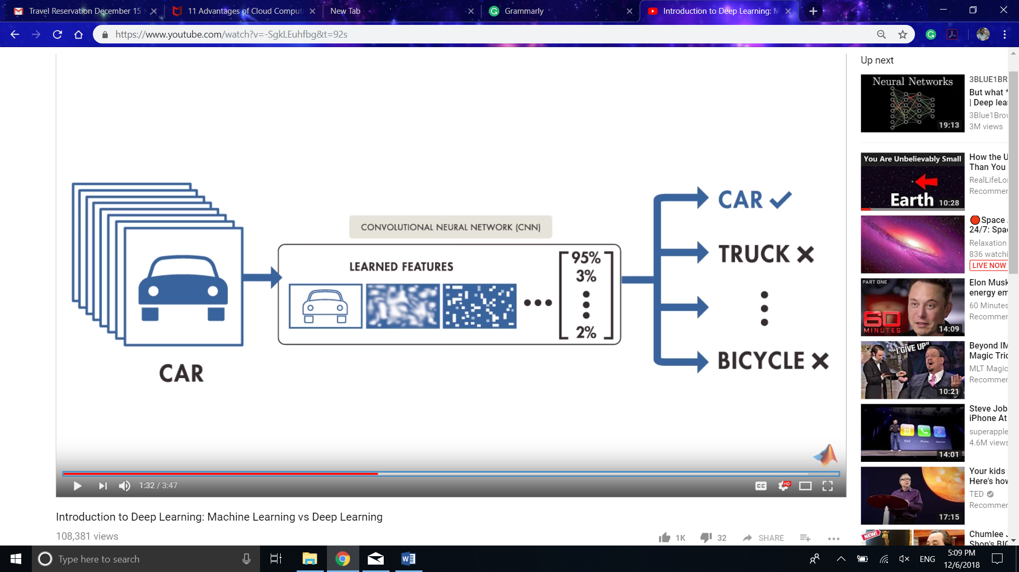But if we see in the case of deep learning, it has a different approach on how the program works. In deep learning the analysis of object is based on the data which is provided to it. Let's take that cat image example again. It looks in data which is loaded in the algorithm and make out the feature on how the cat looks on its own and then gives the result. in this type of learning, accuracy can be increased just by giving the algorithm with more data. According to the article by Quora issued in the year, 2018 following are the merits of deep learning:

• Deep learning reduces the need for feature engineering, one of the most time-consuming parts of machine learning practice.

• Deep learning is an architecture that can be adapted to new problems relatively easily e.g. Vision, time series, language etc., are using techniques like convolutional neural networks, recurrent neural networks, long short-term memory etc.

• Deep learning has best-in-class performance on problems that significantly outperforms other solutions in multiple domains. This includes speech, language, vision, playing games like Go etc. This isn’t by a little bit, but by a significant amount.

Everything comes with its merits and demerits. Following are the demerits of deep learning:

• Deep learning requires a large amount of data — if you only have thousands of examples, deep learning is unlikely to outperform other approaches.

• Deep learning is extremely computationally expensive to train. The most complex models take weeks to train using hundreds of machines equipped with expensive GPUs.

• In Deep learning, what is learned is not easy to comprehend. Other classifiers (e.g. decision trees, logistic regression etc.) make it much easier to understand what’s going on.

A close up of a logo

Description generated with high confidenceOther than using Machine learning and deep learning, these devices need to store the data too. This can be a problem since only those devices can function which have algorithm loaded in its hard drive. Devices which does not have any link to this computer have to download the software can it might consume a lot of space. To avoid this kind of problem, Cloud computing can be used. According to the article published by Cameron Coles At MC AFREE website, these are the advantages of using cloud computing:

1. Fresh Software: the latest versions of the applications needed to run the business are made available to all customers as soon as they’re released

2. Do more with less: With cloud computing, companies can reduce the size of their own data centers — or eliminate their data center footprint altogether.

3. Flexible costs: The costs of cloud computing are much more flexible than traditional methods. Companies only need to commission – and thus only pay for – server and infrastructure capacity as and when it is needed.

4. Always-on availability: Most cloud providers are extremely reliable in providing their services, with many maintaining 99.99% uptime.

5. Improved mobility: Data and applications are available to employees no matter where they are in the world. Workers can take their work anywhere via smartphones and tablets—roaming through a retail store to check customers out, visiting customers in their homes or offices, working in the field or at a plant, etc.

6. Expenses can be quickly reduced: During times of recession or business cut-backs (like the energy industry is currently experiencing), cloud computing offers a flexible cost structure, thereby limiting exposure.

7. Less environmental impact: With fewer data centers worldwide and more efficient operations, we are collectively having less of an impact on the environment. Companies who use shared resources improve their ‘green’ credentials.

But This technology does come with it flows. According to the same article, the Cloud Security Alliance has identified several barriers holding back cloud adoption. At 73% of companies, the security of data is the top concern holding back cloud projects. That’s followed by concern about regulatory compliance (38%), loss of control over IT services (38%), and knowledge and experience of both IT and business managers (34%). As organizations address their security and compliance concerns by extending corporate policies to data in the cloud and invest in closing the cloud skills gap, they can more fully take advantage of the benefits of cloud services.

Well, there are a lot of technology that makes up the Robot Reader, But I think these three are the important one. Technology can have both merits and demerits, but it is upon us to see how we can make use of it so that people all around the world can make use of it. Though currently these machines are just checking and grading your articles and essay, but who know they might even become teachers and started teaching and doing other labor work. When that time we come, we sure will face many people who will be jobless and there might be a lot of controversies at that time. What we can do now is to make sure these technologies and products are used in such a way that it benefits society.

REFERENCES

* <https://www.youtube.com/watch?v=-SgkLEuhfbg&t=92s>
* <https://www.theguardian.com/education/2009/sep/25/robots-to-mark-english-essays>
* <https://www.forbes.com/sites/petergreene/2018/07/02/automated-essay-scoring-remains-an-empty-dream/#29da958974b9>
* <https://medium.com/hubert-ai/ai-in-education-automatic-essay-scoring-6eb38bb2e70>
* <https://slate.com/technology/2012/03/robo-reader-software-to-automatically-grade-student-writing.html>
* Stewart, W. (2009). Essays to be marked by 'robots'.*The Times Educational Supplement,*(4858), 2. Retrieved from <http://proxyau.wrlc.org/login?url=https://search-proquest-com.proxyau.wrlc.org/docview/209484956?accountid=8285>
* <https://www.newsweek.com/robots-can-now-read-better-humans-putting-millions-jobs-risk-781393>
* <https://data-flair.training/blogs/advantages-and-disadvantages-of-machine-learning/>