Linux Basics
DevOps Assignment – Documentation
Name: Samriddhi Mishra
Course: DevOps (Tutedude)
Date: 16 October 2026
GitHub Repository: https://github.com/samriddhi0604/Linux_Basics_Samriddhi_Mishra

Objective
Practise essential Linux command-line operations: file and directory management, viewing files, searching, archiving, downloading, permissions and environment variables.

Environment
- OS: Linux (kernel 6.x, x86_64), Bash shell
- Tools: coreutils, grep, Zip 3.0, UnZip, GNU Wget 1.21.4
- Script: linux_basics.sh in the project folder runs all 12 tasks in order.

Command Summary
# | Task | Command
1 | Create a directory named test_dir | mkdir test_dir
2 | Create an empty file example.txt inside test_dir | touch example.txt
3 | Rename example.txt to renamed_example.txt using mv | mv test_dir/example.txt test_dir/renamed_example.txt
4 | Display the contents of /etc/passwd using cat | cat /etc/passwd
5 | Display only the first 5 lines of /etc/passwd using head | head -n 5 /etc/passwd
6 | Display only the last 5 lines of /etc/passwd using tail | tail -n 5 /etc/passwd
7 | Find all lines containing "root" in /etc/passwd using grep | grep "root" /etc/passwd
8 | Compress test_dir into test_dir.zip using zip | zip -r test_dir.zip test_dir
9 | Unzip test_dir.zip into a new directory named unzipped_dir | unzip test_dir.zip -d unzipped_dir
10 | Download a file from a URL using wget | wget -O sample.txt https://raw.githubusercontent.com/torvalds/linux/master/README
11 | Create secure.txt and make it read-only for everyone using chmod | echo "This file is read-only." > secure.txt
12 | Set environment variable MY_VAR to "Hello, Linux!" using export | export MY_VAR="Hello, Linux!"

1. Creating and Renaming Files/Directories

Task 1: Create a directory named test_dir
Commands:
$ mkdir test_dir
$ ls -ld test_dir
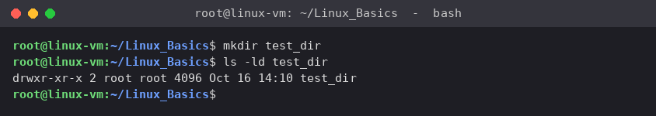
Screenshot: Task 1 (screenshots/task01_mkdir.png)
Explanation:
- mkdir (make directory) creates a new directory named test_dir in the current location.
- ls -ld test_dir is used only to verify: -l shows the long listing and -d lists the directory itself instead of its contents. The leading d in drwxr-xr-x confirms it is a directory.

Task 2: Create an empty file example.txt inside test_dir
Commands:
$ cd test_dir
$ touch example.txt
$ ls -l
$ cd ..
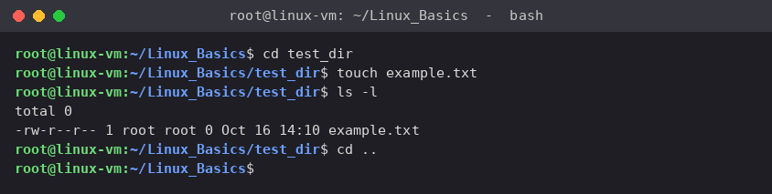
Screenshot: Task 2 (screenshots/task02_touch.png)
Explanation:
- cd test_dir moves into the new directory.
- touch creates an empty file if it does not exist (if it already exists, it only updates its timestamp).
- ls -l shows the file with size 0 bytes, which confirms it is empty. cd .. returns to the parent directory.

Task 3: Rename example.txt to renamed_example.txt using mv
Commands:
$ mv test_dir/example.txt test_dir/renamed_example.txt
$ ls -l test_dir
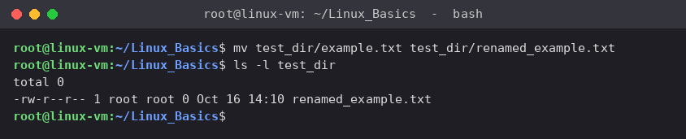
Screenshot: Task 3 (screenshots/task03_mv.png)
Explanation:
- mv (move) moves a file from a source path to a destination path. When the destination is in the same directory with a different name, the file is simply renamed.
- The listing now shows only renamed_example.txt; example.txt no longer exists.

2. Viewing File Contents

Task 4: Display the contents of /etc/passwd using cat
Commands:
$ cat /etc/passwd
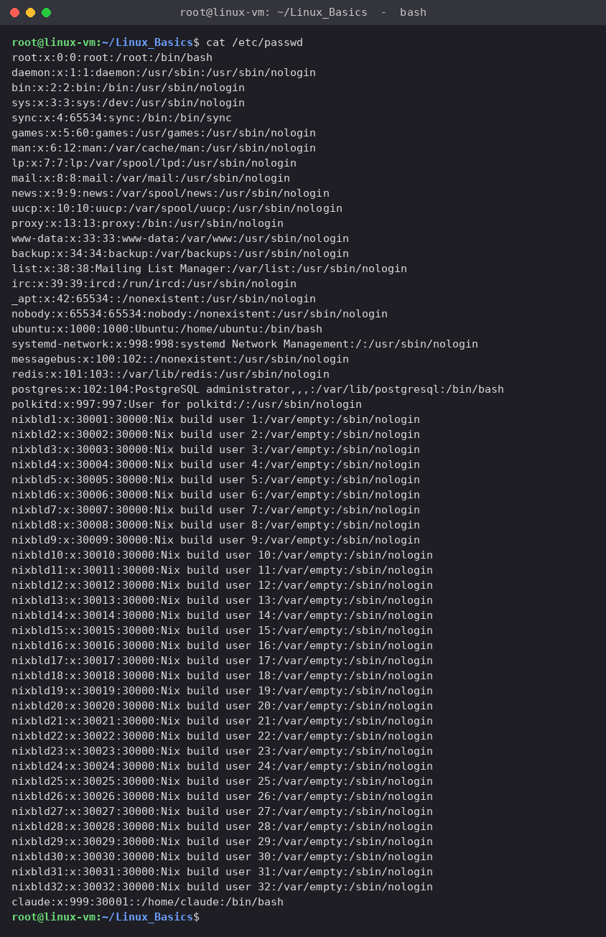
Screenshot: Task 4 (screenshots/task04_cat.png)
Explanation:
- cat (concatenate) prints the entire contents of a file to the terminal.
- /etc/passwd stores one line per user account with 7 colon-separated fields: username:password:UID:GID:comment:home_directory:login_shell. The password field shows x because actual password hashes are kept in /etc/shadow.

Task 5: Display only the first 5 lines of /etc/passwd using head
Commands:
$ head -n 5 /etc/passwd
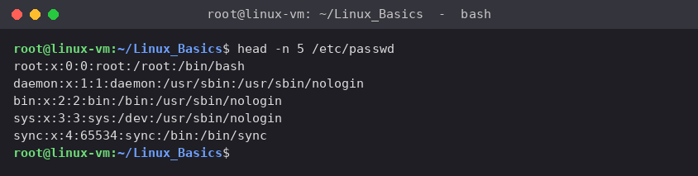
Screenshot: Task 5 (screenshots/task05_head.png)
Explanation:
- head prints the beginning of a file. -n 5 limits the output to the first 5 lines (by default head prints 10).
- The first line is always the root account (UID 0).

Task 6: Display only the last 5 lines of /etc/passwd using tail
Commands:
$ tail -n 5 /etc/passwd
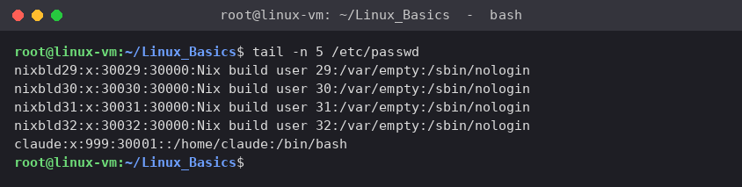
Screenshot: Task 6 (screenshots/task06_tail.png)
Explanation:
- tail prints the end of a file. -n 5 shows only the last 5 lines. Newly created user accounts are usually appended at the end of this file.
- tail -f is also commonly used in DevOps to follow log files live as they grow.

3. Searching for Patterns

Task 7: Find all lines containing "root" in /etc/passwd using grep
Commands:
$ grep "root" /etc/passwd
$ grep -n --color=never "root" /etc/passwd
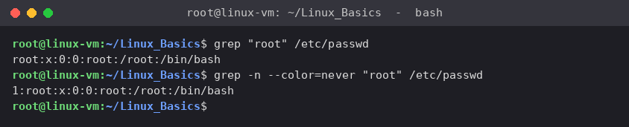
Screenshot: Task 7 (screenshots/task07_grep.png)
Explanation:
- grep searches a file line by line and prints every line that matches the given pattern.
- The second command adds -n to also print the line number of each match (line 1). On this system only one line contains "root"; on other systems you may also see lines such as the operator account whose home directory is /root.

4. Zipping and Unzipping

Task 8: Compress test_dir into test_dir.zip using zip
Commands:
$ zip -r test_dir.zip test_dir
$ ls -l test_dir.zip
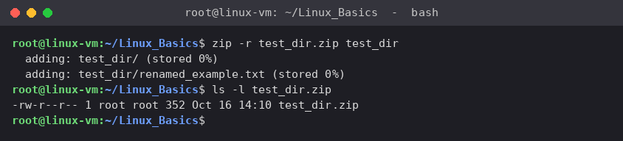
Screenshot: Task 8 (screenshots/task08_zip.png)
Explanation:
- zip creates a compressed archive. The first argument is the archive name and the rest are the files to add.
- -r (recursive) is required for a directory, so that the directory and everything inside it are included. Without -r only the empty directory entry would be added.

Task 9: Unzip test_dir.zip into a new directory named unzipped_dir
Commands:
$ unzip test_dir.zip -d unzipped_dir
$ ls -lR unzipped_dir
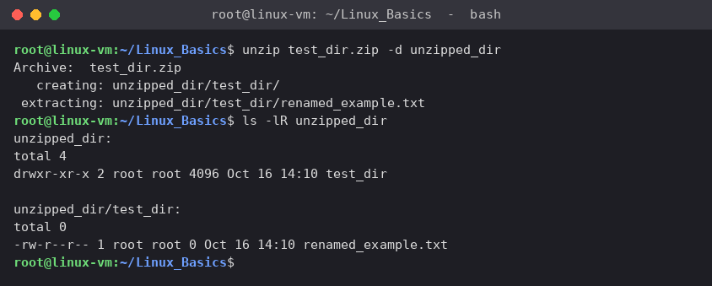
Screenshot: Task 9 (screenshots/task09_unzip.png)
Explanation:
- unzip extracts an archive. -d unzipped_dir sets the destination directory; it is created automatically if it does not exist.
- ls -lR lists the directory recursively and confirms unzipped_dir/test_dir/renamed_example.txt was restored.

5. Downloading Files

Task 10: Download a file from a URL using wget
Commands:
$ wget -O sample.txt https://raw.githubusercontent.com/torvalds/linux/master/README
$ ls -l sample.txt
$ head -n 5 sample.txt
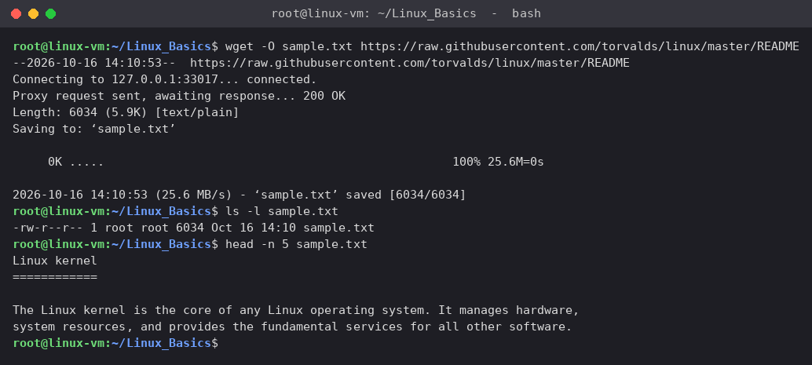
Screenshot: Task 10 (screenshots/task10_wget.png)
Explanation:
- wget downloads files from the web over HTTP, HTTPS or FTP from the command line. -O sample.txt saves the download under the name sample.txt.
- The URL in the assignment (https://example.com/sample.txt) is only an example and the file did not download in my environment, so a real public text file (the Linux kernel README on GitHub) was used. The output 200 OK and saved [6034/6034] confirm a successful download.

6. Changing Permissions

Task 11: Create secure.txt and make it read-only for everyone using chmod
Commands:
$ echo "This file is read-only." > secure.txt
$ ls -l secure.txt
$ chmod 444 secure.txt
$ ls -l secure.txt
$ stat -c '%A %a %n' secure.txt
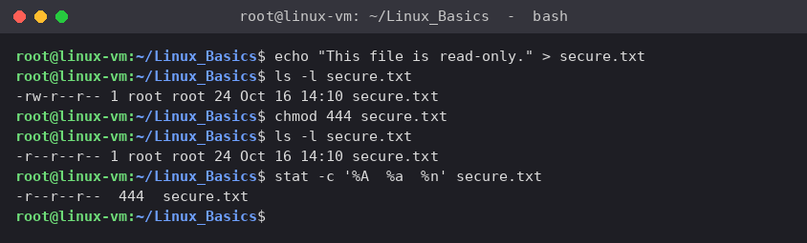
Screenshot: Task 11 (screenshots/task11_chmod.png)
Explanation:
- The file is created with echo ... > and starts with permissions -rw-r--r-- (644).
- chmod 444 sets permissions using octal notation: each digit is for owner, group and others, where 4 = read, 2 = write, 1 = execute. 444 means read only for all three. The symbolic equivalent is chmod a=r secure.txt.
- After the change, ls -l shows -r--r--r-- and stat confirms 444. Note: the root user can still override file permissions, so the restriction is fully enforced for normal users.

7. Working with Environment Variables

Task 12: Set environment variable MY_VAR to "Hello, Linux!" using export
Commands:
$ export MY_VAR="Hello, Linux!"
$ echo $MY_VAR
$ printenv MY_VAR
$ env | grep MY_VAR
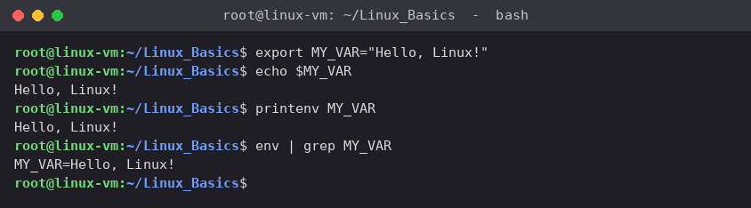
Screenshot: Task 12 (screenshots/task12_export.png)
Explanation:
- export creates the variable and marks it as an environment variable, so it is passed to every program started from this shell. Quotes are needed because the value contains a space and a comma.
- echo $MY_VAR, printenv MY_VAR and env | grep MY_VAR all confirm the value.
- The variable lasts only for the current terminal session. To make it permanent, add the export line to ~/.bashrc and run source ~/.bashrc.

Project Files
- linux_basics.sh – Bash script that performs all 12 tasks
- screenshots/ – Terminal screenshots for every task
- output_files/ – Files produced by the tasks: test_dir, test_dir.zip, unzipped_dir, sample.txt, secure.txt
- README.md – Project overview and how to run
- GitHub_Repository_Link.txt – Link to the GitHub repository

GitHub Repository
https://github.com/samriddhi0604/Linux_Basics_Samriddhi_Mishra

Conclusion
All 12 tasks were completed successfully. The assignment covered creating and renaming files and directories (mkdir, touch, mv), viewing files (cat, head, tail), searching text (grep), archiving (zip, unzip), downloading from the web (wget), managing permissions (chmod) and setting environment variables (export). These commands are the foundation of day-to-day DevOps work such as inspecting servers, reading logs, packaging artefacts and configuring applications.

