News Front Page – Documentation (Part B, C & D)

PART B – EXPLANATION & DOCUMENTATION

1. Design Document

Wireframe / Structural Layout

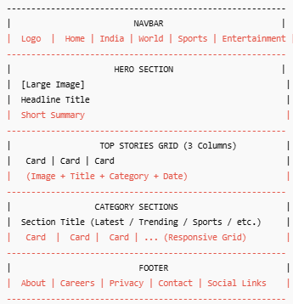

Layout Decisions
• Desktop uses a 3‑column grid.
• Tablet uses 2‑columns.
• Mobile uses single column.
• Hero is highlighted using larger typography and banner image.
• Category sections improve readability and content grouping.

Data-Fetching Strategy
Used Next.js Server Components with fetch().
Reasons:
• Ensures fresh news using no-store cache.
• Better SEO performance.
• Faster initial page load.
Trade-offs:
• Slightly higher server load.
• But required for real-time news updates.

2.Code Explanation

Components Created:

• Navbar.jsx – Navigation bar
• Hero.jsx – Main headline display
• NewsCard.jsx – Reusable article card
• CategorySection.jsx – Section-based grouping
• Footer.jsx – Footer links and info
• Loading.jsx – Skeleton loading state
• Error.jsx – Error fallback screen

Data Model Structure:
Article object contains: id, title, summary, image, date, category.

Challenges & Solutions:
Tailwind not compiling → Fixed config paths.
2. Missing API fields → Added placeholder images & text.
3. Layout issues on mobile → Applied responsive grids.
4. AI code inconsistencies → Cleaned manually and optimized.

Improvements (Future Scope)
• Infinite scroll
• Dark mode
• Better loaders
• Search & filters
• Live API integration

PART C – TESTING & EDGE CASES

Test Scenarios:
Missing image → Shows fallback.
2. No articles → 'No news available' UI.
3. Long titles → line‑clamp prevents overflow.
4. API failure → Renders error UI.
5. Slow network → Displays skeleton loader.

PART D – AI USE & REFLECTION

Where AI Helped:
• Boilerplate code generation
• Component layout suggestions
• Tailwind utility hints
• Wireframe guidance

Where AI Was Incorrect:
• Wrong Tailwind paths
• Suggested invalid classes sometimes
• Added unnecessary wrapper divs

Verification Process:
• Manually tested UI
• Verified Tailwind docs
• Debugged API responses
• Removed redundant AI-generated code

Custom Implementation Beyond AI:
• Improved spacing and responsiveness
• Implemented fallback states
• Optimized user experience for mobile
• Final styling refined manually

