Game Design Document

Fill up the Following document

1. Write the title of your project.

Ludo Star

1. What is the goal of the game?

To win from others

1. Write a brief story of your game?

There is a boy named Rohan and he want to play with his friends but they cannot meet because of lockdown so he planned to create ludo star to play with his friends but he not a good coder so told me to create it.

Four players can play this game.

1. Which are the playing characters of this game?

* Playing characters are the ones which respond to the user based on the input from the user
* Cars, monkeys, dinos, wizards etc, are the playing characters in the game.

|  |  |  |
| --- | --- | --- |
| Number | Character Name | What can this character do? |
| 1 | Rohan and his friends and many more. | They can roll dice.  Move their rider on their own but for the certain times or distance. |
| 2 |  |  |
| 3 |  |  |
| 4 |  |  |
| 5 |  |  |
| 6 |  |  |
| 7 |  |  |
| 8 |  |  |

1. Which are the Non Playing Characters of this game?

* Non Playing characters are the ones which do not have an action or a behaviour when the user interacts with the game.
* Hurdles, stones, bananas, coins, etc are non playing characters in the game.

|  |  |  |
| --- | --- | --- |
| Number | Character Name | What can this character do? |
| 1 | dice | It gives the no. to move the riders |
| 2 |  |  |
| 3 |  |  |
| 4 |  |  |
| 5 |  |  |
| 6 |  |  |
| 7 |  |  |
| 8 |  |  |

Draw your imagination of this game. What does this game look like?

* Draw the game either on your computer or on paper,
* Add images of scenes of the game to show each of the playing and non-playing characters at least once.

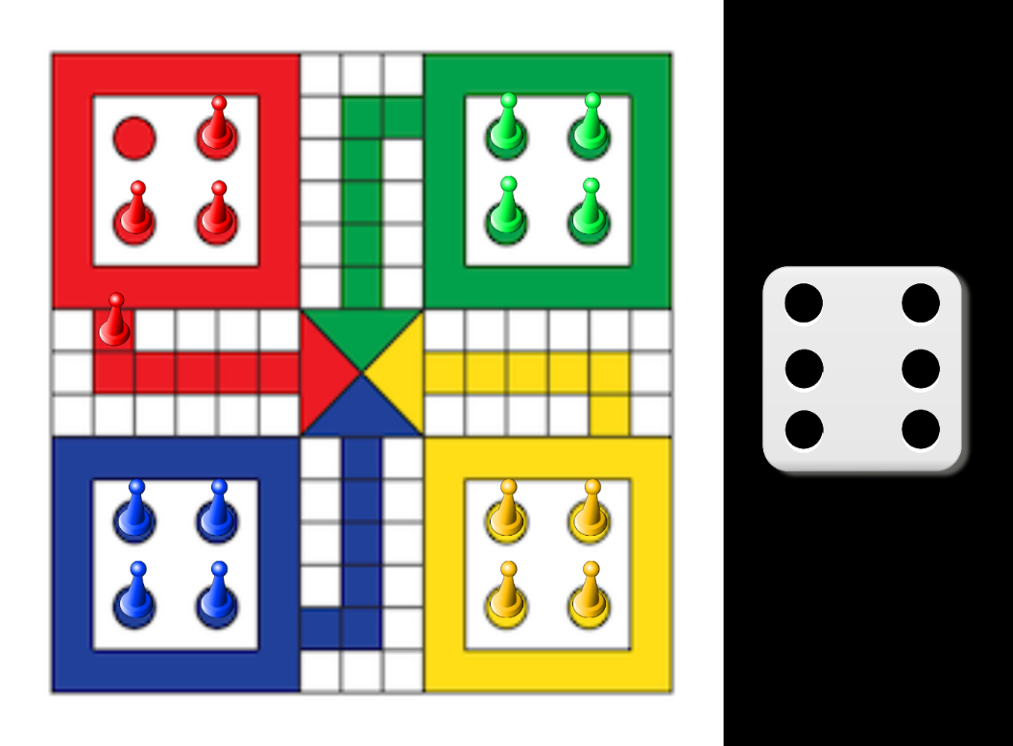

How do you plan to make your game engaging?

This game is played by four persons in this game they can cut each other’s rider. If one player reaches the house the game will not end until the third player reaches and the fourth player is left.