Software Requirements Specification

for

Online Portal for University Students

Version 1.0 approved

Prepared by Samridh Anand, Sakshi S, Shaurya Kabra, Samarth S I

Group number 8

Date created: 9th September 2023

Table of Contents

Table of Contents 2

Revision History 3

Introduction 4

Purpose 4

Intended Audience 4

Product Scope 4

References 4

Overall Description 4

Product Perspective 4

Product Functions 5

User Classes and Characteristics 6

Operating Environment 7

Design and Implementation Constraints 7

2.6 Assumptions and Dependencies 8

External Interface Requirements 9

User Interfaces 9

Software Interfaces 9

Communications Interfaces 9

Analysis Models 9

System Features 10

Online Payments 10

PESU Forums 11

Lecture Materials 11

Exam Results 12

Attendance 13

Other Nonfunctional Requirements 14

Performance Requirements 14

Safety Requirements 14

Security Requirements 14

Software Quality Attributes 14

Business Rules 14

Other Requirements 14

Appendix A: Glossary 14

Appendix B: Field Layouts 15

Appendix C: Requirement Traceability Matrix 16

Revision History

|  |  |  |  |
| --- | --- | --- | --- |
| **Name** | **Date** | **Reason For Changes** | **Version** |
|  |  |  |  |
|  |  |  |  |

# Introduction

## Purpose

We are thrilled to present the Software Requirements Specification (SRS) for our ambitious project—an Online Portal tailored specifically for university students. The purpose of this document is to comprehensively outline the software requirements for the development of the Online Portal. It serves as a crucial reference for developers, project managers, testers, and all stakeholders involved in the project. This SRS details the system's functionalities, user interfaces, and external interfaces, ensuring a clear understanding of the project's scope and goals.

## Intended Audience

This document is intended for a diverse audience, including:

Developers: Who will use this document as a guide for designing and implementing the software.

Project Managers: Who will use it for project planning, resource allocation, and tracking progress.

Testers: Who will rely on this document to create test cases and validate the system's functionality.

Users: University students, faculty, and administrators who will interact with the Online Portal.

Documentation Writers: Who will use this document as a reference for creating user manuals and other documentation.

## Product Scope

The Online Portal is envisioned as a one-stop platform designed to meet the following objectives:

Simplified Access: To provide university students with simplified access to crucial university services and information.

Enhanced User Experience: To create a user-friendly and intuitive interface for students, faculty, and administrators.

Incremental Development: To adopt an incremental development model, allowing flexibility to add new features and functionalities as requirements evolve.

Functional Features: To offer a set of essential features including online payments, discussion forums, lecture material access, exam results, announcements, and attendance tracking.

This project will enhance the existing PESU academy website, ensuring that it aligns with the evolving needs of the university community. By centralizing these services, we aim to streamline administrative processes, improve communication, and enhance the overall educational experience for our users.

## References

1. IEEE. IEEE Std 830-1998 IEEE Recommended Practice for Software Requirements Specifications. IEEE Computer Society, 1998.

# Overall Description

## Product Perspective

**Context and Origin:**

The Online Student Portal is a standalone software product created to serve the needs of university students. It is developed as a new and comprehensive solution to address the challenges and demands of modern higher education. The origin of this product stems from the recognition of the importance of having a centralized, user-friendly platform for university students to access essential services and information. Traditional university administrative processes and communication methods were often fragmented and paper-based. The Online Student Portal aims to modernize and simplify these processes, making it easier for students to interact with their university and access vital resources.

**Relation to Larger System:**

While the Online Student Portal is a self-contained product, it may interact with other systems and components within the larger university ecosystem. Some potential interfaces and relationships include:

1. **Integration with SIS:** The portal might connect with the university's SIS to synchronize student data, course schedules, and grades. This integration ensures that student information is up-to-date and accurate.
2. **Authentication Services:** The portal may rely on the university's authentication system for secure login and user verification. This ensures that only authorized users can access the portal.
3. **Payment Gateways:** For online payments, the portal might interface with payment gateways to facilitate secure transactions.

## Product Functions

1. User Authentication and Registration: Allow users (students, faculty, and administrators) to register for accounts. Authenticate users securely to access the portal's features.
2. Online Payments: Enable users to make online payments for various fees (e.g., tuition, exam, hostel). Provide administrators with a payment tracking system.
3. PESU Forums: Offer a discussion platform where students can engage in discussions. Support threaded discussions for organized conversations.
4. Lecture Material Access: Allow students to view and download lecture materials like notes and slides. Permit faculty to upload and manage study materials.
5. Exam Results: Enable students to check their exam results and provide result analysis. Display seating information for examinations.
6. Notifications and Announcements: Provide a section for important announcements from departments and clubs.
7. Attendance Tracker: Allow faculty to update and manage attendance records for classes. Enable students to monitor their attendance.

These functions collectively ensure that the Online Student Portal serves as a comprehensive platform for students, faculty, and administrators to access essential university services and information efficiently. Detailed requirements for each of these functions will be provided in Section 3 of the SRS.

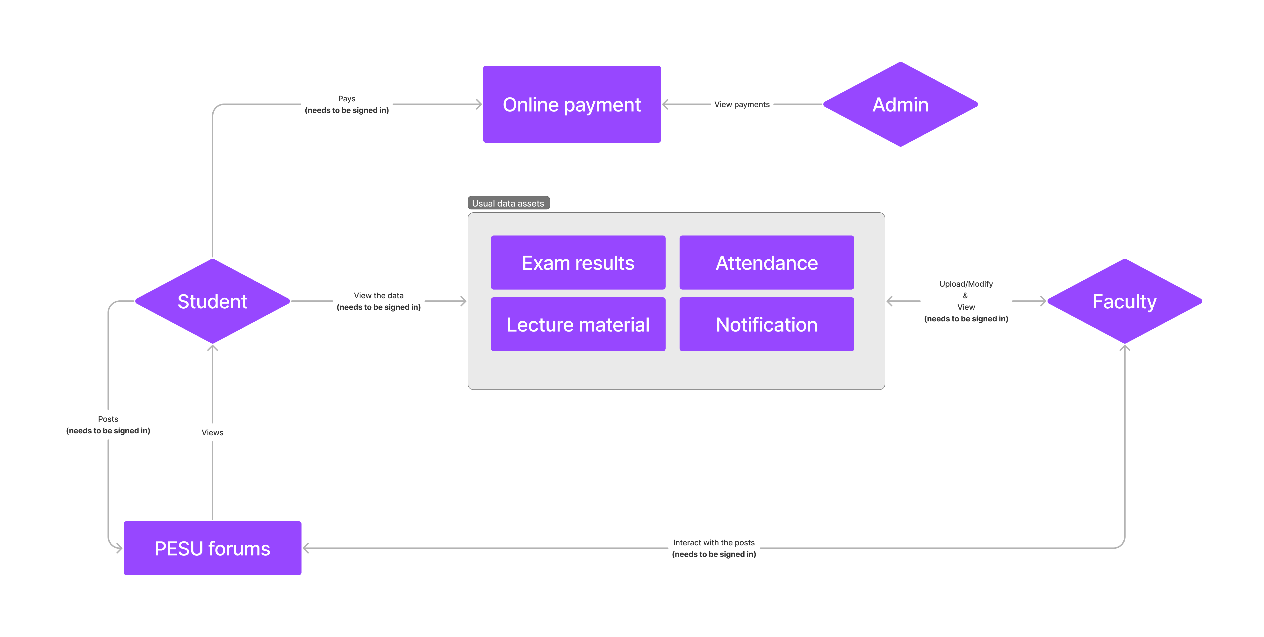

## User Classes and Characteristics

1. University Students:

* Frequency of Use: Regular and frequent use throughout their academic journey.
* Characteristics: Varying technical expertise, ranging from tech-savvy to less tech-savvy students. Diverse educational backgrounds and levels.

1. Faculty Members:

* Frequency of Use: Frequent use for administrative tasks and course management.
* Characteristics: Typically have a higher level of technical expertise. Responsible for uploading study materials, updating attendance, and accessing student-related data.

1. University Administrators:

* Frequency of Use: Frequent use for managing university processes and announcements.
* Characteristics: High level of technical expertise in managing the portal. Responsible for overseeing payment tracking and announcements.

1. System Administrators:

* Frequency of Use: Occasional use for system maintenance and troubleshooting.
* Characteristics: High technical expertise in system administration, responsible for maintaining the portal's functionality and security.

1. Guest Users (Prospective Students and Visitors):\

* Frequency of Use: Occasional use to explore the university's offerings.
* Characteristics: May have limited technical expertise. Access to certain information without the need for user registration.

It's important to note that while students are the primary users, faculty members and university administrators also play critical roles in managing and maintaining the portal. Therefore, ensuring that the portal meets the needs of these user classes is essential for its success. Additionally, guest users, department heads, club administrators, and technical support staff interact with the system to varying degrees, and their requirements should also be considered to provide a well-rounded user experience.

## Operating Environment

As this client side of this portal is a web application it does not require special hardware support, any device with access to a stable internet connection and a modern updates browser (Chrome, Safari, Firefox, Brave and etc) should be able to take advantages the portal has to offer. The portal will be responsive and hence can be accessed on device of any screen size.

The server would be running on Ubuntu server. The server OS needs to be installed on a device that has enough computational power to handle hundreds of requests per second.

## Design and Implementation Constraints

The design and implementation of the Online Student Portal are subject to several constraints and considerations that will influence the development process. These constraints may include:

1. Regulatory Compliance: The software must comply with relevant data privacy regulations (such as GDPR, HIPAA, or local data protection laws) and any other legal requirements that apply to educational institutions and student data.
2. Security Requirements: Security is paramount, and the software must adhere to rigorous security standards to protect sensitive student and administrative data. This includes secure authentication, data encryption, and protection against common web vulnerabilities.
3. Hardware and Performance: The software should be designed to run efficiently on a range of hardware configurations and network conditions, considering factors like bandwidth and latency. It must also accommodate scalability to handle increased user loads.
4. Compatibility: As mentioned earlier, the Online Student Portal should be compatible with various web browsers, operating systems, and devices to ensure accessibility for a diverse user base.
5. Database Compatibility: If specific database systems are required, compatibility with those systems (e.g., MySQL, PostgreSQL) should be ensured.
6. Integration with External Systems: The software may need to integrate with other university systems, such as SIS or LMS. Ensuring smooth and reliable integration is a constraint.
7. User Interface Design: The user interface should follow established design conventions and accessibility standards to ensure usability for all users, including those with disabilities.
8. Parallel Operations: The system should handle parallel operations efficiently, especially during peak usage times like course registration periods or exam result announcements.
9. Communication Protocols: The software must define and adhere to communication protocols for various functionalities, including email notifications, messaging, and data synchronization with external systems.
10. Documentation and Maintenance: Consideration should be given to providing comprehensive documentation for the software's architecture, codebase, and maintenance procedures. It's important to determine whether the customer's organization or development team will be responsible for maintaining the software after deployment.
11. Testing and Quality Assurance: Rigorous testing, including unit testing, integration testing, and user acceptance testing, should be conducted to identify and rectify issues early in the development process.
12. Budget and Resource Constraints: The project may have budget and resource limitations that affect the scope and timeline of development.

Addressing these constraints and considerations in the design and implementation phases is crucial for the successful development and deployment of the Online Student Portal, ensuring that it meets regulatory requirements, functions securely, and provides a positive user experience.

## 2.6 Assumptions and Dependencies

Assumptions:

1. Third-Party Components: It is assumed that the project will rely on certain third-party components, such as web development frameworks, libraries, and possibly commercial software for specific functionalities. The availability, compatibility, and reliability of these components are assumed to meet project requirements.
2. Data Availability: The project assumes that the necessary student and university data required for the Online Student Portal will be available and accessible through existing systems, such as the SIS and LMS
3. User Engagement: It is assumed that students, faculty, and administrators will actively engage with the Online Student Portal, utilizing its features and providing feedback for continuous improvement.

Dependencies:

1. External Systems Integration: The project is dependent on successful integration with external systems, such as the SIS and LMS. Delays or issues in integrating with these systems could impact project timelines.
2. Database Management System: The choice and availability of the database management system (DBMS) for storing data is a dependency. Any changes or issues with the selected DBMS may affect data storage and retrieval.
3. Web Hosting and Infrastructure: The availability and reliability of web hosting infrastructure, including servers and network resources, are dependencies for the online portal's performance and availability.
4. Third-Party Services: If the project relies on third-party services for specific functionalities (e.g., payment gateways), the availability and stability of these services are crucial dependencies.
5. Regulatory Changes: Any changes in data privacy or security regulations during the project's development may require adjustments to meet new compliance standards.

# External Interface Requirements

## User Interfaces

Student Portal Interface: The primary user interface will be the web-based portal accessible to university students. It should have an intuitive and user-friendly design with the following characteristics:

* GUI Standards: Follow modern web design principles for responsiveness, accessibility, and user experience.
* Screen Layout: Ensure a consistent layout across all pages with a header containing navigation links, a content area, and a footer.
* Standard Buttons and Functions: Include standard web functions such as 'Log In,' 'Log Out,' 'Search,' 'Help,' 'Contact Us,' and 'Profile.'
* Error Message Display: Define a standard format for displaying error messages to users.

Faculty and Admin Interface: Faculty and administrative staff will have a separate interface for managing announcements, tracking payments and uploading study materials. This interface should be designed with simplicity and efficiency in mind, allowing easy content management.

## Software Interfaces

* Database Interface: The software will interact with a database system to store and retrieve user data, payment records, lecture materials, exam results, attendance data, and forum discussions. MongoDB database will be used for all database concerned operations .
* Payment Gateway Integration: To facilitate online payments, the system will interface with payment gateways, including net banking, debit/credit card processors, and UPI payment systems. All payments will be done via existing payment gateway such as RazorPay, PayU and etc.
* Integration with Faculty Systems: Faculties will be allowed to upload lecture resources to database, give attendance to specific set of students and view desired student records. All the data will be generated all the requested data will be generated on the server and sent to the client device

## Communications Interfaces

* Email Notifications: The system will send email notifications to users for various events such as payment receipts, new forum posts, exam results, and important announcements, these (except payment reciepts) will also be reflected in the notification area on the portal
* Web Browser Compatibility: Ensure that the system is compatible with standard web browsers (e.g., Chrome, Firefox, Safari) and specify any browser-specific considerations, the web portal should be responsive.
* Network Server Communications: HTTP protocol will be used for all communication between browser and web server during the development phase
* Security and Encryption: HTTPS will enabled by adding SSL certificate during production.

# Analysis Models

Following is the use case diagram of the system

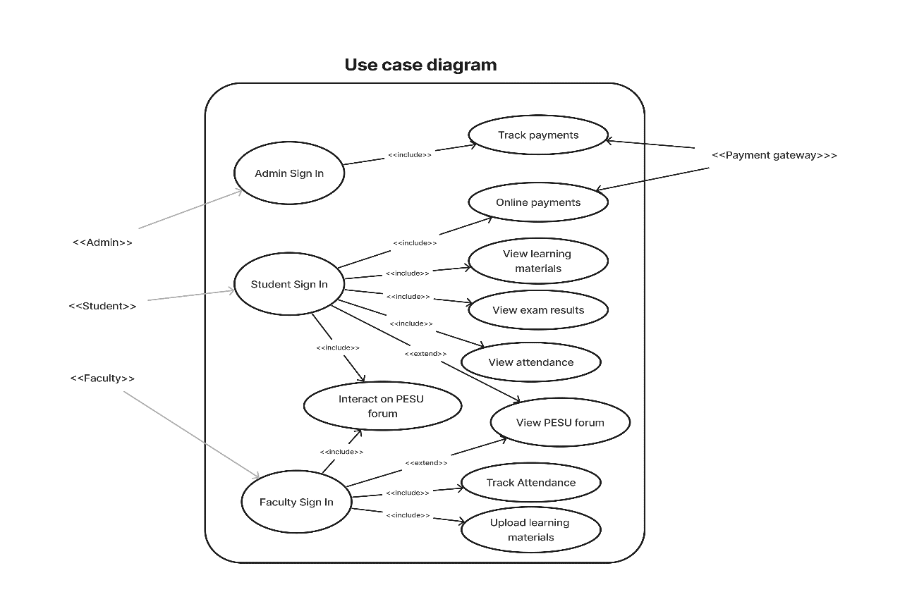

# System Features

## Online Payments

**Description and Priority:**

This feature allows users, primarily university students, to make online payments for various university fees, including exam fees, tuition fees, hostel fees, and miscellaneous fees. It is of high priority due to its critical role in the user's financial transactions and administrative tracking.

**Stimulus/Response Sequences:**

User selects the type of fee payment (e.g., exam, tuition) and payment mode (e.g., net banking, debit/credit card, UPI).

User enters payment details, including amount, payment method, and personal information.

System validates payment information.

If valid, the system processes the payment and provides a payment receipt.

If invalid, the system displays an error message and prompts the user to correct the information.

**Functional Requirements:**

REQ-1: The system shall provide a user-friendly interface for fee payment, allowing users to select the type of fee and payment method.

REQ-2: The system shall securely process payment information, including encryption of sensitive data.

REQ-3: Payment processing shall include validation checks to prevent incorrect payments.

REQ-4: Upon successful payment, the system shall generate and display a payment receipt with transaction details.

REQ-5: In case of payment failure, the system shall display a clear error message and guide the user to correct the issue.

## PESU Forums

**Description and Priority:**

This feature enables students to engage in open discussions on various topics within PESU forums. It also allows students to reply to discussions in a threaded format. This feature is of medium priority as it enhances student engagement and community building.

**Stimulus/Response Sequences:**

User selects a forum topic or starts a new discussion.

User writes a discussion post.

User can view and reply to existing discussions.

System displays posts in a threaded format, allowing users to follow conversations easily.

**Functional Requirements:**

REQ-1: The system shall provide a user-friendly interface to access PESU forums, allowing users to browse existing topics and start new discussions.

REQ-2: Users shall be able to create, edit, and delete their forum posts.

REQ-3: The system shall organize forum discussions in a threaded format for clear conversation flow.

REQ-4: Users shall have the option to subscribe to specific forum topics for notifications of new posts.

## Lecture Materials

**Description and Priority:**

This feature enables users to view and download lecture materials, including notes and slides. Faculty members can upload study materials for their respective courses. It is of high priority as it directly supports the learning process.

**Stimulus/Response Sequences:**

User selects a course or subject.

User browses available lecture materials.

User clicks on a material to view or download it.

Faculty members upload lecture materials to specific course pages.

**Functional Requirements:**

REQ-1: The system shall provide an organized repository for lecture materials, categorizing them by courses and subjects.

REQ-2: Users shall be able to view lecture materials in a user-friendly format directly on the platform.

REQ-3: Users shall have the option to download lecture materials in common file formats (e.g., PDF, PowerPoint).

REQ-4: Faculty members shall be able to upload lecture materials to designated course pages.

## Exam Results

**Description and Priority:**

This feature allows students to check their exam results on the online portal. It also provides an analysis compared to previous exams and includes seating information. It is of high priority as it directly impacts students' academic progress tracking.

**Stimulus/Response Sequences:**

User selects the exam for which they want to view results.

User enters their credentials to access the results.

System retrieves and displays the exam results, including marks obtained and analysis.

System provides a seating chart or seating information related to the exam.

**Functional Requirements:**

REQ-1: The system shall provide a secure login mechanism for students to access their exam results.

REQ-2: Users shall be able to select the specific exam they wish to view results for.

REQ-3: The system shall retrieve and display exam results, including marks, grade, and percentage.

REQ-4: The system shall generate and display an analysis of the student's performance compared to previous exams.

REQ-5: For specific exams, the system shall provide seating information, including the student's seat number.

## Attendance

**Description and Priority:**

This feature allows teachers to update attendance for their respective classes, and students can keep track of their attendance records. It is of medium priority as it aids in both academic monitoring and student engagement.

**Stimulus/Response Sequences For Teachers:**

Teacher selects the class and date.

Teacher marks students as present or absent.

System saves the attendance record.

**For Students:**

Student logs in to the portal.

Student navigates to the attendance tracker.

System displays the student's attendance record.

**Functional Requirements For Teachers:**

REQ-1: The system shall provide teachers with a user-friendly interface to mark attendance for their classes.

REQ-2: Teachers shall be able to select the class and date for which they want to record attendance.

REQ-3: The system shall allow teachers to mark students as present or absent and save the attendance record securely.

**For Students:**

REQ-4: The system shall provide students with access to their attendance records.

REQ-5: Students shall be able to view their attendance history for each class they are enrolled in.

REQ-6: The system shall display attendance data in a clear and organized format, showing the number of classes attended and total classes held.

# Other Nonfunctional Requirements

## Performance Requirements

* Response Time: The system should respond to user requests within 2 seconds for standard operations (e.g., logging in, accessing course materials) to ensure a smooth user experience.
* Scalability: The system should be able to handle a concurrent user load of at least 5,000 users without significant performance degradation during peak times.

## Safety Requirements

* Data Integrity: Ensure that student data, including personal information and academic records, is stored securely to prevent unauthorized access, data breaches, or tampering.
* Backup and Recovery: Implement regular automated backups and establish a disaster recovery plan to ensure minimal data loss and system downtime in case of unexpected events.

## Security Requirements

* Authentication: Users must authenticate using a strong username and password combination or two-factor authentication (2FA) to access sensitive information.
* Data Encryption: All data transmitted over the network, especially sensitive data like grades and financial information, should be encrypted using industry-standard protocols.
* Compliance: The portal must adhere to relevant data protection regulations, such as GDPR, FERPA, or HIPAA, depending on the type of data being handled.

## Software Quality Attributes

* Usability: The user interface should be intuitive and user-friendly.
* Reliability: The system should have a high uptime to ensure uninterrupted access for students and faculty.
* Maintainability: Code should be well-documented and adhere to coding standards to facilitate future maintenance and updates.
* Interoperability: The system should integrate seamlessly with existing university systems, such as the student information system and learning management system.

## Business Rules

* Role-Based Access: Define role-based access controls, ensuring that only authorized individuals (students, faculty, administrators) can perform specific actions based on their roles.

# Other Requirements

* Database Requirements: Data model, storage, migration strategy.
* Data Backup and Disaster Recovery: Backup strategy, disaster recovery plan.
* Project Constraints: Budget and timeline constraints.

Appendix A: Glossary

1. HTTP (Hypertext transfer protocol): Application layer protocol to transfer data between client and server
2. HTTPS (Hypertext transfer protocol secure): Application layer protocol to transfer data between client and server, with an extra layer of security that is achieved using encryption.
3. LMS (Learning management system): a software application for the administration, documentation, tracking, reporting, automation, and delivery of educational courses, training programs, materials or learning and development programs.
4. SIS (Student information system): software or student administration system is a management information system for education sector establishments used to manage student data.

Appendix B: Field Layouts

An Excel sheet containing field layouts and properties/attributes and report requirements.

**Sheet with information required to authenticate the user**

|  |  |  |  |  |
| --- | --- | --- | --- | --- |
| **Field** | **Length** | **Data Type** | **Description** | **Is Mandatory** |
| SRN/Email | 20 | Alphanumeric | User’s USN or Email | Y |
| Password | 15 | Alphanumeric Any alphanumeric value | | Y |
|  |  |  |  |  |
|  |  |  |  |  |
|  |  |  |  |  |
|  |  |  |  |  |
|  |  |  |  |  |
|  |  |  |  |  |
|  |  |  |  |  |
|  |  |  |  |  |

**Sheet with information required to post on Forum:**

|  |  |  |  |  |
| --- | --- | --- | --- | --- |
| Field | Length | Data type | Description | Is Mandatory |
| SRN | 13 | Alphanumeric | User’s USN | Y |
| Name | 20 | Alphabets | User’s Name | Y |
| Data | 200 | Alphanumeric | User’s interaction on the forums | Y |
| IsComment | 1 | Boolean | Whether it is a post or a comment | Y |
| Timestamp | 20 | Date | Date and Time of posting | Y |
| Tags | 15 | Alphabet | To categorize posts | N |

**Sheet with information required to view user’s attendance:**

|  |  |  |  |  |
| --- | --- | --- | --- | --- |
| Field | Length | Data type | Description | Is Mandatory |
| SRN | 13 | Alphanumeric | Student’s USN | Y |
| Name | 20 | Alphabets | Student’s Name | Y |
| Date | 20 | Alphanumeric | Date of entry | Y |
| IsPresent | 1 | Boolean | Whether user was present or not | Y |
|  |  |  |  |  |

**Sheet with information required to view course materials:**

|  |  |  |  |  |
| --- | --- | --- | --- | --- |
| Field | Length | Data type | Description | Is Mandatory |
| Subject code | 12 | Alphanumeric | Subject code | Y |
| Sem | 1 | Numeric | Semester the course is present in | Y |
| Unit | 1 | Numeric | Unit’s number | Y |
| Name | 20 | Alphanumeric | Name of resource | Y |
| Type | 5 | Alphabet | To get a pdf or video | Y |

**Sheet with information required to view exam result:**

|  |  |  |  |  |
| --- | --- | --- | --- | --- |
| Field | Length | Data type | Description | Is Mandatory |
| SRN | 13 | Alphanumeric | User’s USN | Y |
| Name | 20 | Alphabets | User’s Name | Y |
| Course Id | 12 | Alphanumeric | Subject’s code | Y |
| Exams | 3 | Alphabet | Whether it is a ISA or ESA | Y |
| Result | 20 | Numeric | Mark’s attained | Y |
| Sem | 1 | Numeric | Semester in which the course is present | Y |
| Sec | 1 | Alphabet | Student’s section | N |

Appendix C: Requirement Traceability Matrix

|  |  |  |  |  |  |  |  |
| --- | --- | --- | --- | --- | --- | --- | --- |
| **Sl. No** | **Requirement ID** | **Brief Description of Requirement** | **Architecture Reference** | **Design Reference** | **Code File Reference** | **Test Case ID** | **System Test Case ID** |
|  |  |  |  |  |  |  |  |
|  |  |  |  |  |  |  |  |