**Online Portal for University Students**

**Project Plan**

Team number: 8

Team members:

Samridh Anand - PES2UG21CS468

Sakshi S - PES2UG21CS462

Samarth S I - PES2UG21CS466

Shaurya Kabra - PES2UG21CS492

**Lifecycle of the project**

We have decided to follow the iterative model

Justification for Choosing the Iterative Model for our Project:

1. **Continuous Improvement**: It allows for continuous refinement of portal features, ensuring they adapt to the evolving needs of the academic community.
2. **Early User Feedback**: With the Iterative Model, an initial version of the portal can be released to gather valuable feedback from students, teachers, and administrators at PES. This feedback-driven approach ensures that the final portal meets the specific preferences and requirements of users.
3. **Adaptability to Changing Requirements**: The Iterative Model provides the flexibility to seamlessly incorporate changes, whether they are regulatory updates or shifts in educational processes.
4. **Parallel Development**: Different aspects of the portal, such as exam result viewing, materials management, and attendance tracking, can be developed concurrently within the Iterative Model. This approach ensures efficient progress without bottlenecks and supports the diverse needs of PES's academic community.
5. **Risk Mitigation**: The Iterative Model's risk mitigation capabilities are valuable for ensuring the protection of sensitive data throughout the portal's development.
6. **Stakeholder Involvement**: Active engagement and collaboration with students, teachers, and administrators at PES are encouraged throughout the iterative development process. This strengthens the sense of ownership and ensures that the portal is tailored to the academic community's unique needs.
7. **Incremental Delivery**: The Iterative Model enables the delivery of incremental, functional releases of the portal, allowing for the early release of specific features or enhancements to meet immediate requirements at PES.
8. **Quality Control**: Continuous quality control and testing are integral to the iterative development process, ensuring the portal's reliability and seamless performance.

By choosing the Iterative Model, we aim to create a college portal that not only meets functional requirements but also aligns with the dynamic and evolving nature of the academic environment at PES University.

**Tools used in the project:**

Planning tool:

* Either Jira or Trello for planning and tracking tasks

Design tool:

* Figma for wireframming and prototyping
* Canva for asset designing

Version control:

* Git and github

Development tool

* An IDE like VS code

Testing tools and bug finding tools:

* Mocha
* Locust for load testing
* Bugzilla for tackling bugs

Frameworks and packages used for implementation

* Node js
* Npm packages
* EJS

Database tools

* MongoDB
* Mongoose

**Reuse and Build of components**

Deliverables that will be built

1. Front end component (UI/UX): All of the front end component will be built as it will be unique to our software’s usecase
2. Software codebase: This will be built over time and will consist of all the functionalities that are required by the software
3. Test cases: This will be built as it will be tailored to the unique functionalities of each feature
4. APIs: All the api methods will be built from scratch keeping in mind the usecase of our software

Deliverables that will be reused:

1. The payment system: The payment system will reuse the already exisiting payment service providers and gateway
2. Test report: Although the test cases are built, the test report will be generated using an existing testing framework like Mocha
3. Authentication system: It will reuse the exisitng hashing algorithm such as md5 and Oauth systems
4. Web application framework: express js and npm packages will be used to create the application’s fudnamentals

**WBS**

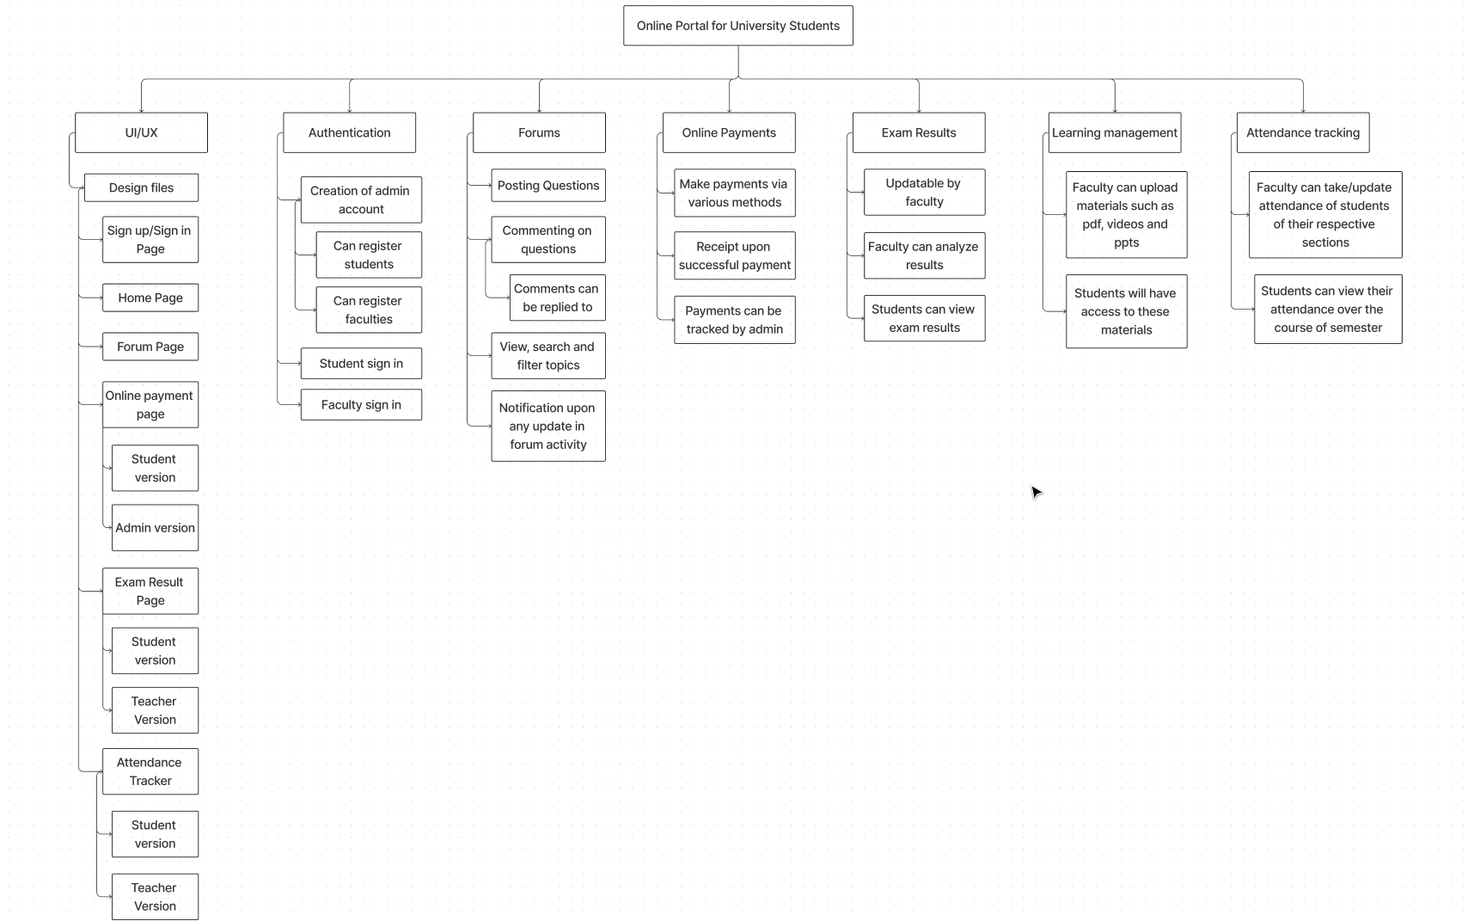

**Estimation of Tasks**

We used orgnaic type form the COCOMO model to do the following estimations

1. Authentication will be 600 LOC which is about 1.4 person-month effort
2. Forum/discussions is about 2000LOC which is about 4.96 person-month effort
3. Online payments is an approximate of 600LOC which comes out to 1.4 person months effort
4. Exam results viewing and updating is an approximate of 1000 LOC which is about 2.4 person-month effort
5. Attendance viewing and maintaining takes around 700 LOC which takes 1.65 person month effort
6. Uploading/downloading and viewing ppt takes around 2000 LOC which takes about 4.96 person month effort

**Gant Chart**

