COMPUTER NETWORKS

PROJECT REPORT ON

*Investigate and analyze Multicast, Unicast and Broadcast traffic over Packet Tracer*

MANIPAL UNIVERSITY JAIPUR

Made by:

Samridhi Kohli 169108125

Puranjay Guleria 168108110

Pulkit Vaid 169108109

TOPOLOGY DIAGRAM

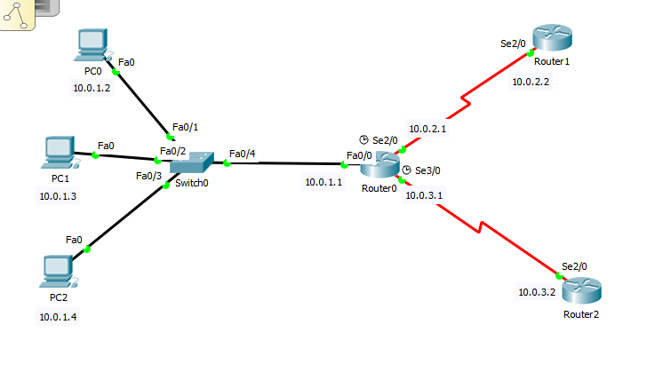

PROCEDURE

1.Select three generic PC’S

2.Select 2960 switch

3.Select three generic routers

4.Connect them using copper straight through and serial cables as shown in the topology diagram above.

5.Select PC0-Desktop-IP Configuration-assign IP address 10.0.1.2 subnet as 255.255.255.0 and default gateway as 10.0.1.1

6.Repeat step 5 for PC1 but assign IP address 10.0.1.3

7.Repeat step 5 for PC2 but assign IP address 10.0.1.4

8.Select Router0-CLI

>enable

>configure terminal

>interface fa0/0

>ip address 10.0.1.1 255.255.255.0

>no shut down

>end

>copy running-config startup-config

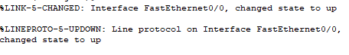

>interface se2/0

>ip address 10.0.2.1 255.255.255.0

>no shut down

>end

>copy running-config startup-config



>interface se3/0

>ip address 10.0.3.1 255.255.255.0

>no shut down

>end

>copy running-config startup-config



>exit

9.Select Router1-CLI

>enable

>configure terminal

>interface se2/0

>ip address 10.0.2.2 255.255.255.0

>no shut down

>end

>copy running-config startup-config



10.Select Router2-CLI

>enable

>configure terminal

>interface se2/0

>ip address 10.0.3.2 255.255.255.0

>no shut down

>end

>copy running-config startup-config



11.Router2-CLI

>enable

>configure terminal

>ip route 10.0.1.0 255.255.255.0 10.0.3.1

>end

12.Router1-CLI

>enable

>configure terminal

>ip route 10.0.1.0 255.255.255.0 10.0.2.1

>end

13.**UNICAST**

Select a simple PDU click on PC0 and then Router2. Click on capture/forward. Select ICMP and EIRGP only from edit filters. The packet travels from the PC to the switch then to Router0 and finally to Router2.The reverse path is used and the packet finally reaches back to PC0.

14.**BROADCAST**

Click on a complex PDU and then PCO. Enter destination IP address as 255.255.255.255 (broadcast address). Fill in the sequence number as 1 and one shot time as 0 sec. Click on capture/forward. Select ICMP and EIRGP only from edit filters. The packet travels from PC0 to switch. The switch then sends it to PC1, PC2 and Router1. The packet reaches back to PC0 via the switch.

15.**MULTICAST**

Click on a complex PDU and then Router0. Enter destination IP address as 224.0.0.10(group of EIGRP routers). Fill in the sequence number as 1 and one shot time as 0 sec. Click on capture/forward. Select ICMP and EIRGP only from edit filters. The packet travels from Router0 to both the routers and the switch. The switch then forwards the packet to the three PC’s. The PC’s however reject the packets.

CONCLUSION

The unicast packet moves through the network destined for a specific device, the broadcast gets sent to every device in the local area network and the multicast is sent to all devices but only processed by those that are part of the multicast group.