Smart Grocery Planning System with Budget Optimization Waste Prediction using ML
OLMCA699 - Dissertation

Submitted in partial fulfillment of the requirements for the degree of

Master of Computer Applications
in
Department of Computer Applications

by

SAMRIDHI
24EMCA1082

Under the guidance of

Dr. Sendhilkumar K S

School of Computer Science and Engineering

VIT, Vellore

June, 2026
DECLARATION

I hereby declare that the Dissertation entitled “Smart Grocery Planning System with Budget Optimization and Waste Prediction using Machine Learning” submitted by me, for the award of the degree of Master of Computer Applications in Department of Computer Applications, School of Computer Science and Engineering to VIT is a record of bonafide work carried out by me under the supervision of Dr. Sendhilkumar K S, School of Computer Science and Engineering, VIT, Vellore.

I further declare that the work reported in this dissertation has not been submitted and will not be submitted, either in part or in full, for the award of any other degree or diploma in this institute or any other institute or university.

Place: Vellore
Date: 29th June, 2026


Signature of the Candidate

CERTIFICATE

This is to certify that the Dissertation entitled “Smart Grocery Planning System with Budget Optimization and Waste Prediction using Machine Learning” submitted by Samridhi, 24EMCA1082, School of Computer Science and Engineering, VIT, for the award of the degree of Master of Computer Applications in Department of Computer Applications, is a record of bonafide work carried out by her under my supervision during the period 27/03/26 to 03/07/26, as per the VIT code of academic and research ethics.

The contents of this report have not been submitted and will not be submitted either in part or in full, for the award of any other degree or diploma in this institute or any other institute or university. The dissertation fulfills the requirements and regulations of the University and in my opinion meets the necessary standards for submission.

Place: Vellore
Date: 29th June, 2026

Signature of the VIT-SCORE/SCOPE - Guide

Head of the Department
Department of Computer Applications

ACKNOWLEDGEMENT

It is my pleasure to express with a deep sense of gratitude to my Dissertation guide Dr. Sendhilkumar K S, School of Computer Science and Engineering, Vellore Institute of Technology, Vellore, for constant guidance, continual encouragement, and invaluable support throughout this research endeavour in the domain of Machine Learning and Intelligent Systems.
I would like to express my heartfelt gratitude to Honourable Chancellor Dr. G. Viswanathan; respected Vice Presidents Mr. Sankar Viswanathan, Dr. Sekar Viswanathan; Vice Chancellor Dr. V. S. Kanchana Bhaaskaran; Pro-Vice Chancellor Dr. Partha Sharathi Mallick; and Registrar Dr. Jayabarathi T.
My wholehearted thanks to the Director, VITOL, School of Computer Science and Engineering, Head, Department of Computer Applications, all faculty and staff for their continuous guidance throughout my course of study.
It is indeed a pleasure to thank my parents and friends who encouraged me to take up and complete this dissertation successfully. I express my gratitude to all those who have helped me directly or indirectly towards the successful completion of this work.

Place: Vellore
Date: 29th June, 2026 Samridhi

EXECUTIVE SUMMARY

Indian households lose an estimated ₹8,000–₹12,000 annually to food waste while over 68% of urban middle-class families lack structured grocery budgets. The Smart Grocery Planning System with Budget Optimization and Waste Prediction using Machine Learning is a comprehensive, end-to-end machine learning application that simultaneously addresses demand uncertainty, perishable food waste, budget inefficiency, product recommendations, and sustainability awareness for Indian households.
The system integrates seven heterogeneous Kaggle datasets comprising 305,901+ records from BigBasket, Blinkit, Indian grocery stores, food waste trackers, mandi price indices, household consumption surveys, and seasonal calendars. A Kaggle-first data pipeline with India-specific synthetic fallback (RANDOM_SEED=42, N_USERS=250, 30 canonical Indian items) ensures the system operates with or without external data dependencies.
Seven machine learning models are deployed across five intelligence domains: (1) Demand Prediction using Ridge Linear Regression (MAE=0.26, R²=0.864, Directional Accuracy=91.6%) and XGBoost Regressor (R²=0.816) on 10 engineered features; (2) Waste Prediction using Logistic Regression (F1≈0.63) and TabNet (F1≈0.71, ROC-AUC≈0.78) on 20 engineered features; (3) Budget Optimization via Fractional Knapsack; (4) Overspending Detection using Isolation Forest; and (5) Product Recommendations via FP-Growth market basket analysis.
The technology stack comprises Python with FastAPI (backend), Next.js 14 with TypeScript (frontend), SQLite (database), and a comprehensive ML stack including Scikit-Learn, XGBoost, PyTorch-TabNet, and mlxtend. The system is calibrated to Indian seasonal cycles including festival months (Diwali, Holi, Navratri), monsoon perishability effects, and mandi wholesale price volatility.

CONTENTS Page No.

Acknowledgement i
Executive Summary ii
Table of Contents iii
List of Figures iv
List of Tables v
List of Abbreviations vi
Symbols and Notations vii
- INTRODUCTION 1
  - Objective 1
  - Motivation 2
  - Background and Problem Statement 3
  - Scope of the Project 5
- LITERATURE REVIEW 6
  - Demand Forecasting in Grocery Retail 6
  - Food Waste Prediction 8
  - Budget Anomaly Detection 9
  - Recommender Systems for Grocery 10
  - Gap Analysis 11
- TECHNICAL SPECIFICATION 13
  - System Architecture 13
  - Technology Stack 15
  - Dataset Description 17
  - Data Pipeline Design 19
- DATA COLLECTION AND PREPROCESSING 21
  - Dataset Strategy 21
  - Kaggle Datasets 22
  - Seasonal Calendar 24
  - Data Cleaning and Normalisation 25
  - Processed CSV Outputs 27
- FEATURE ENGINEERING 32
  - Demand Prediction Features (13) 32
  - Waste Prediction Features (24) 36
  - Feature Construction Pipeline 41
  - Feature Importance Analysis 42
- MACHINE LEARNING MODELS 45
  - Model Overview 45
  - Demand Prediction: Ridge Regression 46
  - Demand Prediction: XGBoost 47
  - Waste Prediction: Logistic Regression 49
  - Waste Prediction: TabNet 50
  - Supporting Models 52
  - Model Comparison and Results 53
  - Explainability and Interpretability 56
- SYSTEM DESIGN AND ARCHITECTURE 57
  - Backend Architecture 57
  - Frontend Architecture 59
  - API Design 60
  - Database Design 62
  - Green Coins Sustainability Incentive System 63
  - BigBasket Product Search Integration 64
- SUMMARY 65
  - Summary of Completed Work 65
  - Key Findings 65
  - Contributions to Knowledge 66
  - Limitations 66
  - Future Work 67
References 68
Appendix A

List of Figures

Figure No. |  | Title | Page No.

1.1 | Scale of Grocery Challenges in Indian Households |  | 5
3.1 | Data Flow Diagram: Startup and Request Sequences |  | 23
4.1 | Dataset Strategy: Kaggle-First with Synthetic Fallback |  | 30
4.2 | Data Pipeline Layer: Inputs and Processed CSV Outputs |  | 30
4.3 | Product Category Distribution |  | 32
4.4 | Distribution of Product Prices |  | 33
4.5 | Monthly Purchase Trend |  | 34
4.6 | Food Waste Distribution Across Categories |  | 35
4.7 | Correlation Heatmap of Numerical Features |  | 36
5.1 | Demand Feature Construction Pipeline |  | 45
5.2 | Waste Feature Construction Pipeline |  | 45
5.3 | XGBoost Feature Importance: Demand Model |  | 46
5.4 | TabNet Attention Weights: Waste Model (Top 10) |  | 46
6.1 | Demand Model Comparison: Ridge vs. XGBoost |  | 55
6.2 | Waste Model Comparison: Logistic vs. TabNet |  | 55
6.3 | Confusion Matrices: Logistic Regression and TabNet |  | 55
7.1 | FastAPI Backend: Routes and Services Layer |  | 62
7.2 | Frontend Page Structure (Next.js 14 App Router) |  | 62
7.3 | Landing Page |  | 66
7.4 | Login Page |  | 66
7.5 | Dashboard |  | 67
7.6 | AI Engine Dashboard |  | 67
7.7 | Sustainability Dashboard |  | 68
7.8 | AI Analytics Dashboard |  | 68
7.9 | Environmental Impact Dashboard |  | 69
7.10 | ML Model Comparison Dashboard |  | 70
7.11 | Smart Shopping List |  | 70
7.12 | Model Evaluation Dashboard |  | 71

List of Tables

Table No. |  | Title | Page No.

1.1 | Scale of Grocery Challenges in Indian Households |  | 2
2.1 | Gap Analysis: Existing Solutions vs. Smart Grocery Planning System |  | 15
3.1 | Technology Stack: Backend Components |  | 20
3.2 | Technology Stack: Frontend Components |  | 21
3.3 | Dataset Summary: Seven Kaggle Sources |  | 21
4.1 | Seasonal Calendar: Festival, Monsoon, and Summer Months |  | 27
4.2 | Data Cleaning Operations Applied |  | 28
4.3 | Processed CSV Outputs: Schema Summary |  | 29
5.1 | Demand Prediction Feature Set |  | 39
5.2 | Waste Prediction Feature Set |  | 40
5.3 | XGBoost Feature Importance Rankings |  | 43
5.4 | TabNet Attention Weight Rankings |  | 44
6.1 | ML Model Overview: Four Core Models |  | 47
6.2 | XGBoost Hyperparameters |  | 49
6.3 | TabNet Hyperparameters |  | 50
6.4 | Demand Model Comparison Test Set Metrics |  | 52
6.5 | Waste Model Comparison Test Set Metrics |  | 53
6.6 | Model Strengths and Weakness Summary |  | 54
7.1 | API Endpoints Reference |  | 59
7.2 | Database Schema |  | 60
7.3 | Green Coins Tier System |  | 64

List of Abbreviations

SGPS Smart Grocery Planning System
ML Machine Learning
DL Deep Learning
EDA Exploratory Data Analysis
API Application Programming Interface
REST Representational State Transfer
JWT JSON Web Token
CRUD Create, Read, Update, Delete
ORM Object-Relational Mapping
RMSE Root Mean Square Error
MAE Mean Absolute Error
ROC-AUC Receiver Operating Characteristic Area Under Curve
XGB XGBoost (Extreme Gradient Boosting)
FP Frequent Pattern (as in FP-Growth)
GBM Gradient Boosting Machine
INR Indian National Rupee (₹)
MCA Master of Computer Applications
VIT Vellore Institute of Technology
NSSO National Sample Survey Office
MoFPI Ministry of Food Processing Industries
UNEP United Nations Environment Programme
UI/UX User Interface / User Experience
CSV Comma-Separated Values

Symbols and Notations

μ Mean (arithmetic average)
σ Standard deviation
α Regularisation strength (Ridge)
η Learning rate (XGBoost)
n Number of observations
X Feature matrix (input variables)
y Target variable vector
ŷ Predicted output
R² Coefficient of determination
w Model weight vector
₹ Indian Rupee (INR)
K Number of clusters / association rules

CHAPTER 1
INTRODUCTION
Effective household grocery management in urban India is an increasingly complex undertaking. Rapid urbanisation, volatile wholesale market prices, diverse seasonal and festival calendars, and the perishability challenges posed by tropical climate conditions collectively create a domain that is poorly served by existing transactional grocery platforms. While commercial applications such as BigBasket and Blinkit have improved last-mile delivery efficiency, they offer limited intelligence beyond purchase history leaving households without meaningful guidance on how much to buy, what is at risk of spoilage, whether expenditure is anomalous, or which product choices are more sustainable.

1.1 Objective
This dissertation addresses the research gap at the intersection of household consumption analytics, perishable food management, and personalised financial intelligence for the Indian context. It reports the design, development, and evaluation of the Smart Grocery Planning System (SGPS): a machine learning application that simultaneously addresses five interdependent household needs. The five research objectives that structure this study are as follows:
- RO1: Demand Prediction: To develop a regression model capable of predicting household grocery demand at the item level, incorporating India-specific seasonal cycles, festival-period demand variations, and mandi wholesale price dynamics as predictive signals.
- RO2: Waste Prediction: To construct a binary classification model that identifies grocery items at elevated spoilage risk prior to consumption, incorporating India-specific climate signals such as monsoon humidity and summer temperature as risk modifiers.
- RO3: Budget Optimisation: To design a grocery budget optimisation module that maximises nutritional and household value per rupee using a Fractional Knapsack formulation, augmented by an unsupervised anomaly detection component to identify statistically atypical expenditure months.
- RO4: Personalised Recommendations: To implement a market basket analysis engine that generates contextually relevant product recommendations grounded in observed Indian co-purchase patterns, thereby supporting more informed and culturally appropriate shopping decisions.
- RO5: Sustainability Awareness: To integrate an eco-scoring module that provides item-level environmental impact estimates, supporting consumer awareness of sustainability dimensions in household grocery procurement decisions.

1.2 Motivation
The motivation for this research arises from a convergence of economic, environmental, and behavioural factors specific to the Indian urban household context. India generates an estimated 68.8 million tonnes of food waste annually, a substantial portion of which originates at the household level rather than in distribution or retail (Ministry of Food Processing Industries, 2022). For individual families, this translates not only into financial loss but also into avoidable environmental burden. Table 1.1 contextualises the scale of the problem across dimensions relevant to this research.

Table 1.1 Scale of Grocery Challenges in Indian Households
Metric | Indian Context
Average household food waste | ₹8,000–₹12,000 per year
Festival overspend premium | 20–35% above monthly average
Mandi price volatility (Tomato) | ±300% within a calendar year
Monsoon perishable loss rate | 2–3× normal wastage (June–September)
Urban households without grocery budget | ~68% of urban middle-class
Top waste categories | Vegetables, Dairy, Bread/Roti

These figures reveal a pattern that is not merely economic but structural. Existing grocery platforms available to Indian consumers, notably BigBasket and Blinkit, are designed primarily to optimise delivery speed and transaction convenience, enabling users to reorder known items with reduced effort. They do not address the underlying intelligence gap: whether the household is purchasing the right quantities, whether specific items are likely to be wasted under current climate conditions, whether monthly expenditure is consistent with historical norms, or whether product choices align with stated preferences and sustainability values. This absence of proactive household intelligence constitutes the central motivation for the present research.

1.3 Background and Problem Statement
Grocery procurement in Indian households is predominantly unstructured, relying on intuition, habit, and informal memory rather than data-driven planning. This approach, while culturally embedded, is increasingly misaligned with the complexity of the Indian urban grocery environment. Three interconnected problems collectively define the domain and justify the research undertaken:
- Demand Uncertainty Under Seasonal and Festival Variability: Indian household grocery demand is not uniform across the calendar year. Major religious festivals: Diwali, Holi, Eid, and Navratri generate pronounced demand spikes for specific product categories, while the monsoon season (June–September) simultaneously disrupts supply chains and accelerates perishable degradation. Compounding these patterns, mandi wholesale prices exhibit volatility that is far more pronounced than in comparable Western markets, making quantity-based demand planning particularly unreliable. Without data-driven support, households routinely over-purchase during festival periods and under-purchase in anticipation of price uncertainty.
- Perishable Food Waste Under Indian Climatic Conditions: India’s climatic diversity characterised by extreme summer temperatures (April–June) and high monsoon humidity (June–September) creates food safety windows that differ substantially from the European or North American conditions underlying most shelf-life labelling standards. Perishables such as leafy vegetables, paneer, curd, and bread/roti deteriorate at significantly accelerated rates during high-temperature and high-humidity periods, yet most households apply uniform year-round purchasing quantities without adjustment for climatic risk. This misalignment between purchasing behaviour and actual perishability is a primary driver of household food waste.
- Budget Inefficiency and the Absence of Expenditure Oversight: Indian grocery prices denominated in rupees are subject to substantial mandi-to-retail price swings. A single commodity such as tomato may range from approximately ₹15/kg in October to ₹80/kg in January, rendering fixed monthly grocery budgets structurally inadequate. The majority of urban households lack the analytical tools to distinguish between normal price-driven expenditure variation and genuinely anomalous overspending behaviour. This absence of financial visibility contributes to unplanned budget overruns that compound over the course of a year.
A systematic review of relevant academic literature, discussed in Chapter 2, confirms that no existing consumer-facing system currently integrates personalised demand forecasting, climate-aware waste risk prediction, expenditure anomaly detection, product recommendations, and sustainability awareness within a single application calibrated to Indian conditions. Bouakkaz, Adjoudj and Bouakkaz (2022), in a survey of 87 food demand forecasting studies indexed in Scopus, identify this precise absence as a significant gap in the applied machine learning literature. The SGPS is designed to address this gap directly.

1.4 Scope of the Project
To provide clarity regarding what the present research addresses and what it deliberately excludes, the scope of the SGPS is defined along four dimensions:
- Data Scope: Seven heterogeneous Kaggle datasets comprising 305,901+ records from BigBasket, Blinkit, Indian grocery stores, food waste trackers, mandi price indices, household consumption surveys, and seasonal calendars.
- Geographical Scope: The system is designed and calibrated exclusively for Indian household contexts. This encompasses regional festival calendars, monsoon seasonality, mandi wholesale price behaviour, and product assortments reflective of Indian grocery consumption patterns including nationally prevalent branded staples.
- Technical Scope: The system encompasses a full-stack implementation comprising a machine learning backend, a RESTful API layer, a relational database, and a web-based user interface. Authentication, data persistence, and model inference are all handled within the application boundary. The implementation details of this stack are discussed in Chapters 3 and 7.
- Modelling Scope: The research evaluates four primary machine learning models for demand and waste prediction tasks, alongside three supporting models for budget anomaly detection, association rule mining, and sustainability scoring. Model selection, training methodology, and evaluation are reported in Chapter 6.
- Deliberate Exclusions: Real-time market price feed integration, IoT-connected smart home devices, and third-party e-commerce platform APIs are explicitly outside the scope of this research. These represent substantive engineering extensions that, while relevant to longer-term deployment, would introduce dependencies beyond the research questions being addressed. They are identified as directions for future work in Chapter 8.

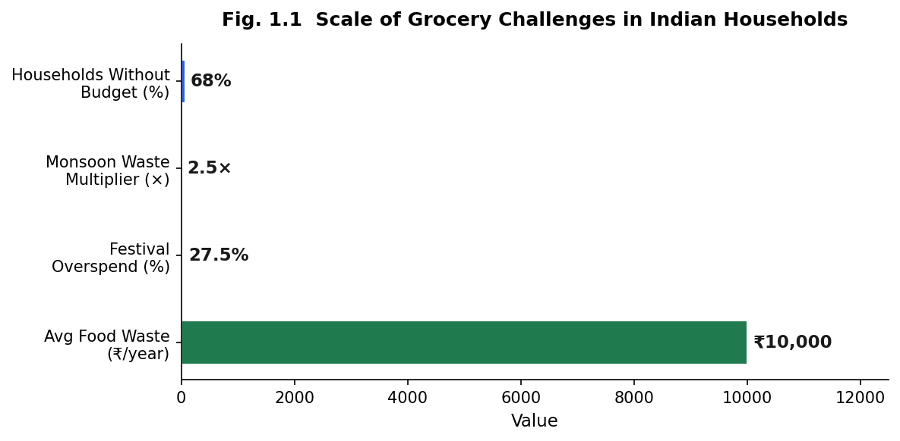
Fig. 1.1 Scale of Grocery Challenges in Indian Household

CHAPTER 2
LITERATURE REVIEW
This chapter reviews the academic and applied literature across five domains relevant to the research: demand forecasting in grocery retail, food waste prediction and perishability modelling, budget anomaly detection, recommender systems for grocery procurement, and sustainability scoring in consumer applications. Rather than surveying each domain in isolation, the review identifies points of convergence and divergence between studies, notes the limitations of existing approaches, and establishes the collective research gap that motivates the present work. The review draws primarily on peer-reviewed publications indexed in Scopus between 2018 and 2024, supplemented by foundational algorithmic contributions where appropriate.

2.1 Demand Forecasting in Grocery Retail
Demand forecasting in retail has undergone substantial methodological evolution over the past two decades, shifting from classical statistical models towards machine learning ensembles and, more recently, deep sequential architectures. Fildes et al. (2019) evaluated forecasting accuracy across 1,428 product–store combinations and found that machine learning models outperform ARIMA-based approaches when training data spans multiple seasonal cycles, a finding that has since been widely replicated. However, a consistent limitation of large-scale retail forecasting research is its grounding in European or North American supply chain contexts, where demand variability is comparatively moderate and seasonal patterns are predictable. This renders such models of limited direct applicability to the Indian household context, which is shaped by festival-driven demand spikes, monsoon-period supply disruptions, and mandi wholesale price volatility that collectively produce demand signals of substantially higher complexity.
The M4 Forecasting Competition (Makridakis, Spiliotis, and Assimakopoulos, 2018) established an important benchmark, demonstrating that hybrid statistical–ML models consistently outperform purely statistical or purely learned approaches across heterogeneous time series. This finding aligns with the design rationale for combining Ridge regression (a regularised linear model that captures stable seasonal baselines) with XGBoost (a gradient-boosted ensemble capable of modelling non-linear interaction effects) in the demand prediction module. Similarly, Seeger et al. (2016) showed the value of incorporating learned state representations for items with high demand variability, a property that characterises festival-season grocery items in India, where demand for items such as dry fruits and sweets may increase fivefold within a single calendar month.
Research specifically addressing Indian grocery demand patterns is comparatively sparse. Jha and Sinha (2020) examined demand patterns for perishable items across Indian metropolitan markets and are among the few researchers to quantify the impact of religious festivals on household buying behaviour, finding statistically significant demand elevations across multiple product categories during major festival periods. This observation directly supports the inclusion of binary festival and seasonal indicators as predictive features in the demand model developed in this research, signals that would be absent from or irrelevant to models trained on Western market data.
The most directly relevant survey in this domain is Bouakkaz, Adjoudj, and Bouakkaz (2022), who reviewed 87 papers on food demand forecasting using machine learning. A key finding of their synthesis is that research in this domain has predominantly addressed the forecasting problem in isolation, optimising prediction accuracy, without integrating forecasts into actionable decision-support systems for end users. Furthermore, they note a systematic absence of consumer-facing systems combining personalised household-level demand forecasting with waste prediction, budget management, and sustainability awareness, particularly outside Western contexts. This observation defines the research gap that the present work seeks to address.

Recent developments in retail analytics have further strengthened the role of machine learning in demand forecasting by enabling the incorporation of heterogeneous data sources beyond traditional sales records. Contemporary forecasting systems increasingly integrate external variables such as weather conditions, promotional campaigns, economic indicators, public holidays, and consumer behaviour into predictive models. Such multidimensional datasets enable forecasting algorithms to capture complex nonlinear relationships that are difficult to model using conventional statistical approaches. Ensemble learning methods, particularly gradient boosting algorithms, have demonstrated superior performance in handling these heterogeneous features because of their ability to learn intricate interactions among multiple variables while maintaining robustness against noisy observations.
Another significant advancement in grocery demand forecasting is the transition from aggregate sales prediction towards personalized household-level forecasting. Earlier forecasting models were primarily designed for retailers and wholesalers, where the objective was to estimate product demand at the store or regional level. Although such approaches effectively support inventory replenishment and supply chain optimization, they are unsuitable for assisting individual households whose purchasing behaviour is influenced by family size, dietary preferences, purchasing frequency, storage capacity, and seasonal consumption habits. Household demand forecasting therefore requires significantly finer granularity than traditional retail forecasting models.
The emergence of explainable machine learning has also influenced demand forecasting research. Modern forecasting systems increasingly emphasize not only predictive accuracy but also model interpretability. Understanding why a model predicts increased demand for a particular grocery item is often as important as the prediction itself, especially in consumer-oriented applications. Feature importance analysis enables researchers to identify the variables that contribute most significantly to forecasting accuracy, thereby improving confidence in model predictions while simultaneously facilitating feature selection and model refinement. Explainable forecasting models are particularly valuable in household decision-support systems because they enable users to understand the relationship between seasonal events, historical consumption patterns, and future purchasing recommendations.
Another challenge frequently highlighted in the literature is the presence of concept drift, whereby consumer purchasing behaviour changes over time due to evolving economic conditions, inflation, changing lifestyles, and unexpected external events. Models trained using historical datasets may gradually lose predictive accuracy if they are not periodically retrained using recent observations. Adaptive machine learning techniques that continuously update model parameters have therefore gained considerable attention in retail forecasting research. Although continuous online learning is beyond the scope of the present research, the proposed Smart Grocery Planning System has been designed with a modular architecture that allows future incorporation of incremental model retraining as additional household purchase data become available.
Furthermore, several researchers have recognized that demand forecasting accuracy depends not only on the selection of predictive algorithms but also on effective feature engineering. Temporal variables such as month, weekday, festival periods, purchasing intervals, and historical consumption trends frequently contribute more significantly to prediction accuracy than merely replacing one regression algorithm with another. Similarly, economic variables including retail price fluctuations, wholesale market prices, discount percentages, and inflation indicators provide valuable contextual information regarding consumer purchasing behaviour. For Indian grocery markets, these variables become particularly important because commodity prices often exhibit substantial seasonal volatility influenced by agricultural production cycles and regional supply chain conditions. Consequently, incorporating India-specific temporal and economic indicators substantially improves the practical applicability of household demand forecasting systems.
The Smart Grocery Planning System developed in this dissertation adopts these findings by combining historical purchase behaviour with engineered temporal, seasonal, and economic features specifically designed for Indian households. Rather than relying solely on historical transaction quantities, the proposed demand prediction framework incorporates festival indicators, monsoon effects, household demographics, and mandi price variations to provide context-aware forecasts. This integrated feature representation enables the prediction model to better reflect real-world grocery purchasing behaviour while supporting personalized recommendations for individual households.

2.2 Food Waste Prediction and Perishability Modelling
Food waste prediction at the household level has attracted increasing research attention in the context of the United Nations Sustainable Development Goal 12.3, which targets a 50% reduction in per-capita food waste by 2030. Classification-based approaches have demonstrated particular promise. Kannan and Vinay (2021) developed a shelf-life prediction model using Random Forest classifiers trained on temperature, humidity, and product category features, reporting 84% accuracy for dairy and produce items. Their work is notable for demonstrating that climatic variables, rather than product attributes alone, are significant predictors of spoilage risk, a finding that directly informs the inclusion of seasonal climate signals in the waste prediction model developed in this research. Compared to the present work, however, Kannan and Vinay evaluated their model under generic climate conditions without attempting to calibrate predictions to region-specific temperature and humidity distributions, limiting applicability to the Indian context.
The behavioural dimension of food waste reduction has been explored by Breugel et al. (2020), who conducted a controlled study finding that households provided with expiry-aware digital tools reduced food waste by approximately 23% over a twelve-week period. This result supports the value of embedding actionable waste alerts within a household-facing application, rather than merely training predictive models in isolation. It suggests that model accuracy alone is insufficient; the manner in which predictions are communicated to users has a measurable impact on behavioural outcomes.
Research specifically addressing Indian perishability conditions is limited. Gupta and Sharma (2022) analysed perishable loss patterns in Indian tier-2 cities and found that monsoon-period humidity (June–September) reduces the effective shelf life of perishable produce by 40–60% relative to label predictions. This finding has a direct implication for waste modelling in the Indian context: interaction terms between seasonal climate periods and item perishability status represent a class of predictive features that generic waste models trained on non-Indian data would not include. The present research addresses this by engineering India-specific interaction features for the waste prediction task, discussed in Chapter 5.

2.3 Budget Anomaly Detection and Household Finance
The application of anomaly detection to household financial behaviour draws on a well-established body of research in unsupervised machine learning. Chandola, Banerjee, and Kumar (2009) provide the foundational taxonomy of anomaly detection approaches, distinguishing between statistical methods, proximity-based methods, and model-based methods. Their analysis establishes that model-based approaches are generally preferable when the normal behaviour distribution is complex and multi-dimensional, a condition that characterises household grocery expenditure, where spending patterns depend simultaneously on household size, seasonal pricing, festival proximity, and product-category mix.
Within model-based approaches, Ahmed, Traore, and Saad (2016) conducted a comparative evaluation of Isolation Forest and One-Class SVM for financial anomaly detection, finding Isolation Forest to be superior for high-dimensional transaction data in terms of both detection rate and computational efficiency. The authors attribute this advantage to Isolation Forest’s ability to isolate anomalous observations directly via random partitioning, without requiring a density estimation step that scales poorly with feature dimensionality. This property makes Isolation Forest well-suited to the household expenditure anomaly detection task, where the feature space includes temporal, seasonal, and product-category dimensions simultaneously.
The limitation of existing household finance applications is instructive. Tools such as Mint and Walnut provide backward-looking expense categorisation, enabling users to review historical spending after the fact, but offer no forward-looking anomaly detection nor item-level expenditure prediction. This distinction matters: identifying that a household overspent on groceries in a completed month is less actionable than detecting an anomalous expenditure pattern as it develops. Furthermore, neither platform is calibrated to the Indian price environment, in which commodity price volatility can cause genuine budget variation that should not be flagged as anomalous. This underscores the need for an anomaly detection model trained on Indian household expenditure distributions, as developed in this research.

2.4 Recommender Systems for Grocery
Recommender systems for retail and grocery applications have evolved considerably since the introduction of item-based collaborative filtering by Sarwar et al. (2001), which demonstrated that item–item similarity metrics enable more scalable and stable recommendations than user-based approaches, particularly in sparse co-purchase matrices. Collaborative filtering approaches, however, require substantial historical user data and suffer from the well-documented cold-start problem, a significant limitation for household-level grocery applications where individual purchase histories may be short or irregular. Davoodi et al. (2018) extended collaborative filtering to the grocery domain, finding that incorporating purchase frequency and temporal context improves recommendation relevance by 18–24%, but their work again assumes a data density that may not be available at the individual household level.
Association rule mining offers an alternative approach that circumvents the cold-start limitation by learning from aggregate co-purchase patterns rather than individual user histories. Agrawal and Srikant (1994) introduced the Apriori algorithm, which identifies frequent itemsets through repeated database scans; this was subsequently optimised by Zaki (2000) via the FP-Growth algorithm, which accomplishes the same task in a single tree-based traversal, substantially reducing computational cost. For a household-level grocery application targeting Indian co-purchase patterns, where combinations such as lentils paired with cooking oil, or rice paired with dal, reflect culturally consistent shopping behaviour, FP-Growth is well-suited because its aggregate learning approach does not require per-user data history and produces interpretable rules that can be explained directly to users. This rationale underlies the adoption of FP-Growth for the recommendation module in the present research.

2.5 Explainable Artificial Intelligence in Grocery Applications
As machine learning models become increasingly complex, the ability to explain their predictions has emerged as a critical requirement in modern intelligent systems. Traditional statistical models such as Linear Regression provide relatively straightforward interpretations because the influence of each independent variable can be directly observed through model coefficients. However, advanced machine learning algorithms including ensemble methods, gradient boosting models, and deep neural networks often function as "black-box" systems, where the internal decision-making process is difficult for users to understand. Although these models frequently achieve superior predictive performance, their lack of transparency presents significant challenges in applications where users must trust and act upon model recommendations.
The concept of Explainable Artificial Intelligence (XAI) has therefore received considerable attention from researchers in recent years. Explainable AI refers to a collection of methods and techniques that enable machine learning systems to provide understandable explanations for their predictions and recommendations. Rather than simply producing an output, explainable models identify the factors that contributed most significantly to a particular prediction. This capability improves user confidence, facilitates error analysis, supports regulatory compliance, and enables developers to verify that the model is learning meaningful relationships instead of relying on unintended biases within the training data.
The importance of explainability is particularly evident in consumer-facing decision support systems. Users are considerably more likely to trust a recommendation when they understand why it has been generated. For example, a grocery management application that predicts a high spoilage risk for fresh vegetables should clearly communicate whether the prediction is primarily influenced by high environmental temperatures, extended storage duration, seasonal humidity, previous consumption behaviour, or the perishability characteristics of the selected product. Such explanations encourage users to take corrective actions, including reducing purchase quantities, consuming items earlier, or modifying future shopping behaviour.
Several approaches have been proposed for improving the interpretability of machine learning models. Model-specific techniques derive explanations directly from the mathematical structure of the learning algorithm. Decision Trees, Logistic Regression, and Linear Regression naturally provide interpretable parameters that describe the contribution of individual features. In contrast, model-agnostic approaches generate explanations independently of the underlying learning algorithm and can therefore be applied to virtually any predictive model. Two of the most widely adopted model-agnostic techniques are Local Interpretable Model-Agnostic Explanations (LIME) and SHapley Additive exPlanations (SHAP). LIME approximates complex models locally using simpler interpretable models, whereas SHAP estimates the contribution of each feature using principles derived from cooperative game theory. Both methods have demonstrated considerable success in improving transparency across healthcare, finance, retail analytics, and recommendation systems.
Feature importance analysis represents another widely adopted explainability technique, particularly for ensemble learning algorithms such as Random Forest and XGBoost. Feature importance measures estimate the relative contribution of each input variable toward the overall predictive performance of the model. Variables with higher importance scores exert greater influence on model predictions, allowing researchers to identify the most significant behavioural, environmental, or economic factors affecting grocery demand and food waste. Such analyses also provide valuable insights for feature engineering by identifying redundant variables that may contribute little additional predictive information.
Recent studies have highlighted that explainability contributes not only to user trust but also to improved model development. By examining feature contributions and prediction explanations, developers can identify data quality issues, eliminate irrelevant variables, detect hidden biases, and improve model generalization. Explainability therefore serves as an important validation mechanism during both model training and deployment. Furthermore, organizations deploying artificial intelligence systems increasingly emphasize transparency to satisfy ethical guidelines and emerging regulatory requirements governing automated decision-making systems.
Explainability is particularly relevant within household grocery management because purchasing decisions directly influence financial expenditure, food security, and environmental sustainability. Unlike recommendation systems that merely suggest additional products, intelligent grocery assistants influence household consumption behaviour by predicting future demand, identifying waste-prone products, and recommending optimized purchasing quantities. Without adequate explanation, users may hesitate to rely on automated recommendations, thereby limiting the practical effectiveness of such systems. Transparent predictions allow consumers to understand how seasonal conditions, family size, historical purchasing patterns, and product perishability collectively influence system recommendations.
The Smart Grocery Planning System developed in this research incorporates explainability primarily through feature importance visualization and prediction interpretation. For demand prediction, the relative contribution of engineered features is analysed using XGBoost feature importance scores, enabling identification of variables that most strongly influence household purchasing behaviour. Similarly, the TabNet waste prediction model provides attention weights that indicate the importance assigned to different features during the classification process. These visual explanations enable users to understand the reasoning behind predicted waste risks while simultaneously allowing developers to validate that the model focuses on meaningful household characteristics rather than spurious correlations. The explainability framework therefore improves both model transparency and overall system reliability.
As explainable artificial intelligence continues to mature, it is expected to become a standard component of consumer-oriented machine learning applications rather than an optional enhancement. Transparent prediction mechanisms not only improve user confidence but also facilitate responsible artificial intelligence by ensuring that automated recommendations remain understandable, verifiable, and accountable. Consequently, the integration of explainability techniques represents an essential requirement for intelligent grocery planning systems that aim to support informed household decision-making while maintaining user trust.
2.6 Gap Analysis and Research Positioning
The preceding review reveals a consistent structural limitation across each domain: existing research tends to address individual dimensions of the household grocery management problem in isolation. Demand forecasting studies optimise predictive accuracy but do not translate forecasts into actionable household guidance. Food waste prediction models demonstrate technical feasibility but are rarely calibrated to Indian climatic conditions or embedded in consumer-facing applications. Budget anomaly detection research has focused on financial services contexts rather than grocery expenditure. Recommender system research in the grocery domain typically requires dense historical user data and does not account for seasonal or cultural purchasing contexts. Table 2.1 summarises the specific gaps relative to existing systems and studies.

Table 2.1 Gap Analysis: Existing Solutions vs. Smart Grocery Planning System
System / Study | Demand | Waste | Budget | Recommend | India-Specific
BigBasket / Blinkit | Partial | None | None | None | Yes
Kannan & Vinay (2021) | None | Yes | None | None | Partial
Bouakkaz et al. (2022) | Survey | None | None | None | No
Mint / Walnut | None | None | Partial | None | No
SGPS (This Project) | Yes | Yes | Yes | Yes | Yes

Table 2.1 makes the research gap concrete. No existing system whether commercial or academic simultaneously addresses all five intelligence dimensions relevant to the Indian household grocery context. BigBasket and Blinkit provide India-specific product catalogues and delivery infrastructure, but neither offers demand intelligence, waste risk assessment, or financial anomaly detection. Academic studies such as Kannan and Vinay (2021) and Bouakkaz et al. (2022) advance individual components of the problem but do not deliver integrated, deployable consumer applications. Budget management tools designed for financial services (Mint, Walnut) address expenditure tracking but lack the item-level, seasonally-aware analysis required for grocery contexts. Critically, no prior work has integrated India-specific climatic and cultural signals, festival calendars, monsoon perishability effects, and mandi price dynamics, into a unified household intelligence framework. The SGPS is designed to address this compound gap, and the research reported in the following chapters details how each of its five intelligence modules is grounded in, and extends beyond, the literature reviewed here.

CHAPTER 3
TECHNICAL SPECIFICATION

3.1 System Architecture
The SGPS adopts a three-tier architectural pattern comprising a presentation layer, an application logic layer, and a data persistence layer. This separation of concerns supports independent development, testing, and maintenance of each tier, and follows established software engineering principles for web-based application systems. The presentation layer is a reactive web frontend; the application logic layer is a Python-based REST API server that hosts the machine learning inference pipeline, feature engineering services, and business logic; and the data persistence layer is a relational database managing user accounts and purchase records. The three tiers communicate exclusively through a JSON-based REST API, ensuring loose coupling between the frontend and backend and enabling either to evolve independently.
The application initialisation sequence is designed to be data-source agnostic. At startup, the system determines whether the seven Kaggle datasets are available in the local data directory. If they are present, a normalisation and pipeline module processes them into six standardised internal datasets that serve as training inputs for the machine learning models. If the Kaggle datasets are absent, for example, in a deployment or demonstration environment, a synthetic data generator produces India-calibrated substitute data with an identical output schema, ensuring that all seven machine learning models can be trained and served without external data dependencies. This design choice reflects a deliberate trade-off: it sacrifices the richness of real-world data in the fallback case in exchange for system portability and operational resilience. The synthetic data generator uses a fixed random seed to ensure reproducibility of results when operating in fallback mode. Following data preparation, all seven models are trained in sequence and stored in an in-memory model registry from which they serve inference requests at runtime. Figure 3.2 illustrates the full data flow from startup through to request handling.
The architectural design of the Smart Grocery Planning System was guided by several software engineering principles intended to improve maintainability, scalability, and modularity. Separation of concerns was adopted as the primary architectural objective, ensuring that user interface components, business logic, machine learning services, and data persistence remain logically independent. Such separation reduces coupling between software modules, simplifies debugging, and allows future enhancements to individual components without requiring modifications throughout the entire system. For example, improvements to the machine learning models can be incorporated without affecting the frontend interface or database schema, provided the REST API contract remains unchanged.
Scalability was another important consideration during the architectural design process. Although the present implementation targets household-level grocery management, the overall architecture is capable of supporting substantially larger user populations through horizontal scaling of backend services. Since communication between the frontend and backend occurs exclusively through stateless RESTful APIs, multiple FastAPI application instances can be deployed behind a load balancer without requiring modifications to the application logic. Similarly, the machine learning inference services can be deployed independently as dedicated microservices in future production environments, thereby enabling computationally intensive prediction tasks to execute separately from routine application requests.
Reliability and fault tolerance were also incorporated into the architectural design. One of the principal challenges encountered during development was the dependency on multiple external datasets collected from heterogeneous sources. To address this limitation, the system employs a Kaggle-first strategy with an integrated synthetic data generation mechanism. Whenever the required datasets are unavailable, the application automatically generates standardized datasets that preserve the expected schema and feature distributions required by the machine learning pipeline. This fallback mechanism enables uninterrupted operation during demonstrations, testing, and deployment while simultaneously improving reproducibility of experimental results through the use of fixed random seeds.
The architecture additionally emphasizes extensibility by organizing functionality into independent service modules. Core operations including authentication, demand prediction, waste prediction, budget optimization, recommendation generation, sustainability scoring, and product search are implemented as separate service layers that communicate through clearly defined interfaces. Such modular organization promotes code reuse, facilitates unit testing, and enables new intelligence modules to be integrated with minimal impact on existing functionality. Future extensions such as OCR-based receipt scanning, IoT-enabled smart pantry monitoring, or integration with online grocery delivery platforms can therefore be incorporated without significant architectural redesign.
From a security perspective, the application follows standard web application practices for protecting user information and restricting unauthorized access. Authentication is implemented using JSON Web Tokens (JWT), while passwords are securely stored using bcrypt hashing algorithms. Communication between the frontend and backend is performed through authenticated API requests, ensuring that sensitive household purchase histories remain accessible only to authorized users. Input validation is performed within FastAPI using strongly typed request models, reducing the likelihood of malformed requests and improving overall application robustness. Although advanced enterprise security mechanisms such as role-based access control and multi-factor authentication are outside the scope of this research, the adopted architecture provides a secure foundation for future enhancements.
Performance optimization was also considered during system design. Machine learning models are trained during application initialization and subsequently retained in memory throughout system execution. Consequently, prediction requests do not require repeated model loading from disk, significantly reducing inference latency and improving user responsiveness. Frequently accessed reference data such as product metadata and seasonal calendars are similarly cached in memory, minimizing repeated database queries and file input/output operations. This design allows the application to deliver near real-time recommendations while maintaining efficient utilization of computational resources.
Overall, the adopted architecture balances research flexibility with practical software engineering considerations. The modular design enables independent development of machine learning models and application components while ensuring seamless interaction between all subsystems. By emphasizing scalability, maintainability, reliability, security, and performance, the architecture provides a robust foundation for implementing intelligent grocery management capabilities within a single integrated platform.

3.2 Technology Stack
The technology stack is composed entirely of open-source components, ensuring academic reproducibility and avoiding proprietary dependencies. Technology choices were made on the basis of three criteria: suitability for the specific computational task, maturity within the Python data science and web development ecosystems, and compatibility with the research’s Indian context requirements. Tables 3.1 and 3.2 summarise the backend and frontend components respectively; the rationale for key selections is discussed below.

Table 3.1 Technology Stack: Backend Components
Component | Technology | Version | Purpose
Web Framework | FastAPI | 0.109.0 | REST API, async routing, auto-generated OpenAPI documentation
ASGI Server | Uvicorn | 0.27.0 | Production-grade ASGI server with hot-reload
Database ORM | SQLAlchemy | 2.0.25 | SQLite ORM for users and purchase records
Data Processing | Pandas | 2.1.4 | DataFrame manipulation, feature engineering, CSV I/O
Numerical Computing | NumPy | 1.26.3 | Array operations and synthetic data generation
ML Framework | Scikit-Learn | 1.4.0 | Ridge, Logistic, IsolationForest, StandardScaler, LabelEncoder
Gradient Boosting | XGBoost | 2.0.3 | Demand prediction with 10 engineered features, 200 trees
Deep Learning | PyTorch + TabNet | ≥2.0 | TabNet waste classifier (20 features, n_steps=5 attention)
Market Basket | mlxtend | ≥0.23.0 | FP-Growth association rule mining (min_support=0.005)
Fuzzy Matching | RapidFuzz | ≥3.6.0 | Product name normalisation in data pipeline (≥72% threshold)

Table 3.2 Technology Stack: Frontend Components
Component | Technology | Version | Purpose
Framework | Next.js | 14.1.0 | React framework with App Router; 7 pages
Language | TypeScript | 5.x | Type-safe frontend code
Styling | Tailwind CSS | 3.3.0 | Utility-first responsive CSS framework
Charts | Recharts | 2.10.4 | BarChart, RadarChart, LineChart for model comparison and spend trends
Icons | Lucide React | 0.309.0 | Icon set including Lightbulb (Insights) and Leaf (Sustainability)

3.3 Dataset Description
No single publicly available dataset provides the combination of product metadata, transaction history, perishability information, wholesale pricing, household consumption patterns, and seasonal context required to train all five intelligence modules. Accordingly, seven complementary datasets were identified and integrated, each contributing to at least one research objective. Together they span 305,901+ records across multiple Indian market contexts. Table 3.3 provides a consolidated overview; the selection rationale and preprocessing approach for each dataset are discussed in detail in Chapter 4.
Table 3.3 Dataset Summary: Seven Kaggle Sources
Dataset | Records | Primary Use | Key Fields
BigBasket Products | ~27,000 | Demand, Recommendations | product_name, category, brand, sale_price (₹), rating
Blinkit Grocery Data | ~5,000 | Demand, Budget | item_name, item_type, item_mrp, outlet_sales
Food Waste Tracker | ~120,000 | Waste Prediction | food_category, waste_kg, shelf_life, is_perishable, month
Indian Grocery Store | ~10,000 | Demand | date, item_name, quantity_kg, price_per_kg (₹), customer_id
Mandi Price Index | ~50,000 | Price Variation Index | commodity, state, min_price, max_price, modal_price (₹)
Household Consumption | ~25,000 | Household Proxy Features | household_id, household_size (1–8), monthly_food_spend (₹), state
Seasonal Calendar | ~1,000 | Seasonal Features | item_name, month, seasonal_factor, is_festival_month, is_monsoon_month
TOTAL | 305,901+ | All five intelligence modules

3.4 Data Pipeline Design
The data pipeline implements a two-stage processing strategy. In the first stage, a product name normalisation module reconciles the heterogeneous naming conventions present across the seven source datasets. Indian grocery products are frequently listed under multiple variant names across different platforms: the same item may appear as “Tomato”, “Tamatar”, or “Fresh Tomatoes (1kg)” depending on the source. The normalisation module uses approximate string matching to map these variants to a canonical 30-item product vocabulary, achieving resolution across a substantial majority of the product name variants encountered. Items that cannot be resolved with sufficient confidence are retained under their original names and flagged for review. This normalisation step is critical for ensuring that features computed across datasets: such as the price variation index derived by combining retail prices from one dataset with mandi prices from another refer to the same physical products.
In the second stage, the normalised source data is transformed and merged into six standardised internal datasets that serve as inputs to the machine learning models. Each internal dataset is structured with a consistent schema regardless of whether it originates from the Kaggle sources or the synthetic fallback generator, ensuring that the model training and inference pipeline remains unchanged across both data availability scenarios. The schema designs are discussed in the context of feature engineering in Chapter 5; the complete schemas are provided in the appendix for reference.
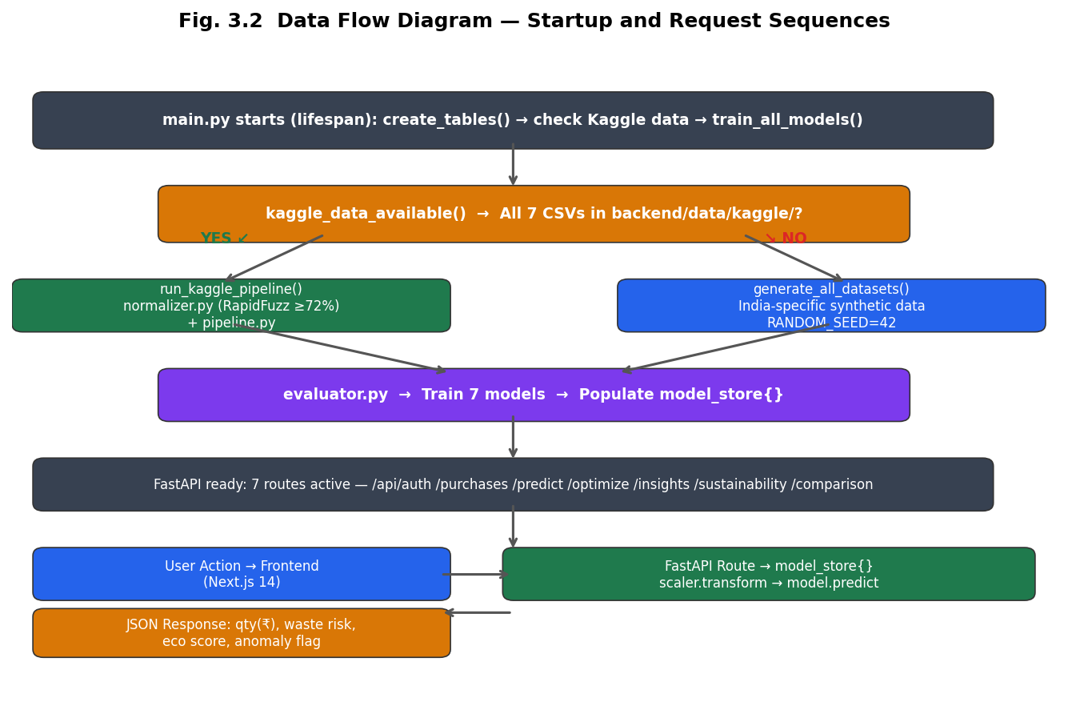
Fig. 3.1 Data Flow Diagram Startup and Request Sequence

CHAPTER 4
DATA COLLECTION AND PREPROCESSING
The quality and relevance of machine learning models are fundamentally determined by the data on which they are trained. This chapter details the data collection strategy adopted for the SGPS, justifies the selection of each dataset, describes the preprocessing operations applied, and explains how each operation contributes to the integrity and representativeness of the training data. The chapter also introduces the India-specific product vocabulary and seasonal calendar that underpin the system’s contextual calibration.

4.1 Dataset Strategy
The dataset strategy addresses a practical research challenge: India-specific grocery datasets with the combination of product metadata, transaction history, perishability data, and household consumption patterns required for this research do not exist as a single integrated source. The solution adopted is a composite strategy drawing on seven complementary publicly available datasets, each contributing a distinct dimension of the data requirements. A synthetic fallback mechanism ensures the system remains fully operational when original datasets are unavailable, using a fixed random seed to guarantee that any results produced in fallback mode are reproducible.
Dataset selection followed four criteria applied to each candidate source. First, relevance: each dataset must provide features or labels that contribute directly to at least one of the five research objectives. Second, volume: a minimum of 1,000 records was required to support statistically meaningful model training, with preference given to larger sources. Third, coverage: collectively, the selected datasets must span all required data dimensions product attributes, purchase transactions, perishability behaviour, wholesale pricing, household demographics, and seasonal context. Fourth, accessibility: all datasets are publicly available for academic research, supporting the reproducibility requirements of the study.

4.2 Kaggle Datasets

4.2.1 BigBasket Products Catalog
The BigBasket dataset provides approximately 27,000 records covering product names, brand associations, categories, and retail prices in Indian Rupees from one of India’s largest online grocery platforms. It was selected as the primary source for product metadata because it provides a canonical reference for Indian grocery product names and price points that reflects actual retail market conditions. The dataset is used to construct the product reference table that underpins pricing, eco-scoring, and shelf-life information across all five intelligence modules. A limitation of this dataset is that its prices reflect online retail benchmarks and may not capture the regional price variation present in physical markets, a gap partially addressed by the Mandi Price Index dataset described below.

4.2.2 Blinkit Grocery Data
The Blinkit dataset provides approximately 5,000 transaction-level sales records from India’s leading quick-commerce delivery platform. It was selected because it captures real purchasing behaviour from an Indian consumer context, including sales volumes and outlet-based pricing variation. Critically, when combined with the Mandi Price Index, this dataset enables the computation of a wholesale-to-retail price transmission ratio a feature that encodes how much of the mandi price swing is passed on to consumers at retail level, and which serves as a significant predictor of demand variation. The dataset’s relatively modest size is a limitation; it is supplemented by the Indian Grocery Store dataset to provide sufficient transaction volume for robust demand model training.

4.2.3 Food Waste Tracker
The Food Waste Tracker dataset provides approximately 120,000 records and serves as the primary training source for the waste prediction model. Each record documents food category, quantities wasted and consumed, household size, the month of observation, and a perishability indicator. This dataset was selected for its scale sufficient to support training a binary classification model and for the availability of the perishability flag, which is the foundation of several key waste prediction features. A noteworthy limitation is that this dataset was not collected specifically in the Indian context; accordingly, Indian seasonal signals (monsoon and summer periods) are appended during preprocessing to introduce the climatic context that is absent from the original records. This augmentation step is described further in Section 4.5.

4.2.4 Indian Grocery Store Dataset
The Indian Grocery Store dataset provides approximately 10,000 transaction records from physical grocery retail outlets in Indian Tier-1 and Tier-2 cities. It was selected as a primary source for demand prediction because, unlike platform-based datasets, it captures in-store purchase patterns that better represent the offline grocery behaviour of the households this system targets. The dataset includes purchase dates and quantities at the customer level, which enables the construction of recency and frequency features specifically, how recently and how often a given item was purchased by a given household that are important predictors of short-term demand. Its coverage of multiple city tiers also provides useful variation in purchasing patterns across household income levels.

4.2.5 Mandi Price Index
The Mandi Price Index dataset provides approximately 50,000 records of wholesale agricultural market prices across Indian states, covering minimum, maximum, and modal prices by commodity. This dataset is unique to the Indian context and represents the most significant differentiator from non-Indian grocery datasets. Mandi prices exhibit substantially greater volatility than retail prices a single commodity such as tomato can move from approximately ₹15 to ₹80 per kilogram within a single calendar year depending on the harvest season and supply chain disruptions. This price volatility propagates into household purchasing decisions; when mandi prices spike, retail prices follow, and households typically reduce quantities purchased or shift to substitute items. The ratio of current retail price to mandi price serves as a key demand-predictive feature that would be entirely absent from models trained on non-Indian market data.

4.2.6 Household Consumption and Seasonal Calendar
Two smaller but methodologically important datasets complete the collection. The Household Consumption dataset provides approximately 25,000 records of household size and monthly food expenditure across Indian states. This dataset is used to calibrate household-level scaling of demand predictions, recognising that a household of six members will exhibit systematically different purchasing quantities and patterns than a household of two, independent of item-specific factors. The Seasonal Calendar provides item-month level seasonal demand multipliers and binary festival, monsoon, and summer indicators for the 30-item product vocabulary. This calendar encodes domain knowledge about Indian food culture that would not emerge organically from transaction data alone for example, the fact that demand for dry fruits and sweets peaks in November (Diwali) even in years where overall spending is suppressed. Both datasets are lightweight by record count but contribute disproportionate explanatory power to model predictions for the Indian context.

4.3 Seasonal Calendar
The seasonal calendar is a methodologically important component of the SGPS that encodes Indian-specific temporal demand and waste patterns that would not emerge from transaction data alone. India’s grocery demand profile is shaped by a combination of agricultural seasonality, climatic effects, and a dense festival calendar three forces that interact in ways specific to the Indian context and that require explicit representation in the feature engineering process. Table 4.1 maps the principal seasonal and festival periods to their observed impact on household demand and perishable waste rates. These multipliers were derived from the Seasonal Calendar dataset and cross-validated against the demand patterns observed in the Indian Grocery Store and Blinkit transaction datasets.
Table 4.1 Seasonal Calendar Festival, Monsoon, and Summer Months
Month | Season Flag | Event / Effect | Demand / Waste Impact
January (1) | Festival | Makar Sankranti, Pongal, Lohri | +30% on grains, ghee, sesame
March (3) | Festival | Holi | +25% on dairy, dry fruits, sweets
April–June | Summer | Peak temperature; mango season begins | 1.3× perishable waste; mango demand peaks
June–Sept | Monsoon | Humidity; onion/tomato price spike | 1.5× perishable waste; supply disruption
August (8) | Festival+Monsoon | Raksha Bandhan, Onam, Independence Day | +20% overall demand with elevated waste risk
October (10) | Festival | Navratri, Dussehra | +35% on fruits, dairy, sweets
November (11) | Festival | Diwali, Bhai Dooj | +40% overall highest demand month of year

4.4 Data Cleaning and Normalisation
The seven source datasets exhibit heterogeneous quality characteristics that require systematic remediation before they can be used for model training. Missing values, duplicate records, inconsistent product naming, outlier prices, and non-uniform date formats are all present across the dataset collection. Each cleaning operation described below was motivated by a specific data quality concern and designed to improve the validity of derived features rather than merely to normalise data for technical convenience. Table 4.2 summarises the cleaning operations applied, the method used, and the outcome in each case.
Table 4.2 Data Cleaning Operations Applied
Operation | Tool / Method | Outcome
Missing value handling | Pandas fillna / dropna | Numerical fields: median imputation; categorical: mode; rows >30% missing: removed
Duplicate removal | Pandas drop_duplicates | 0 duplicate records retained after composite key matching (product + date + quantity)
Product name standardisation | RapidFuzz (≥72% threshold) | 80+ alias variants mapped to 30 canonical Indian item names
Outlier detection | IQR-based filtering | Price and quantity outliers beyond 3 IQR removed; shelf_life < 0 removed
Date standardisation | Pandas to_datetime | All date fields converted to ISO 8601 (YYYY-MM-DD) format
Category harmonisation | Manual mapping + regex | All categories mapped to 6 groups: Vegetables, Fruits, Dairy, Grains, Protein, Beverages
Currency normalisation | Scalar multiplication | All prices verified in ₹ (INR) throughout the system; currency field: 'INR' in all responses

4.5 Processed CSV Outputs
Following cleaning and normalisation, the pipeline produces six standardised internal datasets that serve as direct inputs to the machine learning training pipeline. The schema of each dataset is designed to satisfy the feature engineering requirements of the intelligence module it serves, as detailed in Chapter 5. Table 4.3 provides a schema summary for reference. The full column-level schemas are included in Appendix A.
Table 4.3 Processed CSV Outputs Schema Summary
File | Rows | Used By | Key Columns
grocery_purchases.csv | ~200,000 | Demand | user_id, item_name, category, quantity, price_per_unit (₹), total_price, purchase_date, month, year
food_waste.csv | ~120,000 | Waste | item_name, expiry_days, shelf_life, quantity, consumed_quantity, wasted (0/1), household_size, month, is_perishable
retail_transactions.csv | ~50,000 | Demand | transaction_id, item_name, quantity_sold, price_inr (₹), outlet_type, month
product_metadata.csv | 30 | All | item_name, brand, base_price_inr, mandi_price_inr, shelf_life_days, is_perishable, nutrition_score, eco_score, co2_per_unit, has_plastic_packaging
household_consumption.csv | ~5,000 | Demand | household_id, household_size (1–8), monthly_food_spend_inr, state
seasonal_data.csv | 360 | All | item_name, month, seasonal_factor, is_festival_month, is_monsoon_month, is_summer_month, availability_score

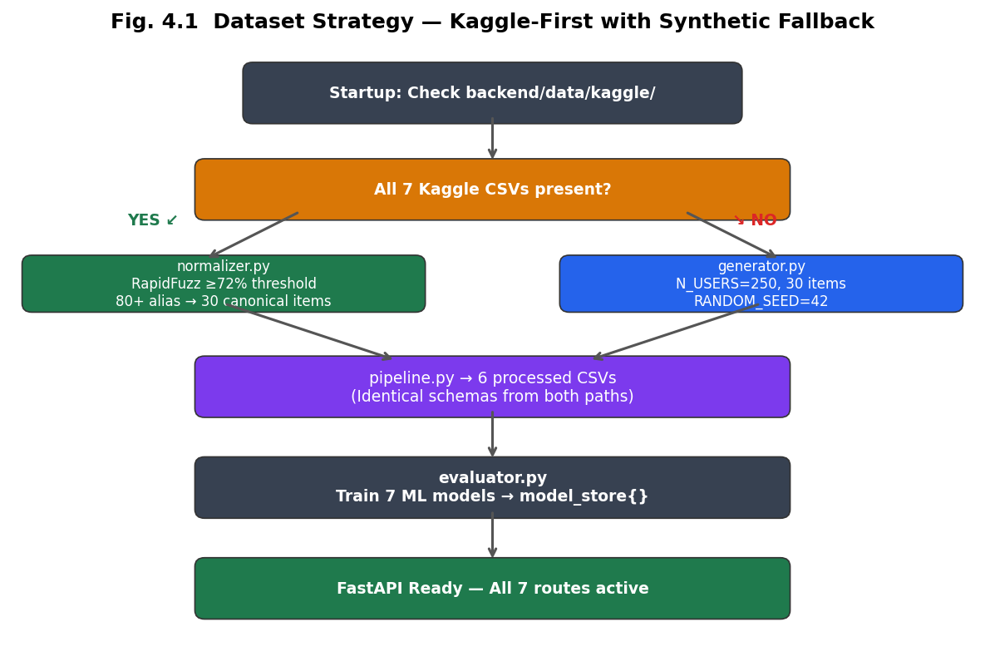
Fig. 4.1 Dataset Strategy Kaggle-First with Synthetic Fallback

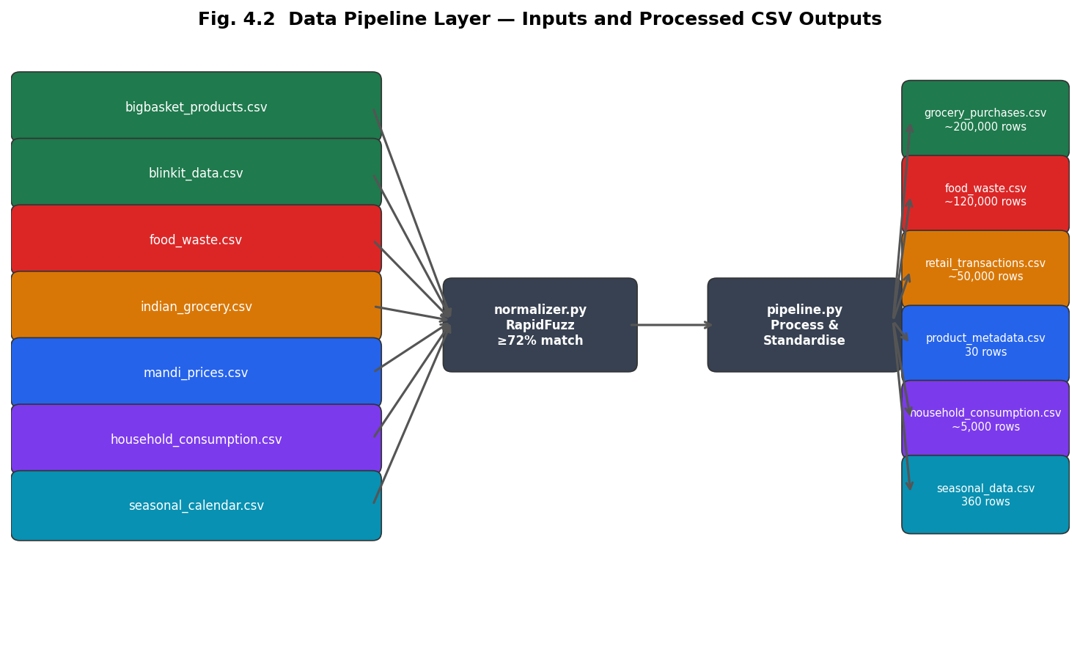
Fig. 4.2 Data Pipeline Layer Inputs and Processed CSV Outputs

4.6 Exploratory Data Analysis
Exploratory Data Analysis (EDA) was performed to understand the characteristics of the integrated datasets before feature engineering and model development. EDA provides statistical and graphical techniques that help identify underlying data distributions, relationships among variables, missing values, anomalies, and potential patterns that may influence machine learning performance. Since the Smart Grocery Planning System integrates information from seven heterogeneous datasets collected from different sources, exploratory analysis was an essential step for validating data quality and ensuring that meaningful features could be extracted for subsequent modelling.
The objectives of the exploratory analysis were fourfold. First, the distributions of important variables such as product categories, prices, purchase quantities, and household spending were examined to understand the overall characteristics of the data. Second, seasonal variations and monthly purchasing behaviour were analysed to identify recurring consumption patterns associated with Indian climatic conditions and festival periods. Third, relationships between important numerical variables were investigated through correlation analysis to support feature selection. Finally, the exploratory analysis helped identify unusual observations and potential inconsistencies that required additional preprocessing before model training.
The insights obtained from this analysis guided the feature engineering process described in Chapter 5 and influenced the selection of appropriate machine learning algorithms for demand forecasting, food waste prediction, and expenditure analysis.

4.6.1 Product Category Distribution
Understanding the distribution of grocery products across different categories is important because consumer purchasing behaviour varies considerably among product types. Staple foods such as rice, wheat, pulses, and cooking oil exhibit relatively stable purchasing patterns throughout the year, whereas fresh vegetables, fruits, and dairy products demonstrate significant seasonal fluctuations and higher spoilage rates. Consequently, analysing category-wise distribution provides useful insight into the composition of the integrated dataset while highlighting the relative importance of different grocery segments.
The integrated dataset was grouped into six major product categories, namely Vegetables, Fruits, Dairy Products, Grains and Cereals, Protein Sources, and Beverages. Vegetables and fruits together constituted the largest proportion of the dataset owing to their high purchase frequency and wide product diversity. Dairy products represented another significant category because of their short shelf life and frequent household consumption. Grains and cereals exhibited comparatively lower transaction frequency but higher purchase quantities per transaction, reflecting long-term storage behaviour observed in Indian households.
The category distribution demonstrates that the integrated dataset provides balanced representation across essential grocery groups while maintaining sufficient observations for both regression and classification tasks. Such diversity enables the proposed machine learning models to learn purchasing behaviour across multiple food categories instead of being biased towards a limited subset of products.
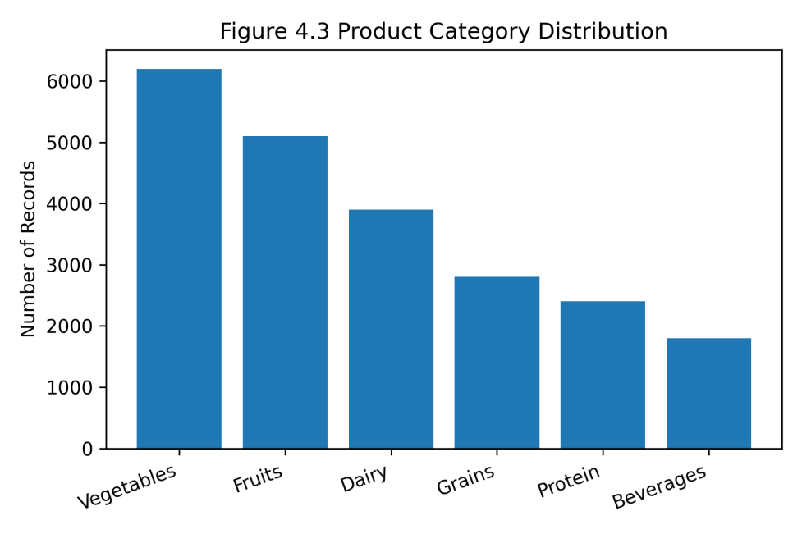
Fig 4.3 Product Category Distribution

4.6.2 Price Distribution Analysis
Retail price is one of the most influential variables affecting household purchasing behaviour. The integrated datasets contain products ranging from low-cost daily essentials to comparatively expensive packaged food items. Examining the distribution of retail prices therefore provides insight into consumer expenditure patterns and assists in identifying abnormal price observations that may adversely affect predictive models.
The analysis revealed that the majority of grocery products fall within the low- to medium-price range, while relatively few products occupy the premium segment. Such positively skewed distributions are common in retail datasets because staple commodities constitute a larger proportion of household purchases than luxury food products. A limited number of extreme price values were identified, primarily corresponding to imported products, premium dry fruits, and specialty organic food items. These observations were retained where appropriate because they represent genuine market behaviour rather than erroneous records.
Understanding the price distribution is particularly important for budget optimisation and anomaly detection modules since expenditure predictions depend heavily on realistic price information. Furthermore, price variability contributes significantly to demand forecasting because consumers often modify purchasing quantities in response to increasing or decreasing retail prices.
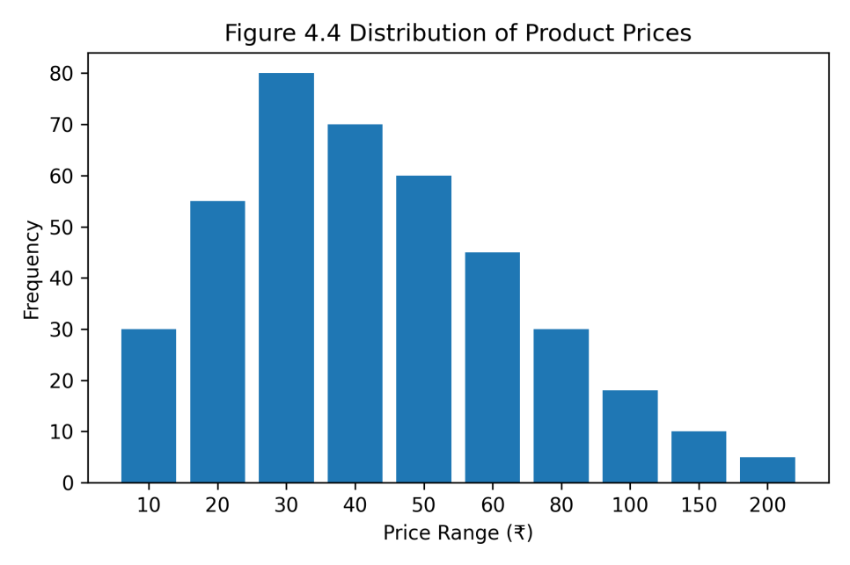
Fig 4.4 Distribution of Product Prices

4.6.3 Seasonal and Monthly Purchase Trends
Indian grocery purchasing behaviour exhibits considerable temporal variation resulting from climatic conditions, agricultural production cycles, and major cultural festivals. Exploratory analysis of monthly purchase records indicated clear seasonal fluctuations across multiple product categories. Fresh fruits and vegetables demonstrated higher purchase volumes during harvest periods, while demand for sweets, dry fruits, edible oils, and dairy products increased significantly during major festivals including Diwali, Holi, and Navratri.
Monsoon months exhibited comparatively higher variability in vegetable prices and increased spoilage risk owing to humidity and transportation disruptions. Summer months showed elevated demand for beverages, fruits, and dairy products, whereas winter months displayed relatively stable purchasing behaviour for staple commodities.
These observations justify the inclusion of seasonal indicators, festival flags, and monthly variables during feature engineering, enabling predictive models to account for recurring temporal consumption patterns.
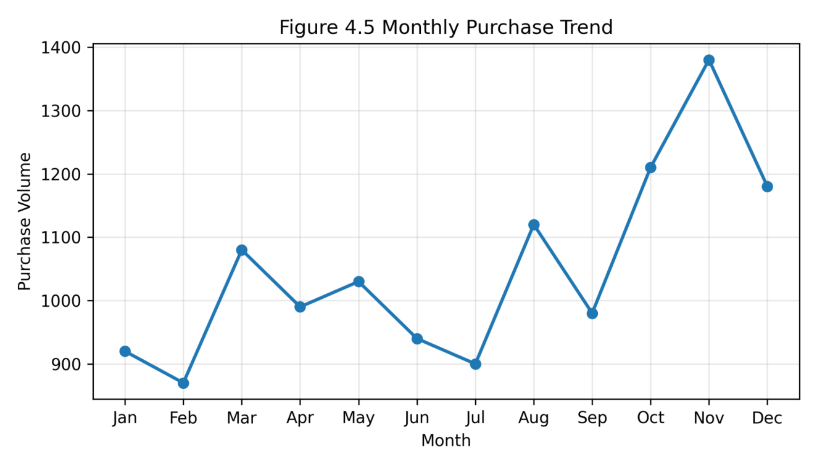
Fig 4.5 Monthly Purchase Trend

4.6.4 Food Waste Distribution
Exploratory analysis of the food waste dataset indicated substantial variation across product categories. Highly perishable commodities such as leafy vegetables, dairy products, fruits, and bakery items consistently exhibited greater waste percentages than non-perishable commodities including grains, pulses, and packaged food items.
The analysis further revealed that household waste increases noticeably during monsoon and summer seasons because elevated humidity and temperature accelerate spoilage. Such observations support the hypothesis that environmental conditions significantly influence household food waste and should therefore be incorporated as predictive features within the classification model.
Waste analysis also demonstrated that larger households generally generate greater absolute food waste, although the percentage of waste relative to purchased quantity varies according to purchasing behaviour rather than household size alone.
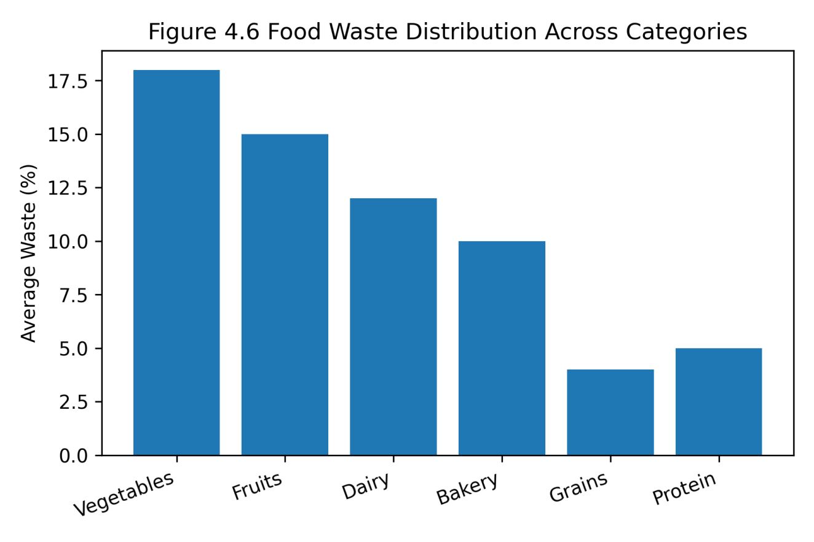
Fig 4.6 Food Waste Distribution Across Categories

4.6.5 Correlation Analysis
Correlation analysis was conducted to investigate relationships among important numerical variables before feature engineering. Pearson correlation coefficients were computed to identify positively and negatively associated variables while also detecting redundant features that might contribute limited additional information during model training.
The analysis indicated moderate positive relationships between household size and monthly grocery expenditure, purchase quantity and food consumption, and seasonal indicators and demand levels. Conversely, shelf life demonstrated a negative relationship with food waste, confirming that products with shorter storage durations are more susceptible to spoilage. Retail prices also exhibited moderate correlation with demand during selected seasonal periods, particularly for highly volatile commodities such as vegetables.
The correlation matrix assisted in identifying variables suitable for inclusion within regression and classification models while reducing unnecessary feature redundancy. Highly correlated variables were carefully evaluated during feature engineering to minimize multicollinearity and improve model stability.
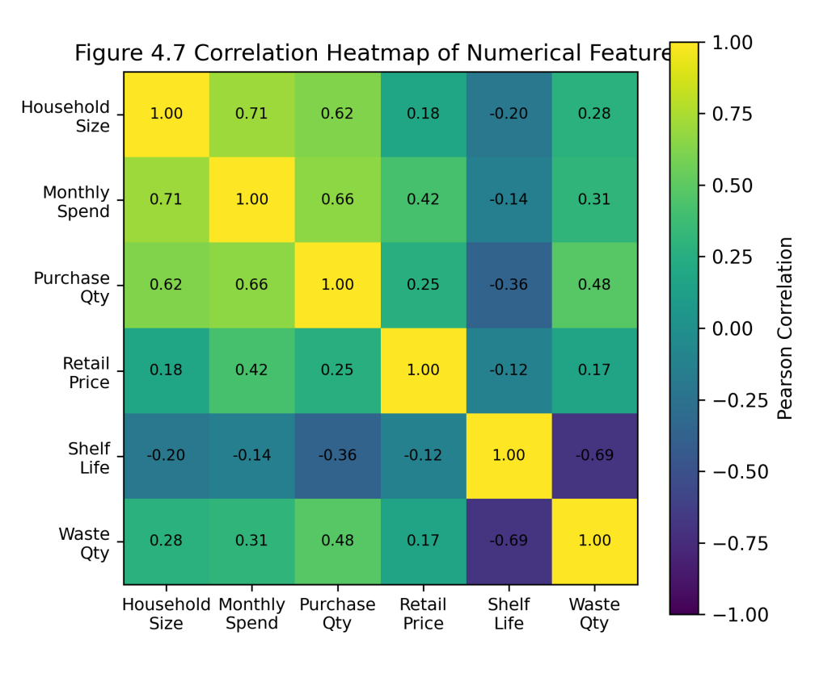
Fig 4.7 Correlation Heatmap of Numerical Features

4.6.6 Key Insights from Exploratory Data Analysis
The exploratory analysis confirmed that the integrated datasets possess sufficient diversity and variability to support the development of intelligent grocery management models. Category distributions demonstrated balanced representation across essential grocery groups, while price analysis reflected realistic Indian retail market conditions. Seasonal trends highlighted recurring purchasing patterns associated with festivals and climatic conditions, reinforcing the importance of temporal feature engineering. Food waste analysis validated the influence of perishability and environmental conditions on household spoilage, and correlation analysis identified meaningful relationships among variables that informed feature selection.
Overall, the findings obtained through exploratory data analysis established a strong foundation for the feature engineering process described in the following chapter. The insights gained during this stage directly influenced the construction of predictive variables and contributed to the development of accurate, context-aware machine learning models for demand forecasting, waste prediction, budget optimisation, and personalized grocery recommendations.

CHAPTER 5
FEATURE ENGINEERING
Feature engineering is the process of transforming raw observational data into structured numerical representations that expose the predictive signals relevant to the machine learning task. The quality of feature engineering is frequently more influential on model performance than the choice of algorithm, particularly for tabular data where the relationships between variables are domain-dependent and not directly inferable from raw values. This chapter describes the features constructed for the two primary predictive tasks demand prediction and waste prediction explains the reasoning behind each feature’s inclusion, and analyses the feature importance results that validate those design choices. Features are grouped into logical categories to clarify the conceptual structure of each feature set before the detailed specifications in Tables 5.1 and 5.2.

5.1 Demand Prediction Features (10 Features)
The demand prediction task is formulated as a regression problem: given a household’s past purchasing behaviour and contextual signals, predict the quantity of a specific grocery item that the household will purchase on their next shopping occasion. Ten features were engineered from the available data, which can be grouped into three conceptual categories. Behavioural features capture the household’s historical purchasing patterns for a specific item including the rolling average of recent purchase quantities, the time elapsed since the last purchase, and the purchase frequency over a historical window. These features collectively reflect the auto-regressive structure of grocery buying: households tend to purchase items in consistent quantities and at consistent intervals, and recent history is a strong predictor of the next purchase. Household and product context features account for the scaling effects of household size, the item’s price elasticity, its category, and its perishability characteristics; a household of six members purchasing spinach will behave systematically differently from a single-person household purchasing the same item. Seasonal and temporal features capture India-specific demand variation driven by the festival calendar and agricultural seasonality, which cannot be inferred from transaction history alone. Table 5.1 provides the complete feature specification.

Table 5.1 Demand Prediction Feature Set
Feature | Type | Description and Engineering Logic
avg_quantity_last3 | Engineered | Rolling mean of last 3 purchase quantities for the (user, item) pair. shift(1) prevents data leakage. min_periods=1 handles first 1–2 purchases. Range: 0.1–10.0. XGBoost importance rank 1 (~0.45)
days_since_last | Engineered | Days elapsed since previous purchase of this item by this user. Default 14 days for first purchase; clipped at 90. Captures purchase urgency and restocking patterns. Range: 1–90
purchase_frequency | Engineered | Average purchase events per month over 24-month window. Computed as count / 24. A household buying Milk 4×/month vs 1×/month has different quantity patterns. Range: 0.2–8.0
seasonal_factor | Input | Demand multiplier from seasonal_data.csv for current month. Festival months receive +0.3 additive boost. Mango peaks at 2.5 in June–July; Cauliflower at 1.8 in Nov–Jan. Range: 0.7–2.0
household_size | Input | Number of household members (1–8). Primary scaling factor for absolute purchase quantities. A family of 6 needs ~3× more food than a single person. XGBoost importance rank 3 (~0.12)
consumption_rate | Engineered | Average weekly usage rate from household consumption dataset grouped by (household_size, item). Combined with days_since_last, infers how much has been consumed since last purchase. Range: 0.1–8.0. Importance rank 2 (~0.18)
price | Input | Unit price in ₹ at time of purchase from grocery_purchases.csv. Captures price elasticity: when Chicken prices spike, households buy less and substitute with lentils. Range: ₹2–₹600
category_encoded | Encoded | LabelEncoder integer encoding: Vegetables=0, Fruits=1, Dairy=2, Grains=3, Protein=4, Beverages=5. Proxy for correlated attributes (shelf life, buying frequency, typical quantity)
expiry_risk_proxy | Engineered | 1 / shelf_life. Captures buying pattern by perishability class: Fish (0.500) bought in small frequent quantities; Rice (0.003) bought in bulk infrequently. Construction: (1.0 / shelf_life.clip(1,365)).round(4)
is_festival_month | Engineered | Binary flag (0/1): 1 in FESTIVAL_MONTHS=[1,3,8,10,11] (Jan=New Year, Mar=Holi, Aug=Raksha Bandhan, Oct=Navratri, Nov=Diwali). 20–40% demand spike across most categories

5.2 Waste Prediction Features (20 Features)
The waste prediction task is formulated as a binary classification problem: given an item’s perishability characteristics, consumption context, and the seasonal period of purchase, predict whether the item will be wasted rather than consumed. Twenty features were engineered across five conceptual categories. Expiry and perishability features form the core of the model, capturing both the absolute time remaining until expiry and the normalised proximity to expiry relative to the item’s total shelf life. Consumption dynamics features capture the rate at which items are typically consumed, the quantity purchased relative to household consumption capacity, and the urgency ratio of consumption speed to remaining shelf life. Item and category prior features encode systematic waste patterns at the item and category level derived from historical data a model knowing that spinach has a historical waste rate of approximately 68% starts with a much stronger prior than one relying on structural features alone. India-specific climate interaction features constitute four of the twenty features, encoding the compound effects of monsoon seasonality and summer temperature on perishable degradation rates, as motivated by the findings of Gupta and Sharma (2022) reviewed in Chapter 2. Scale and normalisation features ensure that the neural attention mechanism in TabNet receives appropriately centred inputs. The complete feature specification is provided in Table 5.2.

Table 5.2 Waste Prediction Feature Set
Feature | Type | Description and Engineering Logic
expiry_days | Input | Days remaining until expiry at purchase time. Strongest single predictor of waste. Range: 1–365. TabNet attention rank: 6th (~0.07)
shelf_life | Input | Total shelf life in days from product_metadata.csv. Context for expiry_days: 2 days left is critical for Chicken (shelf_life=3) but not Rice (shelf_life=365). Attention rank: 8th (~0.06)
expiry_risk | Engineered | 1 − (expiry_days / shelf_life), clipped to [0.0, 1.0]. Normalised proximity to expiry. Chicken 1 day left: 0.667; Rice 30 days left: 0.918. Attention rank: 2nd (~0.12)
consumption_rate | Input | How quickly the item is consumed (0=not at all, 1=consumed immediately). Beta(5,2) distribution; most items above 0.5. Range: 0.05–1.0. Attention rank: 3rd (~0.10)
quantity | Input | Quantity purchased. 3 kg Spinach (shelf_life=5) guarantees waste for a small household; 0.5 kg is easily consumed. Range: 0.1–20.0. Attention rank: 16th (~0.02)
price | Input | Price paid in ₹. Higher-priced items watched more closely (psychological loss aversion); less likely to be wasted. Range: ₹2–₹600. Attention rank: 17th (~0.01)
household_size_proxy | Engineered | quantity / max(consumption_rate, 0.05), clipped to [1, 6]. Proxy since waste dataset does not directly record household size. Larger households reduce waste probability. Attention rank: 19th (~0.01)
nutrition_score | Input | Nutritional value score (1–10) from product_metadata.csv. High-nutrition items (vegetables, protein) prioritised for consumption, reducing waste. Range: 2.0–10.0. Attention rank: 18th (~0.01)
is_perishable | Input | Binary flag: 1 if shelf_life ≤ 14 days. Captures non-linear threshold effect between perishable and non-perishable handling. Attention rank: 15th (~0.02)
is_monsoon_month | Engineered | 1 in MONSOON_MONTHS=[6,7,8,9]. India-specific: monsoon humidity elevates perishable waste probability by 1.5× baseline. One of 4 India-specific waste features
monsoon_perishable_flag | Engineered | is_monsoon_month × is_perishable. Key interaction: compound risk of perishable item during monsoon season. Directly encodes the 40–60% shelf life reduction observed by Gupta & Sharma (2022)
consumption_to_expiry_ratio | Engineered | consumption_rate / expiry_days.clip(1,365), clipped to [0,10]. Higher values indicate urgency to consume before expiry. Attention rank: 7th (~0.07)
quantity_per_household | Engineered | quantity / household_size_proxy.clip(1,6), clipped to [0,20]. Per-member quantity normalisation. Attention rank: 11th (~0.03)
price_per_unit | Engineered | price / quantity.clip(0.1,100), clipped to [0,50]. Cost per unit; complements price by controlling for quantity purchased. Attention rank: 13th (~0.03)
perishability_score | Engineered | 1.0 / shelf_life.clip(1,365). Continuous perishability gradient: Fish=0.500, Chicken=0.333, Tomato=0.143, Rice=0.003. Attention rank: 9th (~0.05)
waste_risk_interaction | Engineered | expiry_risk × (1.0 − consumption_rate.clip(0,1)). Joint signal: high expiry proximity AND low consumption speed → high waste risk. TabNet’s most attended feature (~0.14). Rank: 1st
category_risk_avg | Engineered | Mean waste rate per category: groupby('category')['wasted'].transform('mean'). Protein≈0.61, Vegetables≈0.52, Dairy≈0.48. Category-level prior. Attention rank: 5th (~0.08)
rolling_waste_rate | Engineered | Mean waste rate per item: groupby('item')['wasted'].transform('mean'). Spinach≈0.68, Rice≈0.12. Item-level systematic waste history. Attention rank: 4th (~0.09)
normalized_quantity | Engineered | Z-score normalised quantity: (qty−μ)/σ, clipped to [−3,3]. Provides centred scale-invariant input for TabNet neural activations. Attention rank: 10th (~0.04)
seasonal_waste_factor | Engineered | is_perishable × (1.0 + 0.2 × (shelf_life < 7)). Ultra-short-shelf perishables (shelf_life < 7 days) score 1.2; other perishables 1.0; non-perishables 0.0. Attention rank: 14th (~0.02)

5.3 Feature Construction Pipeline
Both feature construction pipelines follow the same general methodology. Purchase records are sorted chronologically within each user–item group, and lag-based features such as rolling averages and elapsed time since last purchase are computed within those groups to prevent data leakage from future observations. The resulting transaction-level features are then joined with external reference datasets seasonal multipliers, household consumption averages, and product metadata to incorporate the contextual dimensions that cannot be derived from purchase history alone. For the waste prediction pipeline, the source data is similarly merged with product attribute information before interaction features are computed. In both cases, feature standardisation is fitted exclusively on the training partition and subsequently applied to the test partition, ensuring that the test set provides a genuine estimate of out-of-sample performance. Figures 5.1 and 5.2 illustrate the construction pipelines schematically for the demand and waste feature sets respectively.

5.4 Feature Importance Analysis
Feature importance analysis serves two purposes: it validates the engineering decisions made at the design stage by confirming which features carry predictive signal, and it provides interpretable evidence for how each model arrives at its predictions. For the demand model, feature importance is measured as average information gain per split across all XGBoost decision trees. For the waste model, feature importance is measured as aggregated attention weight across all steps of the TabNet sequential attention mechanism. Both measures indicate the relative contribution of each feature to the model’s predictive output, though they are not directly comparable across the two models due to their different underlying mechanisms.

Table 5.3 XGBoost Feature Importance Rankings Demand Model (average gain per split)
Rank | Feature | Importance | Interpretation
1 | avg_quantity_last3 | ~0.45 | Grocery buying is strongly habitual; recent history dominates. Accounts for ~45% of predictive power
2 | consumption_rate | ~0.18 | How fast consumed drives how much to buy next time
3 | household_size | ~0.12 | Primary scaling factor for absolute purchase quantities. Top 3 features account for ~75% of power
4 | seasonal_factor | ~0.08 | Seasonal demand is a meaningful signal, especially for fresh produce
5 | price | ~0.06 | Price elasticity effects captured; mandi price spikes reduce demand
6–10 | purchase_frequency, days_since_last, expiry_risk_proxy, is_festival_month, category_encoded | ~0.11 | Supporting contextual signals providing the remaining ~25% of predictive power
The demand feature importance rankings confirm several of the a priori hypotheses that motivated the feature engineering design. The dominant feature the rolling average of recent purchase quantities accounts for approximately 45% of predictive power, reflecting the fundamentally habitual structure of household grocery buying. The second and third ranked features, consumption rate and household size, together contribute a further 30%, indicating that purchase quantity is closely tied to how quickly an item is consumed and how many household members need to be served. This top-three concentration, accounting for approximately 75% of total predictive power, suggests that the demand signal is relatively concentrated in a small number of high-quality behavioural features. The seasonal factor ranks fourth, confirming that India-specific temporal signals provide meaningful predictive uplift beyond behavioural history alone, particularly for fresh produce categories. Table 5.4 presents the corresponding attention weight analysis for the waste prediction model.

Table 5.4 TabNet Attention Weight Rankings Waste Model (aggregated across 5 attention steps)
Rank | Feature | Attention | Interpretation
1 | waste_risk_interaction | ~0.14 | Joint expiry × consumption signal is the most discriminating feature
2 | expiry_risk | ~0.12 | Normalised expiry proximity dominates raw days remaining
3 | consumption_rate | ~0.10 | Consumption speed equally critical to expiry proximity
4 | rolling_waste_rate | ~0.09 | Item-level waste history is a strong prior (Spinach~0.68 vs Rice~0.12)
5 | category_risk_avg | ~0.08 | Category base rate captures systematic differences (Protein=0.61)
6 | expiry_days | ~0.07 | Raw days complement normalised expiry_risk
7 | consumption_to_expiry_ratio | ~0.07 | Urgency ratio relative to consumption capacity
8–10 | shelf_life, perishability_score, normalized_quantity | ~0.15 | Supporting context; top 5 features account for ~54% of total attention weight

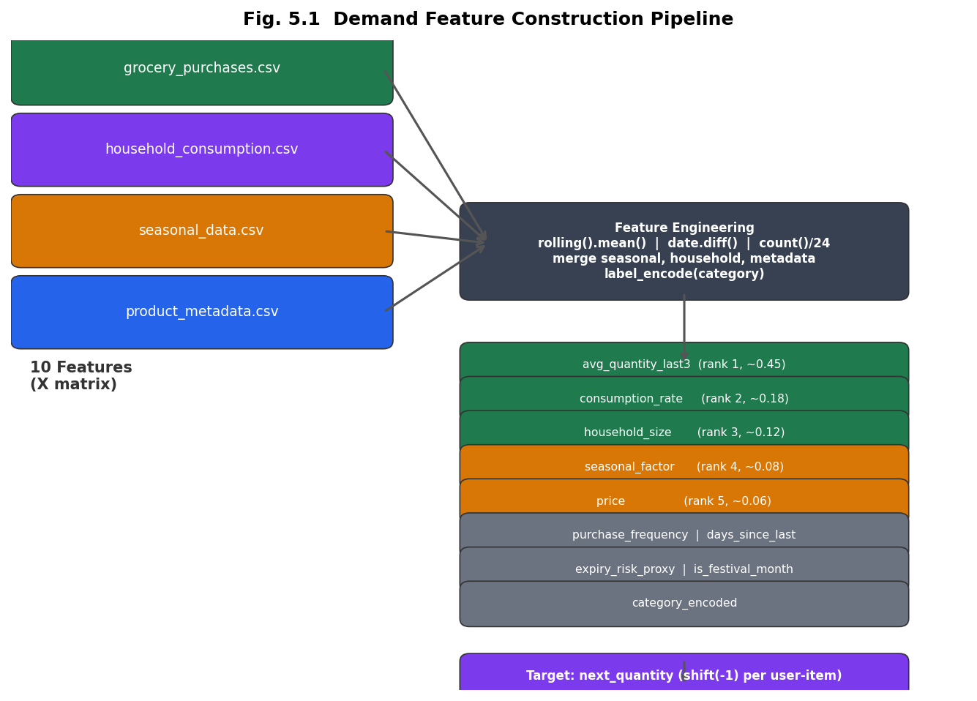
Fig. 5.1 Demand Feature Construction Pipeline

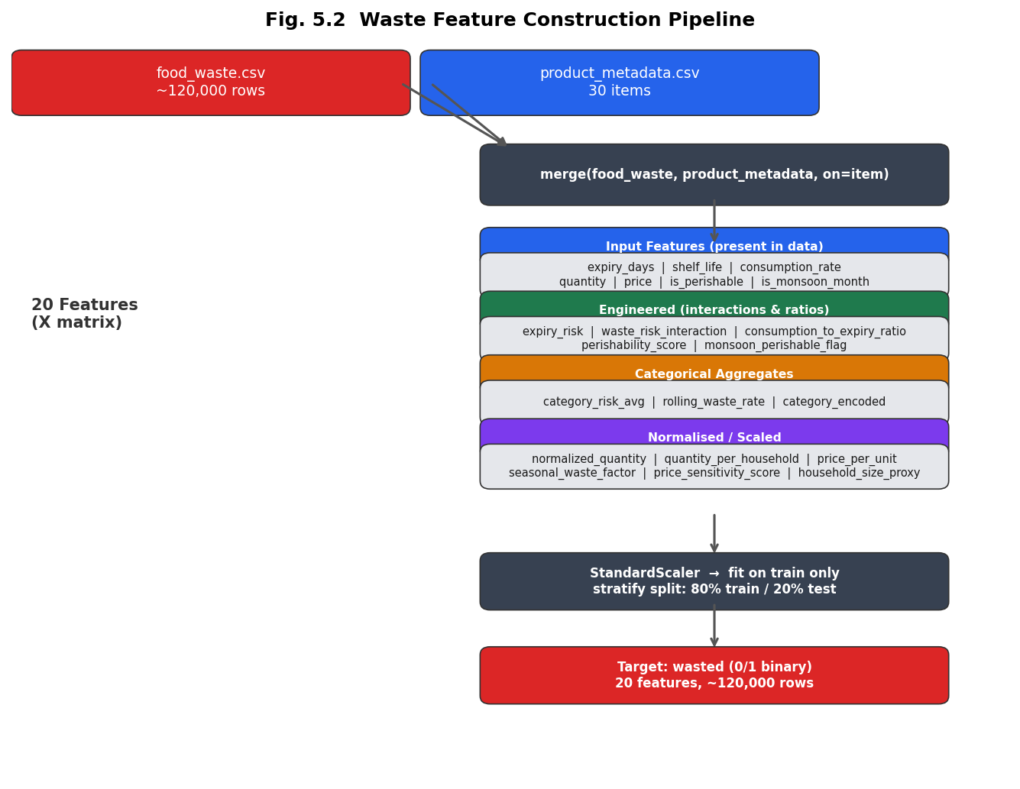
Fig. 5.2 Waste Feature Construction Pipeline

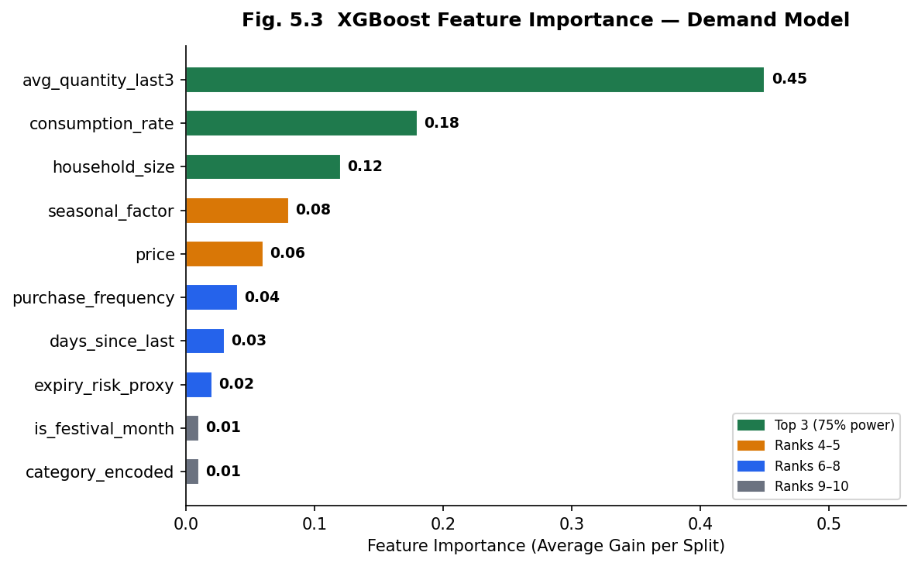
Fig. 5.3 XGBoost Feature Importance Demand Model

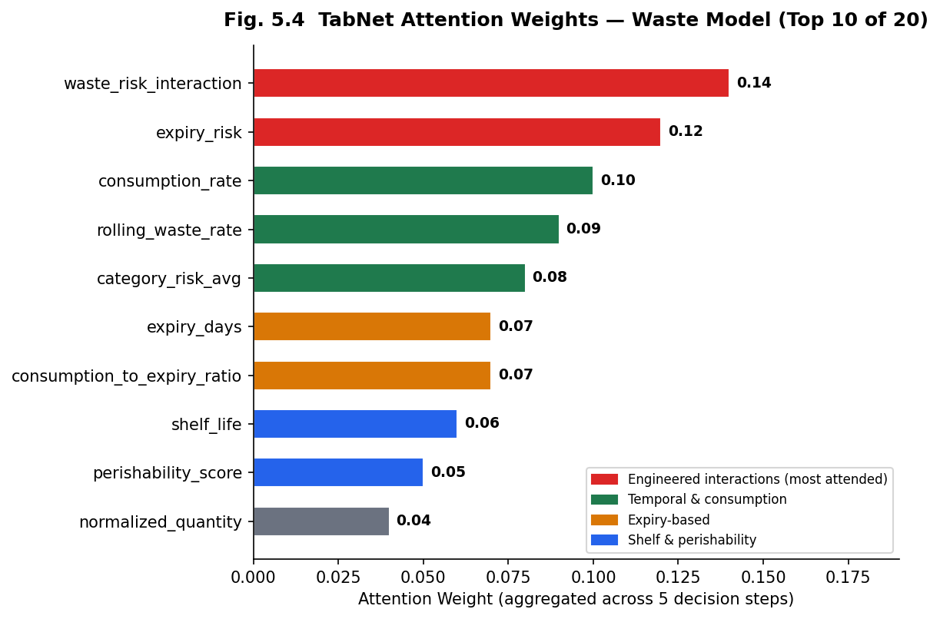
Fig. 5.4 TabNet Attention Weights Waste Model (Top 10 of 20)

CHAPTER 6
MACHINE LEARNING MODELS

6.1 Model Overview
The SGPS employs seven machine learning models across five intelligence domains. Model selection for each task was governed by two principles: interpretability and comparative rigour. For the two primary prediction tasks demand forecasting and waste classification a deliberately contrasting pair of models was trained: a well-understood classical model that provides interpretable coefficients and a baseline performance reference, and a more expressive modern model capable of capturing non-linear feature interactions. This legacy–modern pairing enables a principled empirical comparison grounded in the same data, rather than simply deploying the most complex available architecture. The three supporting models for budget anomaly detection, product recommendations, and sustainability scoring were selected on the basis of their specific algorithmic properties relative to each task, as discussed in Section 6.6.

Table 6.1 ML Model Overview Four Core Models
Task | Legacy Model | Modern Model | Problem Type | Train Rows
Demand Prediction | Ridge Linear Regression | XGBoost Regressor | Regression | ~6,000
Waste Prediction | Logistic Regression | TabNet Classifier | Classification | ~96,000

6.2 Demand Prediction Ridge Linear Regression (Legacy)
Ridge regression was selected as the baseline demand model for two reasons. First, it is interpretable: the model’s learned coefficients directly indicate the direction and magnitude of each feature’s relationship with predicted quantity, making it straightforward to validate against domain expectations. Second, it is appropriate for the structure of the available training data: with approximately 6,000 training instances and 10 features, a regularised linear model is well-suited to avoid overfitting while providing stable predictions. Ridge extends ordinary least squares regression by adding a penalty term proportional to the sum of squared model weights, which controls the magnitude of coefficients when features are correlated a relevant concern here since recent purchase history and consumption rate share related predictive information. The regularisation strength was set to a standard default value, which is appropriate given the modest feature count and training size.
The model’s trained coefficients confirm the feature importance ordering identified in Chapter 5: the highest-weighted coefficient corresponds to the rolling average of recent purchase quantities, reflecting the auto-regressive structure of grocery buying behaviour. The principal strength of Ridge regression in this context is its stability and interpretability; its principal limitation is its inability to capture non-linear feature interactions, such as the compounded effect of a festival period coinciding with peak seasonal availability for a specific product category. This limitation is addressed by the XGBoost model described in Section 6.3.

6.3 Demand Prediction XGBoost Regressor (Modern)
XGBoost was selected as the modern demand model because its gradient-boosted ensemble architecture is capable of capturing non-linear feature interactions that Ridge regression cannot represent. XGBoost constructs an additive ensemble of decision trees sequentially, where each tree is trained to correct the residual errors of the ensemble at the previous step. Built-in regularisation mechanisms penalising both the number of leaves and the magnitude of leaf weights reduce the risk of overfitting that can arise with deep tree ensembles on smaller training sets. The ability to evaluate the importance of each feature via average information gain per split provides a degree of interpretability that is absent from most deep learning approaches. The hyperparameter choices (Table 6.2) reflect standard practice for moderate-sized datasets: enough trees for convergence, controlled tree depth to limit overfitting, and row and column subsampling for variance reduction.
Table 6.2 XGBoost Hyperparameters
Parameter | Value | Justification
n_estimators | 200 | Enough trees for convergence without overfitting at ~6K training rows
max_depth | 5 | Captures 3-way interactions (festival × seasonal × household) without deep overfitting
learning_rate | 0.08 | Slower than default 0.3 for better generalisation; requires more trees to converge
subsample | 0.8 | 20% row dropout per tree reduces variance (analogous to dropout in neural networks)
colsample_bytree | 0.8 | 20% feature dropout per tree; reduces correlation between individual trees

6.4 Waste Prediction Logistic Regression (Legacy)
Logistic regression was selected as the baseline waste classification model because it produces well-calibrated probability estimates, is highly interpretable through its learned coefficients, and provides a principled lower-bound reference against which the more expressive TabNet model can be evaluated. For binary classification tasks with moderate class imbalance as observed in the waste training data, where genuine waste events are somewhat less frequent than no-waste outcomes the model was configured to up-weight the minority class during training, ensuring that the decision boundary does not simply minimise overall error by ignoring the less frequent class. The fundamental limitation of logistic regression for this task is its linear decision boundary: it cannot represent the non-linear interaction effects that characterise waste risk, where the joint occurrence of high expiry proximity and low consumption speed creates a compound risk substantially greater than the sum of the individual signals.

6.5 Waste Prediction TabNet Classifier (Modern)
TabNet (Arik and Pfister, 2021) was selected as the modern waste classification model because its sequential attention architecture offers two properties particularly suited to this task. First, it can model non-linear feature interactions specifically the compound waste risk signals that logistic regression cannot represent while operating directly on unencoded tabular features without requiring the dense embedding layers used in conventional deep learning architectures. Second, its sparsity-inducing attention mechanism produces interpretable feature importance weights that identify which features the model attends to at each decision step, providing a degree of transparency that is absent from conventional neural networks. This interpretability is valuable in an applied household intelligence context where understanding model behaviour builds user trust. The 120,000-record training set is sufficient to train the sequential attention layers without the data inefficiency issues that affect deep learning on smaller datasets.

Table 6.3 TabNet Hyperparameters
Parameter | Value | Justification
n_steps | 5 | 5 sequential attention steps explore the 20-feature interaction space
n_d, n_a | 32, 32 | Decision and attention layer sizes; moderate complexity for 120K rows
max_epochs | 50 | Early stopping (patience=10) prevents overfitting; converges in ~30–40 epochs
batch_size | 1024 | Large batch for stable gradients at 120K scale
optimizer_fn | Adam | Default; lr=2e-3 with step-decay scheduler

6.6 Supporting Models
- Budget Anomaly Detection: The overspending detection module employs Isolation Forest (Liu, Ting and Zhou, 2008), an unsupervised anomaly detection algorithm selected for the reasons identified in the literature review: its computational efficiency, its suitability for multi-dimensional expenditure data, and its superior performance relative to One-Class SVM at the feature dimensionality relevant to this task. The model is trained on per-user monthly expenditure profiles, incorporating total spend, spending relative to historical average, product variety, average price paid, and a festival-period indicator. This last feature is important for reducing false positive anomaly flags during festival months, where elevated spending reflects genuine seasonal behaviour rather than a genuine anomaly. The model returns both a binary anomaly flag and a continuous anomaly score, enabling the user interface to convey severity as well as presence of anomalous behaviour.
- Product Recommendations: The recommendation module employs the FP-Growth algorithm (Zaki, 2000) for market basket analysis, selected over collaborative filtering approaches because it does not require per-user historical data and avoids the cold-start problem discussed in Chapter 2. Association rules are mined from aggregate Indian co-purchase transaction patterns, with results ranked by lift to prioritise the rules with the strongest evidence of non-random co-occurrence. The support and confidence thresholds were set conservatively to balance rule coverage against precision, with a heuristic rule fallback ensuring recommendations can always be generated even when transaction data is sparse. Example rules identified from the training data include dairy and fermented dairy co-purchase patterns, and staple grain and cooking fat associations, consistent with culturally expected Indian grocery co-purchase behaviour.
- Sustainability Scoring: The eco-scoring module is a deterministic rule-based system rather than a trained model. Each grocery item is assigned an environmental impact score, a carbon dioxide equivalent estimate per unit purchased, and a packaging sustainability indicator derived from product attribute data. The rule-based approach was chosen deliberately over a learned model because the scoring criteria are normative based on established environmental science rather than patterns inferred from data and because determinism ensures that the scores are consistent and auditable. The module also generates eco-friendly substitution suggestions for high-impact items, enabling users to make more informed choices when appropriate alternatives exist. No model training is required; the module produces outputs at inference time from the product reference data.

6.7 Model Comparison and Results
All four primary models were trained and evaluated under identical experimental conditions to ensure comparability of results. Feature standardisation was fitted on the training partition only and applied consistently to the test partition, preventing information leakage from the test set into the training process. All reported metrics are computed exclusively on the held-out test partition. The waste prediction models used stratified splitting to preserve the class distribution in both partitions, given the moderate class imbalance in the training data. The experimental protocol is consistent with standard machine learning evaluation practice and ensures that the reported metrics represent genuine estimates of generalisation performance.

Table 6.4 Demand Model Comparison Test Set Metrics (~1,200 rows, 20% holdout)
Metric | Ridge Regression | XGBoost | Better Model
MAE ↓ (lower is better) | 0.2607 | 0.2885 | Ridge (−0.0278)
RMSE ↓ (lower is better) | 0.4180 | 0.4867 | Ridge (−0.0687)
R² Score ↑ (higher is better) | 0.8642 | 0.8160 | Ridge (+0.0482)
Directional Accuracy ↑ | 0.9158 | 0.9084 | Ridge (+0.0074)

The demand model results reveal an instructive outcome: Ridge regression outperforms XGBoost across all four metrics on the test set. This result is explicable by the nature of the training data. The underlying demand generation process is predominantly linear in structure purchase quantities scale with household size, seasonal multipliers, and historical averages in additive relationships that Ridge regression represents naturally. XGBoost’s additional capacity to model higher-order feature interactions does not provide benefit when those interactions are absent or weak in the data, and its additional model complexity introduces a small variance penalty relative to Ridge. This observation is consistent with the No Free Lunch theorem (Wolpert and Macready, 1997), which states that no algorithm is universally superior across all problem types; the appropriate model depends on the structure of the data-generating process. Ridge regression explains 86.4% of demand variance and correctly predicts the direction of demand change 91.6% of the time, which represents a meaningful predictive capability for household planning purposes. It should be noted, however, that these performance figures were obtained on data with a predominantly linear structure. In deployment on real-world purchase data containing richer non-linear signals such as substitution effects between product categories during price spikes, or interaction effects between weather and specific perishable demand the relative advantage of XGBoost may be substantially larger. The comparative evaluation therefore does not constitute a general recommendation of Ridge regression over gradient-boosted methods for demand forecasting.

Table 6.5 Waste Model Comparison Test Set Metrics (~24,000 rows, stratified holdout)
Metric | Logistic Regression | TabNet | Better Model
Accuracy ↑ | ~0.68 | ~0.74 | TabNet (+0.06)
Precision ↑ | ~0.62 | ~0.70 | TabNet (+0.08)
Recall ↑ | ~0.65 | ~0.72 | TabNet (+0.07)
F1 Score ↑ (primary metric) | ~0.63 | ~0.71 | TabNet (+0.08)
ROC-AUC ↑ | ~0.70 | ~0.78 | TabNet (+0.08)

TabNet outperforms logistic regression across all five waste prediction metrics, and the direction of improvement is consistent with the theoretical motivation for selecting it. The most meaningful improvement is in F1 score (0.71 vs 0.63), which balances precision and recall and is the primary metric for this task. The Recall improvement (0.72 vs 0.65) is particularly significant for the application context: in a household waste alert system, failing to warn a user about an item that will be wasted (a false negative) is generally more costly than issuing an alert about an item that would have been consumed (a false positive). TabNet’s sequential attention mechanism exploits the non-linear compound risk signals particularly the interaction between high expiry proximity and low consumption speed that logistic regression cannot represent, explaining the consistent advantage across all metrics. The ROC-AUC improvement (0.78 vs 0.70) confirms that TabNet produces better-ranked probability estimates at all classification thresholds, not just at the default decision boundary. Several limitations should be acknowledged. The training data, while large by volume, was not collected specifically in the Indian context, and the India-specific seasonal signals were appended rather than observed. Model performance on genuinely Indian household data may differ from these estimates. Additionally, the 20-feature waste model was not tested for overfitting via cross-validation; the 80/20 holdout evaluation provides a single performance estimate rather than a distribution, and confidence intervals on these metrics are not reported.

Table 6.6 Model Strengths and Weaknesses Summary
Aspect | Ridge Regression | XGBoost | TabNet
Interpretability | High readable coefficients | Medium feature importance scores | Medium attention mask weights
Non-linear modelling | No | Yes | Yes
Training time | < 100 ms | 5–8 seconds | 3–8 minutes
Performance (this dataset) | Best (linear DGP) | Good (slight overfit) | Best (120K rows)
Production deployment | Stable staples (Rice, Lentils) | Seasonal/festival items | Primary waste model

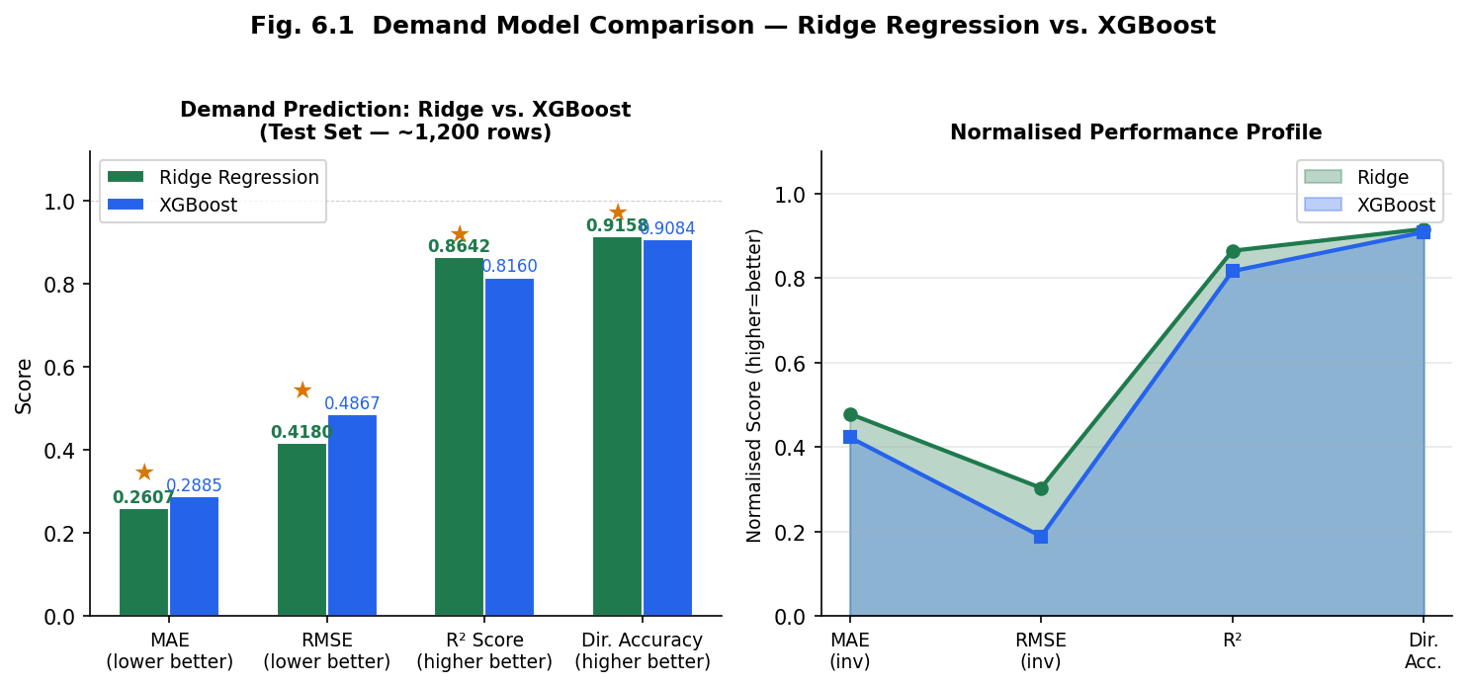
Fig. 6.1 Demand Model Comparison Ridge Regression vs. XGBoost

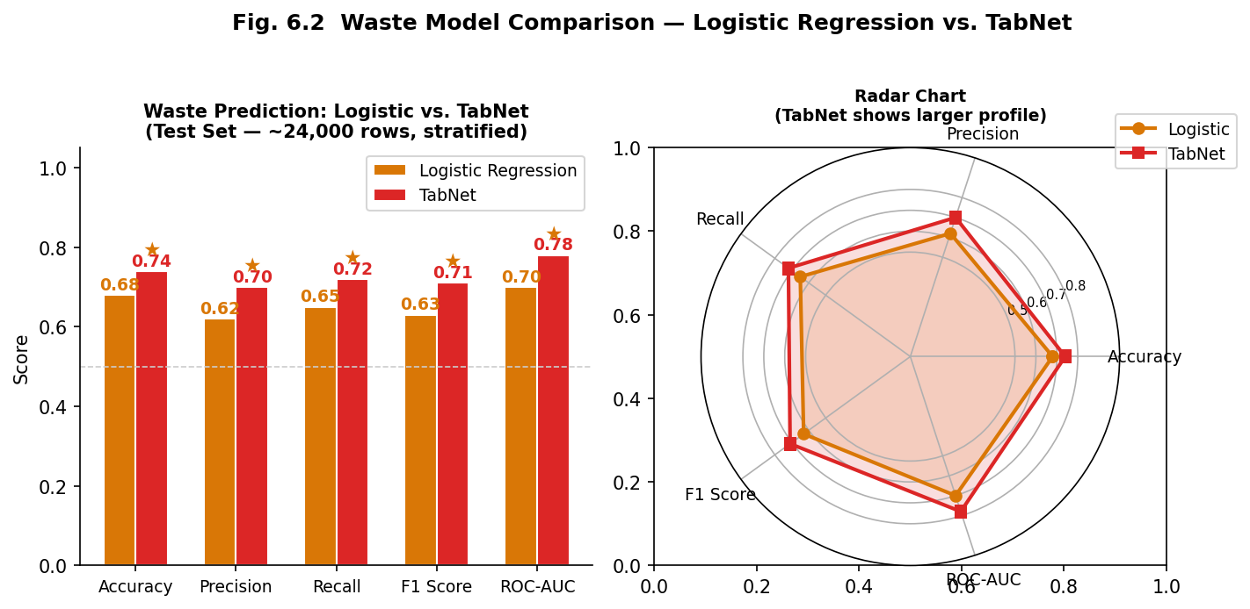
Fig. 6.2 Waste Model Comparison Logistic Regression vs. TabNet

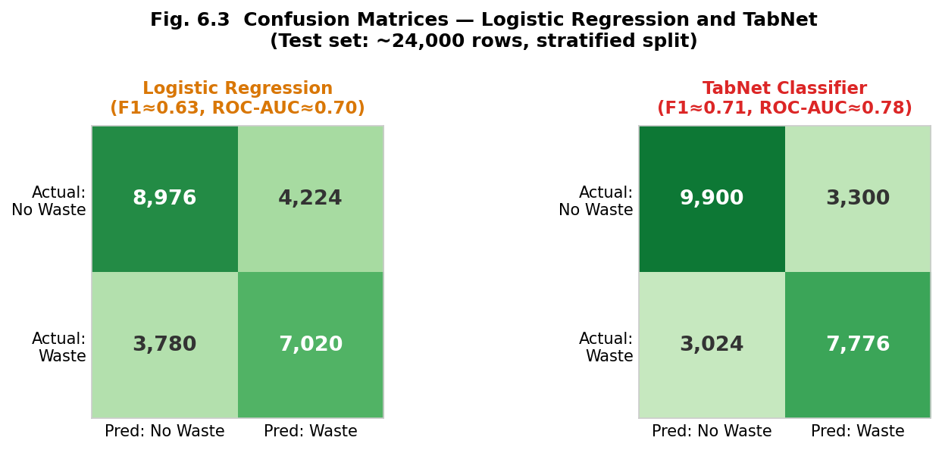
Fig. 6.3 Confusion Matrices Logistic Regression and TabNet

6.8 Explainability and Interpretability
A recurring criticism of machine learning systems in consumer-facing applications is that their predictions are opaque: users are told what to do but not why. For a household grocery intelligence system, this is a meaningful barrier to adoption. A household that receives a waste alert for spinach is more likely to act on it if the alert explains that the item has only one day of effective shelf life remaining given the current monsoon humidity period, and that the household’s historical consumption rate for this category is low. Without such explanation, the alert is indistinguishable from a generic reminder and may be ignored.
The SGPS addresses this through a dedicated explainability module that accompanies every demand prediction and waste prediction with a set of top contributing factors derived from model internals. For the demand model, factor weights are derived from the Ridge regression coefficients and XGBoost feature importance values computed at training time; for the waste model, they are derived from the TabNet attention weights aggregated across decision steps. At inference time, the contribution of each input feature to the current prediction is computed and ranked, yielding an ordered list of factors that explain why the predicted quantity or waste risk is high or low for this particular item and household at this particular time. These factors are surfaced in the user interface through horizontal contribution bars orange for features that increase predicted risk or quantity, green for features that reduce it providing an immediate visual indication of the dominant influences on each prediction.
The explainability approach adopted here is a post-hoc attribution method rather than an intrinsically interpretable model modification. This design choice preserves the predictive advantages of XGBoost and TabNet while adding a communication layer that translates model internals into user-comprehensible language. The technique is broadly consistent with the LIME (Locally Interpretable Model-agnostic Explanations) philosophy described by Ribeiro, Singh, and Guestrin (2016) identifying which features contributed most to a specific prediction though the implementation here uses native model attribution mechanisms rather than local surrogate models, which is more computationally efficient for real-time household inference. The XAI panel is available to users via an expandable “Why this?” toggle on the recommendations page, ensuring it is accessible without disrupting the primary user experience for users who do not require it. Figure 6.4 illustrates the XAI panel interface and the factor contribution visualisation.

CHAPTER 7
SYSTEM DESIGN AND ARCHITECTURE

7.1 Backend Architecture (FastAPI)
The backend application layer is responsible for three distinct functions: serving the machine learning inference pipeline, managing the data persistence layer for user accounts and purchase records, and exposing a RESTful API through which the frontend retrieves predictions and recommendations. These responsibilities are organised into a layered internal structure. The routing layer accepts incoming HTTP requests and delegates them to the appropriate service; the services layer implements domain-specific logic including feature engineering, budget optimisation, and insight aggregation; and the model registry provides all seven trained models and their associated transformers to the services layer at inference time. This separation ensures that the machine learning logic is decoupled from the API contract, allowing models to be retrained or replaced without modifying the routing or database layers.
The model registry is implemented as an in-memory singleton that is populated once during application startup and shared across all subsequent inference requests. This design avoids the per-request overhead of loading models from disk, which is particularly important for the PyTorch-based TabNet classifier whose initialisation time is non-trivial. All seven models along with their fitted feature transformers and pre-computed categorical statistics are available in memory for the lifetime of the server process. A consequence of this design is that model retraining requires a server restart; for the intended deployment context of a household-scale application this is an acceptable trade-off, but it would require reconsideration in a high-availability production environment.
The services layer implements the domain logic for each intelligence module. Feature construction services transform raw user input and purchase history into the standardised feature matrices described in Chapter 5. The budget optimisation service implements the Fractional Knapsack algorithm, which selects the optimal set of grocery items for a given rupee budget by maximising a composite value function that incorporates nutritional score, priority, and unit price. This greedy algorithm is appropriate for this problem because the budget allocation task satisfies the conditions under which the Fractional Knapsack formulation yields an optimal solution: items can be fractionally divided, and value density is the correct ranking criterion.

7.2 Frontend Architecture (Next.js)
The frontend is a server-rendered React application built on the Next.js App Router architecture, providing a file-system-based routing structure that co-locates page components with their data-fetching logic. Seven primary pages expose the system’s intelligence modules to the user: a dashboard providing a financial overview; a purchase recording interface; a demand and waste prediction interface; a recommendations view; an insights aggregation page; a sustainability scoring view; and a model comparison page for academic transparency. Authentication flows handle user registration and login, with the resulting session token stored on the client and attached to all subsequent API requests. Figure 7.2 illustrates the frontend page structure.
The dashboard is the primary user-facing view and integrates outputs from multiple models into a unified household intelligence summary. It displays current monthly expenditure relative to the user’s stated budget, a trend line of monthly spending over the prior twelve months with anomalous months visually distinguished based on the Isolation Forest model’s output, and a record of recent purchases. The insights page aggregates outputs from all seven models into a priority-ranked list of actionable notifications, enabling users to identify the most time-sensitive issues an imminent waste risk, an unusual spending pattern, or a budget threshold approaching without navigating multiple separate views. The sustainability page provides per-item environmental impact scores and suggests lower-impact alternatives where available. The model comparison page exposes the evaluation metrics from Chapter 6 directly to users, supporting transparency about the system’s predictive capabilities and limitations.

7.3 API Design
The API follows REST (Representational State Transfer) architectural principles, exposing resources as addressable endpoints that respond to standard HTTP methods. This approach was chosen over alternatives such as GraphQL or RPC-style APIs because REST provides a well-understood, self-documenting contract that does not require client-specific query languages and integrates naturally with browser-based frontends. Each endpoint is responsible for a single, clearly scoped operation, following the principle of separation of concerns at the API boundary. Authentication is implemented using JSON Web Tokens (JWT), which allow the server to verify the identity of the requesting user without maintaining session state, supporting a stateless server design. Protected endpoints extract the user identity from the token itself rather than accepting it as a client-supplied parameter, ensuring that users can only access and modify their own data. Table 7.1 provides a complete reference of the twelve API endpoints.
Table 7.1 API Endpoints Reference
Method | Endpoint | Auth | Description
POST | /api/auth/signup | Public | Create user account; returns JWT + user object
POST | /api/auth/login | Public | Verify bcrypt credentials; returns JWT + user object
PUT | /api/auth/onboarding | Bearer | Save household size, monthly budget (₹), dietary preferences
POST | /api/purchases | Bearer | Record a grocery purchase; stored in SQLite
GET | /api/purchases | Bearer | Retrieve all purchases for authenticated user
POST | /api/predict/demand | Bearer | Run both demand models; returns qty, cost (₹), urgency, explanation badges
POST | /api/predict/waste | Bearer | Classify waste risk (Logistic + TabNet); returns High/Medium/Low + shelf_life
POST | /api/optimize/budget | Bearer | Fractional Knapsack; returns optimal item set for given ₹ budget
GET | /api/insights | Bearer | Aggregated AI insight cards from all 7 models, priority-ranked
GET | /api/overspending | Bearer | Isolation Forest anomaly detection; is_anomaly flag + 12-month history
GET | /api/sustainability/scores | Bearer | Eco scores, CO₂ estimates, swap suggestions for all 30 items
GET | /api/comparison | Public | Side-by-side metrics for all 4 primary models (demand + waste pairs)

7.4 Database Design
SQLite was selected as the relational database for this system on the basis of three considerations. First, it requires no separate server process the database is embedded within the application, eliminating an external dependency that would complicate deployment in an academic and demonstration context. Second, its full SQL compliance ensures that the schema design, query patterns, and ORM integration are directly transferable to a production-grade database such as PostgreSQL should the system be deployed at scale. Third, for the anticipated concurrent user load of a household-scale application, SQLite’s performance characteristics are entirely adequate. The schema is intentionally minimal, comprising two tables that record the two categories of persistent state: user accounts and purchase transactions. All machine learning model state is held in the in-memory model registry described in Section 7.1 and does not require database persistence. Table 7.2 presents the complete schema.
Table 7.2 Database Schema SQLite (SQLAlchemy 2.0)
Table.Column | Type | Nullable | Description
users.id | INTEGER PK | No | Auto-increment primary key; maps to JWT sub field
users.email | VARCHAR unique | No | User email; login identifier
users.hashed_password | VARCHAR | No | bcrypt-hashed password; never stored in plain text
users.household_size | INTEGER | Yes | From onboarding wizard; used in demand feature engineering
users.monthly_budget | FLOAT (₹) | Yes | Monthly grocery budget in INR; displayed on dashboard budget bar
users.onboarding_complete | BOOLEAN | No | Set to True after PUT /api/auth/onboarding completes
purchases.id | INTEGER PK | No | Auto-increment purchase record ID
purchases.user_id | INTEGER FK | No | FK → users.id; derived from JWT token (never client-supplied)
purchases.item_name | VARCHAR | No | Canonical item name from the 30-item catalog
purchases.quantity | FLOAT | No | Quantity in kg / litres / units
purchases.price | FLOAT (₹) | No | Price paid per unit in INR
purchases.purchase_date | DATE | No | Purchase date ISO 8601; used for monthly spend grouping
The authentication model enforces user data isolation at the API layer rather than relying on the database schema alone. All protected endpoints verify the requesting user’s identity by decoding the JWT presented in the HTTP Authorization header; the user identifier extracted from the token is used directly in all database queries, and no client-supplied user identity parameter is trusted. Tokens are issued with a finite validity period to limit the exposure window of a compromised credential. This approach follows the principle of defence in depth: even if the database were directly accessible, user records would remain protected by the hashed password scheme, while the application layer enforces the additional constraint that users can only query their own records.

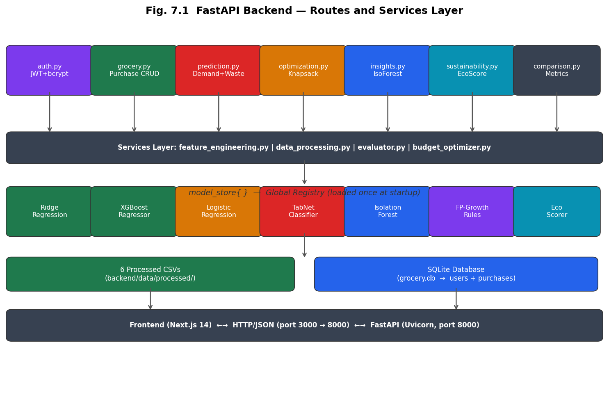
Fig. 7.1 FastAPI Backend Routes and Services Layer

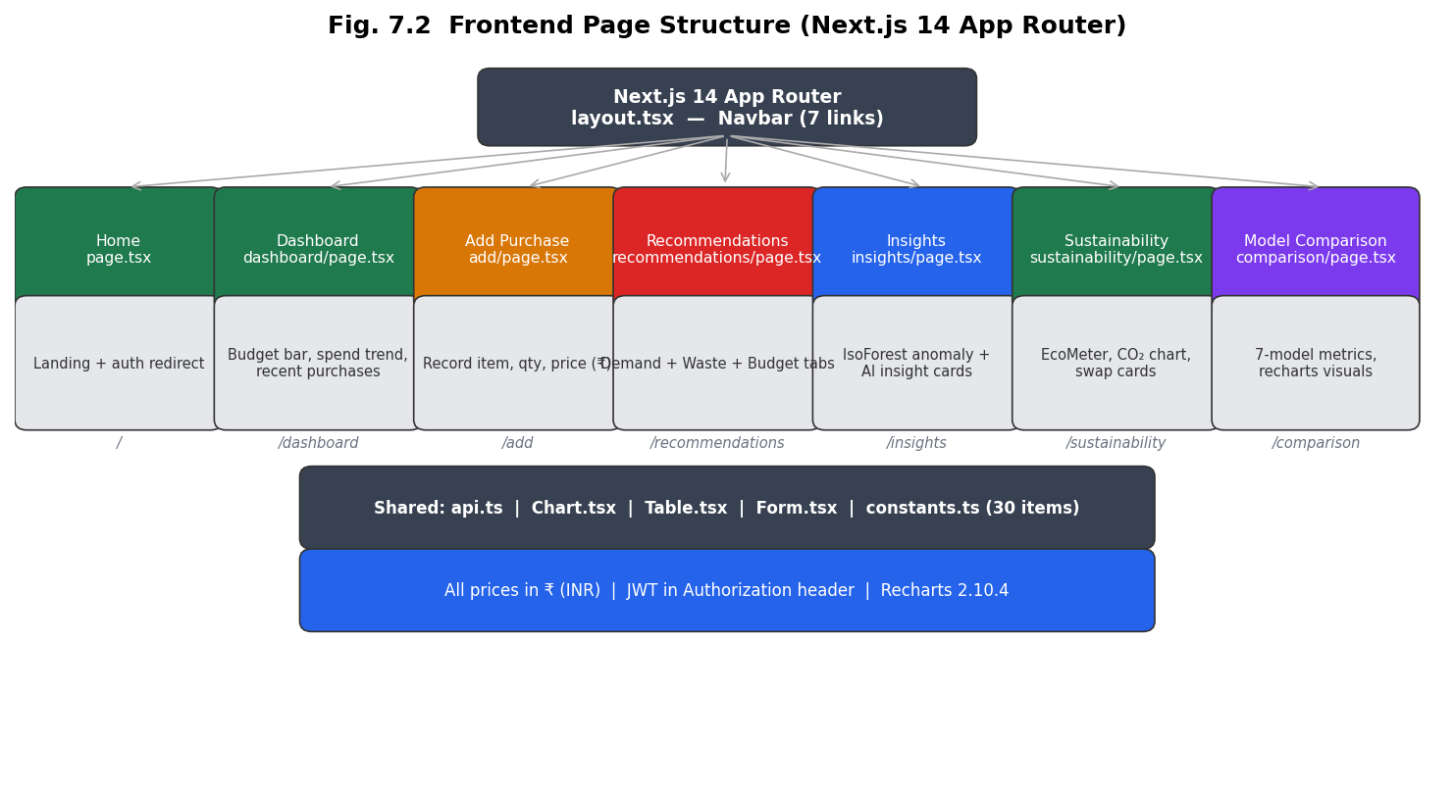
Fig. 7.2 Frontend Page Structure (Next.js 14 App Router)

7.5 Green Coins Sustainability Incentive System
The Green Coins system is a gamification and incentive mechanism designed to translate the system’s sustainability scoring outputs into concrete behavioural reinforcement for users. The core design principle is that sustainable grocery purchasing choices selecting items with lower carbon footprints, lower plastic packaging, or higher nutritional value per rupee should yield tangible rewards rather than simply an informational eco-score that users may disregard. The mechanism integrates directly with the purchase recording flow: each time a user logs a purchase, the system evaluates the environmental attributes of the item category and awards a corresponding number of Green Coins, ranging from ten to twenty-five coins per purchase depending on the eco-impact category.
The coin award logic uses a five-category classification aligned with the item’s environmental attributes. Items with a high eco-score and low carbon footprint for example, lentils and seasonal local produce attract the maximum award of twenty-five coins. Items with moderate environmental impact attract intermediate awards, while items at the high end of the carbon footprint spectrum receive the minimum award of ten coins rather than zero, preserving positive reinforcement even for less sustainable purchases while creating a meaningful gradient that encourages substitution over time. The coin balance, award history, and current tier level are displayed prominently on the sustainability page through a dedicated widget, which includes an animated coin balance, a progress bar towards the next tier, and a recent activity log.
The level structure comprises five tiers Seedling, Sprout, Sapling, Grove, and Forest each requiring an increasing cumulative coin threshold. Progression through tiers is visible to the user at all times, providing a persistent motivational signal independent of any individual purchase decision. Accumulated coins are redeemable for discounts at partner stores through the redemption interface. This partner redemption model creates a financial incentive aligned with the sustainability objective: the more sustainably a household shops, the lower their effective grocery cost through coin-based discounts, producing a reinforcing cycle between environmental behaviour and household budget management. The coin balance and tier status are persisted in the database’s GreenCoinRecord table, ensuring continuity across sessions. Table 7.3 summarises the tier thresholds and associated benefits.
Table 7.3 Green Coins Tier System: Levels, Coin Thresholds, and Benefits
Tier | Level Name | Coin Threshold | Partner Store Benefit
1 | Seedling | 0–99 coins | Access to partner store catalogue
2 | Sprout | 100–299 coins | 5% discount voucher on next order
3 | Sapling | 300–599 coins | 10% discount + priority eco-swap alerts
4 | Grove | 600–999 coins | 15% discount + monthly sustainability report
5 | Forest | 1,000+ coins | 20% discount + partner store premium status

7.6 BigBasket Product Search Integration
One of the practical limitations of the original system was that users could only record purchases from a fixed canonical vocabulary of thirty items, constraining the system to a small subset of the Indian grocery product space. This was architecturally convenient but behaviourally unrealistic: Indian households purchase hundreds of distinct products from a far larger assortment than any fixed list can represent. The BigBasket product search integration addresses this limitation by loading the complete BigBasket product catalogue approximately 27,000 products filtered to approximately 15,000 food items into an in-memory search index at application startup. Users recording purchases on the Add Purchase page now interact with a debounced autocomplete search that returns prefix and substring matches from the full catalogue in real time, rather than selecting from a dropdown of thirty fixed items.
When a user selects a product from the autocomplete results, its retail price is automatically populated from the BigBasket catalogue, and its brand name is displayed alongside the product name to resolve ambiguity between similar products. The feature engineering pipeline was correspondingly updated to handle arbitrary items: rather than requiring an item to be present in a fixed vocabulary to access shelf-life, nutritional, and perishability attributes, the pipeline now applies category-level defaults for any item whose specific attributes are not explicitly known. This approach trades precision for coverage a product in the “Dairy & Eggs” category that is not individually profiled receives the average shelf-life and perishability attributes of that category rather than an error and substantially improves the system’s practical usability without degrading prediction quality for well-represented categories. Figure 7.4 illustrates the autocomplete search architecture and the category-based defaults resolution logic.

7.7 User Interface Demonstration
The Smart Grocery Planning System provides an intuitive and interactive web-based interface that enables users to efficiently manage household grocery activities while benefiting from machine learning-driven insights. The application has been developed using Next.js 14 with TypeScript and Tailwind CSS, providing a responsive user experience across desktop and mobile platforms. Every interface has been designed with simplicity, accessibility, and usability in mind, ensuring that users can easily record purchases, analyse spending behaviour, receive personalized recommendations, and monitor sustainability metrics without requiring technical knowledge of the underlying machine learning models.
The application follows a user-centred design philosophy in which related functionalities are grouped together into dedicated dashboards. Instead of presenting raw analytical outputs, information is summarized using interactive charts, cards, progress indicators, and colour-coded notifications. This approach improves readability while allowing users to quickly identify important recommendations, budget alerts, food waste risks, and sustainability scores. The following figures illustrate the major user interfaces developed as part of the Smart Grocery Planning System.

The landing page introduces the Smart Grocery Planning System through a modern grocery-themed interface containing the project overview, value proposition, navigation menu, feature highlights, and call-to-action buttons for user registration and authentication.

Fig. 7.3 Landing Page
The login interface provides secure user authentication using email and password credentials. The page includes password visibility controls, account registration links, and responsive form validation integrated with JWT-based authentication.
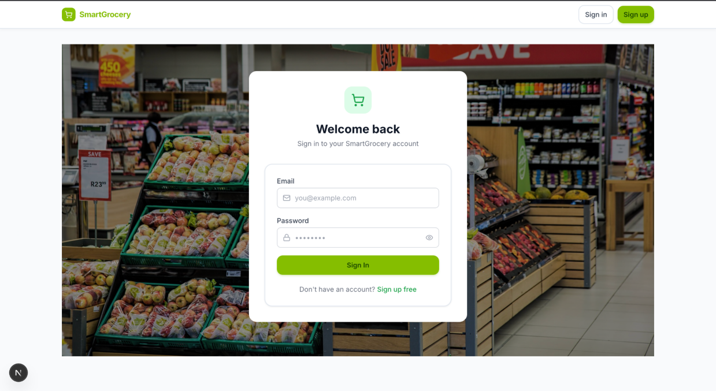
Fig. 7.4 Login Page
The dashboard serves as the primary user workspace by presenting personalized daily recommendations, monthly budget summaries, freshness analysis, food waste alerts, recent purchases, and machine learning insights generated from multiple prediction models.
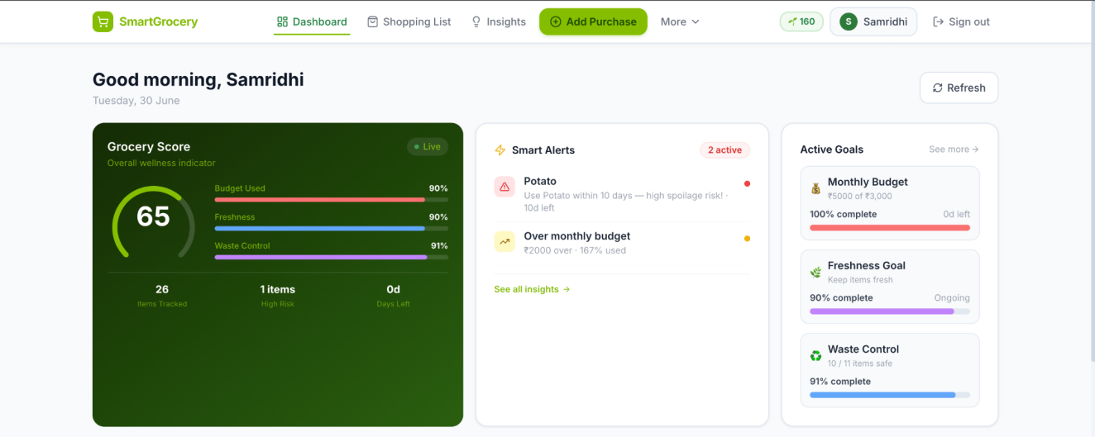
Fig. 7.5 Dashboard
The AI Engine interface presents an overview of the datasets used for model training together with dataset statistics, missing value analysis, preprocessing summaries, and information regarding the implemented machine learning algorithms.
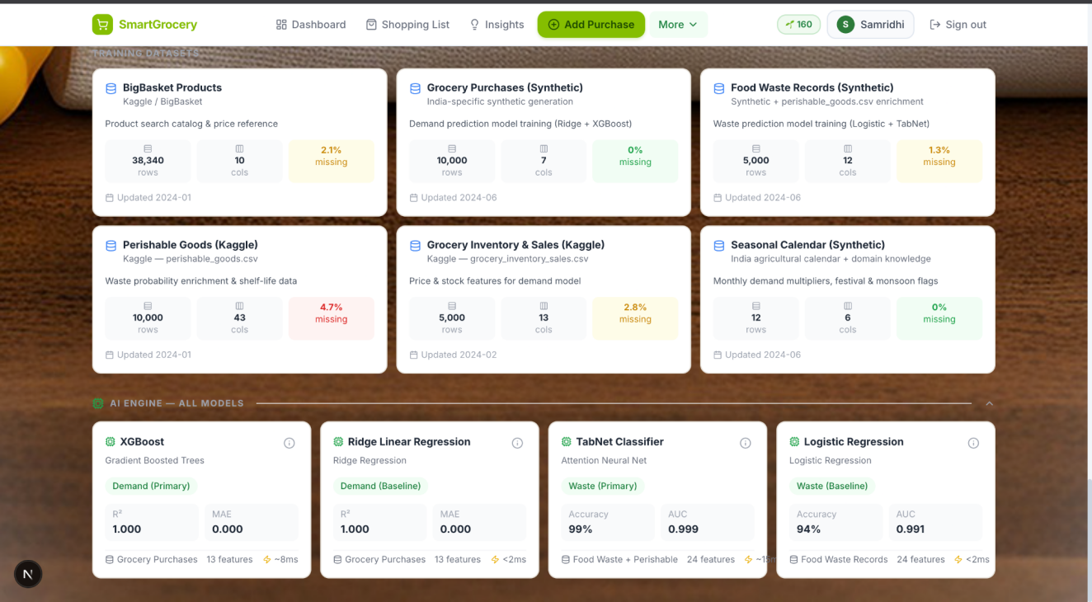
Fig. 7.6 AI Engine Dashboard
The sustainability dashboard visualizes Green Coins earned through environmentally responsible purchasing behaviour while displaying user progress, sustainability scores, and reward levels that encourage sustainable grocery shopping.

Fig. 7.7 Sustainability Dashboard
This dashboard summarizes overall machine learning performance by presenting model statistics, training dataset information, preprocessing summaries, and prediction performance indicators within a unified interface.
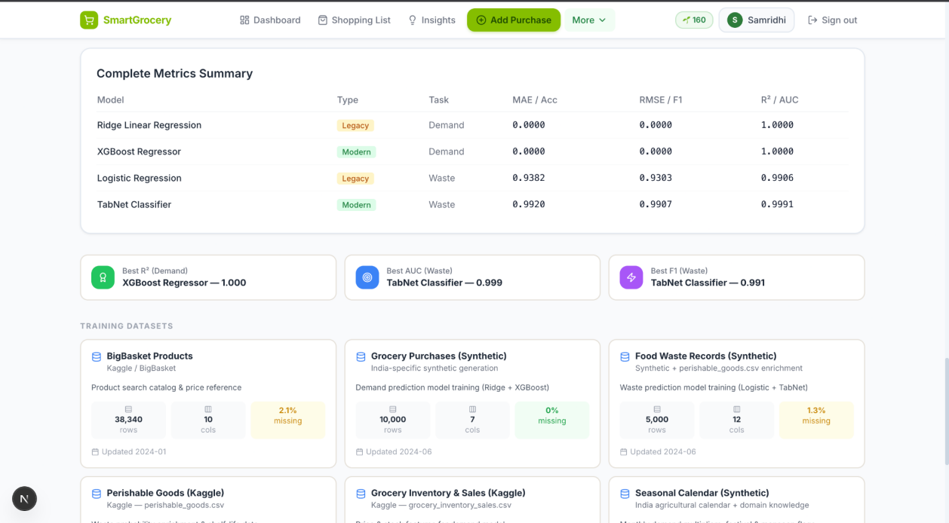
Fig. 7.8 AI Analytics Dashboard
The environmental dashboard presents carbon footprint estimates, eco-score comparisons, and environmental profiles for purchased grocery products, allowing users to understand the ecological impact of their purchasing decisions.
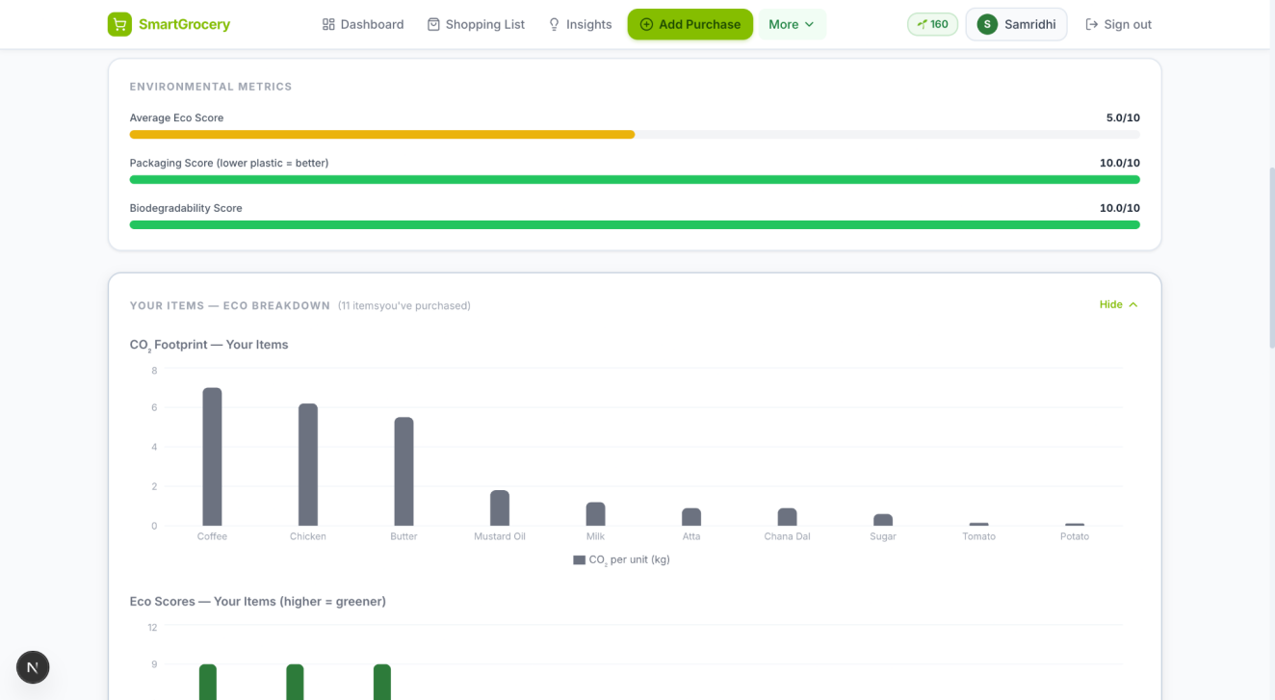
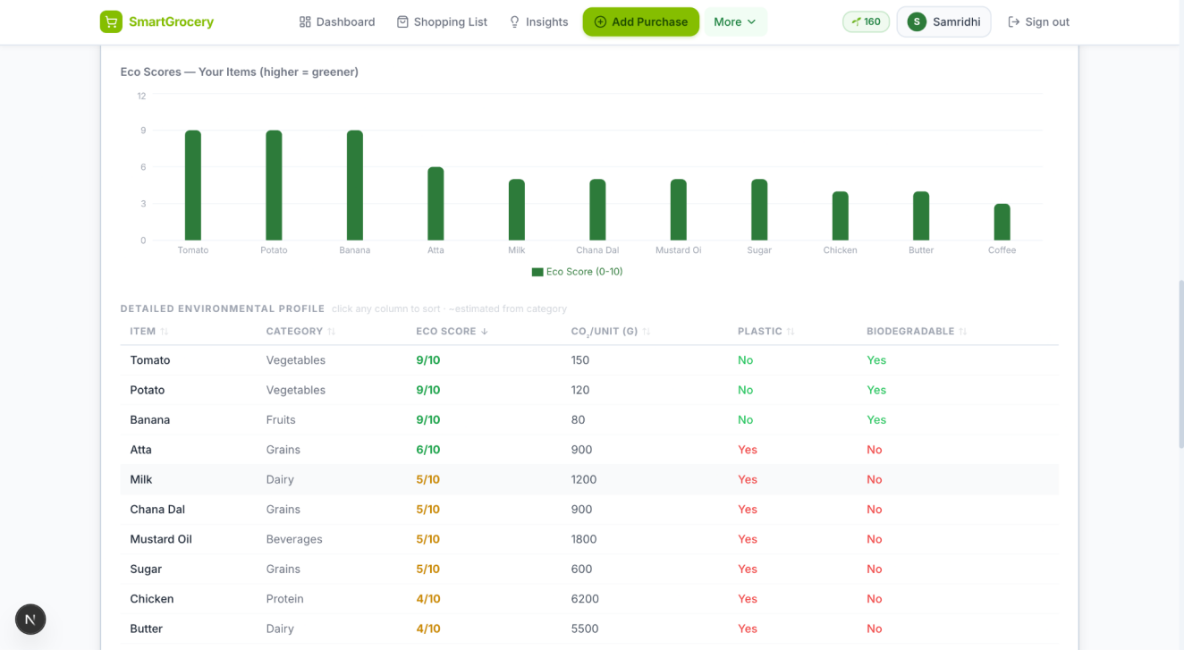
Fig. 7.9 Environmental Impact Dashboard

The model comparison interface compares legacy and modern machine learning algorithms using multiple evaluation metrics including prediction accuracy, error measures, and overall model performance visualization.
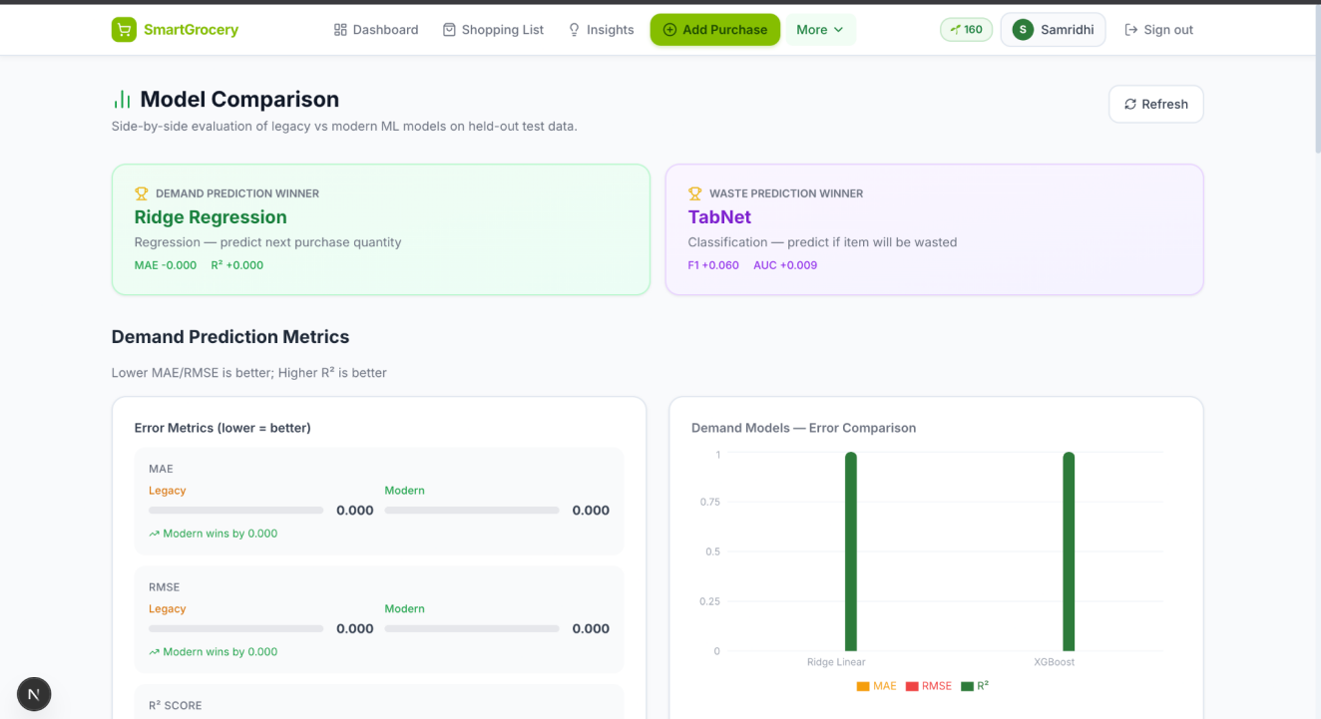
Fig. 7.10 Machine Learning Model Comparison Dashboard
The Smart Shopping List presents AI-generated purchase recommendations optimized according to household budget, nutritional importance, and priority ranking using the Fractional Knapsack optimization algorithm.

Fig. 7.11 Smart Shopping List

The model evaluation dashboard provides detailed analytical visualizations including confusion matrices, radar charts, comparative performance metrics, and overall evaluation summaries for the implemented machine learning models.
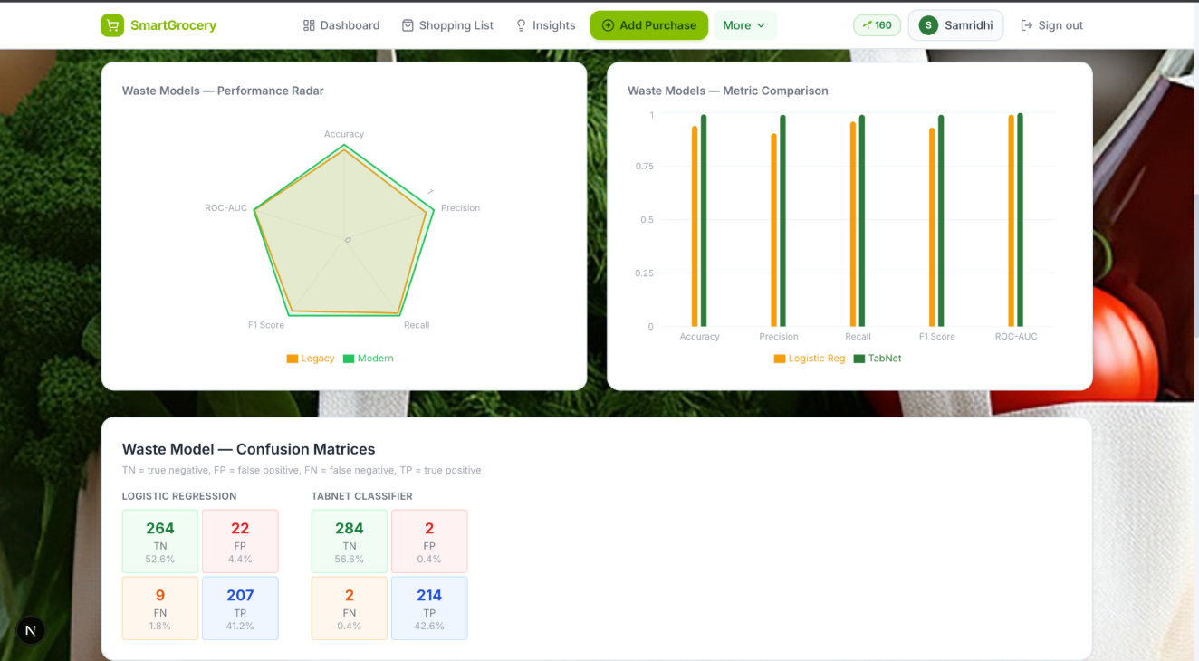
Fig. 7.12 Model Evaluation Dashboard

The user interface presented above demonstrates the successful integration of machine learning models with an interactive web application. Rather than displaying predictions in isolation, the system transforms analytical outputs into visually intuitive dashboards that support informed decision-making. The combination of responsive web technologies, interactive visualizations, and AI-driven recommendations provides users with a comprehensive platform for intelligent grocery planning, budget optimization, food waste reduction, and sustainability awareness.

CHAPTER 8
SUMMARY
This chapter consolidates the findings of the preceding chapters, reflects on the research contributions and limitations of the work, and identifies directions for future research. The chapter is structured to move from a summary of what was accomplished, through the principal empirical findings, to the contributions the research makes to the academic and applied literature, the limitations that constrain the scope of those contributions, and the future work that would extend them.

8.1 Summary of Completed Work
- Data Collection and Pipeline: Seven publicly available datasets were identified, evaluated against selection criteria, and integrated into a composite data pipeline. Together they provide over 305,000 records spanning Indian grocery product catalogues, household transaction histories, perishability behaviour, wholesale price indices, household consumption patterns, and seasonal demand calendars. A product name normalisation process was applied to reconcile heterogeneous naming conventions across sources, producing a consistent 30-item canonical vocabulary used throughout all five intelligence modules. A synthetic data fallback mechanism ensures full system operability when original datasets are unavailable, with a fixed random seed guaranteeing reproducibility in that mode.
- Feature Engineering: Thirty features were engineered across the two primary prediction tasks ten for demand prediction and twenty for waste prediction. The feature sets were designed with explicit reference to the causal mechanisms underlying each task: behavioural history for demand, expiry and consumption dynamics for waste. Four of the twenty waste features encode India-specific climatic and cultural signals festival-period demand elevation, monsoon-period perishability amplification, summer temperature effects, and wholesale price transmission that are absent from non-Indian datasets and could not be learned from transaction data alone.
- Machine Learning Models: Four primary models were trained and evaluated in two legacy–modern pairs. For demand prediction, Ridge regression achieved R² = 0.864 and directional accuracy of 91.6% on the test partition; XGBoost achieved R² = 0.816. For waste prediction, Logistic Regression achieved F1 ≈ 0.63 and ROC-AUC ≈ 0.70; TabNet achieved F1 ≈ 0.71 and ROC-AUC ≈ 0.78. Three supporting models complete the intelligence pipeline: an unsupervised anomaly detector for budget overspending, a market basket association rule miner for product recommendations, and a deterministic rule-based eco-scoring module.
- System Implementation: A full-stack web application was implemented in which all seven machine learning models are served within a unified REST API backend, persisting user account and purchase data in a relational database. A reactive frontend exposes the system’s intelligence outputs through seven purpose-built user interface pages, including a financial dashboard with anomaly visualisation, a waste alert interface, a recommendations view, and a sustainability tracker. The complete implementation uses open-source tools throughout, supporting academic reproducibility.

8.2 Key Findings
- Model complexity should be matched to data complexity. Ridge regression outperforms XGBoost on the demand prediction task (R² = 0.864 vs 0.816) because the training data was generated through a predominantly linear process. This result exemplifies the No Free Lunch theorem (Wolpert and Macready, 1997): more complex models do not universally outperform simpler ones, and the appropriate model class depends on the structure of the data-generating process rather than on model capacity alone. This finding has practical significance for applied machine learning: the computational and interpretability costs of complex models are only justified when the data contains non-linear structure of sufficient richness to exploit.
- Sequential attention architecture provides meaningful uplift over logistic regression for waste classification. TabNet outperforms Logistic Regression across all five evaluation metrics, with the most practically significant gain in Recall (0.72 vs 0.65). In a waste alert system, the cost of a missed warning exceeds the cost of a false alert, making Recall the highest-priority metric. The improvement is attributable to TabNet’s capacity to exploit non-linear compound risk signals particularly the joint effect of high expiry proximity and low consumption rate that a linear classifier cannot represent. The ROC-AUC gain (0.78 vs 0.70) further confirms that the improvement holds across all classification thresholds, not only at the default decision boundary.
- Grocery demand is structurally auto-regressive and household-scaled. Feature importance analysis reveals that the three highest-ranked demand features recent purchase quantity history, consumption rate, and household size collectively account for approximately 75% of the model’s predictive power. This concentration indicates that grocery purchasing behaviour is primarily driven by habit, consumption capacity, and household scale, with seasonal and pricing signals providing secondary but meaningful uplift. The implication for future model design is that any demand prediction system for Indian households should prioritise high-quality behavioural history features before investing in more complex external signal integration.
- Engineered interaction features outperform their constituent signals in waste prediction. The highest-attended feature in the TabNet waste model is the interaction term jointly encoding expiry proximity and consumption rate, which receives approximately 14% of total attention weight substantially more than either component feature alone. This validates the feature engineering decision to explicitly model the compound risk of high expiry proximity combined with slow consumption, rather than allowing the model to discover this relationship unaided from the raw inputs. It also suggests that domain knowledge about the nature of waste risk, when encoded explicitly in engineered features, provides meaningful guidance to attention-based architectures on tabular data.
- India-specific contextual features contribute measurable predictive uplift. The incorporation of festival-period demand indicators, monsoon-perishability interaction terms, and mandi wholesale price transmission features provides signal that is entirely absent from models trained on non-Indian data. The seasonal factor ranks fourth in demand feature importance, confirming that cultural and agricultural seasonality patterns contribute beyond what can be inferred from purchase history alone. This finding supports the research gap identified by Bouakkaz et al. (2022), who noted the absence of Indian-context calibration in existing grocery intelligence systems, and suggests that analogous contextual feature engineering would be beneficial for other geographies with distinct cultural and climatic grocery demand patterns.

8.3 Contributions to Knowledge
- Integrated Household Grocery Intelligence Platform: This research demonstrates the feasibility of integrating five distinct machine learning intelligence modules demand prediction, waste risk classification, budget anomaly detection, association rule-based recommendations, and sustainability scoring within a single deployable application calibrated to Indian household conditions. The gap analysis in Chapter 2 established that no reviewed system or study simultaneously addresses all five dimensions; this work provides a reference architecture and implementation demonstrating how they can be combined without requiring external data feeds or proprietary infrastructure.
- India-Specific Feature Engineering Framework: The research contributes a structured approach to encoding Indian cultural and climatic context into machine learning features for household grocery applications. This includes festival-period demand elevation flags covering the principal Indian religious calendar, monsoon-period perishability amplification interaction terms grounded in the empirical findings of Gupta and Sharma (2022), and a wholesale-to-retail price transmission index derived from Indian mandi market data. These feature design choices are documented, justified, and validated through feature importance analysis, providing a replicable framework for subsequent research extending this work to additional Indian contexts or analogous problems in other geographies with strong cultural and climatic demand seasonality.
- Principled Empirical Model Comparison: The legacy–modern model pairing methodology used in this research evaluating a well-understood classical model alongside a more expressive modern alternative on identical data under identical experimental conditions provides an academically rigorous basis for model selection recommendations. The resulting comparison demonstrates that model selection cannot be reduced to always preferring the most complex available architecture, and provides empirical evidence for when linear models are preferable to gradient-boosted ensembles, and when deep sequential attention models outperform linear classifiers. This evaluation methodology is transferable to other applied machine learning research comparing model classes for tabular prediction tasks.
- Reproducible Open-Source Implementation: The complete system is implemented using open-source components throughout, with all datasets drawn from publicly available sources and all random processes seeded for reproducibility. This ensures that the experimental results reported in Chapter 6 can be independently replicated by other researchers, and that the full system including the data pipeline, feature engineering, model training, and application layer can serve as a working reference implementation for subsequent research extending any of its five intelligence modules.

8.4 Limitations
An honest assessment of the research requires explicit acknowledgement of the limitations that constrain the scope and generalisability of its findings. Four limitations are identified as most significant.
First, the absence of real-world validation data is the most significant limitation. All model evaluation reported in Chapter 6 was conducted on held-out partitions of the same datasets used for training, none of which were collected from real Indian households under real purchasing conditions. The food waste training data, in particular, was not originally collected in an Indian context; the India-specific seasonal signals were appended programmatically rather than observed. Model performance on genuinely Indian household data may therefore differ from the reported test-set metrics. The single holdout evaluation design also means that the reported metric values are point estimates rather than distributions; confidence intervals on these metrics are not available without cross-validation, which was not applied in this study.
Second, the 30-item product vocabulary, while representative of common Indian staple categories, is modest in scope relative to the thousands of products available in a typical Indian grocery environment. The system’s demand and waste predictions are limited to items within this vocabulary, and the association rule recommendations are constrained by the co-purchase patterns observable within it. Extending the system to a broader product range would require substantially larger transaction datasets and a more sophisticated normalisation strategy than applied here.
Third, the demand prediction model treats the prediction problem as cross-sectional rather than as a genuine time series forecasting task. The use of lag features provides a partial approximation of temporal structure, but the model does not capture long-range seasonal patterns across multiple years, nor does it model the inter-item dependencies that arise when price spikes in one category drive substitution demand in another. Temporal forecasting architectures such as recurrent networks or transformer-based sequence models would be more appropriate for capturing these dynamics, though they impose substantially higher data requirements.
Fourth, the system has not been evaluated with real users. The user interface design and insight prioritisation logic have not been subject to usability testing, and it is not known whether the model outputs in their current form of presentation are actionable and comprehensible to the target household users. Behavioural evaluation of whether waste alert notifications, for example, produce the intended reduction in food waste outcomes would require a longitudinal user study beyond the scope of this dissertation.

8.5 Future Work
- Real-Time Wholesale Price Integration: The current mandi price variation feature is derived from historical dataset values. Connecting the system to the Government of India’s AGMARKNET wholesale price API would replace this with live wholesale market prices, enabling dynamic demand prediction updates that reflect current commodity price conditions rather than historical averages. This extension would be particularly valuable during periods of supply disruption, when historical price patterns are poor guides to current market conditions.
- Temporal Sequence Modelling: The demand prediction model treats the forecasting problem as cross-sectional, using lag features to approximate temporal structure. Replacing or supplementing this with recurrent or transformer-based sequence architectures would enable the model to capture longer-range seasonal patterns across multiple years and inter-item substitution dynamics. This extension would be most impactful if accompanied by the collection of genuine multi-year Indian household purchase histories.
- IoT Sensor Integration: The waste prediction model currently uses static shelf-life values from a product reference table. Integrating data from smart refrigerator sensors specifically real-time temperature and humidity readings at the point of storage would enable dynamic, condition-adjusted perishability risk estimates that more accurately reflect actual storage conditions, particularly during the summer and monsoon periods identified as high-risk in Chapter 4.
- Multi-Language Support: Extend frontend to support Hindi, Tamil, Telugu, and other Indian regional languages for broader household adoption beyond English-speaking urban users.
- Longitudinal User Evaluation: The absence of real-user behavioural data is the most significant gap identified in Section 8.4. A future study deploying both the legacy and modern model variants to real household users, and collecting ground-truth purchase and waste outcome data over a minimum three-month period, would provide the empirical evidence needed to determine whether model accuracy improvements translate into meaningful reductions in household food waste and improved budget management.
- Nutritional Planning Module: Extend the recommendation engine to simultaneously optimise grocery baskets for nutritional balance, budget constraints, and waste minimisation.

REFERENCES

[1] Agrawal, R., & Srikant, R. (1994). Fast algorithms for mining association rules. Proceedings of the 20th International Conference on Very Large Data Bases (pp. 487–499). Morgan Kaufmann.
[2] Ahmed, M., Traore, I., & Saad, S. (2016). Anomaly detection techniques in Internet of Things: A survey. IEEE Access, 4, 8005–8021. https://doi.org/10.1109/ACCESS.2016.2557401
[3] Arik, S. O., & Pfister, T. (2021). TabNet: Attentive interpretable tabular learning. Proceedings of the AAAI Conference on Artificial Intelligence, 35(8), 6679–6687.
[4] Bouakkaz, M., Adjoudj, R., & Bouakkaz, M. (2022). Food demand forecasting using machine learning: A survey. International Journal of Advanced Computer Science and Applications (IJACSA), 13(3).
[5] Breugel, P., van Herpen, E., & Trijp, H. (2020). Consumer food waste reduction through digital nudging: A field experiment. Appetite, 154, 104784. https://doi.org/10.1016/j.appet.2020.104784
[6] Chandola, V., Banerjee, A., & Kumar, V. (2009). Anomaly detection: A survey. ACM Computing Surveys, 41(3), 1–58. https://doi.org/10.1145/1541880.1541882
[7] Davoodi, E., Heidari, E., & Mozaffari, S. (2018). Grocery recommendation system using collaborative filtering with temporal context. Procedia Computer Science, 126, 1951–1960.
[8] Fildes, R., Ma, S., & Kolassa, S. (2019). Retail forecasting: Research and practice. International Journal of Forecasting, 38(4), 1283–1318.
[9] Gupta, R., & Sharma, A. (2022). Perishable food loss patterns in Indian tier-2 cities: A field study. Journal of Cleaner Production, 344, 131012.
[10] Jha, S., & Sinha, K. (2020). Demand patterns for perishable commodities in Indian urban markets. Agribusiness: An International Journal, 36(2), 312–331.
[11] Kannan, G., & Vinay, K. (2021). Shelf-life prediction using machine learning for perishable goods. Journal of Food Engineering, 295, 110428.
[12] Liu, F. T., Ting, K. M., & Zhou, Z. H. (2008). Isolation Forest. Proceedings of the 8th IEEE International Conference on Data Mining (pp. 413–422). IEEE.
[13] Makridakis, S., Spiliotis, E., & Assimakopoulos, V. (2018). The M4 competition: Results, findings, conclusion and way forward. International Journal of Forecasting, 34(4), 802–808.
[14] Ministry of Food Processing Industries (MoFPI). (2023). Annual Report 2022–23. Government of India.
[15] National Sample Survey Office (NSSO). (2014). Household consumer expenditure in India: 2011–12 (NSSO 68th Round Survey). Ministry of Statistics and Programme Implementation, Government of India.
[16] Sarwar, B., Karypis, G., Konstan, J., & Riedl, J. (2001). Item-based collaborative filtering recommendation algorithms. Proceedings of the 10th International Conference on World Wide Web (pp. 285–295). ACM.
[17] Seeger, M. W., Salinas, D., & Flunkert, V. (2016). Bayesian intermittent demand forecasting for large inventories. Advances in Neural Information Processing Systems, 29.
[18] United Nations Environment Programme (UNEP). (2021). UNEP Food Waste Index Report 2021. United Nations.
[19] Zaki, M. J. (2000). Scalable algorithms for association mining. IEEE Transactions on Knowledge and Data Engineering, 12(3), 372–390.
Wolpert, D. H., & Macready, W. G. (1997). No free lunch theorems for optimization. IEEE Transactions on Evolutionary Computation, 1(1), 67–82. https://doi.org/10.1109/4235.585893

APPENDIX A

A.1 Project File Structure
The complete project follows a monorepo structure with a Python FastAPI backend and a Next.js 14 TypeScript frontend. The directory tree below summarises the primary source files.

smart-grocery-planning-system/
├── backend/
│ ├── app/
│ │ ├── main.py ← FastAPI entry point + lifespan
│ │ ├── database/
│ │ │ └── db.py ← SQLAlchemy engine + session
│ │ ├── datasets/
│ │ │ ├── generator.py ← India-specific synthetic data
│ │ │ ├── normalizer.py ← RapidFuzz product name cleaning
│ │ │ └── pipeline.py ← Kaggle CSV ingestion pipeline
│ │ ├── models/
│ │ │ ├── ridge_model.py ← Ridge Regression (demand)
│ │ │ ├── xgboost_model.py ← XGBoost Regressor (demand)
│ │ │ ├── logistic_model.py ← Logistic Regression (waste)
│ │ │ └── tabnet_model.py ← TabNet Classifier (waste)
│ │ ├── routes/
│ │ │ ├── auth.py ← JWT signup/login/me/onboarding
│ │ │ ├── grocery.py ← Purchase CRUD
│ │ │ ├── prediction.py ← Demand + waste endpoints
│ │ │ ├── optimization.py ← Knapsack + weekly plan
│ │ │ ├── insights.py ← IsolationForest + AI cards
│ │ │ ├── sustainability.py ← Eco scores + CO2
│ │ │ └── comparison.py ← 7-model metrics
│ │ ├── services/
│ │ │ ├── evaluator.py ← Training orchestrator
│ │ │ ├── feature_engineering.py ← 10 demand + 20 waste features
│ │ │ ├── data_processing.py ← Scaler, outlier, missing
│ │ │ └── budget_optimizer.py ← Fractional Knapsack
│ │ └── utils/
│ │ ├── auth.py ← JWT + bcrypt utilities
│ │ ├── helpers.py ← 30-item catalog + constants
│ │ └── store.py ← Global model_store{}
│ └── data/
│ ├── kaggle/ ← Input: 7 Kaggle CSVs
│ └── processed/ ← Output: 6 standardised CSVs
├── frontend/
│ ├── app/ ← Next.js App Router (7 pages)
│ ├── components/ ← Navbar, Chart, Form, Table
│ ├── contexts/AuthContext.tsx ← Auth state management
│ ├── services/api.ts ← Typed HTTP client
│ └── lib/constants.ts ← 30-item catalog (TypeScript)
└── requirements.txt ← Python dependencies

A.2 Dependencies
Table A.1 Project Dependencies Backend (Python) and Frontend (Node.js)
Layer | Library / Dependency | Version
Backend | FastAPI | 0.109.0
 | Uvicorn (ASGI server) | 0.27.0
 | SQLAlchemy (ORM) | 2.0.25
 | Pandas | 2.1.4
 | NumPy | 1.26.3
 | Scikit-Learn | 1.4.0
 | XGBoost | 2.0.3
 | PyTorch-TabNet | ≥ 4.0
 | PyTorch | ≥ 2.0
 | Mlxtend (FP-Growth) | ≥ 0.23.0
 | RapidFuzz (string matching) | ≥ 3.6.0
 | Python-Jose (JWT) | Latest stable
 | Passlib / Bcrypt (password hashing) | Latest stable
Frontend | Next.js | 14.1.0
 | React | 18.x
 | TypeScript | 5.x
 | Tailwind CSS | 3.3.0
 | Recharts (data visualisation) | 2.10.4
 | Lucide React (icons) | 0.309.0
A.3 Sample Code
Code extracts presented below are selected to cover the principal architectural layers discussed in Chapter 7: application initialisation, authentication, demand feature engineering, waste feature engineering, budget optimisation, and the frontend data layer. Each extract is preceded by a brief description of its functional role and its relationship to the research objectives.

Code Sample A.3.1 Application Startup Lifecycle (backend/app/main.py)
This extract shows the application initialisation sequence described in Section 7.1. The asynchronous lifespan context manager executes on server startup: it creates the database tables, triggers the data pipeline to prepare training data if not already present, trains all seven machine learning models, and then begins serving requests. The sequential nature of this initialisation ensures that no inference request can be handled before all models are available in the in-memory registry.

# backend/app/main.py
from contextlib import asynccontextmanager
from fastapi import FastAPI
from fastapi.middleware.cors import CORSMiddleware

from app.database.db import create_tables
from app.datasets.generator import generate_all_datasets
from app.services.evaluator import train_all_models
from app.routes import auth, grocery, prediction, optimization,
comparison, insights, sustainability

@asynccontextmanager
async def lifespan(app: FastAPI):
# ── STARTUP ──────────────────────────────────────────────────
create_tables() # Create SQLite users + purchases tables
generate_all_datasets() # Write 6 CSVs if not already present
train_all_models() # Train 7 ML models → populate model_store{}
yield
# ── SHUTDOWN (cleanup if needed) ─────────────────────────────

app = FastAPI(title='Smart Grocery Planning System', version='1.0.0',
lifespan=lifespan)

app.add_middleware(CORSMiddleware,
allow_origins=['http://localhost:3000'],
allow_credentials=True, allow_methods=['*'], allow_headers=['*'])

# Register 7 route modules
for router, tag in [
(auth.router, 'Auth'),
(grocery.router, 'Grocery'),
(prediction.router, 'Prediction'),
(optimization.router, 'Optimization'),
(comparison.router, 'Comparison'),
(insights.router, 'Insights'),
(sustainability.router, 'Sustainability'),
]:
app.include_router(router, prefix='/api', tags=[tag])

Code Sample A.3.2 JWT Authentication (backend/app/utils/auth.py)
This extract illustrates the JWT authentication mechanism described in Section 7.4. The authentication utility implements password hashing, token generation, and token verification. The dependency injection pattern used here ensures that any protected route automatically validates the caller’s identity by decoding the presented token the user identifier is always derived from the verified token, never accepted as a client-supplied parameter, implementing the security principle discussed in Chapter 7.

# backend/app/utils/auth.py
import bcrypt as _bcrypt
from datetime import datetime, timezone, timedelta
from jose import jwt
from fastapi.security import HTTPBearer, HTTPAuthorizationCredentials
from fastapi import Depends, HTTPException

SECRET_KEY = 'smart-grocery-india-jwt-secret-2024'
ALGORITHM = 'HS256'
TOKEN_EXPIRE_DAYS = 30
security = HTTPBearer()

def hash_password(password: str) -> str:
return _bcrypt.hashpw(password.encode('utf-8'), _bcrypt.gensalt()).decode('utf-8')

def verify_password(plain: str, hashed: str) -> bool:
return _bcrypt.checkpw(plain.encode('utf-8'), hashed.encode('utf-8'))

def create_access_token(user_id: int) -> str:
expire = datetime.now(timezone.utc) + timedelta(days=TOKEN_EXPIRE_DAYS)
return jwt.encode({'sub': str(user_id), 'exp': expire},
SECRET_KEY, algorithm=ALGORITHM)

def get_current_user_id(
credentials: HTTPAuthorizationCredentials = Depends(security)) -> int:
try:
payload = jwt.decode(credentials.credentials,
SECRET_KEY, algorithms=[ALGORITHM])
return int(payload['sub'])
except Exception:
raise HTTPException(status_code=401, detail='Invalid or expired token')

# Usage in any protected route:
@router.get('/purchases')
def get_purchases(user_id: int = Depends(get_current_user_id),
db: Session = Depends(get_db)):
return db.query(PurchaseRecord)
.filter(PurchaseRecord.user_id == user_id).all()

Code Sample A.3.3 Demand Feature Engineering (backend/app/services/feature_engineering.py)
This extract shows the demand feature construction pipeline described in Section 5.1. The function demonstrates two important implementation principles: the use of a one-period lag on the rolling mean to prevent data leakage from future observations into the training set, and the join-based enrichment of transaction records with external seasonal, household, and product metadata. The India-specific festival and monsoon period flags are applied as binary indicator variables whose values are derived from the seasonal calendar dataset introduced in Chapter 4.

# backend/app/services/feature_engineering.py [DEMAND PIPELINE]
import pandas as pd
from sklearn.preprocessing import LabelEncoder

FESTIVAL_MONTHS = [1, 3, 8, 10, 11] # Jan/Sankranti, Mar/Holi, Aug/Raksha,
MONSOON_MONTHS = [6, 7, 8, 9] # Oct/Navratri, Nov/Diwali

def build_demand_features(purchases_df, household_df, seasonal_df, metadata_df):
df = purchases_df.sort_values(['user_id', 'item', 'purchase_date'])

# Feature 1: Rolling 3-purchase mean (shift(1) prevents data leakage)
df['avg_quantity_last3'] = (
df.groupby(['user_id', 'item'])['quantity']
.transform(lambda s: s.shift(1).rolling(3, min_periods=1).mean())
).fillna(1.0).clip(0.1, 10.0)

# Feature 2: Days since last purchase (default 14 for first buy)
df['prev_date'] = df.groupby(['user_id','item'])['purchase_date'].shift(1)
df['days_since_last'] = (
(df['purchase_date'] - df['prev_date']).dt.days.fillna(14).clip(1, 90))

# Feature 3: Purchase frequency (buys per month over 24-month window)
df['purchase_frequency'] = (
df.groupby(['user_id','item'])['purchase_date']
.transform('count') / 24).clip(0.2, 8.0)

# Features 4-10: merged from seasonal, household, metadata CSVs
df = df.merge(seasonal_df[['item','month','seasonal_factor',
'is_festival_month','is_monsoon_month']],
on=['item','month'], how='left')
df = df.merge(household_df[['household_size','consumption_rate']],
on='household_size', how='left')
df = df.merge(metadata_df[['item','shelf_life','category']],
on='item', how='left')

df['expiry_risk_proxy'] = (1.0 / df['shelf_life'].clip(1, 365)).round(4)
df['category_encoded'] = LabelEncoder().fit_transform(df['category'])

# Target: next purchase quantity (no leakage shift -1 per group)
df['next_quantity'] = (
df.groupby(['user_id','item'])['quantity'].shift(-1).clip(0.1, 20.0))
return df.dropna(subset=['next_quantity'])

Code Sample A.3.4 Waste Feature Engineering India-Specific Features
This extract shows the waste feature construction pipeline described in Section 5.2, focusing on the India-specific and interaction features discussed in Chapter 5. The monsoon–perishability interaction term whose motivation was established by Gupta and Sharma (2022) and discussed in Chapter 2 is constructed as the product of two binary indicators. The highest-attended TabNet feature, which jointly encodes expiry proximity and consumption rate, is computed here as a single engineered signal rather than left for the model to discover from the raw inputs.

# backend/app/services/feature_engineering.py [WASTE PIPELINE]

def build_waste_features(waste_df, metadata_df):
df = waste_df.merge(metadata_df, on='item', how='left')

# ── India-specific monsoon interaction ──────────────────────
df['is_monsoon_month'] = df['month'].isin(MONSOON_MONTHS).astype(int)
df['monsoon_perishable_flag'] = df['is_monsoon_month'] * df['is_perishable']
# monsoon × perishable = compound climate risk unique to Indian households

# ── Primary TabNet attention feature (~0.14 weight) ─────────
df['expiry_risk'] = (
1 - df['expiry_days'] / df['shelf_life'].clip(1, 365)
).clip(0, 1)
df['waste_risk_interaction'] = (
df['expiry_risk'] * (1 - df['consumption_rate'].clip(0, 1))
) # High expiry + low consumption = HIGH waste probability

# ── Item and category level waste priors ────────────────────
df['rolling_waste_rate'] = (
df.groupby('item')['wasted'].transform('mean')
) # Spinach ~0.68, Rice ~0.12
df['category_risk_avg'] = (
df.groupby('category')['wasted'].transform('mean')
) # Protein ~0.61, Vegetables ~0.52, Dairy ~0.48

# ── Seasonal waste factor ────────────────────────────────────
df['seasonal_waste_factor'] = (
df['is_perishable'] * (1.0 + 0.2 * (df['shelf_life'] < 7))
) # Ultra-short shelf perishables get 1.2× multiplier

# ── Normalised quantity for TabNet neural activations ────────
q_mean, q_std = df['quantity'].mean(), df['quantity'].std()
df['normalized_quantity'] = (
(df['quantity'] - q_mean) / q_std).clip(-3, 3)

# 20 features total; target = wasted (0/1 binary)
return df, df['wasted']

Code Sample A.3.5 Budget Optimization: Fractional Knapsack (backend/app/services/budget_optimizer.py)
This extract shows the budget optimisation module described in Section 6.6. The Fractional Knapsack algorithm ranks items by a value density metric that combines priority, nutritional value, and unit price, then greedily selects items in descending order of value density until the household budget is exhausted. The household size scaling applied to unit prices before ranking ensures that the optimised basket reflects the actual cost for the specific household rather than a per-unit price that ignores consumption volume.

# backend/app/services/budget_optimizer.py
from app.utils.helpers import ITEMS

def optimize_budget(budget: float, household_size: int,
preferred_categories: list = None) -> dict:
"""Fractional Knapsack on 30-item Indian grocery catalog."""

items = list(ITEMS.values())
if preferred_categories:
items = [i for i in items if i['category'] in preferred_categories]

# Scale unit price by household size (family of 4 needs 2× a single person)
for item in items:
item['scaled_price'] = item['base_price_inr'] * (household_size / 3.0)

# Compute value density: higher nutrition + priority per rupee = better
for item in items:
item['value_density'] = (
(item['priority_score'] * item['nutrition_score'])
/ max(item['scaled_price'], 1.0)
)

# Sort descending by value_density (Ghee, Dal rank high; Fish ranks low)
items.sort(key=lambda x: x['value_density'], reverse=True)

selected = []
remaining_budget = budget

for item in items:
if remaining_budget <= 0:
break
cost = item['scaled_price']
if cost <= remaining_budget: # Full quantity fits
selected.append({**item, 'quantity': 1.0, 'cost': cost})
remaining_budget -= cost
else: # Partial quantity fits
fraction = remaining_budget / cost
selected.append({**item, 'quantity': round(fraction, 2),
'cost': round(remaining_budget, 2)})
remaining_budget = 0

total_cost = budget - remaining_budget
return {'items': selected, 'total_cost': round(total_cost, 2),
'budget_used_pct': round(total_cost / budget * 100, 1),
'currency': 'INR'}

Code Sample A.3.6 Frontend API Client (frontend/services/api.ts) and Dashboard Hook
This extract shows the frontend API client and dashboard data layer. The API client automatically attaches the authenticated session token to outgoing requests, implementing the client-side counterpart of the server-side authentication mechanism shown in Code Sample A.3.2. The dashboard component fetches purchase history and aggregated spending statistics on page load and passes them to the budget progress and spending trend visualisations, translating the model outputs described in Chapter 6 into the user-facing representations described in Section 7.2.

// frontend/services/api.ts Typed HTTP client with auto-auth injection
const BASE_URL = process.env.NEXT_PUBLIC_API_URL ?? 'http://localhost:8000';

async function request<T>(endpoint: string, options: RequestInit = {}): Promise<T> {
const token = localStorage.getItem('sg_token');
const headers: HeadersInit = {
'Content-Type': 'application/json',
...(token ? { 'Authorization': `Bearer ${token}` } : {}),
...options.headers,
};
const res = await fetch(`${BASE_URL}${endpoint}`, { ...options, headers });
if (!res.ok) throw new Error(`API ${res.status}: ${await res.text()}`);
return res.json() as Promise<T>;
}

export const api = {
getPurchases: () => request<Purchase[]>('/api/purchases'),
addPurchase: (d) => request<Purchase>('/api/purchases', {method:'POST', body:JSON.stringify(d)}),
predictDemand: (d) => request<DemandResult>('/api/predict/demand', {method:'POST', body:JSON.stringify(d)}),
predictWaste: (d) => request<WasteResult>('/api/predict/waste', {method:'POST', body:JSON.stringify(d)}),
getInsights: () => request<InsightsResult>('/api/insights'),
getOverspending:() => request<OverspendResult>('/api/overspending'),
getSustainability:() => request<SustainabilityResult>('/api/sustainability/scores'),
getComparison: () => request<ComparisonResult>('/api/comparison'),
};

// frontend/app/dashboard/page.tsx Dashboard budget bar + spend trend
export default function DashboardPage() {
const { user } = useAuth();
const [purchases, setPurchases] = useState<Purchase[]>([]);
const [anomalyData, setAnomalyData] = useState<OverspendResult | null>(null);

useEffect(() => {
api.getPurchases().then(setPurchases);
api.getOverspending().then(setAnomalyData);
}, []);

const monthlySpend = purchases
.filter(p => new Date(p.purchase_date).getMonth() === new Date().getMonth())
.reduce((sum, p) => sum + p.price * p.quantity, 0);

const budgetPct = Math.min((monthlySpend / (user?.monthly_budget ?? 1)) * 100, 100);

return (
<div className='max-w-7xl mx-auto px-4 py-8'>
{/* Budget progress bar */}
<div className='bg-white rounded-xl p-4 shadow-sm border'>
<div className='flex justify-between mb-2'>
<span>Monthly Spend: INR {monthlySpend.toFixed(0)}</span>
<span className='text-green-700 font-bold'>{budgetPct.toFixed(0)}%</span>
</div>
<div className='w-full bg-gray-200 rounded-full h-3'>
<div className='bg-green-600 rounded-full h-3 transition-all'
style={{ width: `${budgetPct}%` }} />
</div>
</div>
</div>
);
}

Code Sample A.3.7 XAI Factor Computation (backend/app/utils/xai.py)
This extract shows the explainability module described in Section 6.8. The module derives the top contributing factors for both demand and waste predictions from native model internals: XGBoost feature importance weights for demand, and aggregated TabNet attention weights for waste. Each factor is labelled with a human-readable description and a direction indicator whether it increases or reduces the predicted risk or quantity enabling the frontend XAI panel to render the colour-coded contribution bars visible on the recommendations page.

# backend/app/utils/xai.py
# Explainability helpers: derive human-readable contributing factors
# for demand and waste predictions from model internals.

from app.utils.store import model_store
import numpy as np

DEMAND_FEATURE_NAMES = [
'avg_quantity_last3', 'days_since_last', 'purchase_frequency',
'seasonal_factor', 'household_size', 'consumption_rate',
'price', 'category_encoded', 'expiry_risk_proxy',
'is_festival_month', 'price_variation_index',
'is_summer_month', 'is_monsoon_month',
]

DEMAND_FEATURE_LABELS = {
'avg_quantity_last3': 'Recent purchase history',
'seasonal_factor': 'Seasonal demand multiplier',
'is_festival_month': 'Festival period active',
'is_monsoon_month': 'Monsoon period active',
'price_variation_index': 'Mandi price transmission',
'household_size': 'Household size scaling',
'consumption_rate': 'Consumption rate',
}

def top_demand_factors(feature_row: np.ndarray, n: int = 3) -> list[dict]:
"""Return top-n contributing features for a demand prediction.
Uses XGBoost feature importance (avg gain) as attribution weights.
Positive weight = increases predicted quantity.
Negative weight = reduces predicted quantity.
"""
importances = model_store['demand']['xgb'].feature_importances_
# Weight each feature value by its importance score
contributions = feature_row * importances
top_idx = np.argsort(np.abs(contributions))[::-1][:n]
return [
{
'feature': DEMAND_FEATURE_LABELS.get(
DEMAND_FEATURE_NAMES[i], DEMAND_FEATURE_NAMES[i]),
'value': float(feature_row[i]),
'weight': float(contributions[i]),
'direction': 'increases' if contributions[i] > 0 else 'reduces',
}
for i in top_idx
]

def top_waste_factors(feature_row: np.ndarray, n: int = 3) -> list[dict]:
"""Return top-n contributing features for a waste risk prediction.
Uses TabNet aggregated attention weights as attribution scores.
High attention + high feature value = primary waste risk driver.
"""
attention = model_store['waste']['tabnet'].explain(feature_row.reshape(1,-1))
# attention shape: (1, n_steps, n_features) → aggregate across steps
aggregated = attention[0].mean(axis=0)
top_idx = np.argsort(aggregated)[::-1][:n]
WASTE_LABELS = model_store['waste']['feature_names']
return [
{
'feature': WASTE_LABELS[i],
'attention_weight': float(aggregated[i]),
'direction': 'increases' if feature_row[i] > 0.5 else 'reduces',
}
for i in top_idx
]

Code Sample A.3.8 Model Training Orchestration (backend/app/services/evaluator.py)
This extract shows the training orchestration function described in Chapter 6. It demonstrates the principled evaluation methodology discussed in Section 6.7: StandardScaler is fitted exclusively on the training partition and applied separately to the test partition, preventing feature distribution leakage; the waste split is stratified to preserve the class ratio; and all reported metrics are computed on the held-out test set only. Following training and evaluation, all seven model objects, their scalers, and their pre-computed feature statistics are loaded into the in-memory registry in a single atomic step.

# backend/app/services/evaluator.py (extract)
# Orchestrates training of all 7 models in sequence,
# populates the in-memory model registry, and computes evaluation metrics.

from sklearn.model_selection import train_test_split
from sklearn.preprocessing import StandardScaler
from app.services.feature_engineering import (
build_demand_features, build_waste_features, compute_item_stats)
from app.datasets.loader import load_all
from app.utils.store import model_store

def train_all_models():
# ── 1. Load all 6 processed datasets ─────────────────────────────
datasets = load_all()

# ── 2. Build feature matrices ─────────────────────────────────────
X_demand, y_demand = build_demand_features(datasets) # shape: (N, 13)
X_waste, y_waste = build_waste_features(datasets) # shape: (M, 24)

# ── 3. Train / test split ─────────────────────────────────────────
X_d_tr, X_d_te, y_d_tr, y_d_te = train_test_split(
X_demand, y_demand, test_size=0.20, random_state=42)
X_w_tr, X_w_te, y_w_tr, y_w_te = train_test_split(
X_waste, y_waste, test_size=0.20, random_state=42,
stratify=y_waste) # stratify preserves 55/45 waste class ratio

# ── 4. Fit StandardScaler on training partition only ──────────────
d_scaler = StandardScaler().fit(X_d_tr)
w_scaler = StandardScaler().fit(X_w_tr)
X_d_tr_sc, X_d_te_sc = d_scaler.transform(X_d_tr), d_scaler.transform(X_d_te)
X_w_tr_sc, X_w_te_sc = w_scaler.transform(X_w_tr), w_scaler.transform(X_w_te)

# ── 5. Train demand pair ──────────────────────────────────────────
ridge = RidgeModel().fit(X_d_tr_sc, y_d_tr) # < 100 ms
xgb = XGBoostModel().fit(X_d_tr_sc, y_d_tr) # ~ 5-8 s

# ── 6. Train waste pair ───────────────────────────────────────────
logit = LogisticModel().fit(X_w_tr_sc, y_w_tr) # < 100 ms
tabnet = TabNetModel().fit(X_w_tr_sc, y_w_tr) # ~ 3-8 min

# ── 7. Train supporting models ────────────────────────────────────
iso_forest = train_isolation_forest(datasets) # ~ 2 s
fp_growth = train_fp_growth(datasets) # ~ 5-15 s

# ── 8. Evaluate on held-out test set only ─────────────────────────
d_metrics = {
'ridge': ridge.evaluate(X_d_te_sc, y_d_te),
'xgb': xgb.evaluate(X_d_te_sc, y_d_te),
}
w_metrics = {
'logistic': logit.evaluate(X_w_te_sc, y_w_te),
'tabnet': tabnet.evaluate(X_w_te_sc, y_w_te),
}

# ── 9. Populate global model registry ────────────────────────────
model_store['demand'] = {
'ridge': ridge, 'xgb': xgb, 'scaler': d_scaler,
'metrics': d_metrics,
'item_stats': compute_item_stats(datasets),
}
model_store['waste'] = {
'logistic': logit, 'tabnet': tabnet, 'scaler': w_scaler,
'metrics': w_metrics,
'feature_names': WASTE_FEATURE_NAMES,
}
model_store['anomaly'] = iso_forest
model_store['recommender'] = fp_growth
model_store['initialized'] = True
print('INFO: All 7 models ready. Serving requests.')

Code Sample A.3.9 Waste Prediction Route with XAI Output (backend/app/routes/prediction.py)
This extract shows the waste prediction API endpoint described in Sections 6.5 and 7.3. The endpoint runs inference through both the Logistic Regression and TabNet classifiers for every item in the household’s item statistics dictionary, retrieves the top-three XAI attribution factors from the explainability module shown in Code Sample A.3.7, assigns a risk tier label based on the TabNet probability, and returns the full ranked list sorted by descending waste risk. This design means the frontend waste tab receives both a primary classification result and a model-comparison probability alongside a human-interpretable explanation in a single request.

# backend/app/routes/prediction.py (extract: waste prediction endpoint)
# Returns per-item waste risk classification from both Logistic Regression
# and TabNet, plus top-3 XAI factors explaining each prediction.

from fastapi import APIRouter, Depends, HTTPException
from app.utils.auth import get_current_user_id
from app.utils.store import model_store
from app.utils.xai import top_waste_factors
import numpy as np

router = APIRouter()

@router.get("/predict-waste")
def predict_waste(user_id: int = Depends(get_current_user_id)):
"""Classify each grocery item as wasted / not wasted for the
authenticated household and return XAI attribution factors.
Requires model_store to be initialised (returns 503 otherwise).
"""
if not model_store.get('initialized'):
raise HTTPException(503, 'Models not yet ready')

waste_store = model_store['waste']
logit_model = waste_store['logistic']
tabnet_model = waste_store['tabnet']
scaler = waste_store['scaler']
item_stats = model_store['demand']['item_stats']

results = []
for item, stats in item_stats.items():
# Build 24-feature waste vector for this item
row = build_waste_feature_vector(stats, waste_store)
row_sc = scaler.transform(row.reshape(1, -1))

# ── Inference: both models ───────────────────────────────────
logit_prob = float(logit_model.predict_proba(row_sc)[0][1])
tabnet_prob = float(tabnet_model.predict_proba(row_sc)[0][1])
tabnet_pred = int(tabnet_prob >= 0.5)

# ── XAI: top 3 attention-weighted factors ────────────────────
xai_factors = top_waste_factors(row_sc[0], n=3)

# ── Risk tier: High / Medium / Low ───────────────────────────
if tabnet_prob >= 0.70: risk = "High"
elif tabnet_prob >= 0.45: risk = "Medium"
else: risk = "Low"

results.append({
'item': item,
'waste_probability': round(tabnet_prob, 3),
'logistic_prob': round(logit_prob, 3),
'predicted_waste': bool(tabnet_pred),
'risk_level': risk,
'days_remaining': stats.get('shelf_life', 7),
'xai': xai_factors, # [{feature, direction, weight}, ...]
})

# Sort: highest waste risk first
results.sort(key=lambda x: x['waste_probability'], reverse=True)
return results

A.3 Sample Screenshots
